CO2 Country Adapters: WVS OOS Evaluation — Executive Report
Date: 2026-08-19 · 8 QLoRA-DPO adapters on Llama-3.1-8B-Instruct (IND, IDN, NGA, EGY, TUR, NLD, BRA, GRC) · 35 unseen WVS wave-7 items (30 GPS-mapped + 5 demographic) · option log-likelihood → softmax → distributional metrics vs survey-weighted populations · unconditioned prompts (single fixed distribution per model). EGY: 3 items skipped (Q69–71 not asked in Egypt; n=32).

1 · Headline: matched alignment vs base model
Country | Base TVD | Adapter TVD | Δ TVD | Frac. improved | Base JSD | Adapter JSD
IND | 0.494 | 0.511 | -0.017 | 49% | 0.198 | 0.211
IDN | 0.517 | 0.574 | -0.056 | 11% | 0.217 | 0.258
NGA | 0.515 | 0.495 | +0.019 | 60% | 0.220 | 0.207
EGY | 0.532 | 0.577 | -0.046 | 19% | 0.234 | 0.267
TUR | 0.446 | 0.464 | -0.018 | 51% | 0.174 | 0.184
NLD | 0.411 | 0.504 | -0.093 | 9% | 0.154 | 0.214
BRA | 0.486 | 0.478 | +0.008 | 26% | 0.206 | 0.214
GRC | 0.479 | 0.404 | +0.075 | 66% | 0.200 | 0.155
Pooled: base TVD 0.485 vs adapter 0.501 (3 of 8 improve). Δ>0 = adapter closer to its country's population than the base model.
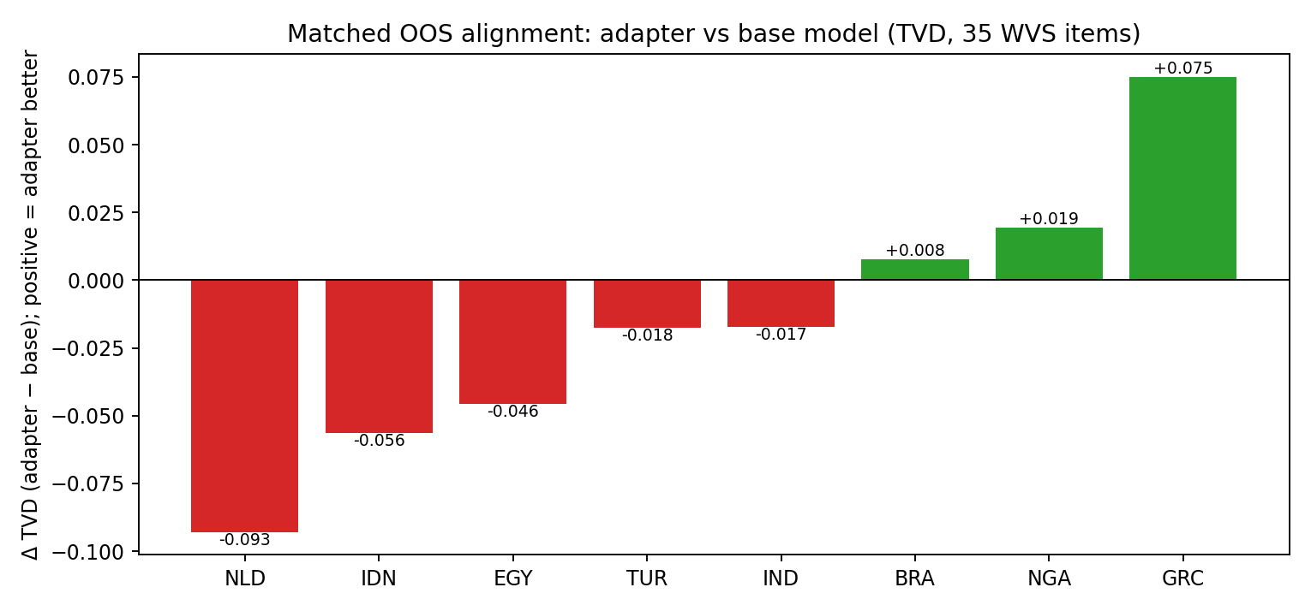

2 · Dimension structure
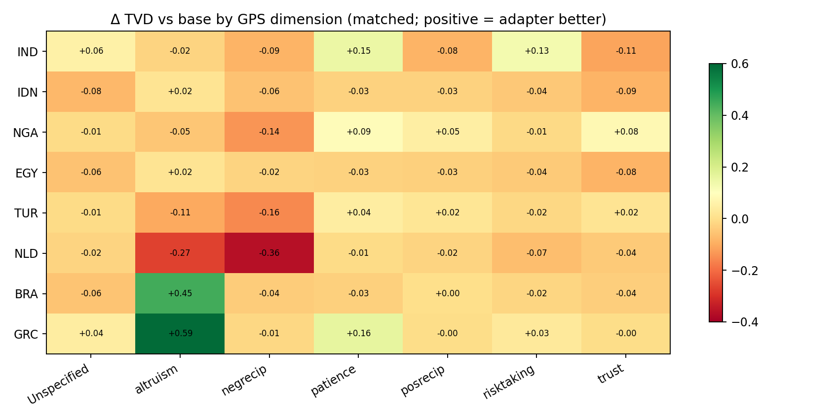
Altruism is the strongest win dimension (BRA +0.446, GRC +0.588, both 100% of questions improved); patience wins for IND/GRC/NGA/TUR. Negative reciprocity is the consistent loser (NLD −0.363 with 0% improved, TUR −0.157, NGA −0.138). Trust is mixed (NGA +0.079/83% vs IND −0.111). NLD degrades on every dimension.

3 · Two layers: preference recovery vs population alignment
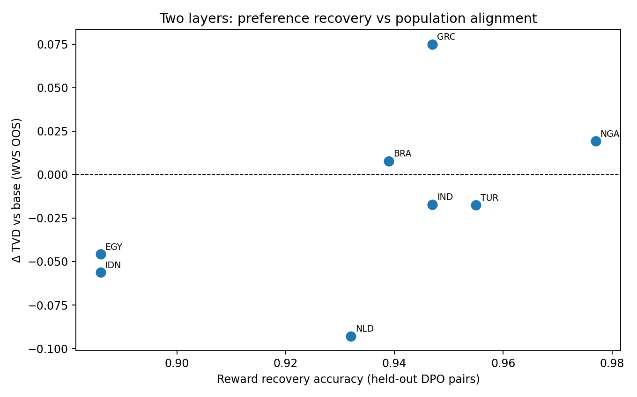
Reward recovery (held-out DPO pairs, 88.6–97.7%) is a sanity layer: it measures whether DPO moved the policy toward the country's synthetic labels. OOS TVD is the validity layer: whether the resulting distribution resembles the real population. The layers are weakly related — high recovery does not imply alignment (IDN/EGY recover at 88.6% yet degrade on TVD), while NGA and GRC align well. Recovery validates the plumbing; only calibration validates the science.
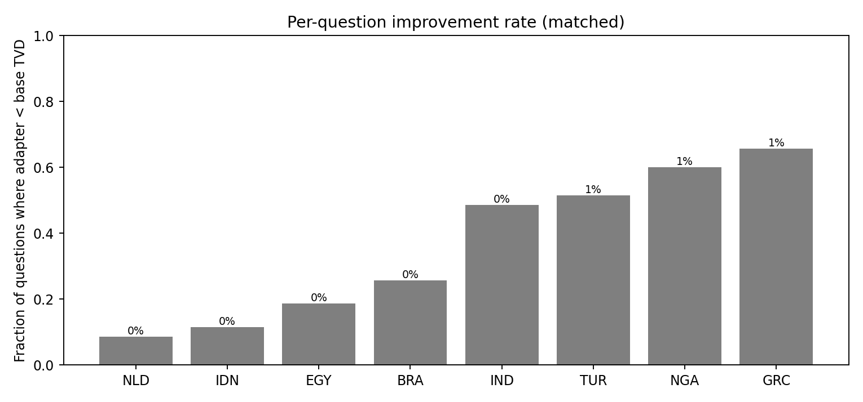

4 · Robustness & caveats
Bootstrap CIs (2,000 reps, per-question resampling) are in survey_metric_bootstrap_summary.csv; ECE in survey_probability_calibration_ece.csv (per-model). Duplicate-preference profiles (sign(z) labeling): IND≡GRC≡LTU and IDN≡EGY have identical training labels — their adapters are effectively one model (IDN_adapter on EGY == EGY_adapter on EGY = 0.578 exactly). EGY scored on 32 items. Unconditioned prompts: matched-vs-cross compares each model's single fixed distribution against each population (distributional alignment, not country-conditioned inference).

5 · Comparison with Ksennia's set (CHN, JPN, GBR, US, MEX, ARG, DEU, RUS)
Dimension | Ksennia's set (qualitative) | CO2 set (quantitative) | Consistency
Trust | Best dimension (MEX/ARG/DEU near-perfect); worst for JPN | Mixed: NGA +0.079/83%, TUR +0.016; IND −0.111, IDN/EGY −0.085 | Dimension-selective, country-heterogeneous
Altruism | Worst dimension (inversions in CHN/USA/DEU/RUS) | Best win dimension (BRA +0.446, GRC +0.588, 100%) | Contradicts — CO2 adapters align where hers invert
Negative reciprocity | Poor (mismatched shapes) | Consistent loser (NLD −0.363, TUR −0.157, NGA −0.138) | Reinforced
Patience | Poor (inversions in GBR/USA) | Win for 4/8 (IND +0.150, GRC +0.162); mild loss otherwise | Mixed
Risk taking | Poor (GBR best); USA near-perfect | Mild loss everywhere (−0.01 to −0.07) | Reinforced (weak)
Overall | USA degrades; MEX selective (trust great, values poor) | 5/8 degrade (NLD −0.093 worst), 3/8 improve (GRC +0.075 best) | Reinforced: degradation is the modal outcome; not universal
Notes: Ksennia's column is a qualitative reading of her distribution grids (her quantitative CSVs were not in the shared document); CO2 numbers are paired per-question mean TVD deltas vs base on matched questions. The USA-adapter degradation from the preliminary 2×2 replicates at scale; the new insight is that the failure is dimension- and country-specific rather than universal — GRC (and BRA's altruism dimension, +0.446/100%) show the mechanism can work when the synthetic sign signal aligns with the population's direction.

