### Proposal for Semi-Customizable Reporting System

### Introduction

### The Terms of Reference (ToR) details a requirement for a site specific Semi-Customizable Reporting System (SCRC) for use by the sites and CMS. The solution should allow quarterly report recipients to examine sub-trends within the metrics presented in the quarterly feedback reports in order to refine their program related activities. The goal of this reporting system provides a way for CMS and the sites to delve deeper into the data as desired for selected subgroups of interest. For example, the user would be able to examine the metrics for 30-day readmission rates or number of specialty physician visits within the hospital stay by subgroups of interest, such as for selected MS-DRGs or service use categories, that may otherwise not be available via the quarterly reports.

Some of the key requirements for the solution are that it:

* blinds results at beneficiary level (i.e., suppresses cell sizes <100) and the site level (i.e., an individual site does not access data relevant from a different site);
* is readily maintainable;
* is accessible to the sites;
* meets data security, privacy issues, and legal requirements;
* meets the level of analytic sophistication at the sites; and
* is useful and usable to the sites.

Other requirements include:

* A report to the contracting officer’s representative (COR)) displaying the proposed approach and template for the site-specific SCRS which identifies specific metrics to be included and the specific drill down capabilities envisioned.
* The data generating the results in the site-specific SCRS should be updated in conjunction with each quarter’s report. It should be cumulative and it should tie directly to the available sample for its corresponding quarterly report.
* An accompanying user manual for the SCRS which shall include information, presented on an aggregate level, on how to use the system as well as the relevant portions of the guide to interpret data associated with the Quarterly Feedback Report.
* An orientation session on using the reporting system delivered through a recorded webinar, which can be subsequently accessed.
* A clearance version of the site-specific SCRS generated in conjunction with the quarterly report in which claims data is first presented. The first version to be distributed to sites will reflect the data associated with the subsequent quarterly report and on a quarterly basis thereafter.

**Approach**

The proposed approach fits with the deliverables as outlined in the ToR, focusing initially on end user and technical engagement before designing a technical and content solution which will meet end user and legal needs.

*This section provides an idea of what Econometrica, Inc. has envisioned for the dashboard*

**Perspectives/Accounts**

There should be three accounts:

* Administrative – total access including content management
* CMS – government entity that can view/read all data for all hospitals presented at the site
* Hospital/Site – hospital entity that can view/read data for their specific hospital (all other hospital data should not be seen unless shown in aggregation such as the run charts below)

**Webpage 1 – Overview Page**

The overview page will be the first thing users see after logging into the website. The graphic for this, a map of New Jersey, will be a clickable map displaying 23 hospitals (see example of NJ Map in e-mail).

* CMS – can select any of the 23 hospitals which will lead them to the initial dashboard page
* Hospital/Site – should only be allowed to click on their hospital which will lead them to the initial dashboard page

Below the map we would like a “Summary of Progress” section which is hospital-specific or CMS-specific where we can show text. Each entity, CMS or hospitals, will see something specific to their login/account.

**Webpage 2 – Initial Dashboard**

This page will have two aspects for the CMS and Hospital User.

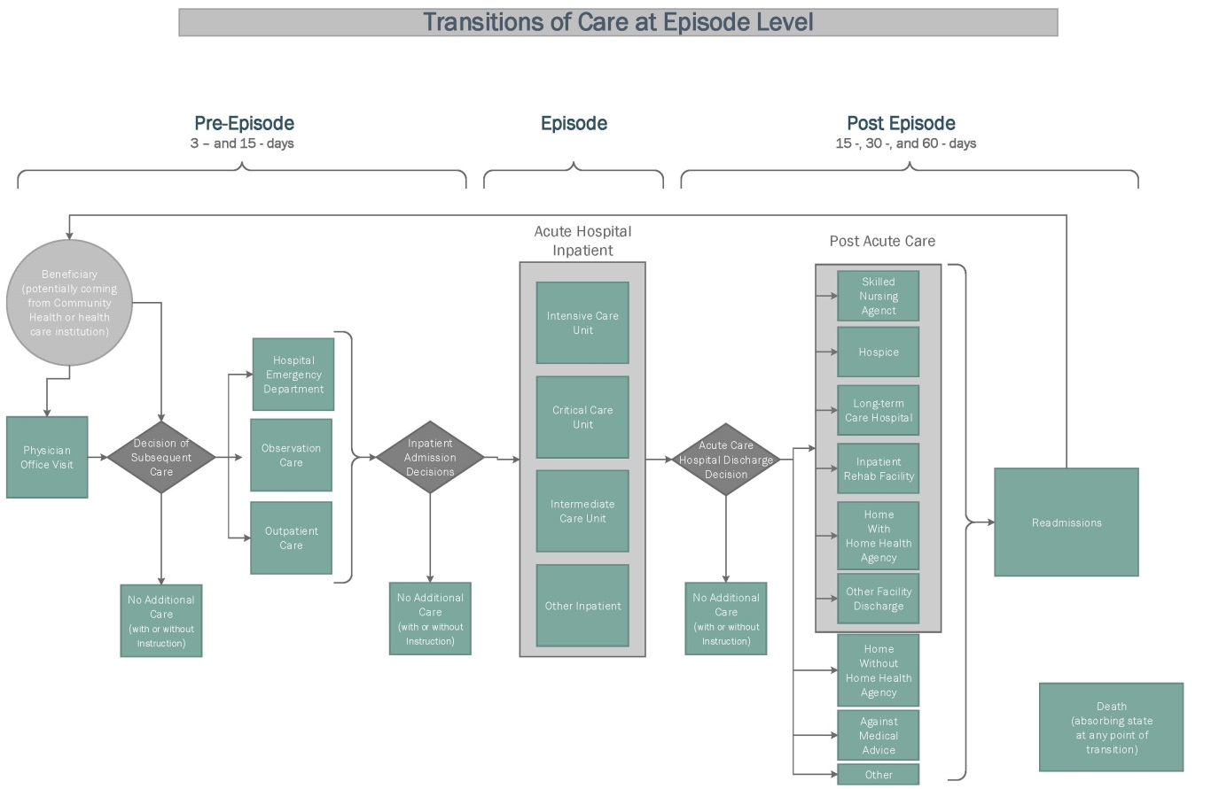

(*image also attached in email*)

First Aspect: The transition of care graphic above (or a slightly changed version) will be displayed. When a hospital rolls over any item in this graphic, a popup instance will display “Quick Statistics”. For example, if the user points/clicks on the “Hospital Emergency Department” box within the image a popup entitled “Quick Statistics: Emergency Department” will appear and display some statistics. The statistics are not currently finalized but would be in a tabular format (though we are open to other displays) that resembles the following:

|  |  |  |  |  |  |
| --- | --- | --- | --- | --- | --- |
| **Measure** | **Your Hospital** | **Other BPCI participants** | **Local Comparison Group** | **True Comparison Group** | **National Average** |
| **Measure 1** | X.YX (+) | X.YX | X.YX | X.YX | X.YX |
| **Measure 2** | X.YX (-) | X.YX | X.YX | X.YX | X.YX |
| **Measure 3** | X.YX (-) | X.YX | X.YX | X.YX | X.YX |
| **Measure 4** | X.YX (+) | X.YX | X.YX | X.YX | X.YX |

**Note:** The (+) or (-) under the “Your Hospital” column would represent increases or decreases from the prior quarter. The actual display of these quick statistics is flexible and the number or measures actually displayed needs to be adjusted by the administrator. It is not likely that more than 6 measures will be displayed per pop-up.

The CMS perspective for this aspect will have a dropdown menu in which the user can select one of the 23 hospitals to view the image map for (and table below) while the Hospital user will only be able to see their own image map.

Second Aspect:

The second aspect of this page is an expandable table. The non-expanded table will display a list of the available domains to look at (e.g., Structural, Quality, Utilization, Payments, Patient Case-Mix, Physician Information, Care Redesign, Gainsharing, Adherence, and Unintended Negative Consequences – some items may be added to this list in order to customize the content). The Unintended Negative Consequences section will only be viewable (and expandable) by CMS and Administrator accounts. The first level of expansion is shown in the table below. Measures under grey headings open up new “dashboards” that only represent text. Measures under light blue headings will lead to Run and Benchmark charts.

| **Domain** | **Measures** |
| --- | --- |
| **Structural Measures** |  |
|  | Health Information Technology |
|  | Leadership Oversight Support |
|  | Staffing Changes |
| **Quality Measures** |  |
|  | Mortality |
|  | Hospital Acquired Conditions |
|  | Readmissions |
|  | Prevention Quality Indicators (PQI) (ambulatory sensitive) |
|  | Inpatient Quality Indicators (IQI) |
|  | Patient Safety Indicators (PSI) |
|  | Outpatient Imaging Efficiency Measures |
|  | Patient Survey |
|  | Emergency Department Efficiency |
|  | **Timely & Effective Care** |
|  | Acute Myocardial Infarction |
|  | Heart Failure |
|  | Pneumonia |
| **Utilization Measures** |  |
|  | Volume of Services |
|  | Physician Referral to Post Acute Care Settings |
|  | Admissions Patterns |
|  | Readmissions |
|  | Length of Stay |
| **Payments** |  |
|  | Incentive Payments |
|  | Medicare Payments |
| **Patient Case-Mix** |  |
|  | Dual Eligible % |
|  | HCC-Risk Score Quartiles |
|  | Age - Breakout % |
|  | Gender - Male % |
|  | Prescription Coverage % |
|  | Capitated Plan Coverage % |
|  | Marital Status - Married % |
|  | Outlier % |
| **Physician Information** |  |
|  | Specialty |
|  | PQRS Participation % |
|  | Average Admission per Physician |
|  | Average Readmissions per Physician |
|  | Gainsharing Participation % |
|  | Average Incentive Payment |
| **Care Redesign Intervention** |  |
|  | Reduce Input Costs |
|  | Improve Quality of Care |
|  | Improve Clinical Practice |
|  | Standardize Procedures |
|  | Other |
| **Gainsharing Methodology** |  |
|  | Savings Calculations |
|  | Physician Gainsharing Eligibility Rules |
|  | Attribution of accountability within the provider |
| **Adherence** |  |
|  | Physicians Adhering to Wavier Rules % |
| **Negative Unintended Consequences** |  |
|  | Care Stinting |
|  | Avoidance of Certain Patient Populations |
|  | Patient Referral Patterns |
|  | Cherry Picking |

**Run/Benchmark Charts**

Examples of generic run charts are posted below. These types of charts will be accessible at the second level of expansion for the table shown above.





Note: The actual display of these charts is not set in stone such that if it is easier to display them all as line or bars in a given charts that would work as well.

Examples of run/benchmark charts in our current subcontractors’ work for these charts is presented below.

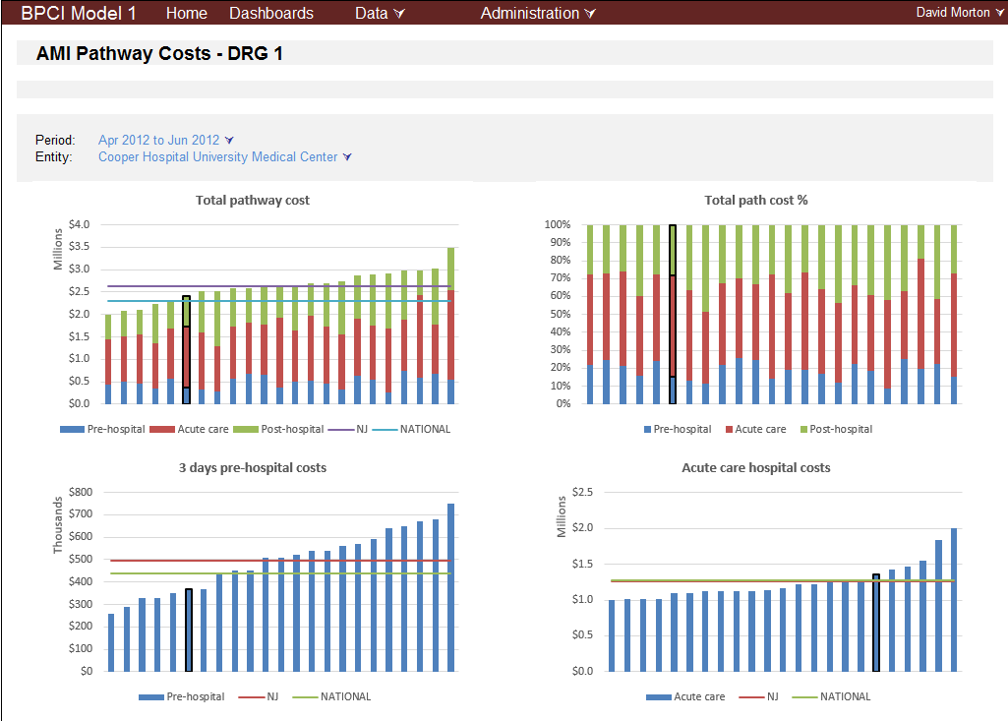

CMS views of benchmark charts:

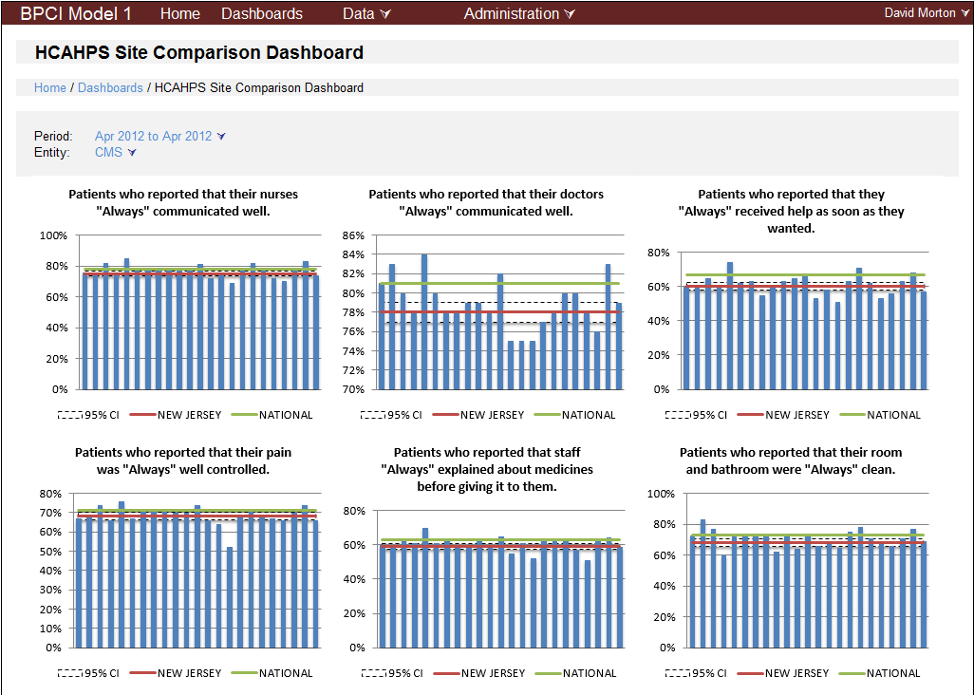

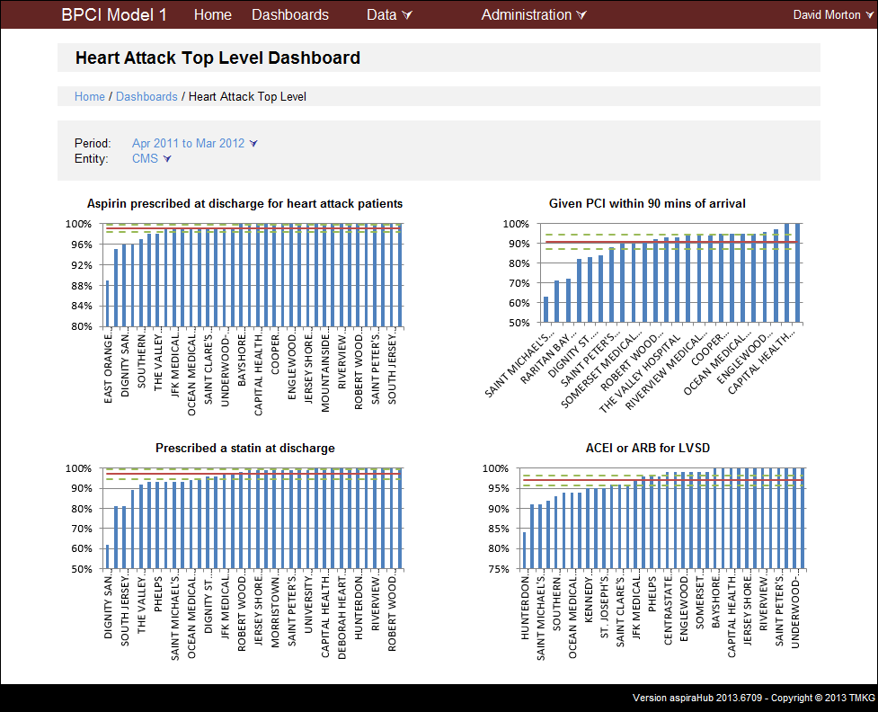

**DRG Selection**

Moving forward, it would be advantageous to have a dropdown or textbox listing of approximately 400 DRGs. Selection of a DRG would display Run and/or Benchmark dashboards for four or five measures (e.g., volume of services, payment, and length of stay). These measures would be the same for any DRG selected by the user.

Below is an example of a DRG run chart in the hospital view:

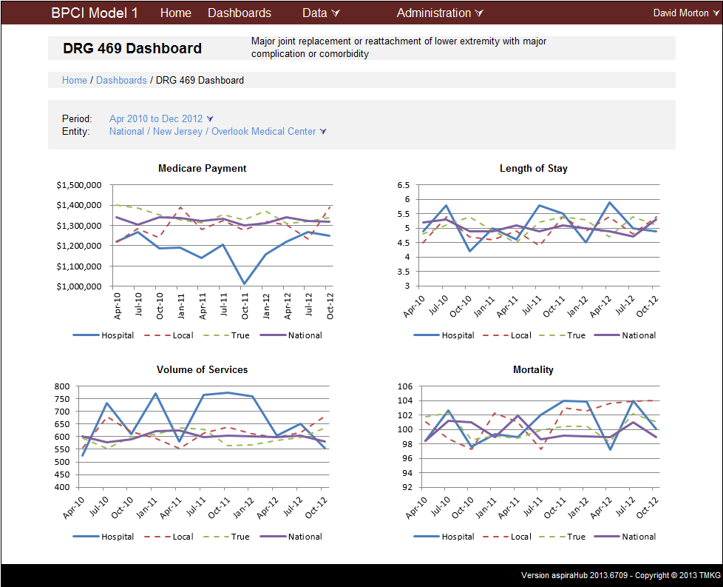

For the CMS perspective, CMS should be able to select the hospital provider (1 of 23) and the DRG desired.

**Administrator Interface/Content Management**

The content will be dynamic in that every quarter we might need to change the measures presented and data for these measures.

We are open to different options for inputting/storing data into the web tool (e.g., website interface or CSV upload stored in SQL or XML files). The data input format could be similar to the table below.

|  |  |  |  |  |  |  |  |  |  |  |  |
| --- | --- | --- | --- | --- | --- | --- | --- | --- | --- | --- | --- |
| **Unit** | **Sub-Unit 1** | **Patient Population** | **Domain** | **Measure** | **Quarter** | **Unit Value - Episode** | **Unit Value- Pre-Episode** | **Unit Value – Post-Episode** | **Control Group 1 Value** | **Control Group 2 Value** | **Control Group 3 Value** |
| **Hospital 1** | None | All | X | X | X | X |  |  | X | X | X |
| **Hospital 1** | DRG 1 |  |  |  |  |  |  |  |  |  |  |
| **…** |  |  |  |  |  |  |  |  |  |  |  |
| **Hospital 2** | DRG 1 | All |  |  |  |  |  |  |  |  |  |
| **Hospital 2** | DRG 1 | Dual Eligible |  |  |  |  |  |  |  |  |  |

In this example, each row would indicate a data point per hospital/site