CSR Initial Analysis

Compiled by Curtis Kephart, [curtis.kephart@nyu.edu](mailto:curtis.kephart@nyu.edu), with [R Markdown](http://rmarkdown.rstudio.com) Notebook.

2017-08-31 17:30:40 GMT, Asia/Dubai

## Real Effort Task

Below, a table of each subject's RET preformance.

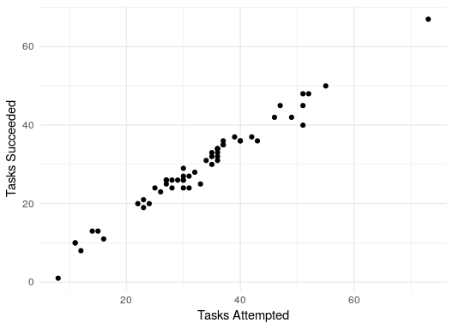

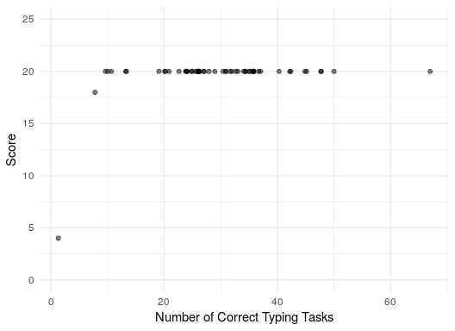

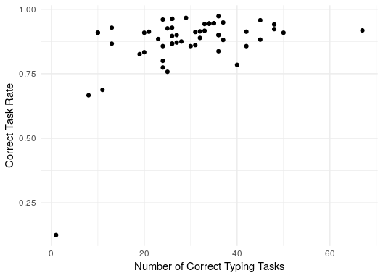

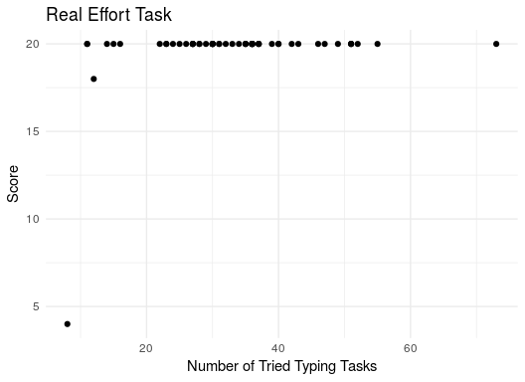

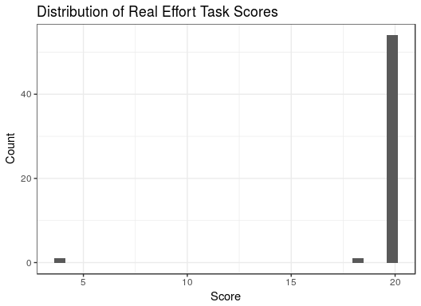

## Public Good Game

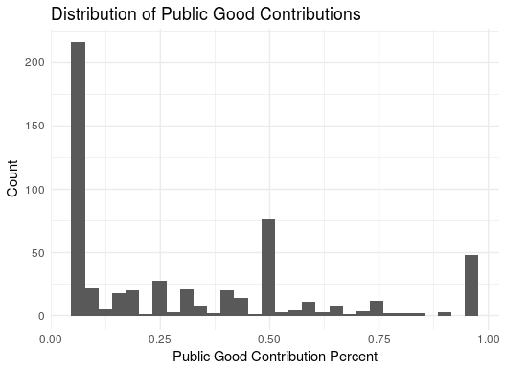

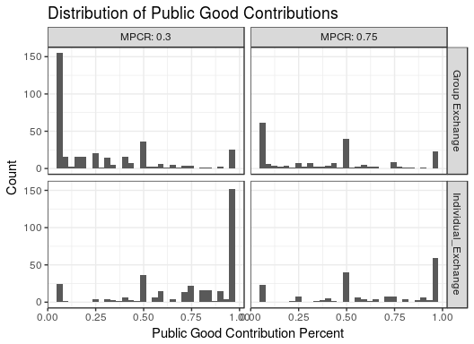

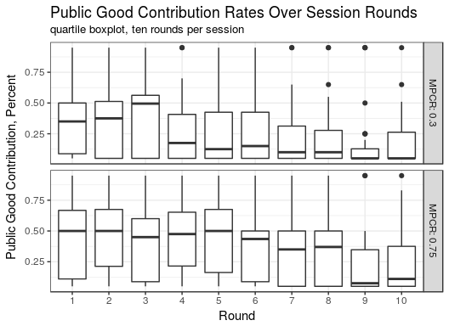

Subjects played ten VCM rounds. As rounds progressed, rates of public goods contribution declined.

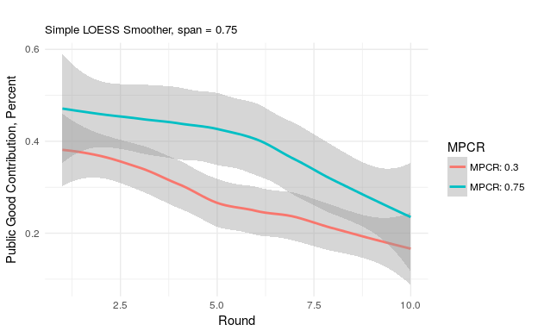

Comparing between MPCRs, the higher rates generally had approximately 10% higher public good contribution rates on average.

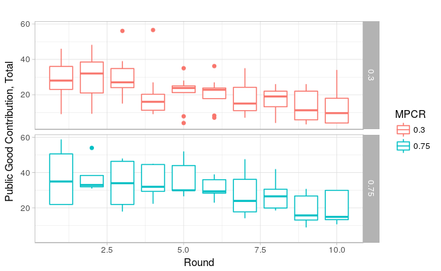

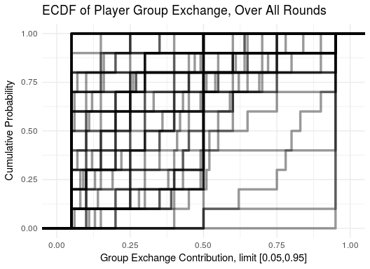

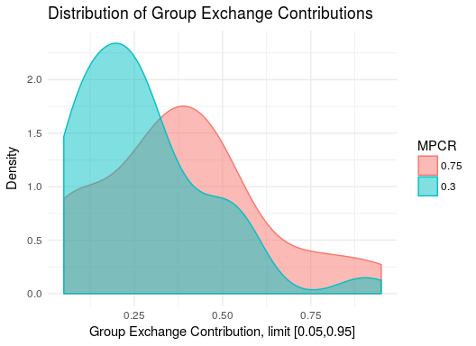

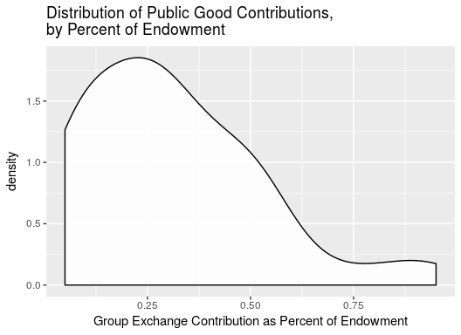

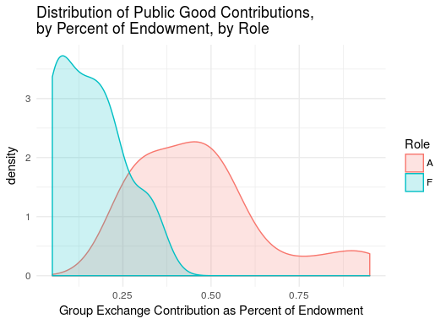

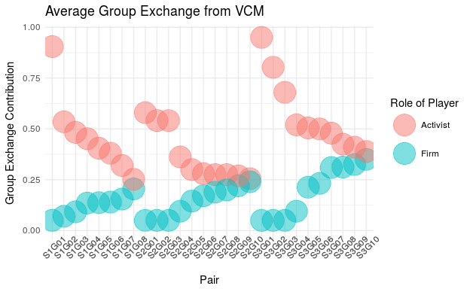

## Stage Game

Treatment subject summary tables

Below, reports the overall percent each terminal node choice was selected by stage game groups. Number of groups are the numbers below divided by two.

|  |  |
| --- | --- |
| MPCR | N Subjects |
| 0.30 | 36 |
| 0.75 | 20 |

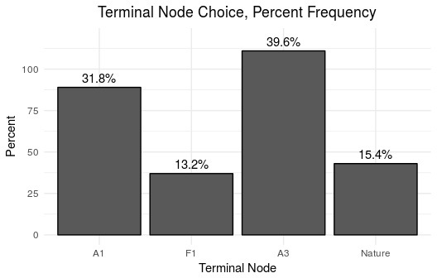

Below, reports how terminal node choices evolved as the session progressed over each of ten rounds.

Groups in the stage game were fixed.

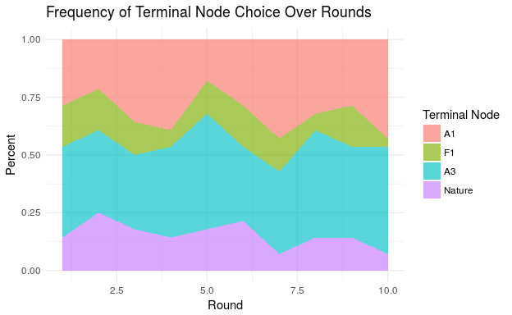

Below, breaks down terminal node choice dynamics by MPCR treatment.

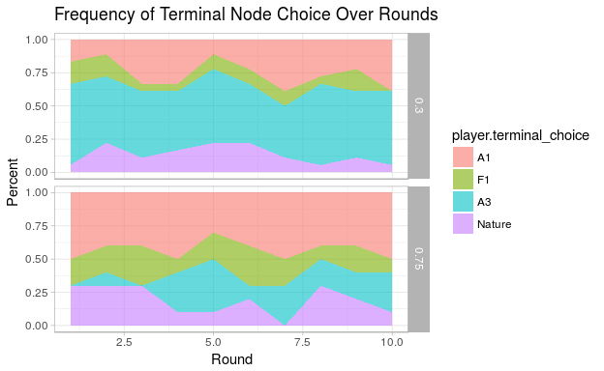

Selections were elicited via the strategy method. For example, even if A1 was selected by the role A player, Role F would still be asked what they would choose if A *had chosen A2* previously. At the end of each round, the terminal node and payoffs were revealed to both players. And the next round begins with the strategy method again.

Below reports the percent of time each choice was selected at each decision.

Nature was selected by a random number generated via the experiment software, with probability of N1 = 0.75.

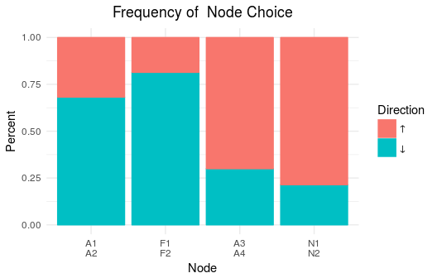

The plot below breaks the above plot down by MPCR treatment.

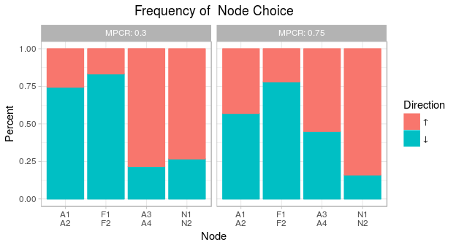

Below, the table shows the average rates at which each MPCR treatment groups reached each possible terminal node.

These groups were composed of two-players in ten repeated rounds. We find the average number of times each group reached each possible terminal node. There were 18 such groups in the MPCR = 0.3 treatment, and 10 such groups in the MPCR = 0.75 treatment regime.

The table is arranged to make it easy to compare terminal node rates between MPCR regimes.

|  |  |  |  |  |  |  |  |  |
| --- | --- | --- | --- | --- | --- | --- | --- | --- |
| terminal_node | A1 | A1 | F1 | F1 | A3 | A3 | Nature | Nature |
| mpcr | 0.30 | 0.75 | 0.30 | 0.75 | 0.30 | 0.75 | 0.30 | 0.75 |
| average | 0.256 | 0.430 | 0.100 | 0.190 | 0.511 | 0.190 | 0.133 | 0.190 |
| se | 0.0149 | 0.0422 | 0.0071 | 0.0307 | 0.0166 | 0.0238 | 0.0076 | 0.0242 |
| n | 18 | 10 | 18 | 10 | 18 | 10 | 18 | 10 |

## [1] "###############################################################################"

## Do groups in MPCR 0.3 and 0.75 reach A1 at the same rates?

##   
## Wilcoxon rank sum test with continuity correction  
##   
## data: (df_tab %>% filter(mpcr == 0.3 & terminal_node == "A1"))$percent and (df_tab %>% filter(mpcr == 0.75 & terminal_node == "A1"))$percent  
## W = 71, p-value = 0.3594  
## alternative hypothesis: true location shift is not equal to 0

## [1] "###############################################################################"

## [1] "Do groups in MPCR 0.3 and 0.75 reach F1 at the same rates?"

##   
## Wilcoxon rank sum test with continuity correction  
##   
## data: (df_tab %>% filter(mpcr == 0.3 & terminal_node == "F1"))$percent and (df_tab %>% filter(mpcr == 0.75 & terminal_node == "F1"))$percent  
## W = 89, p-value = 0.9791  
## alternative hypothesis: true location shift is not equal to 0

## [1] "###############################################################################"

## [1] "Do groups in MPCR 0.3 and 0.75 reach A3 at the same rates?"

##   
## Wilcoxon rank sum test with continuity correction  
##   
## data: (df_tab %>% filter(mpcr == 0.3 & terminal_node == "A3"))$percent and (df_tab %>% filter(mpcr == 0.75 & terminal_node == "A3"))$percent  
## W = 143.5, p-value = 0.01032  
## alternative hypothesis: true location shift is not equal to 0

## [1] "###############################################################################"

## [1] "Do groups in MPCR 0.3 and 0.75 reach Nature at the same rates?"

##   
## Wilcoxon rank sum test with continuity correction  
##   
## data: (df_tab %>% filter(mpcr == 0.3 & terminal_node == "Nature"))$percent and (df_tab %>% filter(mpcr == 0.75 & terminal_node == "Nature"))$percent  
## W = 82.5, p-value = 0.7284  
## alternative hypothesis: true location shift is not equal to 0

## [1] "###############################################################################"

We only see a significant difference between groups' inclination to reach terminal node A3.

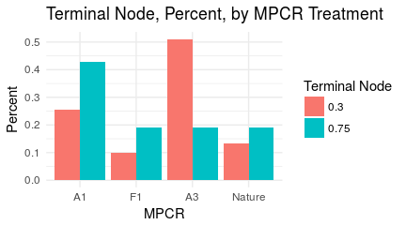

### Inequality Aversion

Below we consider the effect of varying public good contributions on the terminal nodes selected by players in the stage game.

The stage game was played by two-players. Each player had some average public good contribution from their ten rounds of the VCM game.

In the plot below, we see the distribution of these two-player-group differences in public good contributions for each terminal node selected. A large difference implies one player contributed a lot more to the public good relative to the other, while a small difference means the two players contributued at similar rates. The plot above labeled "Average Group Exchange from VCM" shows the public good contributions of each group in the stage game.

The plot shows that F1 tended to be selected where public good contribution differences were the smallest within groups. While players tended to reach the nature node where differences in group exchange contributions were the highest.

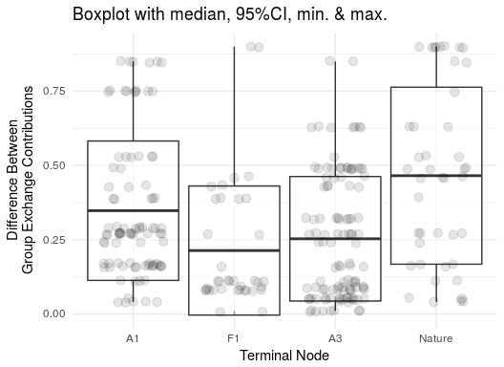

#### Negative Reciprocity

Below is a parametric test,

$N_{g}=β_{0}+β_{1}⋅δMPCR_{g}+β_{3}⋅ln(GEdiff_{g})+β_{4}⋅negrep_{t}est_{a}vg+ϵ_{g}$

* Where $N_{g}$ is the percent of the time group $g$ reached nature as their terminal node,
* $δMPCR_{g}$ is 1 if this group faced a MPCR of 0.3 and 0 otherwise,
* $GEdiff_{g}$ is this group's difference between player average public good contribution rates in the VCM game.
* $negrep_{t}est_{a}vg$ is the percent of times the Role F player selected F2 in rounds 1 through 9.

##   
## Call:  
## lm(formula = Nature_percent ~ MPCR_0.30 + log(GE_diff) + negrep_test_avg,   
## data = df)  
##   
## Residuals:  
## Min 1Q Median 3Q Max   
## -0.26568 -0.08325 -0.01629 0.04668 0.52833   
##   
## Coefficients:  
## Estimate Std. Error t value Pr(>|t|)  
## (Intercept) 0.16424 0.12651 1.298 0.207  
## MPCR_0.30 -0.02686 0.07015 -0.383 0.705  
## log(GE_diff) 0.05468 0.03337 1.638 0.114  
## negrep_test_avg 0.11695 0.12395 0.944 0.355  
##   
## Residual standard error: 0.1745 on 24 degrees of freedom  
## Multiple R-squared: 0.162, Adjusted R-squared: 0.05725   
## F-statistic: 1.547 on 3 and 24 DF, p-value: 0.2282

Below is another parametric test, this time using group-round level observations to test the following,

$N_{gt}=β_{0}+β_{1}⋅δMPCR_{g}+β_{3}⋅ln(GEdiff_{g})+ϵ_{gt}$

* Where $N_{gt}$ is 1 if group eached nature as terminal node in round and 0 otherwise,
* is 1 if this group faced a MPCR of 0.3 and 0 otherwise,
* is this group's difference between player average public good contribution rates in the VCM game.
* $negrep_{t}est$ in the second model is whether or not the Role F player selected F2 in the previous round.

We exclude to rounds 2 through 10.

##   
## Call:  
## lm(formula = Nature ~ MPCR_0.30 + log(GE_diff) + negrep_test,   
## data = df)  
##   
## Residuals:  
## Min 1Q Median 3Q Max   
## -0.26420 -0.19849 -0.14353 -0.07222 0.92978   
##   
## Coefficients:  
## Estimate Std. Error t value Pr(>|t|)   
## (Intercept) 0.22192 0.06899 3.217 0.00147 **  
## MPCR_0.30 -0.02163 0.04777 -0.453 0.65102   
## log(GE_diff) 0.05838 0.02259 2.584 0.01034 *   
## negrep_test 0.04843 0.05774 0.839 0.40246   
## ---  
## Signif. codes: 0 '***' 0.001 '**' 0.01 '*' 0.05 '.' 0.1 ' ' 1  
##   
## Residual standard error: 0.3583 on 248 degrees of freedom  
## Multiple R-squared: 0.03393, Adjusted R-squared: 0.02224   
## F-statistic: 2.903 on 3 and 248 DF, p-value: 0.03547

##   
## Call:  
## glm(formula = Nature ~ MPCR_0.30 + log(GE_diff) + negrep_test,   
## family = binomial(link = "probit"), data = df)  
##   
## Deviance Residuals:   
## Min 1Q Median 3Q Max   
## -0.8293 -0.6602 -0.5226 -0.3899 2.2861   
##   
## Coefficients:  
## Estimate Std. Error z value Pr(>|z|)   
## (Intercept) -0.78409 0.31844 -2.462 0.0138 *  
## MPCR_0.30 -0.09826 0.20365 -0.483 0.6294   
## log(GE_diff) 0.27191 0.10858 2.504 0.0123 *  
## negrep_test 0.26216 0.27571 0.951 0.3417   
## ---  
## Signif. codes: 0 '***' 0.001 '**' 0.01 '*' 0.05 '.' 0.1 ' ' 1  
##   
## (Dispersion parameter for binomial family taken to be 1)  
##   
## Null deviance: 217.16 on 251 degrees of freedom  
## Residual deviance: 207.88 on 248 degrees of freedom  
## AIC: 215.88  
##   
## Number of Fisher Scoring iterations: 5

#### Reaching Nature

Below is a parametric test,

$N_{g}=β_{0}+β_{1}⋅δMPCR_{g}+β_{3}⋅ln(GEdiff_{g})+β_{4}⋅negrep_{t}est_{a}vg+ϵ_{g}$

* Where $N_{g}$ is the percent of the time group $g$ reached nature as their terminal node,
* $δMPCR_{g}$ is 1 if this group faced a MPCR of 0.3 and 0 otherwise,
* $GEdiff_{g}$ is this group's difference between player average public good contribution rates in the VCM game.

##   
## Call:  
## lm(formula = Nature_percent ~ MPCR_0.30 + log(GE_diff), data = df)  
##   
## Residuals:  
## Min 1Q Median 3Q Max   
## -0.24538 -0.09942 -0.01578 0.07281 0.52152   
##   
## Coefficients:  
## Estimate Std. Error t value Pr(>|t|)   
## (Intercept) 0.26269 0.07139 3.680 0.00112 **  
## MPCR_0.30 -0.01794 0.06935 -0.259 0.79801   
## log(GE_diff) 0.06099 0.03263 1.869 0.07334 .   
## ---  
## Signif. codes: 0 '***' 0.001 '**' 0.01 '*' 0.05 '.' 0.1 ' ' 1  
##   
## Residual standard error: 0.1742 on 25 degrees of freedom  
## Multiple R-squared: 0.1309, Adjusted R-squared: 0.06139   
## F-statistic: 1.883 on 2 and 25 DF, p-value: 0.1731

Below is another parametric test, this time using group-round level observations to test the following,

$N_{gt}=β_{0}+β_{1}⋅δMPCR_{g}+β_{3}⋅ln(GEdiff_{g})+ϵ_{gt}$

* Where $N_{gt}$ is 1 if group eached nature as terminal node in round and 0 otherwise,
* is 1 if this group faced a MPCR of 0.3 and 0 otherwise,
* is this group's difference between player average public good contribution rates in the VCM game.
* $negrep_{t}est$ in the second model is whether or not the Role F player selected F1 in the

We exclude to periods 2 through 10.

##   
## Call:  
## lm(formula = Nature ~ MPCR_0.30 + log(GE_diff), data = df)  
##   
## Residuals:  
## Min 1Q Median 3Q Max   
## -0.25626 -0.18761 -0.13486 -0.06081 0.94173   
##   
## Coefficients:  
## Estimate Std. Error t value Pr(>|t|)   
## (Intercept) 0.26269 0.04893 5.368 1.82e-07 ***  
## MPCR_0.30 -0.01794 0.04754 -0.377 0.70620   
## log(GE_diff) 0.06099 0.02236 2.727 0.00684 **   
## ---  
## Signif. codes: 0 '***' 0.001 '**' 0.01 '*' 0.05 '.' 0.1 ' ' 1  
##   
## Residual standard error: 0.3581 on 249 degrees of freedom  
## Multiple R-squared: 0.03119, Adjusted R-squared: 0.02341   
## F-statistic: 4.008 on 2 and 249 DF, p-value: 0.01935

##   
## Call:  
## lm(formula = Nature ~ MPCR_0.30 + log(GE_diff), data = df)  
##   
## Residuals:  
## Min 1Q Median 3Q Max   
## -0.25626 -0.18761 -0.13486 -0.06081 0.94173   
##   
## Coefficients:  
## Estimate Std. Error t value Pr(>|t|)   
## (Intercept) 0.26269 0.04893 5.368 1.82e-07 ***  
## MPCR_0.30 -0.01794 0.04754 -0.377 0.70620   
## log(GE_diff) 0.06099 0.02236 2.727 0.00684 **   
## ---  
## Signif. codes: 0 '***' 0.001 '**' 0.01 '*' 0.05 '.' 0.1 ' ' 1  
##   
## Residual standard error: 0.3581 on 249 degrees of freedom  
## Multiple R-squared: 0.03119, Adjusted R-squared: 0.02341   
## F-statistic: 4.008 on 2 and 249 DF, p-value: 0.01935

#### Reaching F1

Below is a parametric test,

$F1_{g}=β_{0}+β_{1}⋅δMPCR_{g}+β_{3}⋅ln(GEdiff_{g})+ϵ_{g}$

* Where $F1_{g}$ is the percent of the time group $g$ reached F1 as their terminal node,
* $δMPCR_{g}$ is 1 if this group faced a MPCR of 0.3 and 0 otherwise,
* $GEdiff_{g}$ is this group's difference between player average public good contribution rates in the VCM game.

##   
## Call:  
## lm(formula = F1_percent ~ MPCR_0.30 + log(GE_diff), data = df)  
##   
## Residuals:  
## Min 1Q Median 3Q Max   
## -0.29176 -0.13154 -0.04023 0.04979 0.55105   
##   
## Coefficients:  
## Estimate Std. Error t value Pr(>|t|)  
## (Intercept) 0.11350 0.08372 1.356 0.187  
## MPCR_0.30 -0.10609 0.08133 -1.304 0.204  
## log(GE_diff) -0.05495 0.03826 -1.436 0.163  
##   
## Residual standard error: 0.2043 on 25 degrees of freedom  
## Multiple R-squared: 0.1169, Adjusted R-squared: 0.04629   
## F-statistic: 1.655 on 2 and 25 DF, p-value: 0.2113

Below is another parametric test, this time using group-round level observations to test the following,

$F1_{gt}=β_{0}+β_{1}⋅δMPCR_{g}+β_{3}⋅ln(GEdiff_{g})+ϵ_{gt}$

* Where $F1_{gt}$ is 1 if group $g$ eached F1 as terminal node in round $t$ and 0 otherwise,
* $δMPCR_{g}$ is 1 if this group faced a MPCR of 0.3 and 0 otherwise,
* $GEdiff_{g}$ is this group's difference between player average public good contribution rates in the VCM game.

##   
## Call:  
## lm(formula = F1 ~ MPCR_0.30 + log(GE_diff), data = df)  
##   
## Residuals:  
## Min 1Q Median 3Q Max   
## -0.29176 -0.17313 -0.10985 -0.04649 0.95052   
##   
## Coefficients:  
## Estimate Std. Error t value Pr(>|t|)   
## (Intercept) 0.11350 0.04317 2.629 0.00904 **  
## MPCR_0.30 -0.10609 0.04194 -2.530 0.01198 *   
## log(GE_diff) -0.05495 0.01973 -2.785 0.00572 **  
## ---  
## Signif. codes: 0 '***' 0.001 '**' 0.01 '*' 0.05 '.' 0.1 ' ' 1  
##   
## Residual standard error: 0.3331 on 277 degrees of freedom  
## Multiple R-squared: 0.04301, Adjusted R-squared: 0.0361   
## F-statistic: 6.225 on 2 and 277 DF, p-value: 0.002268

#### Reaching A1

Below is a parametric test,

$A1_{g}=β_{0}+β_{1}⋅δMPCR_{g}+β_{3}⋅ln(GEdiff_{g})+ϵ_{g}$

* Where $A1_{g}$ is the percent of the time group $g$ reached A1 as their terminal node,
* $δMPCR_{g}$ is 1 if this group faced a MPCR of 0.3 and 0 otherwise,
* $GEdiff_{g}$ is this group's difference between player average public good contribution rates in the VCM game.

##   
## Call:  
## lm(formula = A1_percent ~ MPCR_0.30 + log(GE_diff), data = df)  
##   
## Residuals:  
## Min 1Q Median 3Q Max   
## -0.52391 -0.22329 -0.06372 0.22744 0.55824   
##   
## Coefficients:  
## Estimate Std. Error t value Pr(>|t|)   
## (Intercept) 0.53160 0.13405 3.966 0.000541 ***  
## MPCR_0.30 -0.15307 0.13022 -1.175 0.250892   
## log(GE_diff) 0.07298 0.06126 1.191 0.244734   
## ---  
## Signif. codes: 0 '***' 0.001 '**' 0.01 '*' 0.05 '.' 0.1 ' ' 1  
##   
## Residual standard error: 0.327 on 25 degrees of freedom  
## Multiple R-squared: 0.115, Adjusted R-squared: 0.04419   
## F-statistic: 1.624 on 2 and 25 DF, p-value: 0.2172

Below is another parametric test, this time using group-round level observations to test the following,

$A1_{gt}=β_{0}+β_{1}⋅δMPCR_{g}+β_{3}⋅ln(GEdiff_{g})+ϵ_{gt}$

* Where $A1_{gt}$ is 1 if group $g$ eached A1 as terminal node in round $t$ and 0 otherwise,
* $δMPCR_{g}$ is 1 if this group faced a MPCR of 0.3 and 0 otherwise,
* $GEdiff_{g}$ is this group's difference between player average public good contribution rates in the VCM game.

##   
## Call:  
## lm(formula = A1 ~ MPCR_0.30 + log(GE_diff), data = df)  
##   
## Residuals:  
## Min 1Q Median 3Q Max   
## -0.5239 -0.3266 -0.2168 0.5582 0.8446   
##   
## Coefficients:  
## Estimate Std. Error t value Pr(>|t|)   
## (Intercept) 0.53160 0.05892 9.022 < 2e-16 ***  
## MPCR_0.30 -0.15307 0.05724 -2.674 0.00794 **   
## log(GE_diff) 0.07298 0.02693 2.710 0.00714 **   
## ---  
## Signif. codes: 0 '***' 0.001 '**' 0.01 '*' 0.05 '.' 0.1 ' ' 1  
##   
## Residual standard error: 0.4546 on 277 degrees of freedom  
## Multiple R-squared: 0.05722, Adjusted R-squared: 0.05041   
## F-statistic: 8.406 on 2 and 277 DF, p-value: 0.0002856

#### Reaching A3

Below is a parametric test,

$A3_{g}=β_{0}+β_{1}⋅δMPCR_{g}+β_{3}⋅ln(GEdiff_{g})+ϵ_{g}$

* Where $A3_{g}$ is the percent of the time group $g$ reached A3 as their terminal node,
* $δMPCR_{g}$ is 1 if this group faced a MPCR of 0.3 and 0 otherwise,
* $GEdiff_{g}$ is this group's difference between player average public good contribution rates in the VCM game.

##   
## Call:  
## lm(formula = A3_percent ~ MPCR_0.30 + log(GE_diff), data = df)  
##   
## Residuals:  
## Min 1Q Median 3Q Max   
## -0.44560 -0.15392 -0.07804 0.11240 0.59169   
##   
## Coefficients:  
## Estimate Std. Error t value Pr(>|t|)   
## (Intercept) 0.06774 0.11020 0.615 0.5443   
## MPCR_0.30 0.29539 0.10706 2.759 0.0107 *  
## log(GE_diff) -0.08782 0.05036 -1.744 0.0935 .  
## ---  
## Signif. codes: 0 '***' 0.001 '**' 0.01 '*' 0.05 '.' 0.1 ' ' 1  
##   
## Residual standard error: 0.2689 on 25 degrees of freedom  
## Multiple R-squared: 0.3282, Adjusted R-squared: 0.2744   
## F-statistic: 6.106 on 2 and 25 DF, p-value: 0.006932

Below is another parametric test, this time using group-round level observations to test the following,

$A3_{gt}=β_{0}+β_{1}⋅δMPCR_{g}+β_{3}⋅ln(GEdiff_{g})+ϵ_{gt}$

* Where $A3_{gt}$ is 1 if group $g$ eached A3 as terminal node in round $t$ and 0 otherwise,
* $δMPCR_{g}$ is 1 if this group faced a MPCR of 0.3 and 0 otherwise,
* $GEdiff_{g}$ is this group's difference between player average public good contribution rates in the VCM game.

##   
## Call:  
## lm(formula = A3 ~ MPCR_0.30 + log(GE_diff), data = df)  
##   
## Residuals:  
## Min 1Q Median 3Q Max   
## -0.7319 -0.4256 -0.1758 0.4422 0.8917   
##   
## Coefficients:  
## Estimate Std. Error t value Pr(>|t|)   
## (Intercept) 0.06774 0.05940 1.140 0.25511   
## MPCR_0.30 0.29539 0.05771 5.119 5.76e-07 ***  
## log(GE_diff) -0.08782 0.02715 -3.235 0.00136 **   
## ---  
## Signif. codes: 0 '***' 0.001 '**' 0.01 '*' 0.05 '.' 0.1 ' ' 1  
##   
## Residual standard error: 0.4583 on 277 degrees of freedom  
## Multiple R-squared: 0.1317, Adjusted R-squared: 0.1255   
## F-statistic: 21.01 on 2 and 277 DF, p-value: 3.183e-09

Compiled 2017-08-31 13:31:02 GMT