How are developing economies coping with the Covid-19 crisis?

Teaser:

After the initially negative effects of the pandemic on developing countries’ financial markets, their economies have stabilised. But it has been difficult for governments to implement policies that both protect lives and insulate citizens from severe disruptions to economic activity.

Main text:

When the Government of India first announced a countrywide lockdown in March 2020, thousands of daily wage workers living in urban centres had to flee to their home villages, where they hoped that their social networks would insulate them from the brunt of the crisis. Despite dramatic scenes showing the plight of these migrants on their way home, the government stuck to its decision.

Yet as India experienced a second wave of the pandemic, which dwarfed the first wave by all measures, the country’s prime minister, Narendra Modi, ‘[urged](https://www.hindustantimes.com/india-news/lockdown-should-be-last-resort-pm-modi-urges-states-in-address-to-nation-101618929845565.html)’ state governments to consider lockdown only as the last option. This shift in developing country governments’ approach to the public health crisis is not confined to India. National leaderships from Brazil to Pakistan have so far rejected the possibility of imposing further nationwide lockdowns.

This reluctance to follow in the footsteps of their counterparts in developed countries is not without reason. While many developing countries have done well in restoring stability to their economies, limited state capacity, high degrees of informality and a lack of financial inclusion have made it difficult for many governments to implement the kind of policies that the developed world has used to insulate their citizens from disruptions to economic activity.

# What were the immediate effects of Covid-19?

When the pandemic first reached developing economies and stringent lockdowns were put in place, it was anticipated that the crisis would bring back memories of the 1997 East Asian financial crisis. Capital flows reversed, domestic currencies underwent significant depreciation, national stock markets crashed and credit spreads increased. Against this backdrop, a full-blown financial crisis did not seem too far from the horizon.

In a span of just one month, more than $100 billion left emerging economies, almost 70% of which were outflows from stock markets. At its peak, cumulative outflows by non-residents from Asian markets (excluding China) amounted to almost 1% of their GDP. Non-resident outflows stood at 0.5% of GDP for Latin America and Europe, the Middle East and Africa (the EMEA region).

Emerging economies’ stock markets fell by around 20% in the immediate aftermath of the crisis (International Monetary Fund, [IMF, 2020a](https://www.imf.org/en/Publications/GFSR/Issues/2020/04/14/global-financial-stability-report-april-2020)). Several of the commodity-exporting countries were among the worst hit (Figure 1). The currencies of Brazil, Colombia, Mexico, Russia and South Africa lost more than 20% in value during the first quarter of 2020 ([IMF, 2020a](https://www.imf.org/en/Publications/GFSR/Issues/2020/04/14/global-financial-stability-report-april-2020)).

Figure 1: Currency performance (versus dollar, percent, bars are max drawdown in Q1 2020, points are change through 9 April

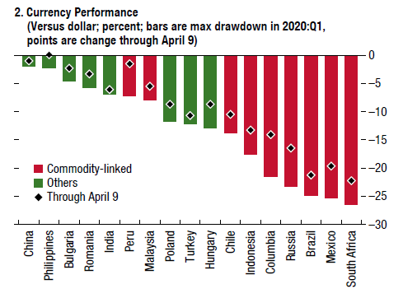

Source: Global Financial Stability Report, IMF, April 2020

These developments came against the backdrop of vulnerabilities that had already started to appear in emerging economies over preceding years. For example, on average, external financing requirements (short-term borrowing requirements in foreign currency) for these economies had increased from around 8% of GDP in 2008 to 11% just before Covid-19.

Likewise, the reliance on inflows to countries’ stock markets also increased from 6% of GDP to around 12%. The increase for relatively riskier economies was significantly greater, from around 1% to 10% of GDP. At the same time, the share of emerging market bonds, in the Emerging Market Bond Index, with a credit rating of *B* increased from close to 10% in 2008 to around 25% just before Covid-19 ([IMF, 2020a](https://www.imf.org/en/Publications/GFSR/Issues/2020/04/14/global-financial-stability-report-april-2020)).

The sudden reversal in capital flows, together with underlying vulnerabilities, threatened the stability of financial systems and the rest of the economy. On average, credit spreads on emerging market dollar-denominated debt increased from less than 250 basis points to around 640 basis points. The increase was as high as 800 basis points for developing economies with credit ratings as low as *B*.

According to the IMF estimates, almost all of this worsening in the financial conditions of emerging economies is explained by the increase in ‘external funding costs’. But the effect spread to most sectors of the economy. Figure 2 shows that as of April 2020, financial vulnerabilities had heightened for sovereigns, financial and non-financial firms, and households, and remained so in the following months ([IMF, 2020b](https://www.imf.org/en/Publications/GFSR/Issues/2020/10/13/global-financial-stability-report-october-2020)).

Figure 2: Financial vulnerabilities by sector and region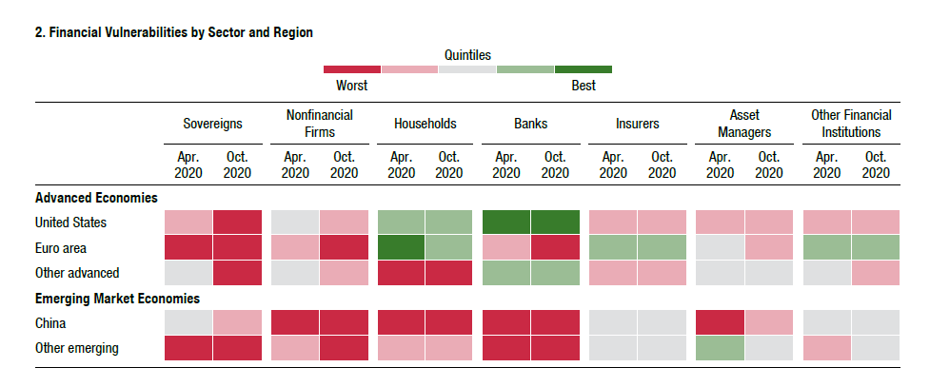

Source: Global Financial Stability Report, IMF, April 2021.

# Policy response: ensuring stability

While the immediate effects of Covid-19 and the associated lockdowns were devastating, the return to stability was equally impressive. Capital flows to emerging markets (excluding China) turned positive in May 2020 and increased thereafter. Credit spreads also started to normalise soon after.

For countries with higher credit ratings (that is, *BBB* and higher), credit spreads have now returned to their pre-pandemic levels, whereas credit spreads for countries with lower ratings are under 150 basis points higher on average. The IMF’s own estimates also point to normalisation of financial conditions across emerging economies before the end of 2020 ([IMF, 2021](https://www.imf.org/en/Publications/GFSR/Issues/2021/04/06/global-financial-stability-report-april-2021)).

Key factors that can be credited for restoring stability in financial markets in developing economies include:

* The ability of national governments to conduct counter-cyclical policies: Expansionary fiscal and monetary policies helped to stabilise economic activity.
* International reserves: Accumulation of international reserves during recent decades allowed national governments to insulate domestic economic activity from sudden reversals in capital flows.
* Stronger banks: Better capitalised banks, together with enough liquid assets to meet short-term liabilities, were able to withstand sharp fluctuations in asset prices and market sentiment.
* US monetary policy: Accommodative policies adopted by the Federal Reserve, America’s central bank, kept dollar markets liquid, thus facilitating developing economies in meeting their external financing requirements (see [Miranda-Agrippino and Rey, 2020](https://academic.oup.com/restud/article/87/6/2754/5834728) for how US monetary policy affects global financial conditions).

Unlike during the 1997 Asian financial crisis or the debt crises of the 1980s and 1990s when crisis-hit governments had to resort to increasing domestic interest rates and fiscal austerity to restore economic stability, most governments across the developing world were successful in reducing interest rates and, moreover, announced large stimulus packages in response to the Covid-19 shock.

A sample covering 104 countries and spanning over four decades from 1960 to 2003 shows that government policies, both fiscal and monetary, had been pro-cyclical for developing countries during this period ([Kaminsky et al, 2004](https://www.nber.org/papers/w10780); see also [Gavin and Perotti, 1997](https://www.nber.org/books-and-chapters/nber-macroeconomics-annual-1997-volume-12/fiscal-policy-latin-america); [Talvi and Vegh, 2000](https://www.nber.org/papers/w7499); and [Ilzetzki and Végh, 2008](https://www.nber.org/papers/w14191)).

Since then, many have moved away from a fixed exchange rate regime, thus allowing their central banks more freedom when it comes to stabilising the domestic economy ([Svensson, 2010](https://www.nber.org/system/files/working_papers/w16654/w16654.pdf)). An increase in foreign currency reserve holdings has also allowed governments to insulate domestic economies in the face of a sudden reverse of capital flows, reducing the need to engage in pro-cyclical policies such as increasing interest rates and implementing fiscal austerity ([Obstfeld et al, 2010](https://www.nber.org/papers/w14217#:~:text=The%20rapid%20growth%20of%20international,markets%2D%2D%2Dremains%20a%20puzzle.&text=Our%20empirical%20financial%2Dstability%20model,on%20external%20short%2Dterm%20debt.); [Jeanne and Ranciere, 2011](https://onlinelibrary.wiley.com/doi/abs/10.1111/j.1468-0297.2011.02435.x)).

As a result of these developments, more recent research finds that during the first decade of the 21st century, fiscal policy in almost one-third of developing economies has escaped ‘the pro-cyclicality trap and actually become countercyclical’ ([Frankel et al, 2011](https://www.nber.org/papers/w17619)). In other words, responsible policy behaviour in times when the economy is stable has allowed policy-makers in these countries to respond more aggressively in times of crises.

Reflecting this transformation, several governments across emerging economies announced large fiscal packages. Likewise, central banks reduced interest rates and, in the face of increasing funding costs from external sources, provided much needed liquidity to the banking system. Central banks also played an active role in facilitating restructuring and deferral of loan repayments.

For example, the *Debt Relief Scheme* introduced by the State Bank of Pakistan received close to two million applications, almost 99% of which were from customers of microfinance banking institutions. As of April 2021, around $6 billion of loans in total had been restructured, amounting to 16% of outstanding loans to private sector businesses and close to 2% of the country’s GDP.

While the banking system across most economies was reasonably strong to withstand the shock, there were vulnerabilities that could potentially have spiralled out of control. For example, the ‘capital adequacy ratio’ (CAR) was significantly above the regulatory minimum of 8% for most South East Asian economies – the highest for Cambodia at 20% and the lowest for Vietnam at 9.4% ([OECD, 2021](https://www.oecd.org/fr/dev/economic-outlook-for-southeast-asia-china-and-india-23101113.htm)). This was also true for developing economies across Latin America.

Yet for several of these economies, the liquid assets to short-term liabilities was significantly less than the 100% recommended under Basel III. As of 2019, the ratio was around 50% for Mexico, Colombia, Peru and Uruguay ([IMF, 2020c](https://www.imf.org/~/media/Files/Publications/REO/WHD/2020/Oct/English/CorporateFinancial.ashx?la=en)). A lower liquidity ratio implies that banks are more likely to rely on borrowing from other institutions to meet their short-term liabilities. As a result, in an event like Covid-19, lack of willingness on the part of financial institutions to lend to each other can adversely affect banks’ ability to meet their liabilities, thus exacerbating the crisis.

Against this backdrop, the policy measures mentioned above, among many others, have been critical in ensuring that national banking systems have enough liquidity to facilitate real economic activity and that banks’ balance sheets remain insulated from the Covid-19 shock ([VoxEU e-book, 2021](https://voxeu.org/content/monetary-policy-and-central-banking-covid-era)).

# The trade-off: a ‘dance of death’

Despite an arguably impressive policy response, which kept their financial systems intact and prevented macroeconomic conditions from worsening further, several developing countries fell short on dealing with the public health crisis.

After the United States, India and Brazil have seen the highest number of Covid-19 cases and deaths since the pandemic started. The number of *new* cases and deaths are also among the highest for these two countries. At the time of writing this article, reported deaths for every million people, since the pandemic started, are the highest for Peru, 10th highest for Brazil, 16th for Colombia, 21st for Mexico and 27th for Chile ([worldometer](https://www.worldometers.info/coronavirus/#countries)).

But unlike most governments in advanced economies, governments in developing economies have hesitated in implementing nationwide lockdowns. Even where the pandemic has been dealt with effectively, it has most often been achieved on the back of state capacity to implement track-and-trace successfully, combined with localised interventions (as in South Korea, Taiwan and Vietnam, among others).

This difference in policy response to the public health crisis across developing and developed economies can arguably be explained by the degree of informality. For example, according to [data](https://www.ilo.org/re-Search/informality/map1_en.html) from the International Labour Organization (ILO), the share of informal employment stands at around 80% for almost all South East Asian economies, excluding China’s at 54.4%. This number is lower for Latin American countries, but it is still considerably higher than for advanced economies.

While official data are not available, news reports, publications by national bodies and anecdotal evidence indicate that it is likely that this pattern is also true for businesses.

For example, in Pakistan, there are close to four million commercial and industrial electricity connections (National Electric Power Regulatory Authority, [NEPRA, 2020](https://nepra.org.pk/publications/State%20of%20Industry%20Reports/State%20of%20Industry%20Report%202020.pdf)). But the total number of companies and association of persons (AOP) that filed income tax returns in 2018 accounted for only slightly more than one-tenth of a million, suggesting a high degree of informality even across firms (Federal Board of Revenue, [FBR, 2018](https://download1.fbr.gov.pk/Docs/20209181193938934TaxDirectoryAnalysisforyearended30June2018.pdf)).

Other indicators present further challenges. For example, a [2017 World Bank report](https://globalfindex.worldbank.org/) on financial inclusion shows that only 20% of the population in Pakistan has a bank account. In the case of India, while an impressive 80% had a bank account as of 2017, half of these were inactive. For developing countries as a whole, 60% of the population have a bank account, but less than 10% have a credit card.

In contrast, a high degree of financial inclusion and a lower degree of informality allows governments in advanced economies to use a combination of direct subsidies, tax cuts, cash transfers and employment guarantees to insulate their citizen and businesses directly from adverse shocks even when economic activity comes to a near standstill.

To put this in perspective, 30% of the UK’s workforce was on furlough during the first half of 2020 (Office for National Statistics, [ONS, 2021](https://www.ons.gov.uk/businessindustryandtrade/business/businessservices/articles/comparisonoffurloughedjobsdata/march2020tojanuary2021)). Leaving aside fiscal considerations, a mere 20% of the total labour force in many developing economies even works in formal employment and could potentially benefit from a similar scheme. In addition, those in formal employment are also generally less vulnerable than those working in informal settings.

Despite these challenges, most governments in the developing world have implemented social protection programmes in the face of Covid-19. But most such programmes continue to cover only a small fraction of their country’s population. For example, out of 141 programmes for which relevant data are available, only 20 cover more than 40% of their respective populations ([World Bank, 2021](https://documents1.worldbank.org/curated/en/281531621024684216/pdf/Social-Protection-and-Jobs-Responses-to-COVID-19-A-Real-Time-Review-of-Country-Measures-May-14-2021.pdf)).

Moreover, even those 20 programmes mostly include developed economies or developing economies with small populations. The two notable exceptions that make this list are Pakistan and the Philippines, with populations in excess of 100 million. Further, countries with high degree of poverty have programmes with the lowest coverage.

# Conclusion

By historical standards, most developing economies have done exceptionally well in stabilising their economies following the Covid-19 outbreak. But the limitations in reaching out to their citizens to insulate them from the shock has also made developing country governments extremely reluctant to impose nationwide lockdowns and bring economic activity to a halt.

This trade-off faced by the developing economies that are currently facing the brunt of the pandemic greatly increases the risks to their citizens’ health and lives. The longer the public health crisis persists, the more infectious the virus becomes and the greater the need for social restrictions. In contrast, the harsher the measures to contain the pandemic, the more unsustainable these become, giving people the incentives to violate them.

What is needed is a global effort towards both making vaccines available and strengthening the state capacity of these governments to complete the vaccination drive effectively. From climate change to the pandemic, we are only as strong as the weakest link in the chain.

**Where can I find out more?**

* The International Monetary Fund publishes the [Global Financial Stability Report](https://www.imf.org/en/Publications/GFSR), which contains a bird-eye-view of how economic events are affecting financial conditions across countries.
* The [Bank of International Settlements](https://www.bis.org/) (BIS) provides detailed information on global financial conditions.
* The International Labour Organization [Trends 2020](https://www.ilo.org/global/research/global-reports/weso/2020/WCMS_734455/lang--en/index.htm) report provides an overview of global and regional employment, unemployment and labour market changes.
* A recent VoxEU [e-book](E://Bristol%20Uni/Econ%20Observatory/Central%20banking%20in%20the%20covid%20era.pdf) discusses the steps taken by central banks across the world to protect their respective economies from the effects of Covid-19 pandemic.

**Who are experts on this question?**

* Helene Rey
* Jeffrey Frankel
* Gita Gopinath
* Maurice Obstfeld

Author: Ahmed Jamal Pirzada

# Topics:

Banks and financial markets

Aid and development

Jobs and pay

Related articles:

[How might costly sovereign debt default in emerging economies be averted?](https://www.economicsobservatory.com/how-might-costly-sovereign-debt-default-emerging-economies-be-averted)

[How are firms in emerging markets reacting to the coronavirus crisis?](https://www.economicsobservatory.com/how-are-firms-emerging-markets-reacting-coronavirus-crisis)

[How will coronavirus change the global microfinance industry?](https://www.economicsobservatory.com/how-will-coronavirus-change-global-microfinance-industry)