Exercise 3

A & B.

|  |  |  |  |  |  |  |  |  |  |  |
| --- | --- | --- | --- | --- | --- | --- | --- | --- | --- | --- |
|  | mkt_mean | mkt_std | mkt_skew | mkt_kurt | bond_mean | bond_std | bond_skew | bond_kurt | cov | corr |
| annual | 0.129 | 0.171 | -0.487 | 0.223 | 0.062 | 0.115 | 0.805 | 0.795 | -0.002 | -0.085 |
| monthly | 0.010 | 0.042 | -0.544 | 1.918 | 0.005 | 0.028 | 0.560 | 3.597 | 0.000 | 0.058 |
| daily | 0.000 | 0.010 | -0.543 | 16.017 | 0.000 | 0.005 | 0.053 | 6.846 | 0.000 | 0.021 |

According to the skewness and kurtosis estimation, returns do not appear to be drawn from normal distributions

C

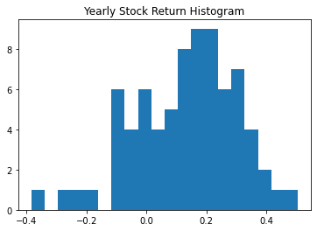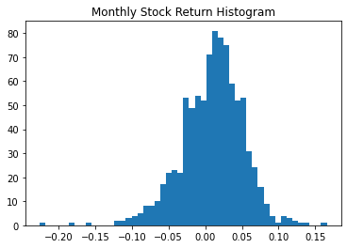

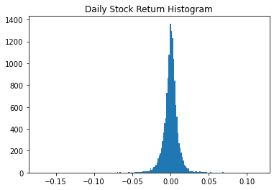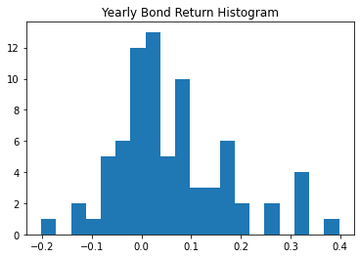

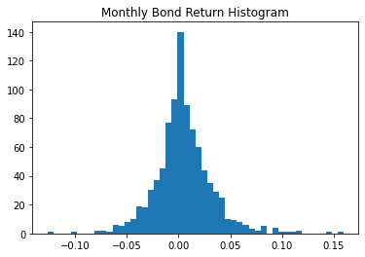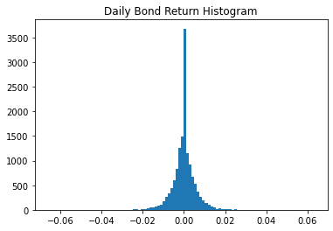

D.

Confidence interval for stock return next year is [-0.2066, 0.4649], for arithmetic return over next 30 years is [0.0679, 0.1905]

Confidence interval for stock return next month is [-0.0724, 0.0923], for arithmetic return over next 30 months is [-0.0051, 0.0250]

Confidence interval for stock return next day is [-0.0186, 0.0194], for arithmetic return over next 30 days is [-0.0031, 0.0039]

Confidence interval for bond return next year is [-0.1630, 0.2868], for arithmetic return over next 30 years is [0.0208, 0.1029]

Confidence interval for stock return next month is [-0.0492, 0.0592], for arithmetic return over next 30 months is [-0.0049, 0.0149]

Confidence interval for stock return next day is [-0.0106, 0.0107], for arithmetic return over next 30 days is [-0.0019, 0.0020]

E.

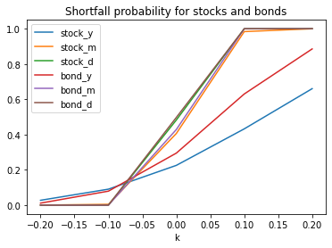

F.

The probability that the stock return over the next year will be lower than the bond return is 0.3720

The probability that the stock return over the next month will be lower than the bond return is 0.4604

The probability that the stock return over the next day will be lower than the bond return is 0.4863