**15.433 Assignment 2**

Group Member:

Jincheng Cui (923726863)

Yukai Tan (928598798)

Yinan Huang (921772453)

Songhao Li (925322960)

Date: 09/22/2020

Exercise #1:

***Note for Exercise #1: I downloaded all the files before September 15th, so the data were only updated to 202006. Therefore, all the results do not include the data for 202007.

# Output for the mean excess returns for value-weight returns:

Lo10:

Dec2:

Dec3:

Dec4:

Dec5:

Dec6:

Dec7:

Dec8:

Dec9:

Hi10:

output for the difference between the mean returns of the largest decile portfolio and the smallest decile portfolio:

(b)

Lo10:

Dec2:

Dec3:

Dec4:

Dec5:

Dec6:

Dec7:

Dec8:

Dec9:

Hi10:

# output for the difference between the mean returns of the highest book-to-market decile portfolio and lowest book-to-market decile portfolio:

# 1C  Intercept is the alpha.

Lo10:

Dec2:

Dec3:

Dec4:

Dec5:

Dec6:

Dec7:

Dec8:

Dec9:

Hi10:

# 1C difference

#Exercise 2

(A)

Smallest size/highest book-to-market:

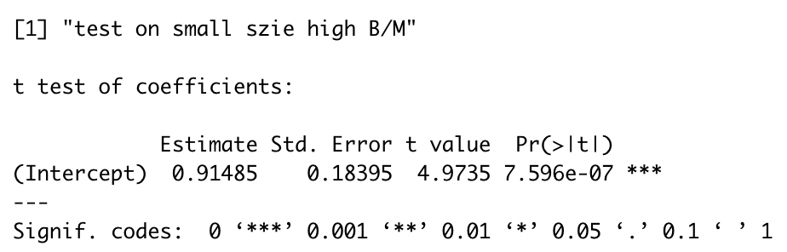

Largest size/lowest book-to-market:

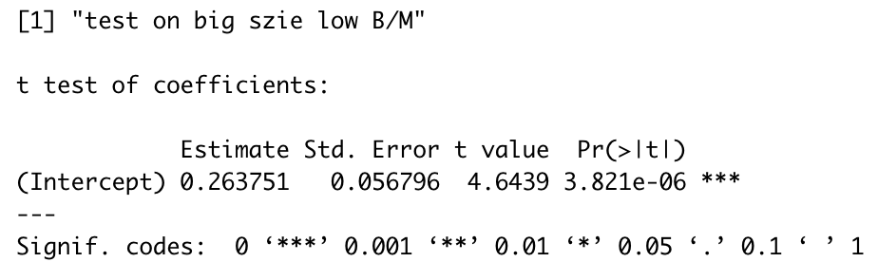

Test on difference:

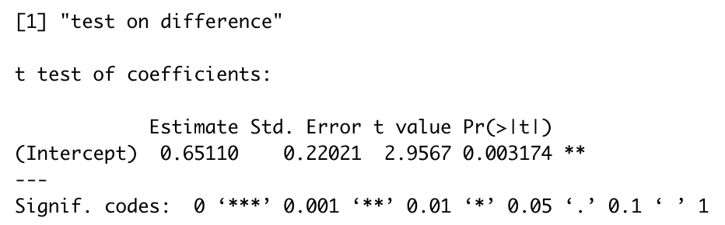

(B)

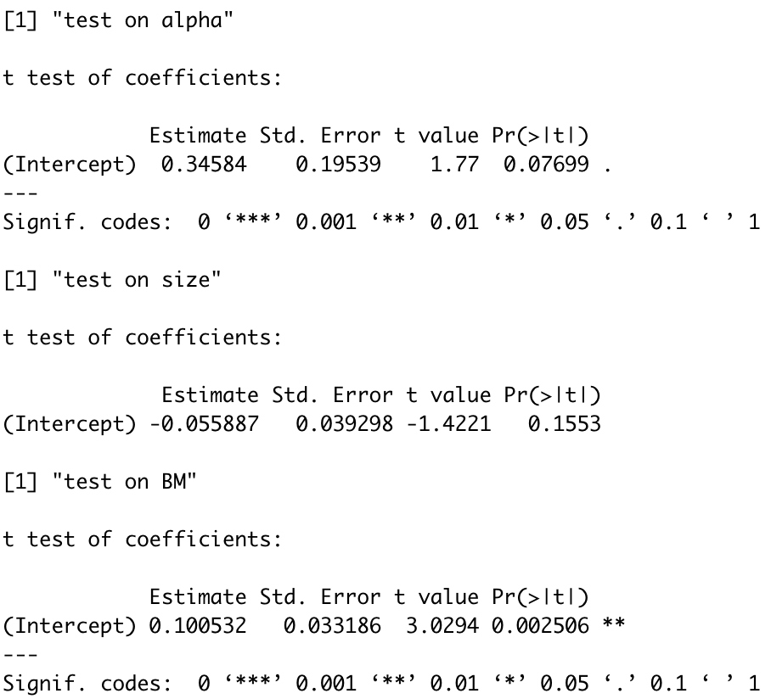

Based on Fama-Macbeth result, although smaller size and higher book-to-market ratio do imply higher return (which is consistent with results in A), the effect from size is not very significant.

(C)

Mean and t-stat on the constant:

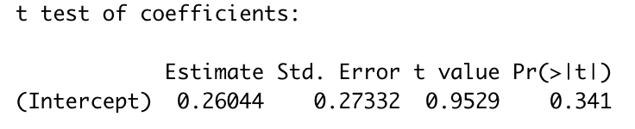

Mean and t-stat on the BETA:

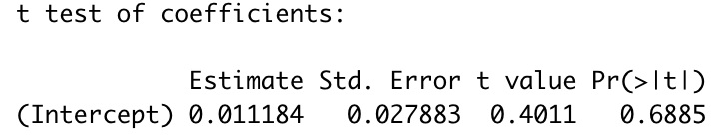

Both values are insignificant, which is bad news for CAPM model.

Exercise #3 (A)

CAPM alpha and associated t-stat for firms in the lowest decile of operating profitability:

Note: Standard Errors are heteroscedasticity and autocorrelation robust (HAC) using 6 lags. It displays z-stat here because z-stat is the same as t-stat here.

CAPM alpha and associated t-stat for firms in the highest decile of operating profitability:

CAPM alpha and associated t-stat for lowest minus highest:

The difference in CAPM alpha for these two portfolios is statistically significant, with absolute value of t-stat greater than 2.

3 (B)

FF3 alpha and associated t-stat for firms in the lowest decile of operating profitability:

FF3 alpha and associated t-stat for firms in the highest decile of operating profitability:

FF3 alpha and associated t-stat for lowest minus highest:

The difference in FF3 alpha for these two portfolios is still statistically significant, with absolute value of t-stat greater than 2. Therefore, the FF3 factors does not explain the risk associated with the difference between low operating profitability and high operating profitability.

Exercise #4

(A) CAPM

Equally-weighted:

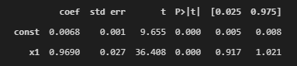

Value-weighted:

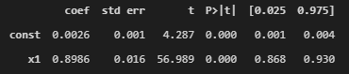

(B)

FF3 model for value-weighted:

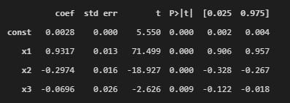

x1 for mkt, x2 for SMB, x3 for HML.

We suspect these firms are big firms with slight small book-to-market ratio.