1. Weighted average trading costs for buyer-initiated trades is 0.625 bp
2. Weighted average trading costs for seller-initiated trades is 0.839 bp
3. Trading cost and volume for buyer-initiated trades:

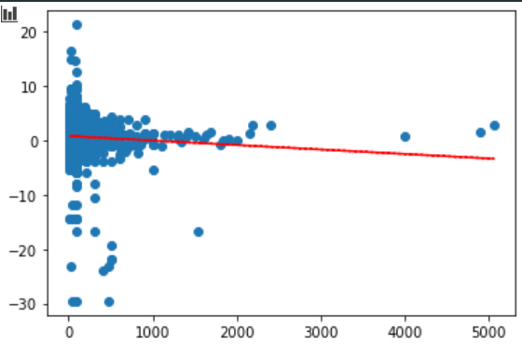

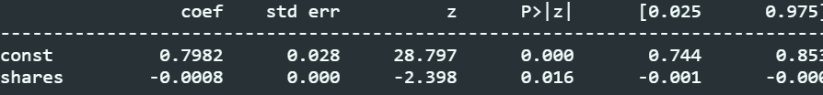

Trading cost and volume for seller-initiated trades:

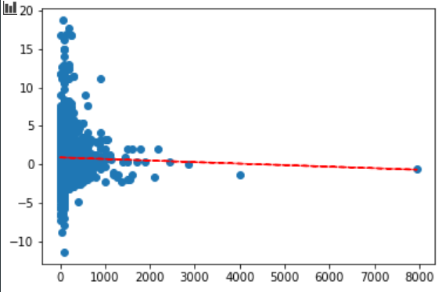

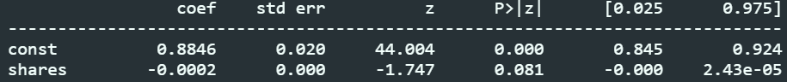

Although OLS estimates negative relation between trade size and transaction costs, the statistical evidence (t-stat) is not very strong

d)

Not very strong evidence in total. Estimation gives a negative relation largely due to variation for company with small market capitalization. For companies with log(mktcap) > 20, the transaction costs are distributed around a similar horizontal level.