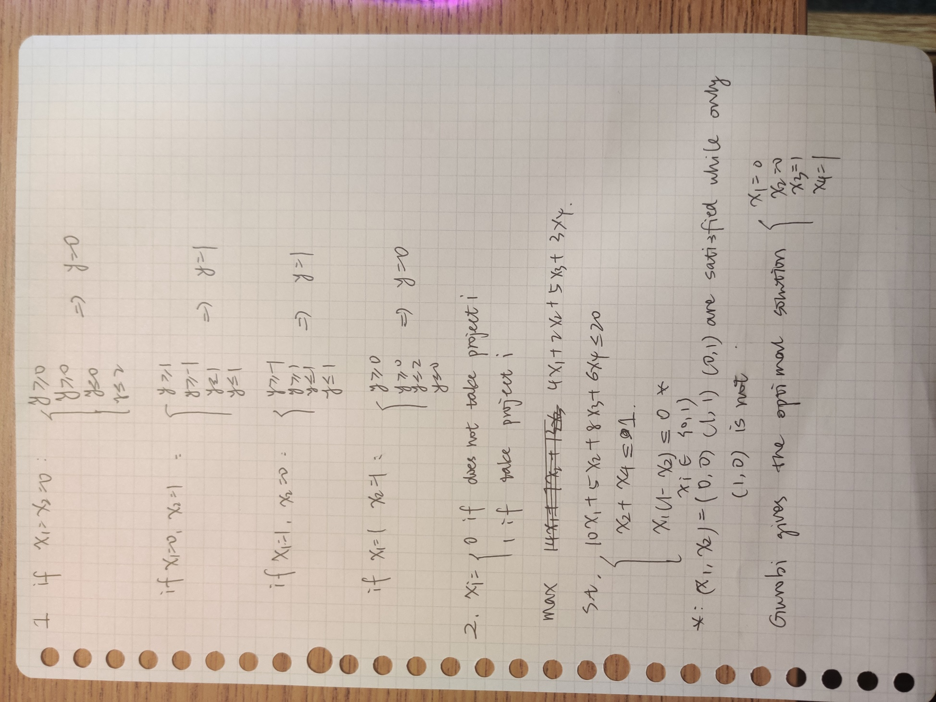

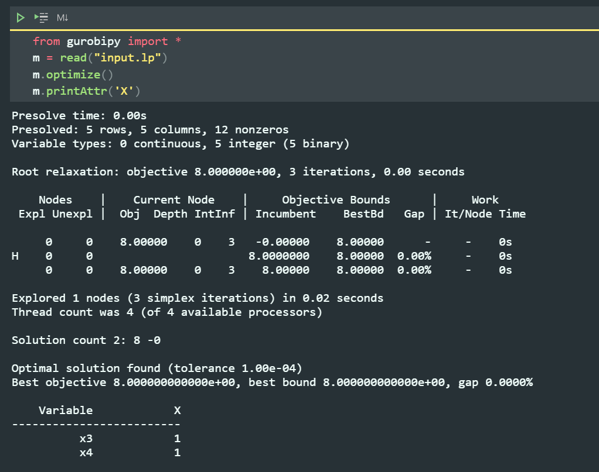

LP file:

\ LP format

Maximize

4 x1 + 2 x2 + 5 x3 + 3 x4

Subject To

c0: 10 x1 + 5 x2 + 8 x3 + 6 x4 <= 20

c1: x2 + x4 <= 1

qc0: x1 - [ x1 \* x2 ] <= 0

Bounds

Binary

x1 x2 x3 x4

End

Question 3

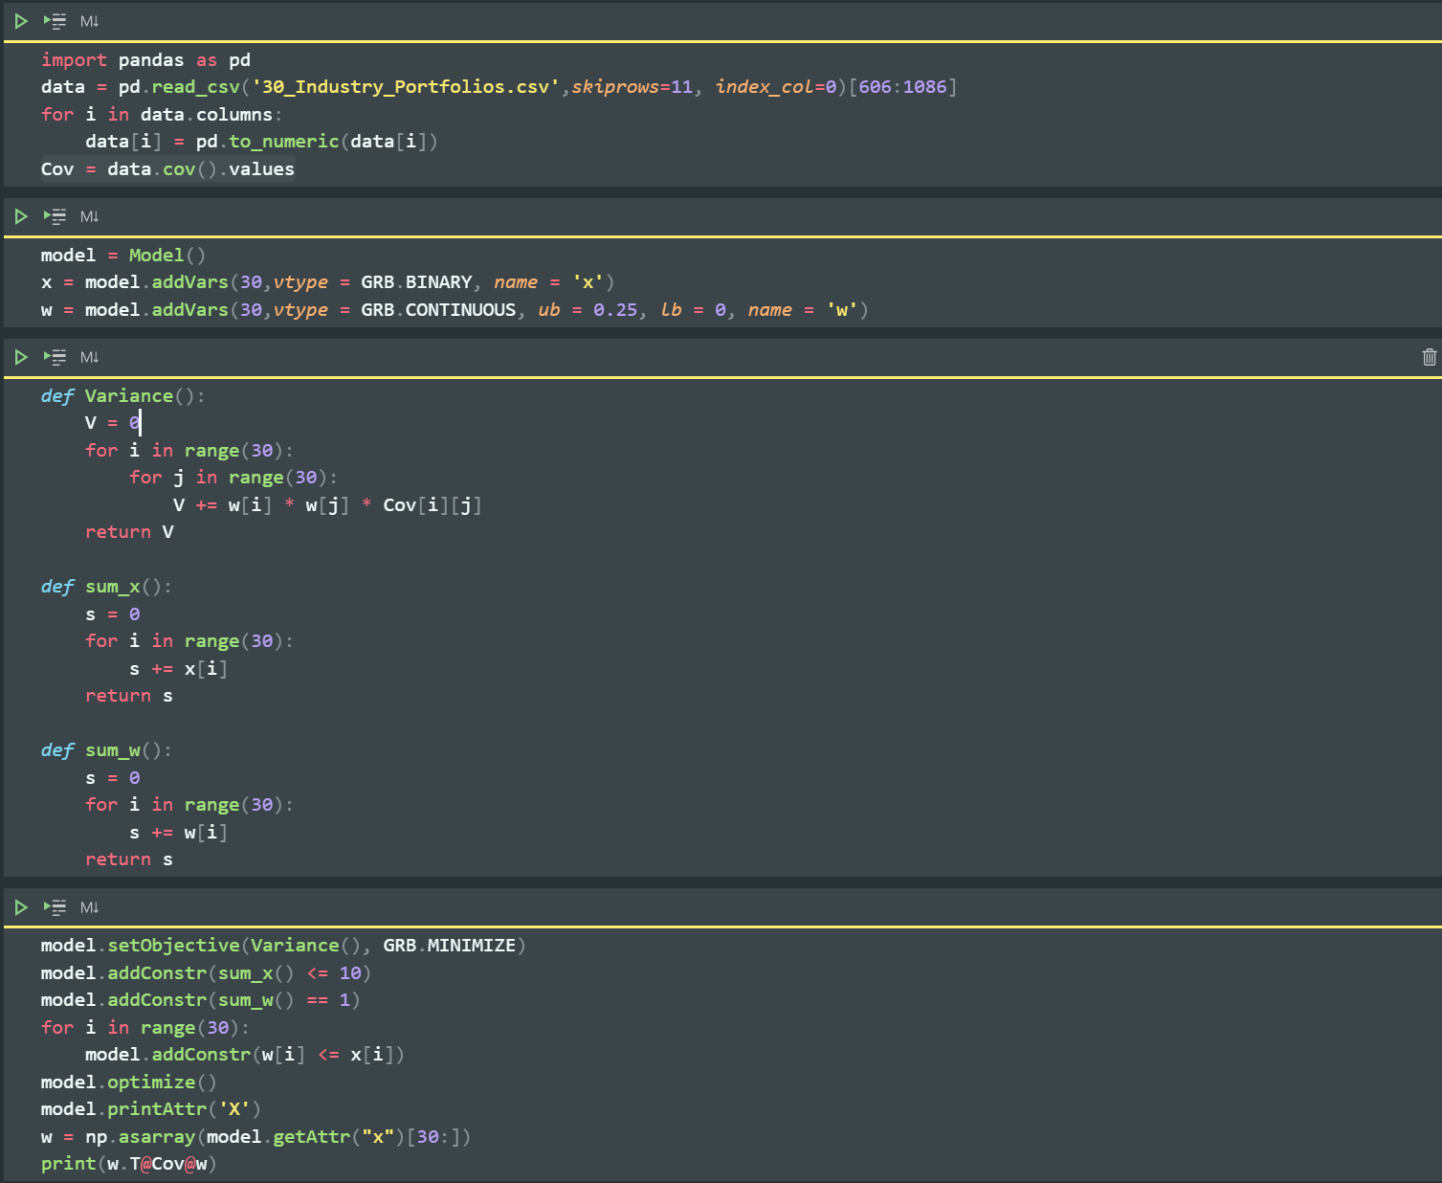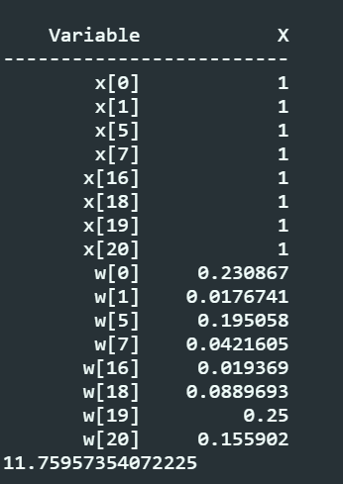

In-sample variance is 11.76

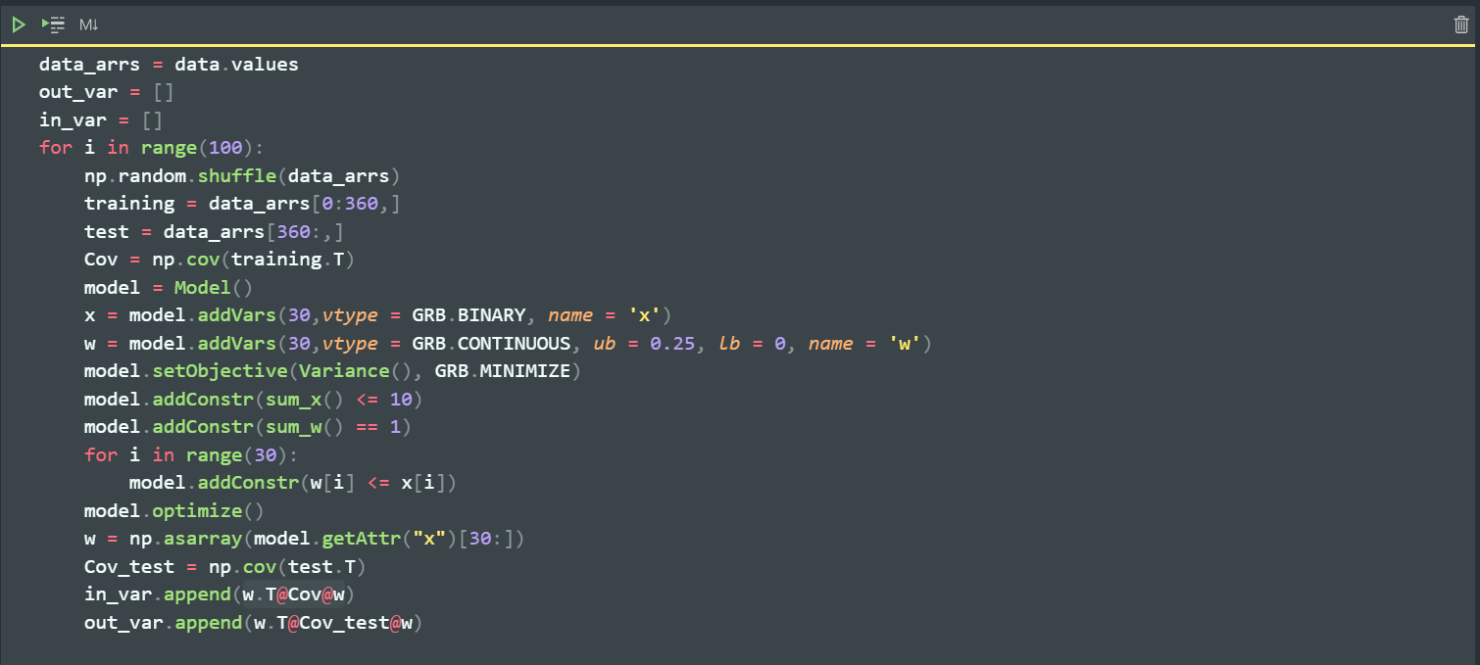

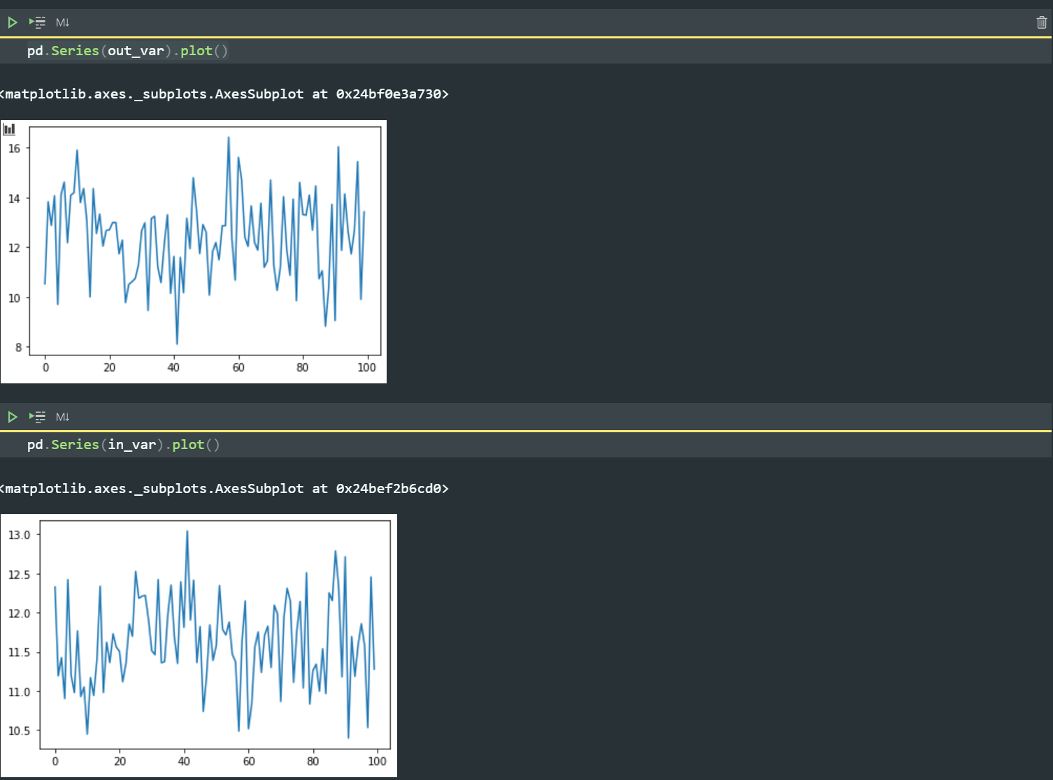

Out-sample variance is much less stable than in-sample variance