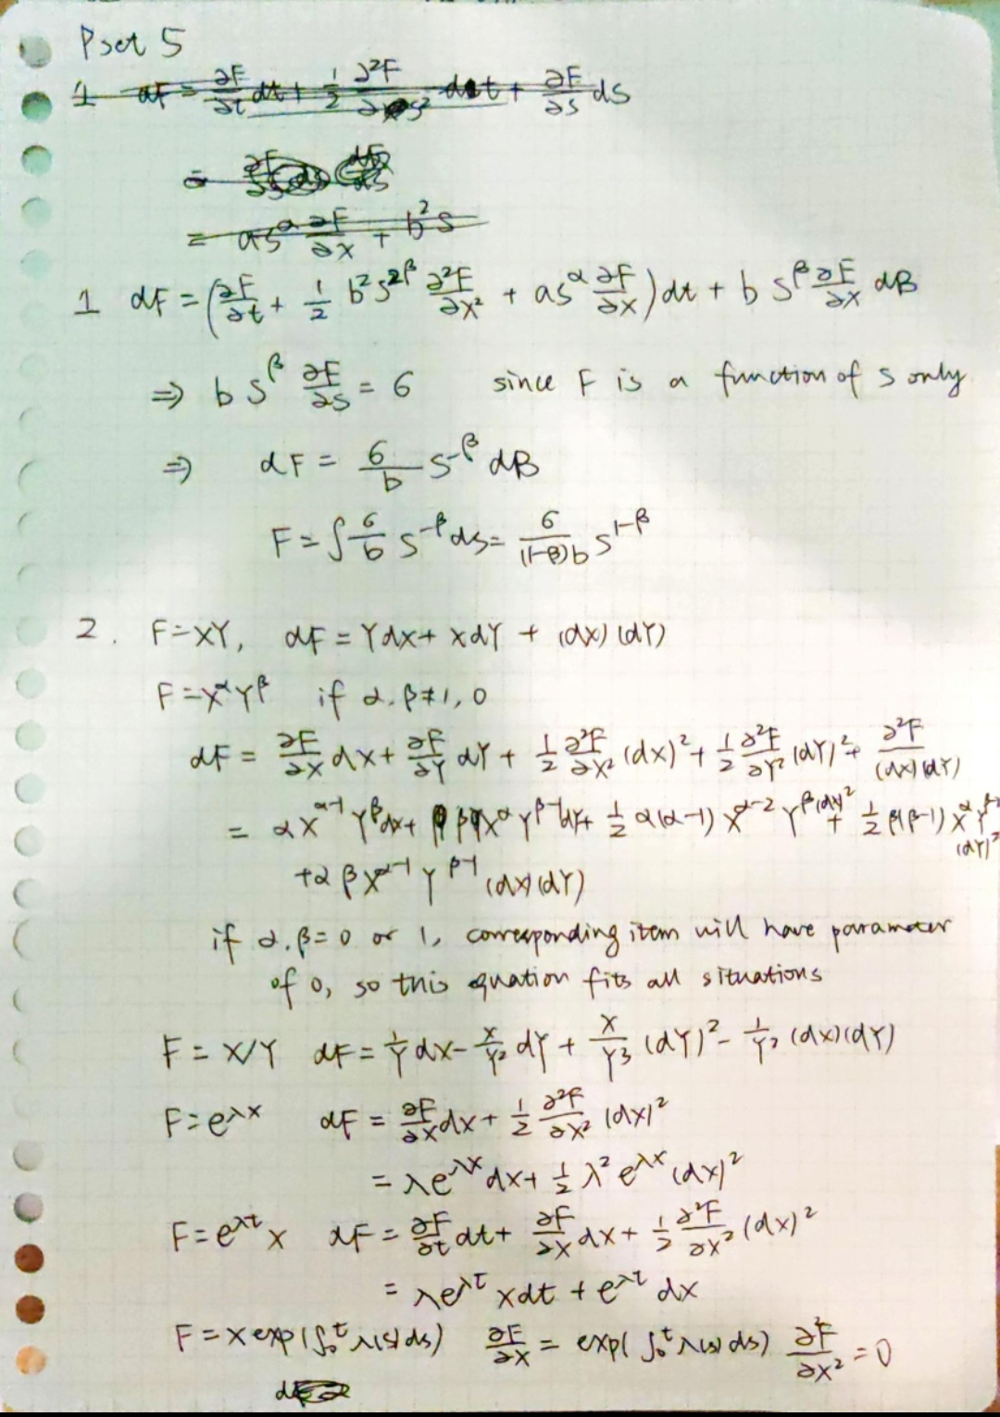

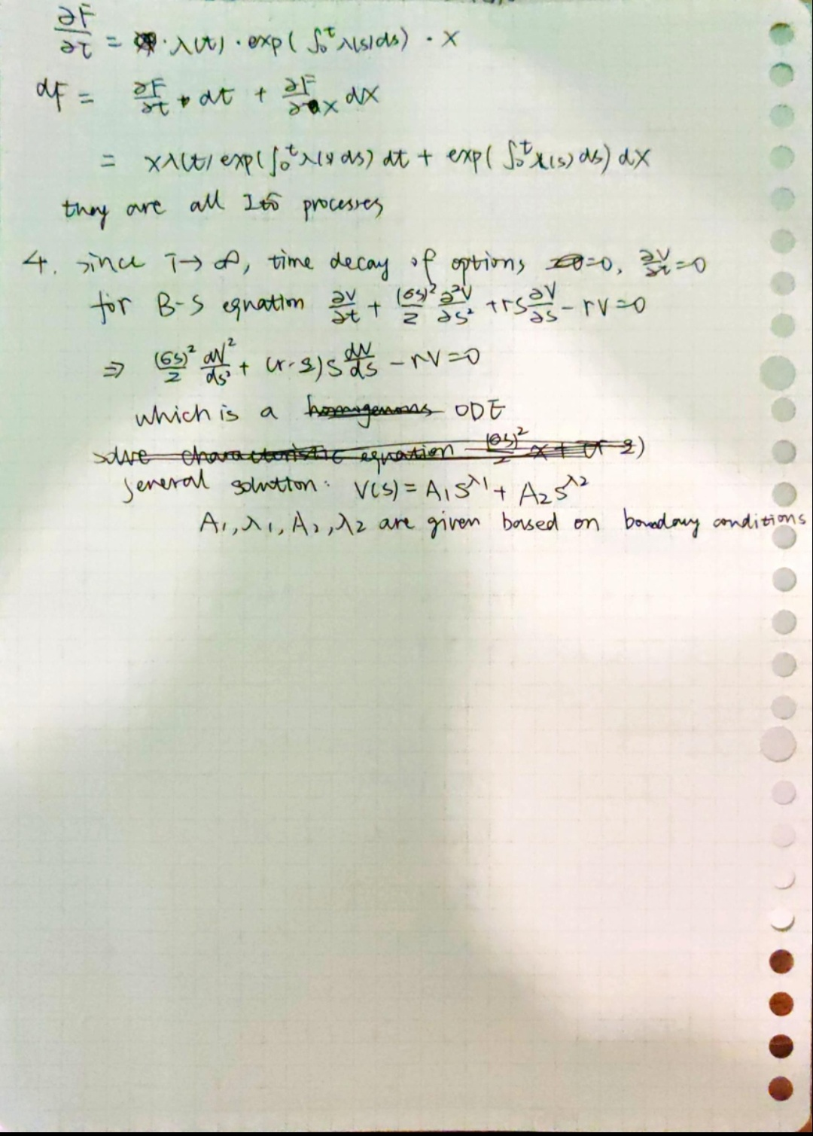

Q3

Monte-Carlo, from R studio:

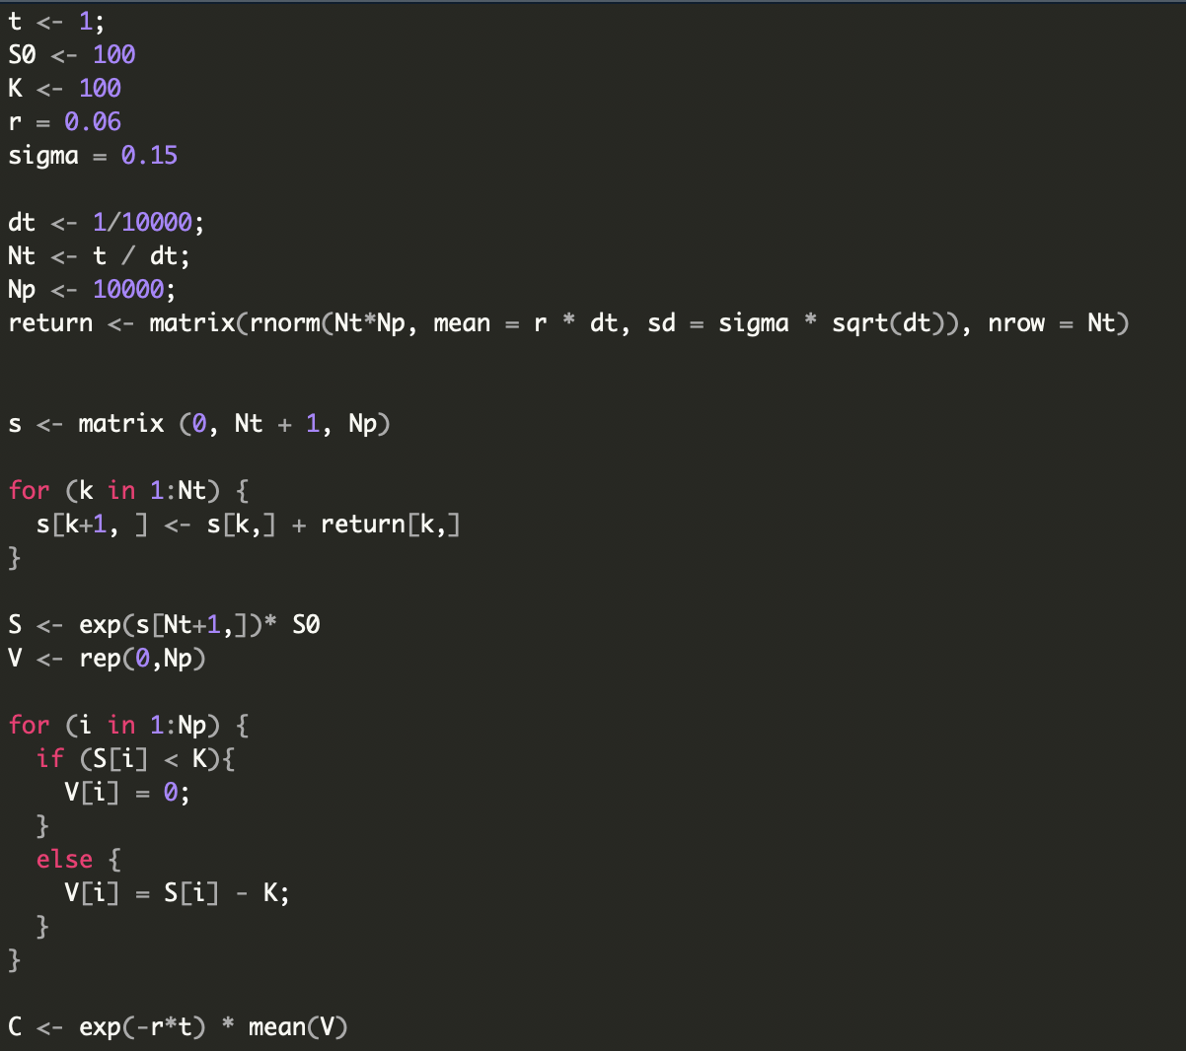

C = 9.8155

Black-Scholes, from Python codes:

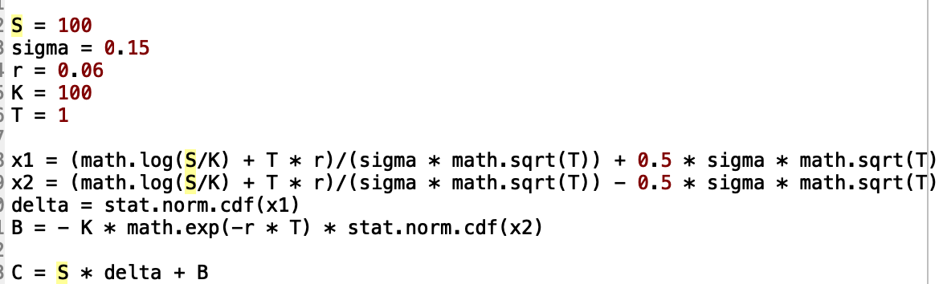

C = ﻿9.173453198408012