Cash Tax Payment = Tax expense (on Income Statement) + Increase in DTA – Increase in DTL

= $110 + ($1454 - $910) – ($1489 - $918)

= $ 83 (Million)

Since the tax rate is 21%, if taxable income had been $1 billion higher, Tesla would pay $210 million extra taxes; if taxable income had been $1 billion lower, Tesla would pay $210 million less taxes.

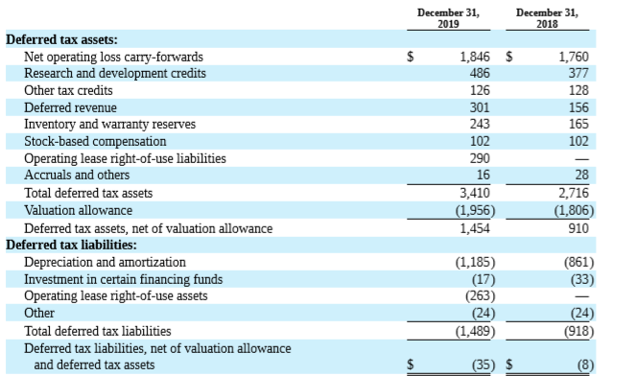

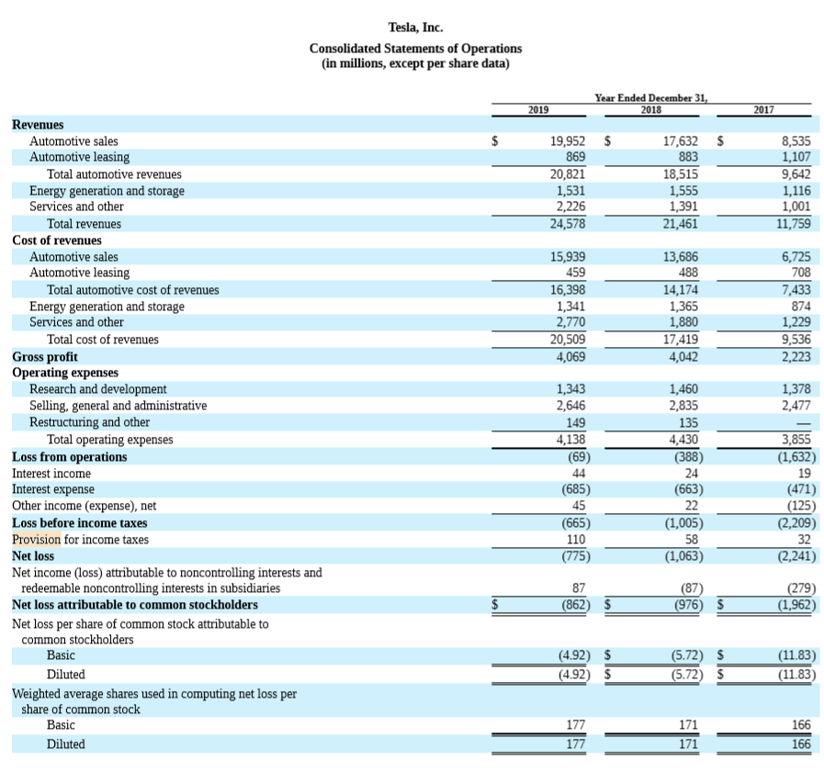

2.

|  |  |  |  |  |  |  |
| --- | --- | --- | --- | --- | --- | --- |
| FV tangible asset | FV intangible asset | goodwill | = | debt and leases | other liabilities | Equity |
| 128 | 105 | 79 |  | 44 | 61 | 207 |

