**Tesla Case Questions**

**This case write up is due Friday July 31 before 8 am. Submit one assignment per team to Canvas. Include all your team members’ names below. Type your answers into this document, and submit either a Word or pdf document (no Excel).**

**Reference note numbers, page numbers, and/or show your work.**

*The Tesla case consists of (1) the case write-up; (2) these case questions; and (3) the financial statements for Tesla for the fiscal year ended December 31, 2019. Put yourself in the position of an analyst who has received these financial statements and must conduct his or her analysis solely on the basis of these statements.*

*We strongly recommend that as you do this case you only refer only to the case materials and these financial statements. Tesla has released subsequent statements and much has been written about Tesla and by Tesla since 2019. But this information will not be helpful to you, and will potentially cause you to make errors on the case.*

**Team Member names:**

1. **Jing Guo**

**2. Jingyi (Candice) He**

**3. Songhao Li**

**4. Yihan Huang**

**5. Haoyu Wang**

**Questions:**

1. *(Class 17)* For the 2019 fiscal year, Tesla recorded a change in its valuation allowance for deferred tax assets. Use the Balance Sheet Equation (BSE) to record this transaction, and clearly label the accounts affected.

How much cash taxes did Tesla pay (was refunded) in 2019? How much extra US taxes would it have paid (been refunded) if its taxable income had been $1 billion higher? How much less US taxes would it have paid (been refunded) if its taxable income had been $1 billion lower?

|  |  |  |
| --- | --- | --- |
| DTA | -Valuation Allowance (XA) | = Tax Expense |
|  | 150 | 150 |

Cash Tax Paid = 91 M (*Source: Tesla 10-K, P113, Total Current Tax)*

Tesla has net carry forward loss of 1.876 Billion; which indicates that 1B increase/decrease in taxable income wouldn’t affect cash pax payment, but would result in adjustment of DTA only.

2. *(Class 11)* In May, 2019, Tesla acquired Maxwell Technologies. Use the balance sheet equation to allocate the purchase price to FV tangible assets, FV intangible assets, goodwill, debt and capital leases assumed, other liabilities assumed, and stockholders’ equity.

|  |  |  |  |  |  |  |  |
| --- | --- | --- | --- | --- | --- | --- | --- |
| FV tangible asset | FV intangible asset | Investment | goodwill | = | debt and leases | other liabilities | Equity |
|  |  |  |  |  |  |  | 207 |
| 128 | 105 | -207 | 79 |  | 44 | 61 |  |

3. *(Class 14)* Tesla sold stock in May 2019. Give the BSE for the share issuance. Based solely on the information in the 10-K, how many shares do you estimate that Tesla issued? Express your number in all digits, i.e., 5,012,021 not 5 million

The sale included $ ? million in transactions costs. How did Tesla account for these costs?

Clue1---68

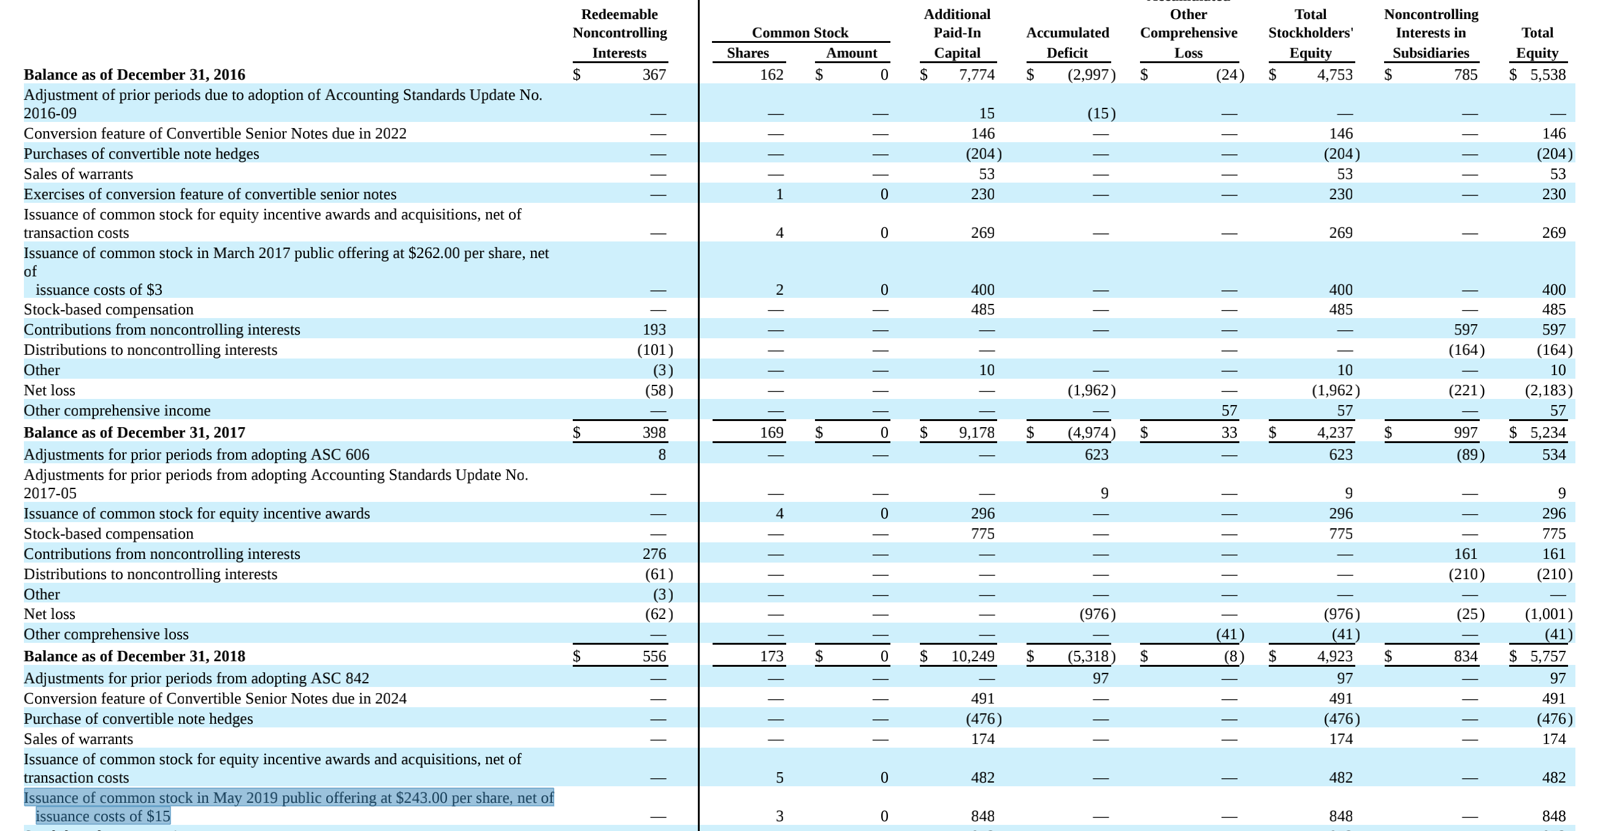

Shares issued = X

243 * X = 0.001 * X + APIC - 15 * X

APIC - 15 * X = 848 * 10^6

X = 3489726 shares

Par value = 3489726 * 0.001 = $3489.73

APIC = 848*10^6-3489.73= $847996510.27

Issuance cost = 3489726*15 = $52345890

Account the issuance cost by reducing APIC

Assets = Par + APIC

+848000000 +3489.73 +847996510.27

-52345890 -52345890

The sale included $ ? million in transactions costs. How did Tesla account for these costs?

4. *(Class 15)* In May 2019, Tesla issued $1,840 million in 2% Convertible Senior Notes due in May 2024 ("2024 Notes").

1. What is the the market interest rate at issuance?
2. How many shares can be issued on conversion?
3. What is value of the value of bond payments discounted at the market interest rate at issuance?
4. What is the value of the equity component?
5. Using the BSE, show how Tesla accounted for the issuance of the notes ignoring issuance costs.
6. Using the BSE, show how Tesla accounted for the issuance costs.
7. Using the BSE, show how Tesla accounted for interest expense for the six months ended November 2019 (the first six months’ interest expense).
8. 
9. From 10-k page 104 we know that “each $1,000 of principal of the 2024 Notes is initially convertible into 3.2276 shares of Tesla’s common stock”, we know that shares can be issued on conversion = 1,840,000,000 / 1000 * 3.2276 = 5,938,784 shares.
10. 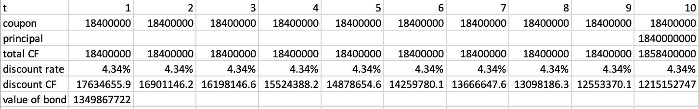

According to the form above, the value of bond payments discounted at the market interest rate at issuance is $1,349,867,722.

1. The value of equity component equals to $1,840,000,000 - $1,349,867,722 = $490,132,278

A = L + SE

Cash = Bond Payable + APIC

1,840,000,000 1,349,867,722 490,132,278

A = L + SE

Cash = APIC

(20,000,000) (20,000,000)

1. According to Note 12, we found that “the resulting debt discount is being amortized to interest expense at an effective interest rate of 8.68%”, we can infer that the first six months’ interest expense is around $1,349 million * 8.68% / 2 = 58.5466 million.

A = L + SE

Cash = Bond Payable RE

(18,400,000) (40,184,259) (58,584,259)

**Hint:**Tesla accounts for convertibles as a separate bond component and equity component. The value of the bond component is the value of bond interest and principal payments discounted at the market interest rate at issuance, and the equity component is the difference between the total amount raised and the value of the bond component. (This is basically the way that IFRS accounts for convertible debt.) *Ignore the convertible note hedge transactions and the sale of warrants that Tesla engaged in in connection with the offering of the Notes.*

5. *(Class 15)* How much was interest expense in 2019? How much cash did Tesla pay for interest in 2019?

Clue 1---54

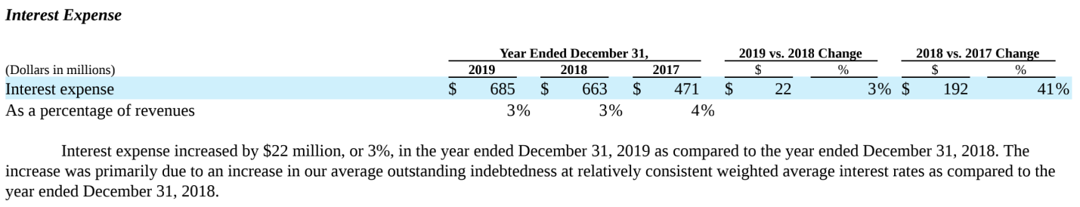

Clue 2---66



Interest Expense = $685million

Clue 1---69



Cash paid for interest = $455million

6. *(Class 8)* How much free cash flow did Tesla generate in years 2017, 2018, and 2019?

7. *(Class 15)* Recall that interest expense is an operating cash flow, but debt repayments are a financing cash flow. How much free cash flow do you **estimate** Tesla must use for debt maturing in 2020? In 2021? Does your answer depend on Tesla’s stock price?

8. *(Class 16)* How much free cash flow must Tesla use for leases maturing in 2020? In 2021? For this part, assume that there is a 5% interest rate in Tesla’s leases. **Hint:** Does Tesla characterize the cash flows from finance leases as operating or financing? What about operating leases?

From the above form, we see that Telsa recognize the Cash flow from the operating leases and the interest payment of the finance leases as the CFO. The remaining part of the financing leases is characterized as the CFF.

Using the information below found on the page 107 of the 10k form, we can calculate the free cash flow from the CFO since there’s no CAPEX for the leasing in this case.

FCF in 2020 is:

$296 + 5% (interest) * $474 = $296 + $23.7 = $319.7 mn

FCF in 2021 is:

$262 + 5% (interest) * $478 = $262 + $23.9 = $285.9 mn

9. *(Class 14)* Suppose that Tesla receives a takeover offer of $1,500 per share. At a price of $1,500 per share, based on the information in the 2019 10-K, what are the values of the following equity components (please report you answers in millions):

1. Shares outstanding
2. Options outstanding (Use the treasury stock method. Note that all unvested options become vested and exercisable upon takeover. *Ignore RSUs.*)
3. Convertible notes (2021, 2022, and 2024) (use the if converted method)

*Again, ignore the convertible note hedge transactions and the sale of warrants that Tesla engaged in in connection with the offering of the Notes.*

1. A screenshot of a cell phone

   Description automatically generatedShares outstanding

$1500 * 181 = $271,500 mn

1. Options outstanding (Use the treasury stock method. Note that all unvested options become vested and exercisable upon takeover. *Ignore RSUs.*)

From the above info, we know that the total numbers of options are 29.995 mn and the weighted average exercise price is $279.49. The total value of is 29.995*279.49 mn. However, after the takeover repurchase, the total outstanding option became

29.995 – 29.995*279.49/$1500=24.410 mn

And the total value of outstanding option becomes 24.410 * $1500 = $36615 mn

1. Convertible notes (2021, 2022, and 2024) (use the if converted method)

10-K Page 97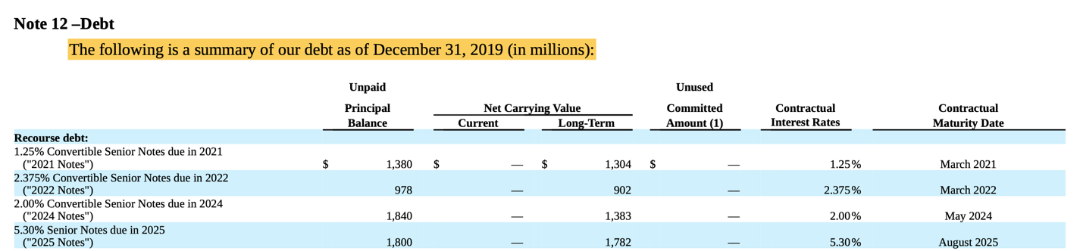

**2021:**



1380 * 1/1000 * 2.7788 = 38334733 shares

38334733 * $1500 = $5752.116 mn

**2022:**



978 * 1/1000 * 3.0534 = 2986225.2 shares

2986225.2 * $1500 = $4479.3378 mn

2024:



1840 * 1/1000 * 3.2276 = 5938784 shares

5938784*$1500 = 8909.176 mn

10. *(Class 8)* **Extra credit:** Forecast cash flow from operations (CFO) in 2020 if (a) Tesla’s sales fall by 50% (that is from $24,578 to 12,289), and (b) using only the information in the 2019 10-K. In doing this, assume that Tesla’s financial relations will be the same in 2020 as in 2019, except for the sales decrease. In other words, if Tesla’s sales in 2020 were $24,578, 2020 income and CFO would be the same as in 2019.

For simplicity, make the following assumptions:

1. Revenue is all cash.
2. All depreciation and amortization expense is part of COGS.
3. All non-cash working capital adjustments are part of COGS.
4. 50% of stock-based compensation expense is in 50% in COGS and 50% in SGA.
5. R&D expense is all cash. Assume that R&D will not be cut if sales fall.
6. Tesla will not be able to sell any PPE or intangible assets.

For simplicity in your analysis, please use the following aggregated income statement and cash flow statement. For example, do not analyze the components of working capital, just assume that all working capital adjustments are part of COGS.

|  |  |
| --- | --- |
| **Income Statement** | 2019 |
| Revenue | 24,578 |
| COGS | -20,509 |
| GM | 4,069 |
| SGA | -1,343 |
| RND | -2,646 |
| Other | -60 |
| Earnings before interest and taxes | 20 |
| Interest expense | -685 |
| Taxes | -110 |
| NI | -775 |

|  |  |
| --- | --- |
| **Cash flow from operations** | 2019 |
| Net loss | -775 |
| Depreciation, amortization and impairment | 2,154 |
| Stock-based compensation | 898 |
| Amortization of debt discounts and issuance costs | 188 |
| Other | 289 |
| Deferred taxes | 19 |
| Changes in WC | -368 |
| CFO | 2,405 |

|  |  |  |  |  |
| --- | --- | --- | --- | --- |
|  |  | rate |  | memo |
| Income Statement | 2019 |  |  |  |
| Revenue | 24,578 |  | 12289 |  |
| COGS | -20,509 |  | -11376.759 | [ 20509 – 2154 (depreciation in 2019)-898/2(stock compensation) ]/2 + 2154 (suppose straight line depreciation so amount will be the same) +539/2 |
| GM | 4,069 |  | 912.24055 |  |
| SGA | -2,646 |  | -1368.2595 | (2646-898/2(half of stock compesation))/2+539/2( 1/2 sc this year) |
| RND | -1,343 |  | -1,343 |  |
| Other | -60 |  | -30 |  |
| Earnings before interest and taxes | 20 |  | -1,829 |  |
| Interest expense | -685 |  | -685 |  |
| Taxes | -110 | 17% | -427.38321 | 2019 effective tax rate is -17% |
| NI | -775 |  | -2,514 | if tax is negative, we don't need to pay tax instead of getting a tax refund? |
|  |  |  |  |  |
| Cash flow from operations | 2019 |  |  |  |
| Net loss | -775 |  | -2,514 |  |
| Depreciation, amortization and impairment | 2,154 |  | 2,154 |  |
| Stock-based compensation | 898 |  | 539.5189 | As of December 31, 2019, we had $1.57 billion of total unrecognized stock-based compensation expense related to non-performance awards, which will be recognized over a weighted-average period of 2.91 years. |
| Amortization of debt discounts and issuance costs | 188 |  | 188 |  |
| Other | 289 |  | 289 |  |
| Deferred taxes | 19 |  | 19 |  |
| Changes in WC | -368 |  | -184 |  |
| CFO | 2,405 |  | 492 |  |