1. Introduction to Finance

arbitrage: non-positive initial cf, non-negative future cf, one strict

Law of one price

fin market: allocating resources, price discovery

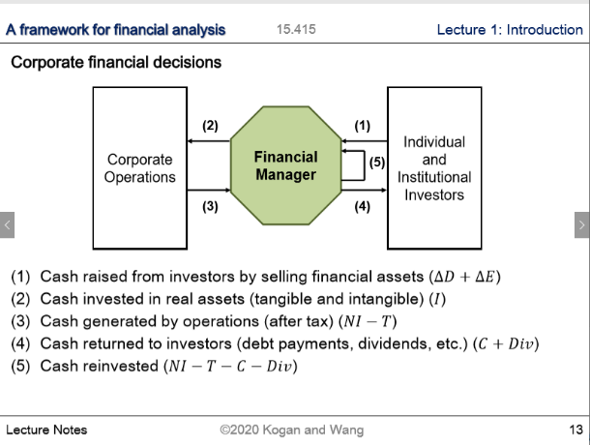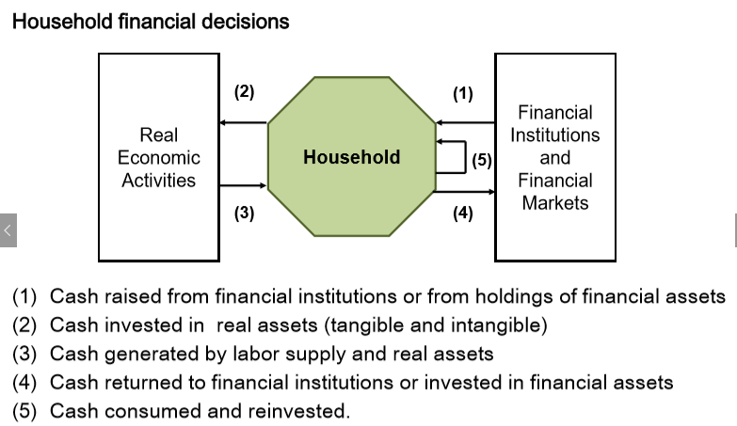market imperfection: transaction costs, information asymmetry, tax

1. Market Prices and Present Values

State-Price, AD securities

COC: oppurtunity cost of capital

Real CF = Nominal CF / inflation

Real rate of retern = nominal return / inflation

1. 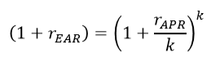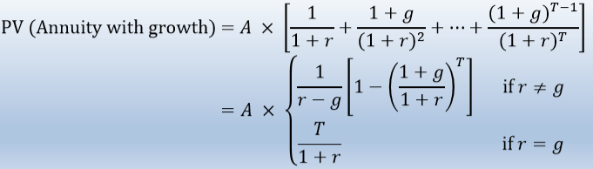Discounting & Compounding

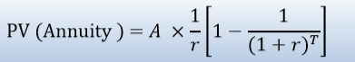

mortgage: sum [M / (1 + APR/k)^t] Payment – Rem.Principal \* interest rate = Principal Deduction

4-5 Corporate Finance I

Investment, Financing, Payment and Risk management

Justification for value maximization: can only help with increasing wealth

CF = (1-t) [Operating Profits w/o Depr] – [CapEx] + t[Depr] – delta[Working Capital]

6. Fixed Income

Yield Curve: Spot interest rate ~ Maturity

Relative Valuation:

each row is a bond, each row is a time, Matrix \* Price of Discount Bond = Price of bonds

Arbitrage:

each row is time, each column is bond. Matrix \* position = payoff

YTM: IRR of a bond, weighted average of spot rates. Coupon rate > YTM, sell at a premium

EH: does not hold in reality. Long-term bonds over-predict future short term rates

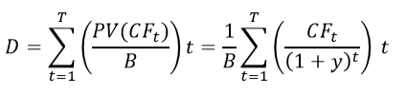(Macaulay) Duration:

MD = D / (1+y)

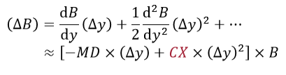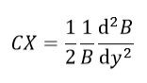 

CX = 1/2 \* 1/B \* 1 /(1+y)^2 \* sum [(t^2+t)PV(t)]

7. Common Stock

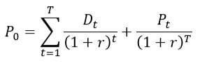

With Growth Opportunities: PV(FCF from 1 to T) + PV(Horizon Value at T)

Horizon value is typically multiples

8. Forward & Futures

Currency forward, Commodity futures, swap