HPWHsim General Overview

**Motivations**

Heat Pump Water Heaters (HPWHs) provide an economical way to substantially reduce the amount of energy used in domestic water heating which is the second largest use of energy in residences. It follows that the proper application of HPWHs can potentially have a large impact in reducing energy use. To help understand and estimate the amount of energy savings that can be achieved, a HPWH simulation was developed and calibrated. This HPWH simulation was developed with whole house simulation in mind; it is intended to be run independently of the the overarching simulation's timesteps and other parameters, and does not aggregate its own outputs. It was also designed to run quickly, as the typical use case would see many simulations run, each a year long or more.

**Flexibility**

The simulation was designed to model storage tank water heaters, specifically HPWHs. The configuration of a HPWH varies between different models so the simulation must accommodate these variations. Common variables are the number and position of electric resistance elements, the arrangement of the condensing coils, and the performance of the compressor system, among others. Figure 1 shows a schematic representation of two possible HPWHs.

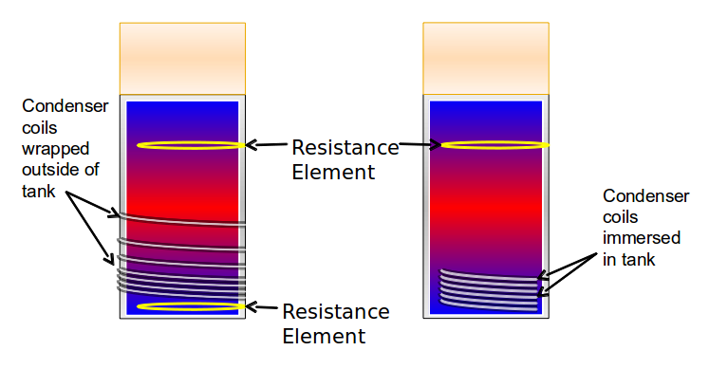

Figure 1: Possible HPWH configurations

To allow for more flexibility in the specification of heat sources, the concept of “condensity” was developed. A portmanteau of “condenser” and “density”, the condensity represents the section of the tank in which a heat source will add the heat it generates. A resistance element, for example, would have a condensity concentrated entirely in one node. The condensity is specified by 12 points which should sum to 1. A related factor, the “condentropy” is calculated from the condensity and used along with the condensity and the temperature of the water to calculate the distribution of heat from wrapped condenser coils. Submerged heat sources use a simpler technique, adding heat to all the nodes at or above their level which have the same temperature.

In addition to the physical properties of the HPWH and the topology of its heat sources, each model of HPWH has a unique set of criteria which direct it to engage or disengage its various heat sources. This logic is specifiable as well, by choosing from a set of standard decision criteria, such as the temperature of the top third of the tank, and supplying setpoints for those criteria. Although the simulation does not model interaction with the environment, the ability to set up a ducted HPWH is available due to the separate specification of the evaporator temperature and the tank ambient temperature.

**Limitations**

As a general comment, the operation of heat pump water heaters, and especially those with resistance elements, is highly complex, interdependent, and non-linear. Subtle changes in seemingly benign inputs like inlet water temperature or ambient air temperature can lead to different heat sources firing at different times, which, especially in the case of resistance elements, can cause dramatically different efficiency. For a HPWH trigger happy with its resistance element, the difference between a daily energy factor of 3 and 1.5 could be a mere gallon during the morning shower. The solution for overcoming the interdependent complexity of draws, control logic, and operating conditions, is to simulate draw patterns with as much randomness as possible. Simulating the same draw profile over and over again for an entire year creates an estimate that is extremely fragile and sensitive to operating conditions, such as ambient temperature, inlet water temperature, and setpoint. It is preferable to either define a unique draw profile for the entire year based on real-life water usage data, or for a more compact representation repeat a given daily/weekly draw pattern with added stochastic variations. Throw as much randomness as possible at the simulation to generate the most robust possible estimate of real life performance (this is also preferable because, as we know, real life provides an ample quota of randomness).

**Simulation Limitations**

The requirement for speed and simplicity place several limitations on the simulation. First, there is no hydrodynamic simulation done for the water in the tank. Heat transport within the tank is not modeled directly, but is taken into account in the way heat sources add heat to the tank. Thus there is a possibility that the tank could be warmer on the bottom than the top, though this would require unusual circumstances and has not been observed when simulating with realistic data.

There is a single water supply which enters the tank at the bottom and leaves from the top. This limitation does not affect most water heaters, but could rule out certain combined-use water heaters.

To simplify water temperature profile calculations, the simulation uses a nodal approximation. That is to say, the tank of water is vertically divided into equal-volume sections, each of which has a temperature. Figure 2 shows an example with 12 nodes, where the color represents temperature. The number of nodes is a variable, however certain calculations require that it be a multiple of 12. For most simulations, 12 nodes is sufficient, however certain models benefit from additional nodes. The reason for this is because any time a partial node volume is drawn from the tank, each node mixes with the node above it. For water heaters that are especially sensitive to tank temperature profile, additional nodes can improve accuracy at the cost of performance.

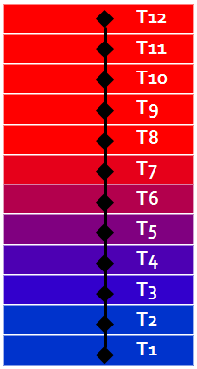

Figure 2: The nodal approximation

Another approximation used to simplify the calculations are the coefficient of performance (COP) and input power curves. In lieu of simulating a vapor compression cycle from first principles, each model of HPWH is tested in a lab and the input power and COP are characterized as functions of the evaporator and condenser temperatures. It is assumed that these functions are linear in evaporator temperature and at most quadratic in condenser temperature. Example COP curves are shown in Figure 3.

These linear approximations work quite well for the packaged units with a traditional, single speed, vapor-compression cycle. However, the variable speed Sanden ramps up or down to maintain mostly constant output capacity, which, when combined with an approximately linear relationship between COP and air temperature, leads to a roughly hyperbolic shape of input power with varying air temperature. Allowing a hyperbola for the relationship between input power and air temperature was deemed outside the scope of this version of HPWHsim, although it is a desired upgrade in the future. As such, the Sanden model results are only trustworthy along a range of approximately 30 F to 80 F.

To simplify calculating the standby losses, the total losses are calculated using the average temperature of the tank as a whole. These losses are then equally split amongst all of the nodes. In cases where the bottom of the tank is cold and the top is hot, this can result in a node which is below ambient temperature losing heat. This is an uncommon occurrence though, and the procedure is consistent with the measurement of the UA, which is done for the entire tank.

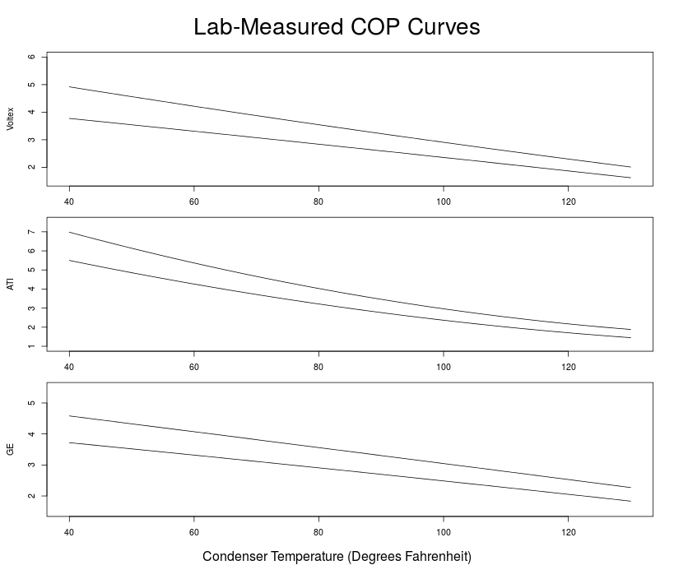

Figure 3: COP curves for three makes of water heater. Upper curve in each graph is measured at 67 F, lower curve at 47 F

**Data Limitations**

There are several key notes as to the applicable ambient temperature ranges for the HPWH models defined in the simulation. These models were largely specified based on lab testing data that was motivated by determining performance in a northwest climate. This led to testing largely at two ambient conditions, 50F and 67F, as well as determining a low temperature compressor cutoff. The results from the simulation are likely applicable to a range of temperatures up to 80F. For more extreme ambient temperatures, such as 90F, as could be found in a garage in a warmer climate, we make no assertions as to the accuracy of the simulation, as we simply do not currently have the data to make such assertions.