To: Dave Kresta, NEEA

From: Michael Logsdon and Ben Larson, Ecotope, Inc

Date: June XX, 2012

Re: Heat Pump Water Heater Simulation

This memo summarizes development and calibration of the heat pump water heater (HPWH) simulation developed by Ecotope, Inc. There are two main points to discuss: the machinery of the simulation itself, and the calibration of the output to measured field data.

1. Simulation Development

Drawing upon a surfeit of HPWH laboratory test data – including BPA study XX and NEEA study YY – Ecotope, Inc developed a simulation for HPWH energy consumption and efficiency. The simulation takes a hot water set-point and inlet water temperature, and steps through a schedule of water draws and ambient space temperatures, tracking tank temperature and activating heating components accordingly. As such, the core of the model is a relationship between input power, water temperature, and ambient space temperature; a relationship between Coefficient of Performance (COP), water temperature, and ambient space temperature; and a set of control logic parameters, dictating when to activate the heat pump in response to a draw, the resistance element in response to a large draw, and the heat pump in response to standby losses.

The relationships for input power and COP were extracted from tests in which the unit was filled with cold water and heated to set-point, all at a uniform temperature. The control logic was inferred from a combination of manufacturer's literature (when available), dedicated operating mode tests, DOE energy factor tests, and sundry other draw profiles meant to illuminate HPWH behavior.

The simulation steps through a draw schedule at one-minute increments. During each minute, the simulation performs a series of operations.

1. Reduce temperature for standby losses – heat lost to the surroundings. Lab measurements inform the rate of standby loss for each HPWH, which is a function of average tank temperature and ambient space temperature.
2. If a draw is present, shift the water column upward, with hot water exiting from near the top and cold water (at a pre-specified inlet temperature) filling the bottom. Update the temperature distribution accordingly.
3. Check the control logic and decide whether to activate or deactivate a heating component based on the updated temperature distribution.
4. If a heating component is activated or remains active, compute COP and input power from curve fits, in which the water temperature variable is set equal to average tank temperature in the bottom third of the tank. Update temperatures and record energy inputs and outputs based on the combination of calculated capacity and model-specific instructions for distributing the added heat throughout the tank.

Two primary difficulties were encountered. The first was development of stable and easily adjustable COP curve fits. The original approach was to fit a single master equation from all of the lab data. The master equation would report COP as a function of water temperature, air temperature, and humidity. The problems with this approach revealed themselves as twofold. First, it is only useful or applicable for units in which we possess an abundance of lab data at many different water temperatures, air temperatures, and humidities. Second, it is difficult to shift such an equation to better match observed field performance. With these concerns in mind, we developed a much simpler approach, in which twin curves for COP are developed as a function only of water temperature: one curve at 50 degrees air temperature, and one curve at 67 degrees air temperature. COP at some arbitrary air temperature is calculated linearly between the corresponding values at 50 degrees and 67 degrees. Most HPWH usage in the Northwest should occur in or near this temperature range, in which the behavior of COP with respect to air temperature is approximately linear.

The second difficulty encountered was extrapolating input power and COP behavior – that was measured during lab testing in a tank of uniform temperature – to the behavior of a stratified tank with some amount of mixing. The input power and COP are determined by water temperature adjacent to the condenser, and this quantity is often elusive. In the controlled COP tests, where the tank temperature was constant throughout, the water temperature adjacent to the condenser was simply the temperature everywhere in the tank. During actual operation, however, there is typically a range of temperatures, varying with height. A perfect simulation would somehow integrate over heat exchanger area and stratified temperature to compute a distribution of added heat. An approach of this complexity, though, would seem to lead down a possibly endless rabbit-hole, and is not guaranteed to provide any better results due to the stochasticity of water mixing. We selected a simpler approach, in which an average water temperature “seen” by the condensing heat exchanger is computed, and a manually tuned set of equations distribute heat in such a way as to match simulation patterns to measured patterns.

To make the last point more obvious, and below display real data and simulated data respectively for the Air Generate ATI66 DOE energy factor test. The thin lavender lines represent thermocouple temperatures at equal volume segments, ascending the tank. Notice that the shape of the thermocouple lines during recovery in the simulation qualitatively resembles the corresponding lines in the measured data. and below show the same test (run at 50 degrees ambient temperature) for a different HPWH, the AO Smith Voltex. Due to differing condenser shape and refrigerant type, the Voltex heat pump distributes added heat differently than the ATI, which leads to a different pattern in the thermocouple lines. A pair of tuning parameters, set for each HPWH model based on lab data, controls the distribution of added heat for each model.

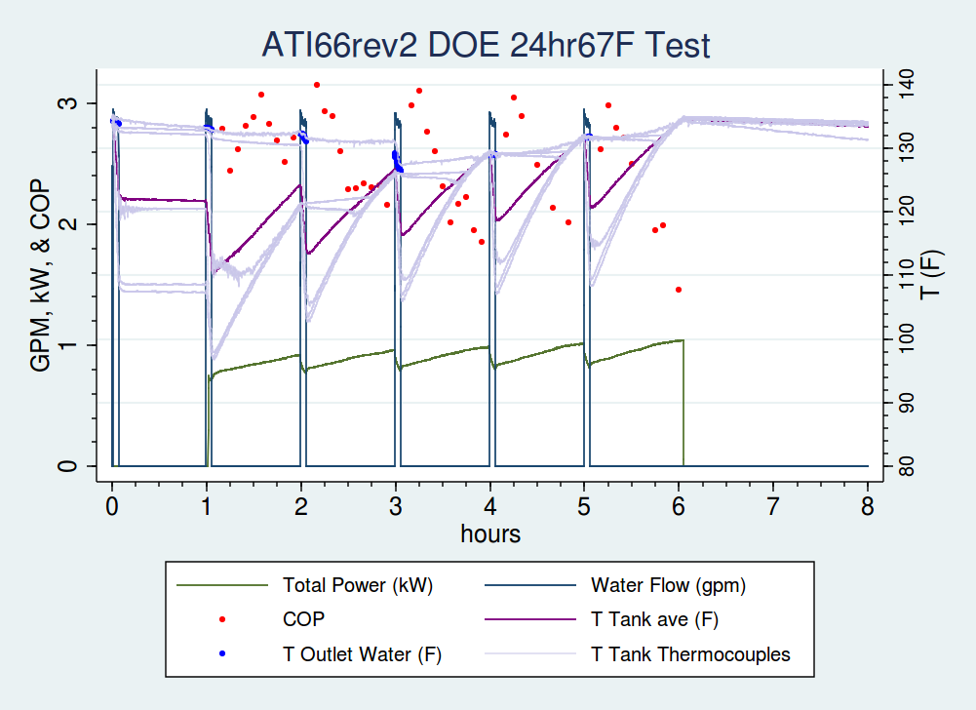

Figure 1, DOE Energy Factor Test for ATI66rev2

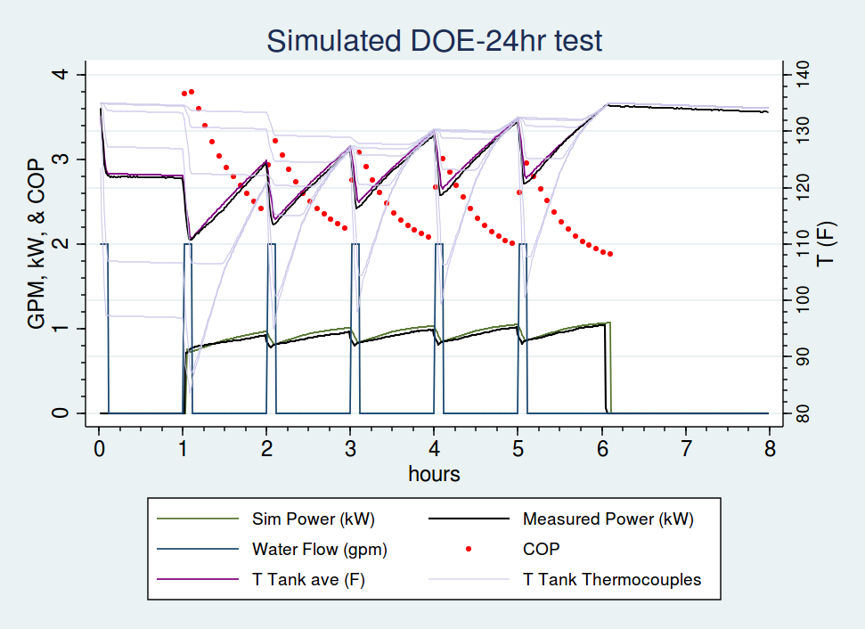

Figure 2, Simulated DOE Energy Factor Test for ATI66rev2. Measured values are shown in thick black lines

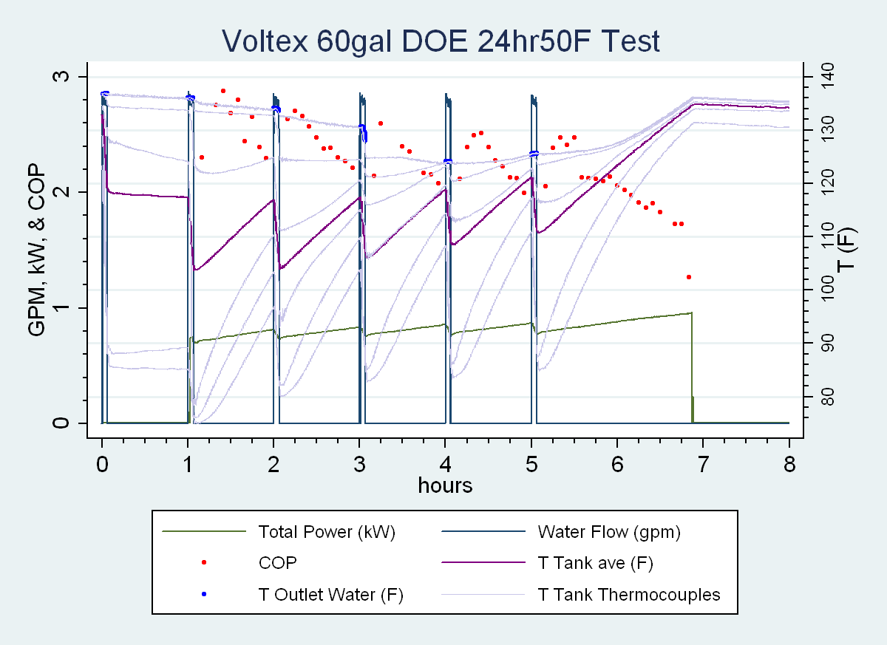

Figure 3, DOE Energy Factor Test for AOSmith Voltex 60 gallon tank, performed at 50 degrees Fahrenheit ambient temperature.

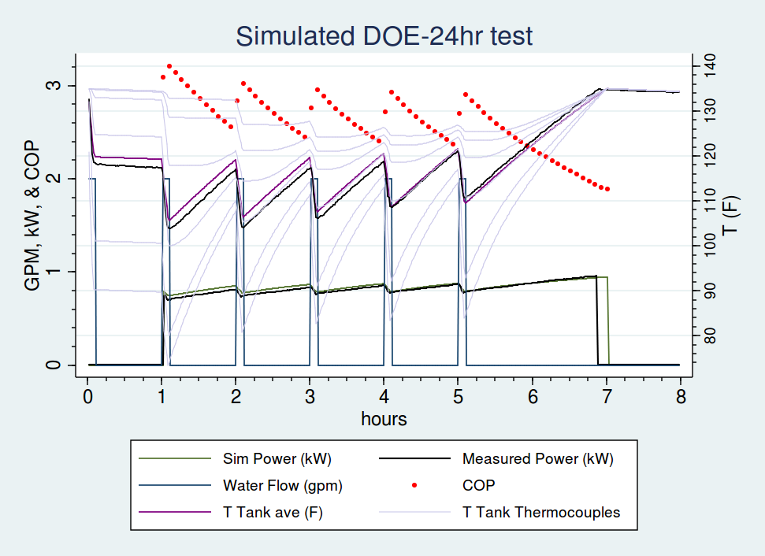

Figure 4, Simulated DOE Energy Factor Test for AOSmith Voltex 60 gallon tank, performed at 50 degrees Fahrenheit ambient temperature. Measured values are shown with thick black line. Notice different thermocouple line shapes as opposed to ATI66 water heater.

1. Simulation Calibration

Writing a simulation inspired by laboratory data is a good first effort, but what is ultimately desirable is the ability to simulate units as they operate in the field, which may or may not be the same. Varying installation practices, nuances between individual units, or the disorder of actual scenarios as opposed to tightly controlled laboratory ones may introduce discrepancy between lab results and field results. As such the simulation must be calibrated to accurately reflect the performance of installed units.

[Insert background on Fluid Field data, who collected it, what is it, what's the deal with Clear Result]

With any deterministic simulation that will be calibrated to field data, it is important to leave a few degrees of freedom in the model. Theoretically, all simulation parameters could be rigidly set according to lab data, but that decision would lead to a somewhat futile calibration exercise, in which the simulation data and lab data do not match, and all you can do is scratch your head and puzzle over the source of the discrepancies. Best practices dictate that the most uncertain parameters be allowed to float during simulation calibration.

In the case of the water heater simulation, COP was the most difficult quantity to pin down. COP is the ratio of useful energy added to energy input; energy input is a straightforward measurement of power consumption, but useful energy added is a wily quantity. In the lab data, a thermocouple “tree” – a rod with temperature-sensing thermocouples – was placed vertically in the water heater and reported six temperatures corresponding to six equal volume segments of the tank. From these temperature readings an average tank temperature was calculated, and useful energy added was computed as proportional to the difference in average tank temperature (with constant equal to the product of water mass and heat capacity of water). Even when the tank is mixed, the uncertainty of using six discrete measurements to wholly describe tank temperature distribution, and the natural fluctuations of the heat pump process, create an at-times high variance COP model. See below .

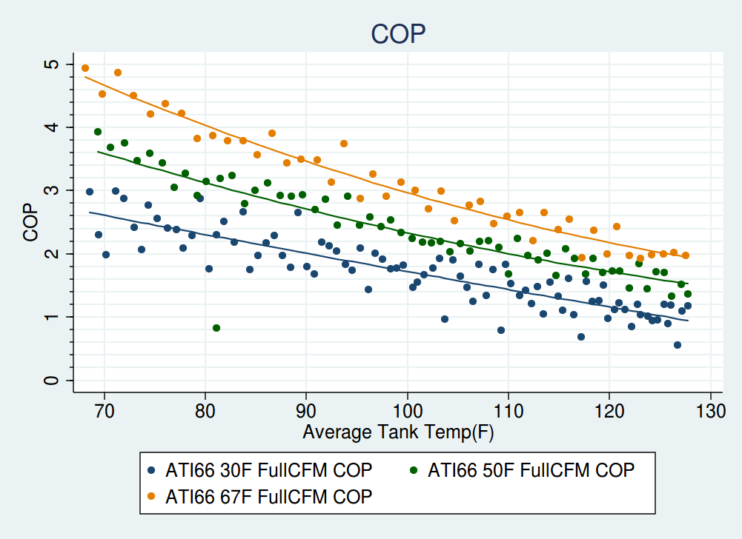

Figure 5, Laboratory COP measurements for ATI66 HPWH

During calibration, the COP curves and control logic parameters were allowed to float. The rationale for varying those parameters was that COP may in practice differ from the constant temperature tank situation, due to mixing and temperature stratification along the condensing heat exchanger. Control logic was allowed to vary because the simulation “temperature sensors” are not necessarily in the same position as the actual water heater temperature sensor(s) that govern behavior.

The parameter space was explored and appraised through a Markov Chain Monte Carlo (MCMC) random walk, where, for each site, the simulation output was defined as a two-dimensional random variable. The error term – the difference between the sum of measured energy input and simulated energy input – was said to be normally distributed, with mean zero and standard deviation five (out of ~50-300 kWh of measured input energy). The standard deviation was taken as fixed and *not* proportional to the magnitude of the measured usage, which lent preference to matching usage at sites with abundant data and usage. This is actually desirable, as the small sample size theater of sites with little data or usage could exert undue leverage on the results, and using a fixed standard deviation allows those sites a greater quota of randomness. Basically, this approach tolerates a larger error percentage for sites with smaller magnitude of usage, and a smaller error percentage for sites with larger magnitude of usage.

The second dimension of the output random variable was defined as the fraction of simulated on-time that corresponded to measured on-time. Not only do we desire equivalent input energy in sum, we also seek a model in which the simulated water heater runs during the same times as the real water heater. This is necessary to accurately model interactions with the space heat and/or ventilation system. As such, the fraction of matching on-time was said to be beta distributed with shape parameter alpha equal to five and shape parameter beta equal to one fifth. Basically, this means that the matching on-time fraction is between zero and one, and it should be closer to one than to zero.

An MCMC random walk is a method of sampling from an unknown distribution by performing a somewhat constrained random walk. In this case, the distribution is likelihood against simulation parameters. The Markov Chain spends time in each region of parameter space proportional to the probability density of that region, so after running the chain for several days, the parameter sets occurring most frequently are those with highest likelihood.

This methodology was applied to a subset of the sites. For purposes of simulation calibration, it is imperative to use the highest-quality data. Of the 30 sites, we declared 19 sufficiently lacking in erroneous sensor channels and atypical water heater behavior to proceed (for example, several units were malfunctioning and received service: we do not want to calibrate to broken water heaters). This quantity is plenty adequate for this exercise.

The results using the most likely parameter combination (of COP curves and control logic) are shown below in , and enumerated in . The simulation struggles with a few of the lighter users, but on the whole performs well.

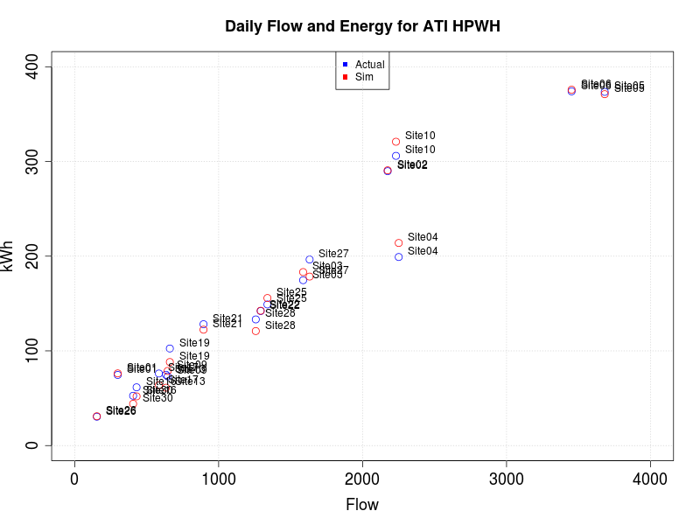

Figure 6, Simulation Calibration Results

Table 1, Simulation Calibration Results

|  |  |  |  |  |  |  |  |  |  |
| --- | --- | --- | --- | --- | --- | --- | --- | --- | --- |
| **Site** | **Location** | **Tamb** | **Gallons** | **Tout** | **ToutSim** | **kWh** | **kWhSim** | **error** | **error%** |
| Site01 | Garage | 50.9 | 299 | 126.0 | 125.9 | 74.6 | 76.2 | 1.6 | 2% |
| Site02 | Garage | 47.6 | 2174 | 122.1 | 122.6 | 289.8 | 290.7 | 1.0 | 0% |
| Site03 | Inside | 62.5 | 1587 | 123.2 | 122.1 | 174.7 | 183.2 | 8.6 | 5% |
| Site04 | Inside | 73.3 | 2251 | 123.1 | 122.8 | 199.1 | 213.9 | 14.8 | 7% |
| Site05 | Inside | 66.2 | 3682 | 124.3 | 123.9 | 373.5 | 371.1 | -2.4 | -1% |
| Site06 | Garage | 55.1 | 3452 | 123.3 | 122.3 | 374.1 | 375.8 | 1.7 | 0% |
| Site09 | Basement | 53.7 | 646 | 131.3 | 129.9 | 73.1 | 78.8 | 5.7 | 8% |
| Site10 | Basement | 49.8 | 2232 | 125.5 | 125.6 | 306.0 | 320.9 | 14.9 | 5% |
| Site13 | Inside | 75.0 | 634 | 123.3 | 121.9 | 74.8 | 61.1 | -13.7 | -18% |
| Site16 | Inside | 55.6 | 430 | 118.5 | 117.5 | 61.5 | 52.0 | -9.6 | -16% |
| Site17 | Garage | 48.0 | 585 | 114.0 | 112.9 | 76.1 | 63.8 | -12.3 | -16% |
| Site19 | Basement | 59.2 | 661 | 125.9 | 124.5 | 102.5 | 88.2 | -14.3 | -14% |
| Site21 | Garage | 53.5 | 895 | 121.9 | 122.5 | 128.2 | 122.4 | -5.8 | -5% |
| Site22 | Garage | 54.9 | 1292 | 118.8 | 119.5 | 142.1 | 142.4 | 0.3 | 0% |
| Site25 | Basement | 56.6 | 1339 | 124.0 | 123.8 | 149.0 | 155.8 | 6.8 | 5% |
| Site26 | Inside | 66.9 | 154 | 120.8 | 118.9 | 30.5 | 31.0 | 0.5 | 2% |
| Site27 | Garage | 55.7 | 1632 | 124.8 | 123.8 | 196.5 | 178.5 | -18.0 | -9% |
| Site28 | Inside | 69.2 | 1258 | 124.3 | 123.6 | 133.2 | 120.9 | -12.3 | -9% |
| Site30 | Inside | 71.9 | 406 | 120.8 | 120.6 | 52.6 | 44.1 | -8.5 | -16% |

The control logic was left virtually unchanged by the calibration exercise, but the COP curves shifted according to . To match field data, the efficiency was pulled down at all temperatures, with the warmer spaces incurring a greater penalty compared to the lab data. This is likely due to the reduced airflow from ducting and dampering interior installs. The graph below references laboratory COP at full fan flow. At 67 degrees, additional COP tests were performed with the 50 gallon ATI at reduced airflow, which are plotted against simulation COP in . It would appear as though the COP penalty, when compared against more applicable reduced airflow cases, is roughly the same across the range of ambient temperatures. [Why do we think the field COP is reduced like this?]

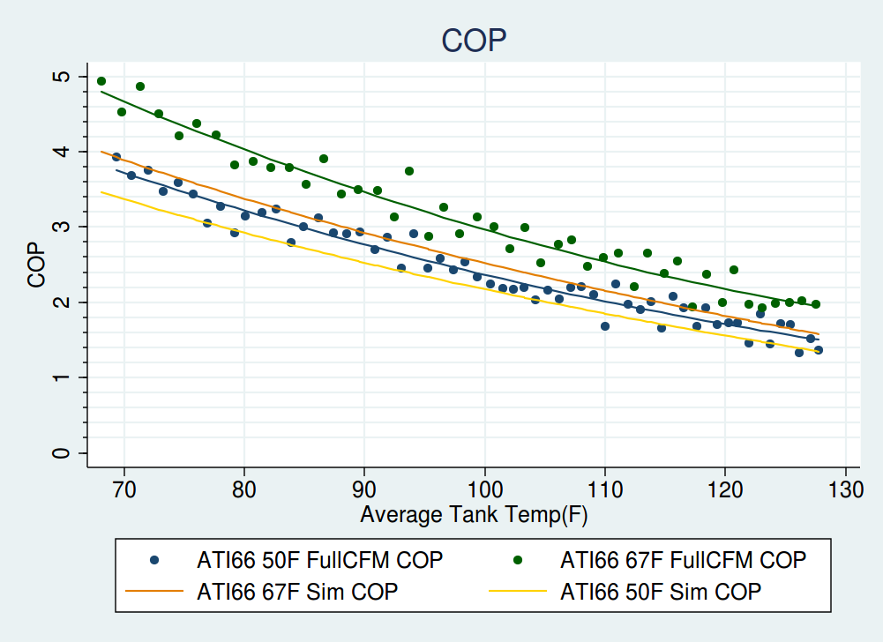

Figure 7, Lab Measured and Field Calibrated COP Curves

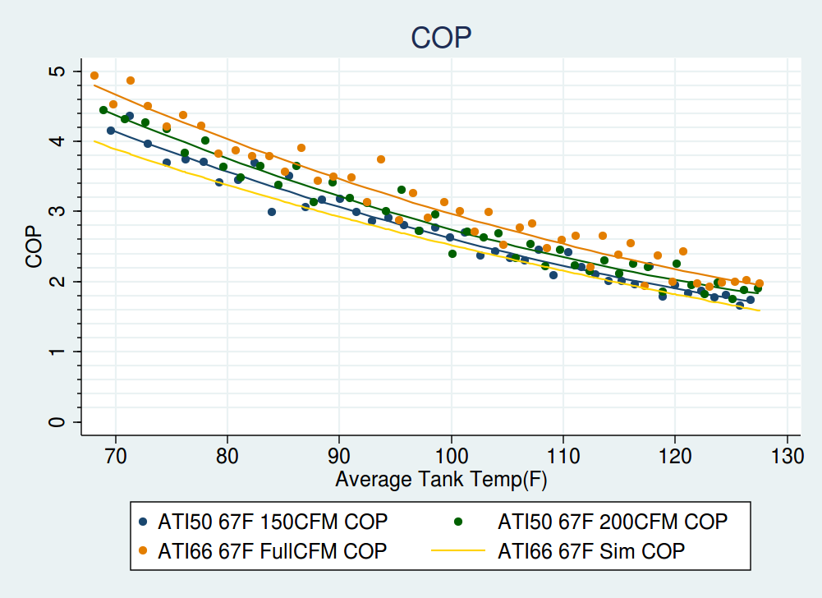

Figure 8, Laboratory COP at different airflows, and Simulated COP

After selecting a set of simulation parameters, detailed graphs were generated comparing all simulation output to measured data. The images show, at times, the simulation as eerily prescient, and at other times shanking it into the weeds. Overall, though, the results appear adequate, and we are confident in the calibrated simulation for the Air Generate ATI66 HPWH.

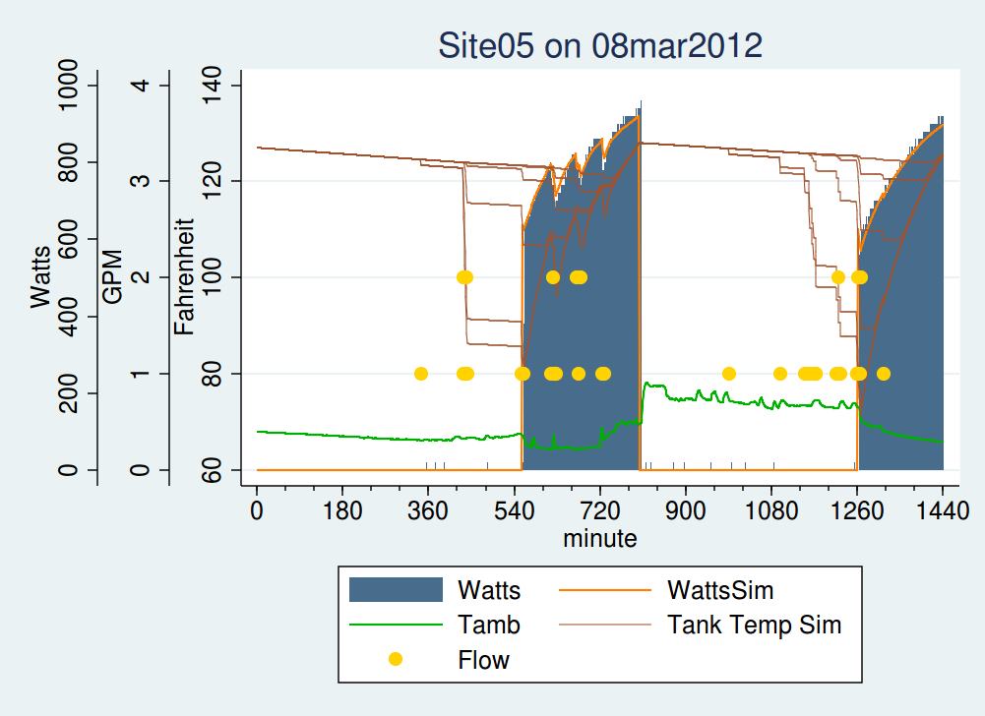

Figure 9, Simulated and Actual Data, an instance of exemplary simulation performance

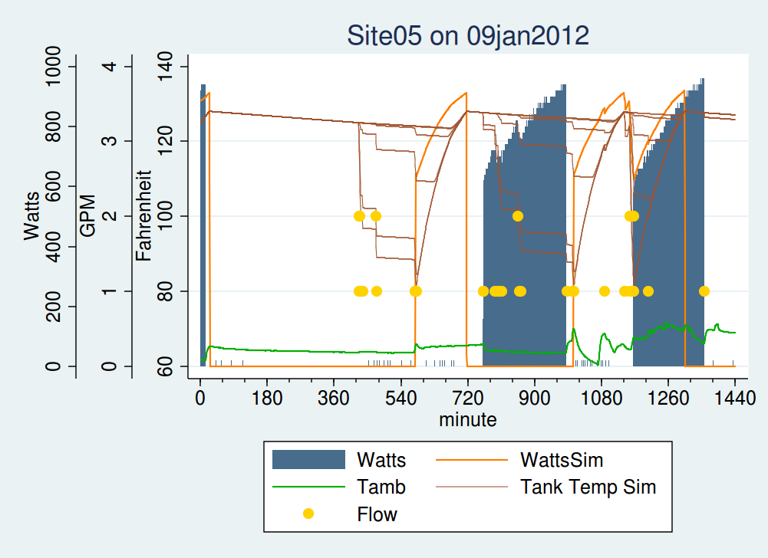

Figure 10, Simulated and Actual Data, an instance of mediocre simulation performance

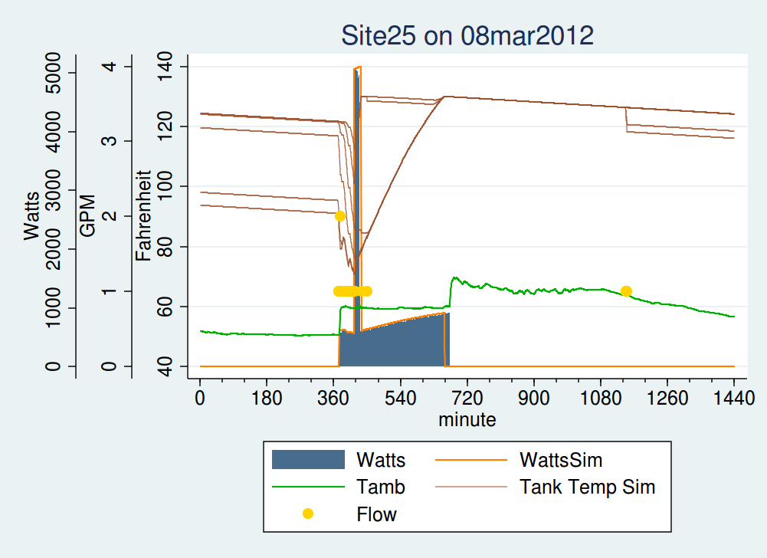

Figure 11, Simulated and Actual Data, an instance of well-matched resistance element operation

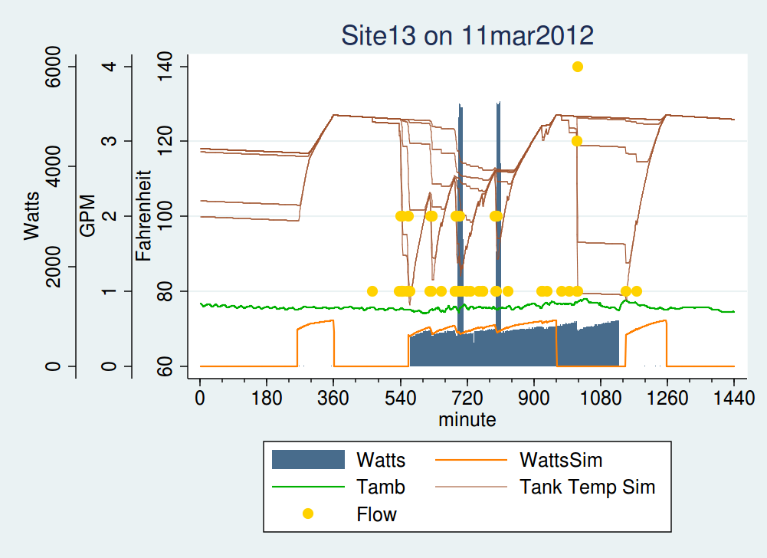

Figure 12, Simulated and Actual Data, an instance of poorly-matched resistance element operation