|  |  |
| --- | --- |
| **HPWH Simulation and Calibration Report** |  |

**April 8, 2015**

revised April 20, 2016

**Prepared by:**

Nicholas Kvaltine

Michael Logsdon

Ben Larson

Ecotope, Inc.

## Motivation

Heat Pump Water Heaters (HPWHs) provide an economical way to substantially reduce the amount of energy used in domestic water heating. From the 2014 Residential Building Stock Assessment Metering Study (RBSA Metering), we have seen that water heating is the second largest use of energy in residences in the Pacific Northwest, after space heating, so the proper application of HPWHs can potentially have a large impact in reducing energy use. To help understand and estimate the amount of energy savings that can be achieved, a HPWH simulation was developed and calibrated.

## Heating Water with Heat Pumps

The most common type of water heater in residential settings is the storage tank water heater. This is essentially an insulated tank of water with a heat source controlled by a thermostat. Traditionally, the source of heat is either an electric resistance element or a gas burner. The efficiency of these traditional water heaters is determined almost exclusively by the efficiency of the heating element/burner in concert with the loss through the insulation. HPWHs, however, are more complex. The efficiency of the compressor-based heat pump system at the heart of a HPWH depends on multiple factors, including the temperature of the air from which it is extracting heat, the temperature of the water which it is heating, and the air flow across its evaporator coils. HPWHs generally also include resistance heating elements for use in adverse conditions, so the control logic for these elements can greatly affect the overall efficiency. Manufacturers address the design challenges in unique ways, as seen in Figure 1. For these reasons, it is necessary to create a simulation that can use all of these parameters and differences to simulate the operation of a HPWH and from that calculate the energy use.

Figure 1. Schematic representation of some possible heating component configurations in HPWHs

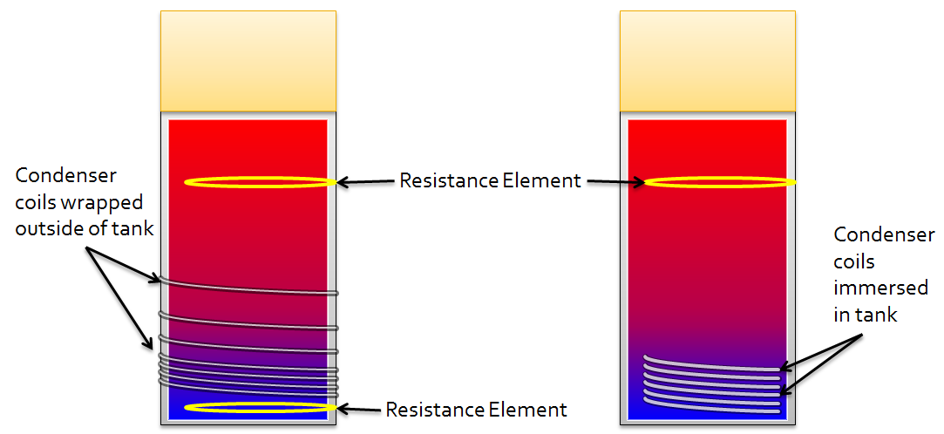

## Lab Measurements

Samples of each of the prominent models of HPWHs that are available to the consumer were acquired and subjected to laboratory testing by Cascade Engineering Services, Inc. The lab tests allow for the measurement of the coefficient of performance (COP) and the input power curves with respect to water and air temperatures, as well as the tank heat loss rate (UA). COP is the ratio of useful energy added to the energy input. Energy input is a straightforward measurement of power consumption, but useful energy added is a less mensurable quantity. To determine useful energy in the lab tests, a thermocouple “tree” – a rod with temperature-sensing thermocouples – was placed vertically in the water heater and reported six temperatures corresponding to six equal volume segments from the top to the bottom of the tank. An average tank temperature was calculated from these temperature readings, and the useful energy added was determined from the change in average tank temperature as heat was added. Even when the tank is mixed, the uncertainty of using six discrete measurements to wholly describe tank temperature distribution, and the natural fluctuations of the heat pump process, result in a high-variance COP measurement. Figure 2 shows an example of the curves measured for the 66 gallon ATI[1] unit. The lab tests also provide an opportunity to investigate the internal logic of the heat pump by observing conditions under which the heat pump engages its heating devices. For example, a common test is to decrease the HPWH's intake air temperature until the unit will no longer use its compressor and must resort to using only resistance heat.

Figure 2. COP and Input Power Curves as Measured in the Lab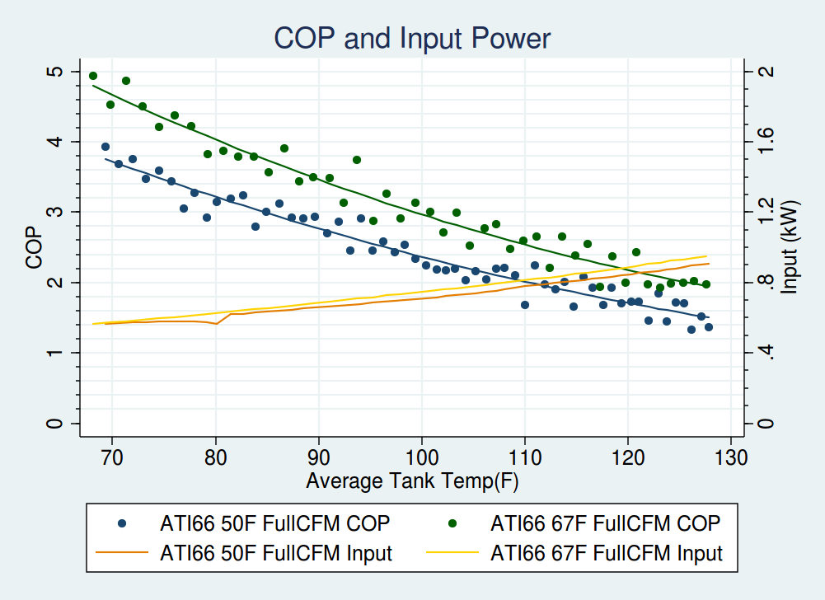

## Measured Data

The lab data provides a substantial amount of information about the operation of each HPWH, however the lab conditions were not developed specifically for the simulation and may not be representative of the performance of the unit in the field. Additionally, to develop a model for the efficiency of HPWHs deployed at large, data was needed to develop regional profiles for air temperature, water temperature, etc. Accordingly, HPWHs were installed and instrumented in over 100 homes across the region. The metered data was collected in three separate studies. The relevant data consists of one minute measurements of ambient air temperature, inlet and outlet water temperature, inlet water flow rate, and total system power, a representative graph of which is shown in Figure 3. The HPWH Validation Study[2] contains more details about the data and its sources.

For most of this data, the flow was reported in 1 gallon increments, so small flow events occur but are not recorded until they total 1 gallon. This is evidenced in the middle of Figure 3 where the inlet and outlet water temperatures spike without an obvious flow. The spikes occur due to the motion of the water in the pipes; as the water stagnates, the temperature comes to equilibrium with the surroundings, and when water is drawn the sensors are flushed with water, resetting the temperature. In one of the studies, the flow measurements were in increments smaller than 1 gallon. Although a bit incongruous, this did not pose any problems for the simulation.

Figure 3. Example Data from a Field-Metered HPWH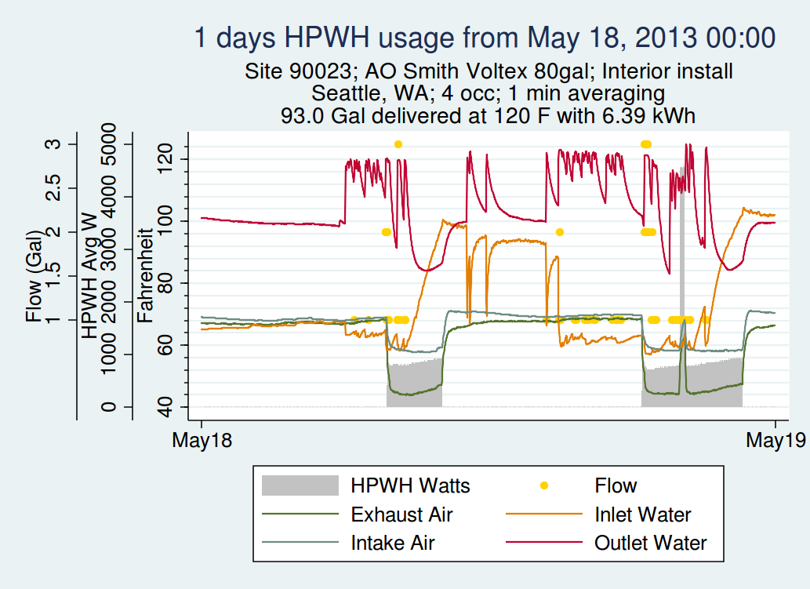

## Simulation

The HPWH simulation takes a hot water set-point, inlet water temperature, and ambient space temperature; it then steps through a draw schedule at one-minute increments, tracking tank temperature and activating heating components accordingly. During each minute, the simulation performs a series of operations:

1. Reduce temperature for standby losses (heat lost to the surroundings). Typically, the DOE Energy Factor test informs the rate of standby loss for each HPWH, which is a function of tank insulation, average tank temperature and ambient space temperature.
2. If a draw is present, shift the water column upward, with hot water exiting from near the top and cold water (at a given inlet temperature) filling the bottom. Update the temperature distribution accordingly.
3. Check the control logic and decide whether to activate or deactivate a heating component based on the updated temperature distribution.
4. If a heating component is activated or remains active, compute COP and input power from curve fits, in which the water temperature variable is set equal to average tank temperature in the bottom third of the tank. This is an estimate for average water temperature “seen” by the condenser. Update temperatures based on calculated capacity and model-specific instructions for distributing the added heat, and record energy input and output.

Each of these steps depends on the distribution of hot water in the tank. As hot water is used and cold water enters in at the bottom of the tank the water becomes stratified by temperature. Calculating the distribution of hot water would require advanced hydrodynamic modelling which would go against the goal of providing a quick and useful simulation. Instead, the water heater is divided into 12 equal-volume nodes, as seen in Figure 4, where each node is assumed to be homogeneous in temperature, and none of the nodes transfer heat from one to another.

Figure 4. System of Nodes for Simulating a Hot Water Tank

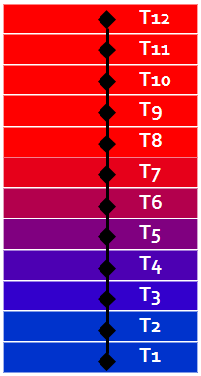

With this in mind, the following section expounds upon the four steps previously listed, describing them in more detail, and with the nodal approximation in mind.

1) The standby losses are computed by finding the average temperature of the entire tank and determining how much heat will be lost by using the measured heat loss rate from lab testing. This heat loss is then divided and applied equally to all 12 nodes. When running in SEEM, this heat loss is then applied as an internal gain to the house.

2) Since the simulation occurs on a per-minute basis, the gallons per minute flow rate of the draw becomes gallons. Typical draws are from 1-3 gallons, whereas the volume of a node is generally around 4-6 gallons, so in most steps only a partial node will be drawn. When this occurs, the draw volume is removed from the top node, and that volume of water is moved from each lower node upward one node, adjusting the temperature of each node accordingly. For the last node, the water is brought in at the inlet temperature, which is given as an input to the simulation. Then, to account for tank mixing that occurs when inlet water fills the tank, the temperature of each node of the bottom third of the tank is adjusted slightly to bring each node in the bottom closer in temperature to one another. Specifically, the simulation calculates the average temperature in the bottom third. Next, using that average, it adds 1/3 of the temperature difference between average temperature and the individual node to that node.

3) The control logic depends on the average temperature of the top third of the tank, the average temperature in the bottom third of the tank, the temperature of the top node, and whether or not any heating element is currently running. Each model has a slightly different logic process, but they are similar enough to be controlled by four variables: "comp_start", "res_start", "standby_thres", and "cutoffTempHysteresis". “comp_start” sets the amount below the HPWH's temperature setpoint the bottom third of the tank must be before the compressor turns on. “res_start” sets the amount below setpoint the top third of the tank must be before the upper resistance element turns on. “standby_thres” sets the amount below setpoint the top node must drop before the compressor turns on, when no element is currently running. “cutoffTempHysteresis” sets the spread in temperatures for when the HPWH switches from compressor to resistance and vice versa due to cold ambient conditions. The actual temperature at which this switch occurs was measured in the lab and is fixed in the simulation.

4) The COP for the current step is determined, as is the input power, by the ambient air temperature and the water temperature. The heat is then applied to the tank, but is spread among the nodes in a particular way. For a resistive heating element, the coldest node above the element is heated until it matches the next coldest, then those both are heated until they match the next, and so on, until the whole tank is heated. When the compressor is providing heat, the procedure is different. Heat is supplied to a number of different nodes at once. The distribution and how it was determined is reviewed below.

If properly specified, the previously discussed processes are all that's required to run an accurate HPWH simulation. However, there were some difficulties to this approach. The first was development of stable and easily adjustable COP curve fits. The original approach was to fit a single master equation from all of the lab data for any given HPWH unit. The master equation would report COP as a function of water temperature, air temperature, and humidity. The problems with this approach revealed themselves as twofold. First, it is only useful or applicable for units in which we possess an abundance of lab data at many different water temperatures, air temperatures, and humidity. Second, it is difficult to shift such an equation to better match observed field performance. With these concerns in mind, we developed a much simpler approach, in which twin curves for COP are calculated as a function only of water temperature: one curve at 50°F and one at 67°F air temperature. COP at a given arbitrary air temperature is calculated linearly between the corresponding values at 50°F and 67°F. Further, the COP is extrapolated linearly beyond this range. Field data to date shows that most HPWH usage in the Northwest should occur in or near the 40°F to 80°F temperature range, in which the behavior of COP with respect to air temperature is approximately linear. Figure 5 shows measurements for COP curves at three different air temperatures. The even spacing between the curves, of nearly evenly spaced air temperature regimes, reinforces the decision to linearly interpolate between air temperatures.

Figure 5. Laboratory COP Measurements for ATI66 HPWH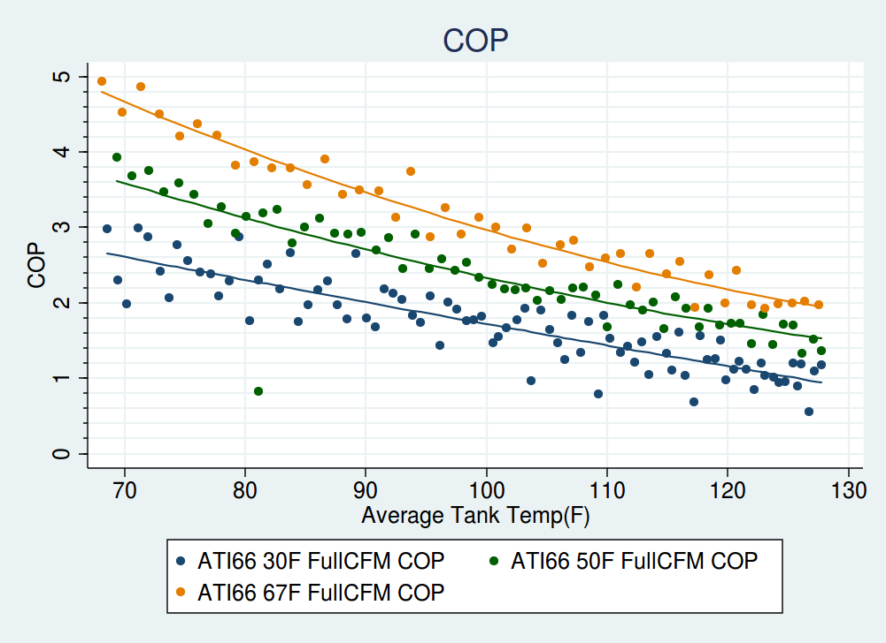

The second difficulty encountered was extrapolating input power and COP behavior – that was measured during lab testing in a tank of uniform temperature – to the behavior of a stratified tank with some amount of mixing. The input power and COP are determined by water temperature adjacent to the condenser, and this quantity is often elusive. In the controlled COP tests, where the tank temperature was constant throughout, the water temperature adjacent to the condenser was simply the temperature everywhere in the tank. During actual operation, however, there is typically a range of temperatures, varying with height. A perfect simulation would somehow integrate over heat exchanger area and stratified temperature to compute a distribution of added heat. An approach of this complexity, however, is not guaranteed to provide any better results due to the stochasticity of water mixing. We selected a simpler approach, in which an equation, where the parameters were fit visually, distributes heat in such a way as to match simulation patterns to measured patterns. The distribution of applied heat is determined by Equation 1.

Equation 1. Distributing Added Heat

where the variables are:

c(n) - the fraction of total heat added going in to node *n, where n=1-12*

Tn - temperature of a node (°F)

T1 - bottom node temperature (°F)

Tset - tank setpoint (°F)

ofst - an offset term, giving the approximate node where the change of heat distribution with

respect to node number is the highest – chosen to be 5

and the tunable parameters varying based on HPWH equipment are:

s - “shrinkage” – perceived distance between lower and upper tank

p - “shape” – modifies concavity with which Tn approach setpoint

The shrinkage and shape parameters are estimated based on the lab performance of the HPWH under consideration. Since they are only observable by having multiple temperature probes spaced within the tank, this measurement is only done in the lab, not in the field. Figure 6 shows how the distribution of heat changes when the “shrinkage” parameter is varied. Larger values tend to increase the amount of heat delivered to water that is warmer, while smaller values tend to keep heat distribution limited to the coldest parts of the tank. The “shape” parameter also serves to distribute heat to colder parts of the tank, but the effect is more subtle and so a graph is not given.

Figure 6. Distribution of Heat with Varying Shrinkage Parameter 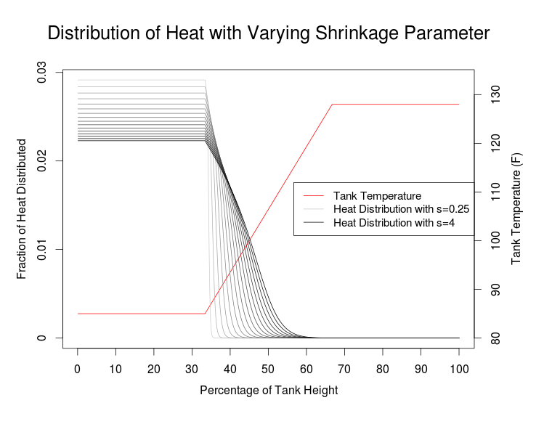

To illustrate the effect of this distribution, Figure 7 and Figure 8 below display real data and simulated data respectively for the Air Generate ATI66 DOE energy factor test. The thin lavender lines represent thermocouple temperatures at equal volume segments, ascending the tank. Notice that the shape of the thermocouple lines during recovery in the simulation qualitatively resembles the corresponding lines in the measured data.

Figure 7. DOE Energy Factor Test for ATI66rev2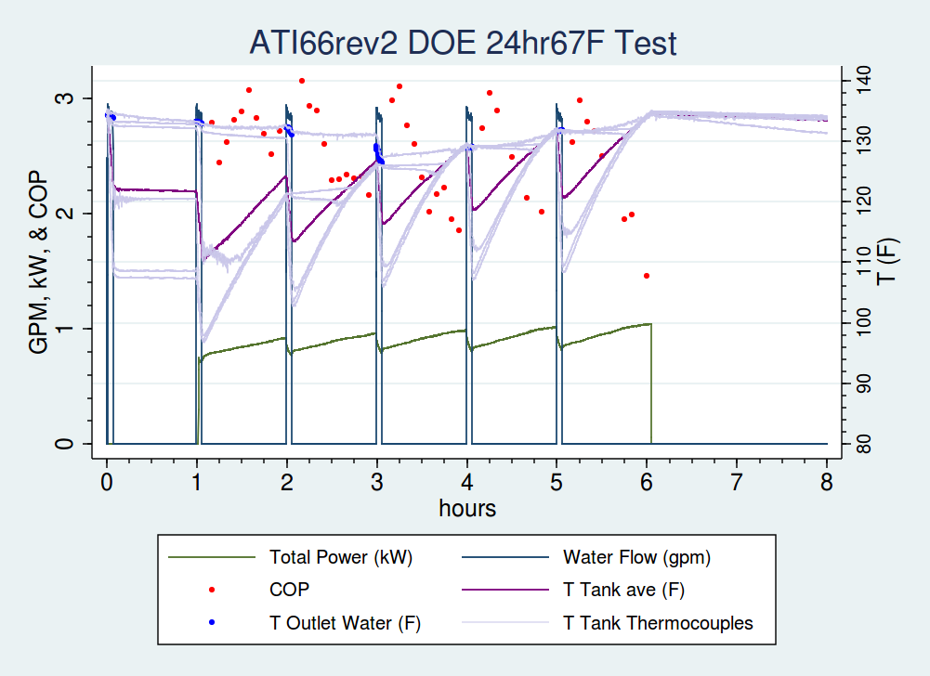

Figure 8. Simulated DOE Energy Factor Test for ATI66rev2

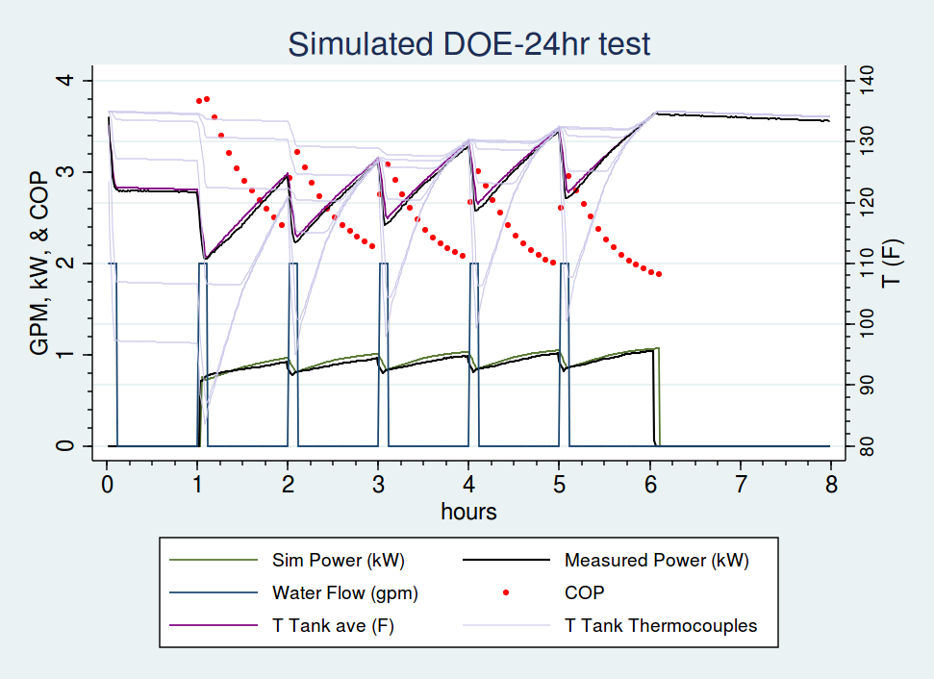

Figure 9 and Figure 10 below show the same test (run at 50°F ambient temperature) for a different HPWH, the AO Smith Voltex 60. Due to differing condenser shape[3] and refrigerant type, the Voltex heat pump distributes added heat differently than the ATI, which leads to a different pattern in the thermocouple lines.

Figure 9. Energy Factor at 50F Ambient Air Test for AO Smith Voltex 60 Gallon Tank

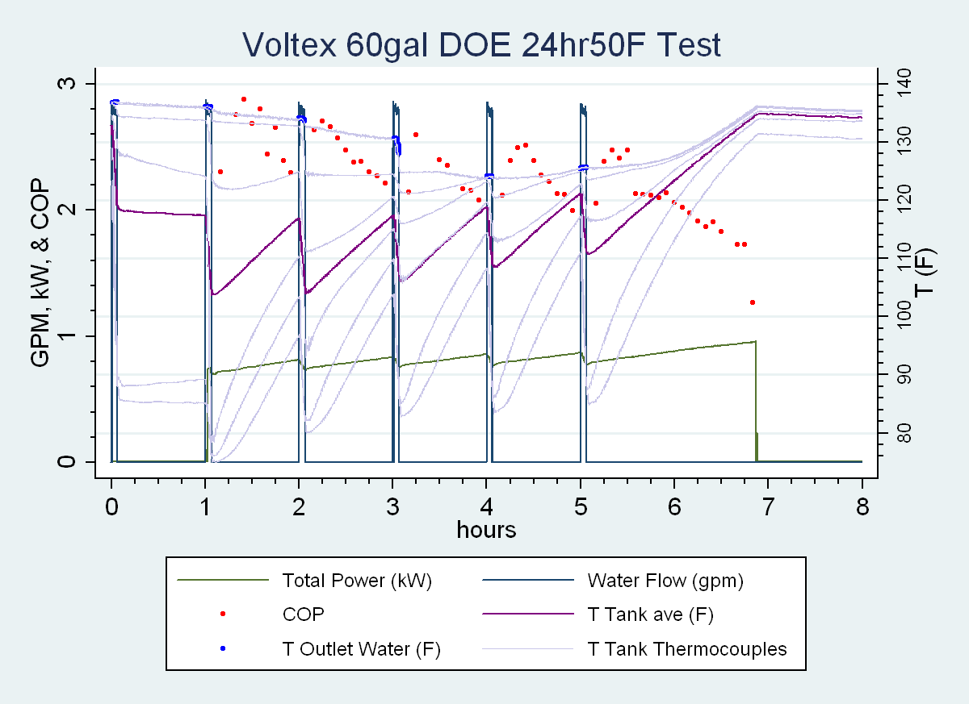

Figure 10. Simulated Energy Factor at 50F Ambient Air Test for AO Smith Voltex 60 Gallon Tank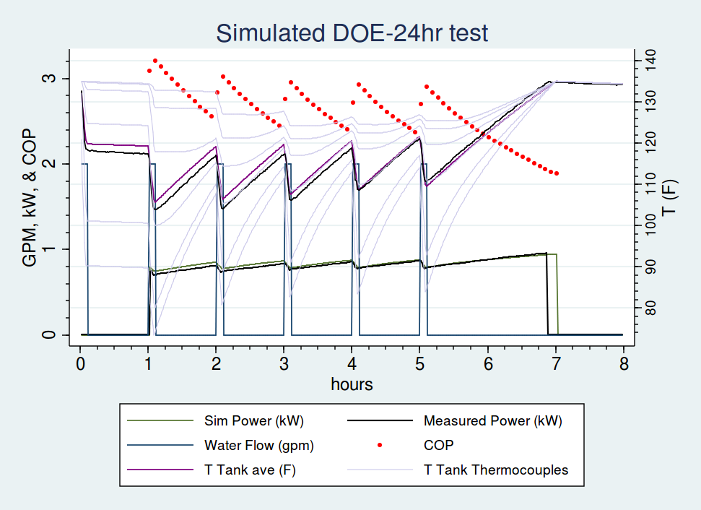

# Simulation Calibration

Writing a simulation inspired by laboratory data is a good starting point, but it is desirable to compare against units operating in the field, which may or may not be the same. Varying installation practices, nuances between individual units, or the disorder of actual scenarios as opposed to tightly controlled laboratory ones may introduce discrepancy between lab results and field results. As such, a calibration was performed using field data to determine if the simulation accurately reflects the performance of installed units.

With any deterministic simulation that will be calibrated to field data, it is important to leave a few degrees of freedom in the model. Best practices dictate that the most uncertain parameters be allowed to float during simulation calibration. In the water heater simulation, COP was the most difficult quantity to pin down due to uncertainty in the measuring process and the response of the COP to tank mixing and stratified tank temperatures. Additionally, the control logic parameters are difficult to measure in the lab, since neither the actual position of the HPWH's sensors nor how the unit interprets these measurements is known.

The parameter space was explored and appraised through a Markov Chain Monte Carlo (MCMC) random walk, where, for each site, the simulation output was defined as a two-dimensional random variable, with total energy use and fraction of synchronous run time as the outputs. An MCMC random walk is a method of sampling from an unknown distribution by performing a somewhat constrained random walk. In this case, the distribution is likelihood against simulation parameters. The Markov Chain spends time in each region of parameter space proportional to the probability density of that region, so after running the chain for several days, the parameter sets occurring most frequently are those with highest likelihood, given the model.

The error term for the energy use – the difference between the sum of measured energy input and simulated energy input – was said to be normally distributed, with mean zero and standard deviation five (out of ~50-300 kWh of measured input energy). The standard deviation was taken as fixed and not proportional to the magnitude of the measured usage, which lent preference to matching usage at sites with more HPWH usage (kWh). This is actually desirable, as the small-sample-size set of sites with little usage could exert undue leverage on the results, and using a fixed standard deviation allows those sites a greater “quota of randomness”. Basically, this approach tolerates a larger error percentage for sites with smaller magnitude of usage, and a smaller error percentage for sites with larger magnitude of usage.

The second dimension of the output, the fraction of simulated on-time that corresponded to observed on-time, was chosen because we desire not only equivalent input energy but also a model in which the simulated water heater runs during the same times as the real water heater. This is necessary to accurately model interactions with the space heat and/or ventilation system. As such, the fraction of matching on-time was said to be beta distributed with shape parameter alpha equal to five and shape parameter beta equal to one fifth. Basically, this means that the matching on-time fraction is between zero and one, and it should be closer to one than to zero.

This methodology was applied to a subset of the sites. For purposes of simulation calibration, it is imperative to use the highest-quality data. Of the 30 ATI sites from one study, we declared 19 sufficiently lacking in erroneous sensor channels and atypical water heater behavior to proceed (for example, several units were malfunctioning and received service: we do not want to calibrate to broken water heaters). This quantity is adequate for this exercise. For the varied sites from the other two studies, 35 sites were used for calibration out of about 60 total. Not all of these sites functioned improperly; 21 were reserved to use as a “test set” in order to determine if the calibration was increasing the fit for sites which were not specifically in the calibration set.

## Calibration Results

The calibrated simulation performed well in excess of expectations. Figure 11 through Figure 14 show examples of simulated power and temperature plotted along with measured power and various measured variables. Both good and bad fits are depicted.

Figure 11. Measured and Modeled Data – Exemplary Simulation Performance

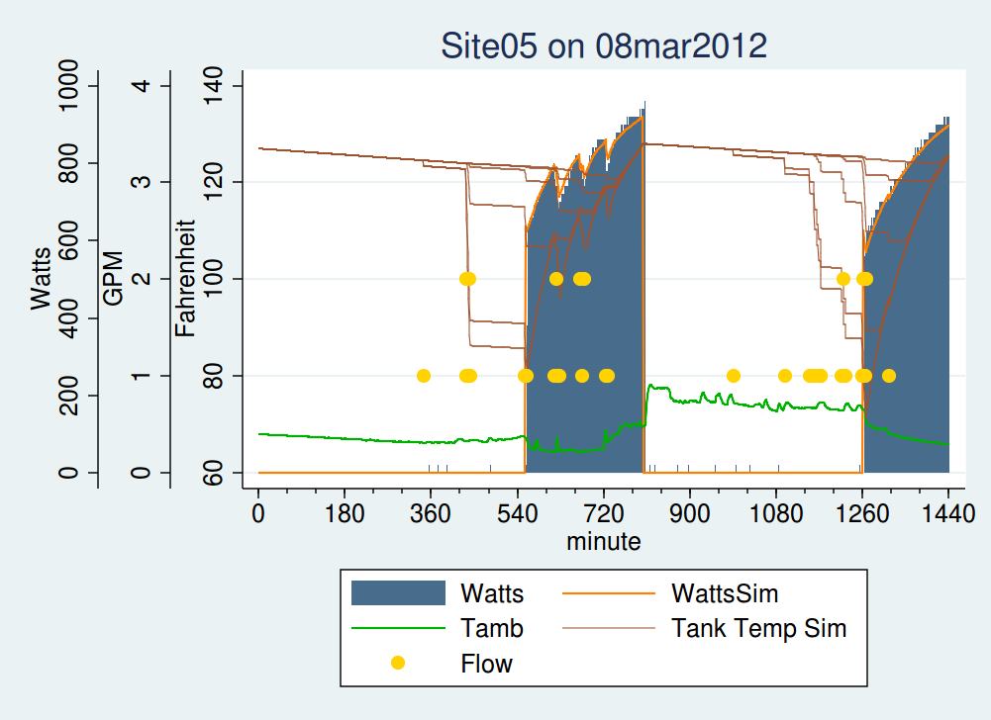

Figure 12. Measured and Modeled – Mediocre Simulation Performance

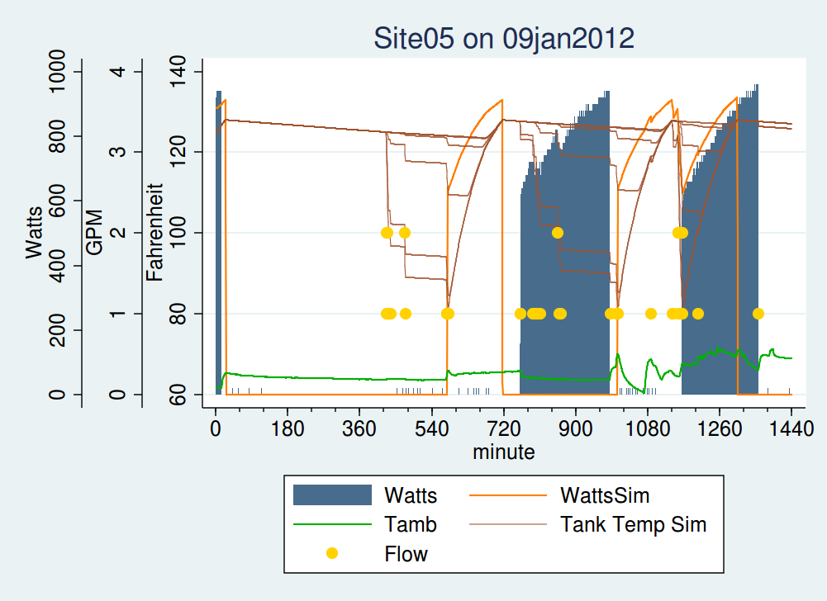

Figure 13. Measured and Modeled Data – Matched Resistance Element Operation

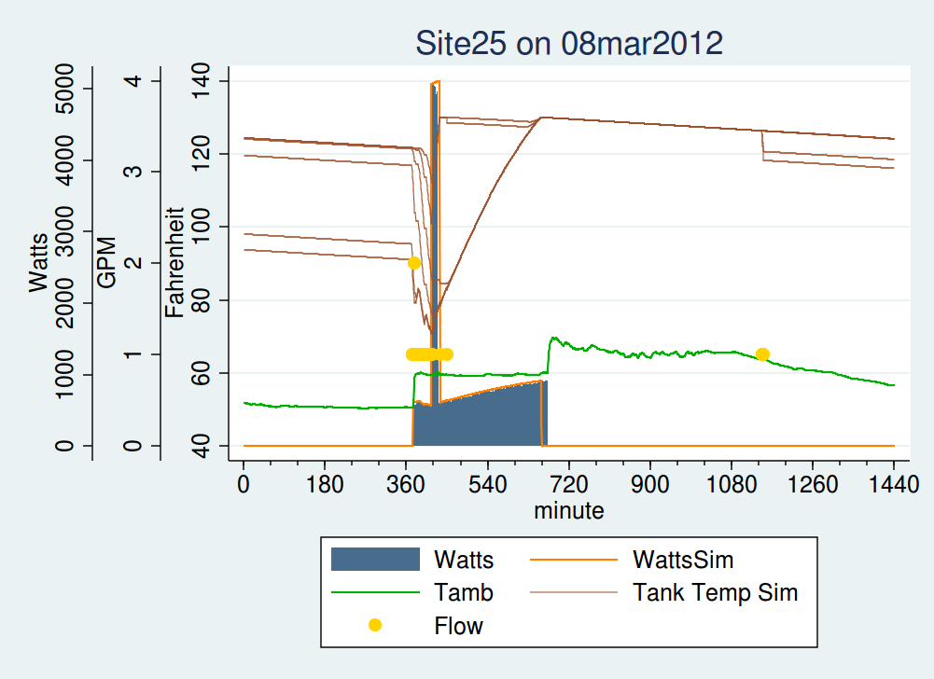

Figure 14. Measured and Modeled Data – Poorly Matched Resistance Element Operation

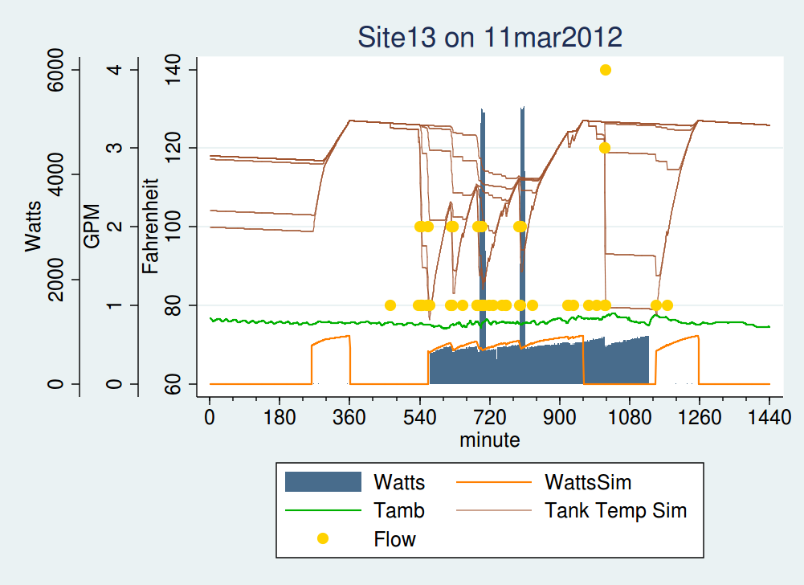

The calibration procedure adjusted the COP differently for each model of HPWH. As seen in Figure , the Voltex curves both raised slightly, the ATI curves both dropped, in different amounts, and the GE curves each changed differently.

Figure 16. Lab-Measured and Field-Calibrated COP Curves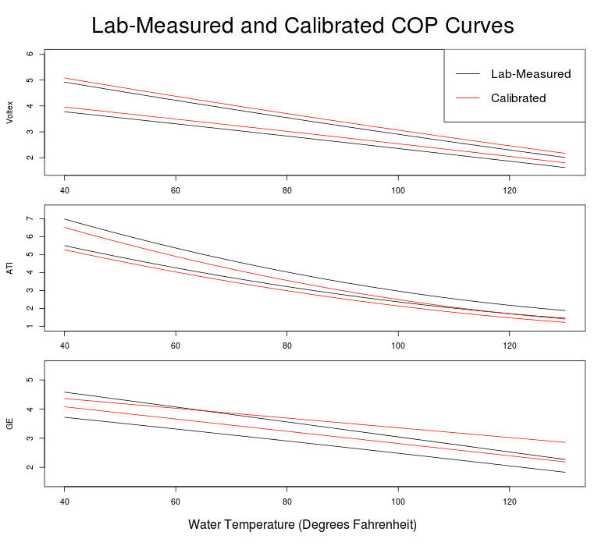

A table of averaged results is presented in Table 1. The average energy used was quite close in most cases. The percentage of run time that the simulation matched the measured data was also high. On average. At least 70 percent of the run time matched for all models.

Table 1. Simulation Output Summary Comparison

|  |  |  |  |  |  |  |  |
| --- | --- | --- | --- | --- | --- | --- | --- |
| **Unit** | **No. of Sites** | **Average Type** | **Actual kWh** | **Simulated  KWh** | **Error (kWh)** | **Error (%)** | **Frac Matching** |
| **GE** | 16 | Simple | 132 | 131 | -1 | -1% | 0.70 |
| Flow Weighted | 148 | 150 | 2 | 1% | 0.71 |
| **Voltex 60** | 14 | Simple | 103 | 103 | 0 | 0% | 0.73 |
| Flow Weighted | 122 | 123 | 1 | 1% | 0.76 |
| **Voltex 80** | 8 | Simple | 159 | 143 | -16 | -10% | 0.82 |
| Flow Weighted | 187 | 159 | -28 | -15% | 0.85 |
| **ATI66** | 19 | Simple | 159 | 156 | -2 | -1% | 0.69 |
| Flow Weighted | 233 | 234 | 0 | 0% | 0.75 |

An alternate way of visualizing the results is presented in Figure 17. This plot shows measured kWh on the x-axis and simulated kWh on the y. The line y=x is plotted for comparison, since all the points would lie along this line if the simulation matched the measured data exactly. As can be easily seen, the energy use predicted by the simulation is similar to the measured energy use throughout the range of observed usages. The separate HPWH models are shown in different colors, but no particular model-based discrepancies are observed.

Figure 17. Modeled vs Measured Monthly Energy Use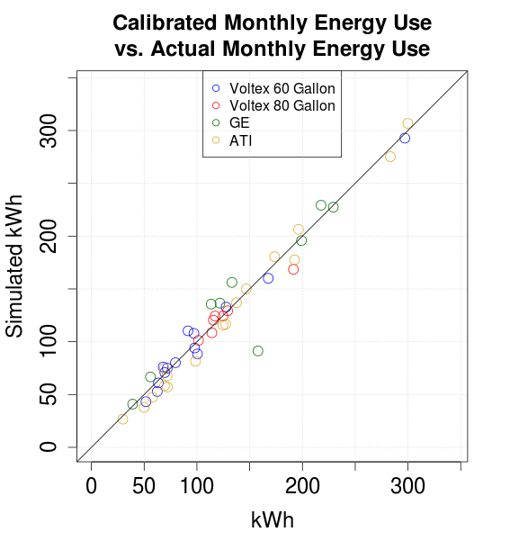

Figure 18 shows a similar graph as Figure 17, except that all of the calibration set is shown in red, independent of model. The test set, a portion of HPWH observations that was not used for calibration, was run using the calibrated variables. The simulated data appear to match closely with the measured data. There appears to be more spread, however this is to be expected since this data was not used in the calibration.

Figure . Predicted vs Measured Energy Use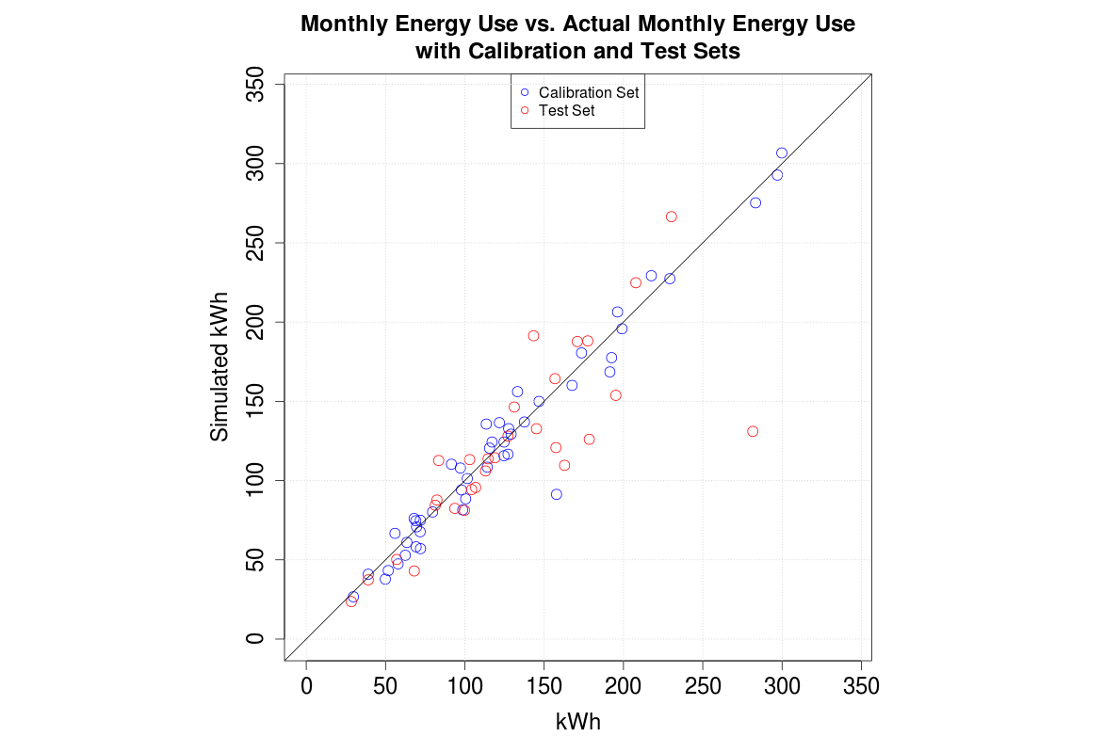

Overall, the simulation does an excellent job predicting the workings of a HPWH given the ambient conditions and draws. The excellent matching of the test set implies that this would be a useful simulation for predicting the energy usage for other sites in the future. The various approximations, including the nodal tank model and the linear COP curves provide enough accuracy and simplify the simulation enough to allow useful results to be obtained in a minimal amount of time.

## References

**RBSA Metering Study** <https://neea.org/docs/default-source/reports/residential-building-stock-assessment--metering-study.pdf>

**HPWH Validation Study** <https://neea.org/docs/default-source/reports/heat-pump-water-heater-saving-validation-study.pdf>

**Multiple Lab Test Reports, including:**

Larson, B., and Logsdon, M. 2012. Laboratory Assessment of General Electric GeoSpring Hybrid Heat Pump Water Heater. Prepared for the Northwest Energy Efficiency Alliance. Retrieved from <https://conduitnw.org/_layouts/Conduit/FileHandler.ashx?RID=1183>.

Larson, B., and Logsdon, M. February 2012. Laboratory Assessment of AO Smith Voltex Hybrid Heat Pump Water Heater. Prepared for the Northwest Energy Efficiency Alliance. Retrieved from: <https://conduitnw.org/_layouts/Conduit/FileHandler.ashx?RID=888>

1. ATI66 from AirGenerate. Equipment evaluated in 2011.
2. <https://neea.org/docs/default-source/reports/heat-pump-water-heater-saving-validation-study.pdf>
3. The Voltex has refrigerant coils wrapped around the outside of the tank whereas the ATI has the heat exchanger submersed inside the tank. Examination of the Voltex tank heating suggests heat is added mostly at the bottom of the tank but is also added at higher points in the tank. In contrast, the ATI tank essentially exchanges all heat near the bottom of the tank.