|  |  |
| --- | --- |
| **HPWHsim: Update to the Calibration Report** |  |

**April 26, 2016**

**Prepared by:**

Nicholas Kvaltine

Michael Logsdon

Ben Larson

Ecotope, Inc.

**Motivation**

The previous HPWH simulation was updated in late 2015/early 20161 based on the current simulation needs and Ecotope’s evolving perspective on heat pump water heating. Due to the changes in several key processes within the simulation, including the shift to a condensity-based framework[1] for heat addition, it was decided that a recalibration of the parameters for existing models of HPWH was necessary. Since the majority of the calibration process is similar to that performed previously, this memo will only summarize the similarities and explain the differences between the previous procedure and the most recent one.

**Similarities**

First and foremost, the essential aspects of the simulation didn’t change. The COP and Input Power are still represented as quadratic curves with respect to water temperature, and still assumed to vary linearly with respect to evaporator temperature. Although evaporator temperature is now specified separately, this is irrelevant for calibrations since ambient and evaporator temperature are the same. The decisions used to turn on or off certain heating elements can still be the same. The greater flexibility of HPWHsim allows new logical choices to be tested, but if desired, the previous choices can be mirrored exactly.

Second, no new field data were collected. Laboratory measurements for existing HPWH models were not repeated either. However, lab data for new models of HPWH have been added, sometimes with a different set of lab tests. The original suite of lab tests has not changed, but an additional DOE standard was rolled out in 2015, so some models have a set of tests that include the new 24 hour test. The process for using the lab results is the same as before, despite there being a few additional units with some new tests.

**Differences**

Originally, heat being added to the water in the tank was distributed using an equation that took two parameters to specify – a “shrinkage” and a “shape” parameter. These were adjusted to visually match the way that thermocouples in the lab tests respond to added heat. Different values of these parameters were needed for submerged or wrapped condenser topologies. HPWHsim has done away with this, and uses instead an indicator for submerged or wrapped topology along with the condensity2. The condenser topology should be known from the HPWH specifications, although the difference in heating behavior is obvious enough to be inferred from thermocouple measurements during lab tests. The condensity is conceptually clearer, which aids with the specification of this parameter. Typically there is some knowledge about the physical extent of the condensing coil, which is combined with observation of tank heating behavior from lab tests to come up with a condensity. The condensity specification is not intended as a precise description; typical condensities are spread equally over a subset of nodes, or include a small portion of lesser condensity near the bottom or top of the subset.

The effectiveness of the condensity values and, indeed, the effectiveness of the entire simulation is assessed via visual comparison to the lab measured data. The more lab measurements available, the more certainty arises from the comparison. For this assessment, any number of lab tests can be used. Typically, the standard DOE tests are available. Ecotope wrote a tool to demonstrate the effectiveness of the simulation. It is available here: <https://ecotope.shinyapps.io/HpwhTestTool/>. There are too many tests and HPWH types to be described here so the reader is encouraged to explore all the possibilities on that website.

A different method was used for calibrating against field data, for the models which had field data. The previous calibration allowed for COP curve parameters as well as logic cutoff parameters to vary, and the parameter space was explored with a Markov Chain Monte Carlo technique. Due to increased confidence in the COP and Input Power curve specifications, these were kept fixed in the current calibration and the logic cutoffs for resistance usage were allowed to vary. Instead of a MCMC, the new procedure iterated over each cutoff parameter, holding all other parameters constant. Each cutoff parameter was optimized by comparing the usage to field measurements. The shift to condensity-based heat distribution necessitated an update to these models, as the previous specifications could not be translated exactly to the new framework. The resulting breakdown of energy usage by heat source for the GE GeoSpring is shown in Figure 1.

Figure 1. Simulated Energy Use vs. Field Measured Energy Use, plotted for compressor, resistance elements and the total. Data is from a calibrated model. The dashed line represents perfect prediction, solid lines are regressions to simulated data.

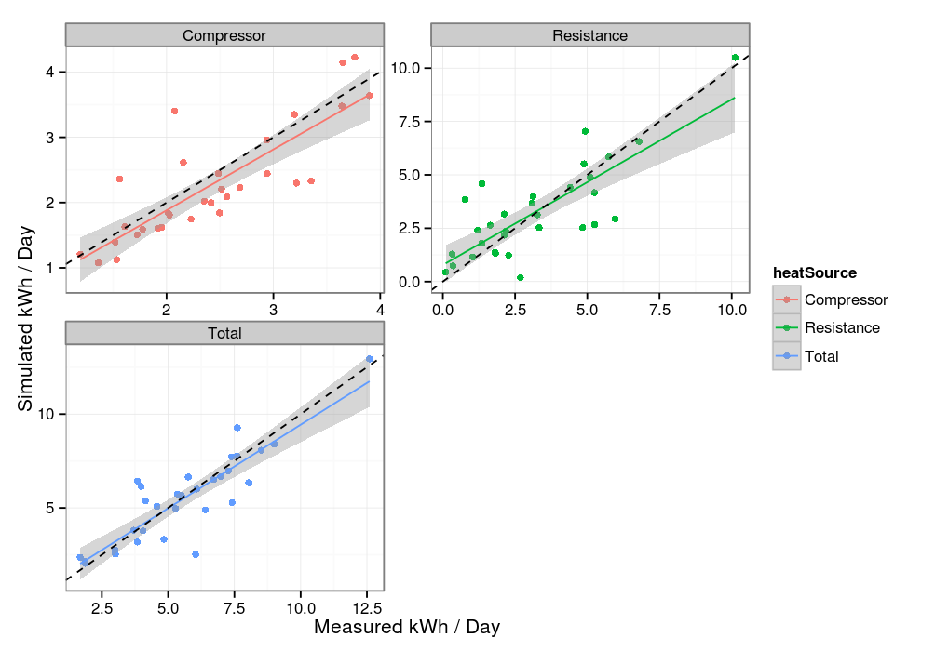

Unlike the previous calibration, the fraction of simulated on-time that corresponded to actual on-time was not used as a measure of fitness. This measure proved to be too variable and not useful enough to justify the added complexity.

1. HPWHsim Guide