# Prospect-R Site and Administration Guide

## Site Administration

### Accessing the Admin Site

### Authentication and Authorization

### Flatblocks

### Survey

### Survey – Questions

### Survey – Bif Settings

### Survey – Pit Score Weights

### Order: Context, Category, Question

### Flatblocks: In Depth

## Site Administration

### Accessing the Admin Site

If you log in to the tool with an account that has administrator priveleges, there is one immediate difference: 'SITE ADMINISTRATION' is now an option in your user menu in the nav bar at the top of the screen.

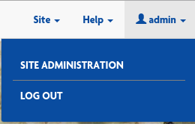

If you believe you are or should be an administrator and you do not see 'SITE ADMINISTRATION in your user menu, contact someone you know who IS an administrator and get your permissions updated. The process to do this is explained in the next section.

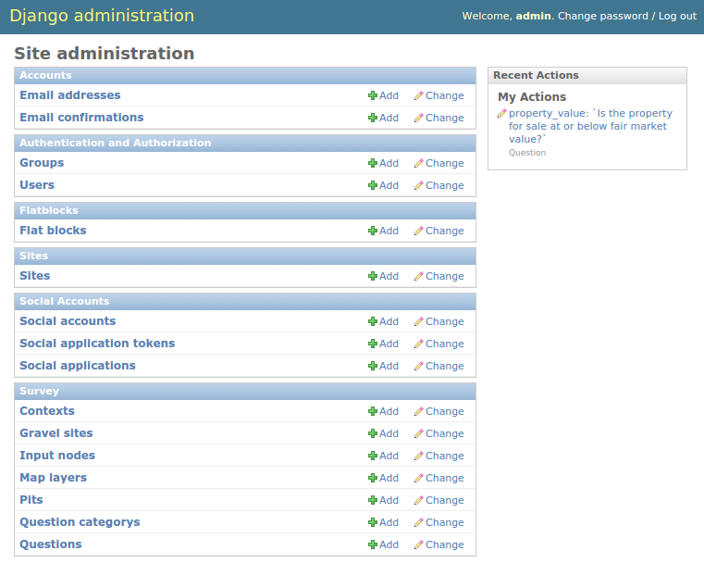

The admin page is where administrators exercise control over the user experience. From this menu they can perform many of the common tasks that this site requires including:

* Creating/deleting accounts (Superusers Only)
* Changing user passwords (Superusers Only)
* Updating webpage content
* Change a user's email address

As seen in the screenshot, administration is organized into 'modules' (the box headers with blue backgrounds) from which you can access the forms you'll need (the blue links with white backgrounds inside each box).

There are three modules that will be of importance while maintaining this site ( only two for non-superusers ) and they each have a section below - the rest should be ignored unless you absolutely know what you're doing.

### Authentication and Authorization

*SUPERUSERS ONLY*

Superusers will have the right to create, edit, and delete user accounts.

Adding an account:

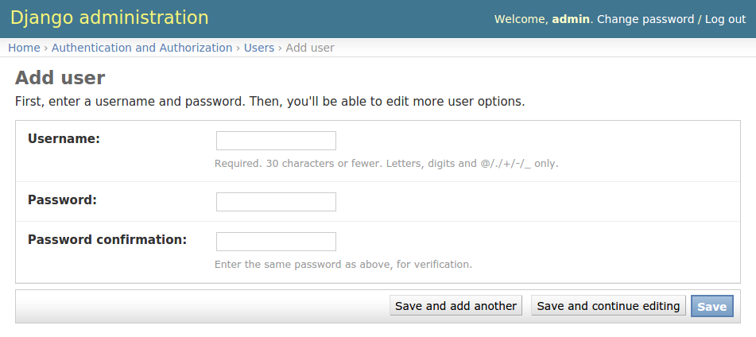

To create a new account, the bare minimum is to give a username and a password. This scenario is unlikely, as anyone can create their own account via the registration process. It is more likely that you are here because you want to create a new Site Admin or Superuser account. Once you've completed this form, click 'Save' to move on the the next steps.

You will now be taken to the 'Edit User' form, which is much more exhaustive. In the first box, you can update the **user's name or password.**

In the second box, you can enter detailed information about the user including **First Name, Last Name, and Email address.** Again, email address is important if the person forgets their password, they can use the site's 'Reset Password' functionality to verify themselves via email.

The permissions form, the third form, is where things start taking a bit more thought. The first three items on the form are checkboxes to assign the new user's privileges:

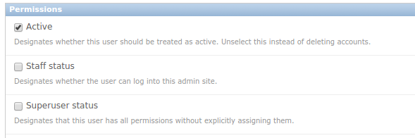

The 'Active' option is selected by default - it is useful in some projects to deactivate users rather than delete their account if you want to maintain information about how many people ever registered, etc...

The 'Staff status' checkbox indicates that a user will have access to the admin pages. If you are NOT checking this box then be sure you have a good reason - non-admins should use the site to register if at all possible.

The 'Superuser status' box indicates whether there should be any restrictions on a user's permissions. Superusers can add/delete/change any form in any module on the admin site with one exception: **IF A SUPERUSER IS NOT ALSO GIVEN STAFF STATUS, THEY CANNOT LOG IN TO THE ADMIN TOOL.** I know that sounds weird, and it is weird, but it's a good thing to know.

You may be noticing a trend: not all users are created are create equal. General public only have permissions to add sites, pits, and answers through the website, and only to their own account. Site Administrators can change some text, but still can't do all of the things a Superuser can. These predefined sets of permissions are called 'Groups':

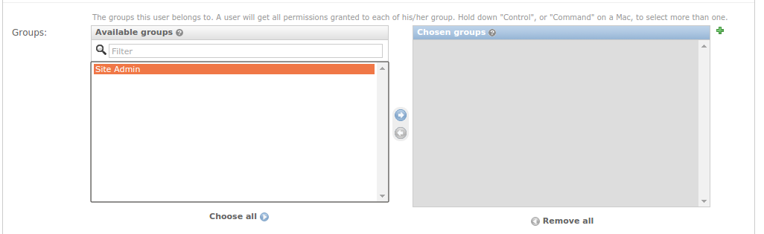

There is no 'Public' group - their permissions are the lowest available. There is not 'Superuser' listed in this form - if the 'Superuser status' checkbox is filled in above, this step and all other parts of the form (except 'Save') are irrelevant. This leaves only the 'Site Admin' group.

To create a 'Site Admin' group member, click on 'Site Admin' in the 'Available groups' box to highlight it like shown above. At this point the 'Right Arrow' button between the two boxes will turn blue. Clicking on the 'Right Arrow' will move the 'Site Admin' group from the 'Available Groups' box over to the 'Chosen groups' box. Once you save this form, that user will have all the rights and privileges of a Site Admin.

Removing group permissions works the same way only with the 'Left Arrow'. You can also choose to use the 'Choose all' or 'Remove all' buttons below.

The green '+' icon at the upper-right corner of the 'Chosen groups' box allows you to define a new group type. This will require some knowledge about specific permissions, which is covered briefly below.

It is possible you will want more control over which permissions a user gets, and if this user's situation is unique (as in, the same exact permissions will not likely be granted other users in the future which would necessitate a new Group) then you can toggle their permissions in the 'User permissions' section:

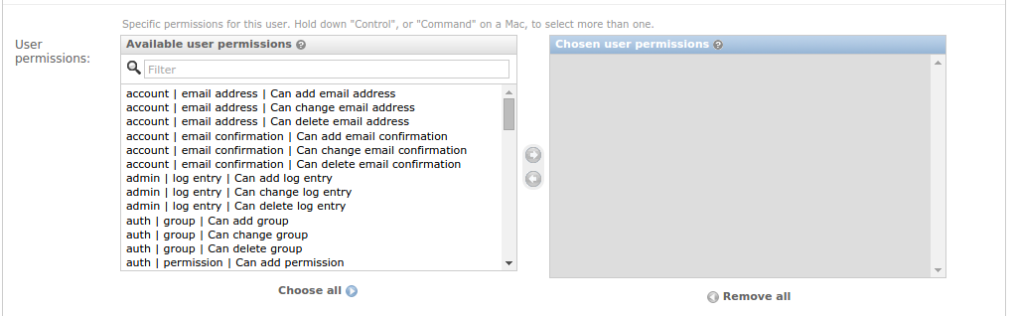

The mechanics for using this form are the same as the groups panel, but there are many, many more options. There is an option for every module, for every form in that module, and an add, a change, and a delete privilege for each of those forms.

For example, suppose you have a user that you want to be able to change flatblocks (described in detail below) but do not want them to have other normal Site Admin permissions like changing contexts. The flat block form is under the flatblocks module, so you would find the following entry in the 'Available user permissions' box on the left: 'flatblocks | Flat block | Can change Flat block'. If you add that permission to the 'Chosen user permissions' box on the right, that user will now see that option (and only that option) when they log in to the site administration.

These permissions are additive - if you want to add 'change user' permissions to a person who was already in the 'Site Admin' group, you only have to add that permission here, it will not remove any permissions that you didn't select.

The next section of the form is 'Important dates'. As the name implies, those dates are (can be) important. Do not change these dates without good reason - they take care of themselves.

Finally the bottom bar is where you can submit this form. It's also where you go to **delete** the user.

Creating a new group works the same as adding specific permissions to a user - select the permissions you want, move them from 'Available permissions' to 'Chosen permissions', give the group a name, and save it. The next time a superuser creates a new user, this name will appear in the list of groups that the user can be added to.

### Flatblocks

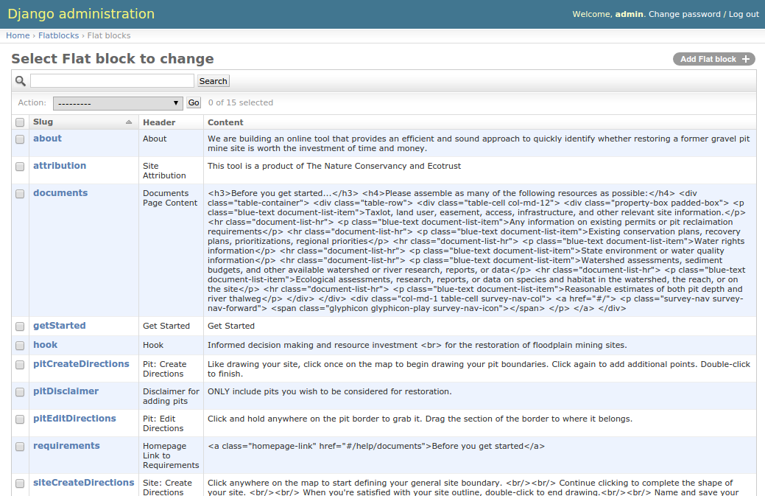

'Flatblocks' are all of the places in the website where the text displayed to public users can be quickly edited and changes. One example would be the 'Get Started' flatblock:



Each flatblock has three parts:

* 'Slug' - which in this case means 'unique id'. It must not be the same as any other flatblocks' slugs. It also is referred to directly in the code, so if this changes, it will not appear in the page anymore.
* 'Header' - A very brief human-readable title explaining what the content is.
* 'Content' - The exact text or html that will be displayed on the site.

In our example, 'Get Started' refers to the 'Get Started' text on the 'Get Started' button on the home page. Currently the 'Content' is 'Get Started' and it appears like this on the site:



Now let's say we went into the admin, and opened up the form to change the content to read "Let's do this!" like so:

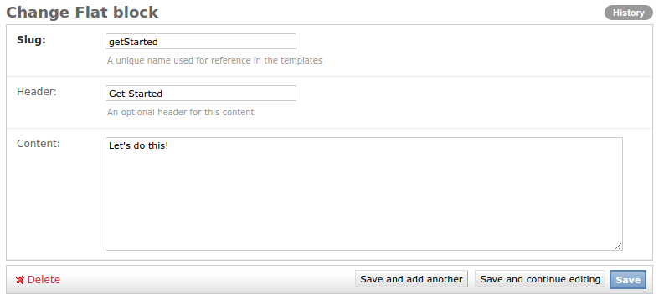

Now if you save your form, then navigate to and refresh the homepage, the 'Get Started' button should now look like this:



NOTE: your personal browser may have cached the old content (remember what it was and assume it hasn't changed). If you don't see your changes reflected on refreshing your browser, try clearing its cache. This is done slightly differently on all browsers, but many of them have the hotkey 'ctrl + shift + r' (for non-macs). If this doesn't do the trick, you may not be changing the text you think you are.

More detailed coverage of the flatblocks is included at the end of this document.

### Survey

The survey module has a series of tweaks that can be made to the site, though most Site Admins should stick to only editing the 'Questions' form. For reference, here are what the other forms are about:

**Contexts** - All questions belong to a category (these can be seen in the 'Questions Menu' in a user's nav bar, and we'll touch on them later). All of these categories, however, are organized into one of three 'contexts':

* + Socio-Economic
  + Landscape
  + Site

You will notice that these 'contexts' relate to all but the 'overall' scores presented in the report and report summary pages. Using their forms, you can change their name or their order that they appear (both in question order or in report order). For more on how order is determined, review the "Order: Context, Category, Question" section below.

**Gravel sites, Input nodes, and Pits** - These are the collections of input values from the users: Every user will create a site ('Gravel site'), each site will contain one or more gravel pit mines ('Pits'), and then each site will have a series of answers to the questions saved ('Input nodes'). Do not change these as they are the user's data that this tool is designed to collect. Users may log in and change their own answers through the tool.

**Question category** - mentioned above, every question belongs to a category, and every category belongs to a context. These are those categories for organizing questions. Each category has a name, a context, and an order. The name you will recognize from the 'Questions Menu' in the Nav bar. The 'order' is used to organize which order the categories' questions will appear within the context. For more on how order is determined, review the "Order: Context, Category, Question" section below.

**Questions** - the questions displayed in the questions portion of the tool. This is a very delicate, and very touchy form that also will likely be a frequent target for change. Because of this, the next section is devoted entirely to it.

### Survey - Questions

The first thing to know about questions is that **they are set in stone.** Adding or removing questions **WILL** break the tool. There are complex calculations going on under the hood that are defined with these **EXACT** questions in mind. That being said, there are parts of the questions that can be edited, some safely, some less so. Also note that Site Admin users will be able to change any field on the question, even the ones that will break the tool. The admin site assumes you know what you're doing, so read this next bit **CAREFULLY**.

Each question has the following fields. This document will try to explain exactly what each one does, and call specific attention to the ones that are good to change, and the ones that are dangerous.

**Name** - This is a 'code-known' name for the question. **THIS MUST NOT CHANGE.** The code looks for this to identify which value to use when calculating the assessment report.

**Title** - This is a brief description of what the question is about. It will show up in the 'Question Menu' drop-down from the user's nav bar, on the question page, and in the reports. It's safe to change, but not likely to need any edits.

**Question** - The question that will be printed on the question page. While it is possible you will want to make some edits to the question text: **THE CONTEXT OF THE QUESTION MUST NOT CHANGE.** If changing how you ask the question is going to change how the user answers (assuming they understand both questions clearly) then your edit is NOT APPROPRIATE. If the edit is just to clarify the original intent of the question, then it is a good change.

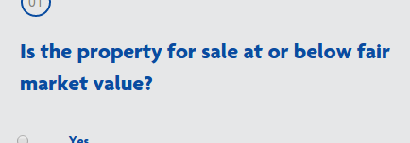

**Detail** - This is a blurb of text printed beneath the question and notes section. This is a good place to clarify uncommon words like 'thalweg', ideas like a '100 year floodplain' or extrapolate on the purpose of or background behind the question.

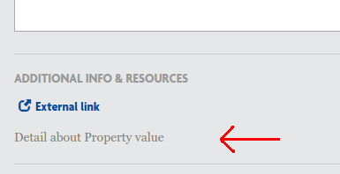

**Order** - Order determines when the question will be asked *relative to other questions in its category.* For more on how order is determined, review the "Order: Context, Category, Question" section below.

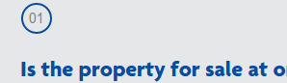

**QuestionCategory** - A drop-down list of the available categories. **DO NOT CHANGE THIS OR ADD NEW CATEGORIES.**

**Image** - If an image file will be helpful in explaining the question, a diagram, examples illustrating a concept, etc..., It can be uploaded and will appear as a 'View Image' link underneath the question with the external links and supplements:

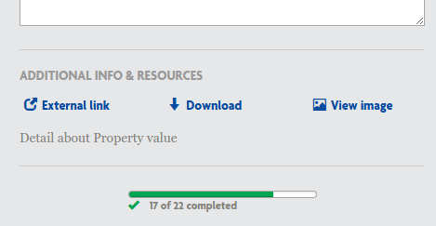

**Supplement** - A downloadable file that may assist the user in accurately answering the question. It appears as 'Download' beneath the question as in the image above.

**ExternalLink** - Sometimes seeing another website for reference on an issue or question will clarify things. In these cases, as helpful link can be provided as 'External Link' beneath the question in the image above.

**Impact** - Explanatory text covering how a user's answer is considered in the assessment. It isn't shown to the user until the report and it should illustrate which situations make for better restoration candidates, and how important this answer is in considering the project.

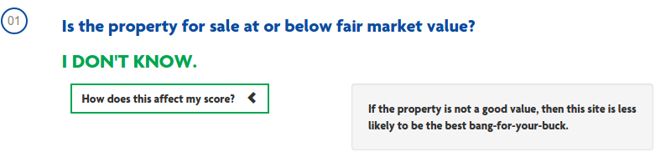

**Choices** - **DO NOT TOUCH THIS.** If you look, the current content of this box includes the brackets and curly-braces that suggest 'computer code'. In this case, this is JSON input given to the webpage to present the users with their multiple choices. Losing so much as a comma from this field will ruin the display of this question, making it unanswerable.

### Survey – Bif Settings

One of the most sensitive features of Prospect-R is the Bif Settings. '.bif' is a file format used to define Bayesian Belief Networks, and being that that is the heart of this tool, making changes without a thorough understanding of what you are doing or having a healthy respect for the implications is HIGHLY discouraged. If you must make changes and updates, please start with this required reading: <https://github.com/Ecotrust/floodplain-restoration/wiki/Defining-Bayseian-Belief-Networks-using-.bif-files> . Much of that document is about the bif file – you no longer have to edit the bif file directly, but the actions you take in the admin tool are making these exact types changes to the bif file under the hood.

Fortunately, you do not have to risk everything to try some changes, large or small. Note that there are several instances under the bif settings admin, one of which is named “Original Settings: Do note toggle” - there are no safeguards to keep you from losing these settings – I recommend avoiding touching this instance unless you absolutely need to. Such cases will be made clear below.

Instead of editing existing bif settings, it is much safer to click on the “Add bif settings” button in the top right and create a new instance. In this case you will want to have an overriding principle behind making changes, such as “The landscape scores seem much too influenced by adjacency to protected areas”. Once you know your desired outcome and theme of this iteration of the scoring scheme, give your new instance a meaningful name in the **Notes:** field such as: “Reduced protected area adjacency impact”. Choose your user name from the **User:** selection field, and click on the “Save and continue editing” button. This will populate initial values for your bif settings directly from the currently used set.

You should now see the same form as before with your answers entered in, but now the **Bif:** field contains many, many sliders underneath associated with each node in our Bayesian network. Knowing the node you wish to change and what branches get you there is key here: trace the network from the top node, and for each branch that won't take you to your node as you scroll down, feel free to click on the downward chevron to collapse that branch. This will keep the total number of sliders from being overwhelming. In our case of protected area adjacency under landscape which is part of overall suitability, the scrolling to find our node would look like this:

* suitability: this is the top node, ours is a direct decendent, so it needs to stay expanded.
  + Site: We're not under site, so we can collapse this.
  + socio_economic: same as site – collapse.
  + Landscape: this is our branch, so we leave it open.
    - geomorphic_controls: close
    - floodplain_characteristics: close
    - abiotic_conditions: close
    - conservation_value: Our node is along this branch, so leave it open:
      * biotic_conditions: not us, close
      * identified_in_conservation_plan: nope
      * relationship_to_protected_areas: this is our node.

Making this change is pretty straightforward: this node has one slider between 'disconnected' and 'connected' – moving this slider adjusts our 'assumed value' for people who do not answer this question. If we want to adjust the impact of answering this question, we need to adjust the probability table of its parent node: conservation_value.

This one is a bit more complicated: if we want to make instances where the property is not connected (or 'disconnected') less likely to make conservation_value 'unsuitable', you would:

1. find the 'conservation_value' node above
2. find the 'relationship_to_protected_areas' column
3. identify all rows where the 'relationship_to_protected_areas' column is 'disconnected'
4. push some or all of those sliders closer to the 'suitable' condition as you see fit
   1. understanding how much you want to move these is very dependent upon having a firm grasp on the required reading mentioned above and a clear view of how you want things to change.

Once done, click on one of the 'save' buttons in the bottom right corner of the page. If you think you may tweak these in an iterative 'guess and check' to get these just right, 'Save and continue editing' is the right option for you.

Now that we know how to change these we should take a look at how to 'undo' those changes. If your changes are complex, it will be hard to track down where those sliders were before you started. Instead of this, you should simply open the bif settings that had been in place before your changes and click 'save' on those without changing anything. Scoring will be immediately reset to the paradigm that had been in place from those. If you are unsure about which is or was the previous settings, look at the 'Date Modified' fields – the most recent is the current, and so on going backwards. You can always reactivate your changes by re-saving your new instance.

Note: These changes affect every single property's scores. No exceptions. Playing with this while other people are likely to be testing out different scenarios may give people poor perception of how their properties fare. Making changes will also give old properties new scores when they come to check in on their properties. This inconsistency will affect peoples' perceptions of the reliability of this tool – another factor to consider before making changes, especially large ones, to the bif settings.

### Survey – Pit Score Weights

Ignoring how this module is poorly named, this is how to impact both how pit scores are displayed, and how they are scored. Due to complexities of the code base, scoring the pits happens outside of the core Bayesian network, but functions the same way. For each question, instead of a slider like the question nodes, there is a 'value' category for the overall node to be set somewhere between 0 and 1. For each answer option for this question there is an associated value as well, representing how likely their answer relates to an ideal scenario.

For example, for “Is hazardous waste present?” the ideal answer is “No, definitely not.” This answer should be given a value at or near '1'. The worst case is the answer “Yes, and it will be expensive and/or very difficult to remediate.” which should have a score at or near '0'.

All of the nodes are currently created – you will not need to add new 'pit score weights', nor will added weights integrate easily with the rest of the tool.

Other fields of note:

**QuestionText:** This is what is displayed, both in the survey form and in the report.

**Visible:** do we want this question shown on the form? Some fields, like surface area, are calculated automatically. This can be handled behind the scenes by un-checking this box.

**Order:** this value controls in which order the questions are shown in.

**Type:** This should not change. This is the type of data being collected: 'text', 'text area', or 'select'

**Info:** If there is additional information that may help some users answer the question, this is where to put it without cluttering the form. For instance, a definition for 'thalweg'.

**Disabled:** For fields that are calculated automatically, but you still want to be shown to the users, you can disable user input to make it clear that this field exists but is not for direct input. Again the best example is surface area – the field is populated by calculating the area of the pit the user draws on save – we do not want users selecting it directly, but we may want them to see the field and be aware that their proposal will be graded against it.

Under 'Pit question answers' you will see some more fields we haven't discussed:

**Label:** How you change the wording of the option.

**Default:** Unlike non-pit questions, pit questions require an answer be given, even if that answer is “I don't know”. For this, a 'default' answer is selected for each question, almost always “I don't know”. Note: Only one answer should have default checked per question.

**Order:** The order that the answer options are presented in. Big gaps are recommended for ease of shuffling later (currently in steps of 10).

### The Other Modules (Briefly)

**Accounts** - When users create their own account, their email addresses (if given) are tracked under 'Email addresses'. If users confirm the email that they were sent, that record gets stored in 'Email Confirmations'. In the case that a user reaches out and says they need to change email addresses and can prove that they have control of their currently set email address, thenthis would be where to update it so they can continue to change their password when necessary.

**Sites** - A setting the framework uses to fill in many templates. **DO NOT CHANGE THIS.**

**Social Accounts** - This is a feature of the authorization tool we use. One of its feature is that (with work) users can use other social media logins to sign in to the site. This practice is not implemented for this site.

### Order: Context, Category, Question

All of the survey questions belong to a Question Category. All of the Question Categories belong to a Context. This hierarchy was designed for the assessment of the user's answers, but is also helpful in organizing the questions into a logical order for presentation to the user.

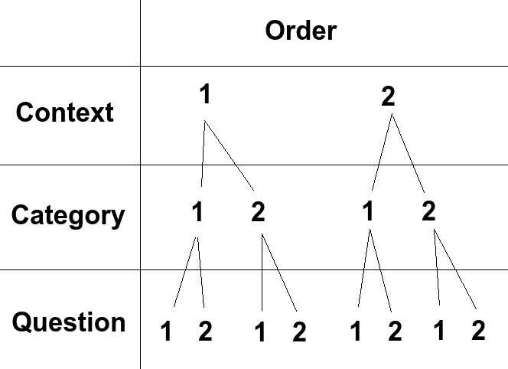

Imagine the following Scenario:

Context Socio-Economic has order value '1.0'

Context Landscape has order value '2.0'

Any question that belongs to a question category the belongs to the 'Socio-Economic' context will be displayed before any question that belongs to a question category that belongs to the context 'Landscape', regardless of either the question's or the question category's order value. Context comes first for ordering.

Category 'Cost Benefit' belongs to Context 'Socio-Economic' with an order value of '1.0'

Category 'Threat to other areas' also belongs to Context 'Socio-Economic' with an order value of '2.0'.

Category 'Conservation value' belongs to Context 'Landscape' with an order value of '1.0'

In this case, using the established context order values from before, any question that belongs to the category 'Cost Benefit' will be shown before any question associated with category 'Threat to other areas'. Also, even though it's own order is lower than that of the other two, because category 'Conservation value' belongs to context 'Landscape', its questions will be displayed after the other categories' questions.

From here, you could make your own examples of different questions with different orders belonging to different categories and working out what their order would be. The lesson here is don't just change the order of a question to 0 and expect it to be the first question displayed to a user.

### Flatblocks: In Depth

Currently there are 17 places on the site that are controlled by flatblocks:

**Help Pages:**

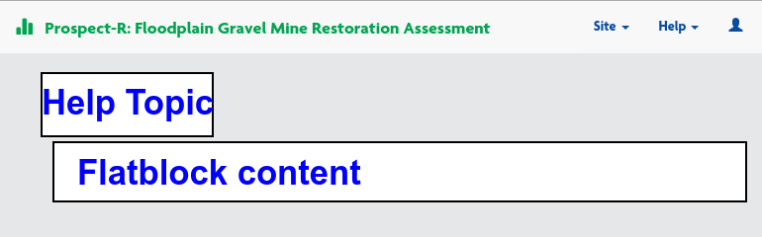

* **about**
  + The 'About this tool' page – should explain the purpose and a little information about how the tool works.
  + Minor HTML may be useful, but not needed.
* **Documents**
  + An list of documents that a user will want to collect before starting to answer questions about their proposed site.
  + HTML heavy. Already filled and hopefully doesn't have to change.
* **Faq**
  + As questions come in, it'd be good to collect them and their answers so that when certain questions seem common, they can be added to this page
  + A little basic HTML will be needed. An example is provided.

**Header**



* **title**
  + The title of the tool
  + 'Prospect-R: Floodplain Gravel Mine Restoration Assessment' by default
  + No HTML

**Main Page**

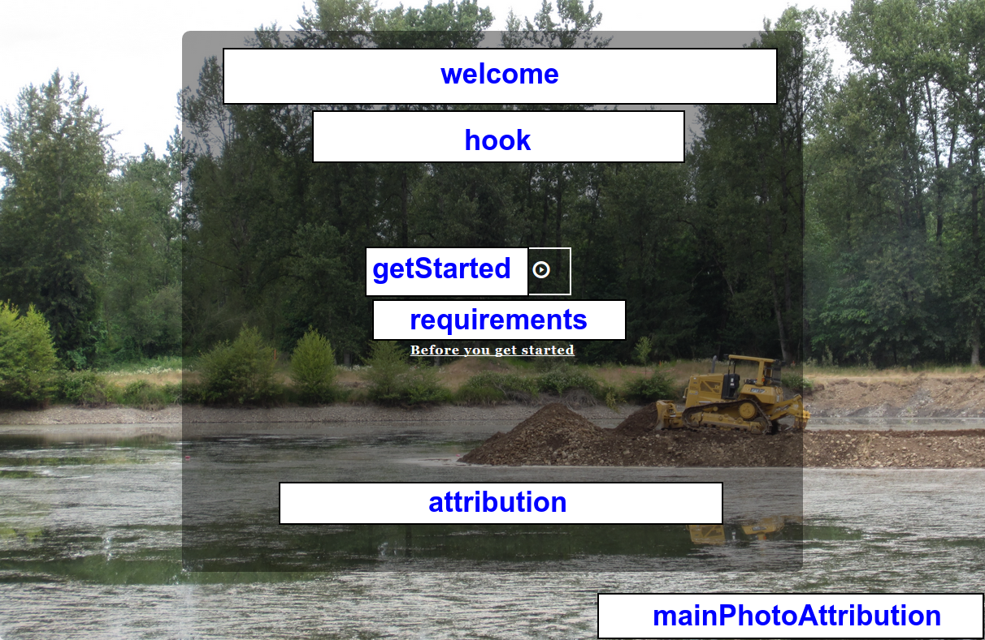

* **welcome**
  + A quick blurb welcoming new users to the site
  + Not HTML
* **hook**
  + A quick blurb introducing the concept of the tool
  + No HTML
* **getStarted**
  + Text for the 'Get Started' button
  + No HTML
* **requirements**
  + A link to get to the list of documents users will need to track down before starting.
  + An HTML link with class 'homepage-link'
* **attribution**
  + A quick blurb giving credit to the organizations that put time, effort, or money into this tool.
* **MainPhotoAttribution**
  + Credit for whoever took the photo on the backdrop of the main page.

**Site List Page:**

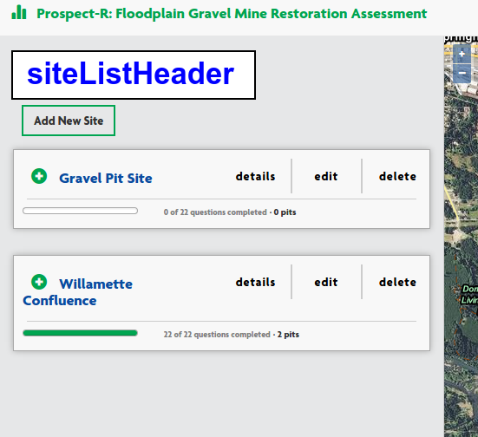

* **siteListHeader**
  + The title for the site list page
  + Default: 'All Sites'
  + No HTML

**Site Create/Edit Page:**

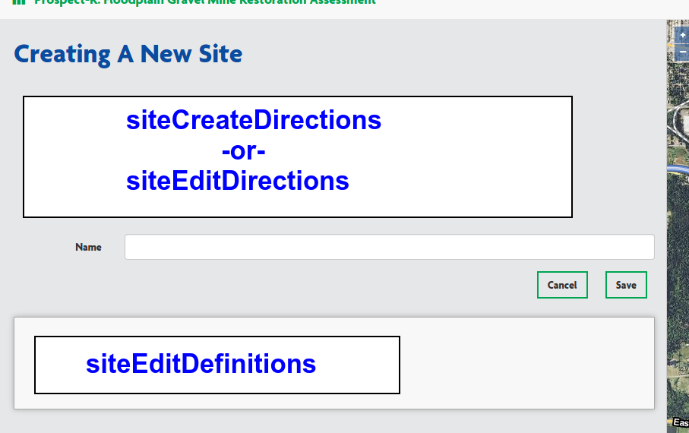

* **siteCreateDirections**
  + If creating a new site, the directions to do so.
  + Minor HTML only
* **siteEditDirections**
  + If editing an existing site, the directions to do so.
  + Minor HTML only
* **siteEditDefinitions**
  + definitions of terms to clarify any ambiguity
  + In this case, specifically what a 'Site' and a 'Pit' are
  + HTML required

**Pit Create/Edit Page:**

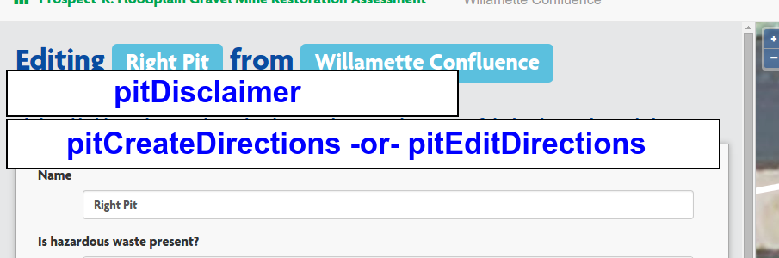

* **pitDisclaimer**
  + a reminder for the user that they don't need to draw pits they don't need to restore
  + no HTML
* **pitCreateDirections**
  + If creating a new pit, directions to help user do so.
  + No HTML required unless directions get complicated.
* **pitEditDirections**
  + If editing and existing pit, directions to help user do so.
  + No HTML required unless directions get complicated.