# Prospect-R Site and Administration Guide

## Site Administration

### Accessing the Admin Site

### Authentication and Authorization

### Flatblocks

### Survey

### Survey - Questions

### Order: Context, Category, Question

## Site Administration

### Accessing the Admin Site

If you log in to the tool with an account that has administrator priveleges, there is one immediate difference: 'SITE ADMINISTRATION' is now an option in your user menu in the nav bar at the top of the screen.

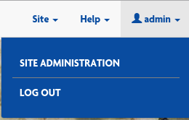

If you believe you are or should be an administrator and you do not see 'SITE ADMINISTRATION in your user menu, contact someone you know who IS an administrator and get your permissions updated. The process to do this is explained in the next section.

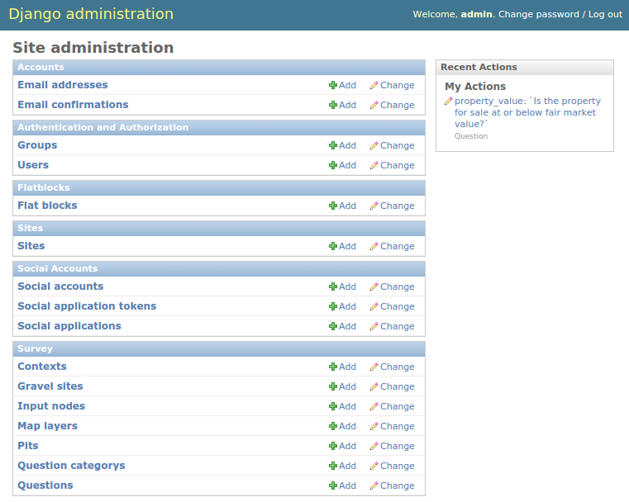

The admin page is where administrators exercise control over the user experience. From this menu they can perform many of the common tasks that this site requires including:

* Creating/deleting accounts (Superusers Only)
* Changing user passwords (Superusers Only)
* Updating webpage content
* Change a user's email address

As seen in the screenshot, administration is organized into 'modules' (the box headers with blue backgrounds) from which you can access the forms you'll need (the blue links with white backgrounds inside each box).

There are three modules that will be of importance while maintaining this site ( only two for non-superusers ) and they each have a section below - the rest should be ignored unless you absolutely know what you're doing.

### Authentication and Authorization

*SUPERUSERS ONLY*

Superusers will have the right to create, edit, and delete user accounts.

Adding an account:

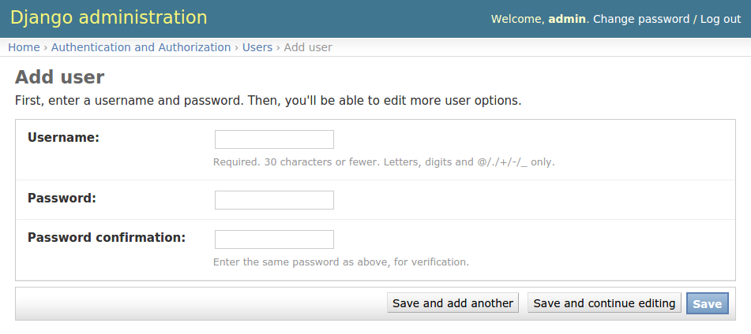

To create a new account, the bare minimum is to give a username and a password. This scenario is unlikely, as anyone can create their own account via the registration process. It is more likely that you are here because you want to create a new Site Admin or Superuser account. Once you've completed this form, click 'Save' to move on the the next steps.

You will now be taken to the 'Edit User' form, which is much more exhaustive. In the first box, you can update the **user's name or password.**

In the second box, you can enter detailed information about the user including **First Name, Last Name, and Email address.** Again, email address is important if the person forgets their password, they can use the site's 'Reset Password' functionality to verify themselves via email.

The permissions form, the third form, is where things start taking a bit more thought. The first three items on the form are checkboxes to assign the new user's privileges:

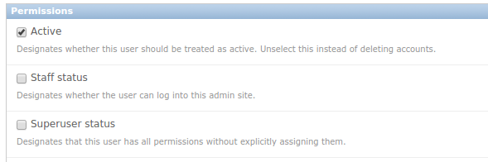

The 'Active' option is selected by default - it is useful in some projects to deactivate users rather than delete their account if you want to maintain information about how many people ever registered, etc...

The 'Staff status' checkbox indicates that a user will have access to the admin pages. If you are NOT checking this box then be sure you have a good reason - non-admins should use the site to register if at all possible.

The 'Superuser status' box indicates whether there should be any restrictions on a user's permissions. Superusers can add/delete/change any form in any module on the admin site with one exception: **IF A SUPERUSER IS NOT ALSO GIVEN STAFF STATUS, THEY CANNOT LOG IN TO THE ADMIN TOOL.** I know that sounds weird, and it is weird, but it's a good thing to know.

You may be noticing a trend: not all users are created are create equal. General public only have permissions to add sites, pits, and answers through the website, and only to their own account. Site Administrators can change some text, but still can't do all of the things a Superuser can. These predefined sets of permissions are called 'Groups':

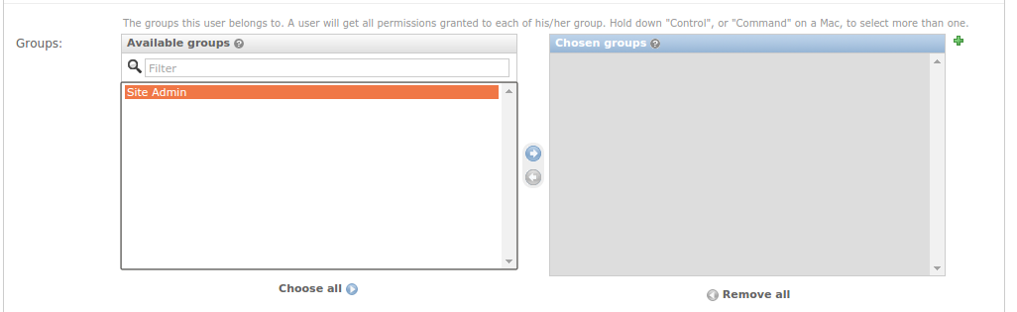

There is no 'Public' group - their permissions are the lowest available. There is not 'Superuser' listed in this form - if the 'Superuser status' checkbox is filled in above, this step and all other parts of the form (except 'Save') are irrelevant. This leaves only the 'Site Admin' group.

To create a 'Site Admin' group member, click on 'Site Admin' in the 'Available groups' box to highlight it like shown above. At this point the 'Right Arrow' button between the two boxes will turn blue. Clicking on the 'Right Arrow' will move the 'Site Admin' group from the 'Available Groups' box over to the 'Chosen groups' box. Once you save this form, that user will have all the rights and privileges of a Site Admin.

Removing group permissions works the same way only with the 'Left Arrow'. You can also choose to use the 'Choose all' or 'Remove all' buttons below.

The green '+' icon at the upper-right corner of the 'Chosen groups' box allows you to define a new group type. This will require some knowledge about specific permissions, which is covered briefly below.

It is possible you will want more control over which permissions a user gets, and if this user's situation is unique (as in, the same exact permissions will not likely be granted other users in the future which would necessitate a new Group) then you can toggle their permissions in the 'User permissions' section:

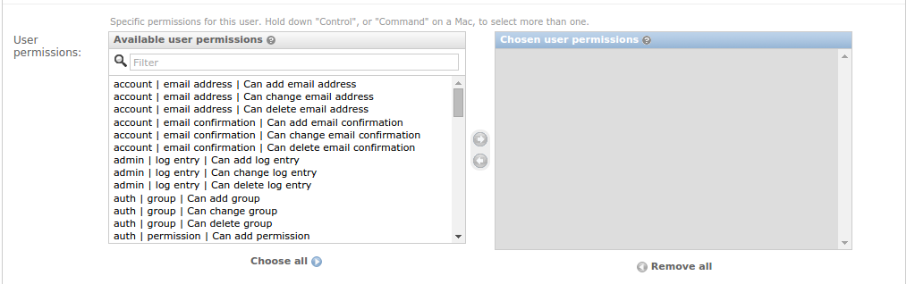

The mechanics for using this form are the same as the groups panel, but there are many, many more options. There is an option for every module, for every form in that module, and an add, a change, and a delete privilege for each of those forms.

For example, suppose you have a user that you want to be able to change flatblocks (described in detail below) but do not want them to have other normal Site Admin permissions like changing contexts. The flat block form is under the flatblocks module, so you would find the following entry in the 'Available user permissions' box on the left: 'flatblocks | Flat block | Can change Flat block'. If you add that permission to the 'Chosen user permissions' box on the right, that user will now see that option (and only that option) when they log in to the site administration.

These permissions are additive - if you want to add 'change user' permissions to a person who was already in the 'Site Admin' group, you only have to add that permission here, it will not remove any permissions that you didn't select.

The next section of the form is 'Important dates'. As the name implies, those dates are (can be) important. Do not change these dates without good reason - they take care of themselves.

Finally the bottom bar is where you can submit this form. It's also where you go to **delete** the user.

Creating a new group works the same as adding specific permissions to a user - select the permissions you want, move them from 'Available permissions' to 'Chosen permissions', give the group a name, and save it. The next time a superuser creates a new user, this name will appear in the list of groups that the user can be added to.

### Flatblocks

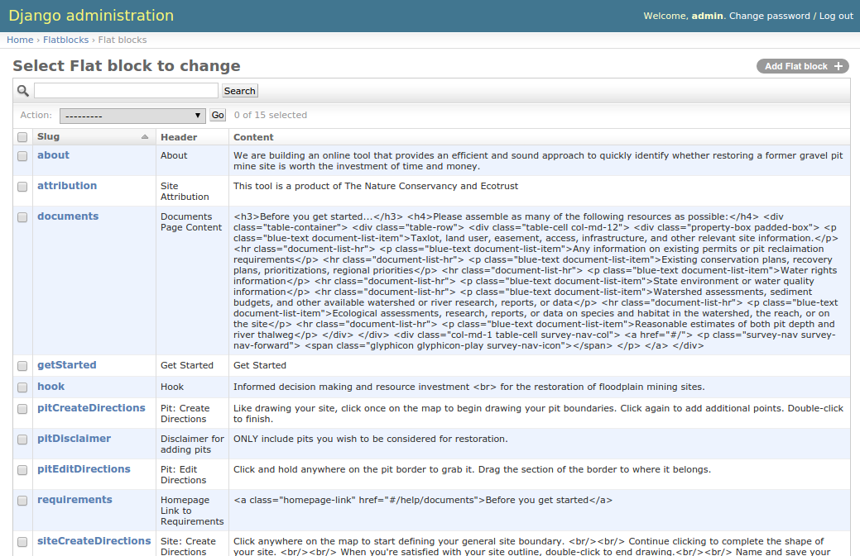

'Flatblocks' are all of the places in the website where the text displayed to public users can be quickly edited and changes. One example would be the 'Get Started' flatblock:



Each flatblock has three parts:

* 'Slug' - which in this case means 'unique id'. It must not be the same as any other flatblocks' slugs. It also is referred to directly in the code, so if this changes, it will not appear in the page anymore.
* 'Header' - A very brief human-readable title explaining what the content is.
* 'Content' - The exact text or html that will be displayed on the site.

In our example, 'Get Started' refers to the 'Get Started' text on the 'Get Started' button on the home page. Currently the 'Content' is 'Get Started' and it appears like this on the site:



Now let's say we went into the admin, and opened up the form to change the content to read "Let's do this!" like so:

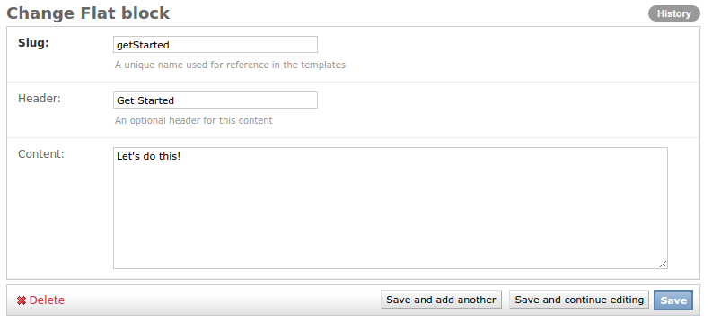

Now if you save your form, then navigate to and refresh the homepage, the 'Get Started' button should now look like this:



NOTE: your personal browser may have cached the old content (remember what it was and assume it hasn't changed). If you don't see your changes reflected on refreshing your browser, try clearing its cache. This is done slightly differently on all browsers, but many of them have the hotkey 'ctrl + shift + r' (for non-macs). If this doesn't do the trick, you may not be changing the text you think you are.

### Survey

The survey module has a series of tweaks that can be made to the site, though most Site Admins should stick to only editing the 'Questions' form. For reference, here are what the other forms are about:

**Contexts** - All questions belong to a category (these can be seen in the 'Questions Menu' in a user's nav bar, and we'll touch on them later). All of these categories, however, are organized into one of three 'contexts':

* + Socio-Economic
  + Landscape
  + Site

You will notice that these 'contexts' relate to all but the 'overall' scores presented in the report and report summary pages. Using their forms, you can change their name or their order that they appear (both in question order or in report order). For more on how order is determined, review the "Order: Context, Category, Question" section below.

**Gravel sites, Input nodes, and Pits** - These are the collections of input values from the users: Every user will create a site ('Gravel site'), each site will contain one or more gravel pit mines ('Pits'), and then each site will have a series of answers to the questions saved ('Input nodes'). Do not change these as they are the user's data that this tool is designed to collect. Users may log in and change their own answers through the tool.

**Question category** - mentioned above, every question belongs to a category, and every category belongs to a context. These are those categories for organizing questions. Each category has a name, a context, and an order. The name you will recognize from the 'Questions Menu' in the Nav bar. The 'order' is used to organize which order the categories' questions will appear within the context. For more on how order is determined, review the "Order: Context, Category, Question" section below.

**Questions** - the questions displayed in the questions portion of the tool. This is a very delicate, and very touchy form that also will likely be a frequent target for change. Because of this, the next section is devoted entirely to it.

### Survey - Questions

The first thing to know about questions is that **they are set in stone.** Adding or removing questions **WILL** break the tool. There are complex calculations going on under the hood that are defined with these **EXACT** questions in mind. That being said, there are parts of the questions that can be edited, some safely, some less so. Also note that Site Admin users will be able to change any field on the question, even the ones that will break the tool. The admin site assumes you know what you're doing, so read this next bit **CAREFULLY**.

Each question has the following fields. This document will try to explain exactly what each one does, and call specific attention to the ones that are good to change, and the ones that are dangerous.

**Name** - This is a 'code-known' name for the question. **THIS MUST NOT CHANGE.** The code looks for this to identify which value to use when calculating the assessment report.

**Title** - This is a brief description of what the question is about. It will show up in the 'Question Menu' drop-down from the user's nav bar, on the question page, and in the reports. It's safe to change, but not likely to need any edits.

**Question** - The question that will be printed on the question page. While it is possible you will want to make some edits to the question text: **THE CONTEXT OF THE QUESTION MUST NOT CHANGE.** If changing how you ask the question is going to change how the user answers (assuming they understand both questions clearly) then your edit is NOT APPROPRIATE. If the edit is just to clarify the original intent of the question, then it is a good change.

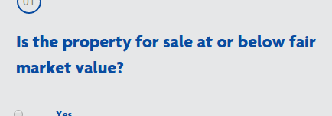

**Detail** - This is a blurb of text printed beneath the question and notes section. This is a good place to clarify uncommon words like 'thalweg', ideas like a '100 year floodplain' or extrapolate on the purpose of or background behind the question.

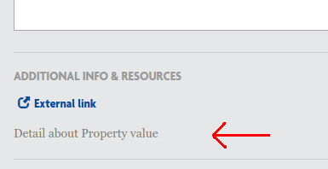

**Order** - Order determines when the question will be asked *relative to other questions in its category.* For more on how order is determined, review the "Order: Context, Category, Question" section below.

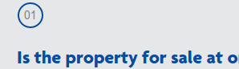

**QuestionCategory** - A drop-down list of the available categories. **DO NOT CHANGE THIS OR ADD NEW CATEGORIES.**

**Image** - If an image file will be helpful in explaining the question, a diagram, examples illustrating a concept, etc..., It can be uploaded and will appear as a 'View Image' link underneath the question with the external links and supplements:

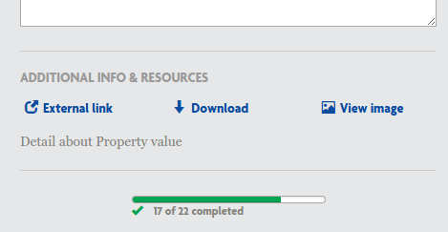

**Supplement** - A downloadable file that may assist the user in accurately answering the question. It appears as 'Download' beneath the question as in the image above.

**ExternalLink** - Sometimes seeing another website for reference on an issue or question will clarify things. In these cases, as helpful link can be provided as 'External Link' beneath the question in the image above.

**Impact** - Explanatory text covering how a user's answer is considered in the assessment. It isn't shown to the user until the report and it should illustrate which situations make for better restoration candidates, and how important this answer is in considering the project.

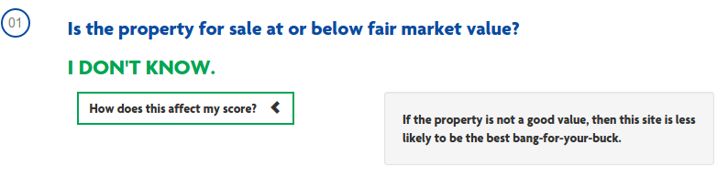

**Choices** - **DO NOT TOUCH THIS.** If you look, the current content of this box includes the brackets and curly-braces that suggest 'computer code'. In this case, this is JSON input given to the webpage to present the users with their multiple choices. Losing so much as a comma from this field will ruin the display of this question, making it unanswerable.

### The Other Modules (Briefly)

**Accounts** - When users create their own account, their email addresses (if given) are tracked under 'Email addresses'. If users confirm the email that they were sent, that record gets stored in 'Email Confirmations'. In the case that a user reaches out and says they need to change email addresses and can prove that they have control of their currently set email address, thenthis would be where to update it so they can continue to change their password when necessary.

**Sites** - A setting the framework uses to fill in many templates. **DO NOT CHANGE THIS.**

**Social Accounts** - This is a feature of the authorization tool we use. One of its feature is that (with work) users can use other social media logins to sign in to the site. This practice is not implemented for this site.

### Order: Context, Category, Question

All of the survey questions belong to a Question Category. All of the Question Categories belong to a Context. This hierarchy was designed for the assessment of the user's answers, but is also helpful in organizing the questions into a logical order for presentation to the user.

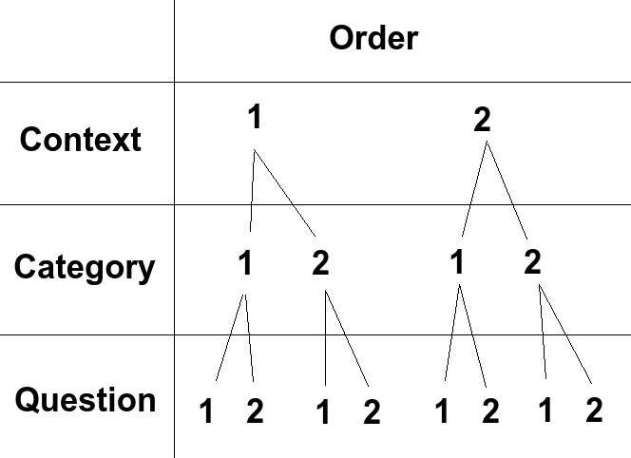

Imagine the following Scenario:

Context Socio-Economic has order value '1.0'

Context Landscape has order value '2.0'

Any question that belongs to a question category the belongs to the 'Socio-Economic' context will be displayed before any question that belongs to a question category that belongs to the context 'Landscape', regardless of either the question's or the question category's order value. Context comes first for ordering.

Category 'Cost Benefit' belongs to Context 'Socio-Economic' with an order value of '1.0'

Category 'Threat to other areas' also belongs to Context 'Socio-Economic' with an order value of '2.0'.

Category 'Conservation value' belongs to Context 'Landscape' with an order value of '1.0'

In this case, using the established context order values from before, any question that belongs to the category 'Cost Benefit' will be shown before any question associated with category 'Threat to other areas'. Also, even though it's own order is lower than that of the other two, because category 'Conservation value' belongs to context 'Landscape', its questions will be displayed after the other categories' questions.

From here, you could make your own examples of different questions with different orders belonging to different categories and working out what their order would be. The lesson here is don't just change the order of a question to 0 and expect it to be the first question displayed to a user.