WCCCD FORMS CENTER

Portal Design and Build Guide
Requirement 1: internal forms portal, IT pilot
Prepared by: Eric Crutchfield Date: October 27, 2026 Status: Proposed design for team review Companion to: Enterprise Forms and Workflow Plan

Purpose
This guide describes the proposed design of the WCCCD Forms Center and how to build it in SharePoint Online for the IT pilot. It covers site structure, the forms library, page layouts, search, content lifecycle, and known limitations. Secure external submissions (Requirement 2) and request tracking (Requirement 3) are outside its scope.
DESIGN PRINCIPLES
- One library, many views. Every form lives in one document library. Pages show filtered views of it. Adding a department means adding a page and tagging forms.
- Standard SharePoint first. The pilot uses out-of-the-box sites, web parts, views, and column formatting. Add-ons are considered only when usage shows a need.
- Every form row answers "how do I submit this?" Format, submission steps, owner, and last review date travel with the form.
- Show only what works. Features and departments appear when they are live.
- Accessible by default. Pages and published forms meet WCAG 2.1 AA.

Site structure
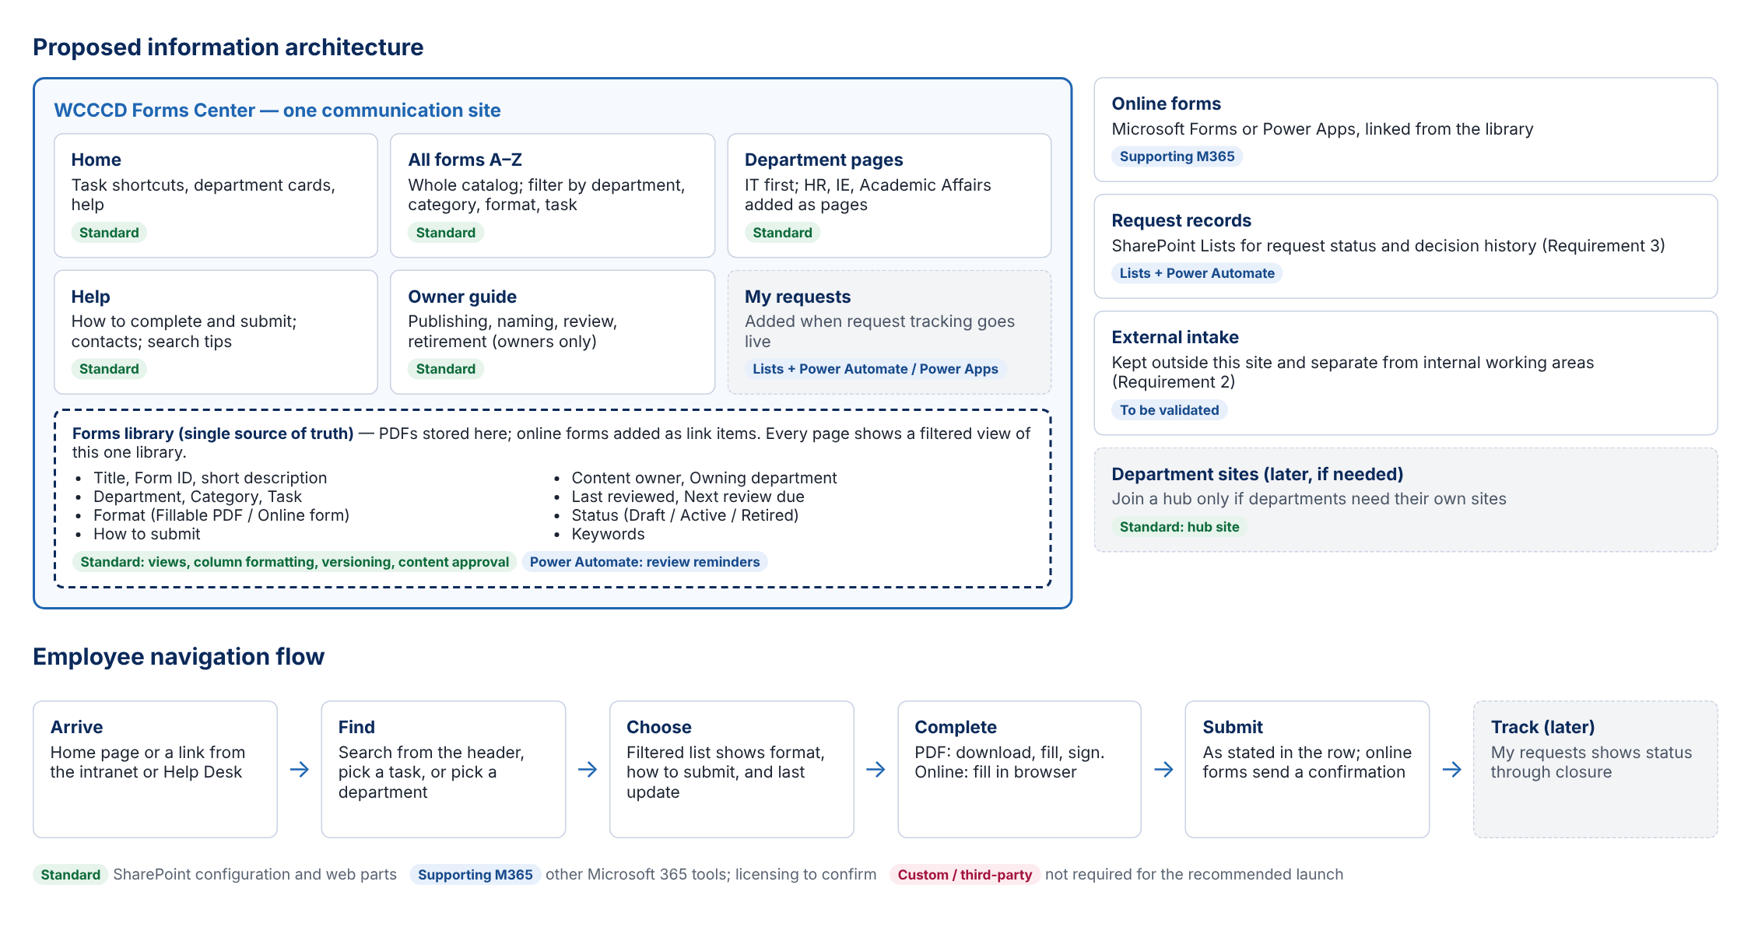
Figure 1. Site structure and employee navigation flow. Grey dashed items are later phases.
Page | Purpose | Built with
Home | Entry point: task shortcuts, department cards, help. | Quick Links, Text, Image, Button
All forms | Full catalog, A–Z, with column filters. | Document Library web part
Departments › IT | IT forms grouped by category, with completion instructions. | Document Library web part, Text
Help | How to complete and submit forms, contacts, search tips. | Text
Owner guide | Publishing, naming, review, and retirement steps. Visible to owners only. | Text; page permissions or audience-targeted link

Site navigation
Home | All forms | Departments (menu: Information Technology) | Help. Cascading menu style is enough at this size. Add each department to the menu when its forms are published. Add My requests when request tracking goes live.

Forms library
One document library, Forms. Fillable PDFs are uploaded as files. Online forms (Microsoft Forms or Power Apps) are added as link items pointing to the form. Turn on content approval and major/minor versioning. Set draft item security so only authors and approvers see unapproved items.

Columns
Column | Type | Values and notes | Shown to employees
Title | Built-in | Plain task name, e.g. "Equipment Request". No version numbers. | Yes (link)
Form ID | Single line | Department prefix and number, e.g. IT-001. Never reused. | Yes
Description | Multiple lines, plain | One sentence on what the form is for. | Yes
Department | Choice | Information Technology; later HR, Institutional Effectiveness, Academic Affairs. | Filter
Category | Choice | IT: Accounts and Access, Equipment, Software, Policies and Acknowledgments. | Group
Task | Choice, multi-select | Get access to a system; Request equipment or software; Starting or leaving a job; Policies and acknowledgments. | Filter
Format | Choice | Fillable PDF; Online form. Shown as a badge via column formatting. | Yes
How to submit | Multiple lines, plain | Where and how to send it, e.g. "Get supervisor signature, then email to the IT Help Desk." | Yes
Content owner | Person | Named person responsible for accuracy. | No
Last reviewed | Date | Set at each review. Displayed in the list. | Yes
Next review due | Date | Drives owner reminders. | No
Status | Choice | Draft; Active; Retired. Employee views show Active only. | No
Keywords | Multiple lines, plain | Synonyms employees might search for, e.g. "laptop, computer, monitor". | No (searchable)
Category as a Choice column is fine for the pilot. When more departments join, consider a managed metadata term set with Department › Category so each department sees only its own categories.

Views
View | Filter, sort, group | Used on
All forms | Status = Active; sort by Title. | All forms page
IT forms | Department = Information Technology, Status = Active; group by Category; sort by Title. | IT page
Task views (one per task) | Task contains value, Status = Active; sort by Title. | Homepage task shortcuts
Due for review | Next review due within 30 days. | Owners
Drafts and retired | Status = Draft or Retired. | Owners

Formatting
- Format badge: JSON column formatting on Format renders a blue "Fillable PDF" or green "Online form" pill with an icon.
- Form cell: JSON formatting on Title shows the form name as the only link, followed by Form ID and Description on a second line.
- Group headers: view grouping by Category with item counts.

Page designs
The concepts show the intended layout. SharePoint renders web parts in its own styles, so spacing and grid details will differ slightly. Form names, IDs, submission steps, and dates in the concepts are illustrative.

Homepage
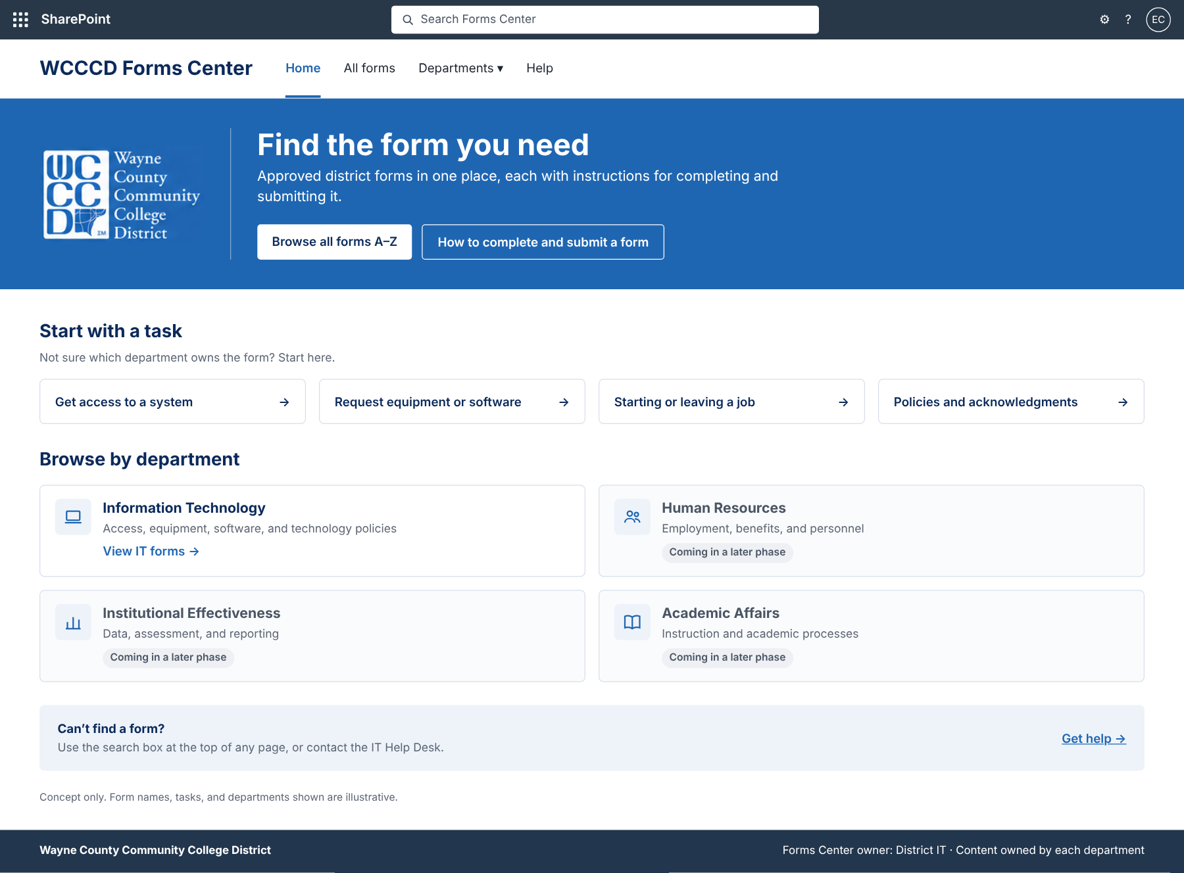
Figure 2. Homepage concept.
Section | Content | Web parts and settings
Banner | Reversed WCCCD logo; "Find the form you need"; one line of supporting text; buttons for Browse all forms A–Z and How to complete and submit a form. | One-third left section, strong theme background; Image, Text, Button
Start with a task | Four task shortcuts. | Quick Links, Button layout; each link opens a task view
Browse by department | IT card links to the IT page. Other departments show "Coming in a later phase" with no link. | Quick Links, List or Button layout with descriptions and icons
Help | "Can’t find a form?" prompt and link to Help. | Text in a section with soft background
Footer | District name; Forms Center owner. | Site footer (communication site)

IT landing page
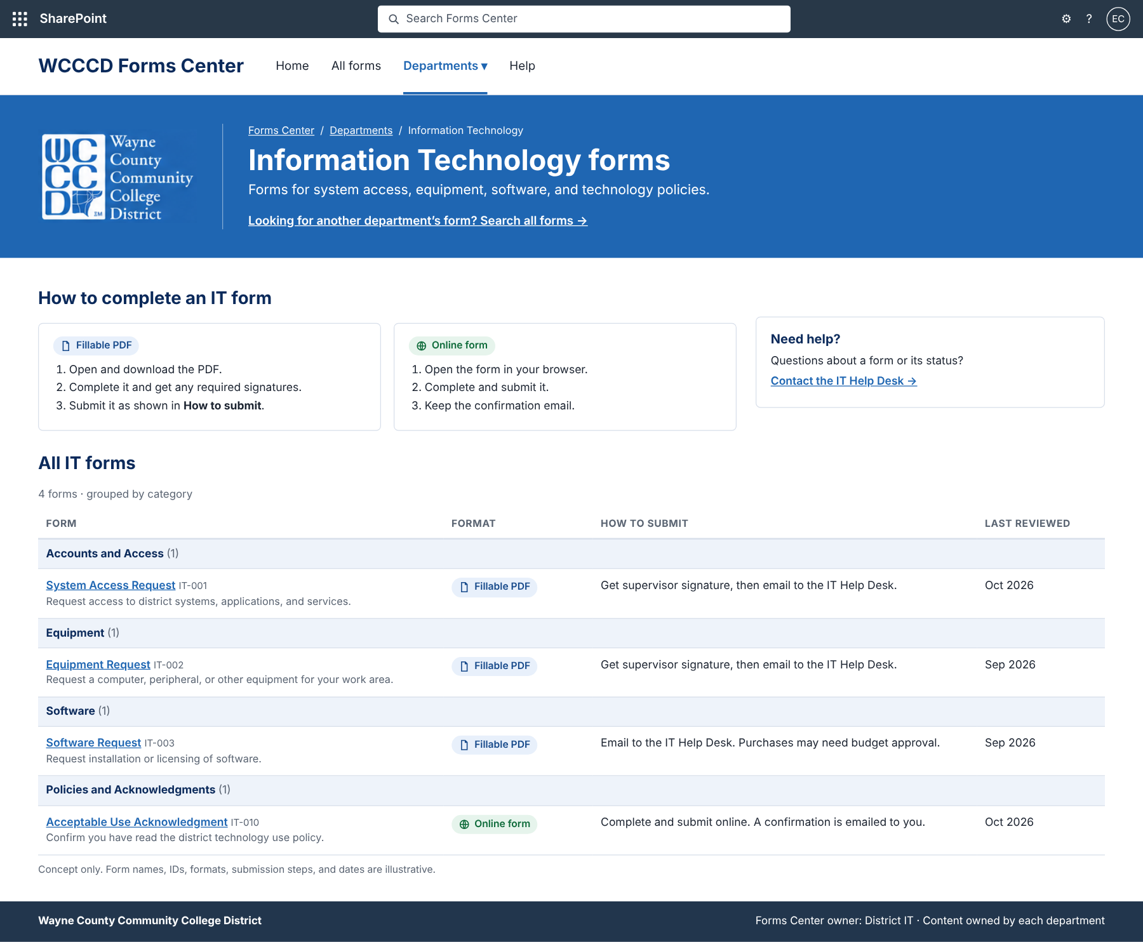
Figure 3. IT landing page concept.
Section | Content | Web parts and settings
Banner | Reversed WCCCD logo beside the title; breadcrumb (Forms Center / Departments / Information Technology); subtitle; link to the All forms page. | One-third left section, strong theme background; Image, Text
How to complete an IT form | Fillable PDF steps; Online form steps; Need help with IT Help Desk contact. | Three-column section, one Text web part per column
All IT forms | IT forms grouped by category. Columns: Form, Format, How to submit, Last reviewed. | Document Library web part, IT forms view
Breadcrumb: modern pages have no automatic breadcrumb. Use static links in the banner Text web part and update them if pages move.
Phones and tablets: sections stack top to bottom in column order: banner, PDF steps, online steps, help, form list. Avoid vertical sections, because their position on phones cannot be controlled.

Search
- District-wide search uses the standard SharePoint header search. On the Forms Center site it searches the site, so it covers every form, including PDF text and library metadata such as Keywords.
- IT-only narrowing comes from the IT forms view and column filters. There is no separate in-page search box, because modern pages have no standard search box web part.
- Promoted results: Microsoft Search editorial bookmarks still work in SharePoint and can surface the most-used forms for common terms. They are created by a search administrator.
- Later option: if search becomes the main way people find forms, PnP Modern Search (open-source SPFx web parts) adds a page search box with filters by department and format. It is community-supported, installed through the app catalog, and must be kept current by IT. A 2026 performance defect was fixed in version 4.23.3.

Content lifecycle
Stage | What happens | How
Publish | Owner uploads the PDF or adds the link item, fills every required column, and submits it for approval. | Content approval; Forms Center owners approve
Update | Owner uploads the new version over the old file. Prior versions stay in history. | Versioning; Form ID and Title unchanged
Review | Owner is reminded before Next review due, confirms or updates the form, and resets both dates. Starting cycle: annual, or sooner when policy changes. | Scheduled Power Automate flow
Retire | Owner sets Status to Retired. The form leaves employee views but remains in history. | Status column; views filter Active

Permissions
- All employees: read access to the site.
- Department content owners: edit access to the Forms library; publishing still needs approval.
- Forms Center owners (District IT): full control; approve content; manage pages and navigation.
A single owners group can edit any department’s forms. If a department needs its forms isolated, use a department folder with unique permissions instead of item-level permissions.

Accessibility
- Publish only tagged, screen-reader-friendly PDFs, or provide an online form as the alternative.
- Check text, badges, and banner links for WCAG 2.1 AA contrast. Give the logo alt text and use real headings in Text web parts.
- DOJ extended the ADA Title II web accessibility compliance dates by one year, to April 2027 for larger public entities. Confirm applicability to WCCCD with counsel.

Components and dependencies
Element | Built with | Type
Site, theme, navigation, footer | Communication site; custom WCCCD theme added by a SharePoint admin. | Standard
Forms catalog, views, badges | Document library, saved views, JSON column formatting. | Standard
Page sections | Image, Text, Button, Quick Links, Document Library web parts. | Standard
District-wide search | SharePoint header search. | Standard
Online forms | Microsoft Forms or Power Apps. | Supporting M365
Review reminders | Power Automate scheduled flow. | Supporting M365
Page search with filters (optional, later) | PnP Modern Search. | Third-party, open source

Dependencies and limitations
- Header logo: every modern site header has a logo position, and SharePoint shows a generated placeholder if no logo is set. Hiding it needs unsupported CSS. Proposed: Minimal header layout with a small square WCCCD mark as the site logo, with the full logo in the page banner. Confirm with Communications before build.
- Theme: the WCCCD blue theme must be added by a SharePoint administrator before the banner sections can use it.
- Reversed logo: a white WCCCD logo file is needed for the blue banner. Request the official asset from Communications.
- Help Desk channel: confirm the contact method (portal, phone, or email) for the Need help text.
- Licensing: Microsoft Forms and Power Automate with standard connectors are commonly included in Microsoft 365 plans. Premium connectors, Power Apps beyond standard use, and Power Pages may need added licenses. Confirm against WCCCD’s plans.

References
- Change the look of your SharePoint site (Microsoft Support)
- Plan navigation in the modern experience (Microsoft Learn)
- Use the Document Library web part (Microsoft Support)
- Use the List web part (Microsoft Support)
- Use the Quick Links web part (Microsoft Support)
- Adding a search function to the page (Microsoft Q&A)
- Microsoft Search bookmarks status (Microsoft Learn)
- Hiding the SharePoint header (Microsoft Q&A)
- Vertical section mobile rendering (Microsoft Tech Community)
- PnP Modern Search performance issue, July 2026
- DOJ extends ADA deadline by one year (Community College Daily)

