 | WCCCD Forms Center: Decision Brief  District forms, external submissions, and request tracking on SharePoint  For: Yoseph Demissie, CIO | From: Eric Crutchfield | November 2026

Problem
District forms are non-fillable PDFs scattered across shared folders. There's no controlled way to take files from outside parties, and requests aren't tracked to closure, so there's no audit record.
What it delivers
- Forms portal. One SharePoint site and library where employees find every approved form, converted to fillable PDF, and how to submit it.
- External submissions. Controlled intake for files from vendors and outside parties, with a purchasing module for RFPs.
- Request tracking. Each request recorded from submission through approval, fulfillment, and closure.
Approach
Phase | What happens | Output
1. Requirements | Pick the IT forms and one workflow. Set naming, ownership, permissions, and retention. Confirm licensing and external sharing. | Approved pilot scope
2. IT pilot | Build the site and Forms library, convert IT forms to fillable PDFs and load them, and run one request with routing, decisions, and closure. | Working IT forms area
3. Purchasing module | Guest sign-in, sealed library, receipts, deadline close, evaluator access, and a fallback link. Tested before any live RFP. | Validated RFP intake
4. Expand | HR, Institutional Effectiveness, and Academic Affairs, converting each department's forms. Name owners, train, and set a review cycle. | Department rollout
Built on tools WCCCD already licenses: SharePoint, Power Automate, Microsoft Forms, Entra, and Purview. Confirm any added licenses before Phase 3.
Purchasing module
Vendors sign in as guests and upload to a sealed library, with receipts and automatic close at the deadline. The Purchasing Module brief has the detail, with joining MITN as a simpler alternative.
Risks to manage
- Flows need a service account and a named support owner.
- RFP controls must be proven in testing, and guest access needs Information Security approval.
- ADA Title II web rules apply by April 2027. The site targets WCAG 2.1 AA; confirm with counsel.
Decision requested
Approve the direction and the IT pilot. Name business owners for forms (IT), external intake (Purchasing), and request tracking.
See the full Forms Center package online
Plan, slide deck, clickable prototype, and design guide, all in one place.
ecrutch1.github.io/WCCCD-FORMS-CENTER

Proposed design
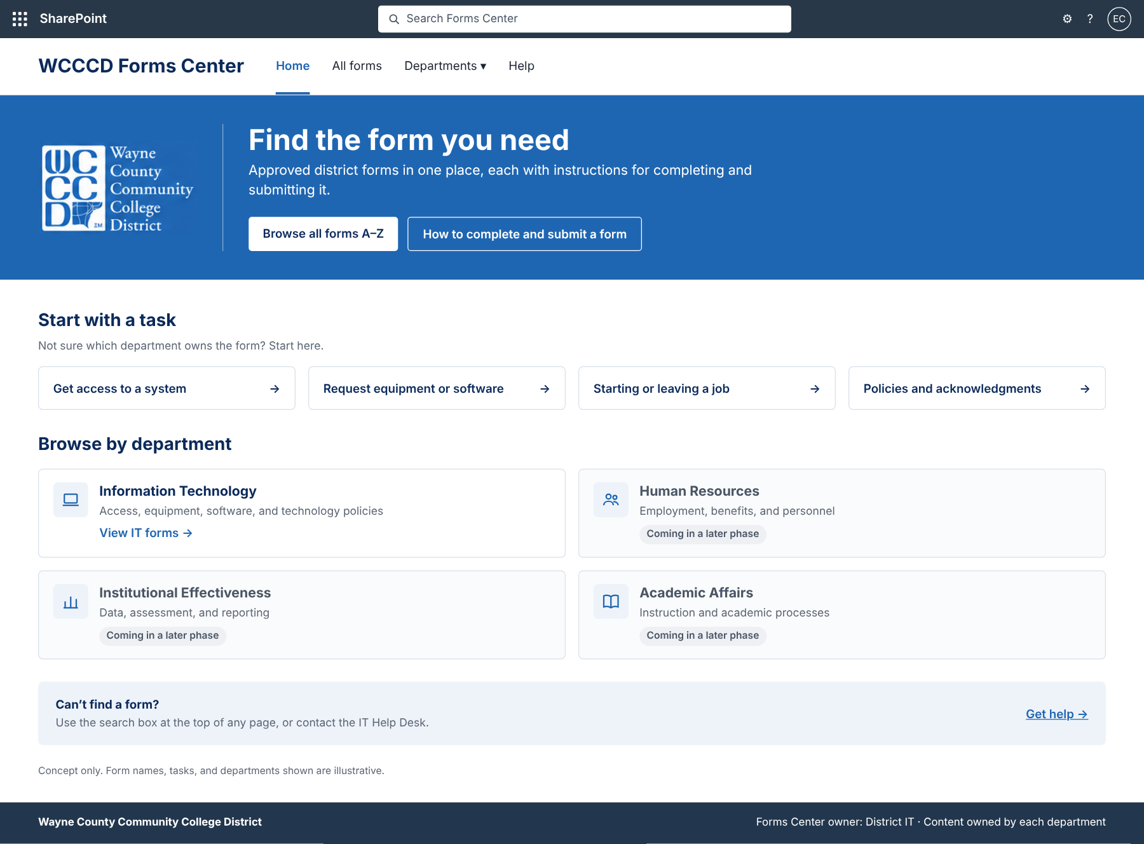
Figure 1. Forms Center homepage: search, task shortcuts, department cards, and help.
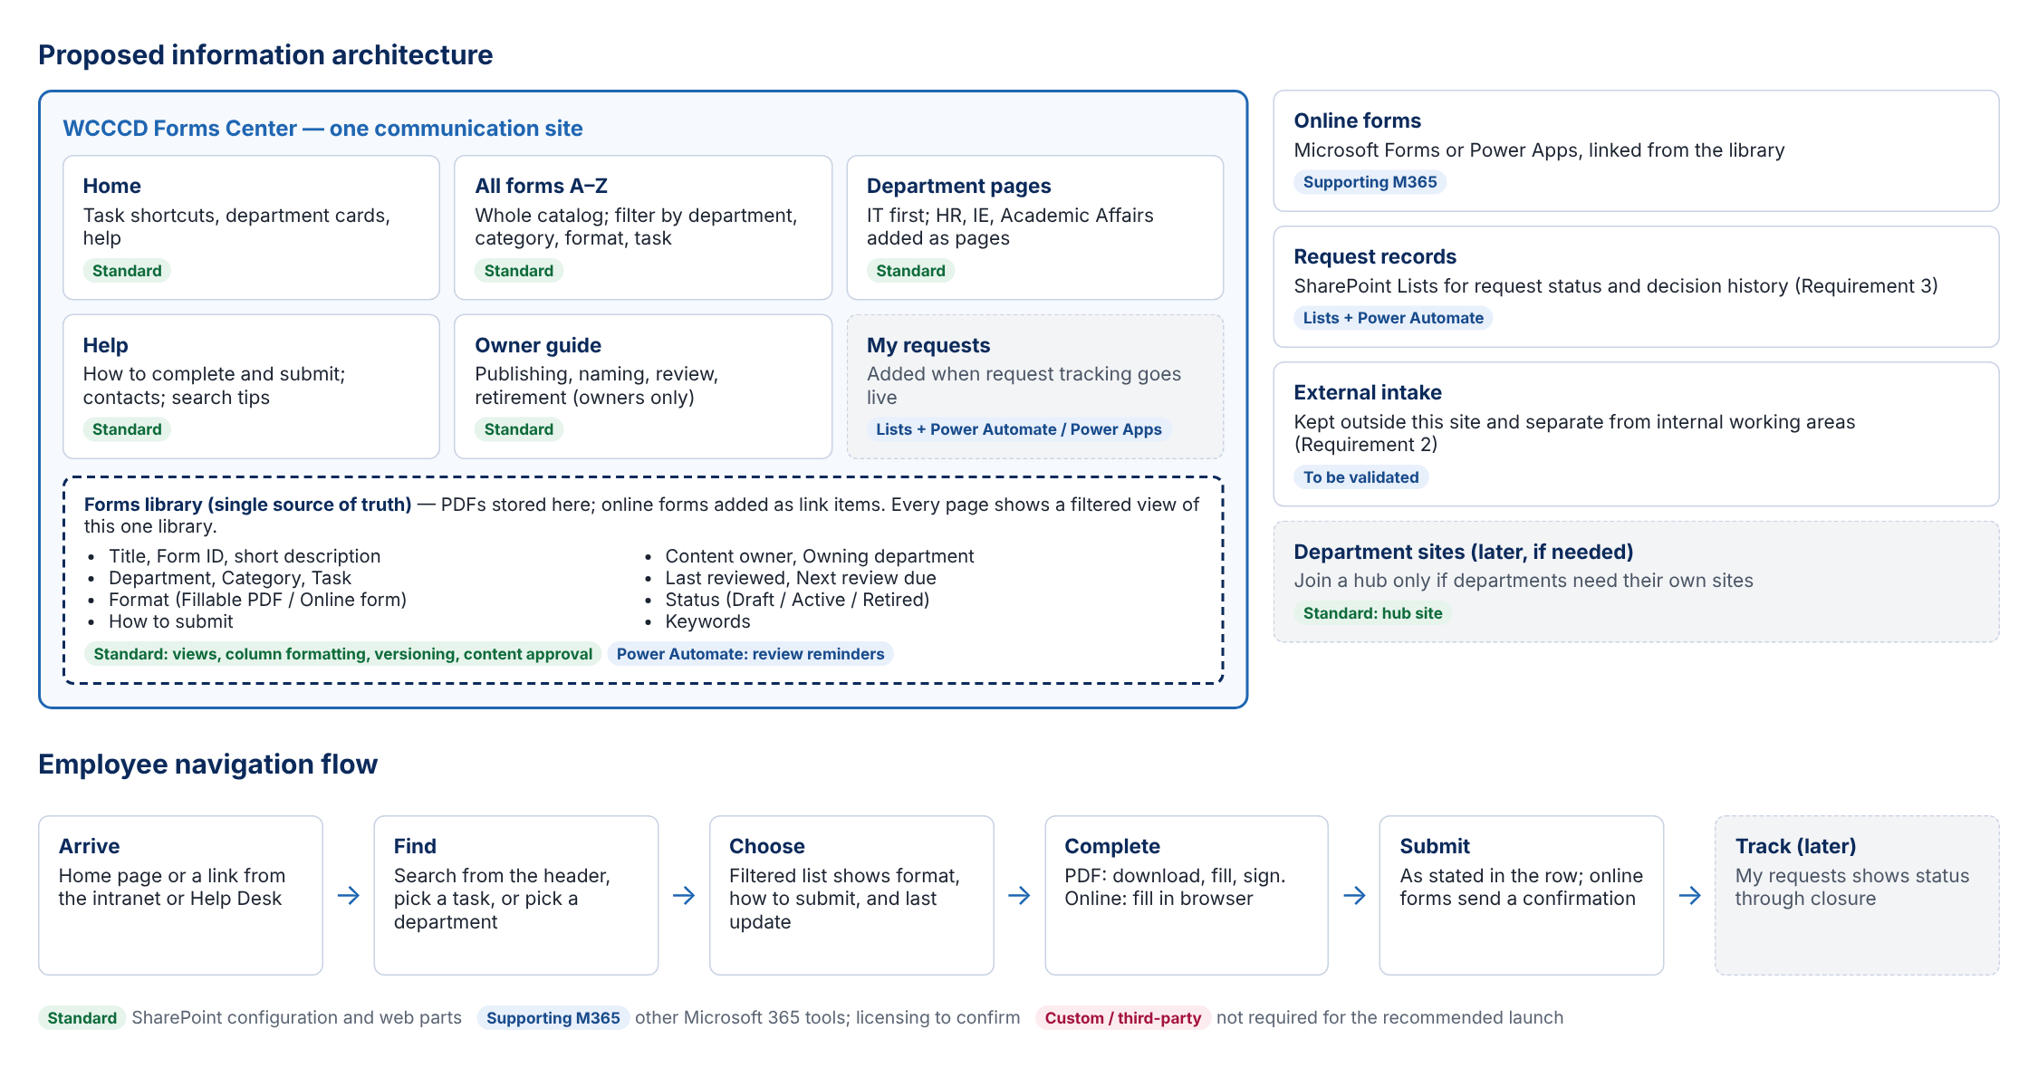
Figure 2. Site structure and employee navigation. Grey dashed items are later phases.
Concept only. Form names and departments are illustrative.

