

S.A.T Team Project

For Centriq Training

Authors:

Alicia Villegas

Gene Cathcart

Project Summary

The goal of this project was to build a Scheduling Administration Tool using MVC with a partner. Alicia and I utilized Github SSMS and Visual Studio to create a functional site that allows the user to create, edit, update, and delete entries for students, courses, and scheduled classes if logged in as an administrator. In the site we also created a functional contact form to allow users to send us an email.

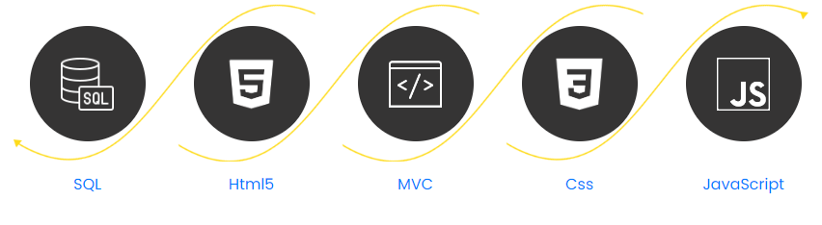

Project Requirements

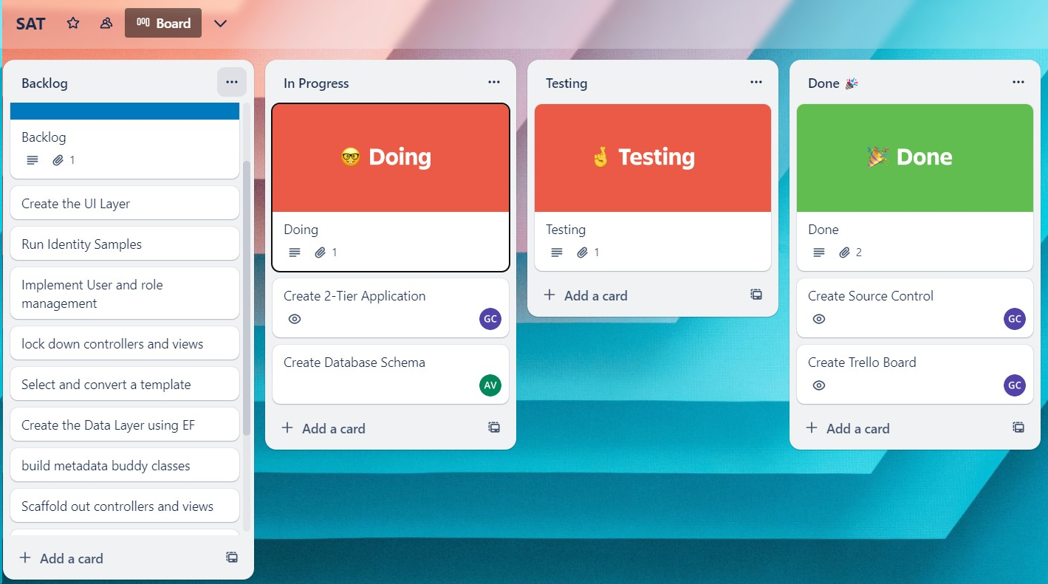

1. Create a SQL Database and add data
2. Create Source Control
3. Implement Identity and Authentication
4. Convert a template
5. Create the Data Layer in the project
6. Create site Navigation
7. Create Metadata and scaffold out controller
8. Build and implement a Contact form
9. Implement a file upload feature for student photos
10. Create a tile view of the Courses
11. Add a download button for the documentation

Creating a SQL Database

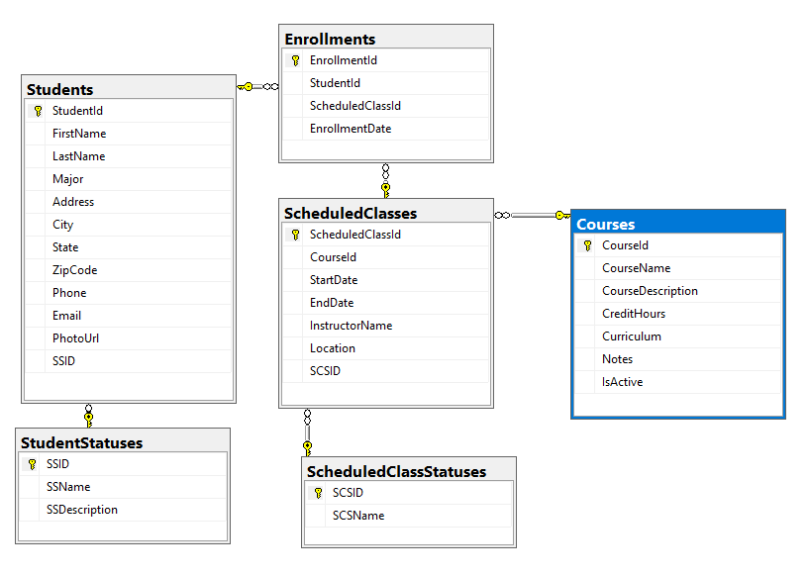

Implemented a Data Schema and built out the data for all tables using SSMS. We were provided the schema by Centriq. This allows us to populate usable data into the site.

Implementing Identity and Authentication

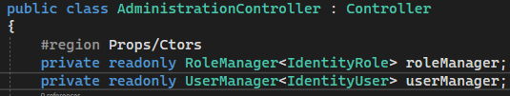

Here we used the Visual Studio to scaffold out the areas and controllers for Identity. This allows us to create and modify user accounts for the site. These accounts can then be set to different types of users to lock down certain aspects of the site.

Converting a Template



We chose a template from Themewagon.com that we found visually pleasing and had the pages we wanted. To convert the template for MVC we had to create a layout view using the header and footer from the template. After we created the layout we were able to create views for all other pages using the templates pages to guide our styling. https://themewagon.github.io/esigned/index.html

Creating Site Navigation

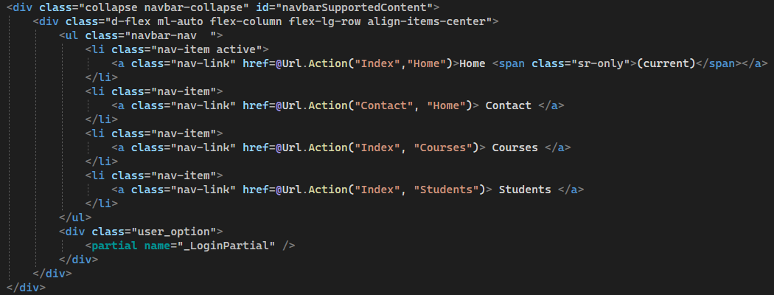

To Create our site navigation we had to modify the existing navigation links to be asp-actions and used bootstrap to customize the way they looked and acted.

Creating Metadata and Scaffolding Controllers

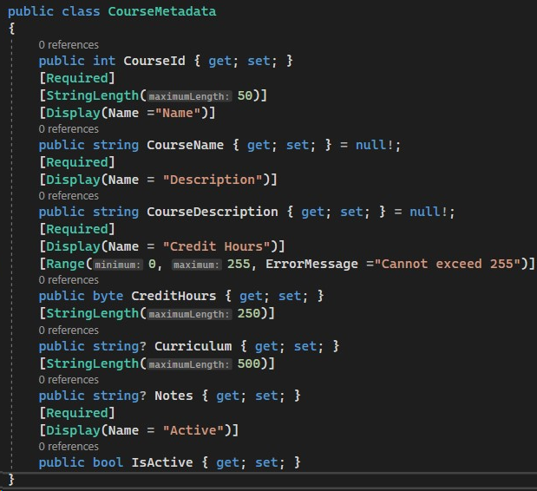

We used Entity Framework to create controllers and views for our database tables. These tables required us to add a metadata file to make sure data being sent to the database was in the proper format.

Building and Implementing a Contact Form

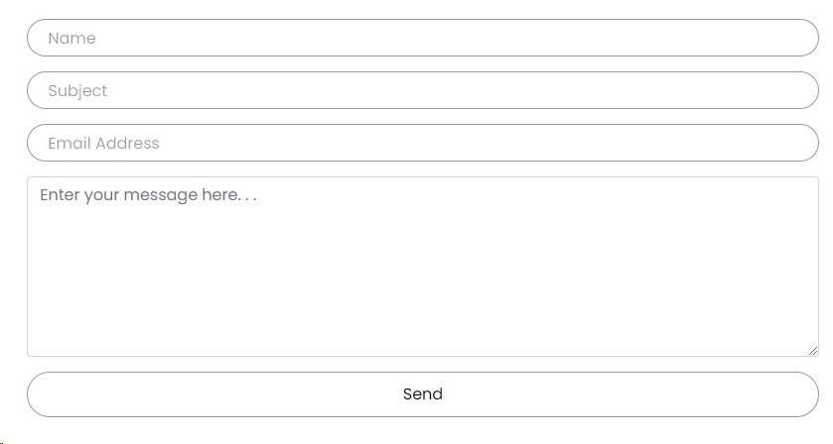

Here we customized the contact form from the template to suit the needs for the functional code to send an email. We utilized the MailKit Nuget package to make the form functional.

Implementing File Upload

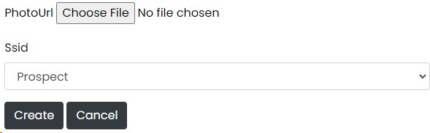

For this functionality we added script that will take a photo and crate a GUID for it before saving it to the images folder. this GUID is saved to the database so when a student is called the uinque photo can be loaded in.

Creating a Tile View

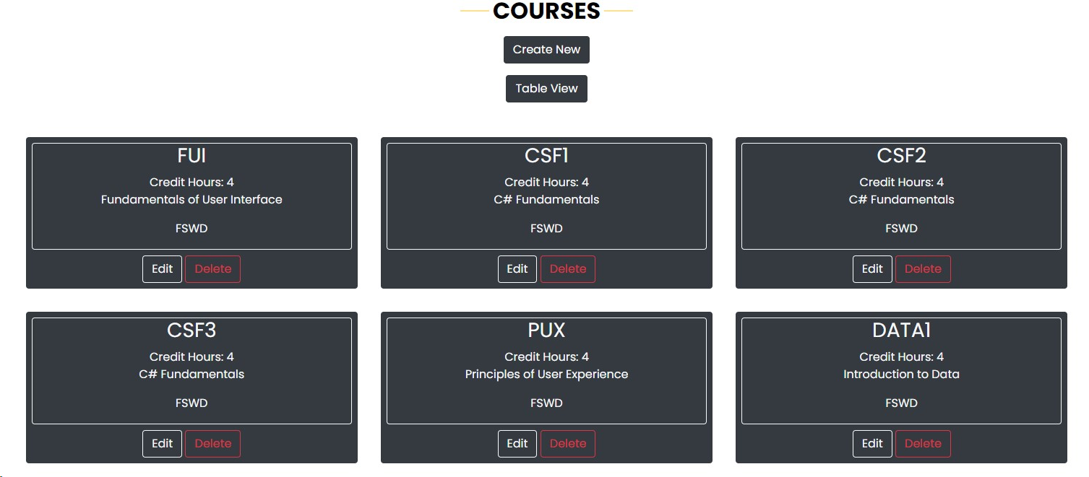

To create a tile view for our courses we had to create a new action in the controller that called our new view. Once this was created we had to style the new view and create buttons to switch between the two views.