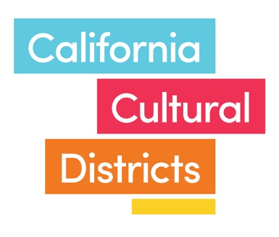**CALIFORNIA   
CULTURAL DISTRICTS**

**COMMUNITY CULTURAL ASSET INVENTORY   
*Background, Instructions, and Template***

***What is a Cultural Asset? Professor Ross Gibson, Sydney College of the Arts***

*In every community that manages to sustain or revive itself over time, there are cultural factors that contribute to the vitality and robustness of the people living there. These factors are shared and creative, which is to say they are cultural and they are assets that make life valuable, that make life worth living. These cultural assets can be material, immaterial, emotional, or even spiritual. They can be 'solid' things like concert halls, galleries, gardens, parklands and stadiums. They can be special tracts of the natural environment which encourage particular types of cultural activities. Or the climate itself might be a cultural asset if it encourages special kinds of creative and communal activities that bind people together in a place over time. Stories too might be cultural assets if they are attached to particular peoples and places if they are powerful enough to encourage people to care about and care for their place. In these stories, values can circulate, and special memories often reside in particular locations mentioned in the tales. Thus the places mentioned in the stories can be regarded as cultural assets if people tell of these places and visit them regularly and develop regular practices or rituals or ceremonies to care for them.*

[*http://camra.culturemap.org.au/page/what-cultural-asset*](http://camra.culturemap.org.au/page/what-cultural-asset)

**BACKGROUND:**

One of the best ways to document the density of cultural resources and activities in an area is to undertake the development of a cultural asset inventory; one that goes beyond just cultural organizations and facilities, and is inclusive of the many diverse contributing elements that make for a vibrant cultural center. A cultural asset inventory can take many forms, from a simple list, to a database or interactive map. In this case the product will be a categorized list, with location and notes sections (see attached template).

Ensuring that all parties have a good understanding of the full array of cultural assets present in the district will be critical to its long-term success. A comprehensive approach to cultural assets helps to ensure authenticity and the preservation of homegrown assets, both of which were indicators of a successful district based on the research conducted to develop this program.