Ed-Fi Generate Plugin

Toggle Configurations –

1. 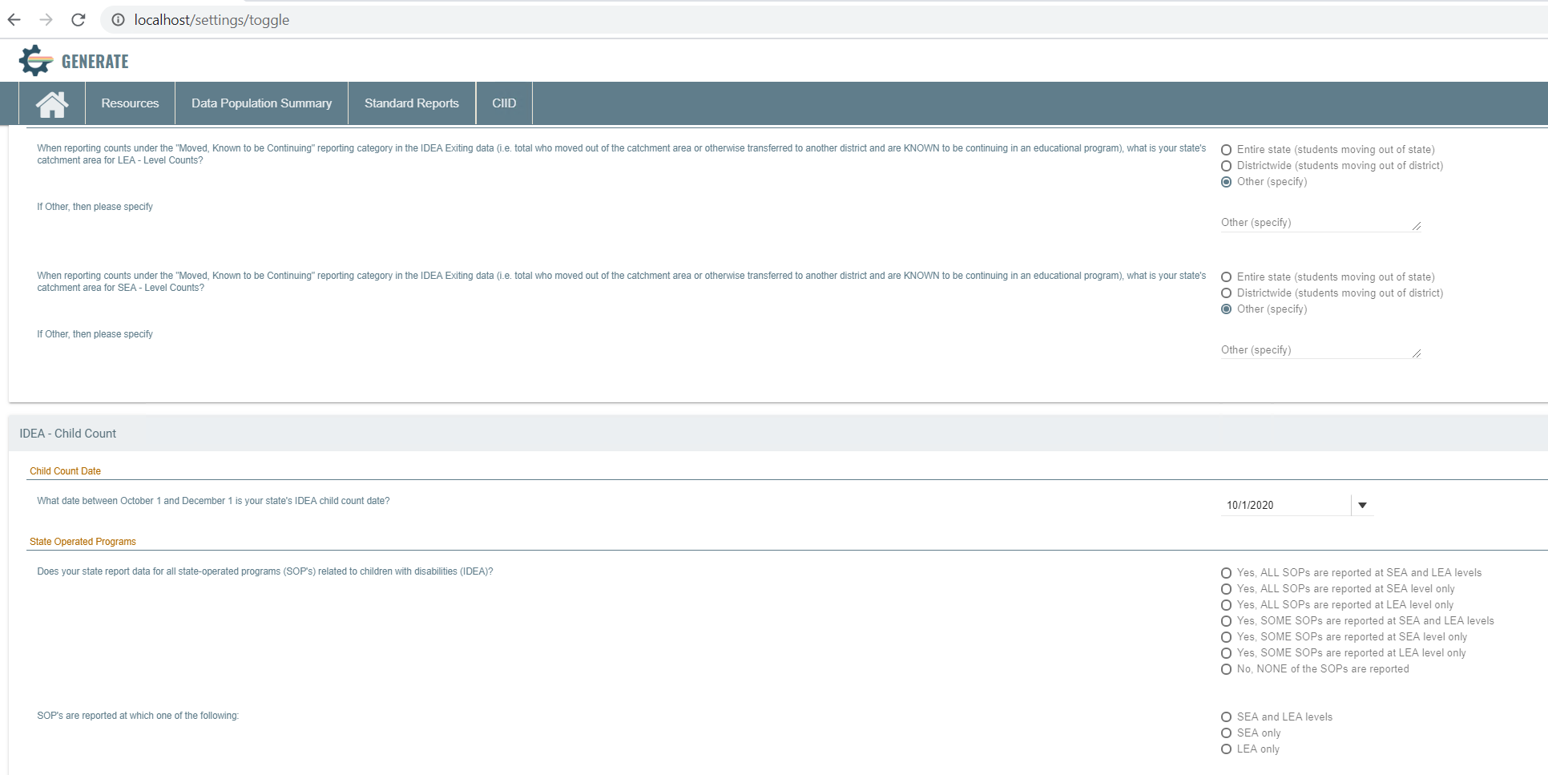
2. Turn on all the indicators

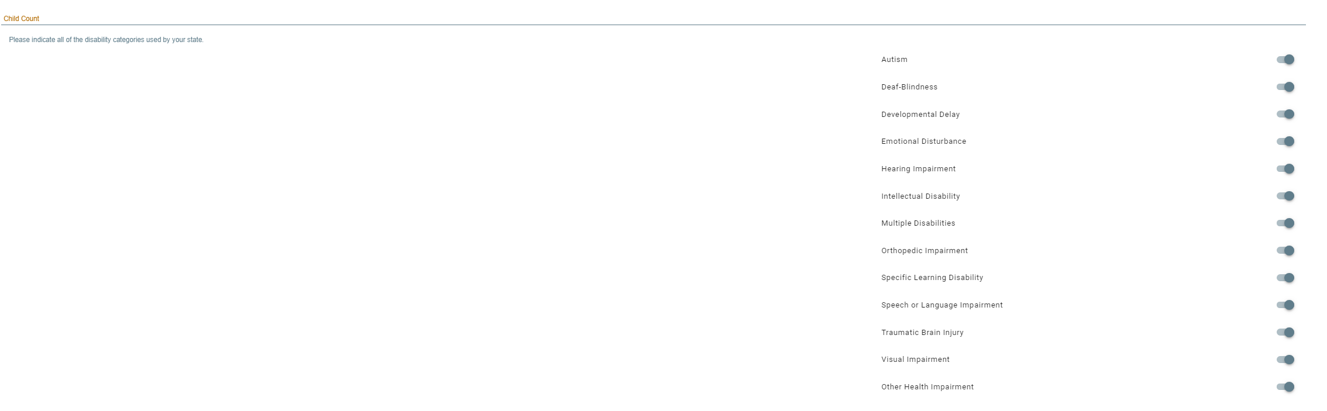

1. 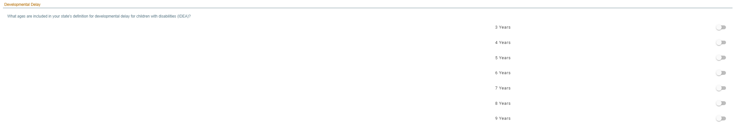
2. 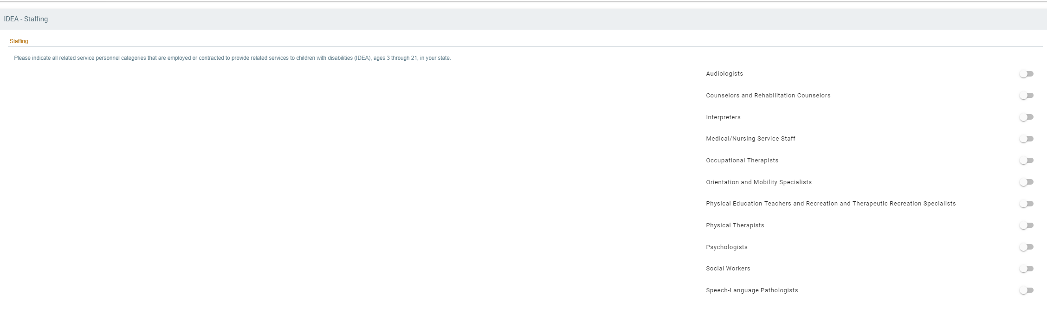
3. 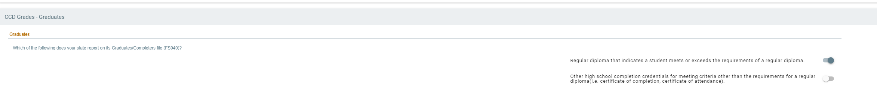
4. 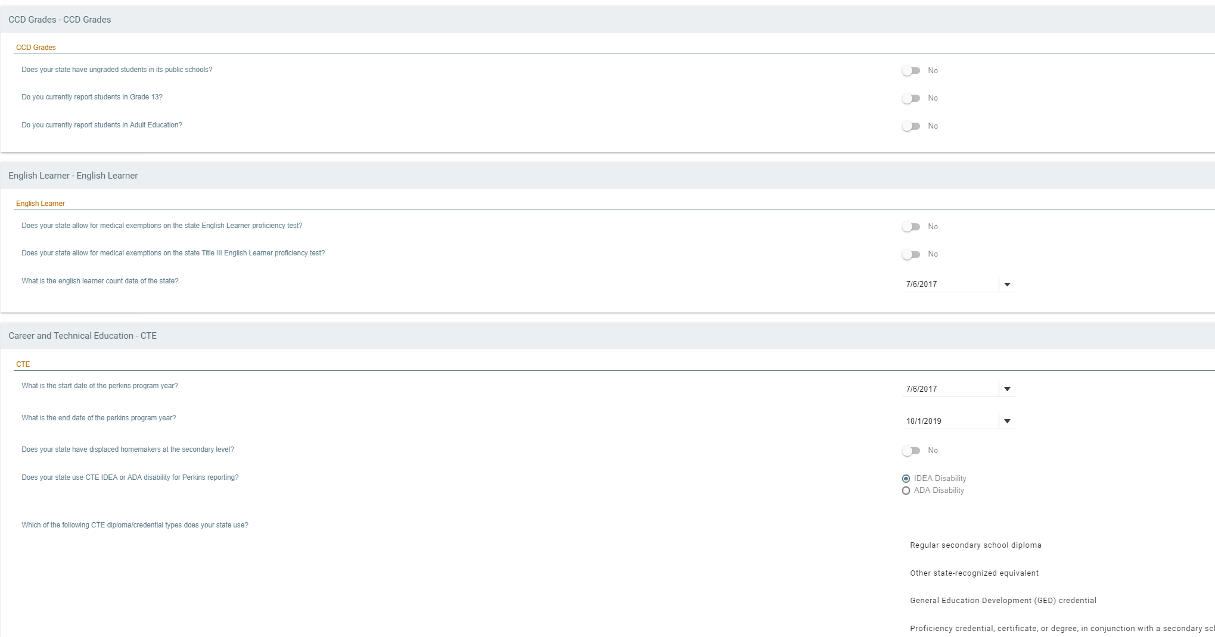
5. 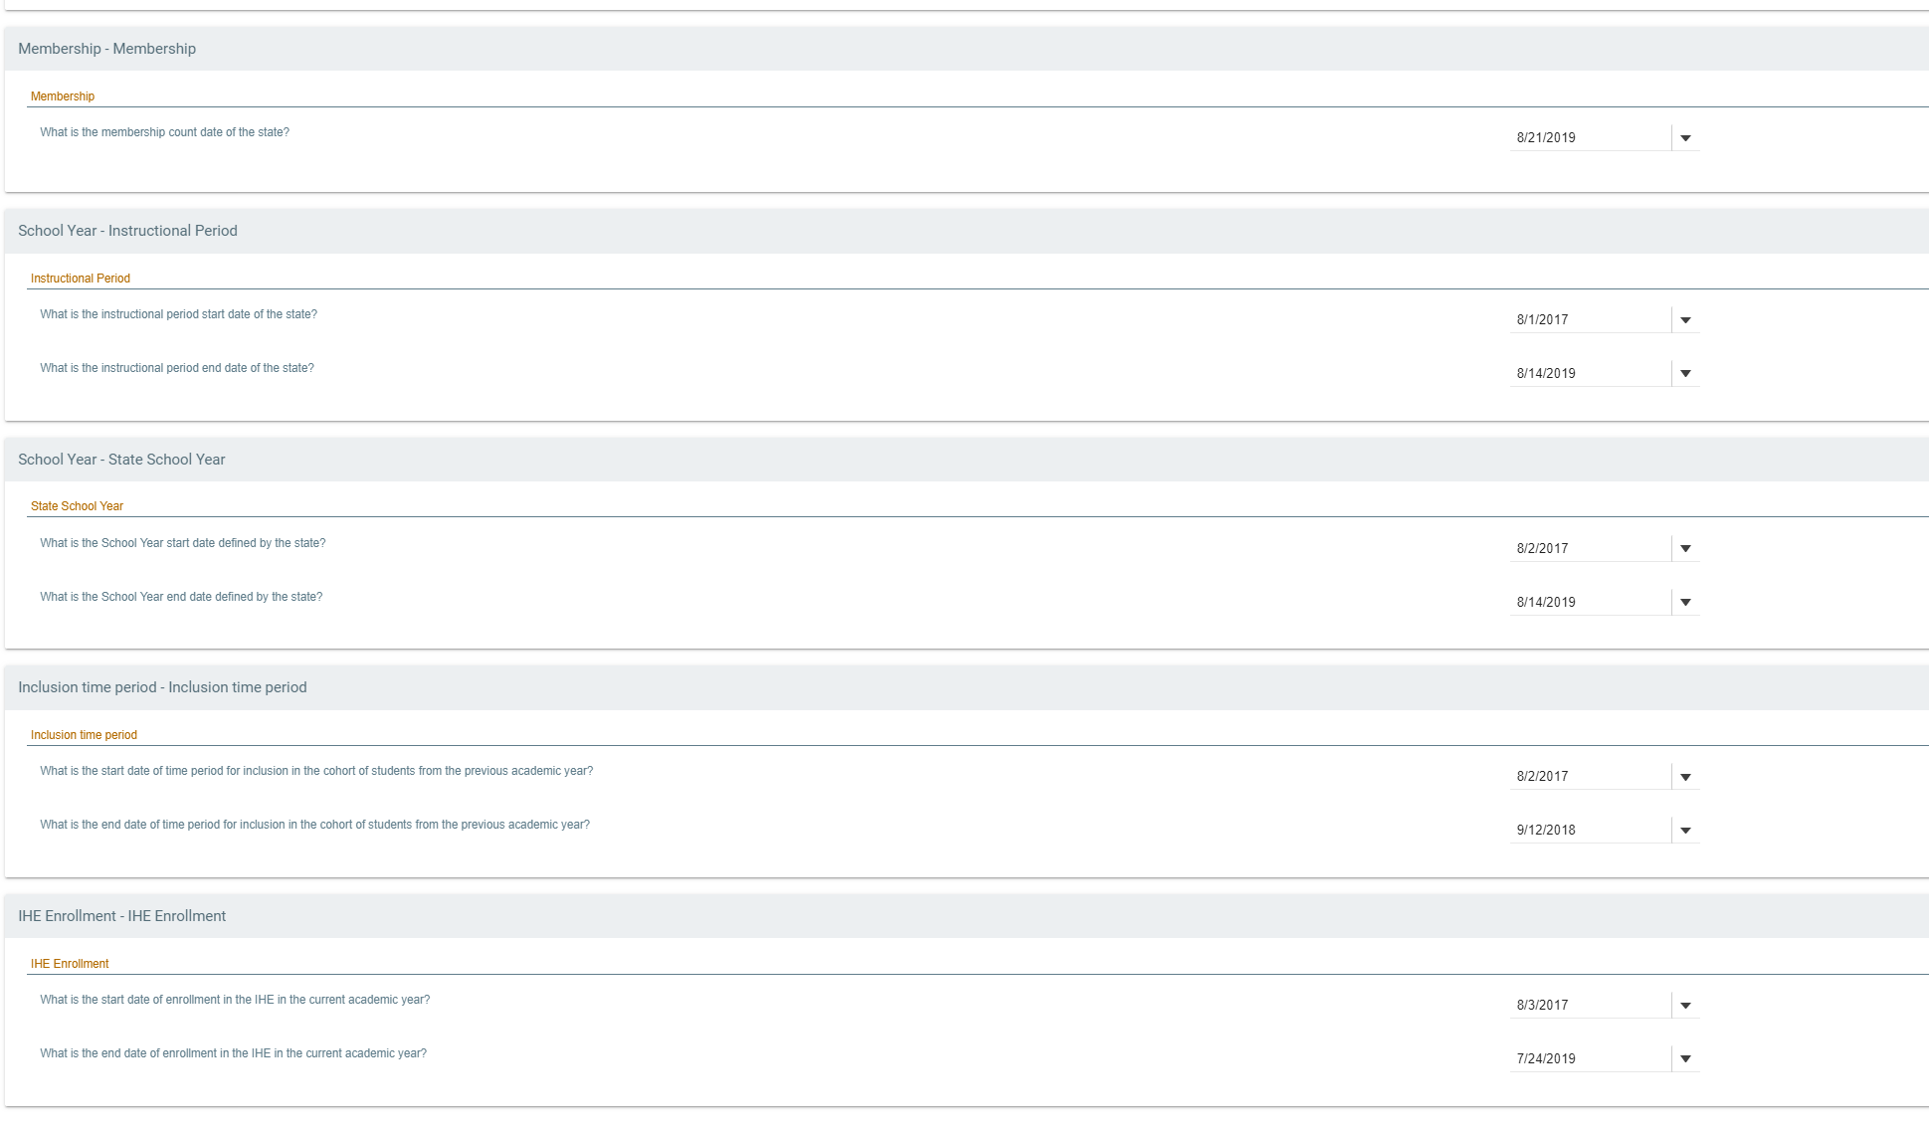
6. 