|  |
| --- |
| Leadership Portal Technical Guide |



|  |  |
| --- | --- |
| Technical documentation |  |
| Email: [juan.ignacio@developers.net]  Website: []  ` | Date: 04/13/2023 |

TABLe OF CONTENTS

Introduction 3

What is the Leadership Portal? 3

What is the purpose of the Leadership Portal? 3

To whom is this system intended? 3

Architecture 4

Data transformation 5

SQL Views 5

Roles, Responsibilities 5

Vacancy report 6

Forecast Vacancy 6

Additional risks impact vacancies 6

Who has left? 6

Identify leaders 7

What is Identify Leaders? 7

Where does the data come from? 7

Directory 8

Staff Search 8

Profiles 9

Profile details page 9

Deployment 10

How to clone and set up 10

Step 1. Install and Configure Windows Components 10

Step 2. Install and Configure Required Software 10

Step 3. Download the Ed-Fi ODS / API Installer Packages 11

Step 4. Install the Ed-Fi Databases 11

Step 5. Install WebAPI 13

How to build and deploy 13

Data Import 14

# Introduction

## What is the Leadership Portal?

The Leadership Portal is a web application designed to help senior district leaders manage campus leadership pipeline through vacancy planning.

## What is the purpose of the Leadership Portal?

The purpose of the platform is to provide district leaders with tools to help forecast vacancies, identify potential future leaders, and select leaders for current vacancies. The dashboard tools allow users to view historical vacancies, causes of those vacancies, who is eligible to retire today, what current performance looks like, and who is eligible for a potential vacancy.

## To whom is this system intended?

The system was designed for district leaders who are responsible for filling principal and ap vacancies. This is usually Superintendents, HR leaders, Principal Supervisors, senior staff members, or Talent Management leaders.

# Architecture

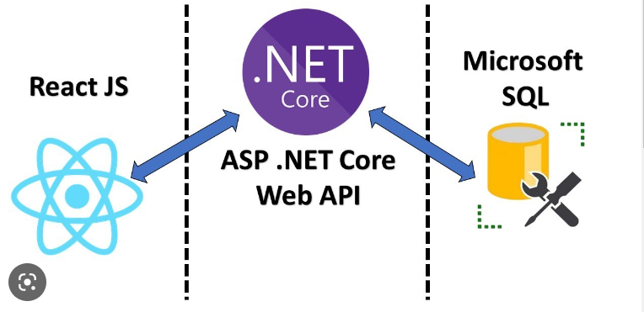The Leadership Portal contains:

.Net Core WebAPI

React UI application

EDFI API (Optional)

The application consists of a Frontend written in Angular and the backend written in .Net Core. It also uses the EDFI data standard in its ODS which allows us to install a secondary EDFI API.

|  |
| --- |
| EDFI ODS  We use EDFI Data Standard to improve interoperability with other education applications. Attached is a correspondence map for the application data in the EDFI and EPDM tables. |

# Data transformation

## SQL Views

The application retrieves the data through a direct SQL connection to the ODS used, processes it through SQL views to obtain a list of staff assignments in recent years, differentiates the data as vacancy-causing, or not, depending on the date of termination with respect to the end of the year, so that if they end before the school year, it means that they have created a vacancy.

The tables contain the following properties:

* The *edfi.StaffEducationOrganizationAssignmentAssociation* table helps us to get the assigned school year, the assigned position, begin date and end date.
* The *edfi.EducationOrganization* table contains the data related to the school, i.e.: name, level, number.
* The *edfi.Staff* table gives us personal information about the educators like unique id, full name, gender, ethnicity, birthday.

## Roles, Responsibilities

* District Administration: Deciding on customizable features of the Leadership Portal (such as position titles, filter criteria, scoring scale and data). Oversight for the District’s Portal.
* IT leadership: Ensuring district resources have what is needed for connecting district data to the ODS.
* IT staff: Provide data copies to be loaded to the ODS & ensure the format is correct. Troubleshoot any upload issues.

|  |  |  |
| --- | --- | --- |
| **District Role** | **Time During Implementation** | **After Portal Launch** |
| District Admin/Central Office | Time at the onset to discuss district requirements of the Portal | Should not be needed |
| IT Leadership & Staff (DBA & admin) | Part time (5-10 hours per week) during implementation | 0-2 hours per week to manage data uploads to ODS |

# Vacancy report

## Forecast Vacancy

The forecast is a five-year average of vacancies for the role selected (Principal or AP). The average serves as a foundational forecast for the number of vacancies a district can expect in the coming school year.

## Additional risks impact vacancies

This section considers some factors involved in educator attrition such as retirement and performance. We start by calling the API to invoke a SQL view which will look at the next tables and bring a list of the last five years assignments that have been identified as vacancies.

* In the first section we group the assignments by school, for each row we name the school and then count and list the staff causing vacancies for that educational institution.
* The remaining years to retirement are calculated as follows: 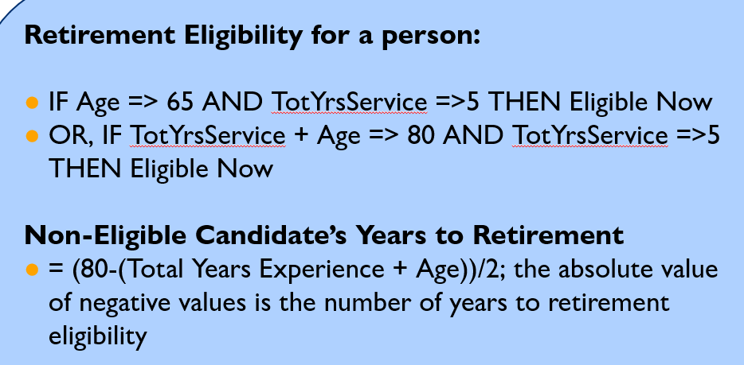
* An indicator of employee's current overall performance is displayed to detect anomalies that could cause vacancies (High/low performers).

## Who has left?

In this section, we provide demographic information to more accurately interpret the vacancies generated.

# Identify leaders

## What is Identify Leaders?

In this section, we can see the list of all the educators in the system and refine the search with criteria such as type of role, school level, certifications, evaluations, and years of experience.

Leaders will use this tool to filter potential candidates to build a pool of talent who can fill future vacancies.

|  |  |  |
| --- | --- | --- |
| Identificación de empleado | Engranajes | Apretón de manos |

## Where does the data come from?

The information is retrieved from an EdFi database and transformed using the WebAPI to display the results.

# Directory

## Staff Search

This is the full directory of all staff available. Here you can find all the information related to the individual employee. This tool allows users to filter results by positions, school categories, schools, tenure, degrees and performance evaluations.

# Profiles

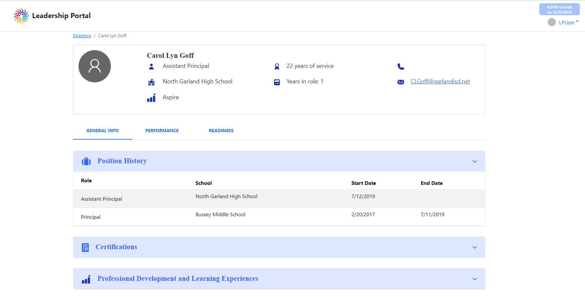

## Profile details page

In this section, we can see the list of all the educators in the system and refine the search with criteria such as type of role, school level, position history, certifications, evaluations, and years of experience.

This is a detailed overview of a district employee. It works with many tables including the main ones below:

* *edfi.Staff,* includes all main Staff data.
* *edfi.StaffEducationOrganizationAssignmentAssociation,* includes the assignments for this educator (job history).
* *edfi.StaffSchoolAssociationGradeLevel*, includes grade level assignments
* *edfi.EducatorRoleDescriptor,* These are the role descriptors.
* *edfi.StaffRecognition,* These are recognitions for the educator in education programs.
* *edfi.StaffLanguageUse,* This contains the languages an educator speaks.

# Deployment

## How to clone and set up

We use EDFI as the Data Standard, so the first steps in this guide are to install EDFI ODS. All the process can be summarized as:

* Install and Configure Windows Components
* Install and Configure Required Software
* Download the Ed-Fi ODS / API Installer Packages
* Install the Ed-Fi Databases
* Install WebAPI
* Install EdFi API (optional)

## Step 1. Install and Configure Windows Components

* Ensure that the following components are installed:
* PowerShell 5.0. PowerShell is used to initialize the development environment.
* .NET Core 3.1.301 SDK. The .NET Core 3.1 Software Developer Kit is required for compiling the solution.
* .NET Core Hosting Bundle 3.1.x The .NET Core 3.1 ASP.NET Hosting Bundle is required for running the ODS / API
* Internet Information Services. IIS is the web server that will run the ODS / API.

## Step 2. Install and Configure Required Software

Ensure that the following software is installed and configured:

* **Microsoft SQL Server 2016 or 2017.** Microsoft SQL Server is used to store the data for the Ed-Fi ODS / API. Local installation of Standard, Developer, or Enterprise Editions with Service Pack 2 or higher is supported.

## Step 3. Download the Ed-Fi ODS / API Installer Packages

The required release packages to install the Ed-Fi ODS / API can be found at the links below. We recommend you to stay current with the latest patch update that has been promoted to [release](https://dev.azure.com/ed-fi-alliance/Ed-Fi-Alliance-OSS/_packaging?_a=feed&feed=EdFi%40Release).

* [EdFi.Suite3.Installer.WebApi](https://dev.azure.com/ed-fi-alliance/Ed-Fi-Alliance-OSS/_artifacts/feed/EdFi/NuGet/EdFi.Suite3.Installer.WebApi/overview/5.3.9)
* [EdFi.Suite3.Installer.SwaggerUI](https://dev.azure.com/ed-fi-alliance/Ed-Fi-Alliance-OSS/_artifacts/feed/EdFi/NuGet/EdFi.Suite3.Installer.SwaggerUI/overview/5.3.5) (Optional, not for production)
* [EdFi.Suite3.RestApi.Databases](https://dev.azure.com/ed-fi-alliance/Ed-Fi-Alliance-OSS/_artifacts/feed/EdFi/NuGet/EdFi.Suite3.RestApi.Databases/overview/5.3.1146)
* [EdFi.Suite3.Ods.Extensions.TPDM.Community.1.1.0](https://dev.azure.com/ed-fi-alliance/Ed-Fi-Alliance-OSS/_artifacts/feed/EdFi/NuGet/EdFi.Suite3.Ods.Extensions.TPDM.Community.1.1.0/overview/5.3.67)

For each of the downloads, **right-click** and select "Properties." Update the file extension (from .nupkg to .zip). Check the box next to **Unblock** (this will prevent Powershell from asking for permission to load every module in the installer) and click **OK**.

## Step 4. Install the Ed-Fi Databases

Extract the contents of the EdFi.Suite3.RestApi.Databases package. The paths in these instructions assume that the package was extracted to a folder with the name of the package (e.g., C:\temp\EdFi.Suite3.RestApi.Databases).

*Download and install the EPDM Database Deployment Scripts*

Download the minimal and populated scripts for your chosen database engine (MS SQL Server or PostgreSQL) and copy them to the Ed-Fi-ODS-Implementation\DatabaseTemplate\Scripts folder of the EdFi.Suite3.RestApi.Databases extracted above

SQL Server:  [Populated Template Script](https://github.com/Ed-Fi-Exchange-OSS/Ed-Fi-TPDM-Community-Artifacts/blob/main/Database%20Installation%20Scripts/TPDMCommunityPopulatedTemplate.ps1)  [Minimal Template Script](https://github.com/Ed-Fi-Exchange-OSS/Ed-Fi-TPDM-Community-Artifacts/blob/main/Database%20Installation%20Scripts/TPDMCommunityMinimalTemplate.ps1)

PostgreSQL: [Populated Template Script](https://github.com/Ed-Fi-Exchange-OSS/Ed-Fi-TPDM-Community-Artifacts/blob/main/Database%20Installation%20Scripts/PostgreSqlTPDMCommunityPopulatedTemplate.ps1)  [Minimal Template Script](https://github.com/Ed-Fi-Exchange-OSS/Ed-Fi-TPDM-Community-Artifacts/blob/main/Database%20Installation%20Scripts/PostgreSqlTPDMCommunityMinimalTemplate.ps1)

*Edit the configuration.json File*

There are several settings in the configuration file that are left empty as they depend on whether you are opting of SQL Server or PostgreSQL backend. Update the settings by consulting the samples provided below.

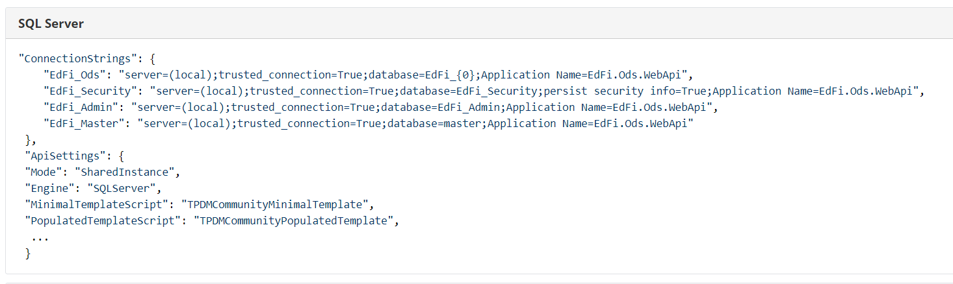

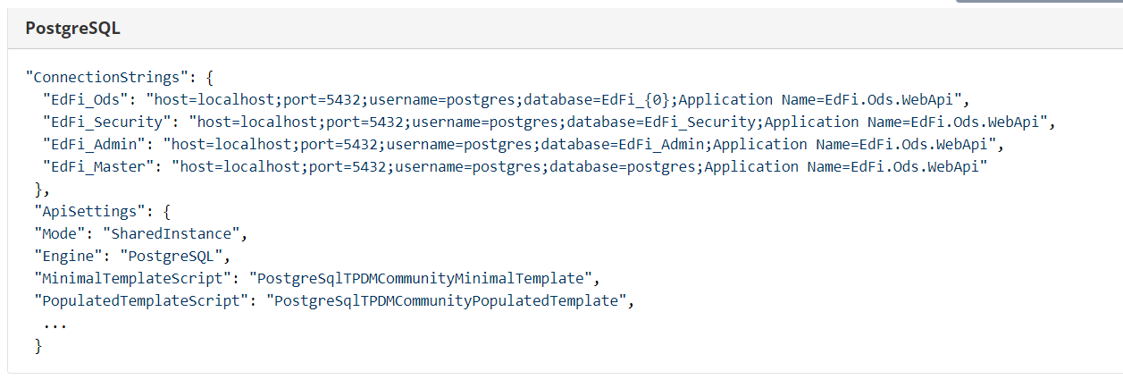

Edit the Plugin section of the configuration file and update the Folder and Scripts values to the following:

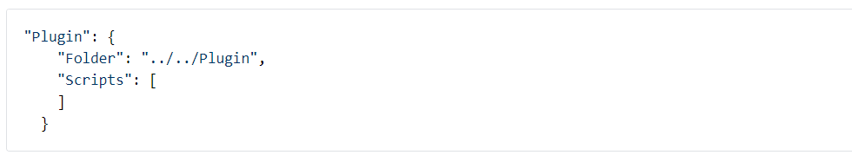

Open a PowerShell window in Administrator mode and navigate to the EdFi.Suite3.RestApi.Databases package folder and run the following Powershell command to load modules for installationRun Installation Script

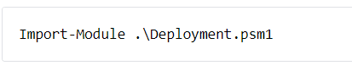

Finally, execute the following command in PowerShell:

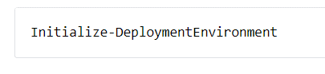

## Step 5. Install WebAPI

Clone the Leadership Portal repo and just build the dependencies.

## How to build and deploy

You should create an Angular build and a C# build that contains it, with the following command.

*Initialize-Build*

Then you can publish this artifacts to a webserver by FTP with the following command.

*Initialize-Publish*

# Data Import

Review the requirements and capabilities of the [Data Import Tool](https://techdocs.ed-fi.org/display/EDFITOOLS/Data+Import).

# About The Holdsworth Center