全加器

功能：

全加器是一种考虑来自低位进位的加法器，即输入a_in和输入b_in和来自低位的进位carry_in经全加器full_adder后得到输出和sum_out与进位输出carry_out。

端口

|  |  |  |  |
| --- | --- | --- | --- |
| PIN Name | Width | Direction | Function |
| a_in | 1 | input | Input data1 |
| b_in | 1 | input | Input data2 |
| carry_in | 1 | input | Input carry_in |
| sum_out | 1 | output | Sum of a_in + b_in + carry_in |
| carry_out | 1 | output | Carry_out a_in + b_in + carry_in |

算法

真值表如下

|  |  |  |  |  |
| --- | --- | --- | --- | --- |
| a_in | b_in | carry_in | sum_out | carry_out |
| 0 | 0 | 0 | 0 | 0 |
| 0 | 0 | 1 | 1 | 0 |
| 0 | 1 | 0 | 1 | 0 |
| 0 | 1 | 1 | 0 | 1 |
| 1 | 0 | 0 | 1 | 0 |
| 1 | 0 | 1 | 0 | 1 |
| 1 | 1 | 0 | 0 | 1 |
| 1 | 1 | 1 | 1 | 1 |

RTL

（1）直接使用“+”， 由综合器综合

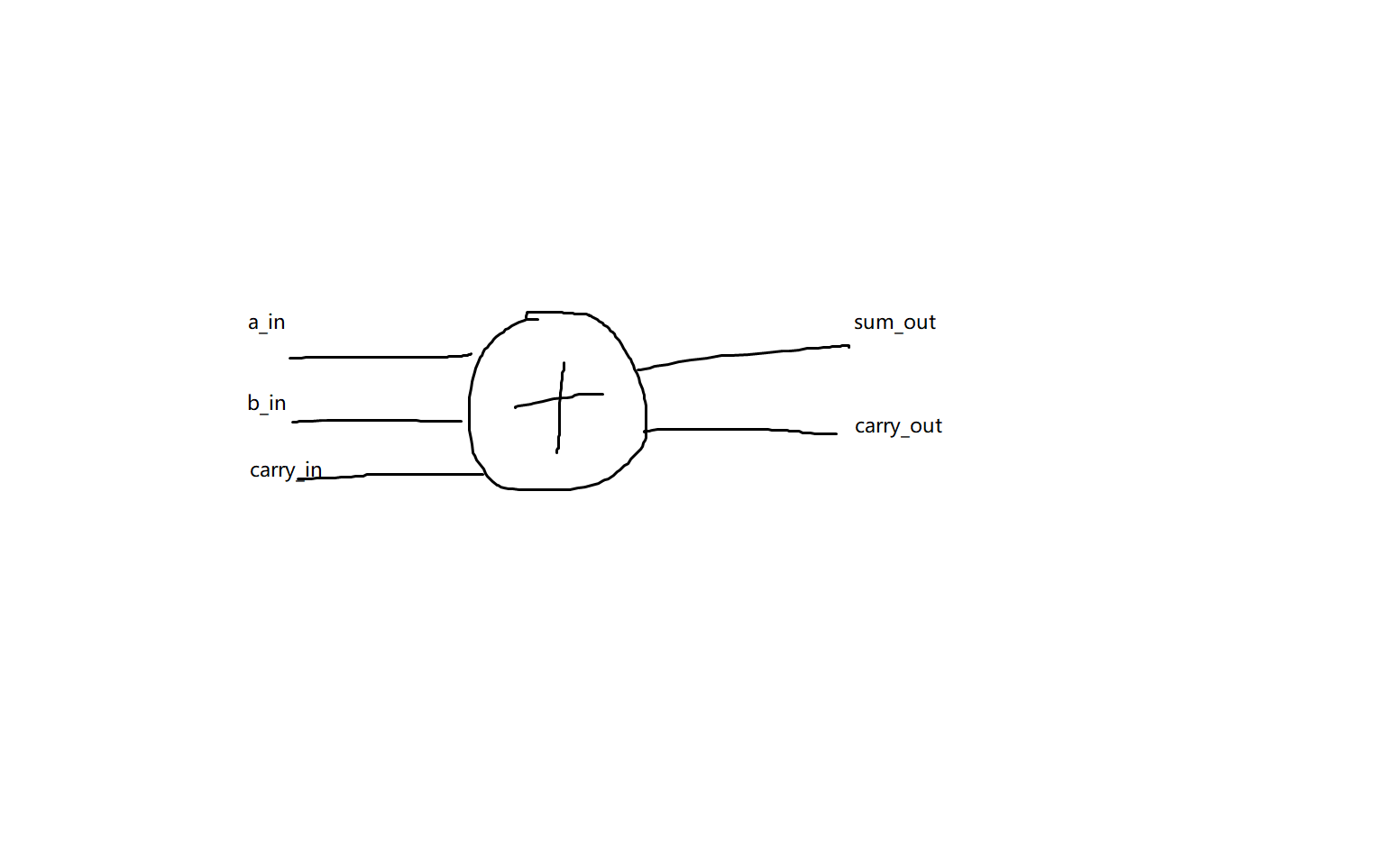

（2）使用已有的半加器

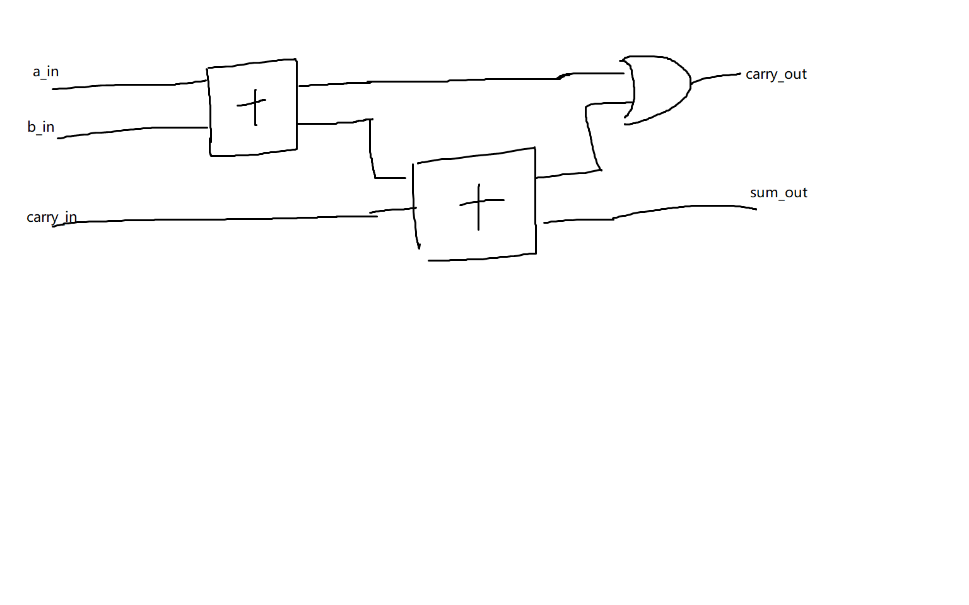

1. 使用门级电路

