Результаты статистического анализа
Набор данных: Файл данных 606be...
Протокол: Первичка — полный отчёт по всем показателям (comparisons vs arm)
Дата: 2026-01-21 00:40

Шаг: cmp__age
Метод: Mann-Whitney U Test
p-value | 0.7595
статистика | 228.500
эффект | rbc -0.06
мощность | -
BF10 | -
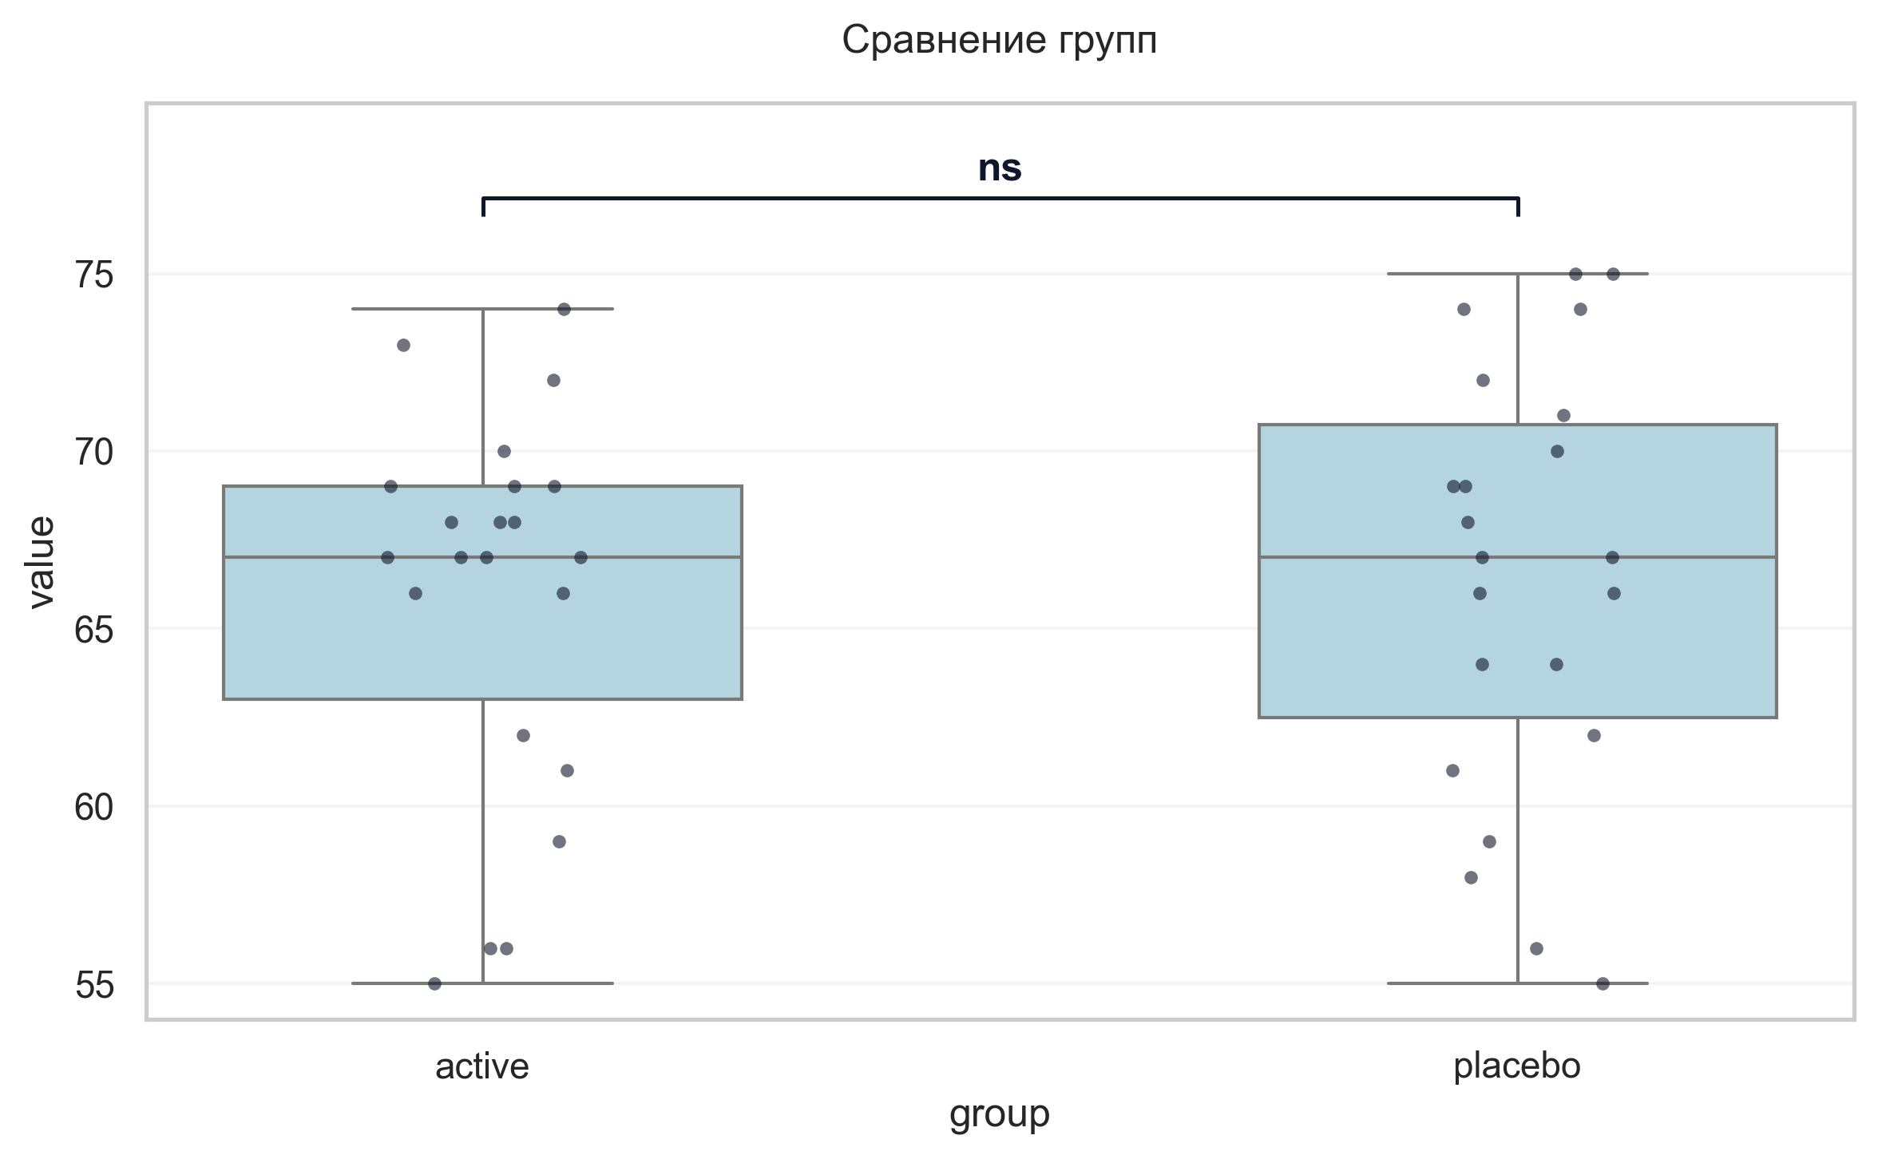
Интерпретация:
An independent Mann-Whitney U Test was conducted to determine if there were differences in age between groups defined by arm. The analysis revealed no statistically significant difference between the groups (p = 0.760, r = -0.06 indicates a trivial effect).

Шаг: cmp__sex
Метод: Chi-Square Test of Independence
p-value | 0.7540
статистика | 0.098
эффект | -
мощность | -
BF10 | -
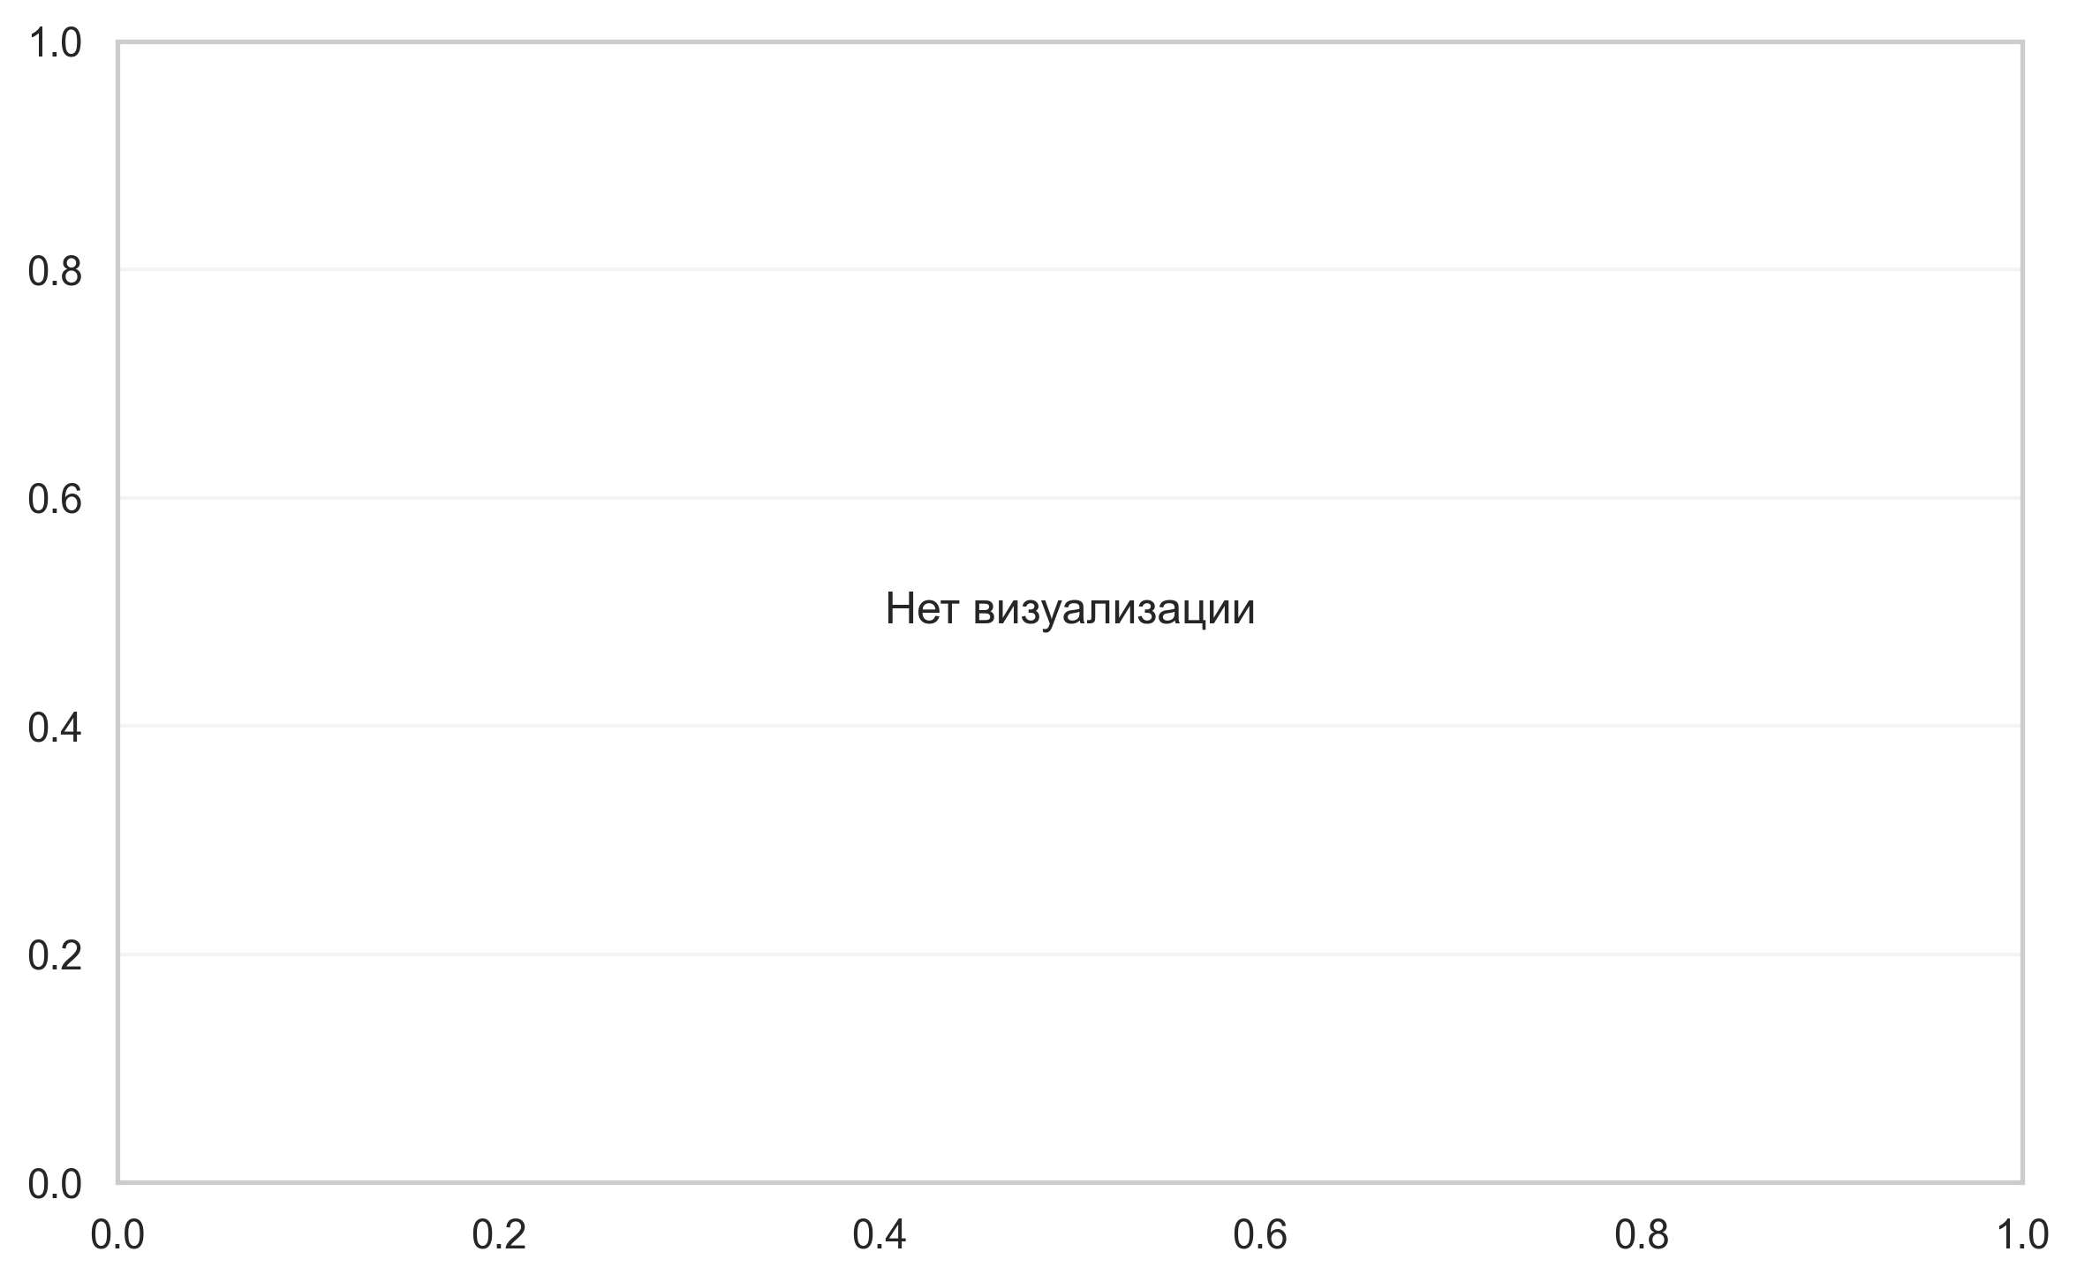
Интерпретация:
A Chi-Square test of independence was performed to examine the relation between sex and arm. The relation between these variables was not significant (p = 0.754). sex appears to be independent of arm.

Шаг: cmp__сад_v1
Метод: Student's t-test (Independent)
p-value | 0.4010
статистика | 0.848
эффект | cohen-d 0.26
мощность | 0.13
BF10 | 0.398
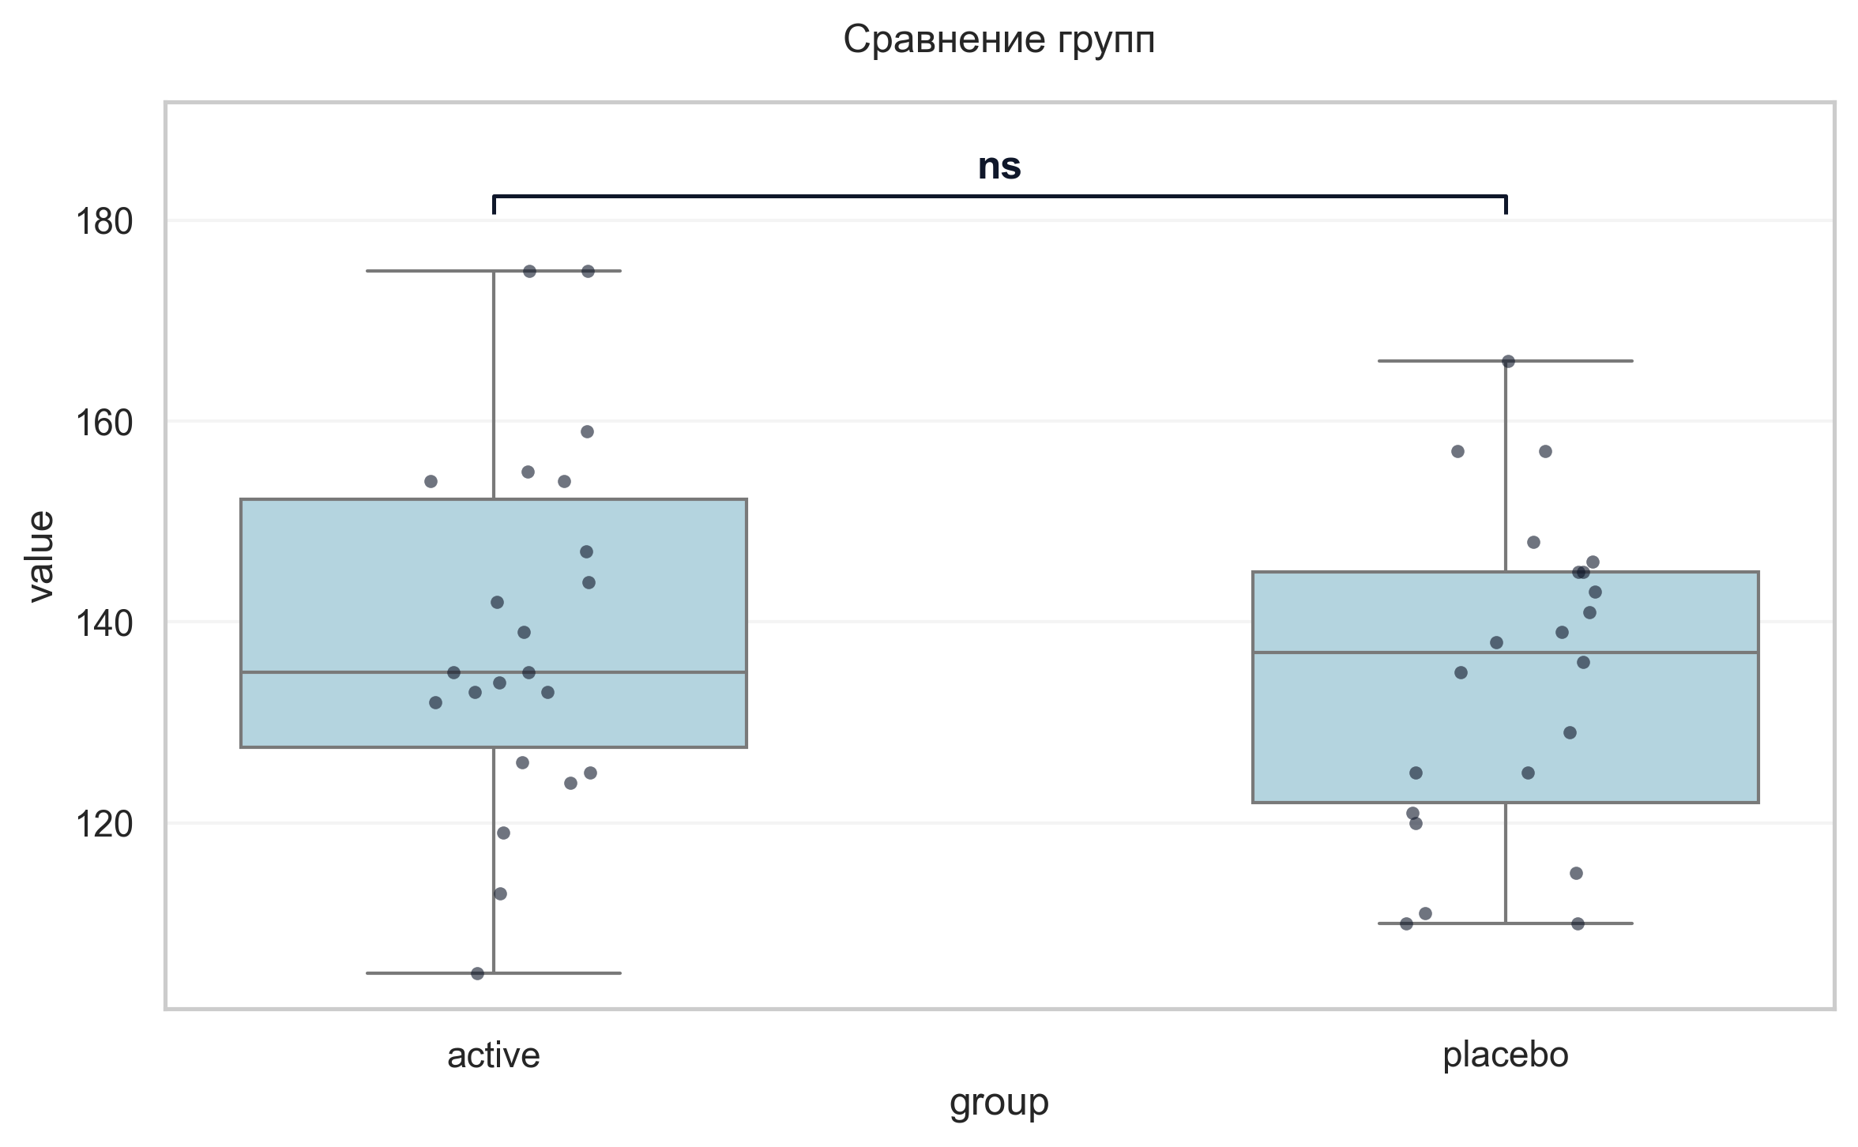
Интерпретация:
An independent Student's t-test (Independent) was conducted to determine if there were differences in САД V1 between groups defined by arm. The analysis revealed no statistically significant difference between the groups (p = 0.401, Cohen's d = 0.26 indicates a small effect).

Шаг: cmp__дад_v1
Метод: Student's t-test (Independent)
p-value | 0.3440
статистика | 0.957
эффект | cohen-d 0.29
мощность | 0.15
BF10 | 0.43
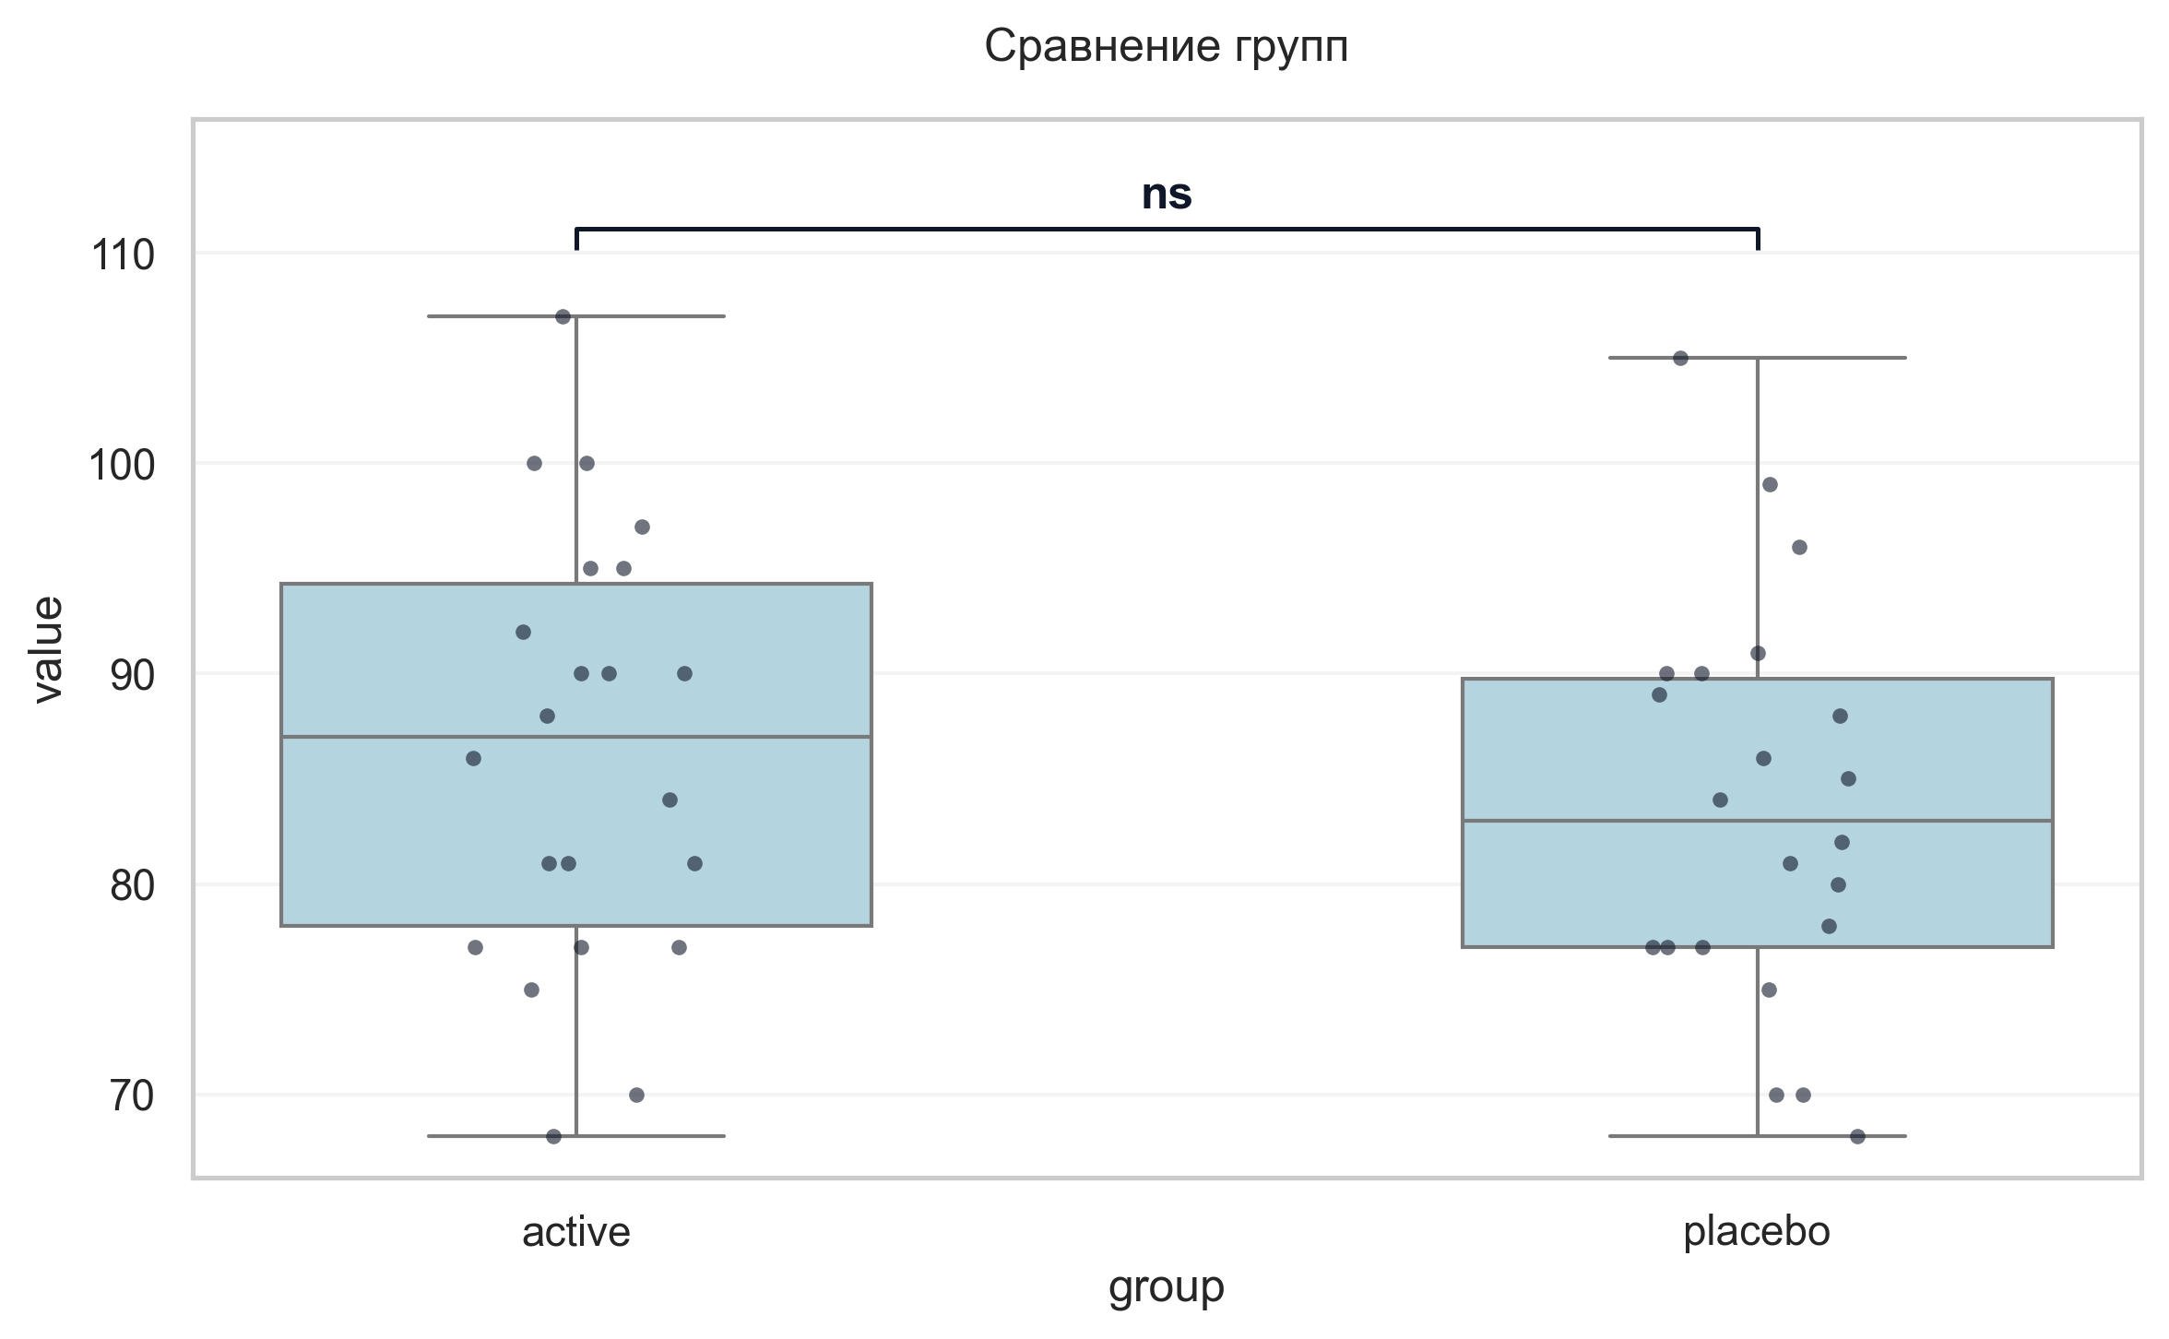
Интерпретация:
An independent Student's t-test (Independent) was conducted to determine if there were differences in ДАД V1 between groups defined by arm. The analysis revealed no statistically significant difference between the groups (p = 0.344, Cohen's d = 0.29 indicates a small effect).

Шаг: cmp__сад_v2
Метод: Mann-Whitney U Test
p-value | 0.9531
статистика | 245.000
эффект | rbc 0.01
мощность | -
BF10 | -
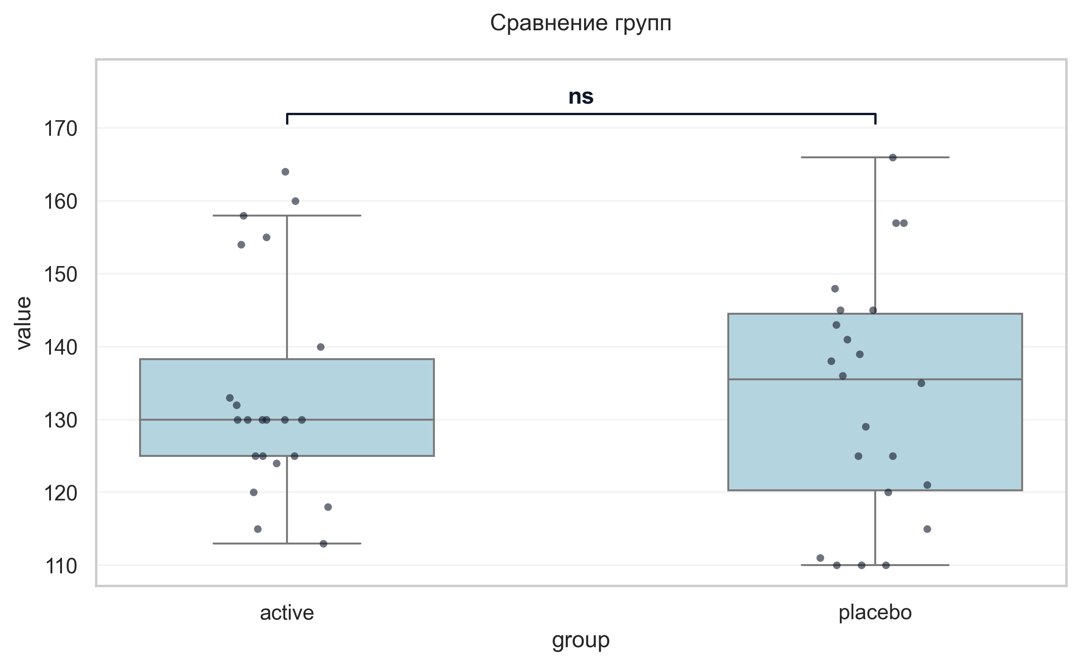
Интерпретация:
An independent Mann-Whitney U Test was conducted to determine if there were differences in САД V2 between groups defined by arm. The analysis revealed no statistically significant difference between the groups (p = 0.953, r = 0.01 indicates a trivial effect).

Шаг: cmp__дад_v2
Метод: Mann-Whitney U Test
p-value | 0.1694
статистика | 300.500
эффект | rbc 0.24
мощность | -
BF10 | -
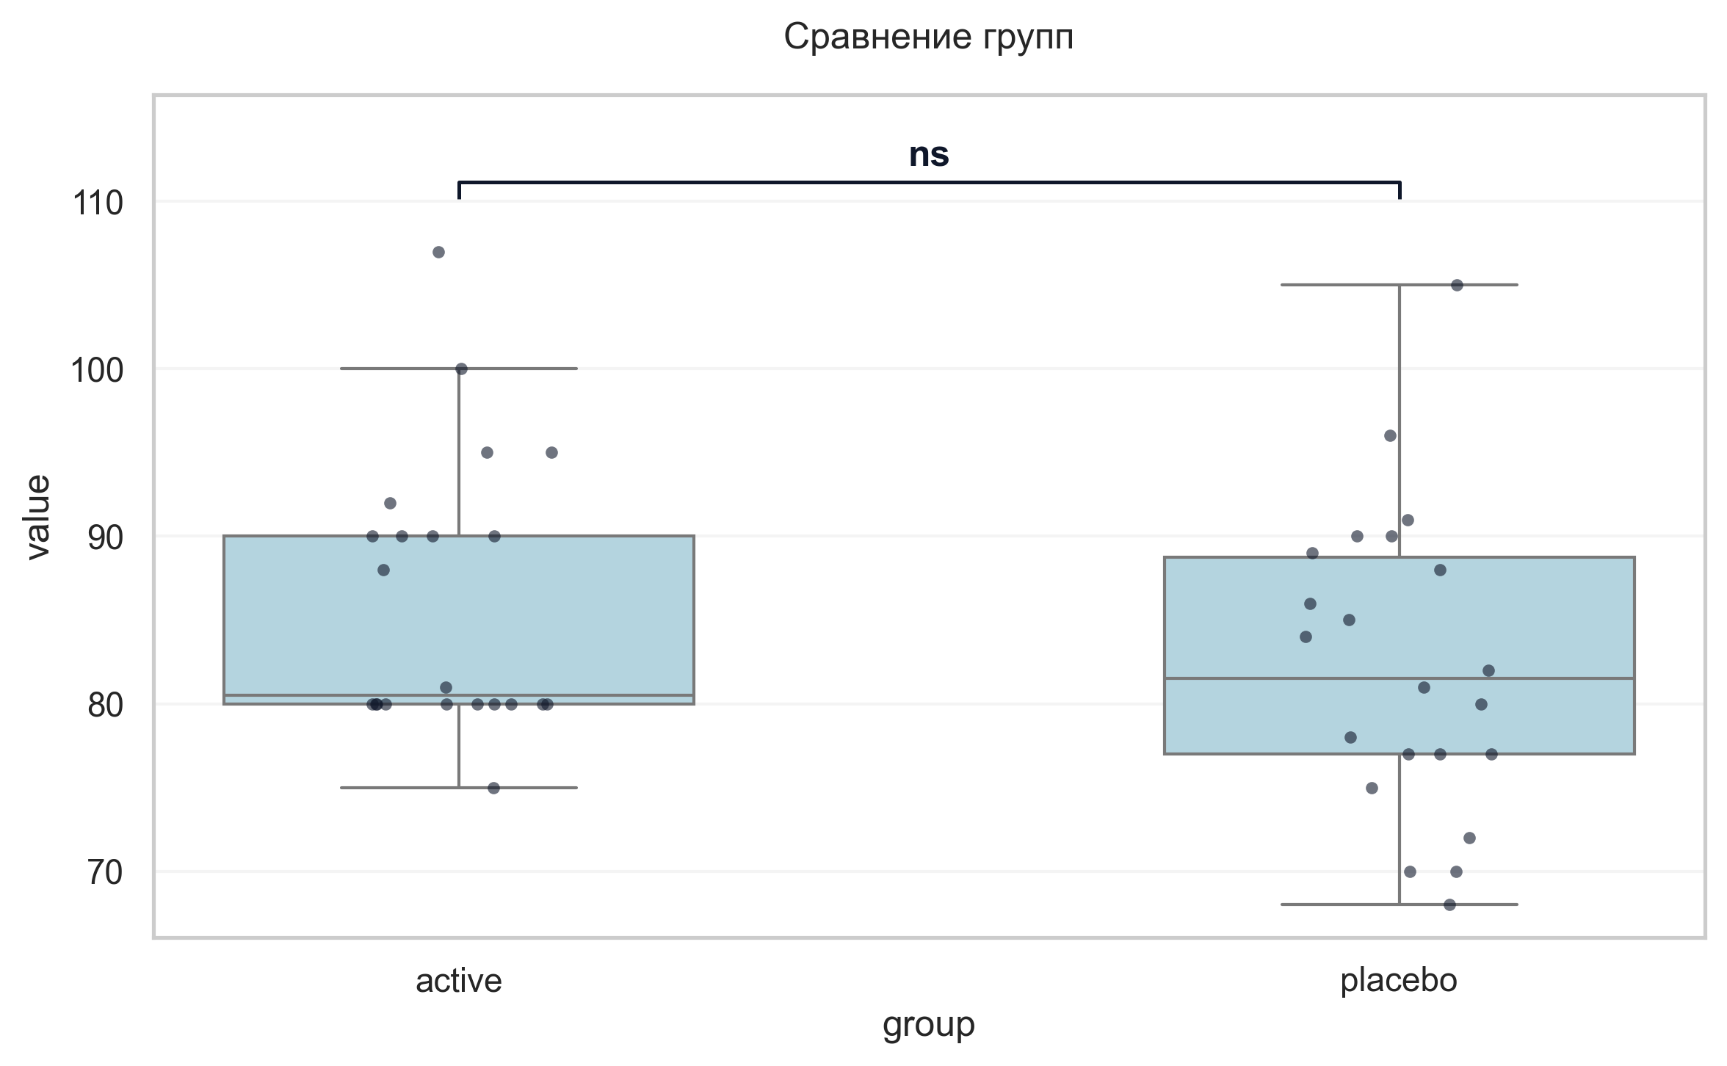
Интерпретация:
An independent Mann-Whitney U Test was conducted to determine if there were differences in ДАД V2 between groups defined by arm. The analysis revealed no statistically significant difference between the groups (p = 0.169, r = 0.24 indicates a small effect).

Шаг: cmp__ушобп_часть_2_повседневная_активность_баллы_v2
Метод: Student's t-test (Independent)
p-value | 0.1539
статистика | 1.452
эффект | cohen-d 0.44
мощность | 0.29
BF10 | 0.69
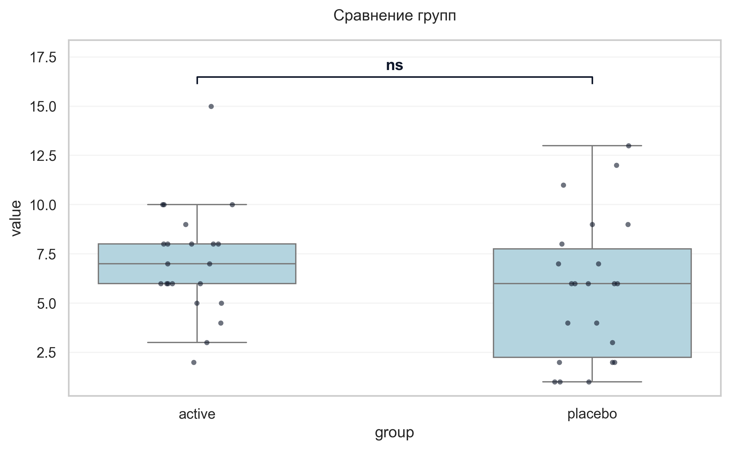
Интерпретация:
An independent Student's t-test (Independent) was conducted to determine if there were differences in УШОБП часть 2 «Повседневная активность» баллы V2 between groups defined by arm. The analysis revealed no statistically significant difference between the groups (p = 0.154, Cohen's d = 0.44 indicates a small effect).

Шаг: cmp__ушобп_часть_3_двигательные_функции_баллы_v2
Метод: Welch's T-Test
p-value | 0.9532
статистика | -0.059
эффект | cohen-d 0.02
мощность | 0.05
BF10 | 0.298
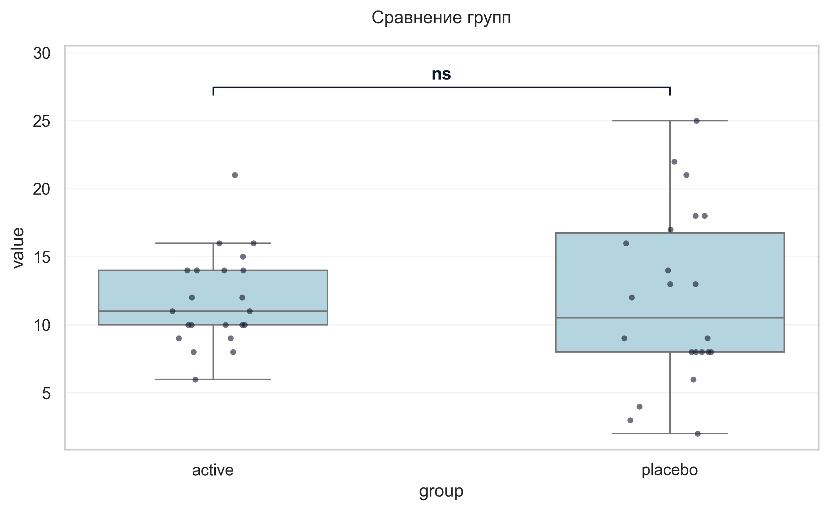
Интерпретация:
An independent Welch's T-Test was conducted to determine if there were differences in УШОБП часть 3 «Двигательные функции» баллы V2 between groups defined by arm. The analysis revealed no statistically significant difference between the groups (p = 0.953, Cohen's d = 0.02 indicates a trivial effect).

Шаг: cmp__шкала_депрессии_тревоги_и_стресса_dass_21_баллы_v2
Метод: Student's t-test (Independent)
p-value | 0.0074
статистика | -2.814
эффект | cohen-d 0.85
мощность | 0.78
BF10 | 6.2
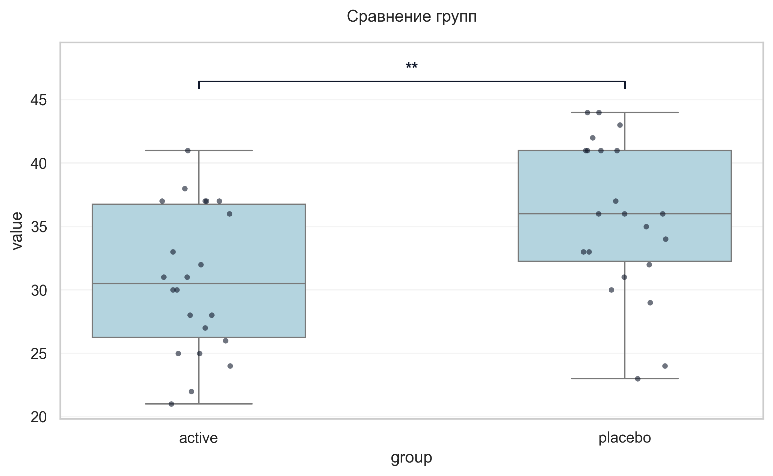
Интерпретация:
An independent Student's t-test (Independent) was conducted to determine if there were differences in Шкала депрессии тревоги и стресса DASS-21 баллы V2 between groups defined by arm. There was a statistically significant difference between the groups (p = 0.007, Cohen's d = 0.85 indicates a large effect). Specifically, the Шкала депрессии тревоги и стресса DASS-21 баллы V2 in the active group (M = 30.73) was significantly lower than in the placebo group (M = 35.73).

Шаг: cmp__шкала_оценки_утомляемости_при_бп_баллы_v2
Метод: Student's t-test (Independent)
p-value | 0.2187
статистика | -1.249
эффект | cohen-d 0.38
мощность | 0.23
BF10 | 0.555
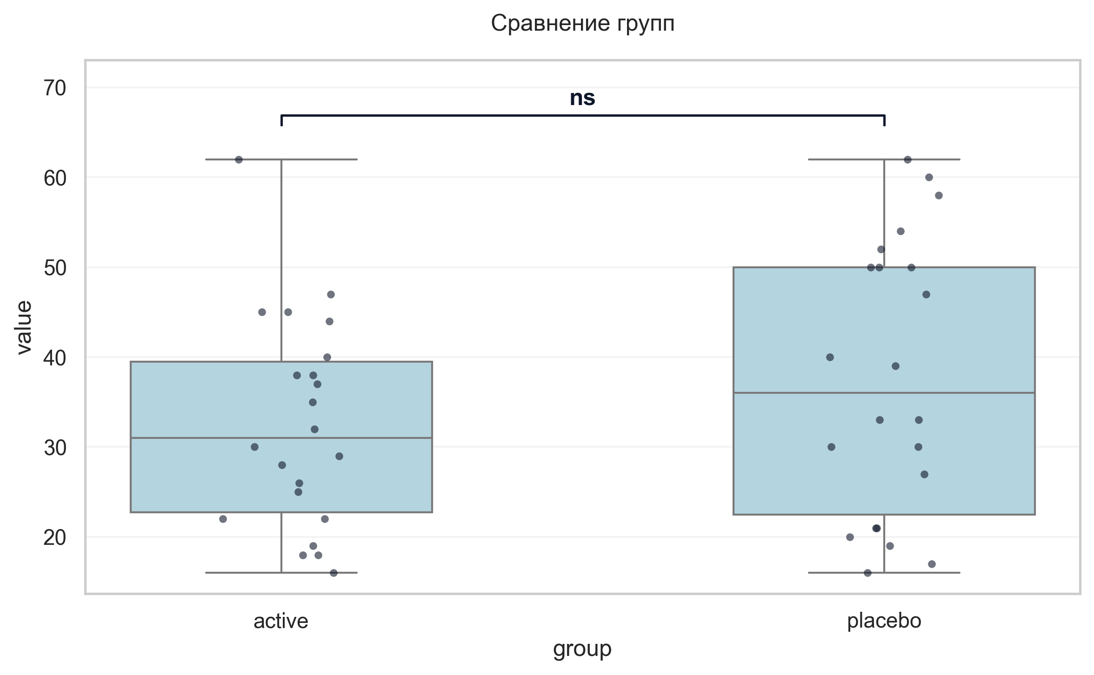
Интерпретация:
An independent Student's t-test (Independent) was conducted to determine if there were differences in Шкала оценки утомляемости при БП баллы V2 between groups defined by arm. The analysis revealed no statistically significant difference between the groups (p = 0.219, Cohen's d = 0.38 indicates a small effect).

Шаг: cmp__шкала_оценки_сонливости_эпуорта_баллы_v2
Метод: Mann-Whitney U Test
p-value | 0.8316
статистика | 232.500
эффект | rbc -0.04
мощность | -
BF10 | -
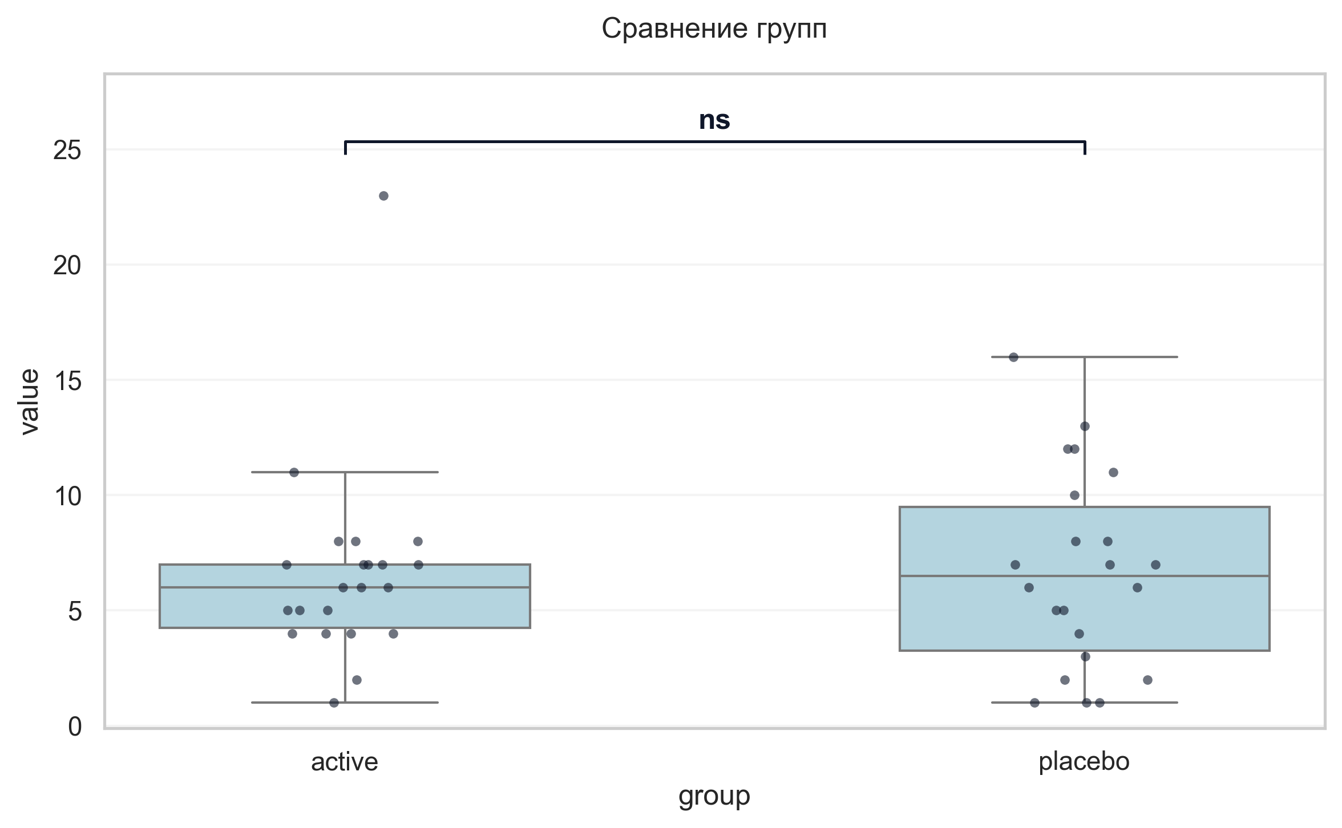
Интерпретация:
An independent Mann-Whitney U Test was conducted to determine if there were differences in Шкала оценки сонливости Эпуорта баллы V2 between groups defined by arm. The analysis revealed no statistically significant difference between the groups (p = 0.832, r = -0.04 indicates a trivial effect).

Шаг: cmp__шкала_апатии_старкстейна_баллы_v2
Метод: Student's t-test (Independent)
p-value | 0.1226
статистика | 1.576
эффект | cohen-d 0.48
мощность | 0.34
BF10 | 0.799
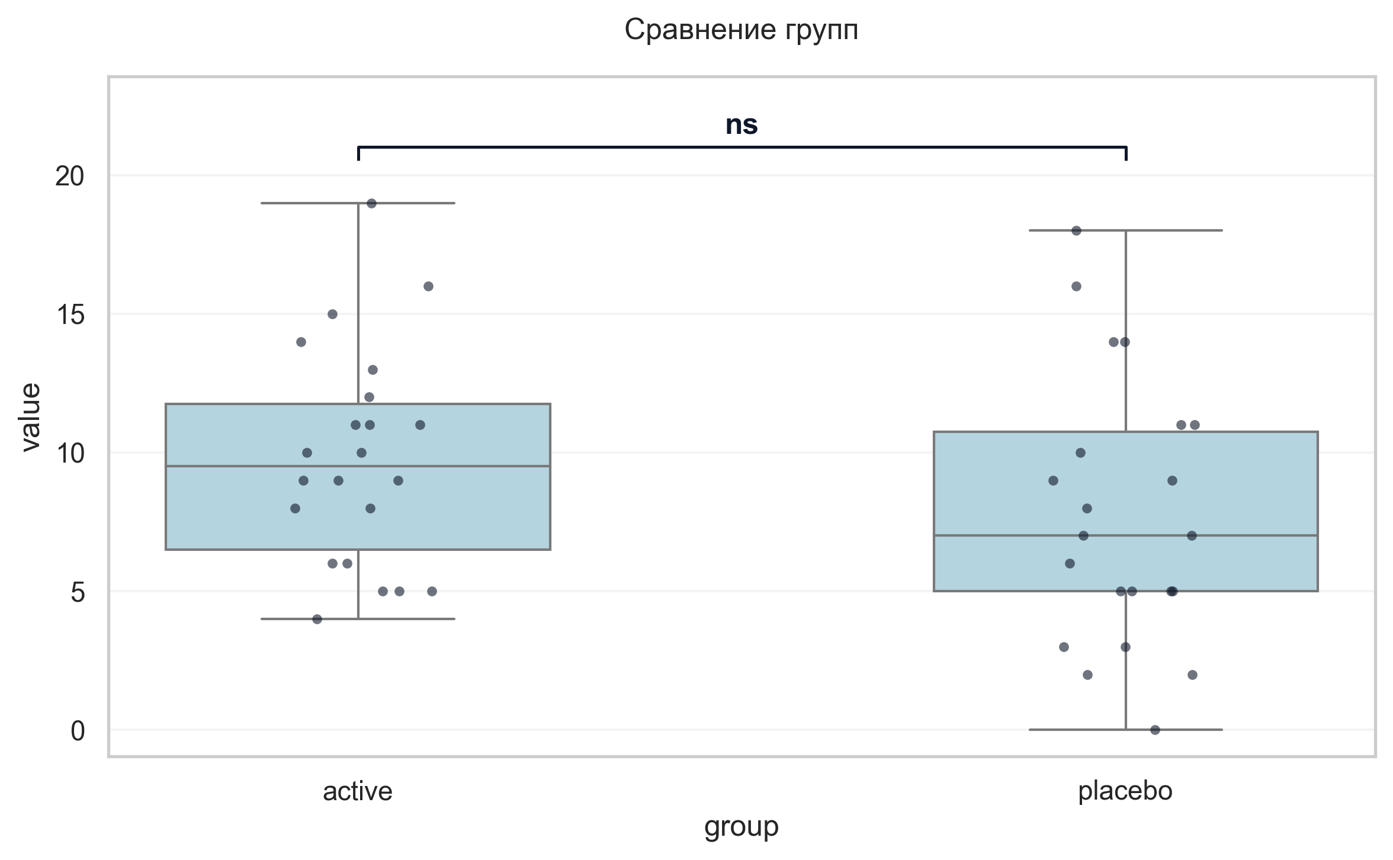
Интерпретация:
An independent Student's t-test (Independent) was conducted to determine if there were differences in Шкала апатии Старкстейна баллы V2 between groups defined by arm. The analysis revealed no statistically significant difference between the groups (p = 0.123, Cohen's d = 0.48 indicates a small effect).

Шаг: cmp__тест_струпа_v2_1
Метод: Mann-Whitney U Test
p-value | 0.4626
статистика | 237.500
эффект | rbc 0.14
мощность | -
BF10 | -
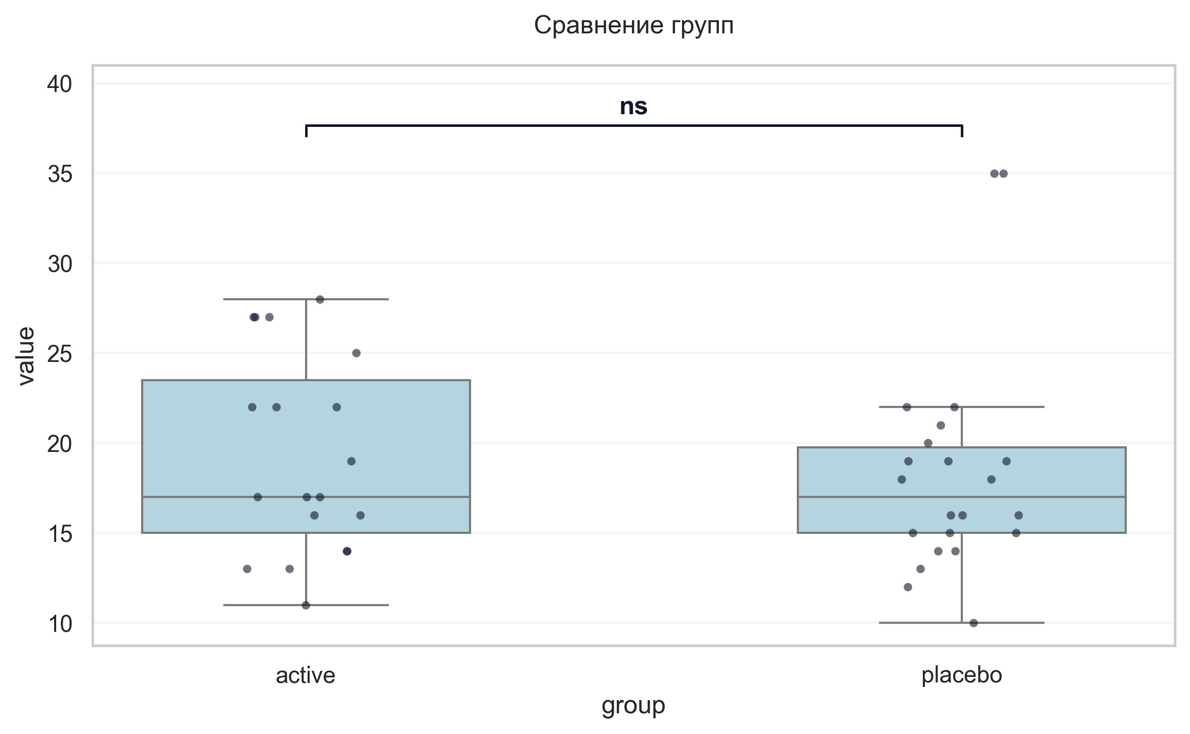
Интерпретация:
An independent Mann-Whitney U Test was conducted to determine if there were differences in Тест Струпа V2 1 between groups defined by arm. The analysis revealed no statistically significant difference between the groups (p = 0.463, r = 0.14 indicates a small effect).

Шаг: cmp__тест_струпа_v2_2
Метод: Mann-Whitney U Test
p-value | 0.0512
статистика | 284.000
эффект | rbc 0.36
мощность | -
BF10 | -
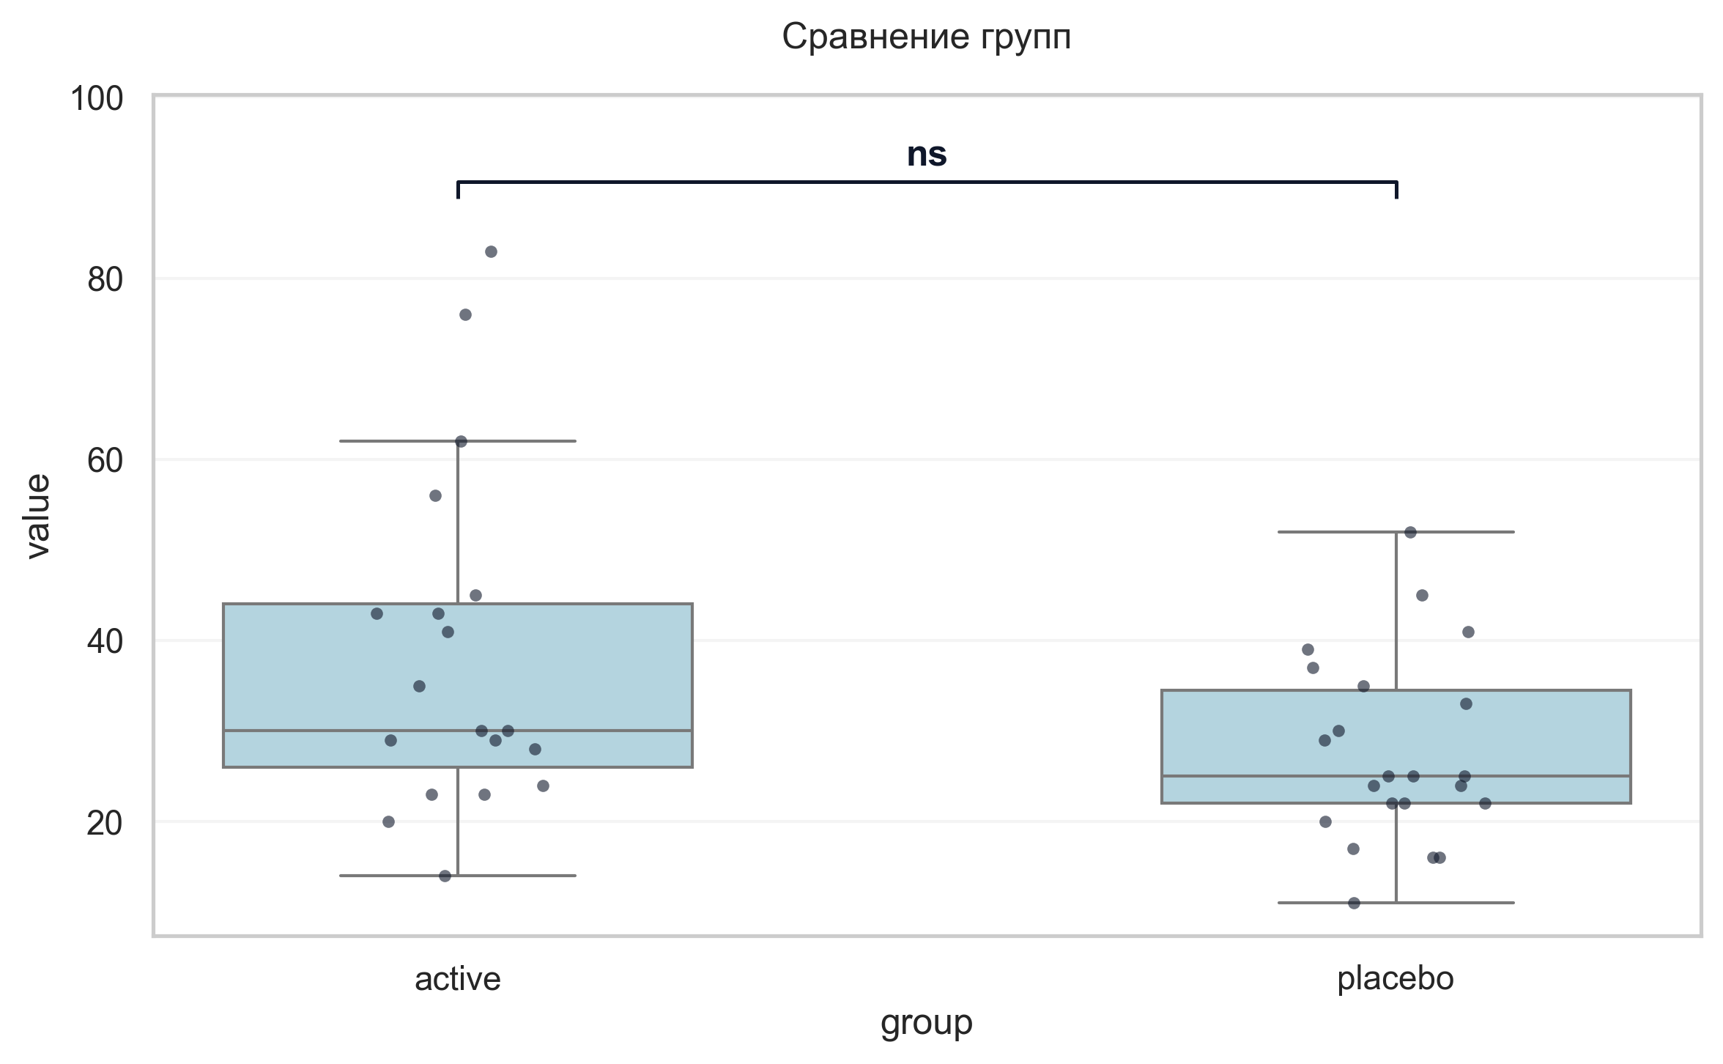
Интерпретация:
An independent Mann-Whitney U Test was conducted to determine if there were differences in Тест Струпа V2 2 between groups defined by arm. The analysis revealed no statistically significant difference between the groups (p = 0.051, r = 0.36 indicates a medium effect).

Шаг: cmp__тест_струпа_v2_3
Метод: Student's t-test (Independent)
p-value | 0.2702
статистика | 1.118
эффект | cohen-d 0.35
мощность | 0.19
BF10 | 0.503
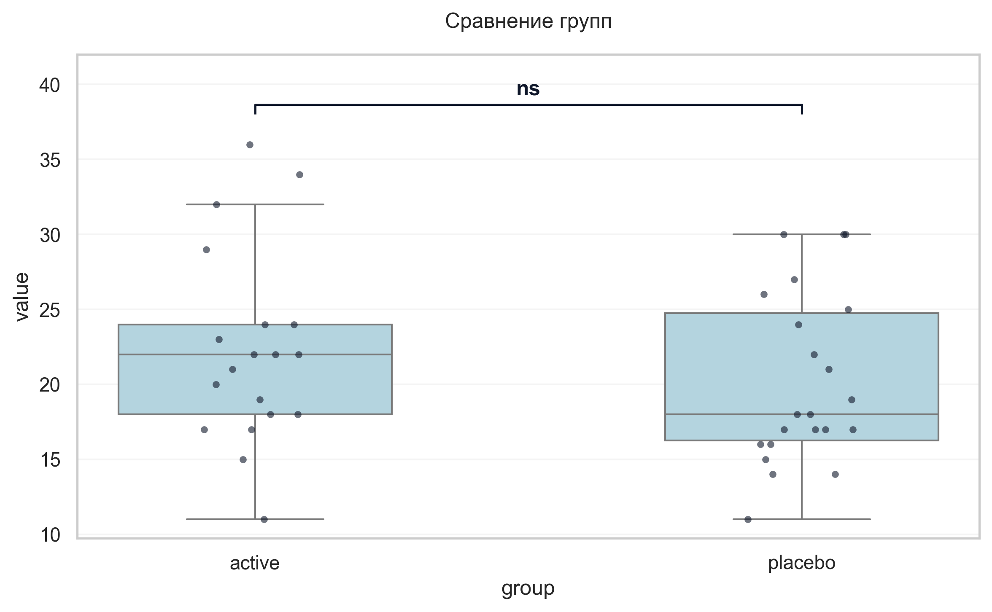
Интерпретация:
An independent Student's t-test (Independent) was conducted to determine if there were differences in Тест Струпа V2 3 between groups defined by arm. The analysis revealed no statistically significant difference between the groups (p = 0.270, Cohen's d = 0.35 indicates a small effect).

Шаг: cmp__индекс_интерференции_v2
Метод: Mann-Whitney U Test
p-value | 0.0330
статистика | 127.000
эффект | rbc -0.39
мощность | -
BF10 | -
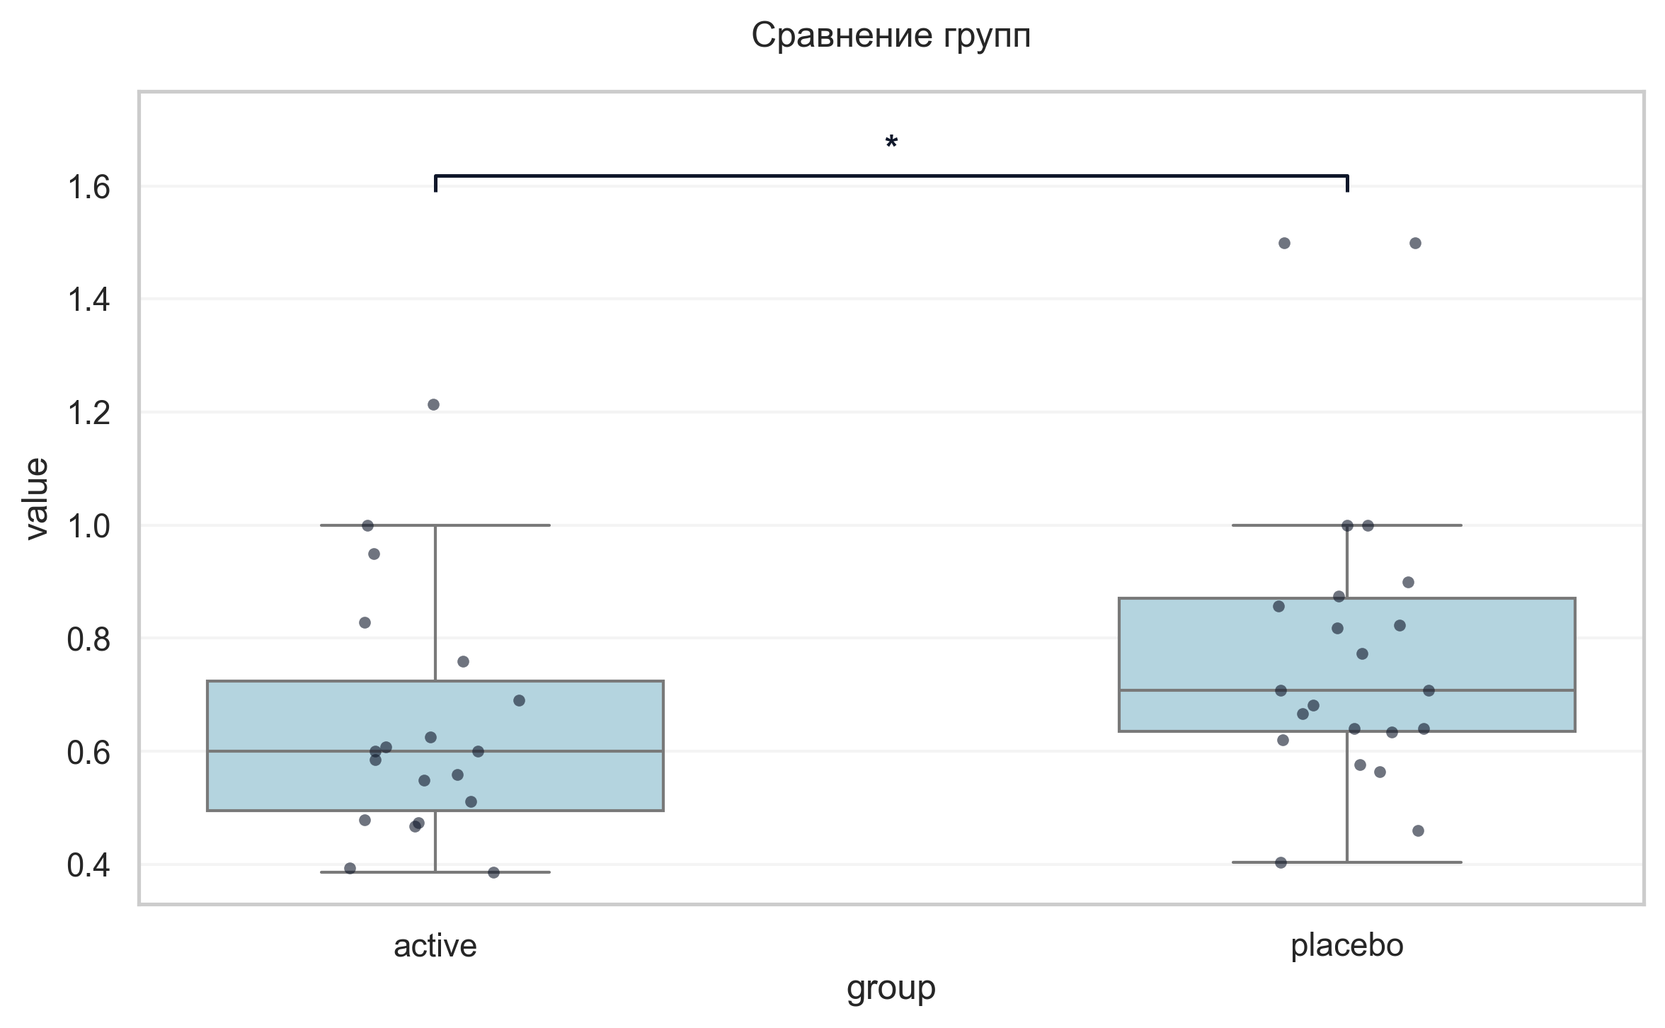
Интерпретация:
An independent Mann-Whitney U Test was conducted to determine if there were differences in Индекс интерференции V2 between groups defined by arm. There was a statistically significant difference between the groups (p = 0.033, r = -0.39 indicates a medium effect). Specifically, the Индекс интерференции V2 in the active group (M = 0.65) was significantly lower than in the placebo group (M = 0.79).

Шаг: cmp__тест_прокладывания_пути_trail_making_test_мин_v2_а
Метод: Mann-Whitney U Test
p-value | 0.7871
статистика | 254.000
эффект | rbc 0.05
мощность | -
BF10 | -
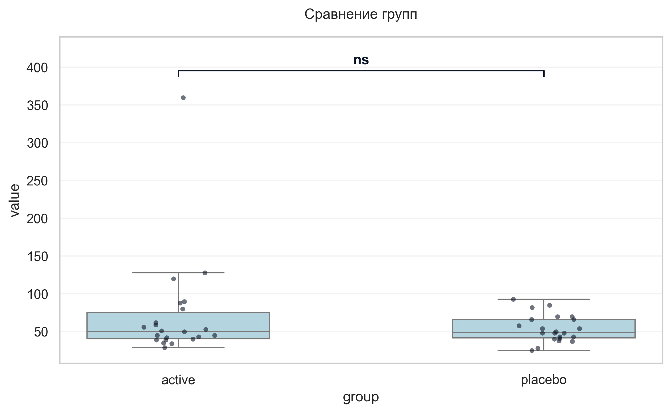
Интерпретация:
An independent Mann-Whitney U Test was conducted to determine if there were differences in «Тест прокладывания пути» Trail Making Test мин V2 А between groups defined by arm. The analysis revealed no statistically significant difference between the groups (p = 0.787, r = 0.05 indicates a trivial effect).

Шаг: cmp__тест_прокладывания_пути_trail_making_test_мин_v2_б
Метод: Mann-Whitney U Test
p-value | 0.5416
статистика | 268.500
эффект | rbc 0.11
мощность | -
BF10 | -
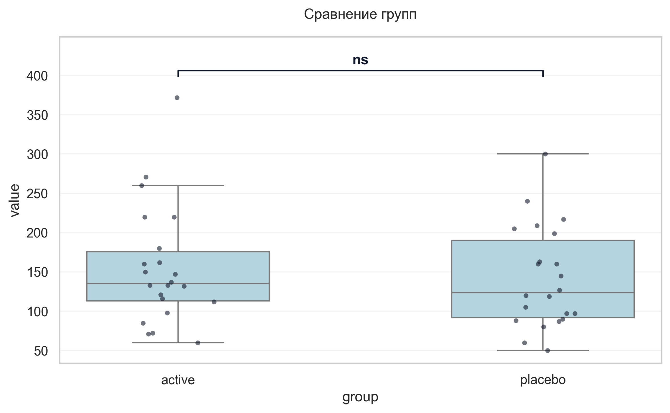
Интерпретация:
An independent Mann-Whitney U Test was conducted to determine if there were differences in «Тест прокладывания пути» Trail Making Test мин V2 Б between groups defined by arm. The analysis revealed no statistically significant difference between the groups (p = 0.542, r = 0.11 indicates a small effect).

Шаг: cmp__шкала_оценки_качества_жизни_при_бп_баллы_v2
Метод: Welch's T-Test
p-value | 0.8776
статистика | -0.155
эффект | cohen-d 0.05
мощность | 0.05
BF10 | 0.3
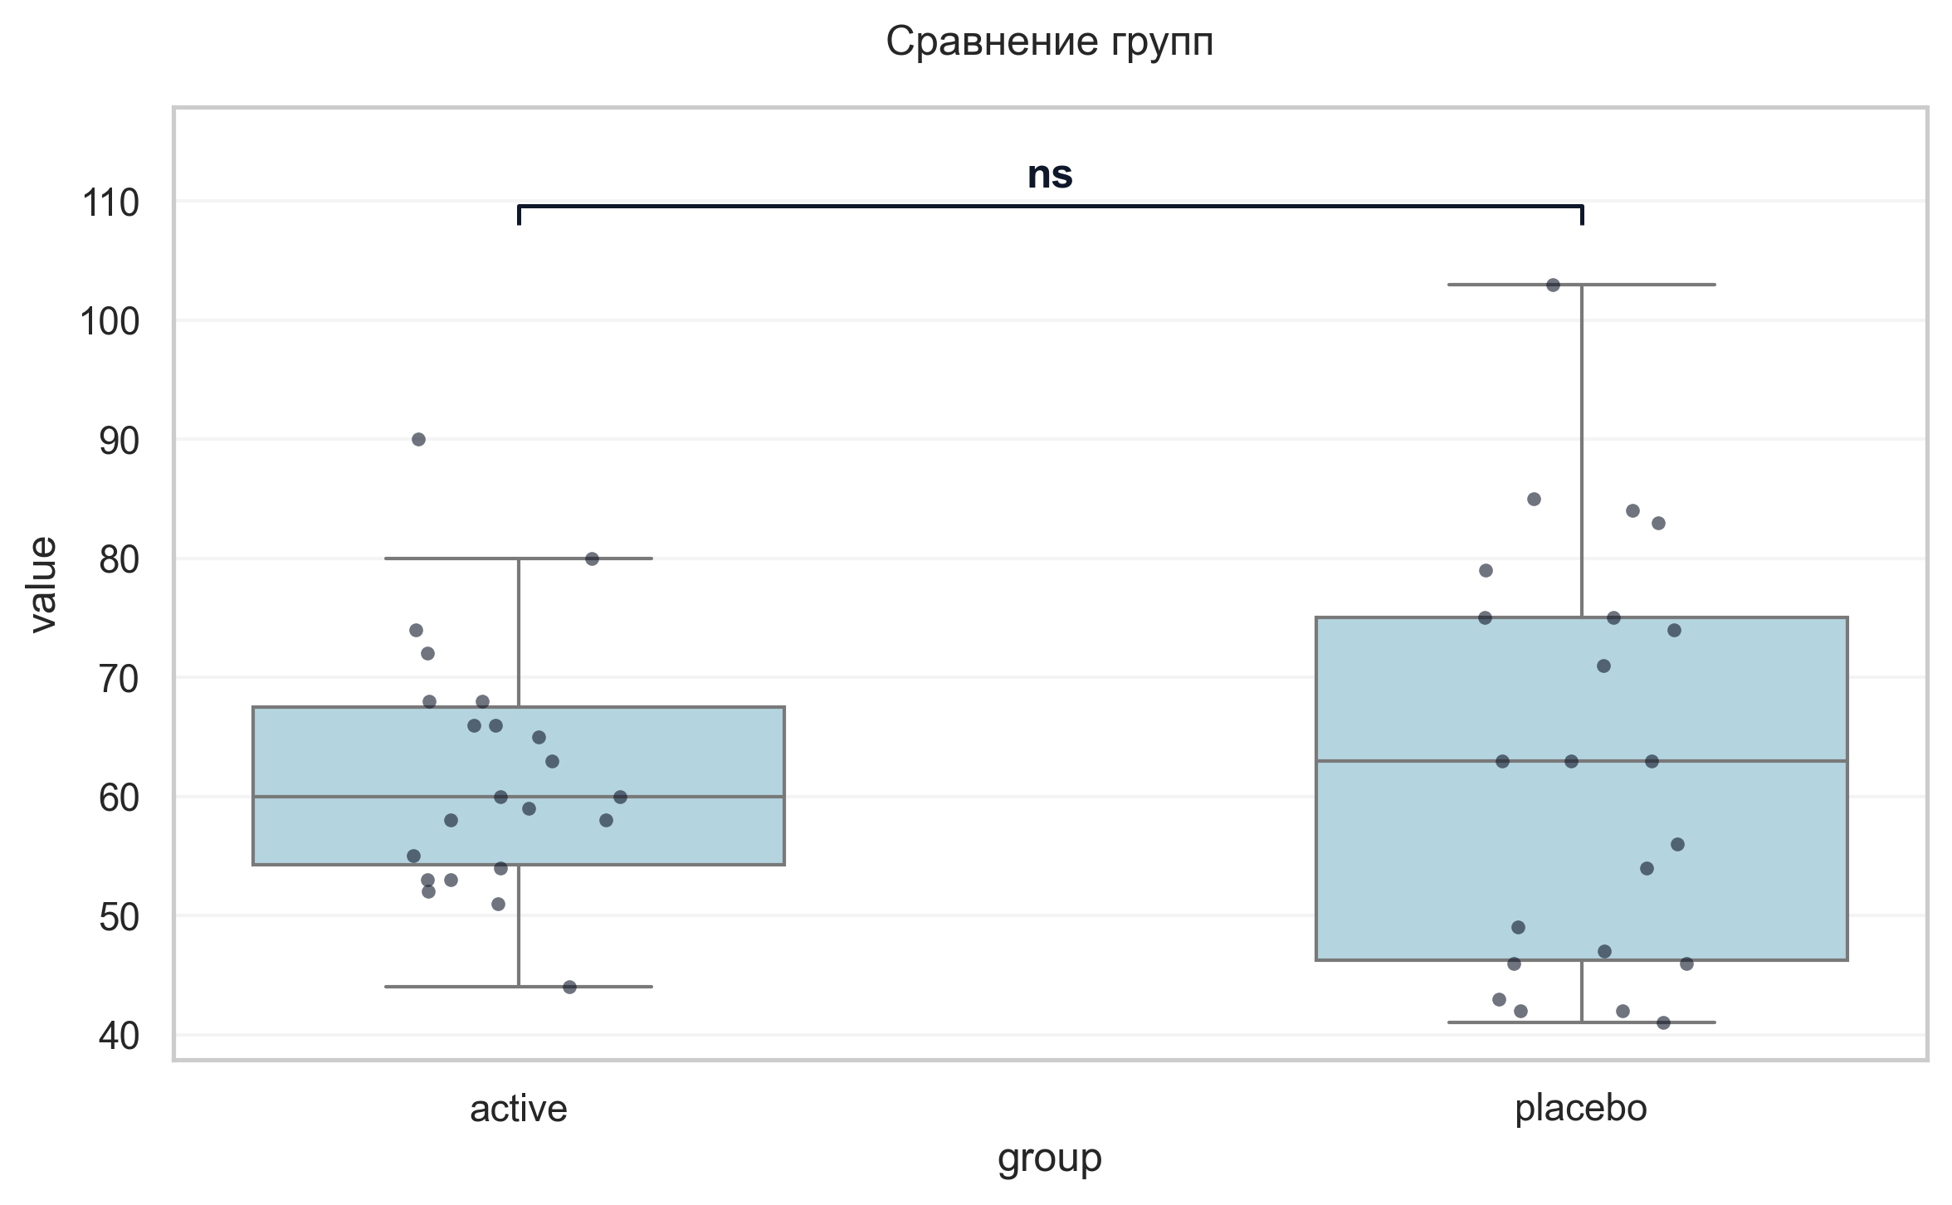
Интерпретация:
An independent Welch's T-Test was conducted to determine if there were differences in Шкала оценки качества жизни при БП баллы V2 between groups defined by arm. The analysis revealed no statistically significant difference between the groups (p = 0.878, Cohen's d = 0.05 indicates a trivial effect).

Шаг: cmp__ушобп_часть_2_повседневная_активность_баллы_v3
Метод: Welch's T-Test
p-value | 0.5366
статистика | 0.624
эффект | cohen-d 0.19
мощность | 0.09
BF10 | 0.348
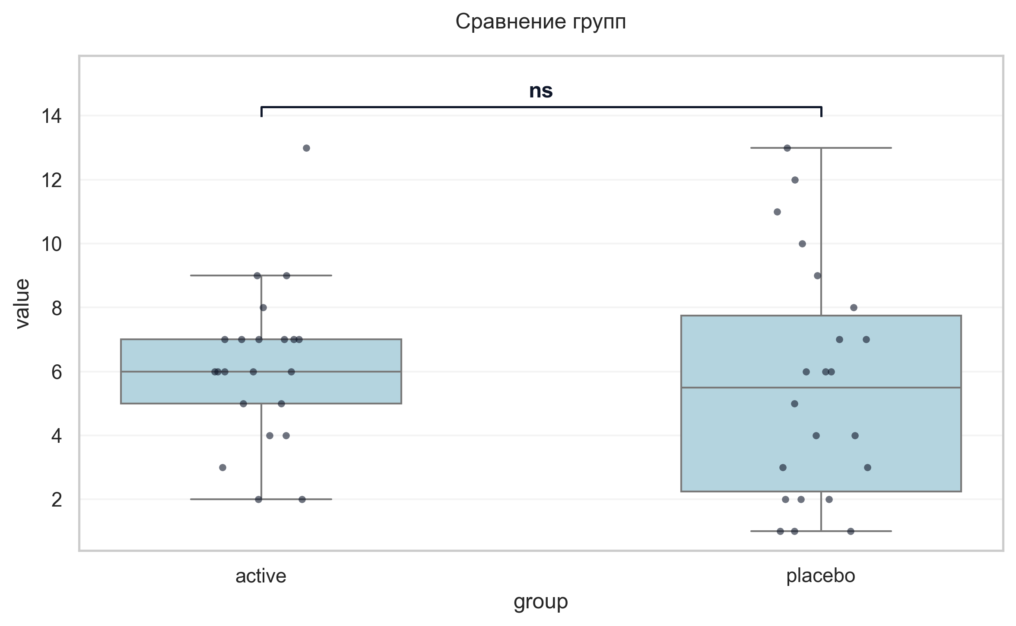
Интерпретация:
An independent Welch's T-Test was conducted to determine if there were differences in УШОБП часть 2 «Повседневная активность» баллы V3 between groups defined by arm. The analysis revealed no statistically significant difference between the groups (p = 0.537, Cohen's d = 0.19 indicates a trivial effect).

Шаг: cmp__ушобп_часть_3_двигательные_функции_баллы_v3
Метод: Welch's T-Test
p-value | 0.4230
статистика | -0.813
эффект | cohen-d 0.25
мощность | 0.12
BF10 | 0.388
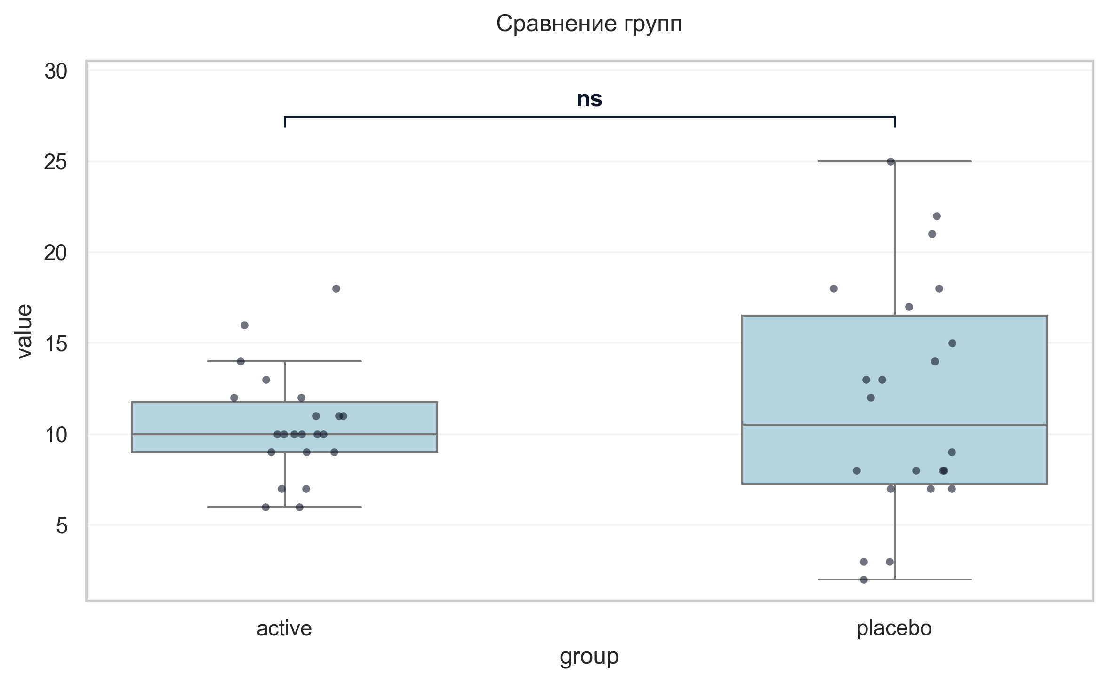
Интерпретация:
An independent Welch's T-Test was conducted to determine if there were differences in УШОБП часть 3 «Двигательные функции» баллы V3 between groups defined by arm. The analysis revealed no statistically significant difference between the groups (p = 0.423, Cohen's d = 0.25 indicates a small effect).

Шаг: cmp__шкала_депрессии_тревоги_и_стресса_dass_21_баллы_v3
Метод: Student's t-test (Independent)
p-value | 0.0025
статистика | -3.221
эффект | cohen-d 0.97
мощность | 0.88
BF10 | 14.892
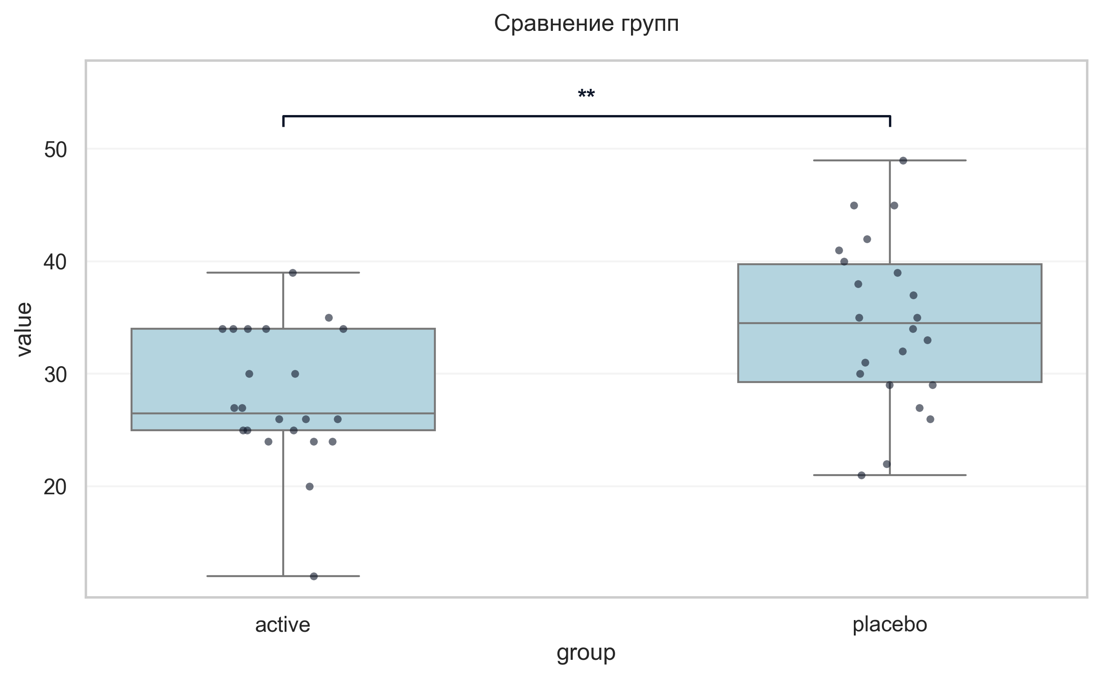
Интерпретация:
An independent Student's t-test (Independent) was conducted to determine if there were differences in Шкала депрессии тревоги и стресса DASS-21 баллы V3 between groups defined by arm. There was a statistically significant difference between the groups (p = 0.002, Cohen's d = 0.97 indicates a large effect). Specifically, the Шкала депрессии тревоги и стресса DASS-21 баллы V3 in the active group (M = 27.95) was significantly lower than in the placebo group (M = 34.55).

Шаг: cmp__шкала_оценки_утомляемости_при_бп_баллы_v3
Метод: Mann-Whitney U Test
p-value | 0.3067
статистика | 198.000
эффект | rbc -0.18
мощность | -
BF10 | -
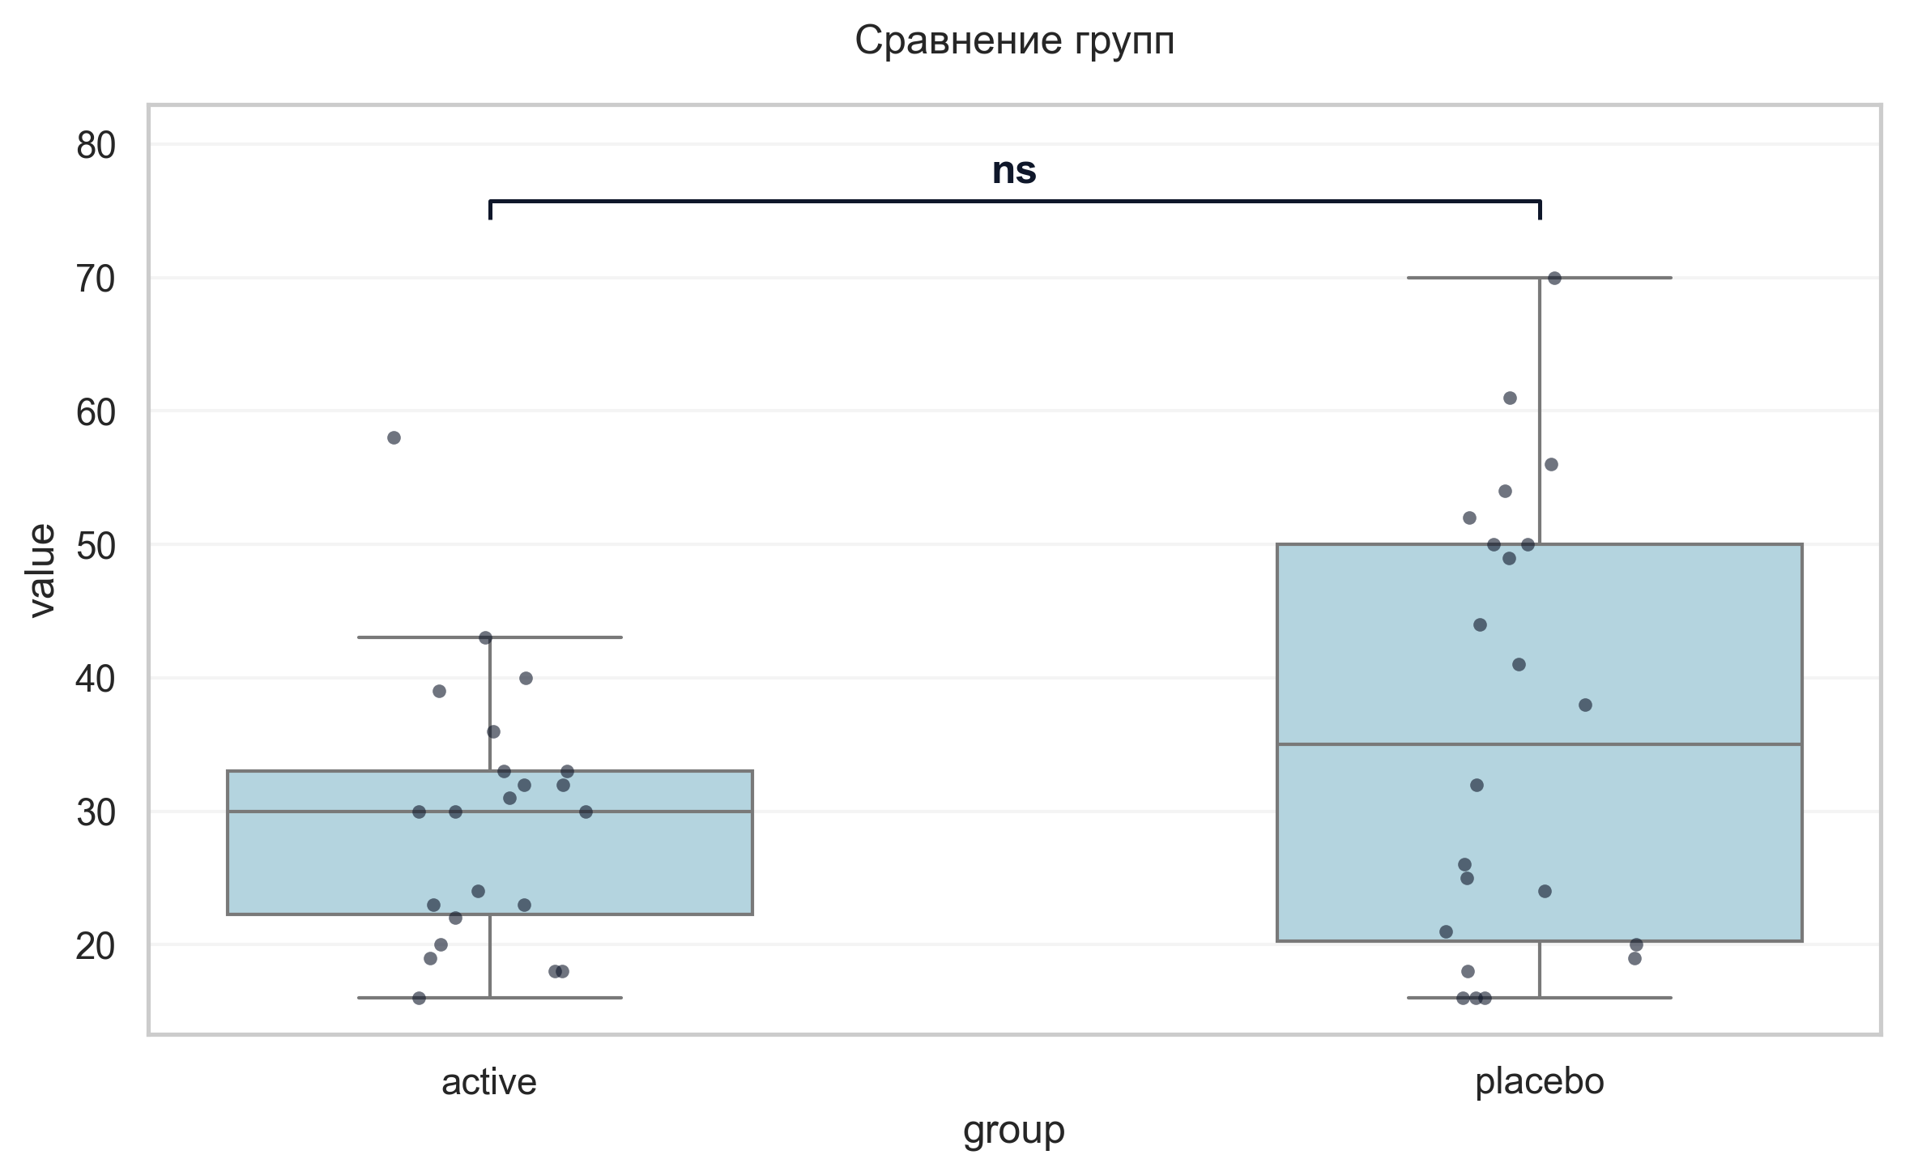
Интерпретация:
An independent Mann-Whitney U Test was conducted to determine if there were differences in Шкала оценки утомляемости при БП баллы V3 between groups defined by arm. The analysis revealed no statistically significant difference between the groups (p = 0.307, r = -0.18 indicates a small effect).

Шаг: cmp__шкала_оценки_сонливости_эпуорта_баллы_v3
Метод: Mann-Whitney U Test
p-value | 0.9246
статистика | 246.500
эффект | rbc 0.02
мощность | -
BF10 | -
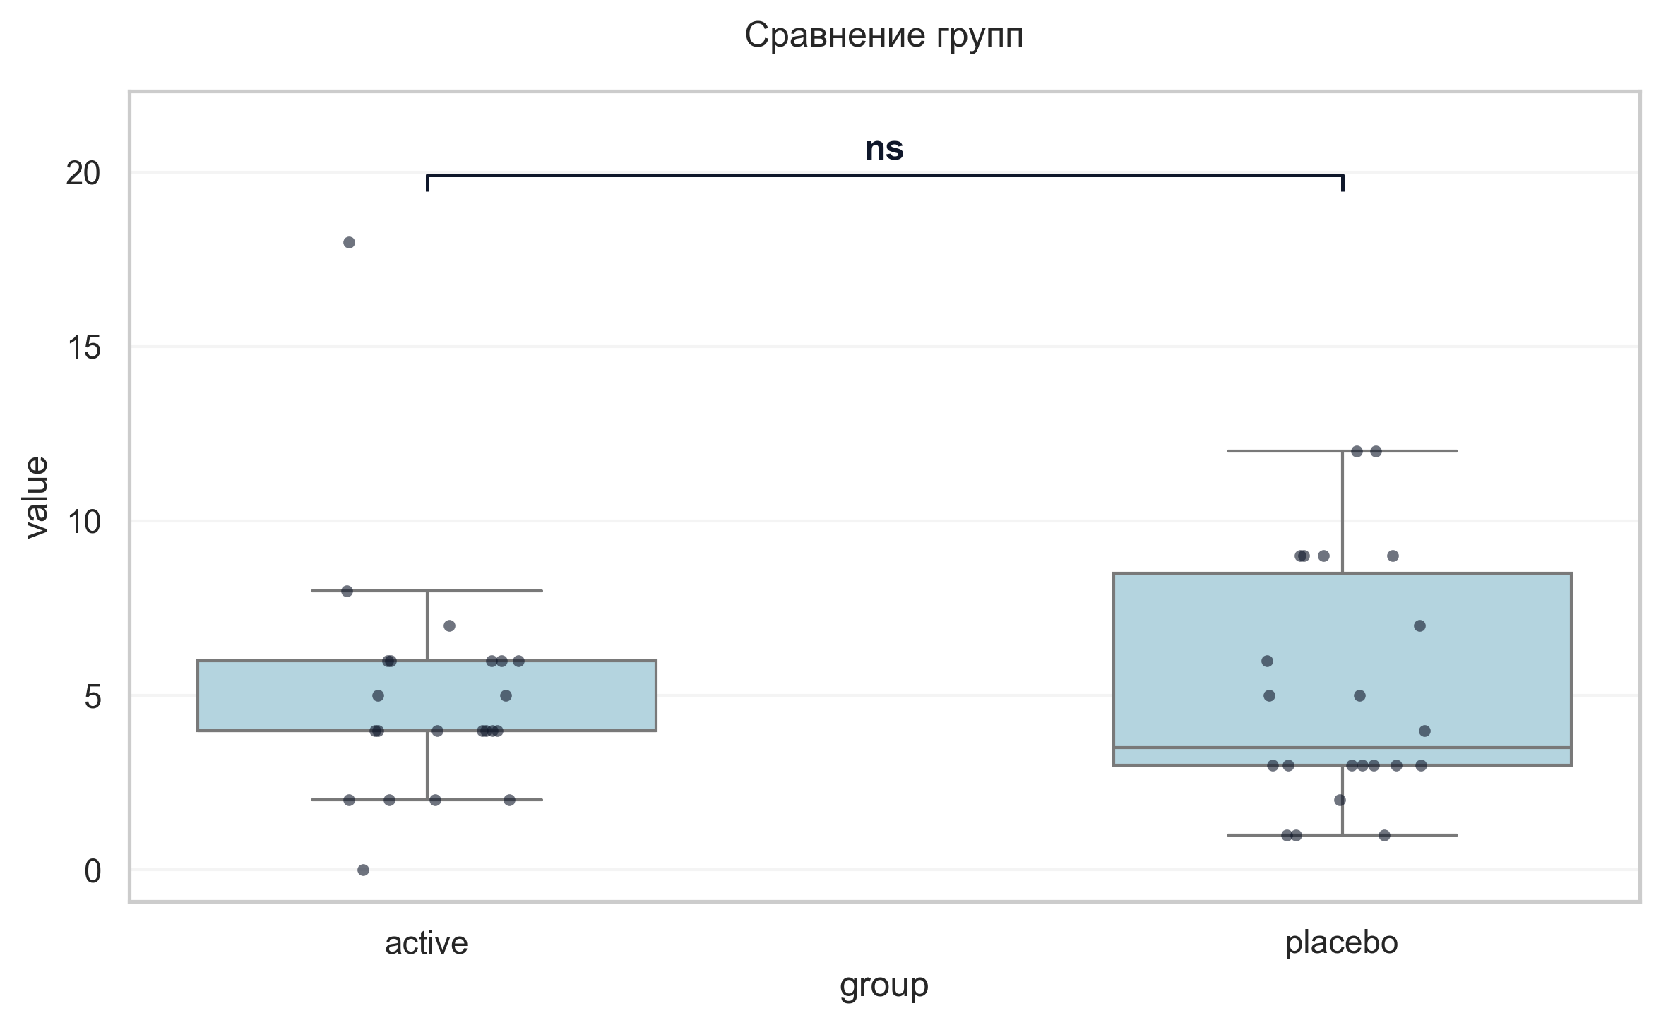
Интерпретация:
An independent Mann-Whitney U Test was conducted to determine if there were differences in Шкала оценки сонливости Эпуорта баллы V3 between groups defined by arm. The analysis revealed no statistically significant difference between the groups (p = 0.925, r = 0.02 indicates a trivial effect).

Шаг: cmp__шкала_апатии_старкстейна_баллы_v3
Метод: Student's t-test (Independent)
p-value | 0.3294
статистика | -0.987
эффект | cohen-d 0.30
мощность | 0.16
BF10 | 0.44
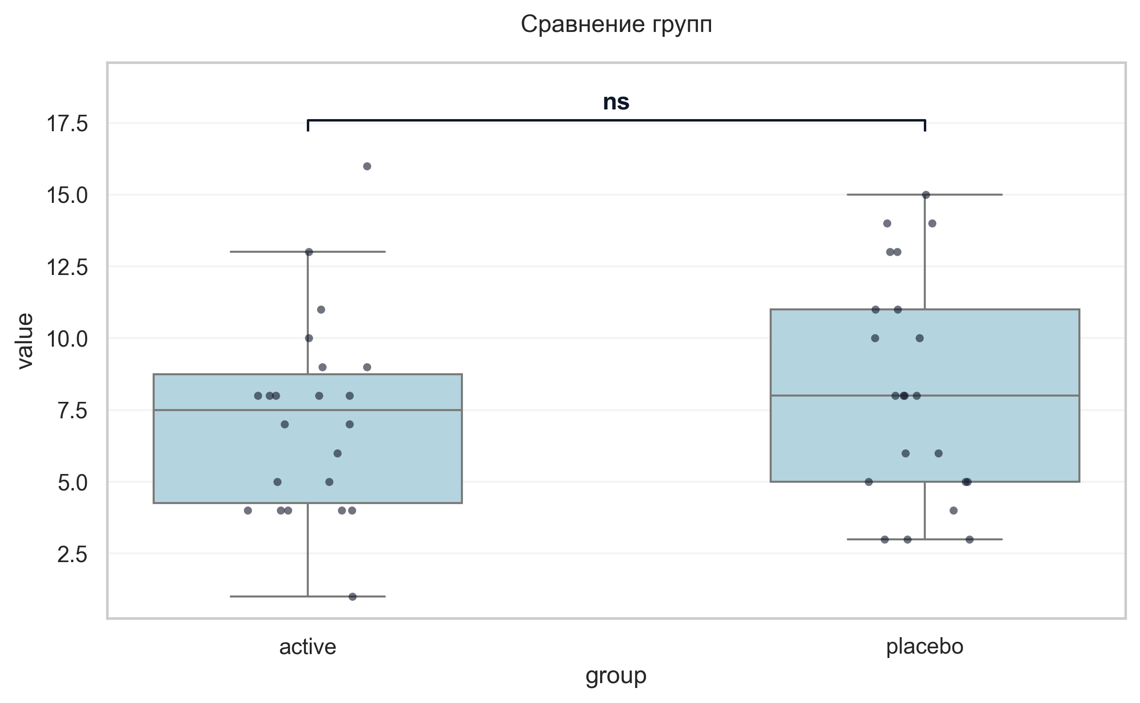
Интерпретация:
An independent Student's t-test (Independent) was conducted to determine if there were differences in Шкала апатии Старкстейна баллы V3 between groups defined by arm. The analysis revealed no statistically significant difference between the groups (p = 0.329, Cohen's d = 0.30 indicates a small effect).

Шаг: cmp__струп_v3_1
Метод: Student's t-test (Independent)
p-value | 0.9964
статистика | -0.005
эффект | cohen-d 0.00
мощность | 0.05
BF10 | 0.3
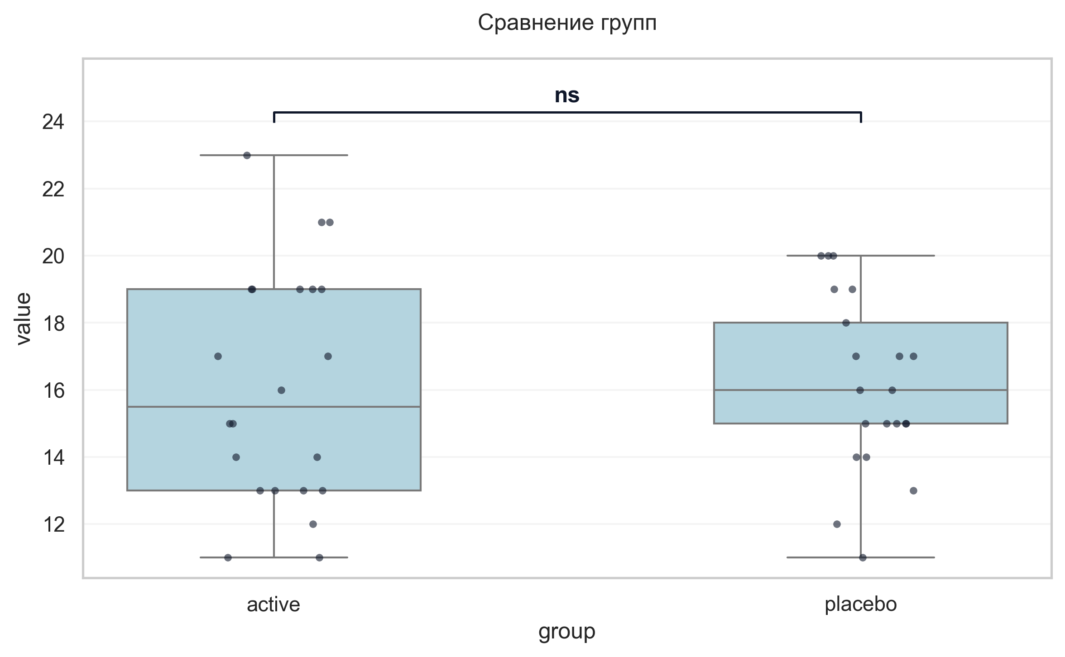
Интерпретация:
An independent Student's t-test (Independent) was conducted to determine if there were differences in Струп V3 1 between groups defined by arm. The analysis revealed no statistically significant difference between the groups (p = 0.996, Cohen's d = 0.00 indicates a trivial effect).

Шаг: cmp__струп_v3_2
Метод: Mann-Whitney U Test
p-value | 0.0068
статистика | 342.500
эффект | rbc 0.48
мощность | -
BF10 | -
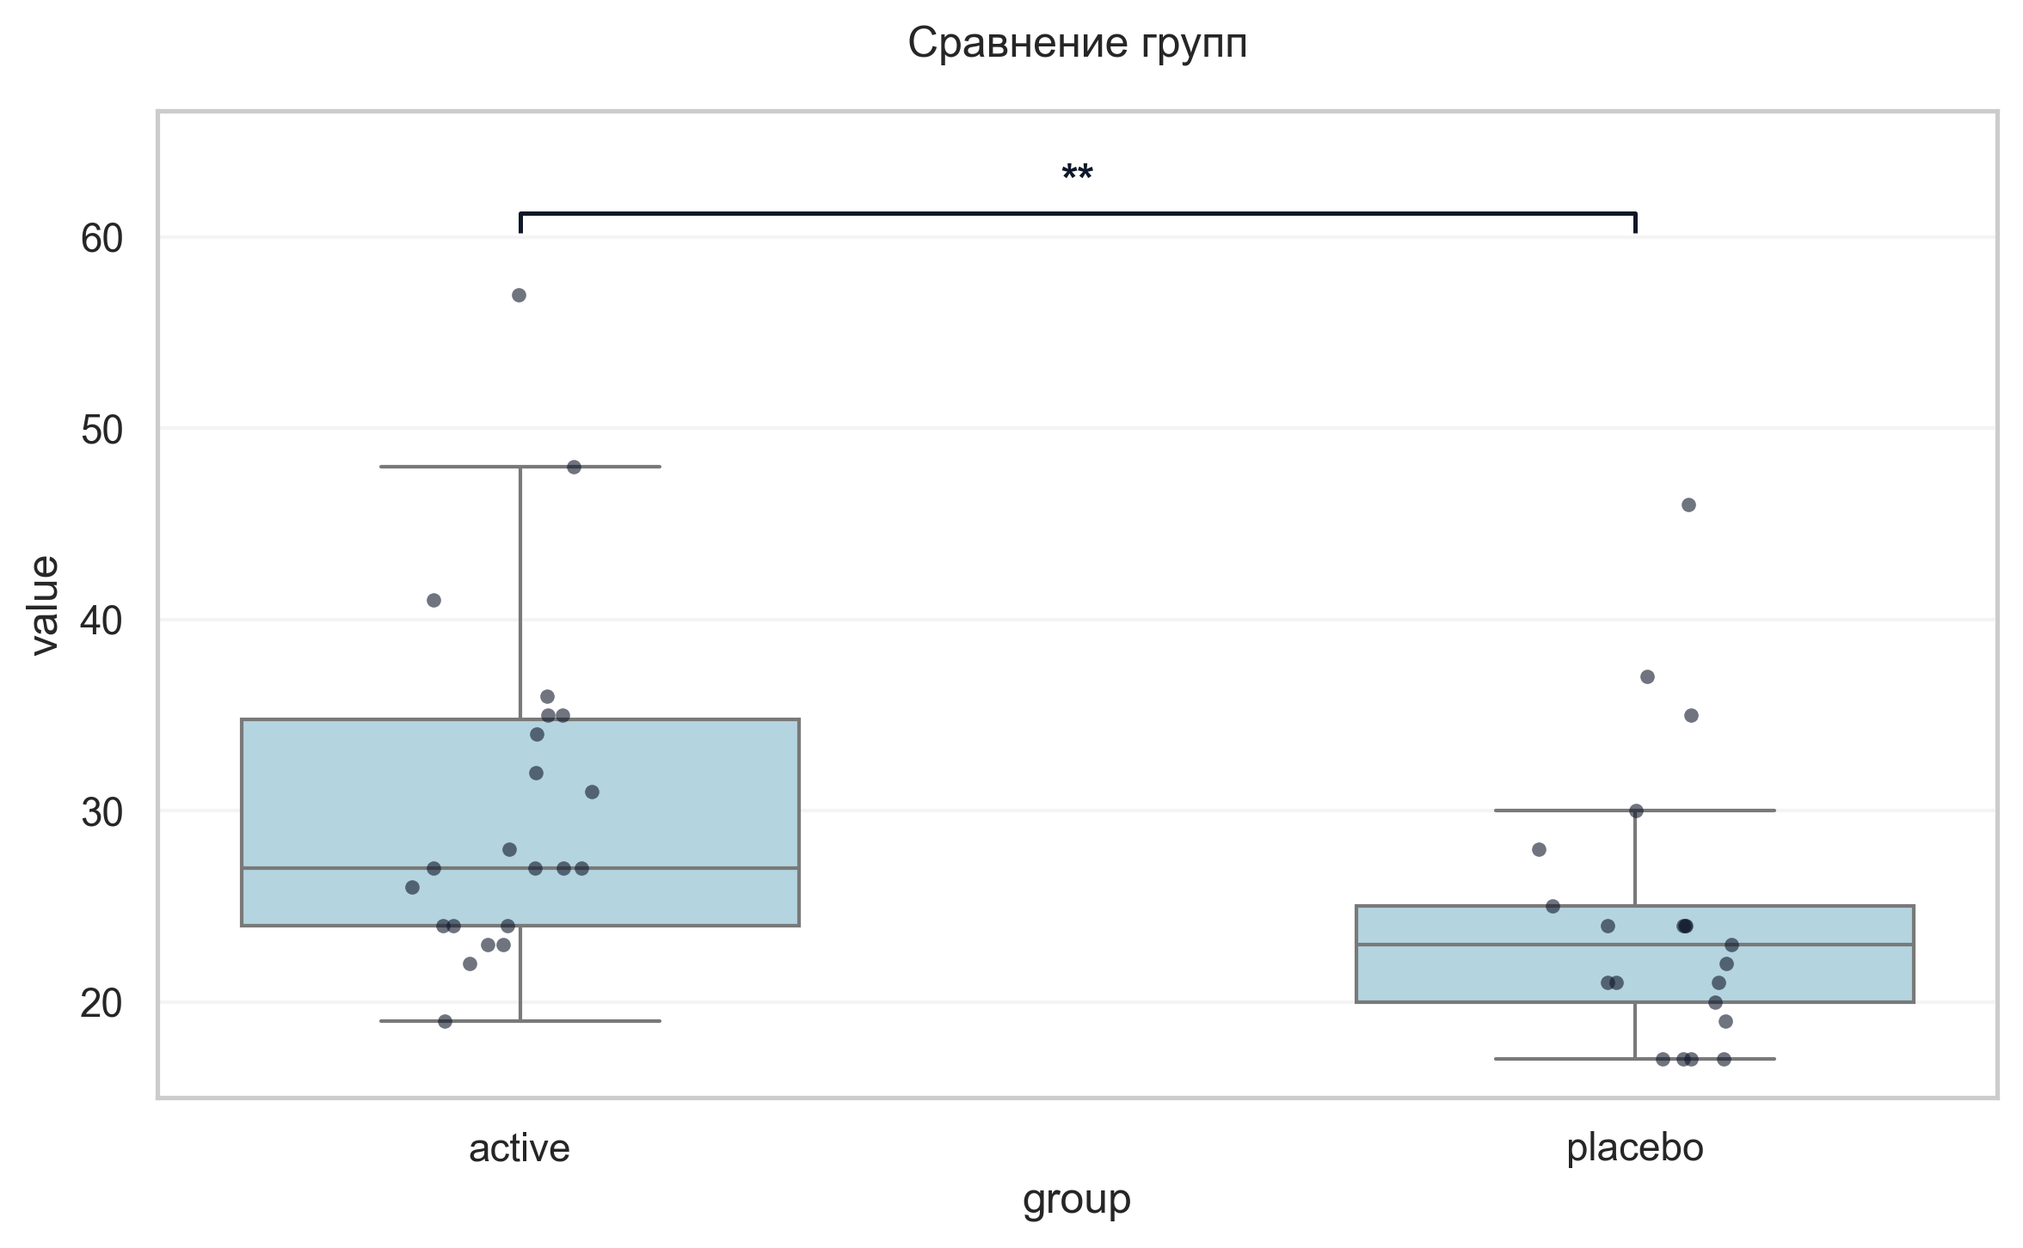
Интерпретация:
An independent Mann-Whitney U Test was conducted to determine if there were differences in Струп V3 2 between groups defined by arm. There was a statistically significant difference between the groups (p = 0.007, r = 0.48 indicates a medium effect). Specifically, the Струп V3 2 in the active group (M = 30.45) was significantly higher than in the placebo group (M = 24.38).

Шаг: cmp__струп_v3_3
Метод: Mann-Whitney U Test
p-value | 0.0116
статистика | 349.500
эффект | rbc 0.44
мощность | -
BF10 | -
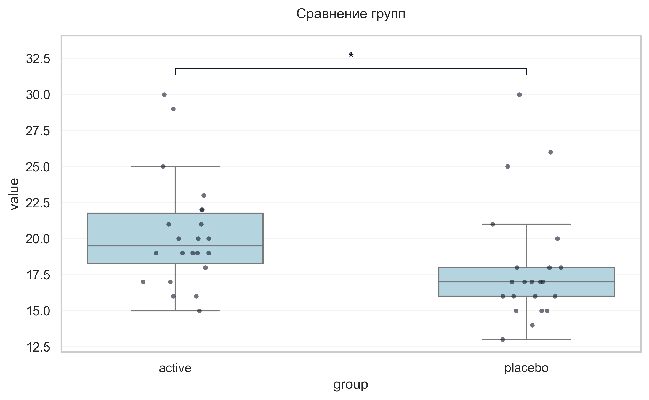
Интерпретация:
An independent Mann-Whitney U Test was conducted to determine if there were differences in Струп V3 3 between groups defined by arm. There was a statistically significant difference between the groups (p = 0.012, r = 0.44 indicates a medium effect). Specifically, the Струп V3 3 in the active group (M = 20.32) was significantly higher than in the placebo group (M = 18.05).

Шаг: cmp__индекс_интерференции_v4
Метод: Student's t-test (Independent)
p-value | 0.2096
статистика | -1.275
эффект | cohen-d 0.39
мощность | 0.24
BF10 | 0.574
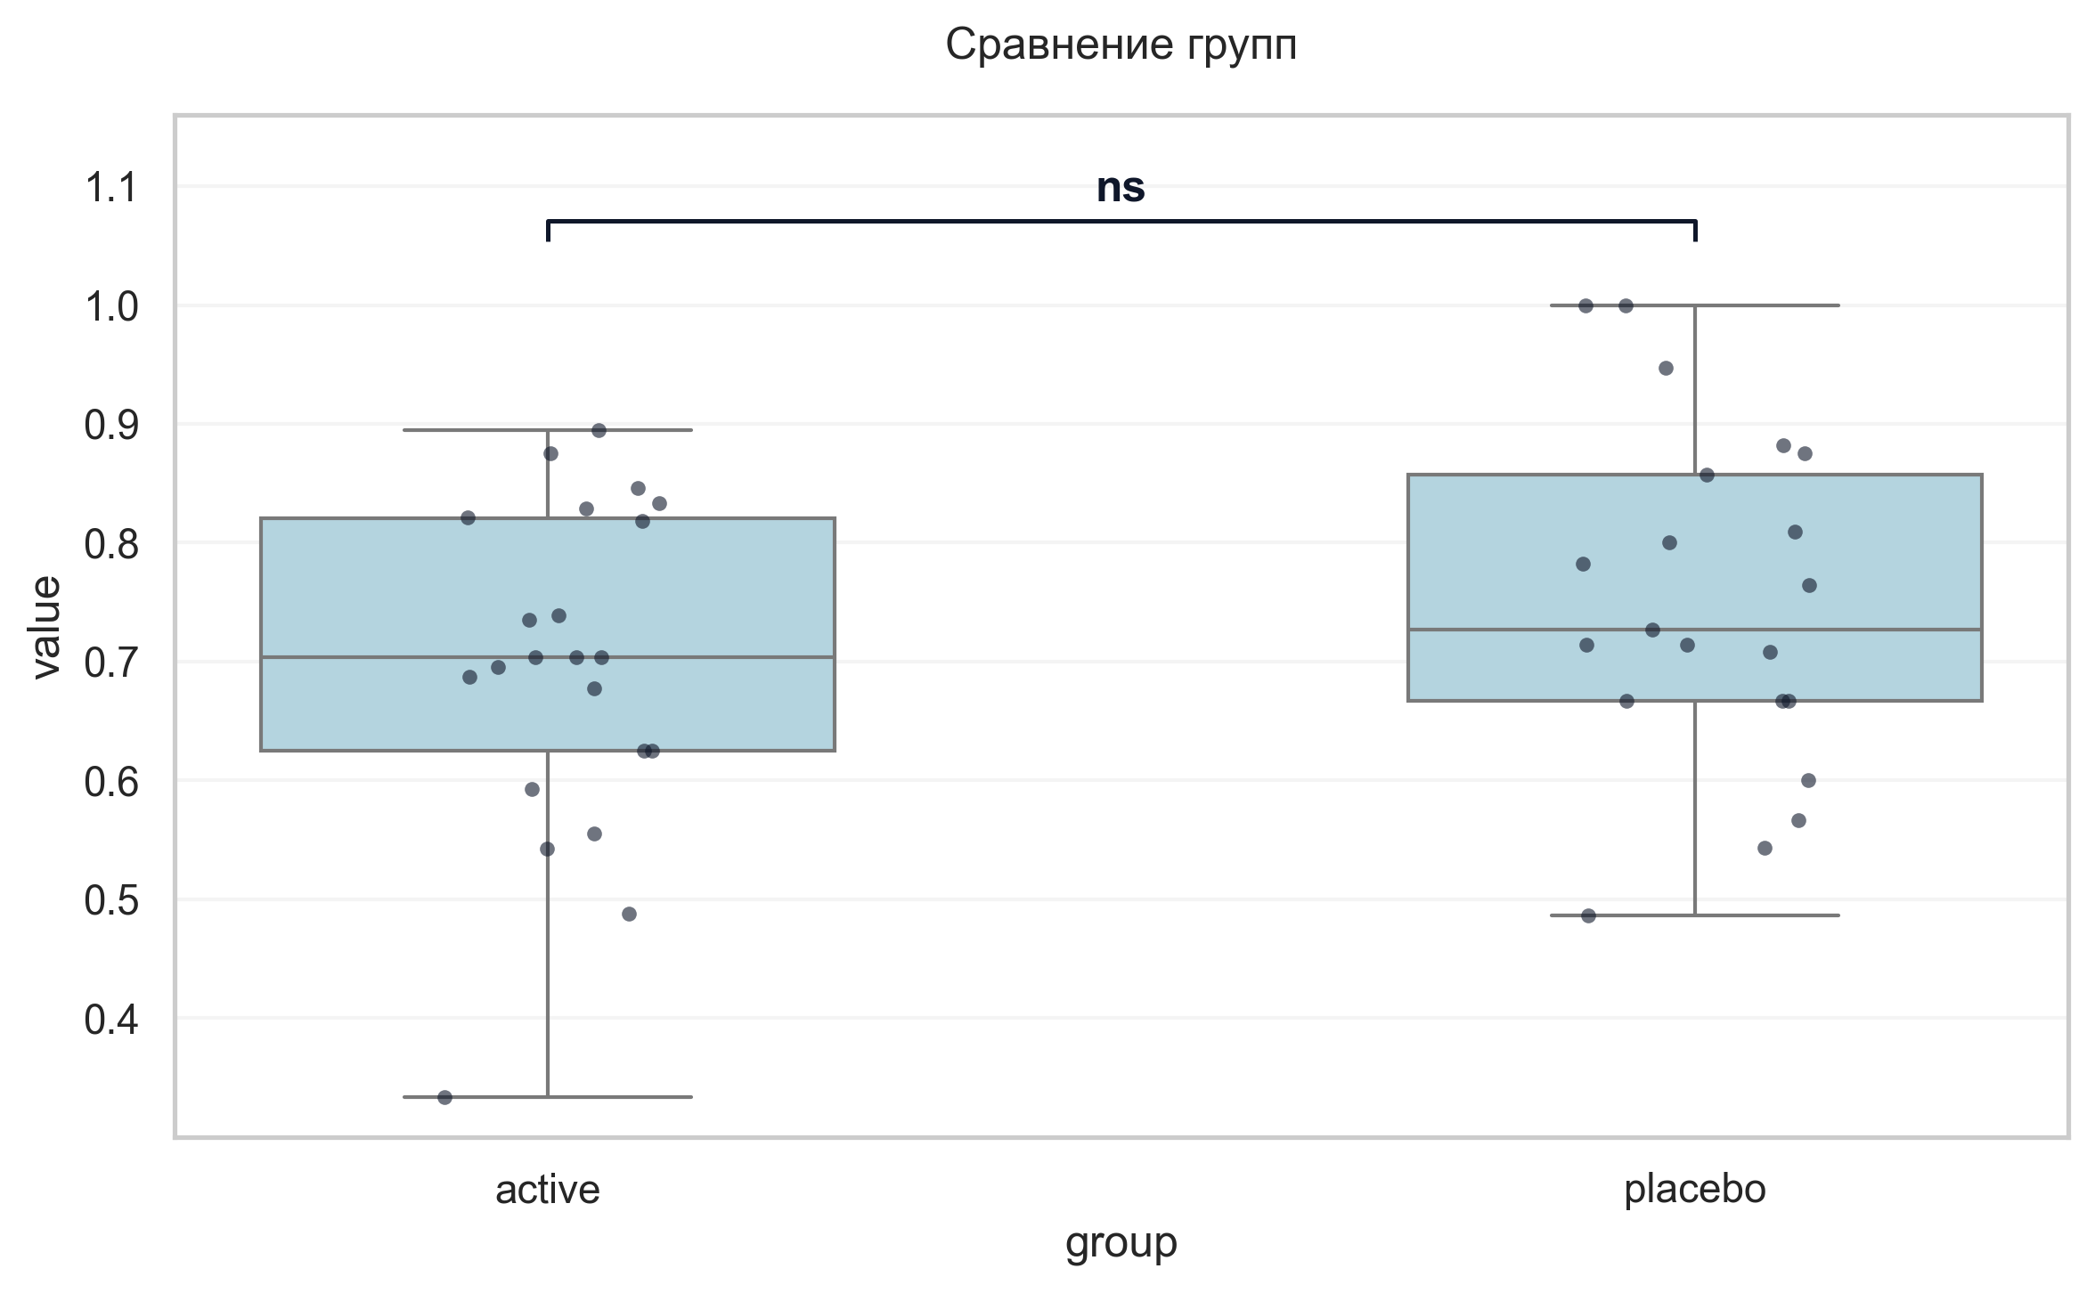
Интерпретация:
An independent Student's t-test (Independent) was conducted to determine if there were differences in Индекс интерференции V4 between groups defined by arm. The analysis revealed no statistically significant difference between the groups (p = 0.210, Cohen's d = 0.39 indicates a small effect).

Шаг: cmp__тест_прокладывания_пути_trail_making_test_мин_v3_а
Метод: Mann-Whitney U Test
p-value | 0.2901
статистика | 196.500
эффект | rbc -0.19
мощность | -
BF10 | -
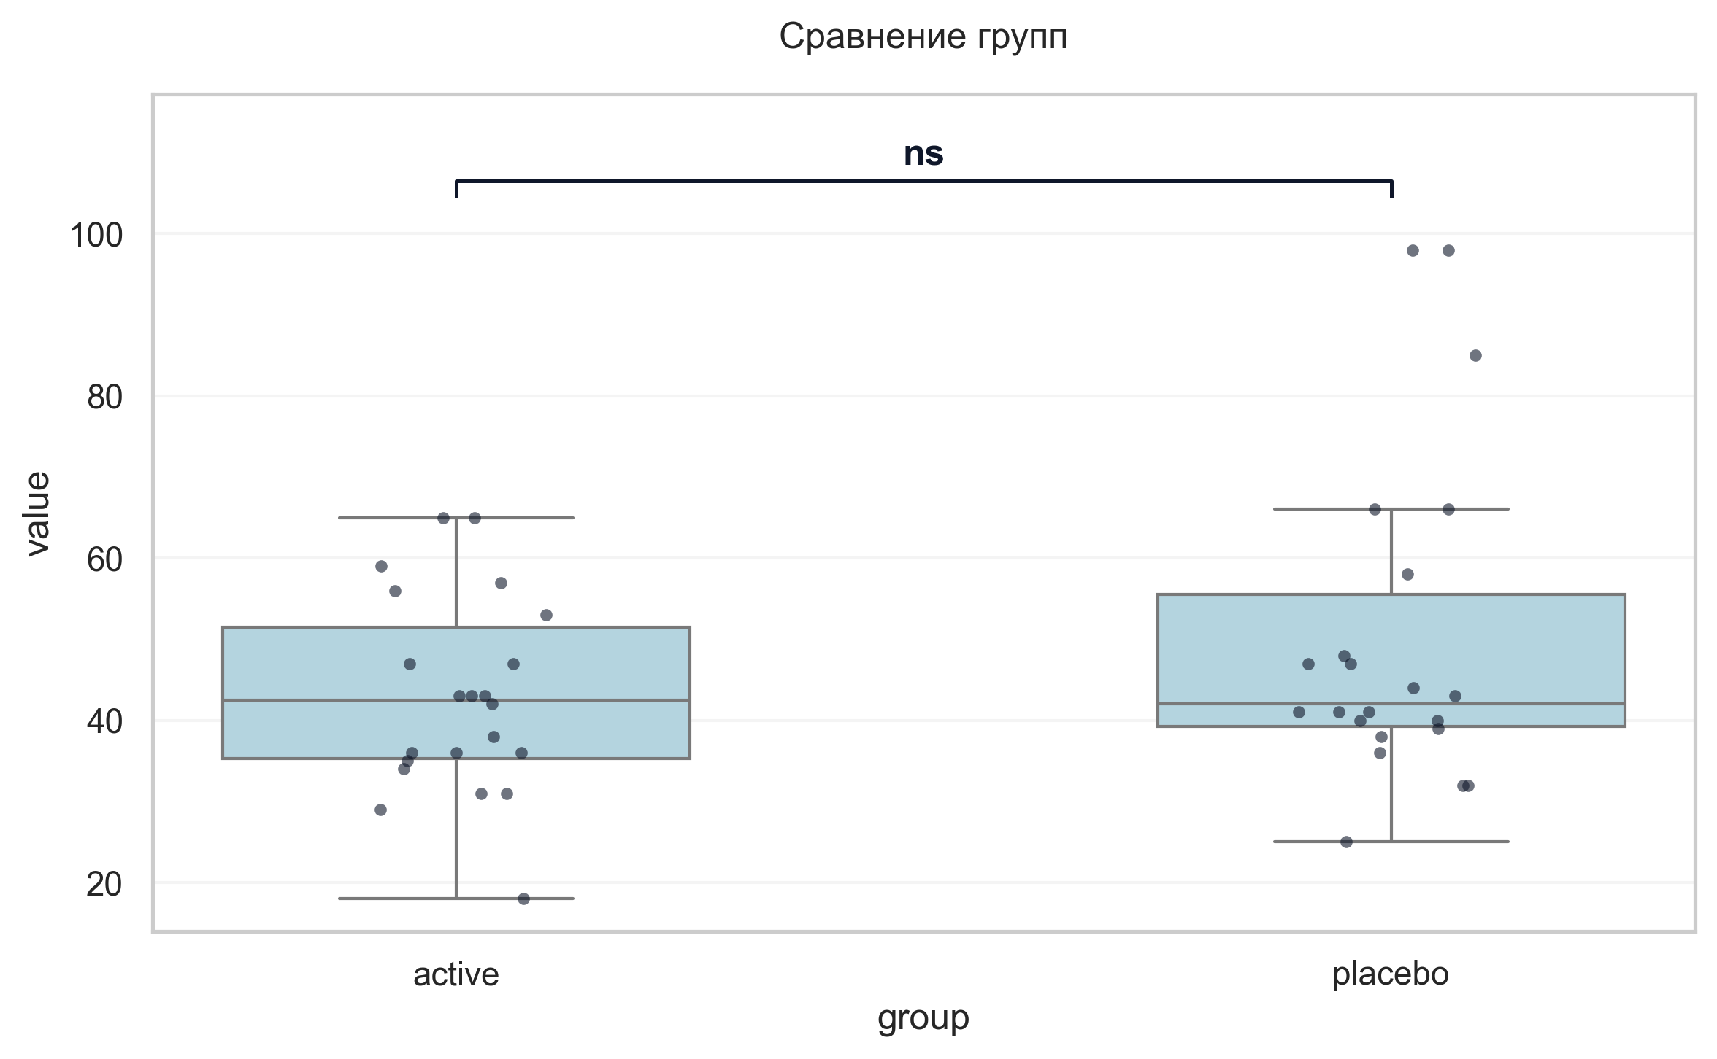
Интерпретация:
An independent Mann-Whitney U Test was conducted to determine if there were differences in «Тест прокладывания пути» Trail Making Test мин V3 А between groups defined by arm. The analysis revealed no statistically significant difference between the groups (p = 0.290, r = -0.19 indicates a small effect).

Шаг: cmp__тест_прокладывания_пути_trail_making_test_мин_v3_б
Метод: Mann-Whitney U Test
p-value | 0.1624
статистика | 302.000
эффект | rbc 0.25
мощность | -
BF10 | -
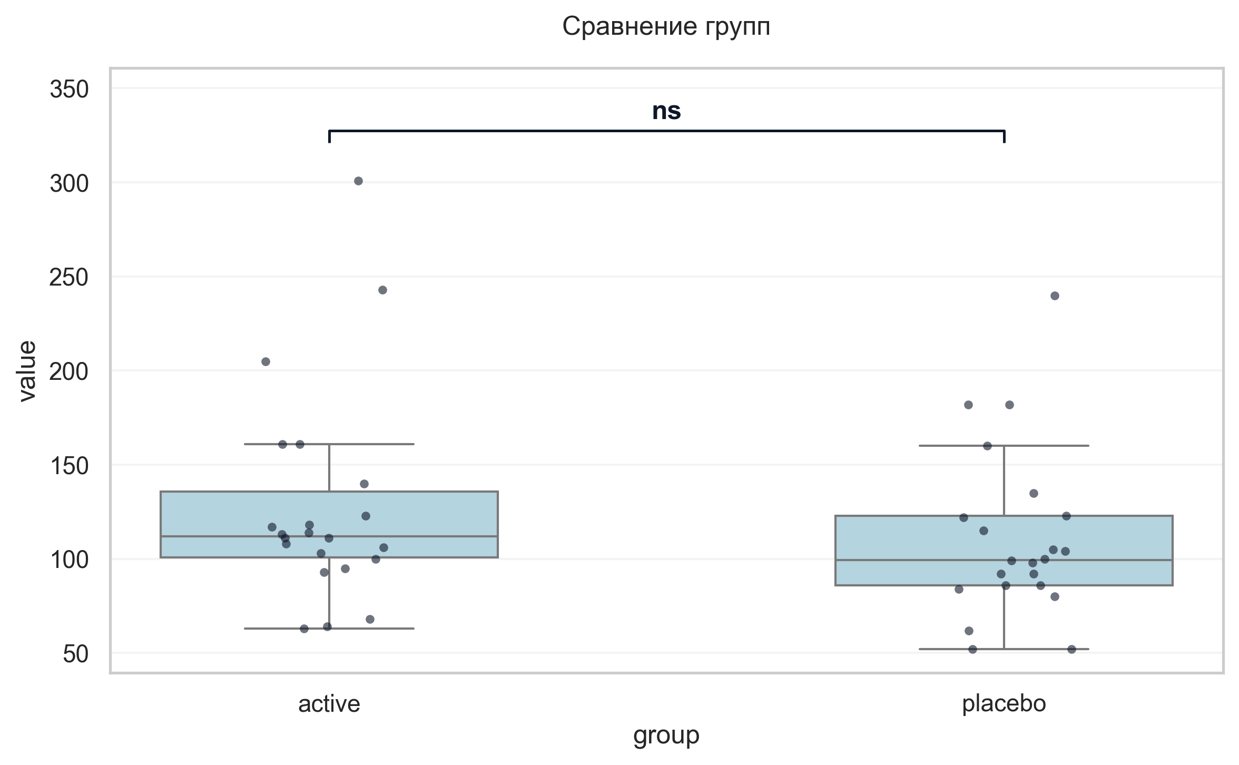
Интерпретация:
An independent Mann-Whitney U Test was conducted to determine if there were differences in «Тест прокладывания пути» Trail Making Test мин V3 Б between groups defined by arm. The analysis revealed no statistically significant difference between the groups (p = 0.162, r = 0.25 indicates a small effect).

Шаг: cmp__шкала_оценки_качества_жизни_при_бп_баллы_v3
Метод: Welch's T-Test
p-value | 0.1144
статистика | -1.621
эффект | cohen-d 0.49
мощность | 0.35
BF10 | 0.845
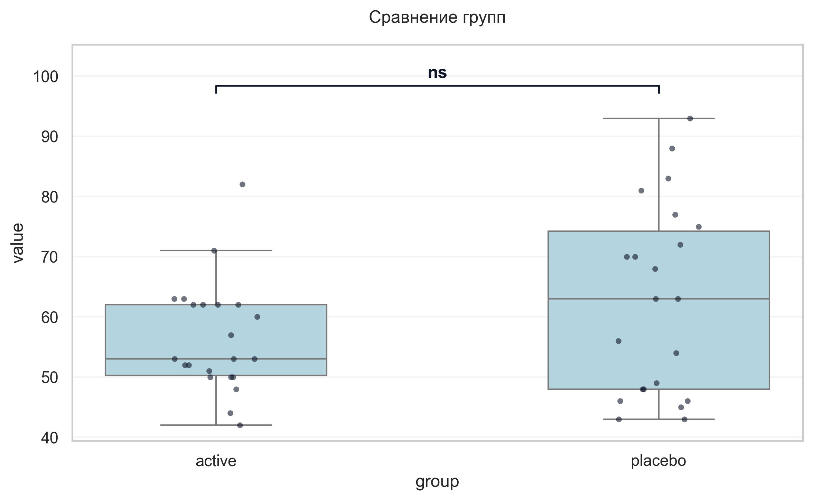
Интерпретация:
An independent Welch's T-Test was conducted to determine if there were differences in Шкала оценки качества жизни при БП баллы V3 between groups defined by arm. The analysis revealed no statistically significant difference between the groups (p = 0.114, Cohen's d = 0.49 indicates a small effect).

Шаг: cmp__сад_v4
Метод: Student's t-test (Independent)
p-value | 0.8353
статистика | -0.209
эффект | cohen-d 0.06
мощность | 0.05
BF10 | 0.303
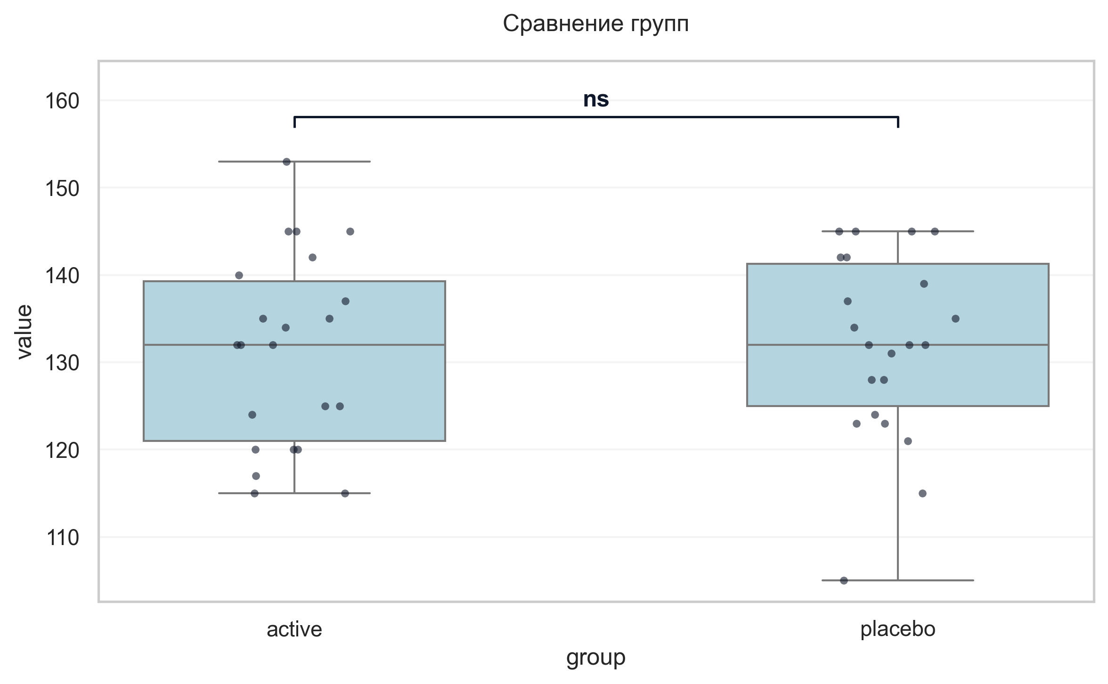
Интерпретация:
An independent Student's t-test (Independent) was conducted to determine if there were differences in САД V4 between groups defined by arm. The analysis revealed no statistically significant difference between the groups (p = 0.835, Cohen's d = 0.06 indicates a trivial effect).

Шаг: cmp__дад_v4
Метод: Mann-Whitney U Test
p-value | 0.1909
статистика | 298.000
эффект | rbc 0.23
мощность | -
BF10 | -
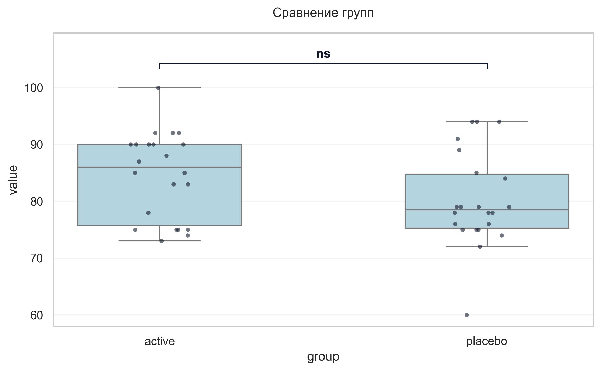
Интерпретация:
An independent Mann-Whitney U Test was conducted to determine if there were differences in ДАД V4 between groups defined by arm. The analysis revealed no statistically significant difference between the groups (p = 0.191, r = 0.23 indicates a small effect).

Шаг: cmp__ушобп_часть_2_повседневная_активность_баллы_v4
Метод: Welch's T-Test
p-value | 0.7560
статистика | 0.313
эффект | cohen-d 0.09
мощность | 0.06
BF10 | 0.31
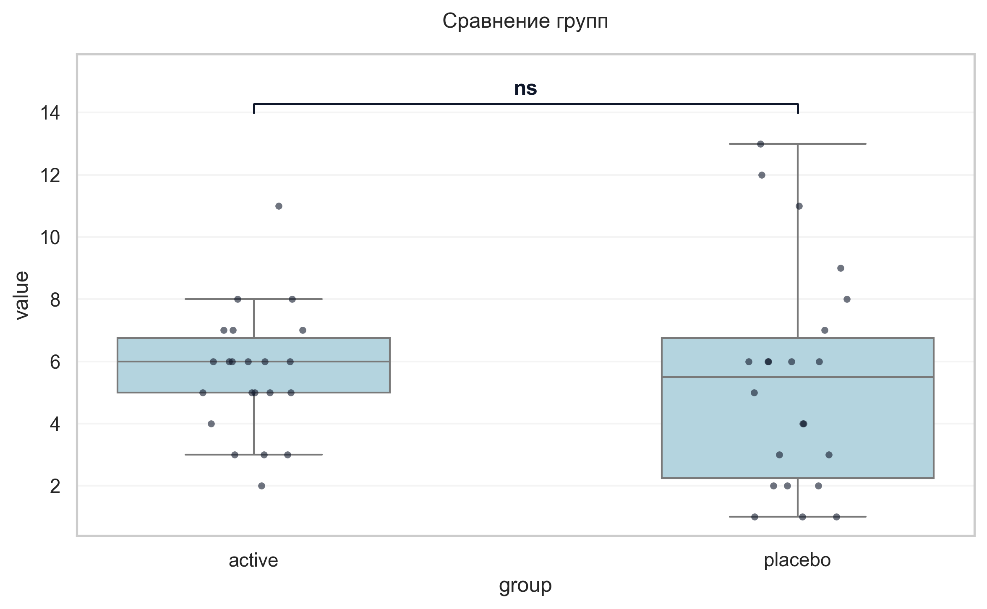
Интерпретация:
An independent Welch's T-Test was conducted to determine if there were differences in УШОБП часть 2 «Повседневная активность» баллы V4 between groups defined by arm. The analysis revealed no statistically significant difference between the groups (p = 0.756, Cohen's d = 0.09 indicates a trivial effect).

Шаг: cmp__ушобп_часть_3_двигательные_функции_баллы_v4
Метод: Welch's T-Test
p-value | 0.1690
статистика | -1.414
эффект | cohen-d 0.43
мощность | 0.28
BF10 | 0.661
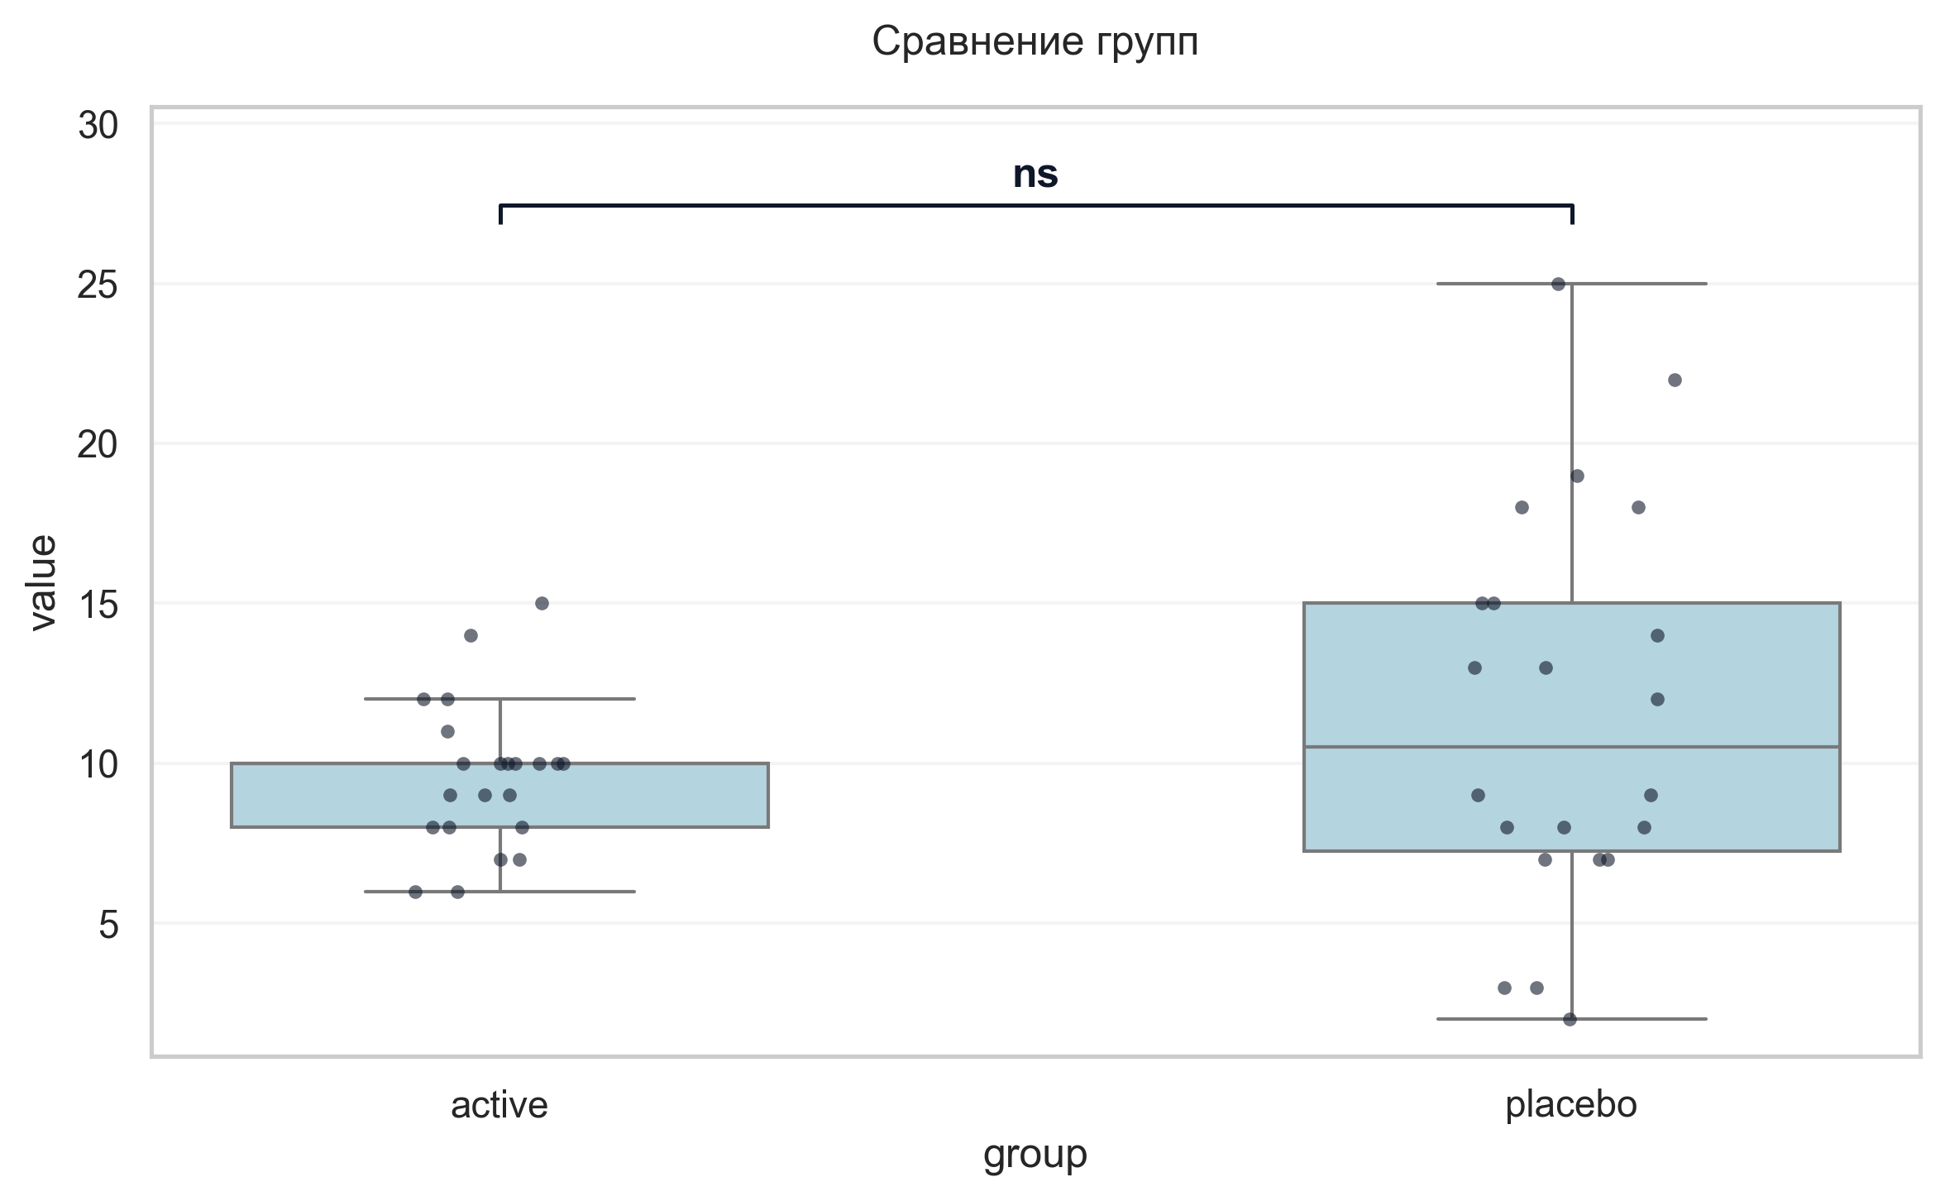
Интерпретация:
An independent Welch's T-Test was conducted to determine if there were differences in УШОБП часть 3 «Двигательные функции» баллы V4 between groups defined by arm. The analysis revealed no statistically significant difference between the groups (p = 0.169, Cohen's d = 0.43 indicates a small effect).

Шаг: cmp__шкала_депрессии_тревоги_и_стресса_dass_21_баллы_v4
Метод: Welch's T-Test
p-value | < 0.001
статистика | -3.876
эффект | cohen-d 1.17
мощность | 0.97
BF10 | 72.108
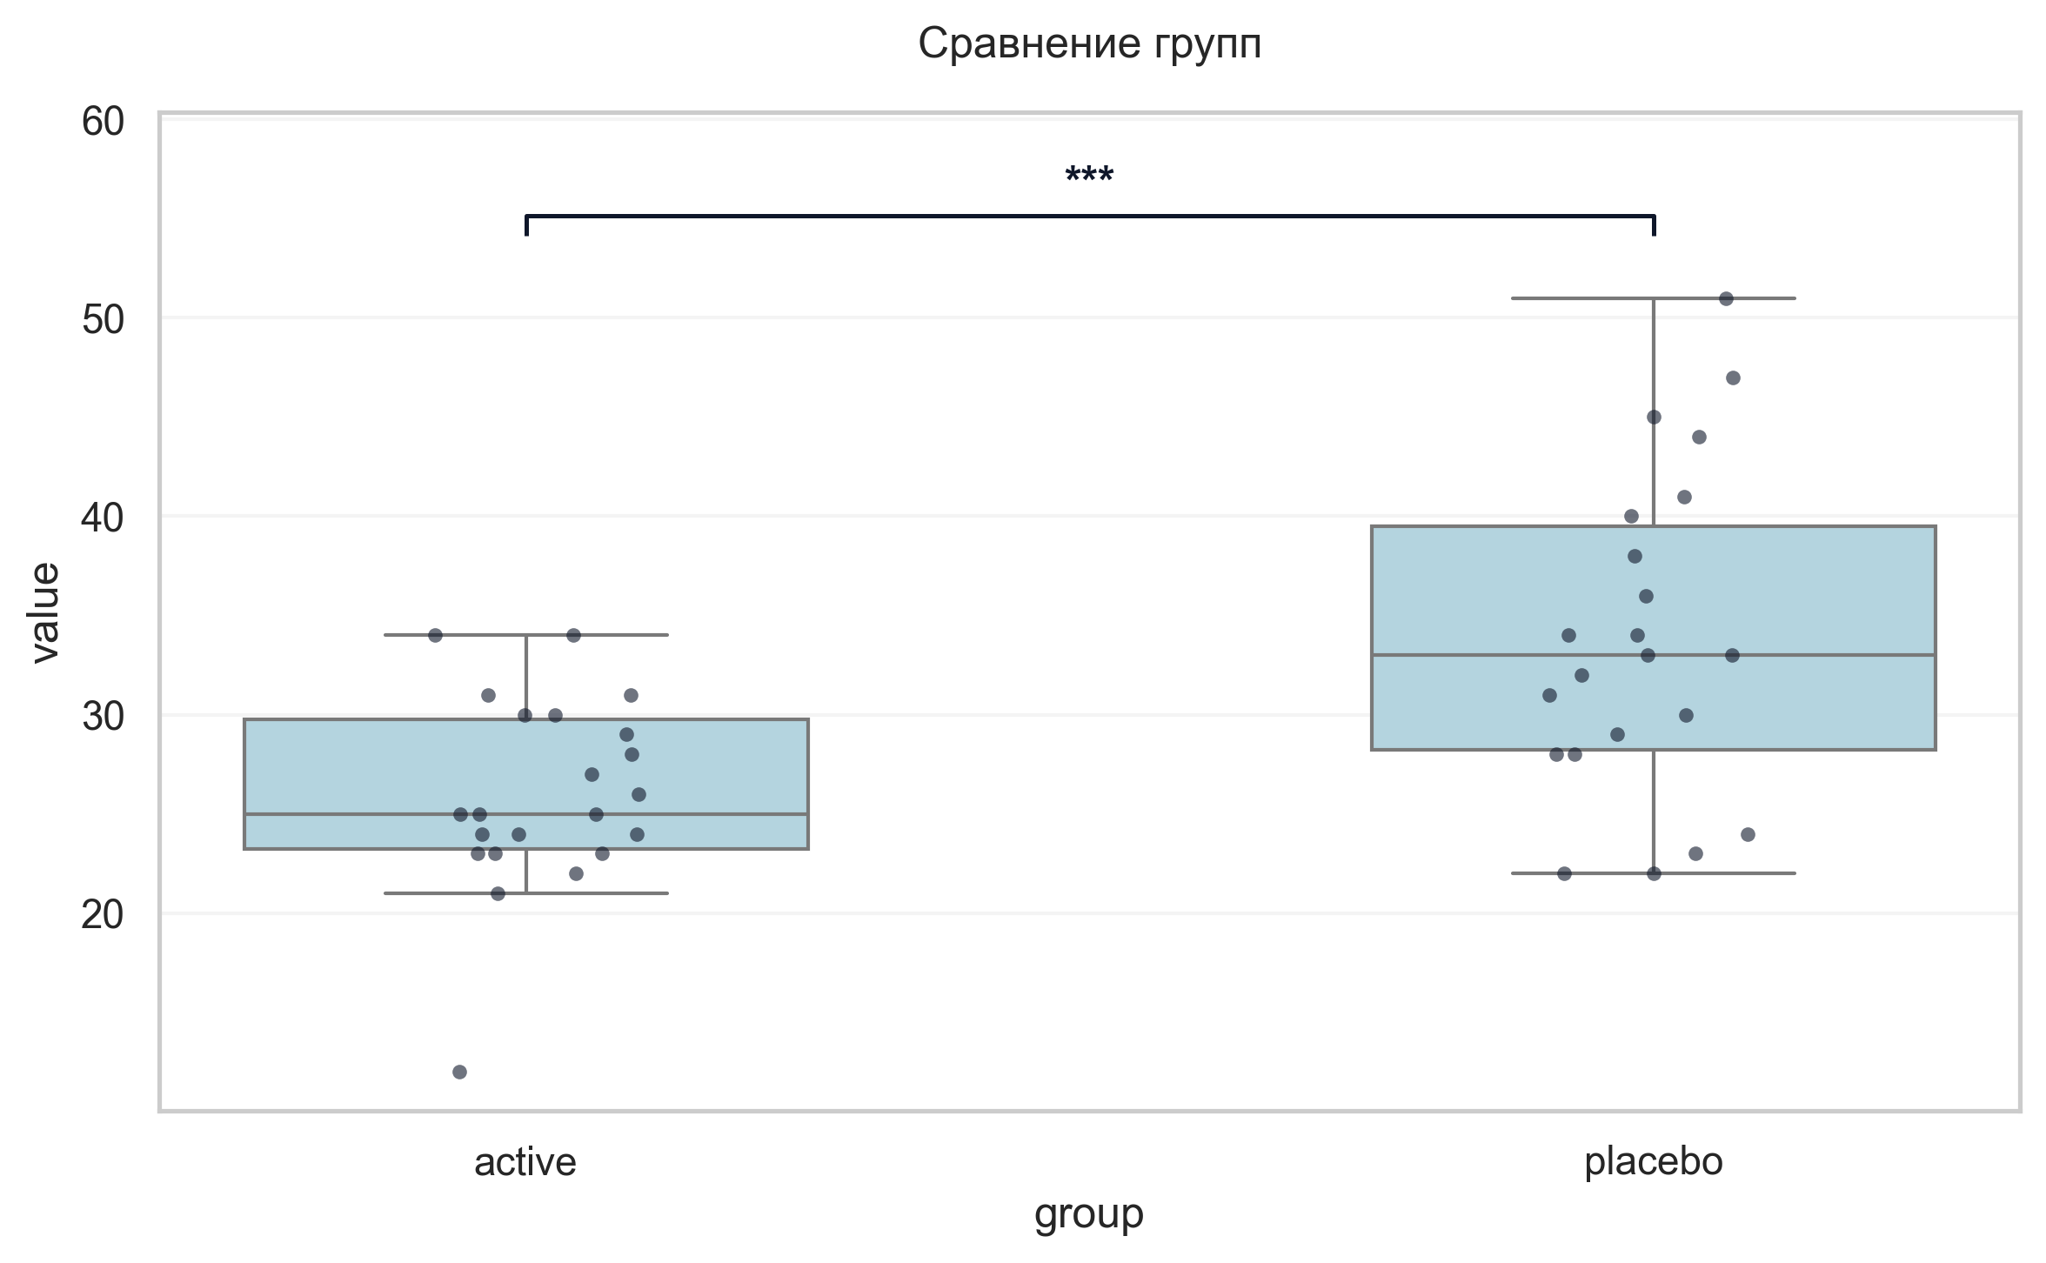
Интерпретация:
An independent Welch's T-Test was conducted to determine if there were differences in Шкала депрессии тревоги и стресса DASS-21 баллы V4 between groups defined by arm. There was a statistically significant difference between the groups (p < 0.001, Cohen's d = 1.17 indicates a large effect). Specifically, the Шкала депрессии тревоги и стресса DASS-21 баллы V4 in the active group (M = 25.95) was significantly lower than in the placebo group (M = 33.86).

Шаг: cmp__шкала_оценки_утомляемости_при_бп_баллы_v4
Метод: Welch's T-Test
p-value | 0.2386
статистика | -1.199
эффект | cohen-d 0.36
мощность | 0.22
BF10 | 0.53
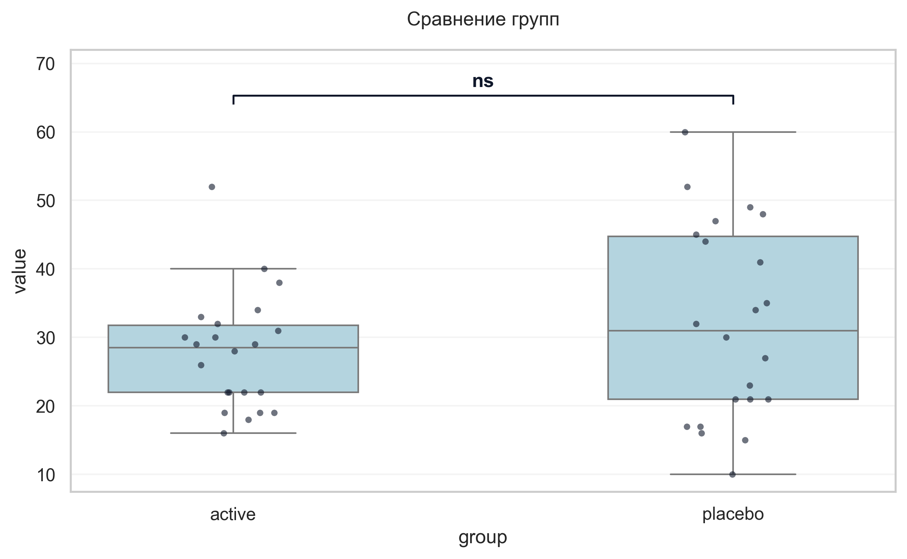
Интерпретация:
An independent Welch's T-Test was conducted to determine if there were differences in Шкала оценки утомляемости при БП баллы V4 between groups defined by arm. The analysis revealed no statistically significant difference between the groups (p = 0.239, Cohen's d = 0.36 indicates a small effect).

Шаг: cmp__шкала_оценки_сонливости_эпуорта_баллы_v4
Метод: Mann-Whitney U Test
p-value | 0.5223
статистика | 214.500
эффект | rbc -0.11
мощность | -
BF10 | -
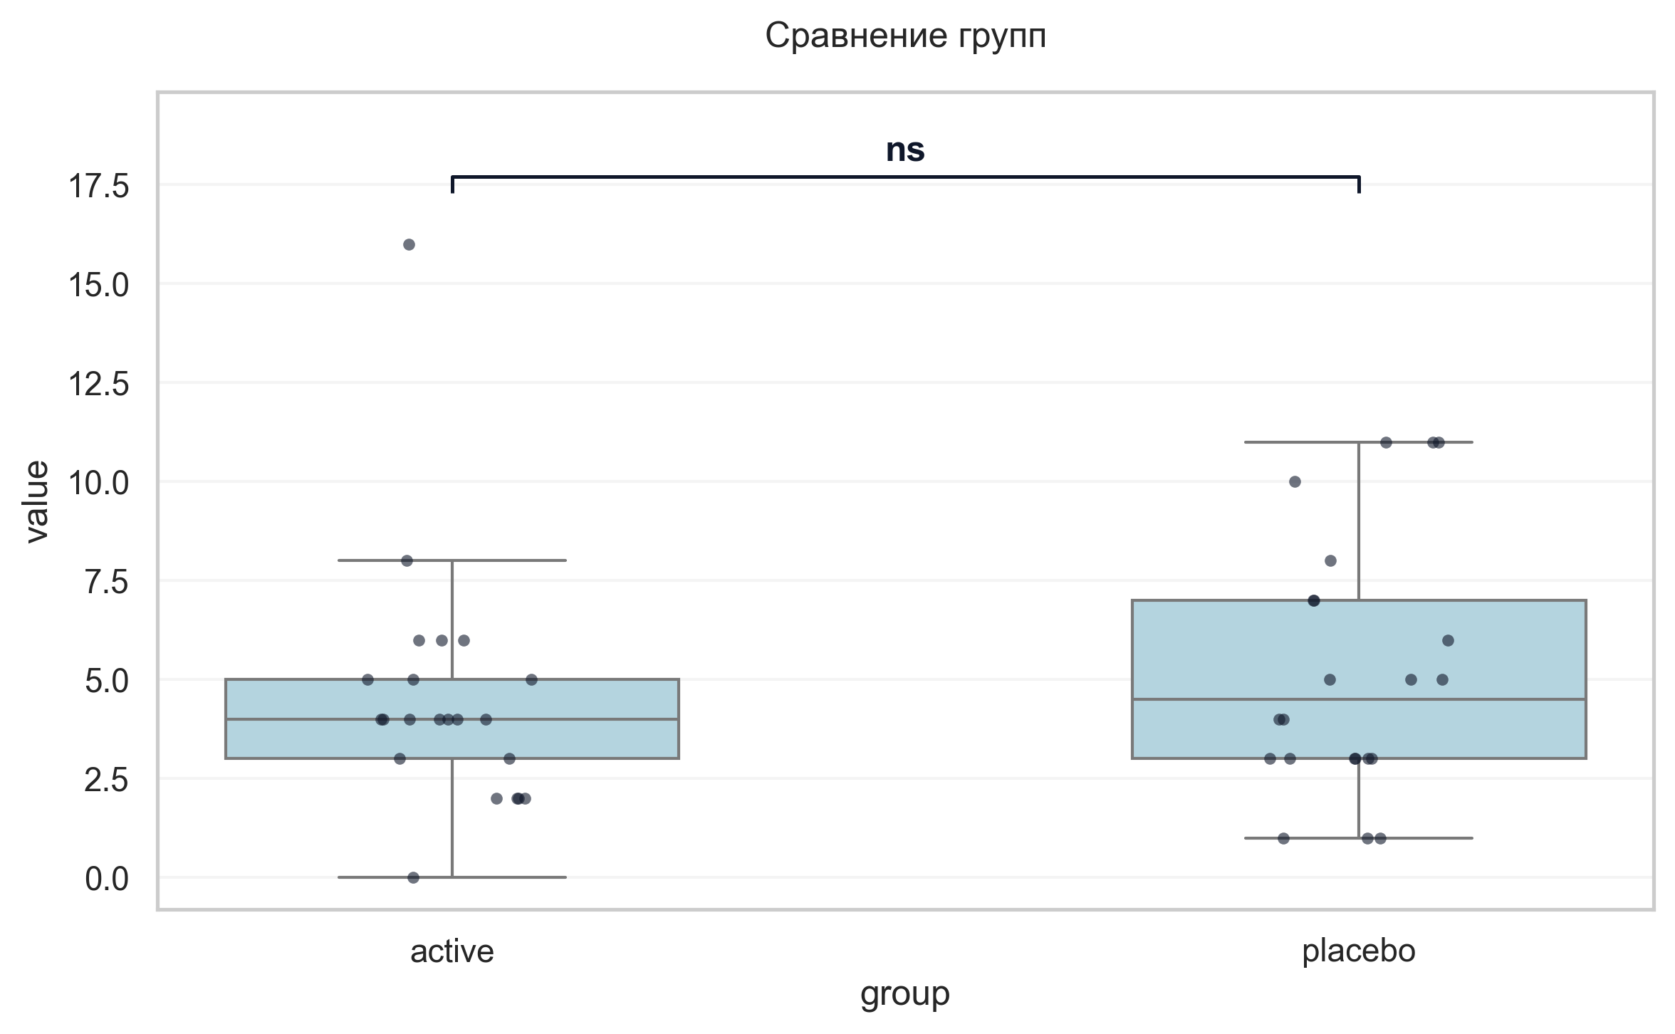
Интерпретация:
An independent Mann-Whitney U Test was conducted to determine if there were differences in Шкала оценки сонливости Эпуорта баллы V4 between groups defined by arm. The analysis revealed no statistically significant difference between the groups (p = 0.522, r = -0.11 indicates a small effect).

Шаг: cmp__шкала_апатии_старкстейна_баллы_v4
Метод: Mann-Whitney U Test
p-value | 0.2322
статистика | 191.000
эффект | rbc -0.21
мощность | -
BF10 | -
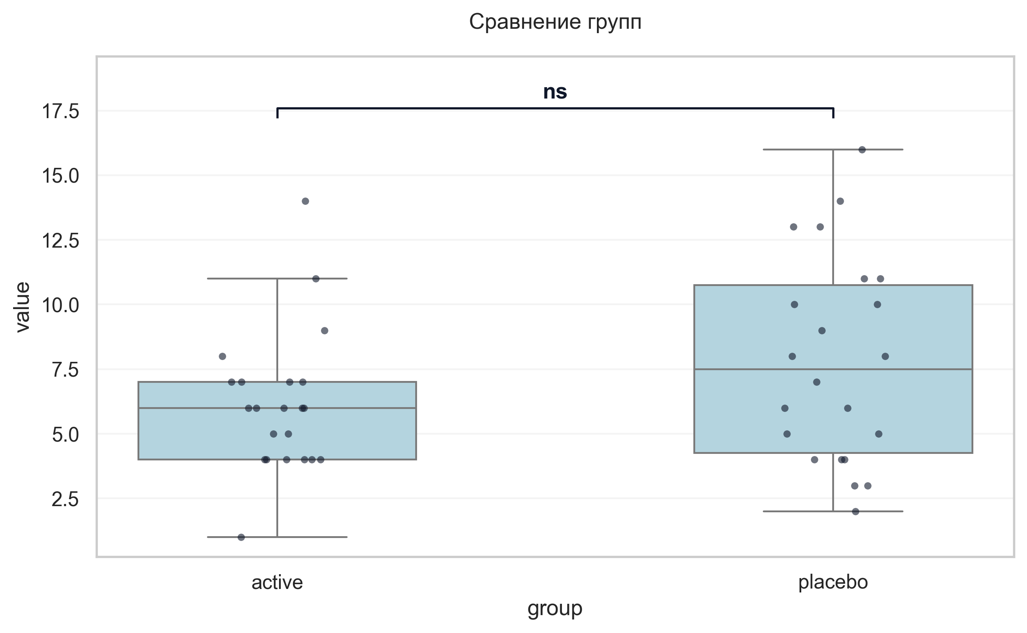
Интерпретация:
An independent Mann-Whitney U Test was conducted to determine if there were differences in Шкала апатии Старкстейна баллы V4 between groups defined by arm. The analysis revealed no statistically significant difference between the groups (p = 0.232, r = -0.21 indicates a small effect).

Шаг: cmp__тест_прокладывания_пути_trail_making_test_мин_v4_а
Метод: Mann-Whitney U Test
p-value | 0.0325
статистика | 150.500
эффект | rbc -0.38
мощность | -
BF10 | -
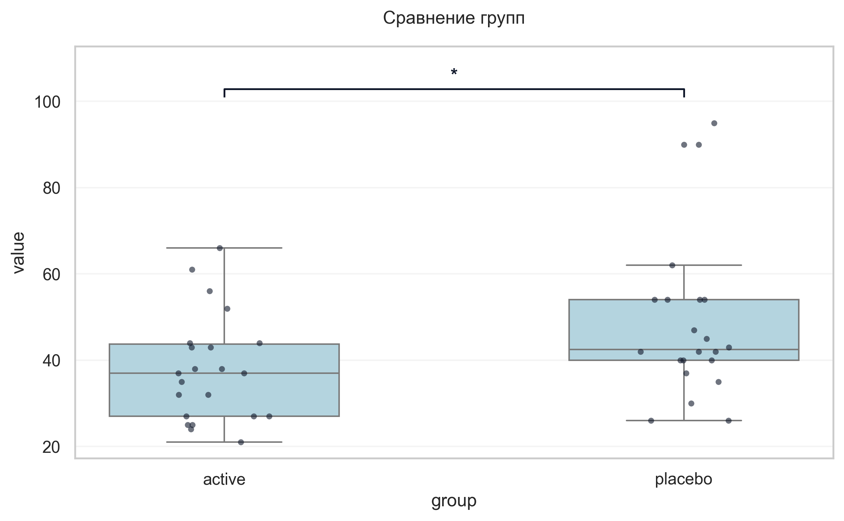
Интерпретация:
An independent Mann-Whitney U Test was conducted to determine if there were differences in «Тест прокладывания пути» Trail Making Test мин V4 А between groups defined by arm. There was a statistically significant difference between the groups (p = 0.032, r = -0.38 indicates a medium effect). Specifically, the «Тест прокладывания пути» Trail Making Test мин V4 А in the active group (M = 37.91) was significantly lower than in the placebo group (M = 49.45).

Шаг: cmp__тест_прокладывания_пути_trail_making_test_мин_v4_б
Метод: Mann-Whitney U Test
p-value | 0.8880
статистика | 235.500
эффект | rbc -0.03
мощность | -
BF10 | -
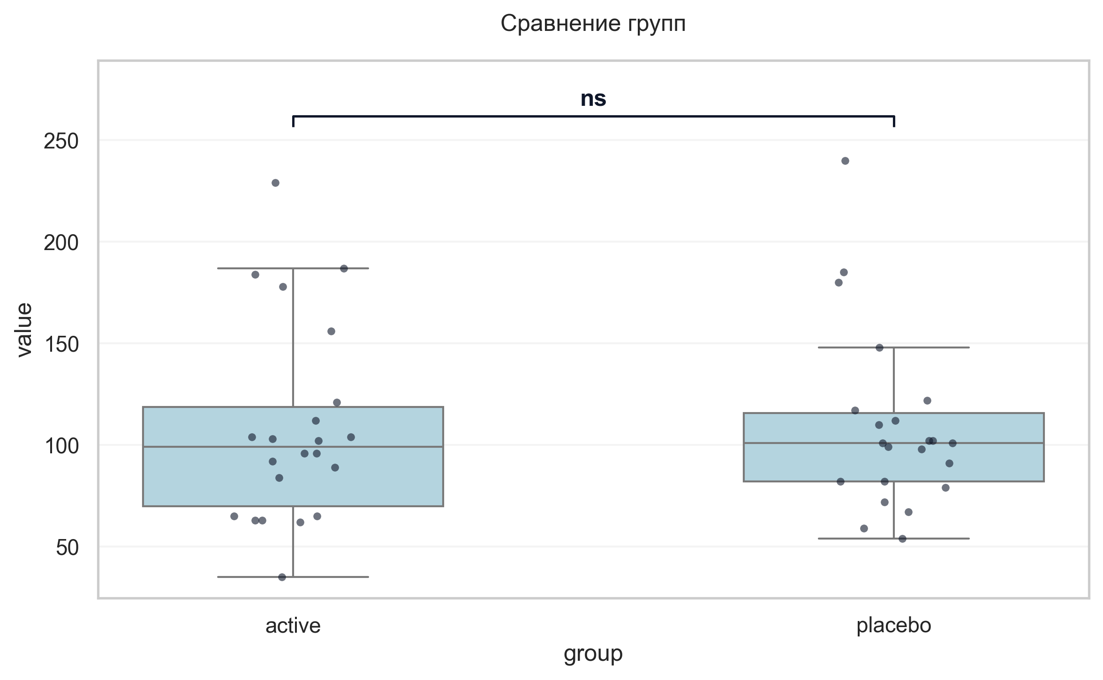
Интерпретация:
An independent Mann-Whitney U Test was conducted to determine if there were differences in «Тест прокладывания пути» Trail Making Test мин V4 Б between groups defined by arm. The analysis revealed no statistically significant difference between the groups (p = 0.888, r = -0.03 indicates a trivial effect).

Шаг: cmp__шкала_оценки_качества_жизни_при_бп_баллы
Метод: Welch's T-Test
p-value | 0.1395
статистика | -1.516
эффект | cohen-d 0.46
мощность | 0.32
BF10 | 0.744
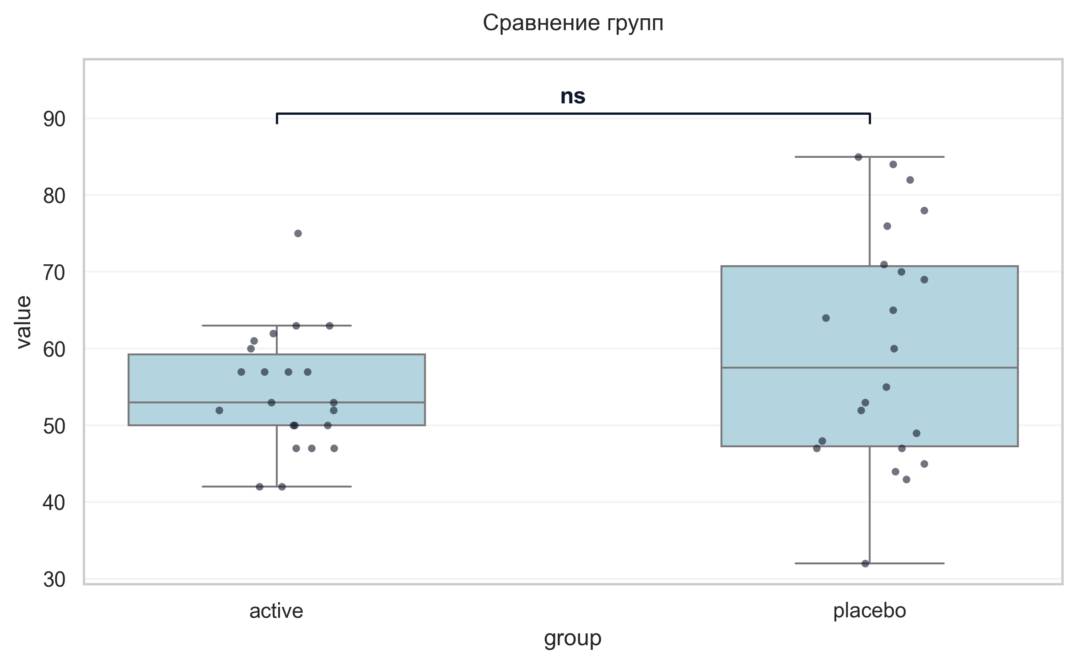
Интерпретация:
An independent Welch's T-Test was conducted to determine if there were differences in Шкала оценки качества жизни при БП баллы between groups defined by arm. The analysis revealed no statistically significant difference between the groups (p = 0.140, Cohen's d = 0.46 indicates a small effect).

Шаг: cmp__ушобп_часть_2_повседневная_активность_баллы_v5
Метод: Welch's T-Test
p-value | 0.7882
статистика | -0.271
эффект | cohen-d 0.08
мощность | 0.06
BF10 | 0.306
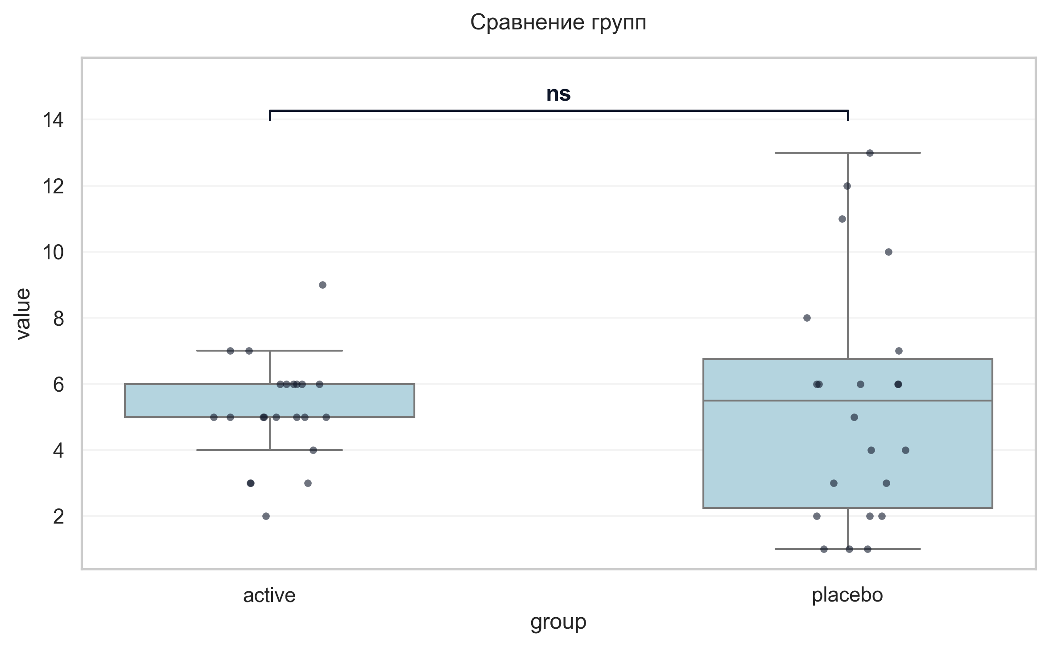
Интерпретация:
An independent Welch's T-Test was conducted to determine if there were differences in УШОБП часть 2 «Повседневная активность» баллы V5 between groups defined by arm. The analysis revealed no statistically significant difference between the groups (p = 0.788, Cohen's d = 0.08 indicates a trivial effect).

Шаг: cmp__ушобп_часть_3_двигательные_функции_баллы_v5
Метод: Welch's T-Test
p-value | 0.0296
статистика | -2.309
эффект | cohen-d 0.70
мощность | 0.62
BF10 | 2.386
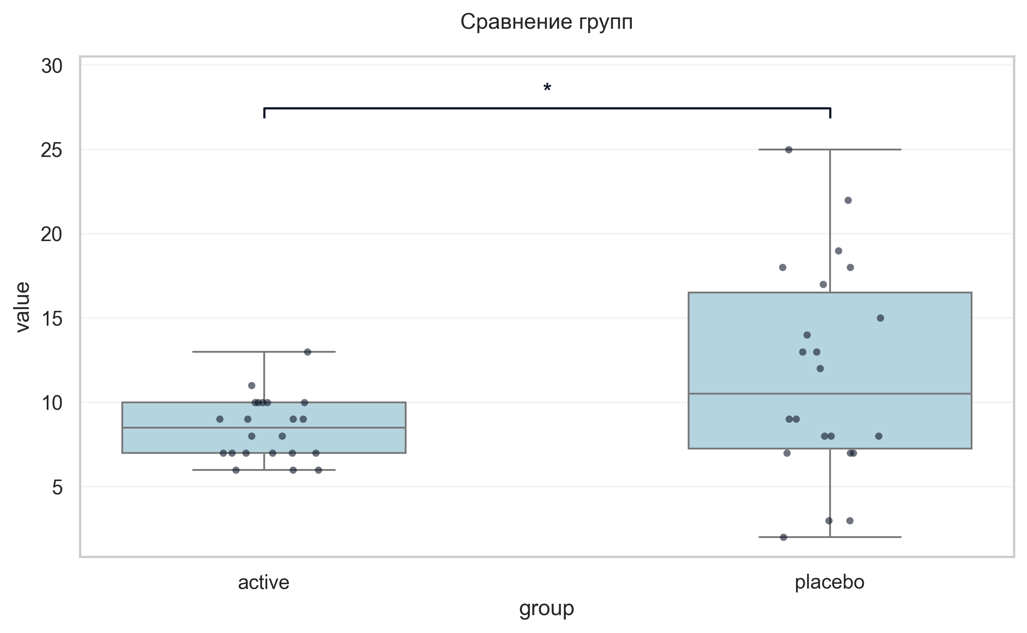
Интерпретация:
An independent Welch's T-Test was conducted to determine if there were differences in УШОБП часть 3 «Двигательные функции» баллы V5 between groups defined by arm. There was a statistically significant difference between the groups (p = 0.030, Cohen's d = 0.70 indicates a medium effect). Specifically, the УШОБП часть 3 «Двигательные функции» баллы V5 in the active group (M = 8.45) was significantly lower than in the placebo group (M = 11.68).

Шаг: cmp__шкала_депрессии_тревоги_и_стресса_dass_21_баллы_v5
Метод: Mann-Whitney U Test
p-value | < 0.001
статистика | 81.500
эффект | rbc -0.66
мощность | -
BF10 | -
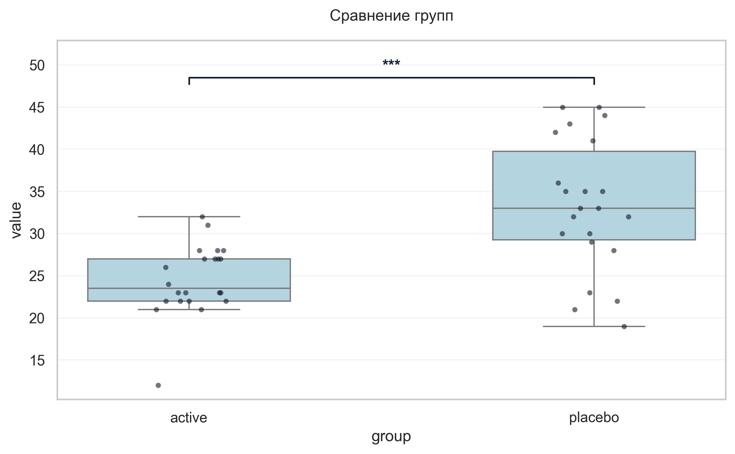
Интерпретация:
An independent Mann-Whitney U Test was conducted to determine if there were differences in Шкала депрессии тревоги и стресса DASS-21 баллы V5 between groups defined by arm. There was a statistically significant difference between the groups (p < 0.001, r = -0.66 indicates a large effect). Specifically, the Шкала депрессии тревоги и стресса DASS-21 баллы V5 in the active group (M = 24.50) was significantly lower than in the placebo group (M = 33.32).

Шаг: cmp__шкала_оценки_утомляемости_при_бп_баллы_v5
Метод: Mann-Whitney U Test
p-value | 0.2002
статистика | 187.000
эффект | rbc -0.23
мощность | -
BF10 | -
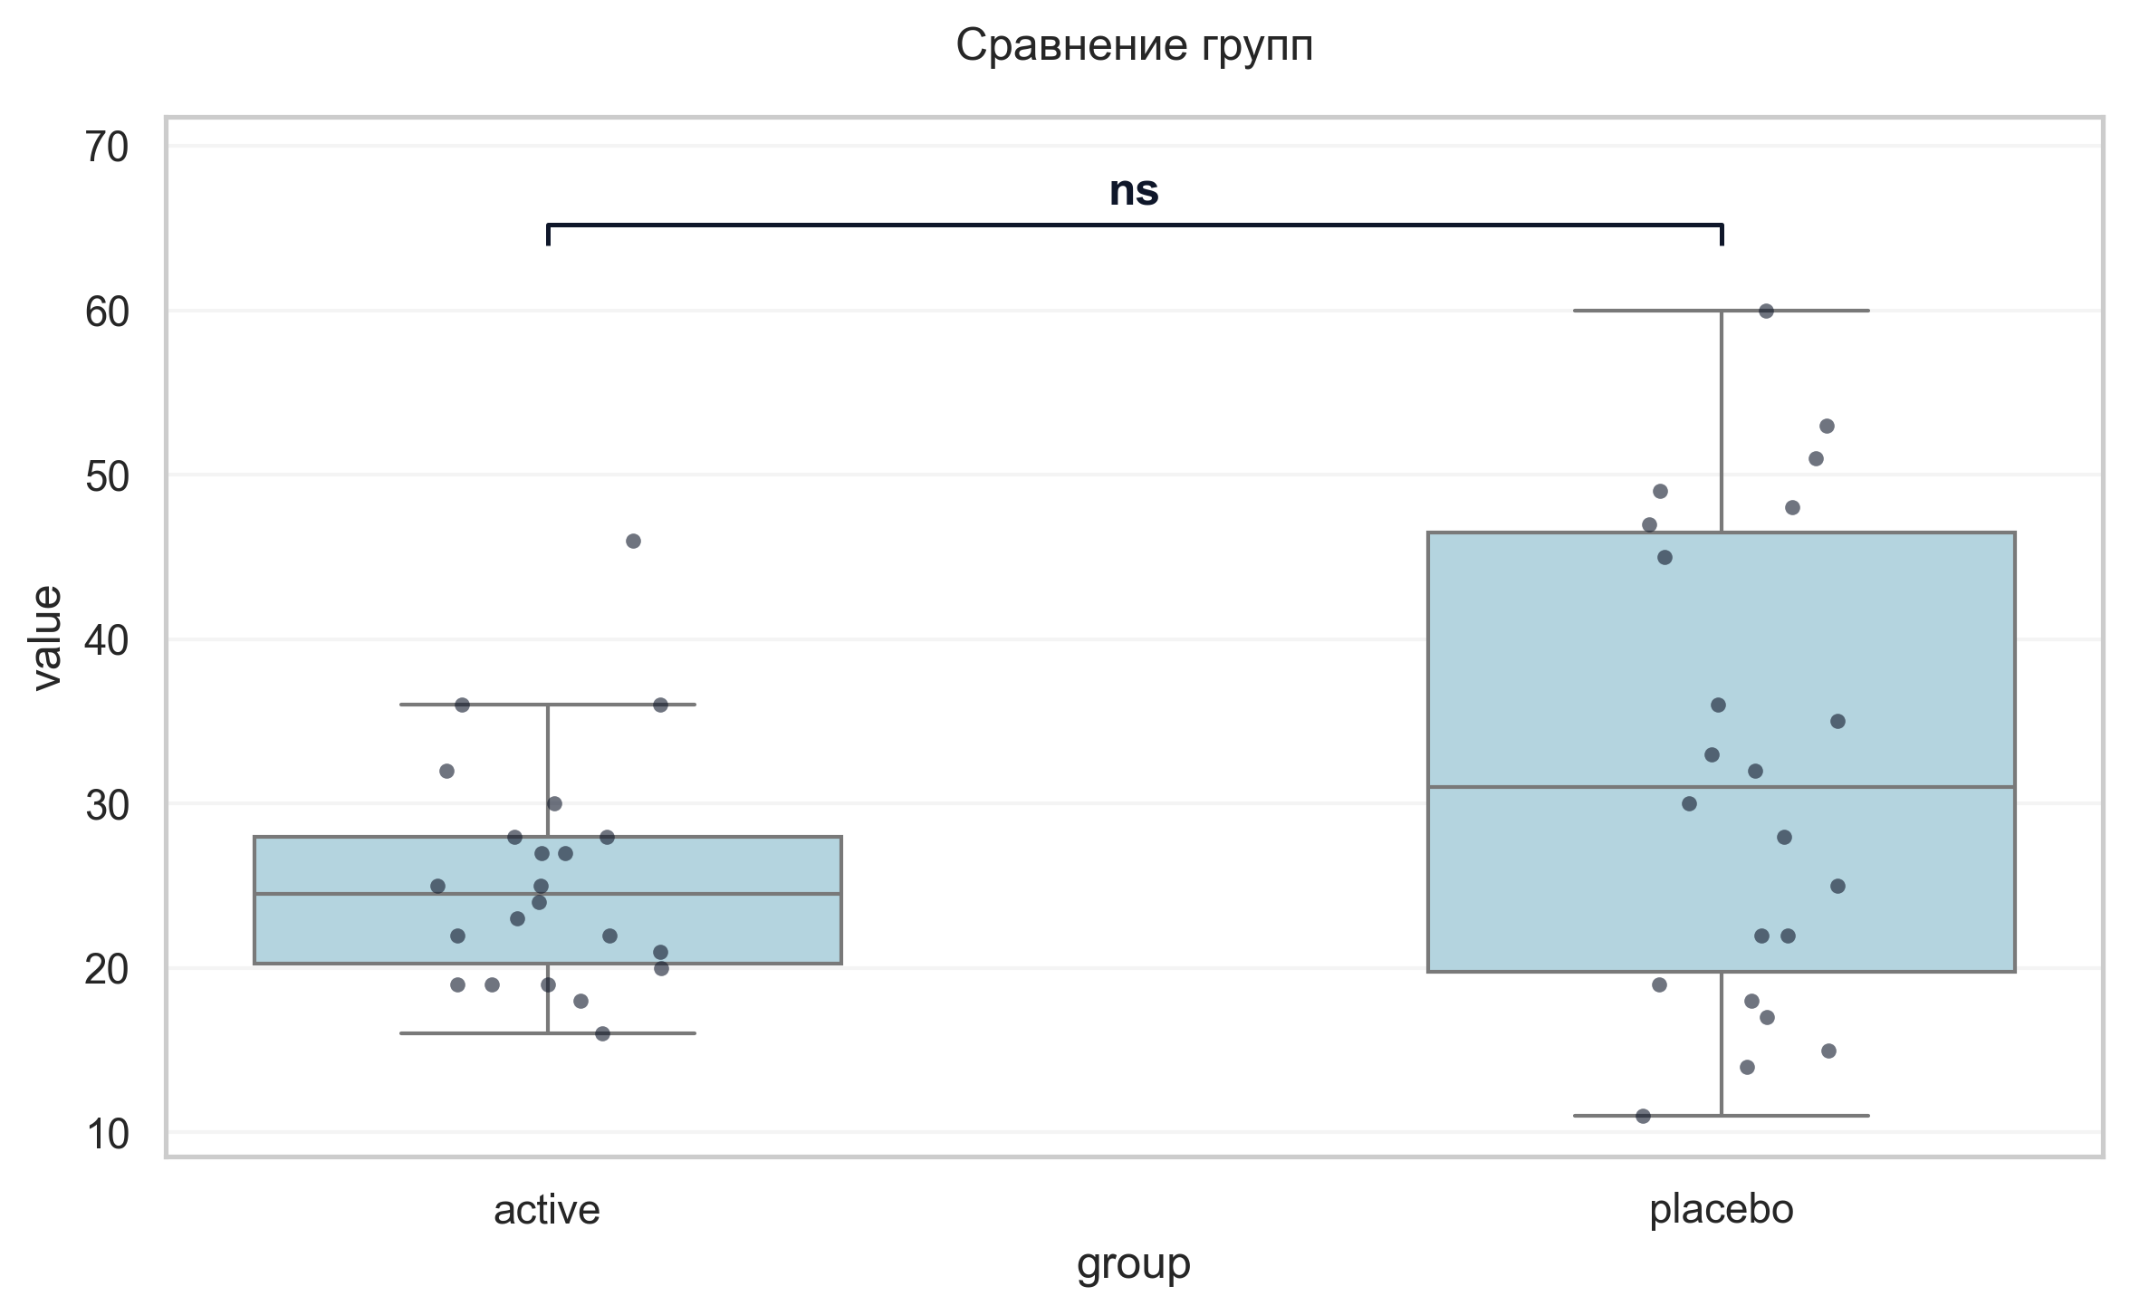
Интерпретация:
An independent Mann-Whitney U Test was conducted to determine if there were differences in Шкала оценки утомляемости при БП баллы V5 between groups defined by arm. The analysis revealed no statistically significant difference between the groups (p = 0.200, r = -0.23 indicates a small effect).

Шаг: cmp__шкала_оценки_сонливости_эпуорта_баллы_v5
Метод: Mann-Whitney U Test
p-value | 0.4322
статистика | 208.500
эффект | rbc -0.14
мощность | -
BF10 | -
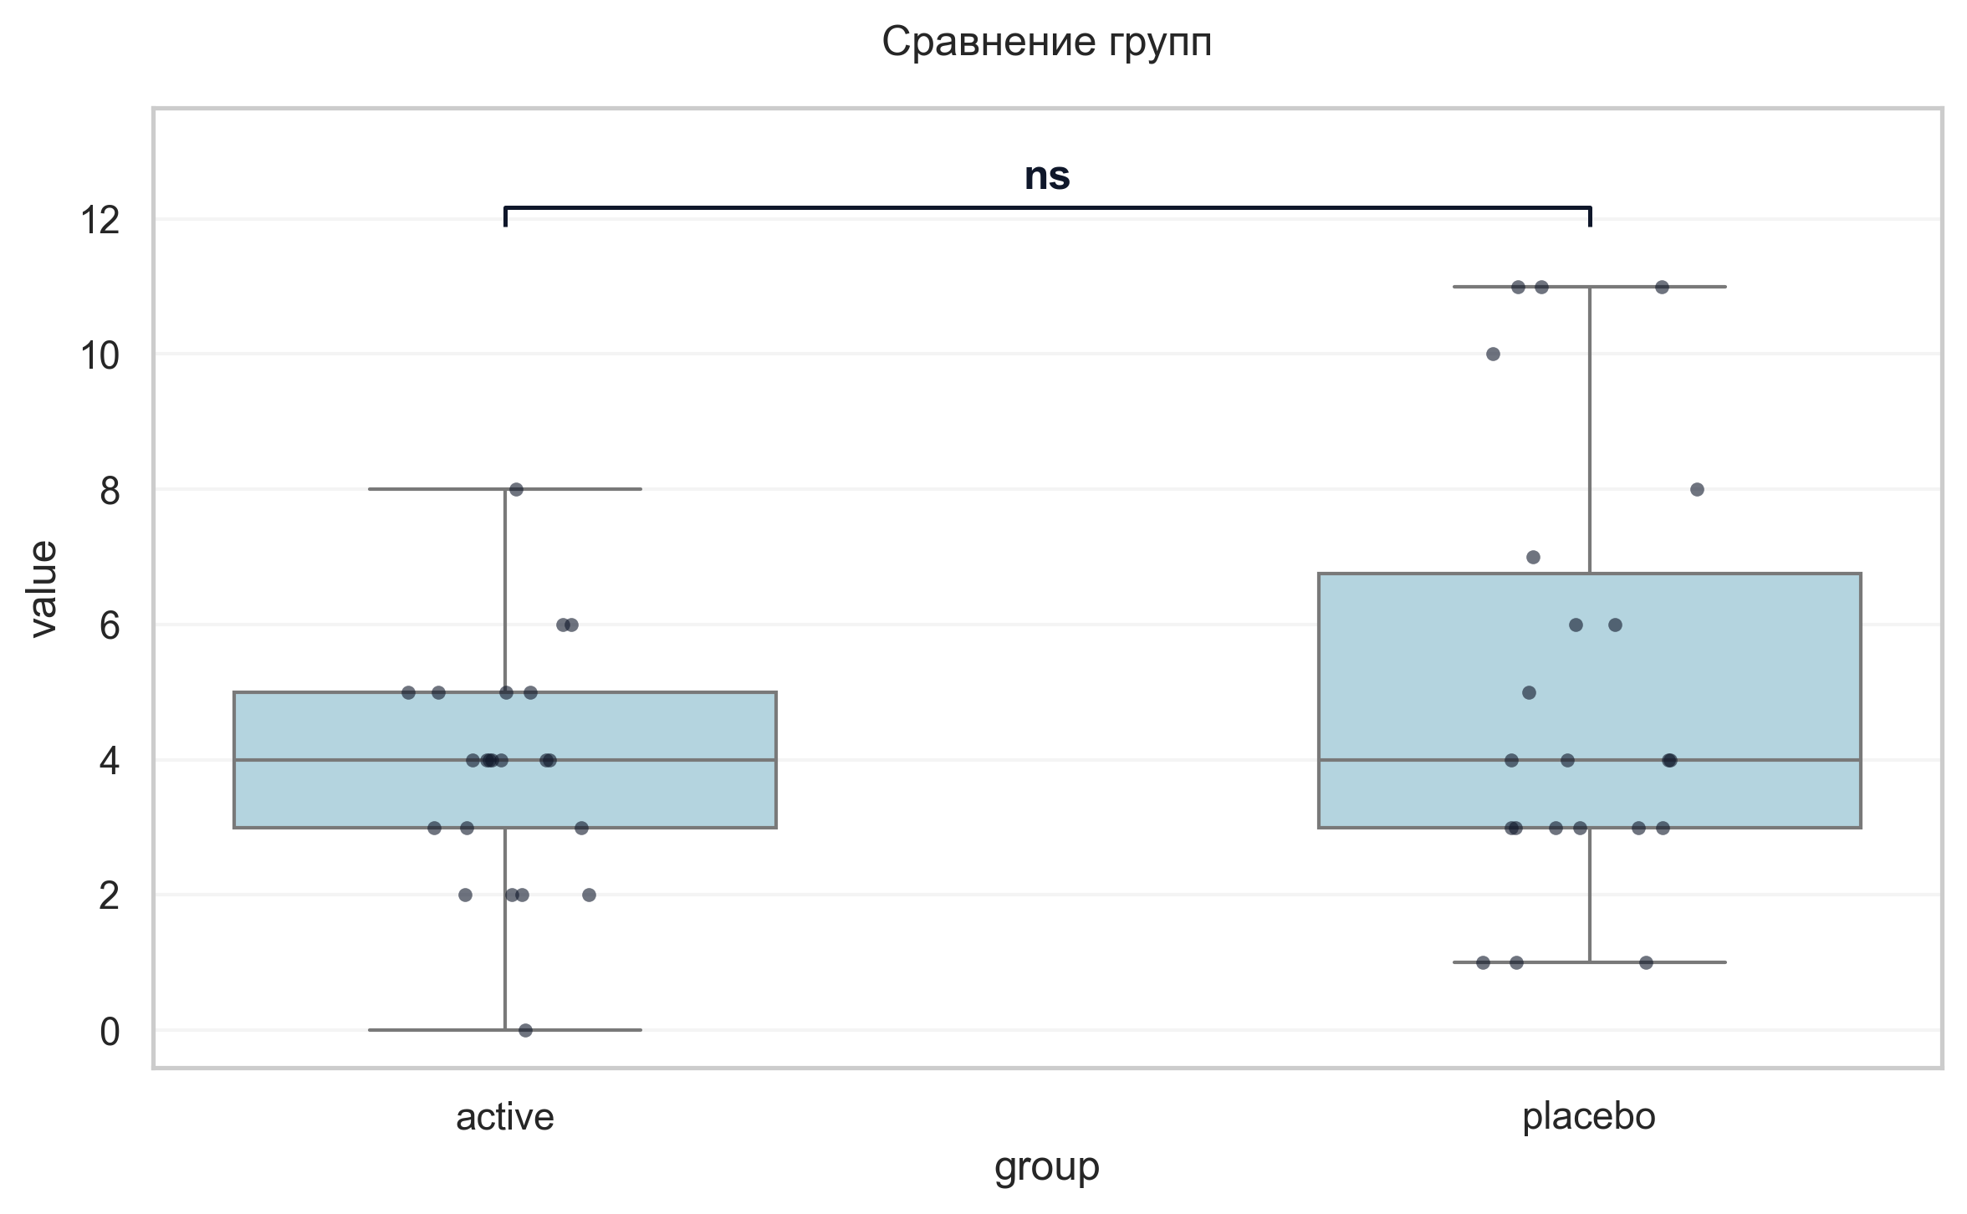
Интерпретация:
An independent Mann-Whitney U Test was conducted to determine if there were differences in Шкала оценки сонливости Эпуорта баллы V5 between groups defined by arm. The analysis revealed no statistically significant difference between the groups (p = 0.432, r = -0.14 indicates a small effect).

Шаг: cmp__шкала_апатии_старкстейна_баллы_v5
Метод: Mann-Whitney U Test
p-value | 0.0949
статистика | 171.000
эффект | rbc -0.29
мощность | -
BF10 | -
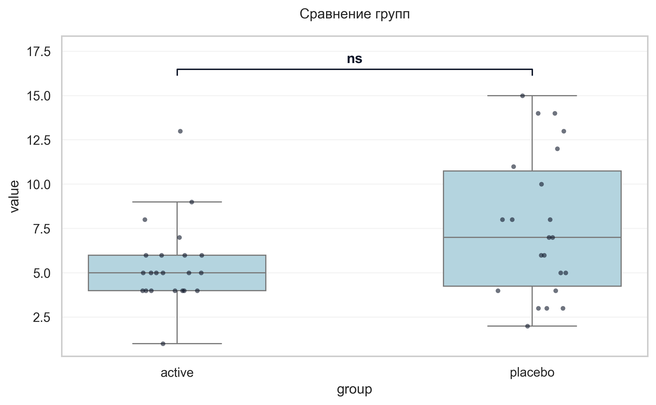
Интерпретация:
An independent Mann-Whitney U Test was conducted to determine if there were differences in Шкала апатии Старкстейна баллы V5 between groups defined by arm. The analysis revealed no statistically significant difference between the groups (p = 0.095, r = -0.29 indicates a small effect).

Шаг: cmp__струп_v5_1
Метод: Student's t-test (Independent)
p-value | 0.0044
статистика | -3.008
эффект | cohen-d 0.91
мощность | 0.84
BF10 | 9.322
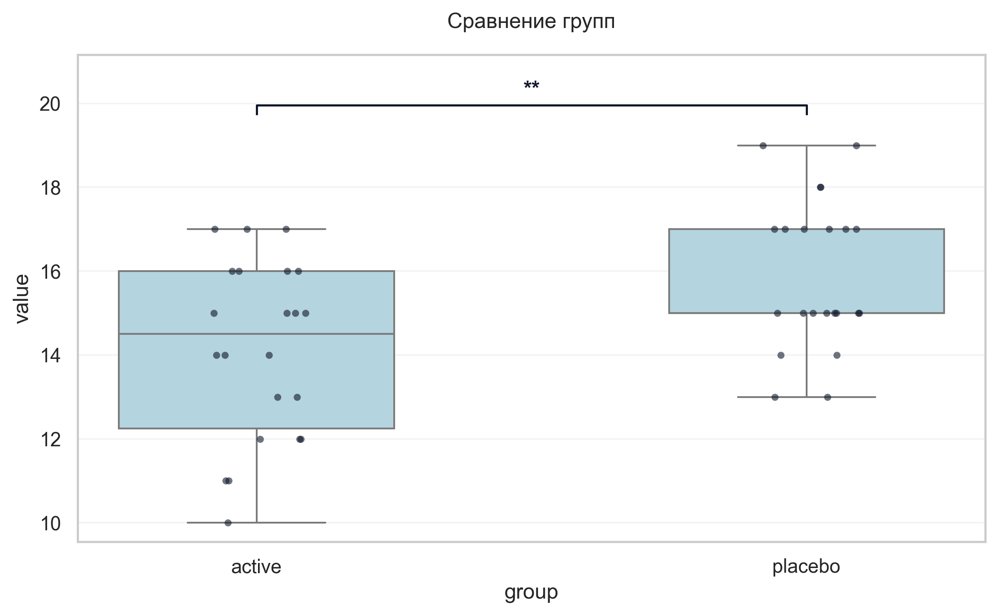
Интерпретация:
An independent Student's t-test (Independent) was conducted to determine if there were differences in Струп V5 1 between groups defined by arm. There was a statistically significant difference between the groups (p = 0.004, Cohen's d = 0.91 indicates a large effect). Specifically, the Струп V5 1 in the active group (M = 14.14) was significantly lower than in the placebo group (M = 15.91).

Шаг: cmp__струп_v5_2
Метод: Student's t-test (Independent)
p-value | 0.0205
статистика | 2.408
эффект | cohen-d 0.73
мощность | 0.65
BF10 | 2.842
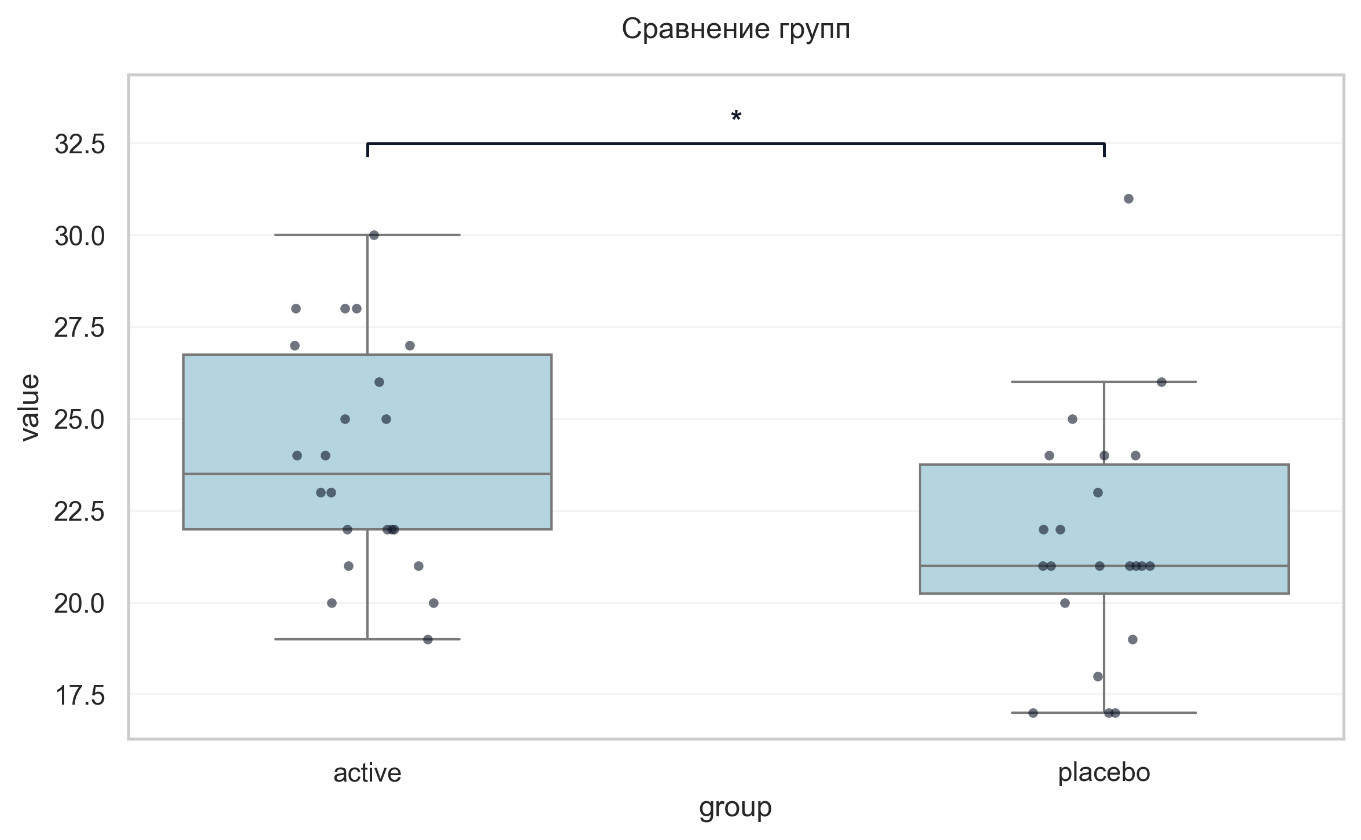
Интерпретация:
An independent Student's t-test (Independent) was conducted to determine if there were differences in Струп V5 2 between groups defined by arm. There was a statistically significant difference between the groups (p = 0.020, Cohen's d = 0.73 indicates a medium effect). Specifically, the Струп V5 2 in the active group (M = 23.95) was significantly higher than in the placebo group (M = 21.64).

Шаг: cmp__струп_v5_3
Метод: Student's t-test (Independent)
p-value | 0.2717
статистика | 1.114
эффект | cohen-d 0.34
мощность | 0.19
BF10 | 0.489
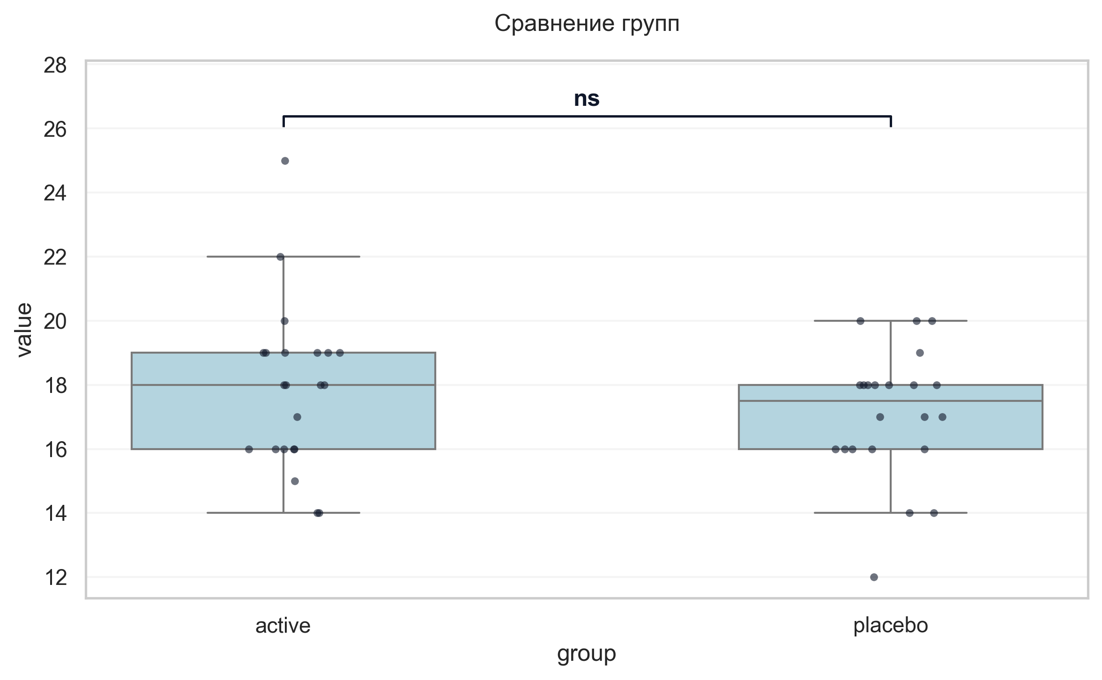
Интерпретация:
An independent Student's t-test (Independent) was conducted to determine if there were differences in Струп V5 3 between groups defined by arm. The analysis revealed no statistically significant difference between the groups (p = 0.272, Cohen's d = 0.34 indicates a small effect).

Шаг: cmp__индекс_интерференции_v5
Метод: Student's t-test (Independent)
p-value | 0.1934
статистика | -1.322
эффект | cohen-d 0.40
мощность | 0.25
BF10 | 0.598
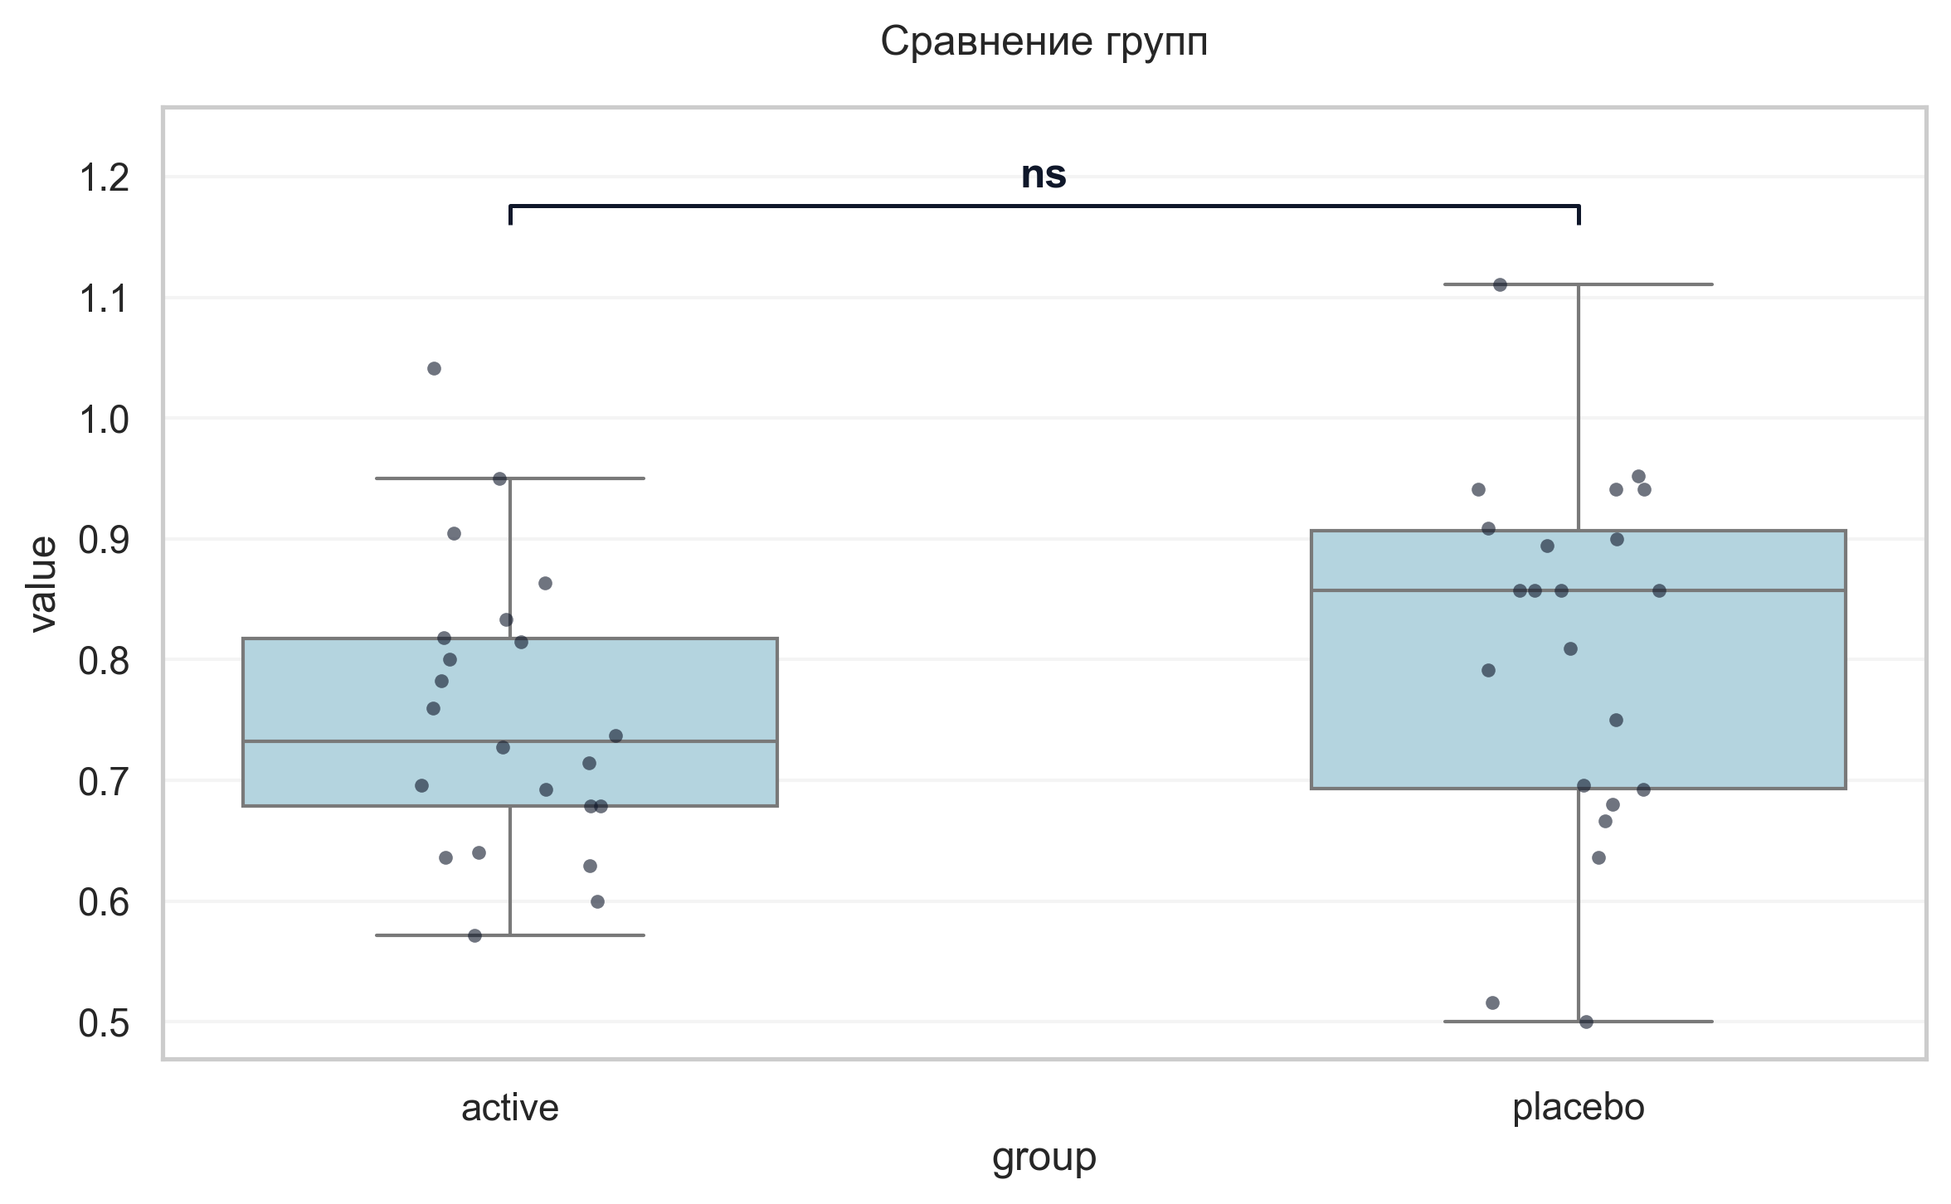
Интерпретация:
An independent Student's t-test (Independent) was conducted to determine if there were differences in Индекс интерференции V5 between groups defined by arm. The analysis revealed no statistically significant difference between the groups (p = 0.193, Cohen's d = 0.40 indicates a small effect).

Шаг: cmp__тест_прокладывания_пути_trail_making_test_мин_v5_а
Метод: Mann-Whitney U Test
p-value | 0.0021
статистика | 110.500
эффект | rbc -0.54
мощность | -
BF10 | -
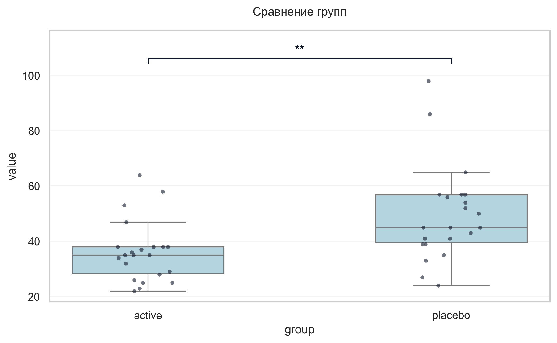
Интерпретация:
An independent Mann-Whitney U Test was conducted to determine if there were differences in «Тест прокладывания пути» Trail Making Test мин V5 А between groups defined by arm. There was a statistically significant difference between the groups (p = 0.002, r = -0.54 indicates a large effect). Specifically, the «Тест прокладывания пути» Trail Making Test мин V5 А in the active group (M = 36.18) was significantly lower than in the placebo group (M = 49.50).

Шаг: cmp__тест_прокладывания_пути_trail_making_test_мин_v5_б
Метод: Mann-Whitney U Test
p-value | 0.7512
статистика | 228.000
эффект | rbc -0.06
мощность | -
BF10 | -
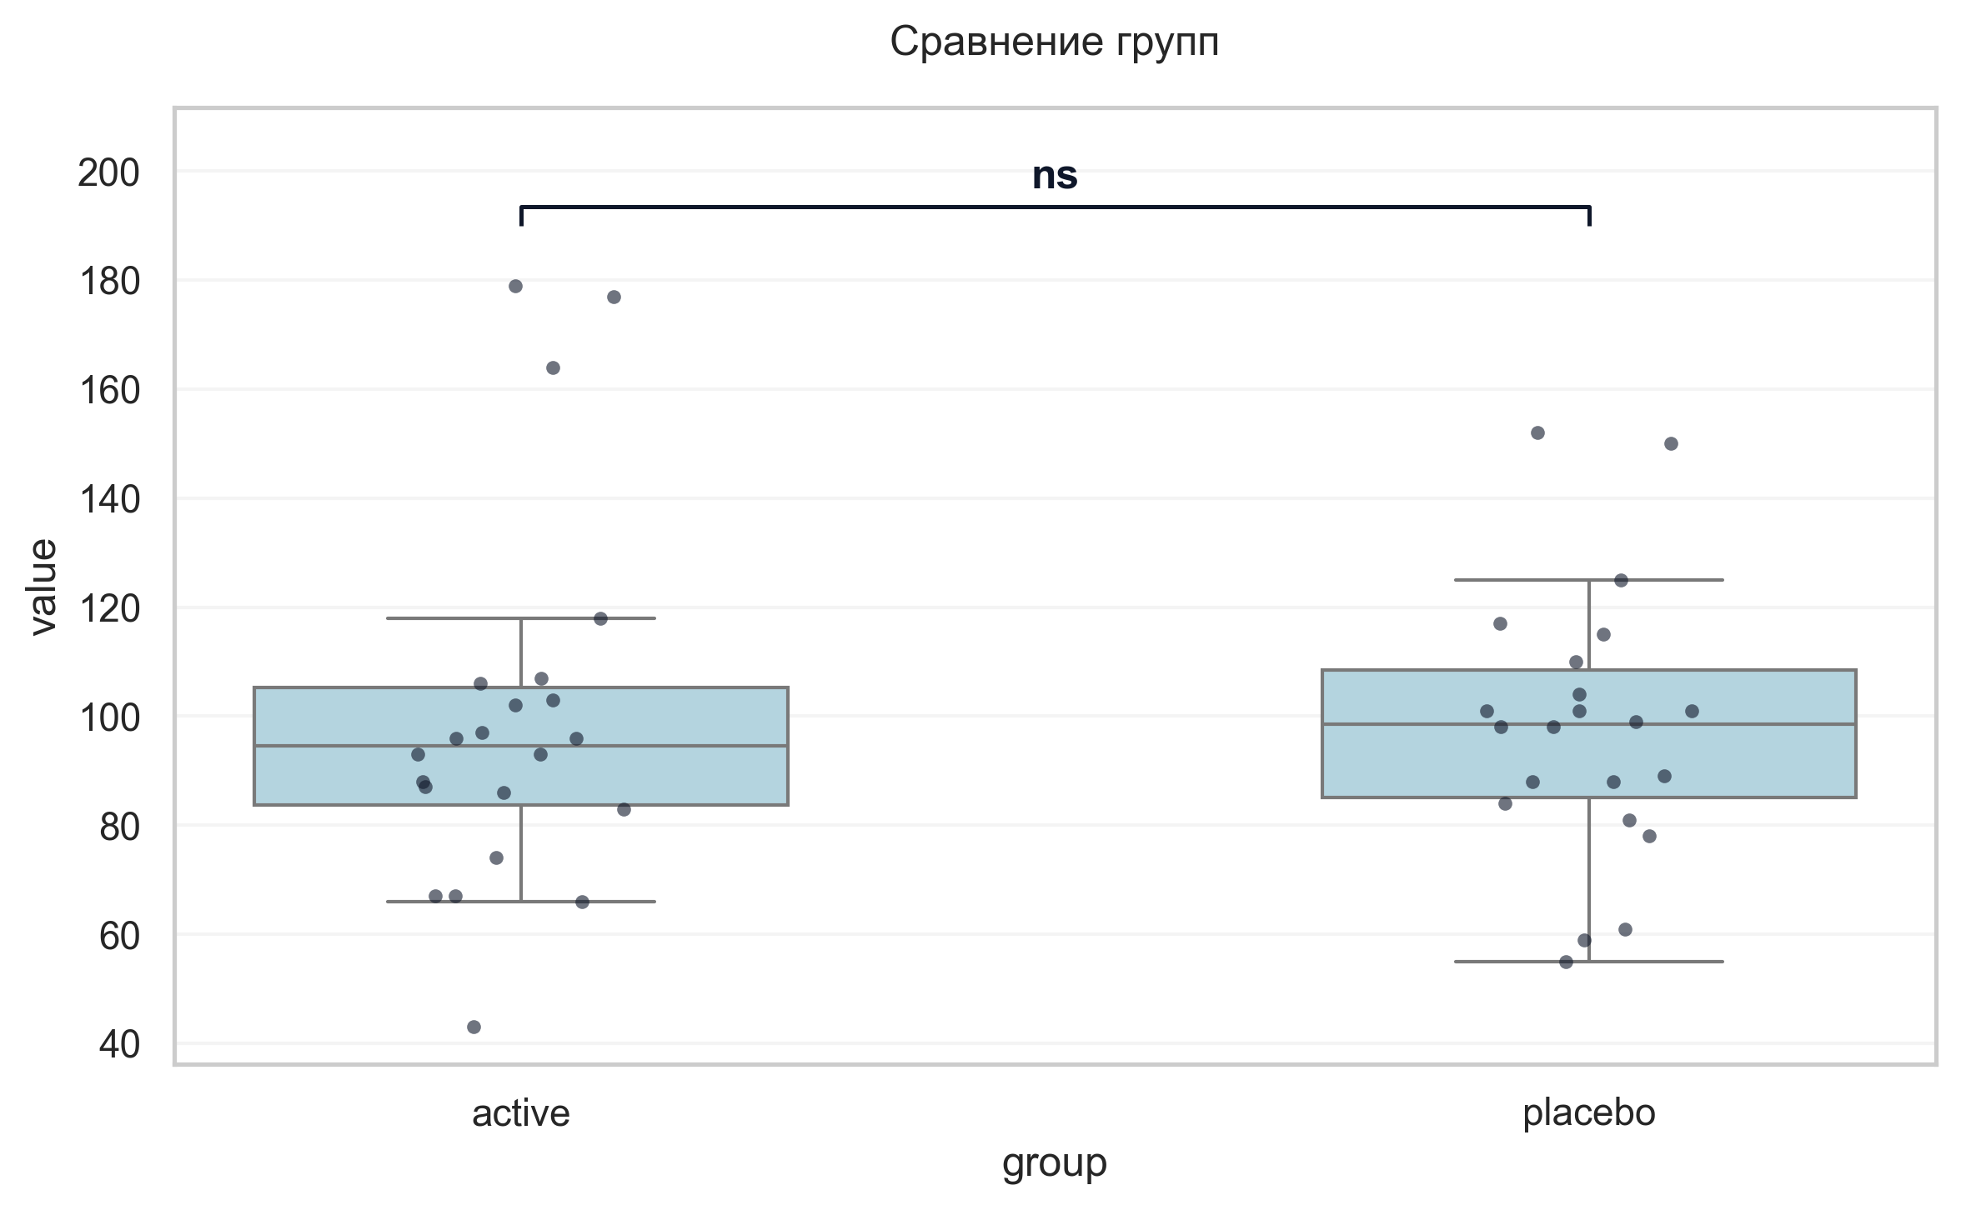
Интерпретация:
An independent Mann-Whitney U Test was conducted to determine if there were differences in «Тест прокладывания пути» Trail Making Test мин V5 Б between groups defined by arm. The analysis revealed no statistically significant difference between the groups (p = 0.751, r = -0.06 indicates a trivial effect).

Шаг: cmp__шкала_оценки_качества_жизни_при_бп_баллы_v5
Метод: Welch's T-Test
p-value | 0.0300
статистика | -2.277
эффект | cohen-d 0.69
мощность | 0.60
BF10 | 2.256
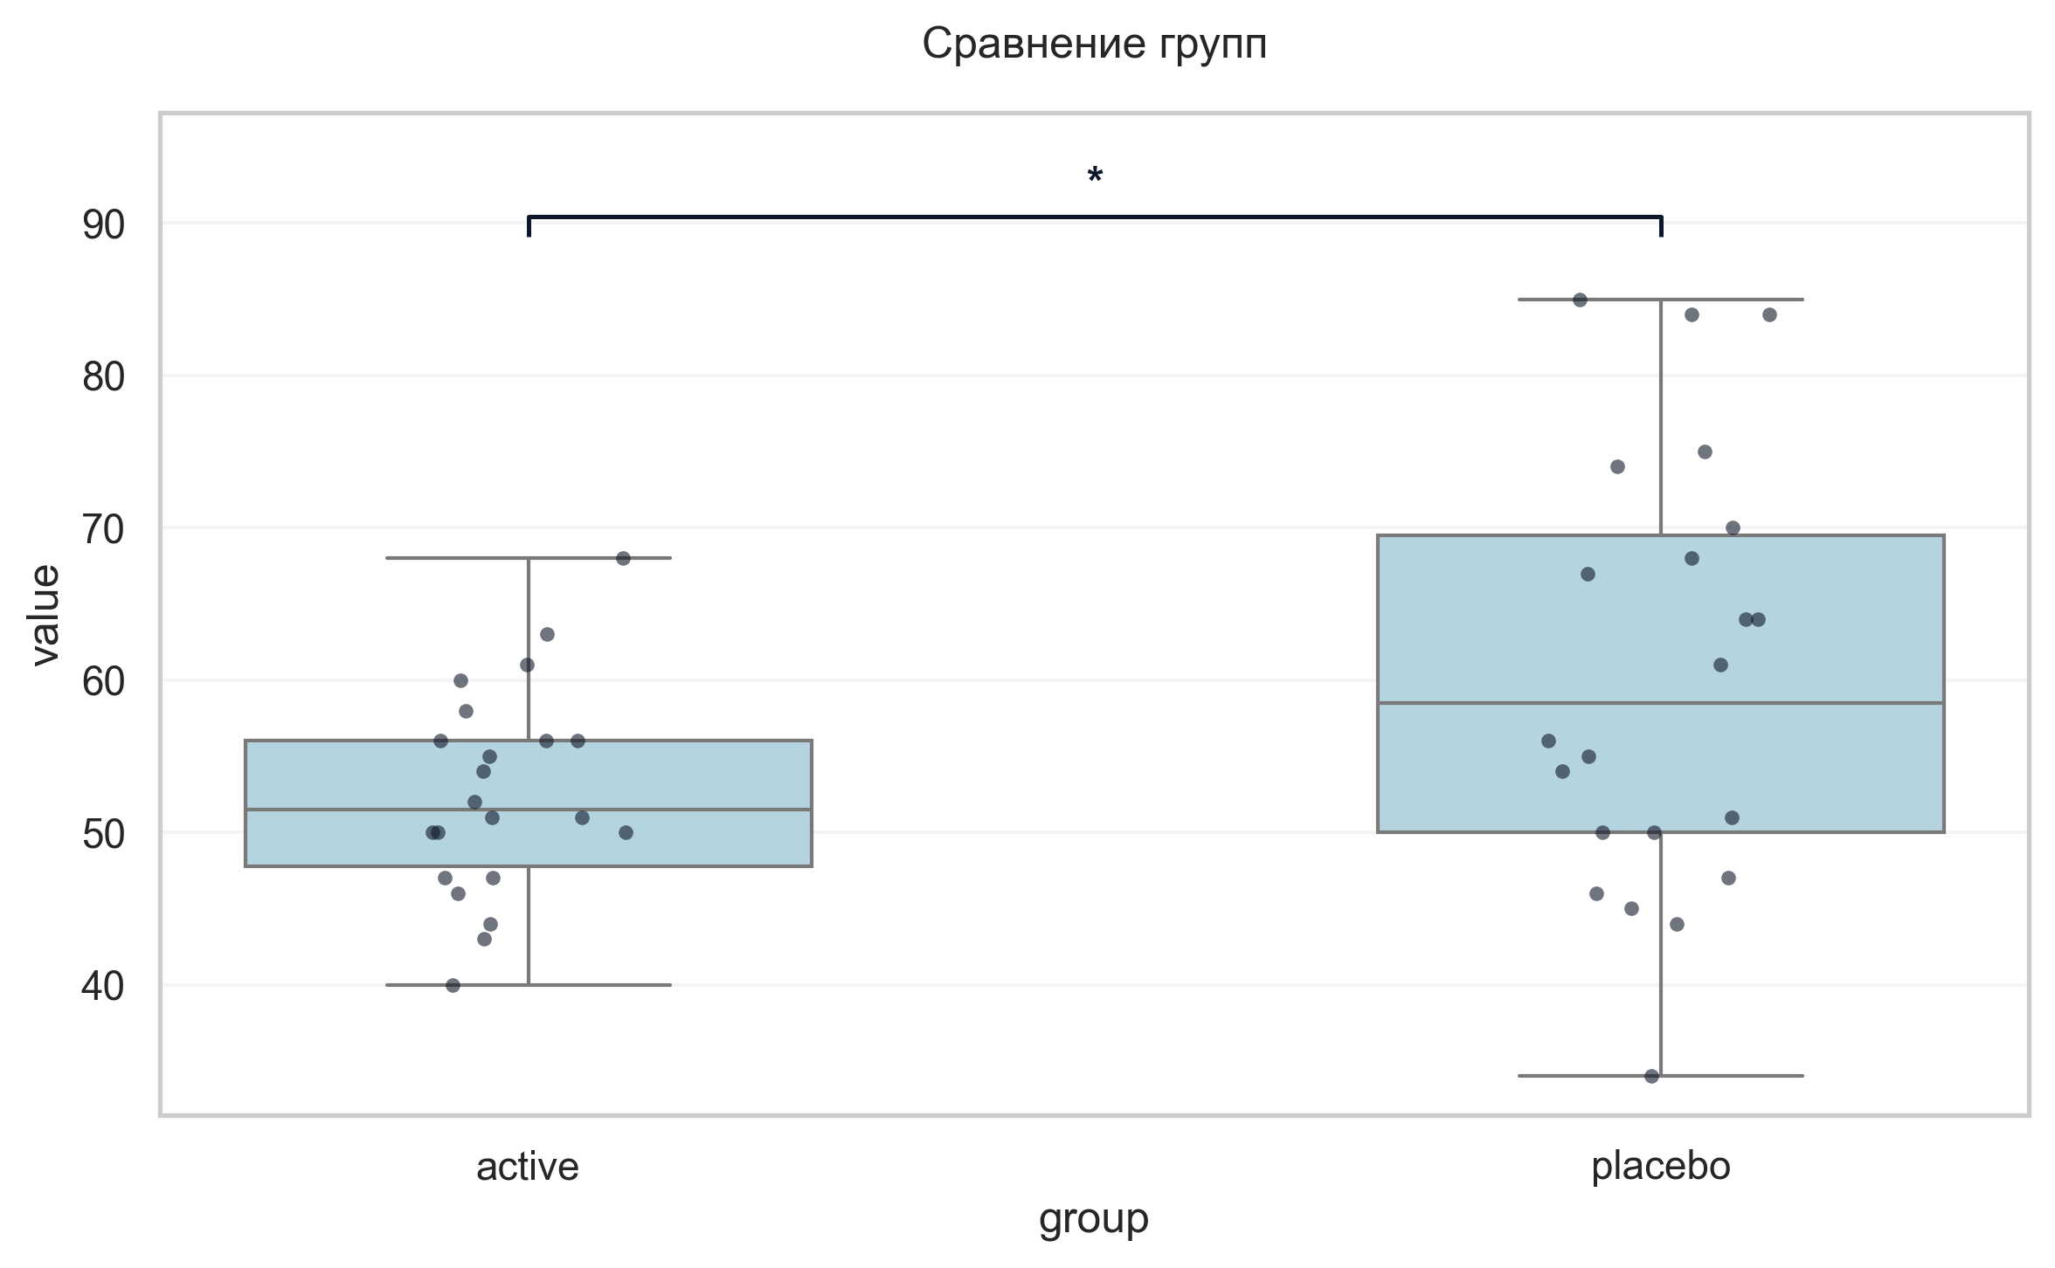
Интерпретация:
An independent Welch's T-Test was conducted to determine if there were differences in Шкала оценки качества жизни при БП баллы V5 between groups defined by arm. There was a statistically significant difference between the groups (p = 0.030, Cohen's d = 0.69 indicates a medium effect). Specifically, the Шкала оценки качества жизни при БП баллы V5 in the active group (M = 52.64) was significantly lower than in the placebo group (M = 60.36).

Шаг: cmp__сад_v6
Метод: Student's t-test (Independent)
p-value | 0.6646
статистика | -0.437
эффект | cohen-d 0.13
мощность | 0.07
BF10 | 0.321
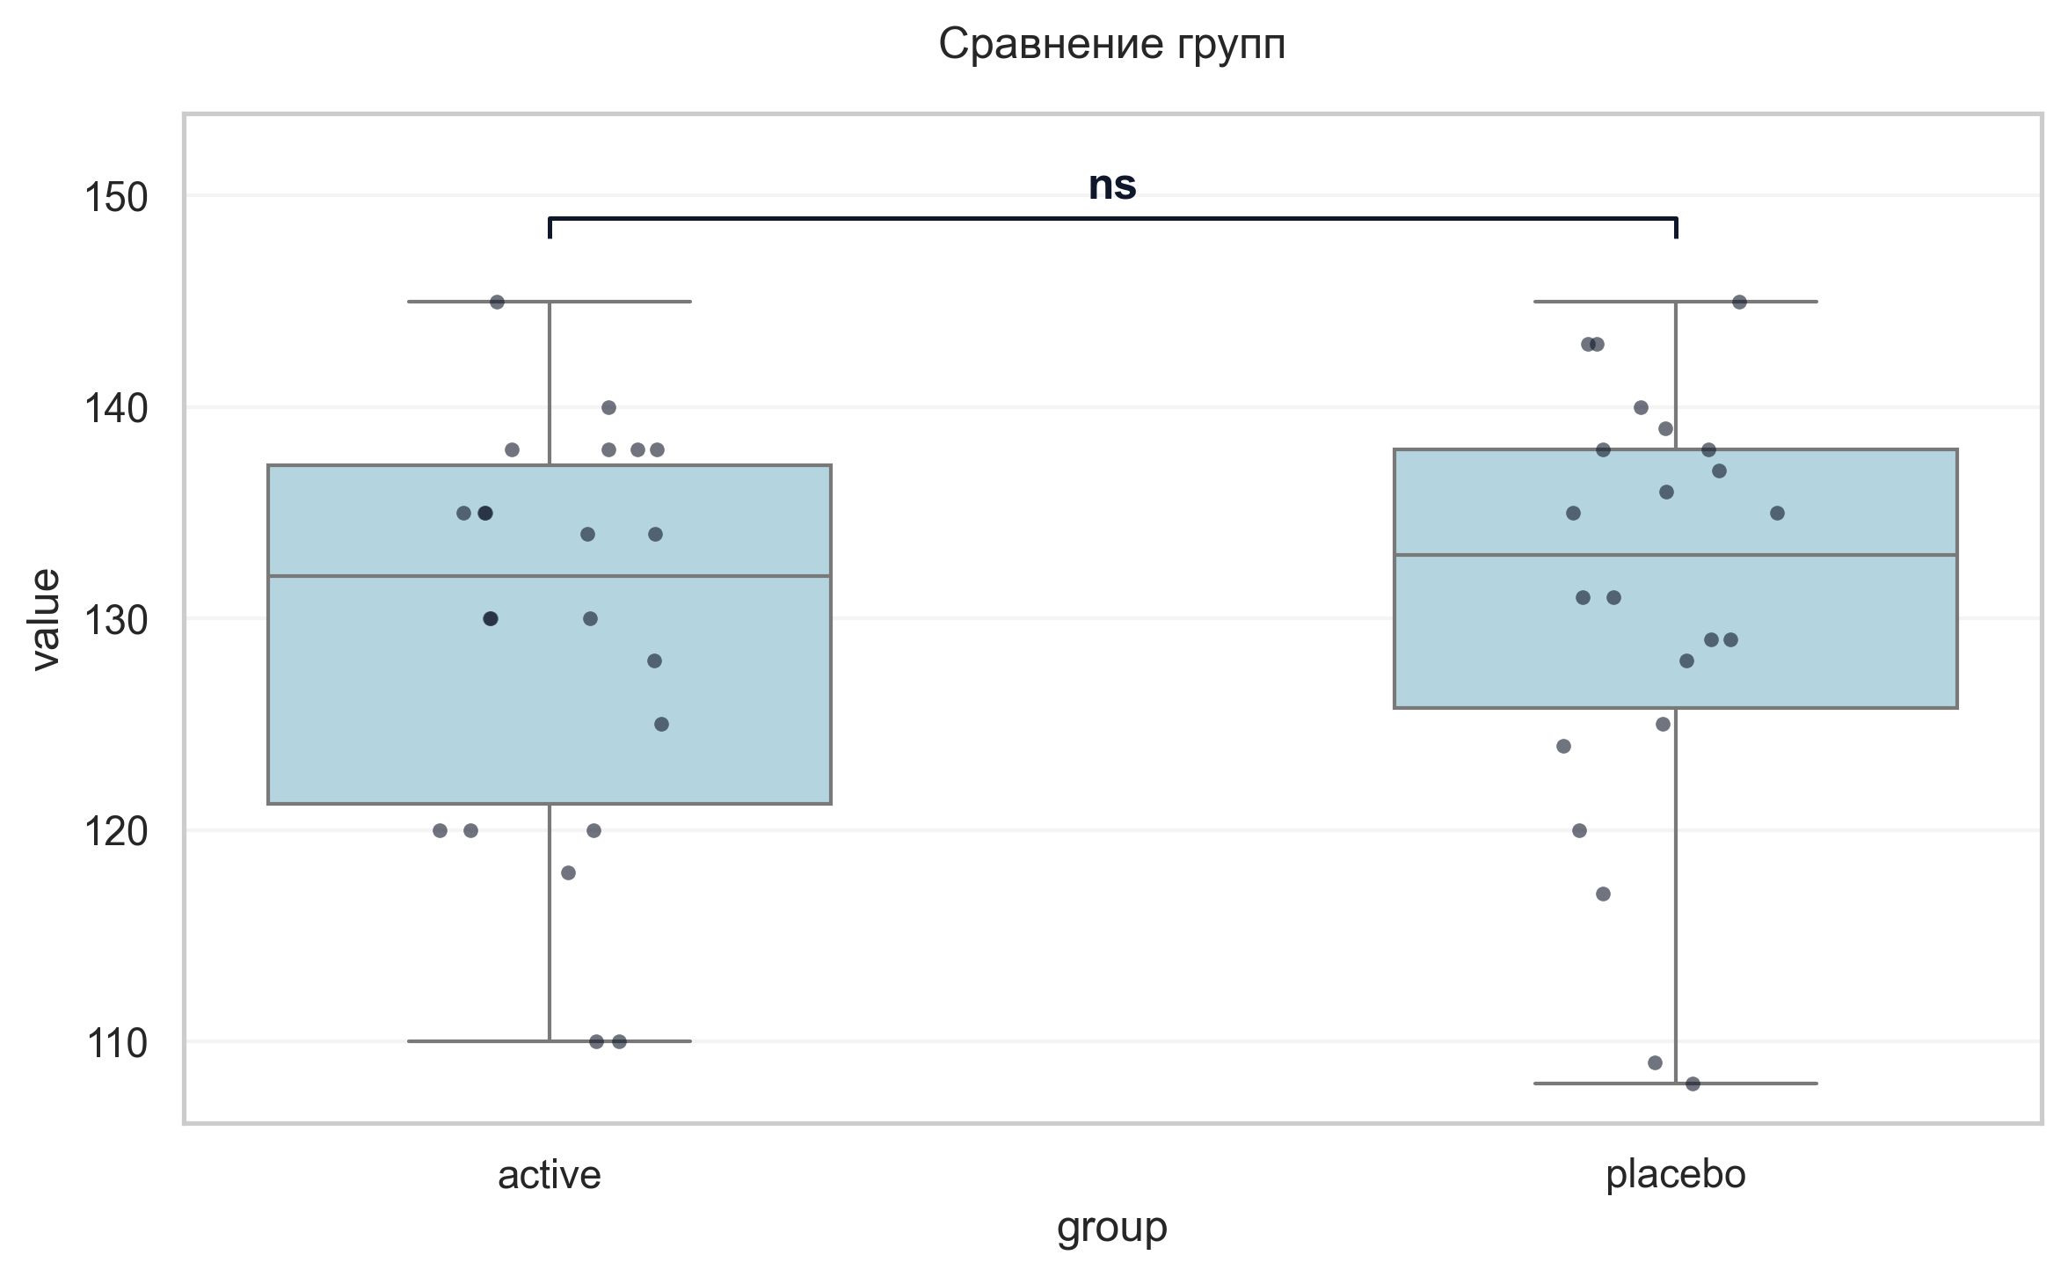
Интерпретация:
An independent Student's t-test (Independent) was conducted to determine if there were differences in САД V6 between groups defined by arm. The analysis revealed no statistically significant difference between the groups (p = 0.665, Cohen's d = 0.13 indicates a trivial effect).

Шаг: cmp__дад_v6
Метод: Student's t-test (Independent)
p-value | 0.0065
статистика | 2.862
эффект | cohen-d 0.86
мощность | 0.80
BF10 | 6.843
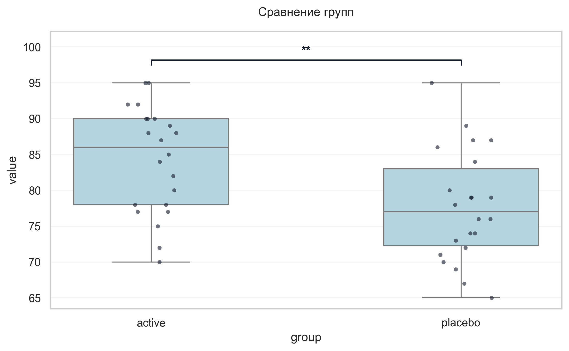
Интерпретация:
An independent Student's t-test (Independent) was conducted to determine if there were differences in ДАД V6 between groups defined by arm. There was a statistically significant difference between the groups (p = 0.007, Cohen's d = 0.86 indicates a large effect). Specifically, the ДАД V6 in the active group (M = 84.27) was significantly higher than in the placebo group (M = 77.73).

Шаг: cmp__ушобп_часть_2_повседневная_активность_баллы_v6
Метод: Welch's T-Test
p-value | 0.7010
статистика | -0.388
эффект | cohen-d 0.12
мощность | 0.07
BF10 | 0.316
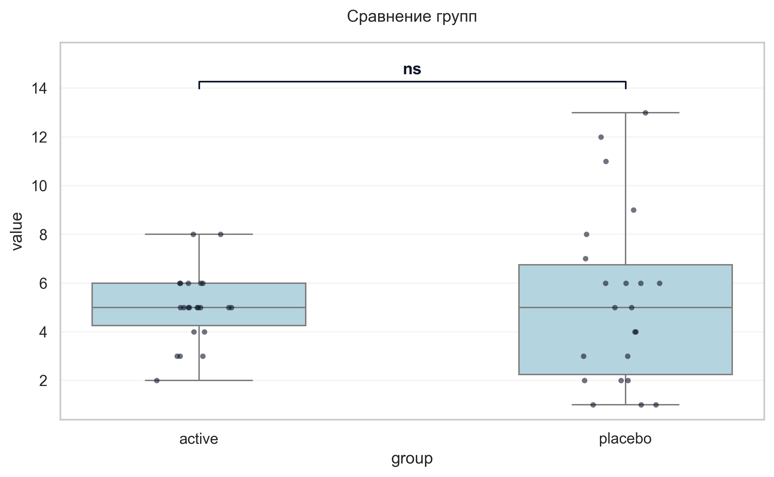
Интерпретация:
An independent Welch's T-Test was conducted to determine if there were differences in УШОБП часть 2 «Повседневная активность» баллы V6 between groups defined by arm. The analysis revealed no statistically significant difference between the groups (p = 0.701, Cohen's d = 0.12 indicates a trivial effect).

Шаг: cmp__ушобп_часть_3_двигательные_функции_баллы_v6
Метод: Mann-Whitney U Test
p-value | 0.0605
статистика | 162.000
эффект | rbc -0.33
мощность | -
BF10 | -
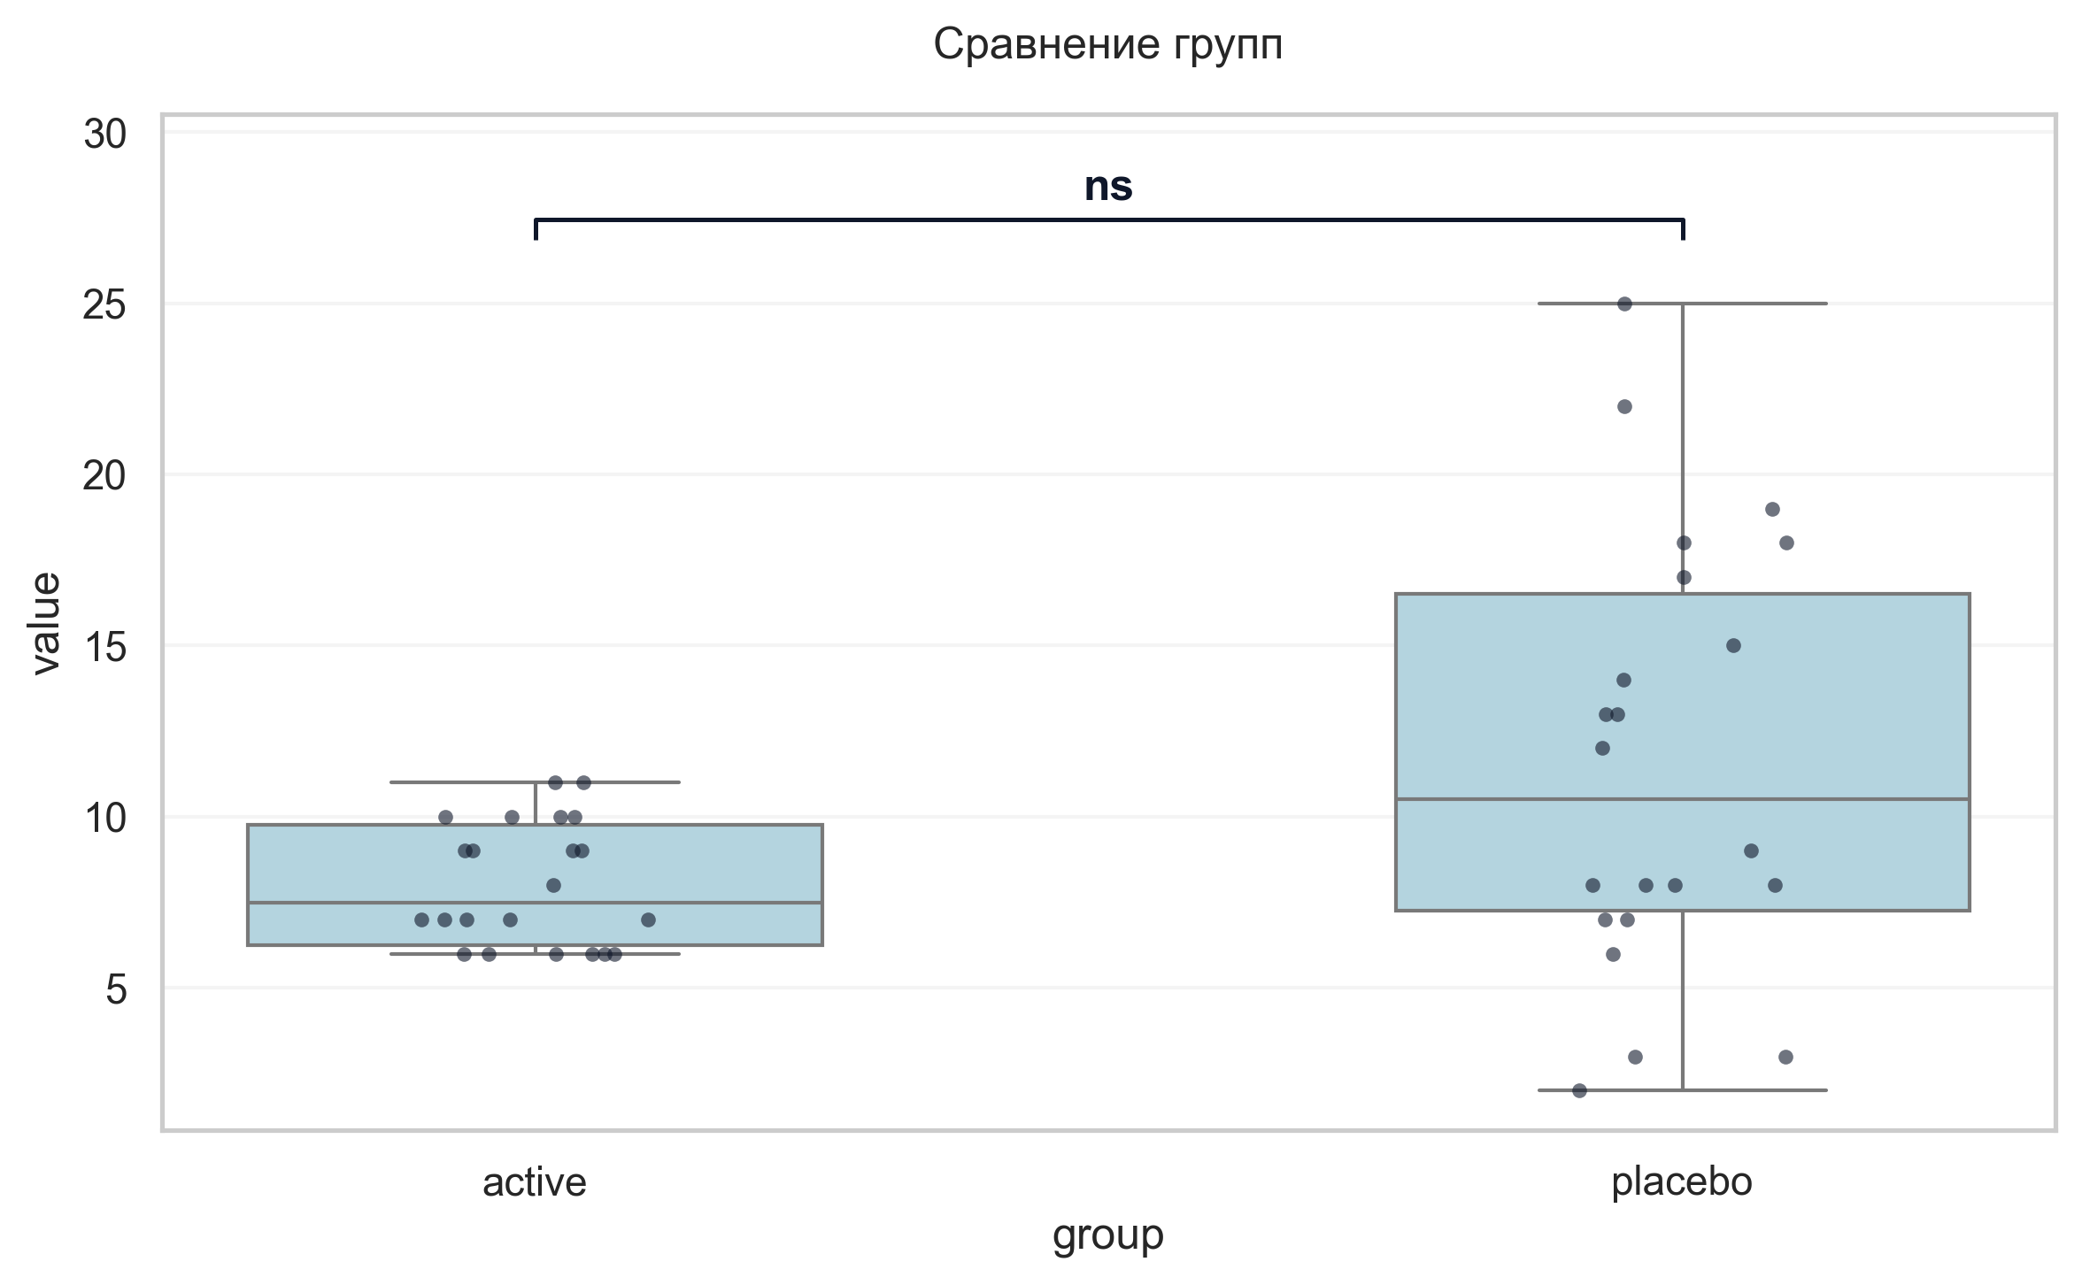
Интерпретация:
An independent Mann-Whitney U Test was conducted to determine if there were differences in УШОБП часть 3 «Двигательные функции» баллы V6 between groups defined by arm. The analysis revealed no statistically significant difference between the groups (p = 0.061, r = -0.33 indicates a medium effect).

Шаг: cmp__шкала_депрессии_тревоги_и_стресса_dass_21баллы_v6
Метод: Mann-Whitney U Test
p-value | < 0.001
статистика | 66.500
эффект | rbc -0.73
мощность | -
BF10 | -
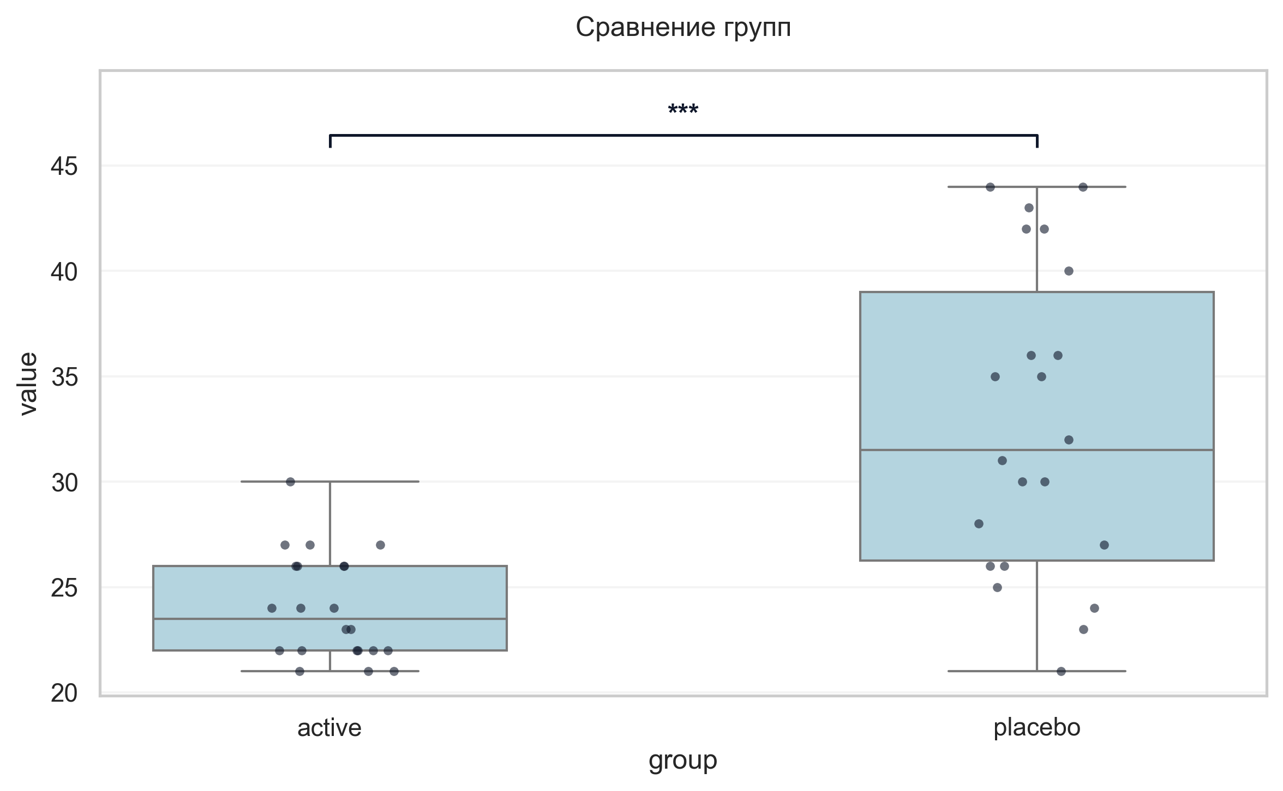
Интерпретация:
An independent Mann-Whitney U Test was conducted to determine if there were differences in Шкала депрессии, тревоги и стресса DASS-21баллы V6 between groups defined by arm. There was a statistically significant difference between the groups (p < 0.001, r = -0.73 indicates a large effect). Specifically, the Шкала депрессии, тревоги и стресса DASS-21баллы V6 in the active group (M = 24.00) was significantly lower than in the placebo group (M = 32.73).

Шаг: cmp__шкала_оценки_утомляемости_при_бп_баллы_v6
Метод: Mann-Whitney U Test
p-value | 0.1922
статистика | 186.000
эффект | rbc -0.23
мощность | -
BF10 | -
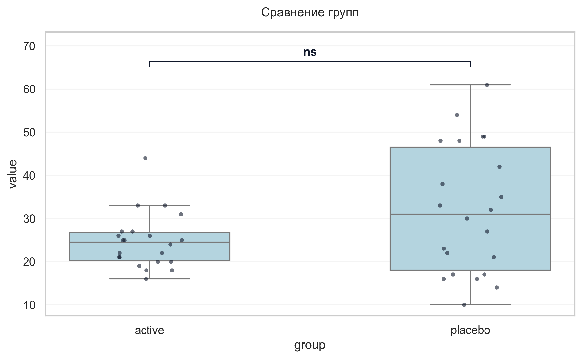
Интерпретация:
An independent Mann-Whitney U Test was conducted to determine if there were differences in Шкала оценки утомляемости при БП баллы V6 between groups defined by arm. The analysis revealed no statistically significant difference between the groups (p = 0.192, r = -0.23 indicates a small effect).

Шаг: cmp__шкала_оценки_сонливости_эпуорта_баллы_v6
Метод: Mann-Whitney U Test
p-value | 0.4983
статистика | 213.000
эффект | rbc -0.12
мощность | -
BF10 | -
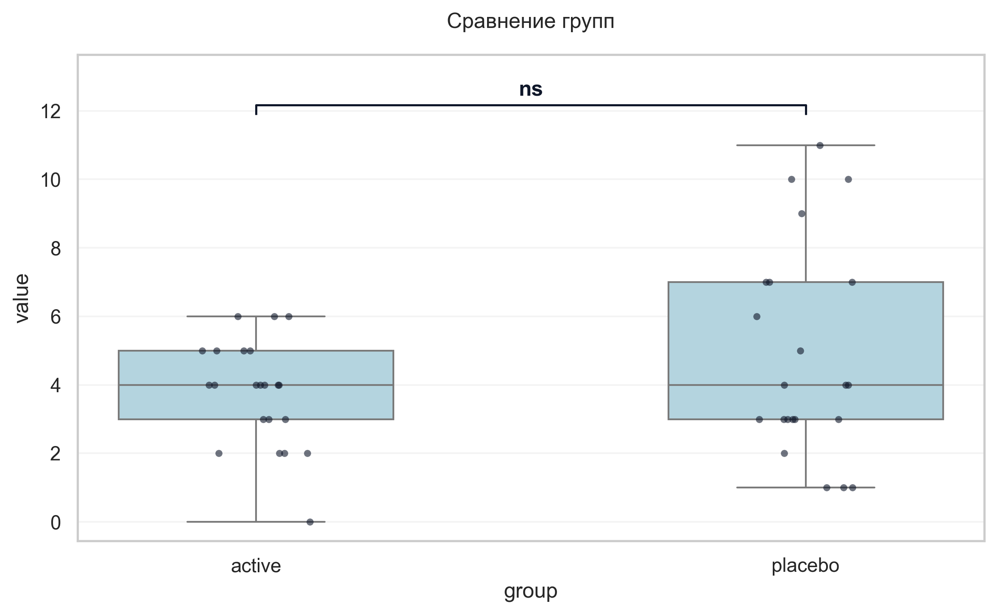
Интерпретация:
An independent Mann-Whitney U Test was conducted to determine if there were differences in Шкала оценки сонливости Эпуорта баллы V6 between groups defined by arm. The analysis revealed no statistically significant difference between the groups (p = 0.498, r = -0.12 indicates a small effect).

Шаг: cmp__шкала_апатии_старкстейна_баллы_v6
Метод: Mann-Whitney U Test
p-value | 0.0298
статистика | 150.000
эффект | rbc -0.38
мощность | -
BF10 | -
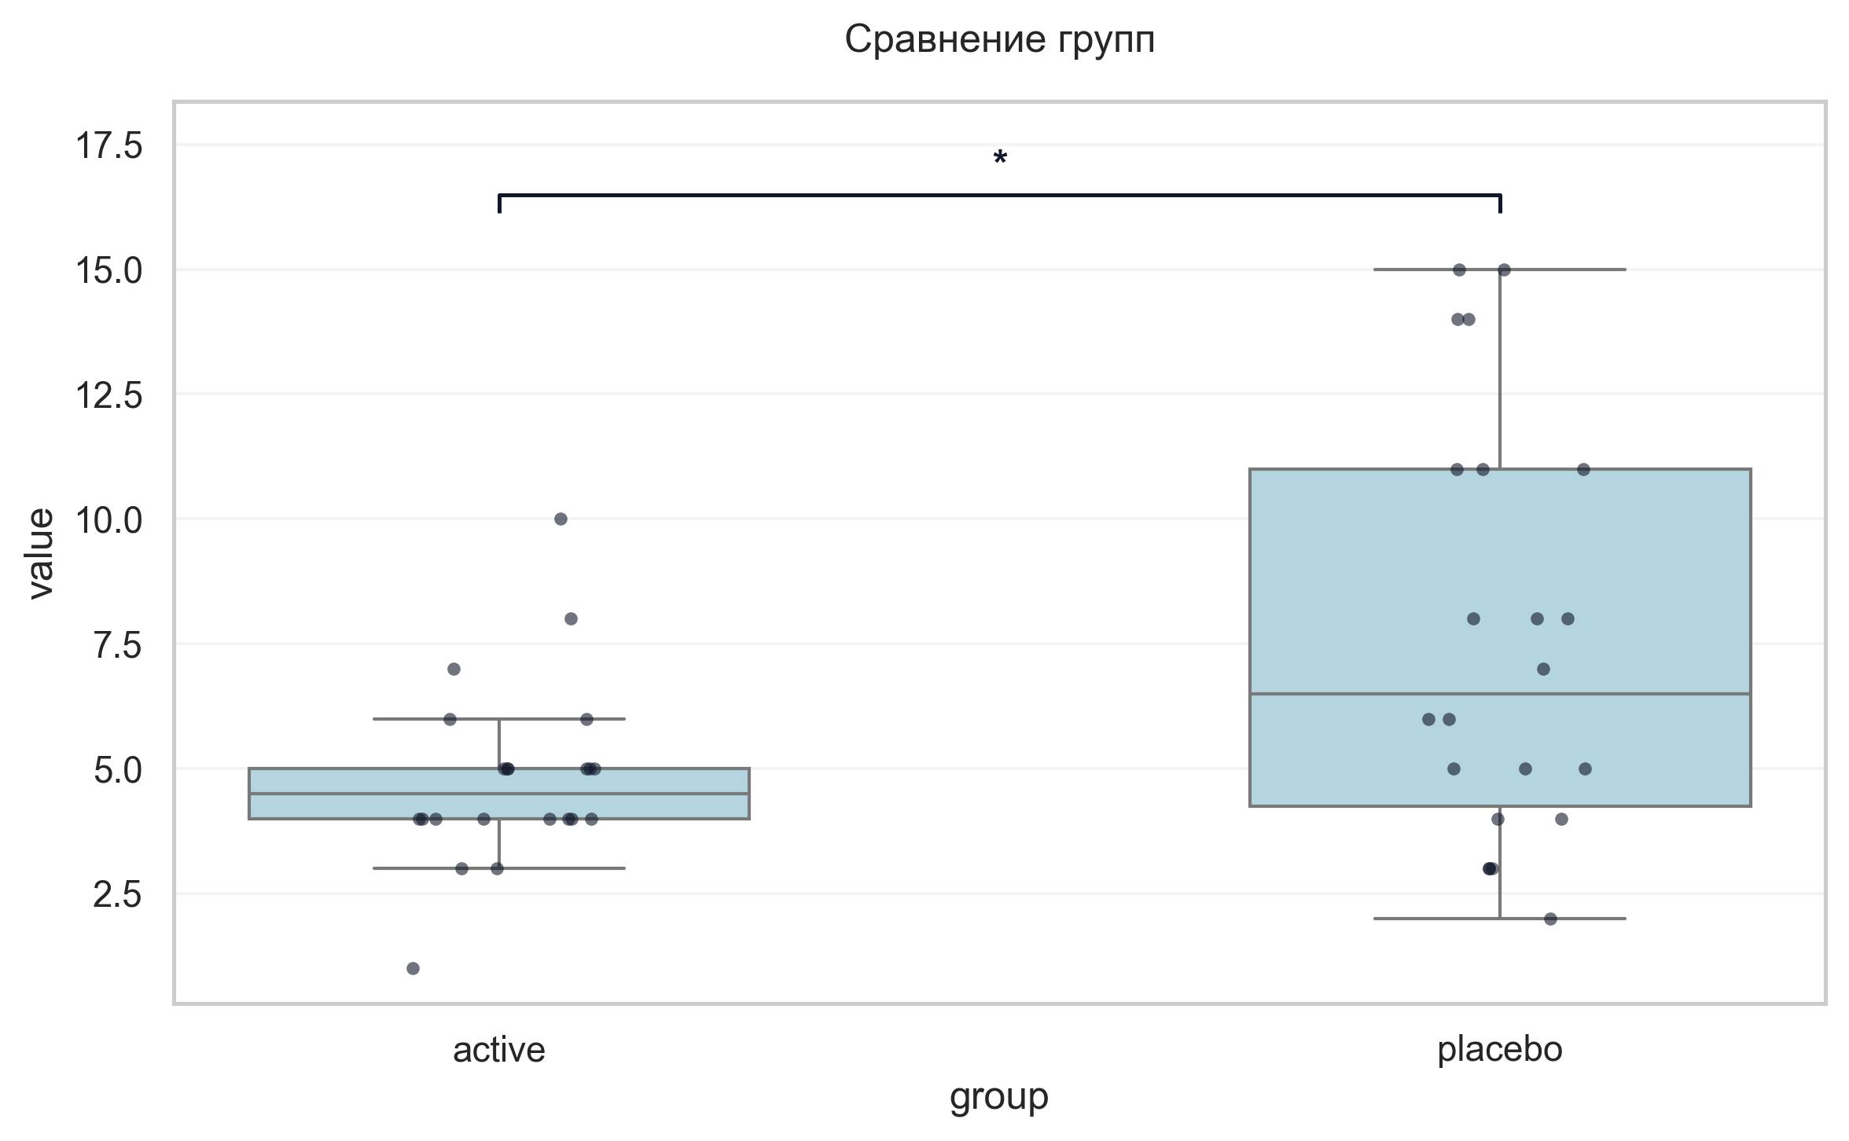
Интерпретация:
An independent Mann-Whitney U Test was conducted to determine if there were differences in Шкала апатии Старкстейна баллы V6 between groups defined by arm. There was a statistically significant difference between the groups (p = 0.030, r = -0.38 indicates a medium effect). Specifically, the Шкала апатии Старкстейна баллы V6 in the active group (M = 4.82) was significantly lower than in the placebo group (M = 7.64).

Шаг: cmp__струп_v6_1
Метод: Mann-Whitney U Test
p-value | < 0.001
статистика | 98.500
эффект | rbc -0.59
мощность | -
BF10 | -
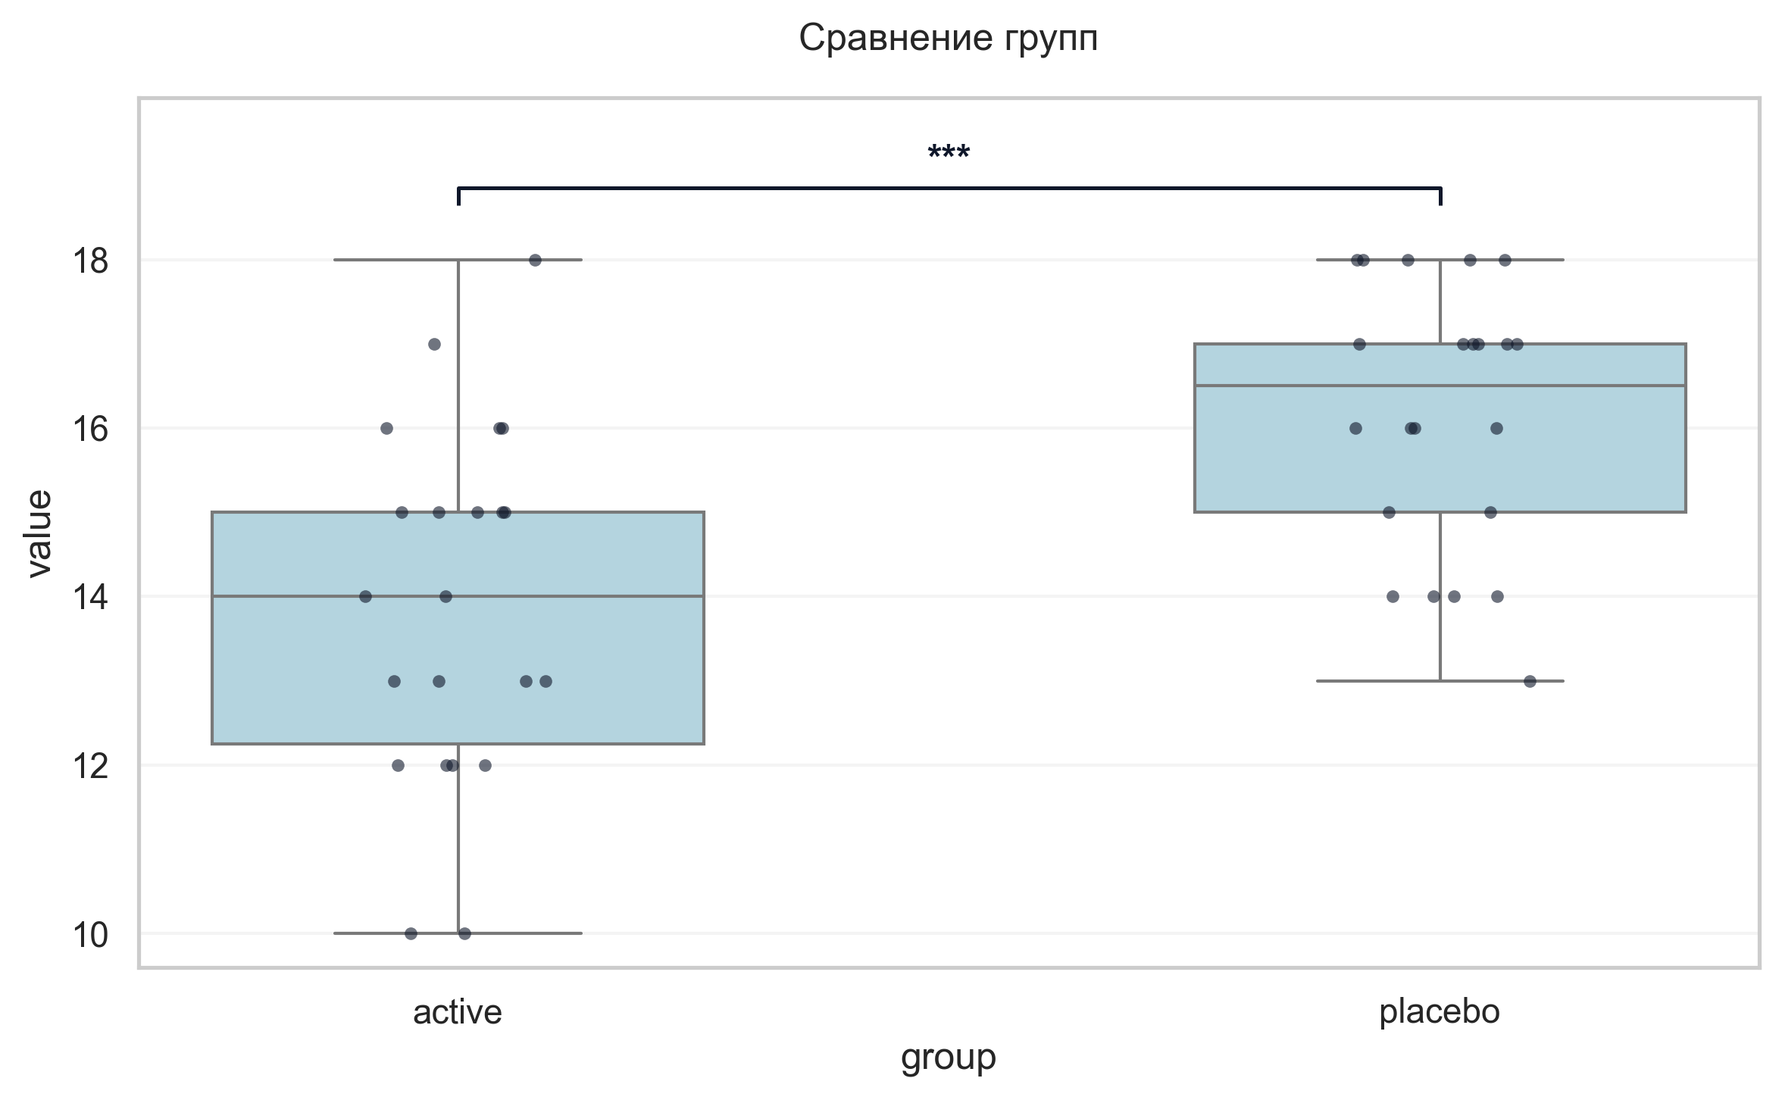
Интерпретация:
An independent Mann-Whitney U Test was conducted to determine if there were differences in Струп V6 1 between groups defined by arm. There was a statistically significant difference between the groups (p < 0.001, r = -0.59 indicates a large effect). Specifically, the Струп V6 1 in the active group (M = 13.91) was significantly lower than in the placebo group (M = 16.14).

Шаг: cmp__струп_v6_2
Метод: Mann-Whitney U Test
p-value | 0.0299
статистика | 334.500
эффект | rbc 0.38
мощность | -
BF10 | -
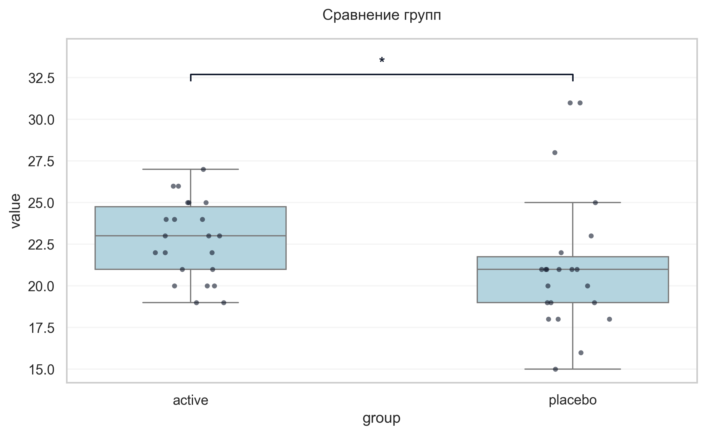
Интерпретация:
An independent Mann-Whitney U Test was conducted to determine if there were differences in Струп V6 2 between groups defined by arm. There was a statistically significant difference between the groups (p = 0.030, r = 0.38 indicates a medium effect). Specifically, the Струп V6 2 in the active group (M = 22.77) was significantly higher than in the placebo group (M = 21.27).

Шаг: cmp__струп_v6_3
Метод: Mann-Whitney U Test
p-value | 0.4882
статистика | 271.500
эффект | rbc 0.12
мощность | -
BF10 | -
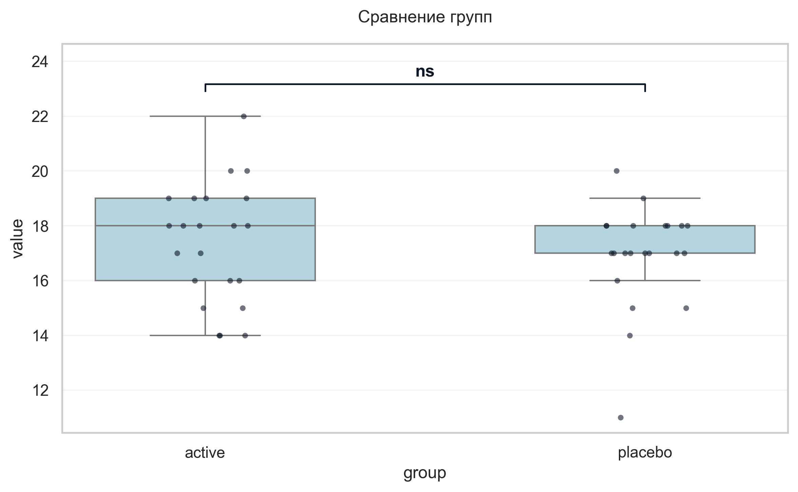
Интерпретация:
An independent Mann-Whitney U Test was conducted to determine if there were differences in Струп V6 3 between groups defined by arm. The analysis revealed no statistically significant difference between the groups (p = 0.488, r = 0.12 indicates a small effect).

Шаг: cmp__индекс_интерференции_v6
Метод: Student's t-test (Independent)
p-value | 0.1819
статистика | -1.357
эффект | cohen-d 0.41
мощность | 0.26
BF10 | 0.621
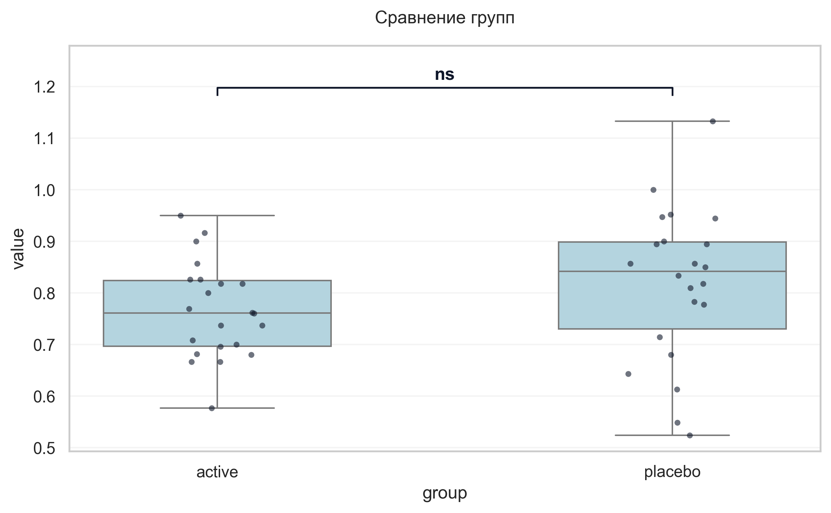
Интерпретация:
An independent Student's t-test (Independent) was conducted to determine if there were differences in Индекс интерференции V6 between groups defined by arm. The analysis revealed no statistically significant difference between the groups (p = 0.182, Cohen's d = 0.41 indicates a small effect).

Шаг: cmp__тест_прокладывания_пути_trail_making_test_мин_v6_а
Метод: Mann-Whitney U Test
p-value | < 0.001
статистика | 92.000
эффект | rbc -0.62
мощность | -
BF10 | -
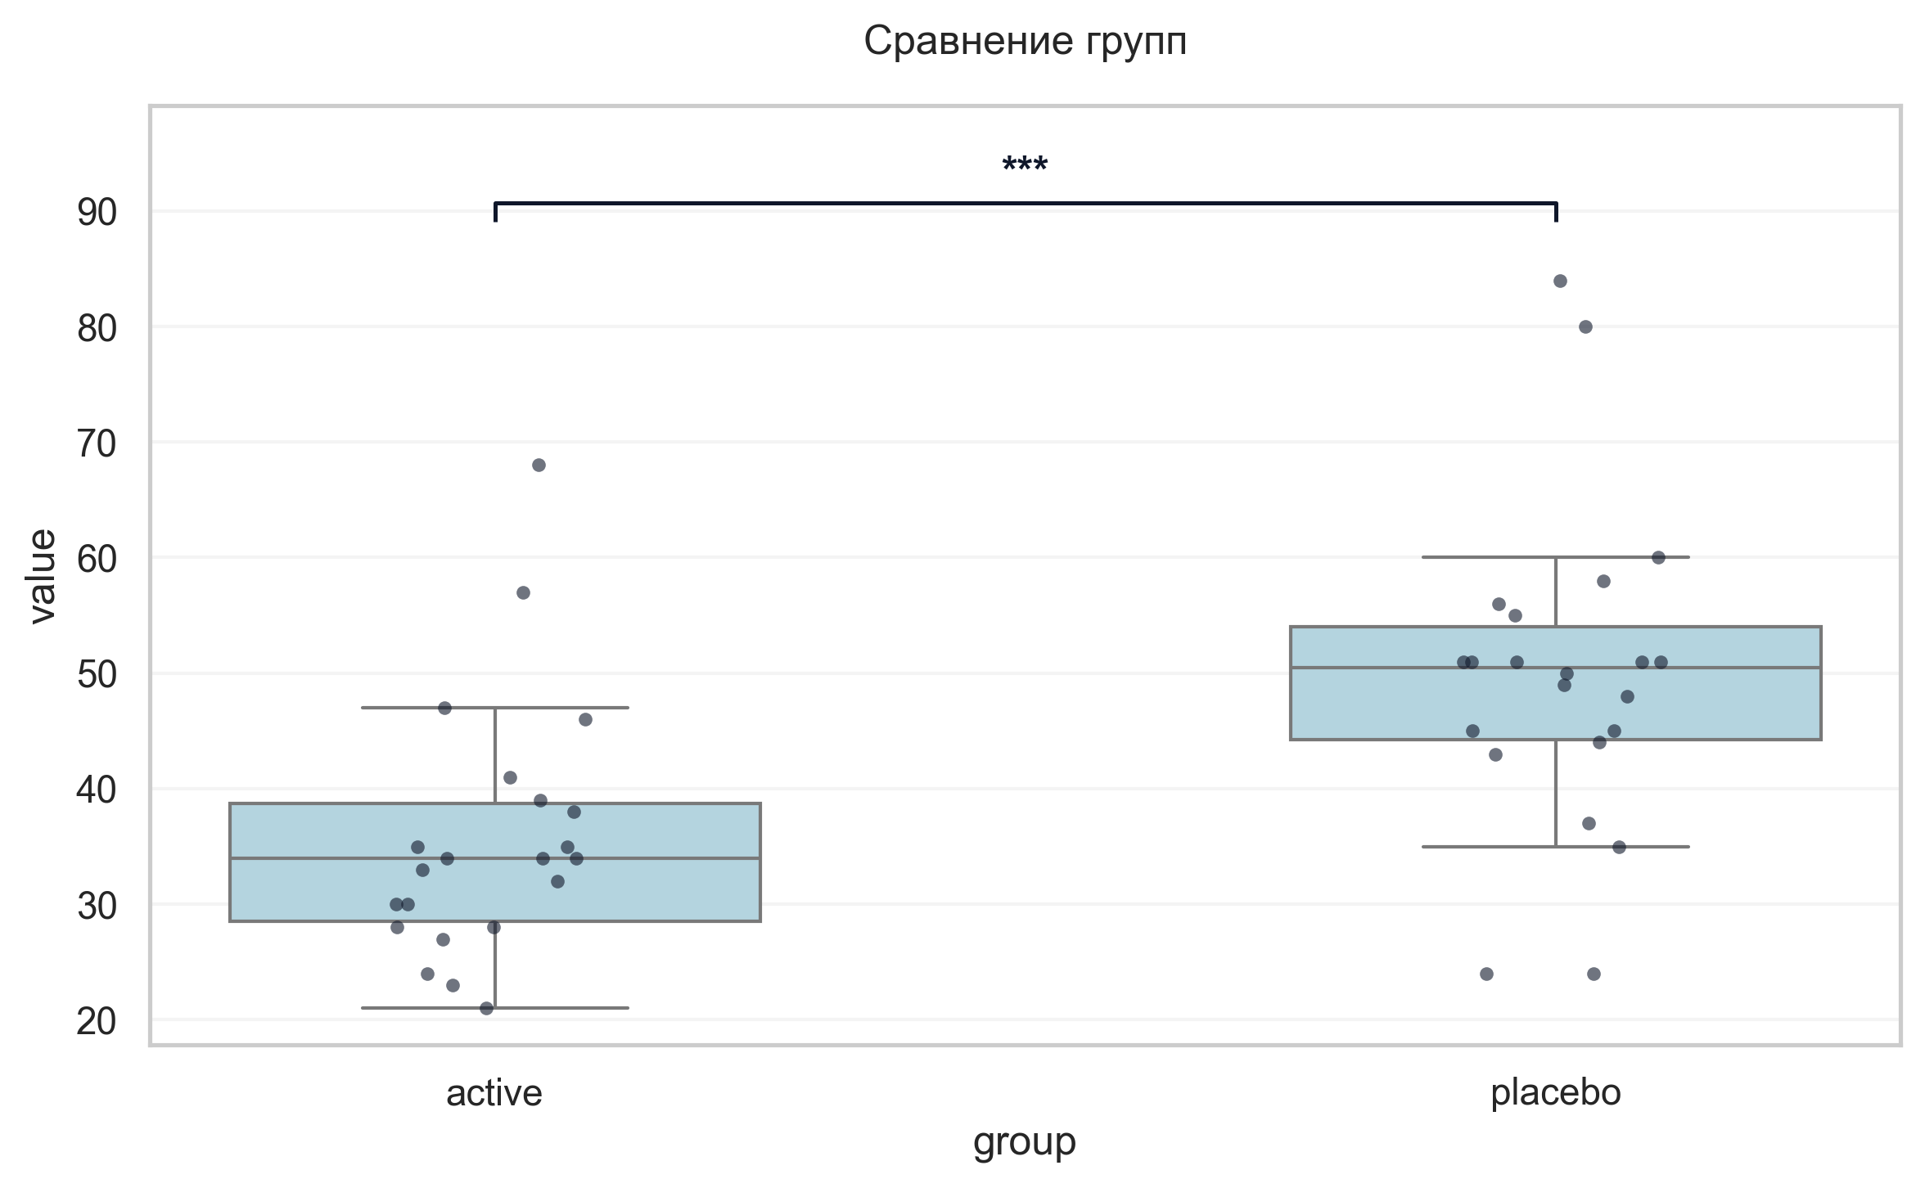
Интерпретация:
An independent Mann-Whitney U Test was conducted to determine if there were differences in «Тест прокладывания пути» Trail Making Test мин V6 А between groups defined by arm. There was a statistically significant difference between the groups (p < 0.001, r = -0.62 indicates a large effect). Specifically, the «Тест прокладывания пути» Trail Making Test мин V6 А in the active group (M = 35.64) was significantly lower than in the placebo group (M = 49.64).

Шаг: cmp__тест_прокладывания_пути_trail_making_test_мин_v6_б
Метод: Mann-Whitney U Test
p-value | 0.2311
статистика | 190.500
эффект | rbc -0.21
мощность | -
BF10 | -
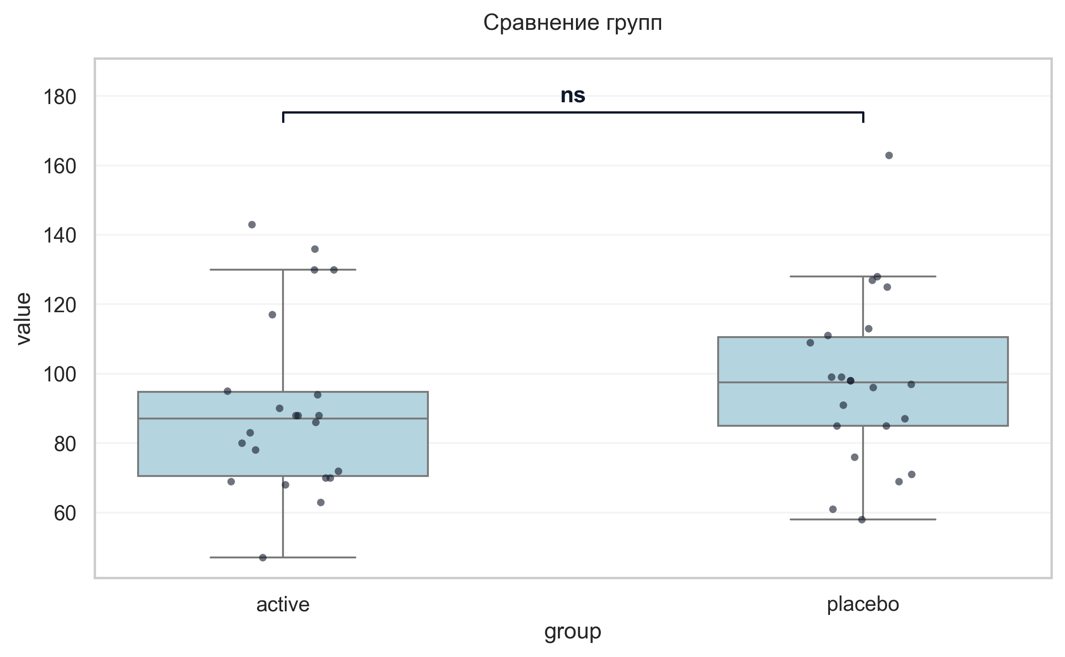
Интерпретация:
An independent Mann-Whitney U Test was conducted to determine if there were differences in «Тест прокладывания пути» Trail Making Test мин V6 Б between groups defined by arm. The analysis revealed no statistically significant difference between the groups (p = 0.231, r = -0.21 indicates a small effect).

Шаг: cmp__шкала_оценки_качества_жизни_при_бп_баллы_v6
Метод: Welch's T-Test
p-value | 0.0038
статистика | -3.146
эффект | cohen-d 0.95
мощность | 0.87
BF10 | 12.582
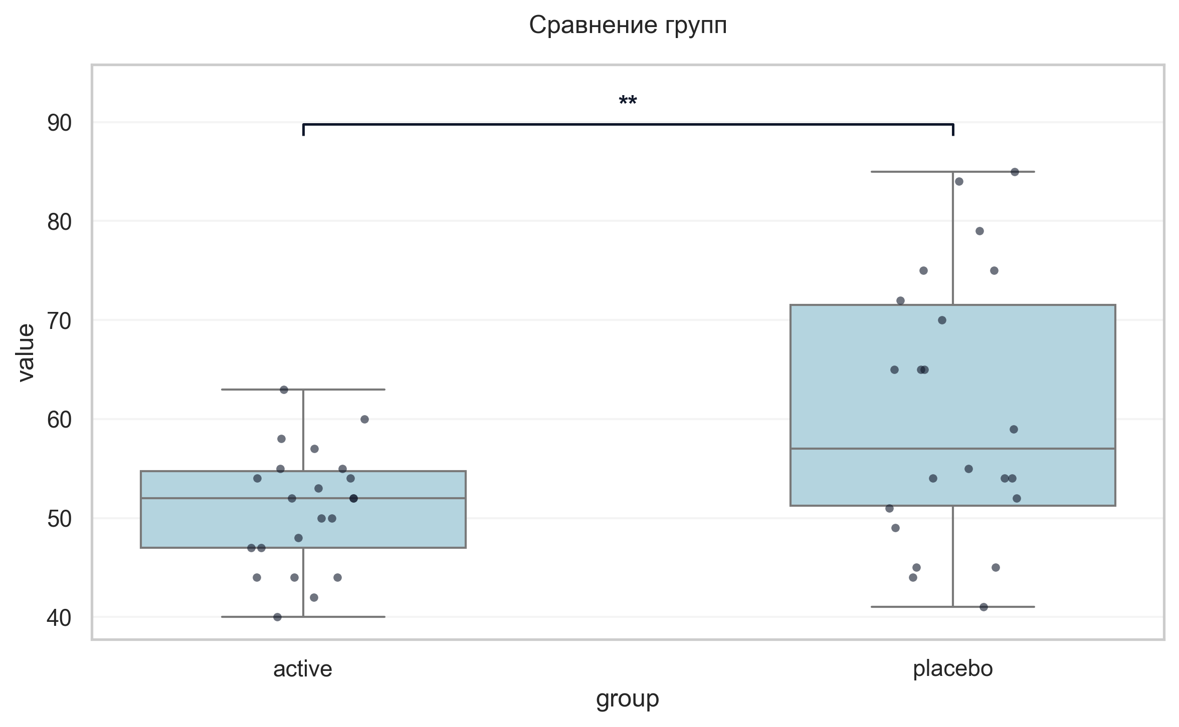
Интерпретация:
An independent Welch's T-Test was conducted to determine if there were differences in Шкала оценки качества жизни при БП баллы V6 between groups defined by arm. There was a statistically significant difference between the groups (p = 0.004, Cohen's d = 0.95 indicates a large effect). Specifically, the Шкала оценки качества жизни при БП баллы V6 in the active group (M = 50.95) was significantly lower than in the placebo group (M = 60.82).

Шаг: cmp__stroop_sum_v2_sec
Метод: Student's t-test (Independent)
p-value | 0.0522
статистика | 2.003
эффект | cohen-d 0.63
мощность | 0.50
BF10 | 1.458
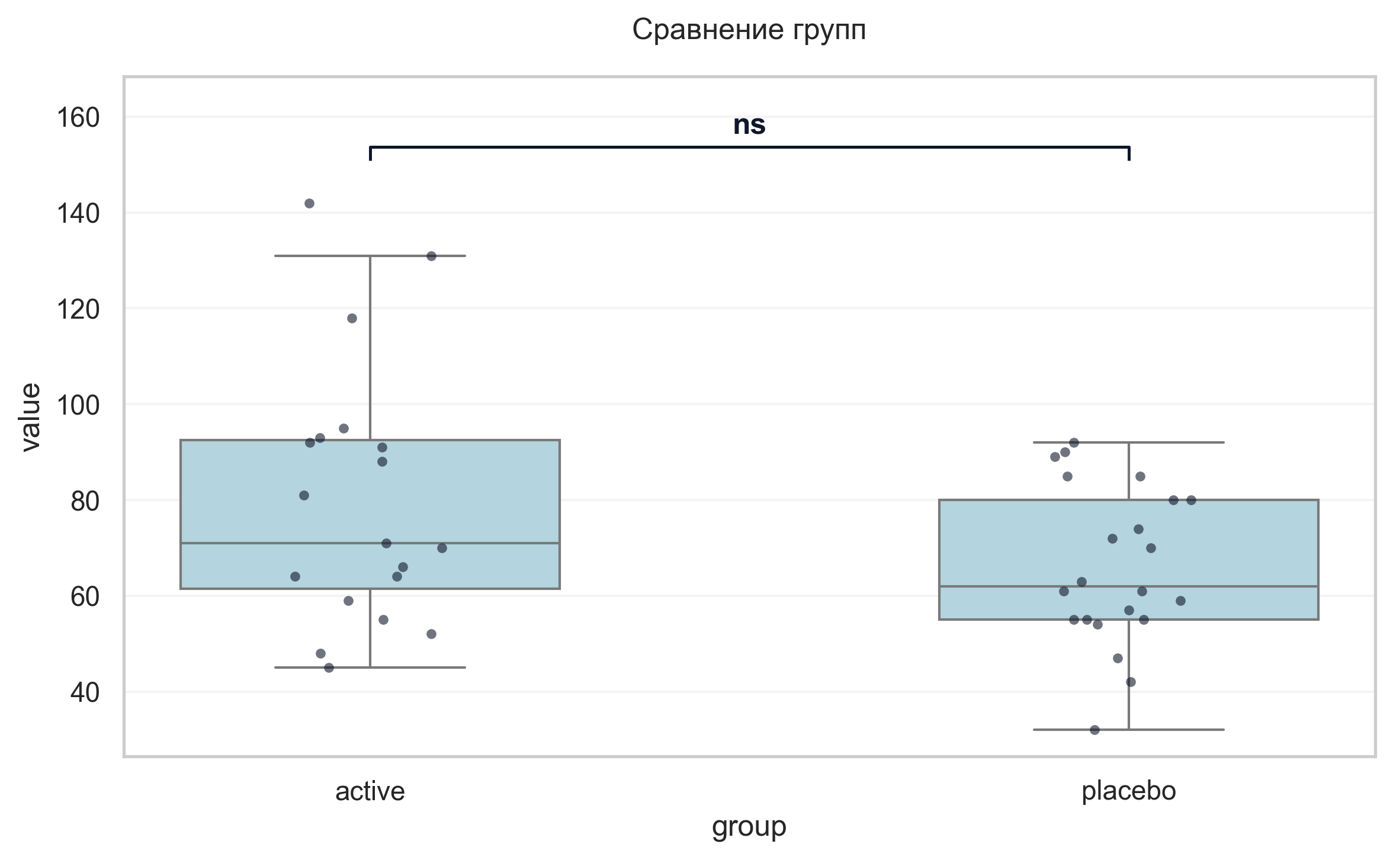
Интерпретация:
An independent Student's t-test (Independent) was conducted to determine if there were differences in Stroop sum V2 (sec) between groups defined by arm. The analysis revealed no statistically significant difference between the groups (p = 0.052, Cohen's d = 0.63 indicates a medium effect).

Шаг: cmp__stroop_sum_v3_sec
Метод: Mann-Whitney U Test
p-value | 0.0076
статистика | 356.000
эффект | rbc 0.47
мощность | -
BF10 | -
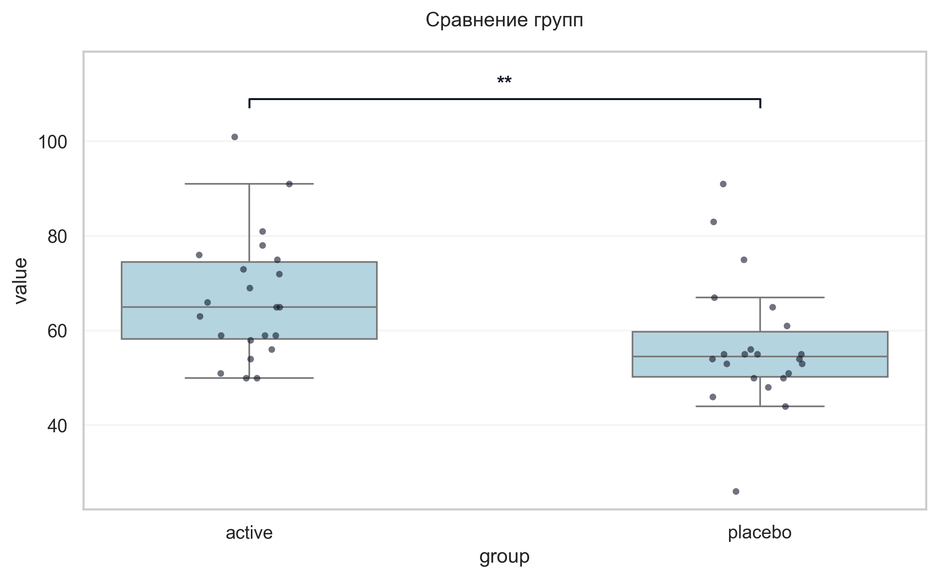
Интерпретация:
An independent Mann-Whitney U Test was conducted to determine if there were differences in Stroop sum V3 (sec) between groups defined by arm. There was a statistically significant difference between the groups (p = 0.008, r = 0.47 indicates a medium effect). Specifically, the Stroop sum V3 (sec) in the active group (M = 66.86) was significantly higher than in the placebo group (M = 56.68).

Шаг: cmp__stroop_sum_v5_sec
Метод: Student's t-test (Independent)
p-value | 0.4061
статистика | 0.839
эффект | cohen-d 0.25
мощность | 0.13
BF10 | 0.395
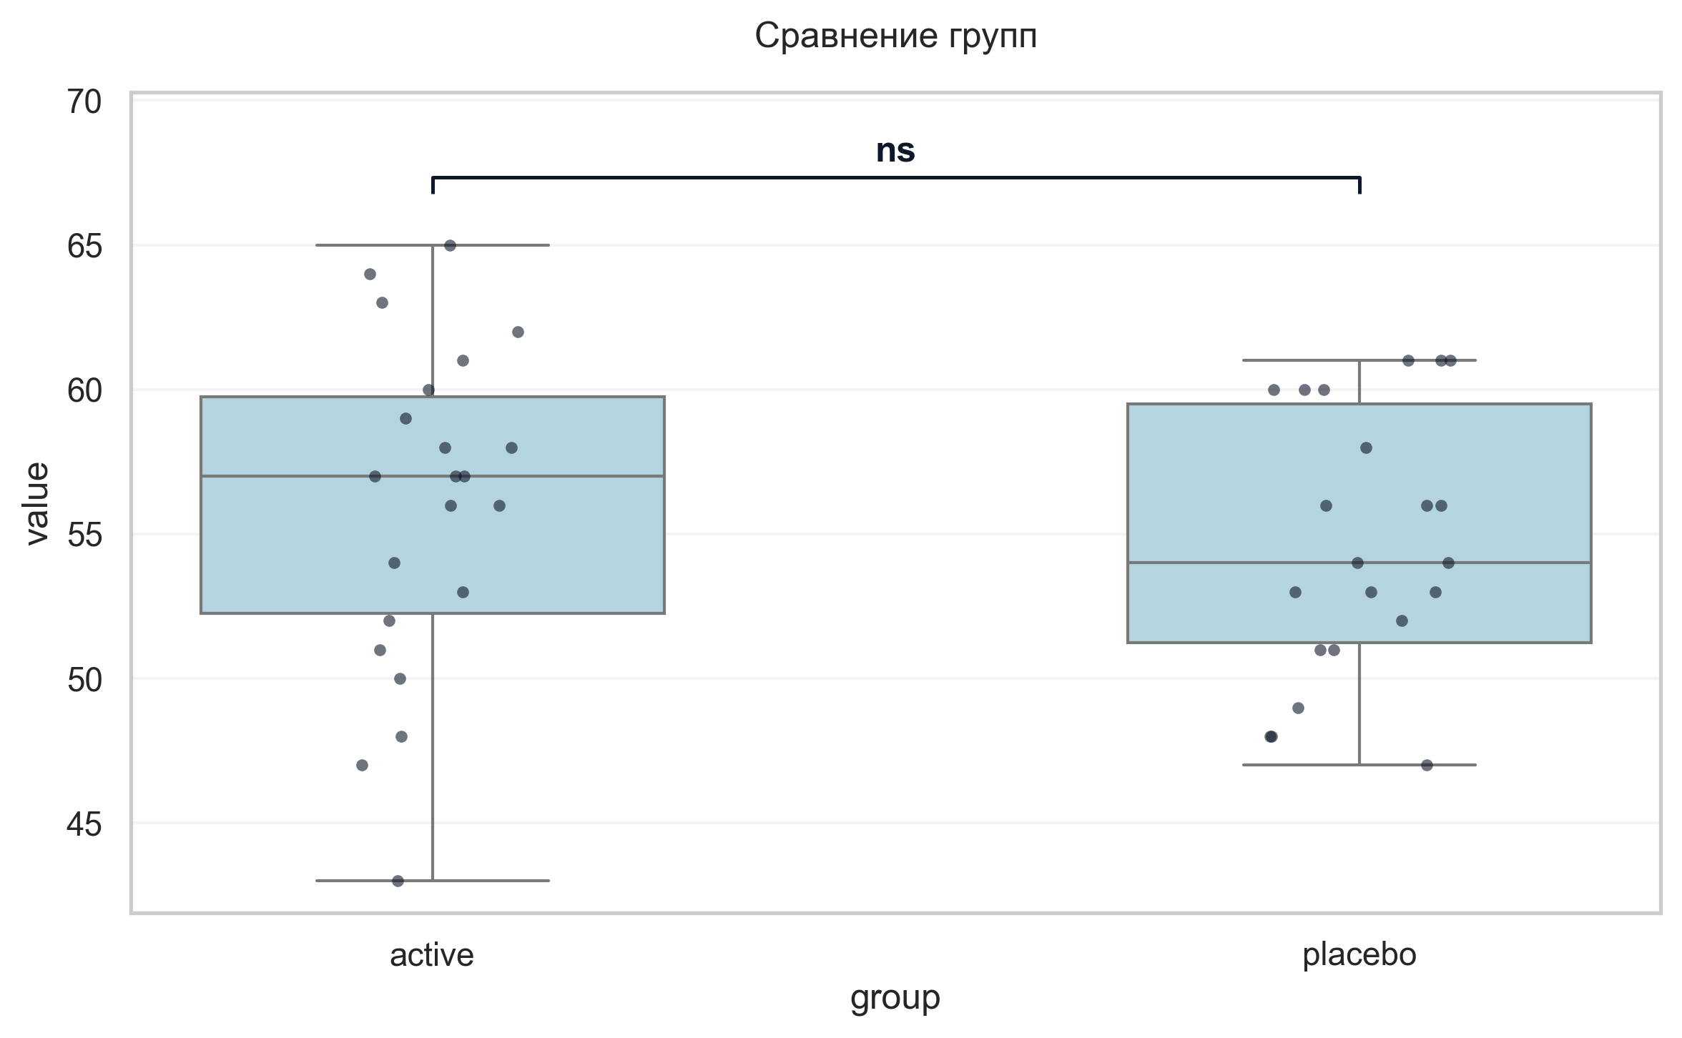
Интерпретация:
An independent Student's t-test (Independent) was conducted to determine if there were differences in Stroop sum V5 (sec) between groups defined by arm. The analysis revealed no statistically significant difference between the groups (p = 0.406, Cohen's d = 0.25 indicates a small effect).

Шаг: cmp__stroop_sum_v6_sec
Метод: Student's t-test (Independent)
p-value | 0.8709
статистика | -0.163
эффект | cohen-d 0.05
мощность | 0.05
BF10 | 0.301
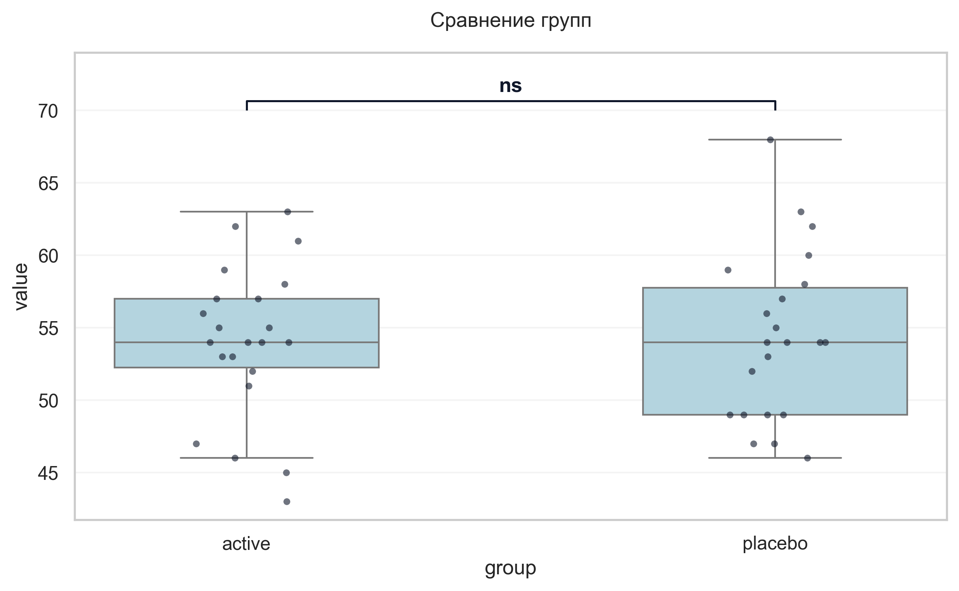
Интерпретация:
An independent Student's t-test (Independent) was conducted to determine if there were differences in Stroop sum V6 (sec) between groups defined by arm. The analysis revealed no statistically significant difference between the groups (p = 0.871, Cohen's d = 0.05 indicates a trivial effect).

Шаг: cmp__trail_a_b_v2_sec
Метод: Mann-Whitney U Test
p-value | 0.5186
статистика | 270.000
эффект | rbc 0.12
мощность | -
BF10 | -
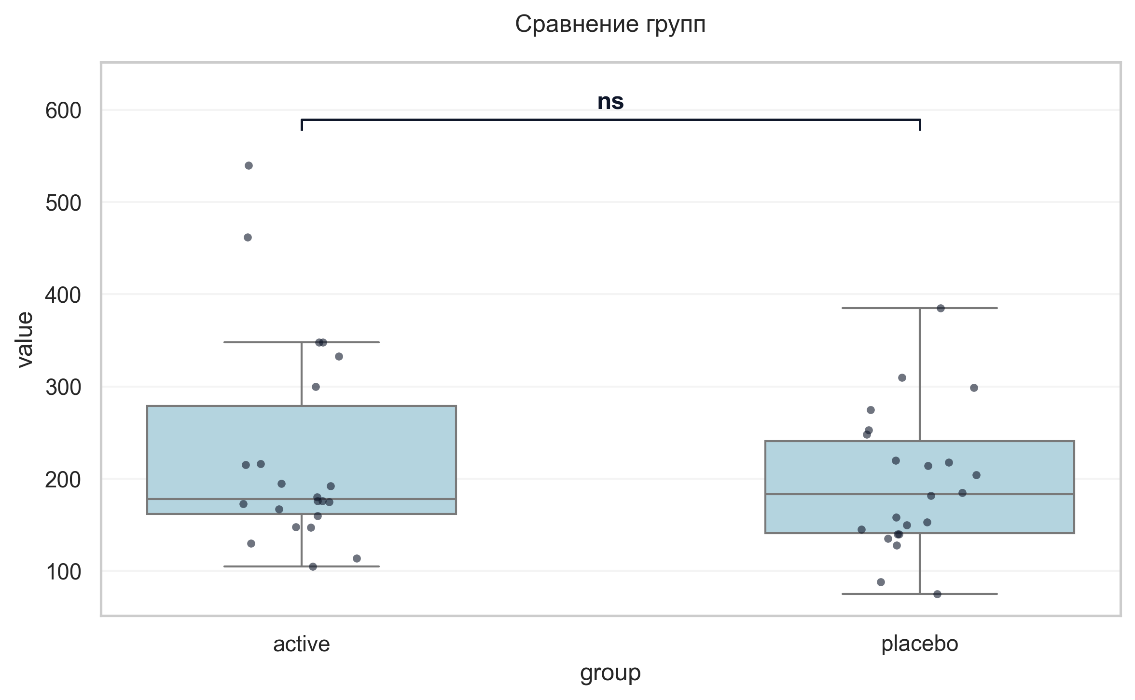
Интерпретация:
An independent Mann-Whitney U Test was conducted to determine if there were differences in Trail A+B V2 (sec) between groups defined by arm. The analysis revealed no statistically significant difference between the groups (p = 0.519, r = 0.12 indicates a small effect).

Шаг: cmp__trail_a_b_v6_sec
Метод: Student's t-test (Independent)
p-value | 0.0317
статистика | -2.222
эффект | cohen-d 0.67
мощность | 0.58
BF10 | 2.056
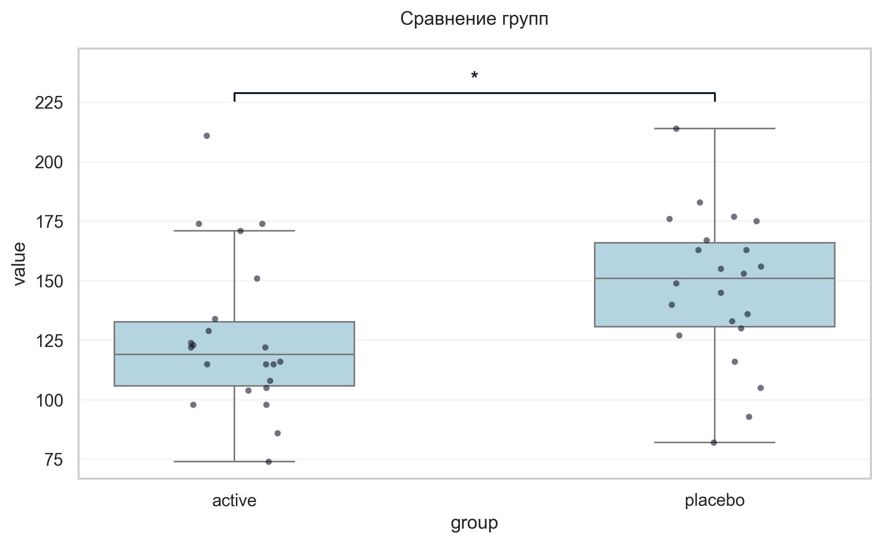
Интерпретация:
An independent Student's t-test (Independent) was conducted to determine if there were differences in Trail A+B V6 (sec) between groups defined by arm. There was a statistically significant difference between the groups (p = 0.032, Cohen's d = 0.67 indicates a medium effect). Specifically, the Trail A+B V6 (sec) in the active group (M = 125.86) was significantly lower than in the placebo group (M = 147.18).

Шаг: cmp__ушобп_часть_3_двигательные_функции_баллы_v2_v6_улучшение
Метод: Mann-Whitney U Test
p-value | < 0.001
статистика | 433.000
эффект | rbc 0.79
мощность | -
BF10 | -
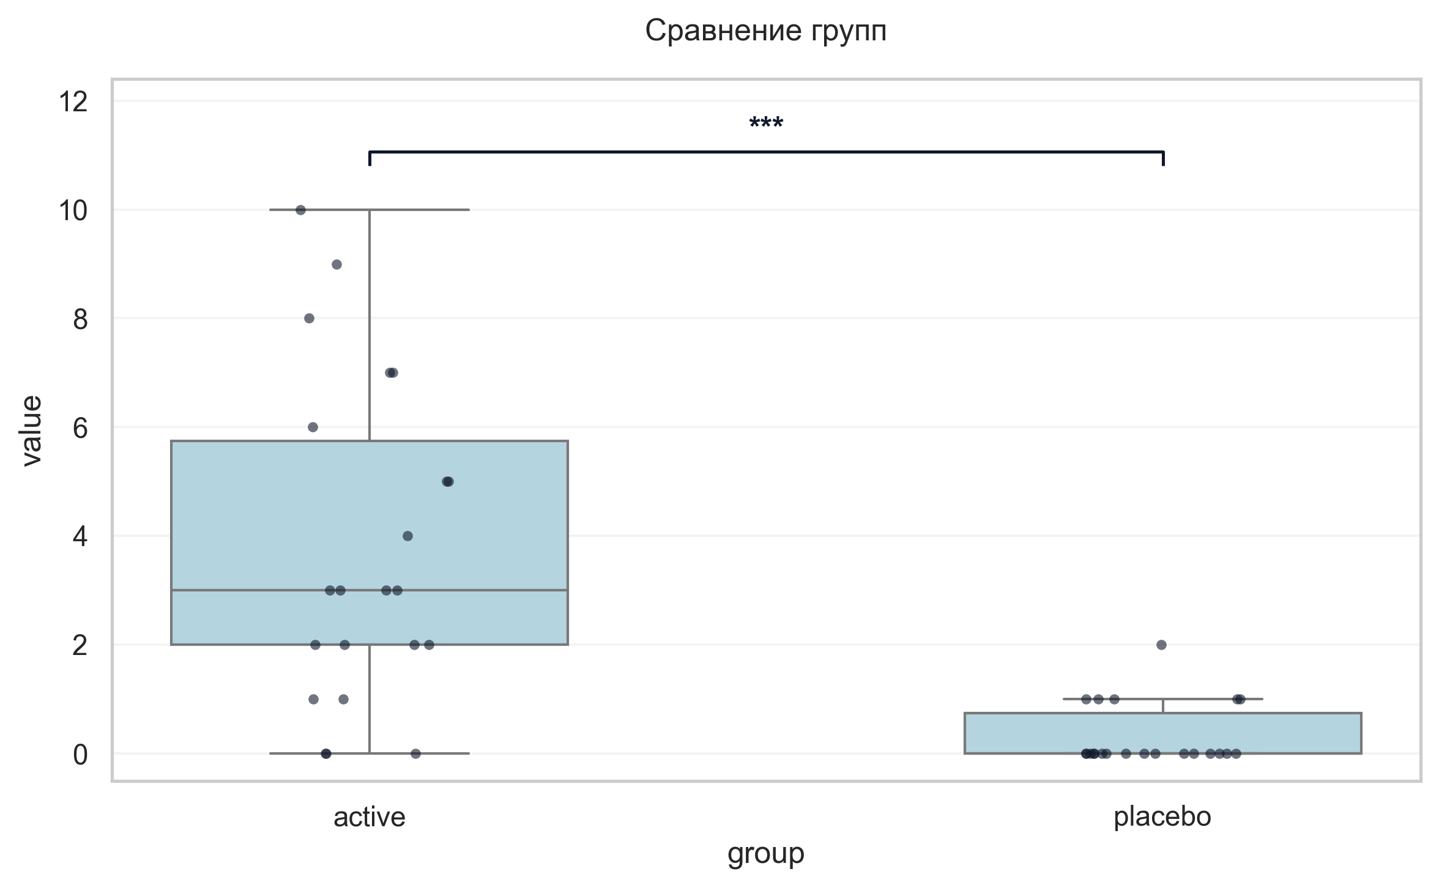
Интерпретация:
An independent Mann-Whitney U Test was conducted to determine if there were differences in Δ УШОБП часть 3 «Двигательные функции» баллы (V2→V6, улучшение) between groups defined by arm. There was a statistically significant difference between the groups (p < 0.001, r = 0.79 indicates a large effect). Specifically, the Δ УШОБП часть 3 «Двигательные функции» баллы (V2→V6, улучшение) in the active group (M = 3.77) was significantly higher than in the placebo group (M = 0.32).

Шаг: cmp__ушобп_часть_2_повседневная_активность_баллы_v2_v6_улучшение
Метод: Mann-Whitney U Test
p-value | < 0.001
статистика | 389.500
эффект | rbc 0.61
мощность | -
BF10 | -
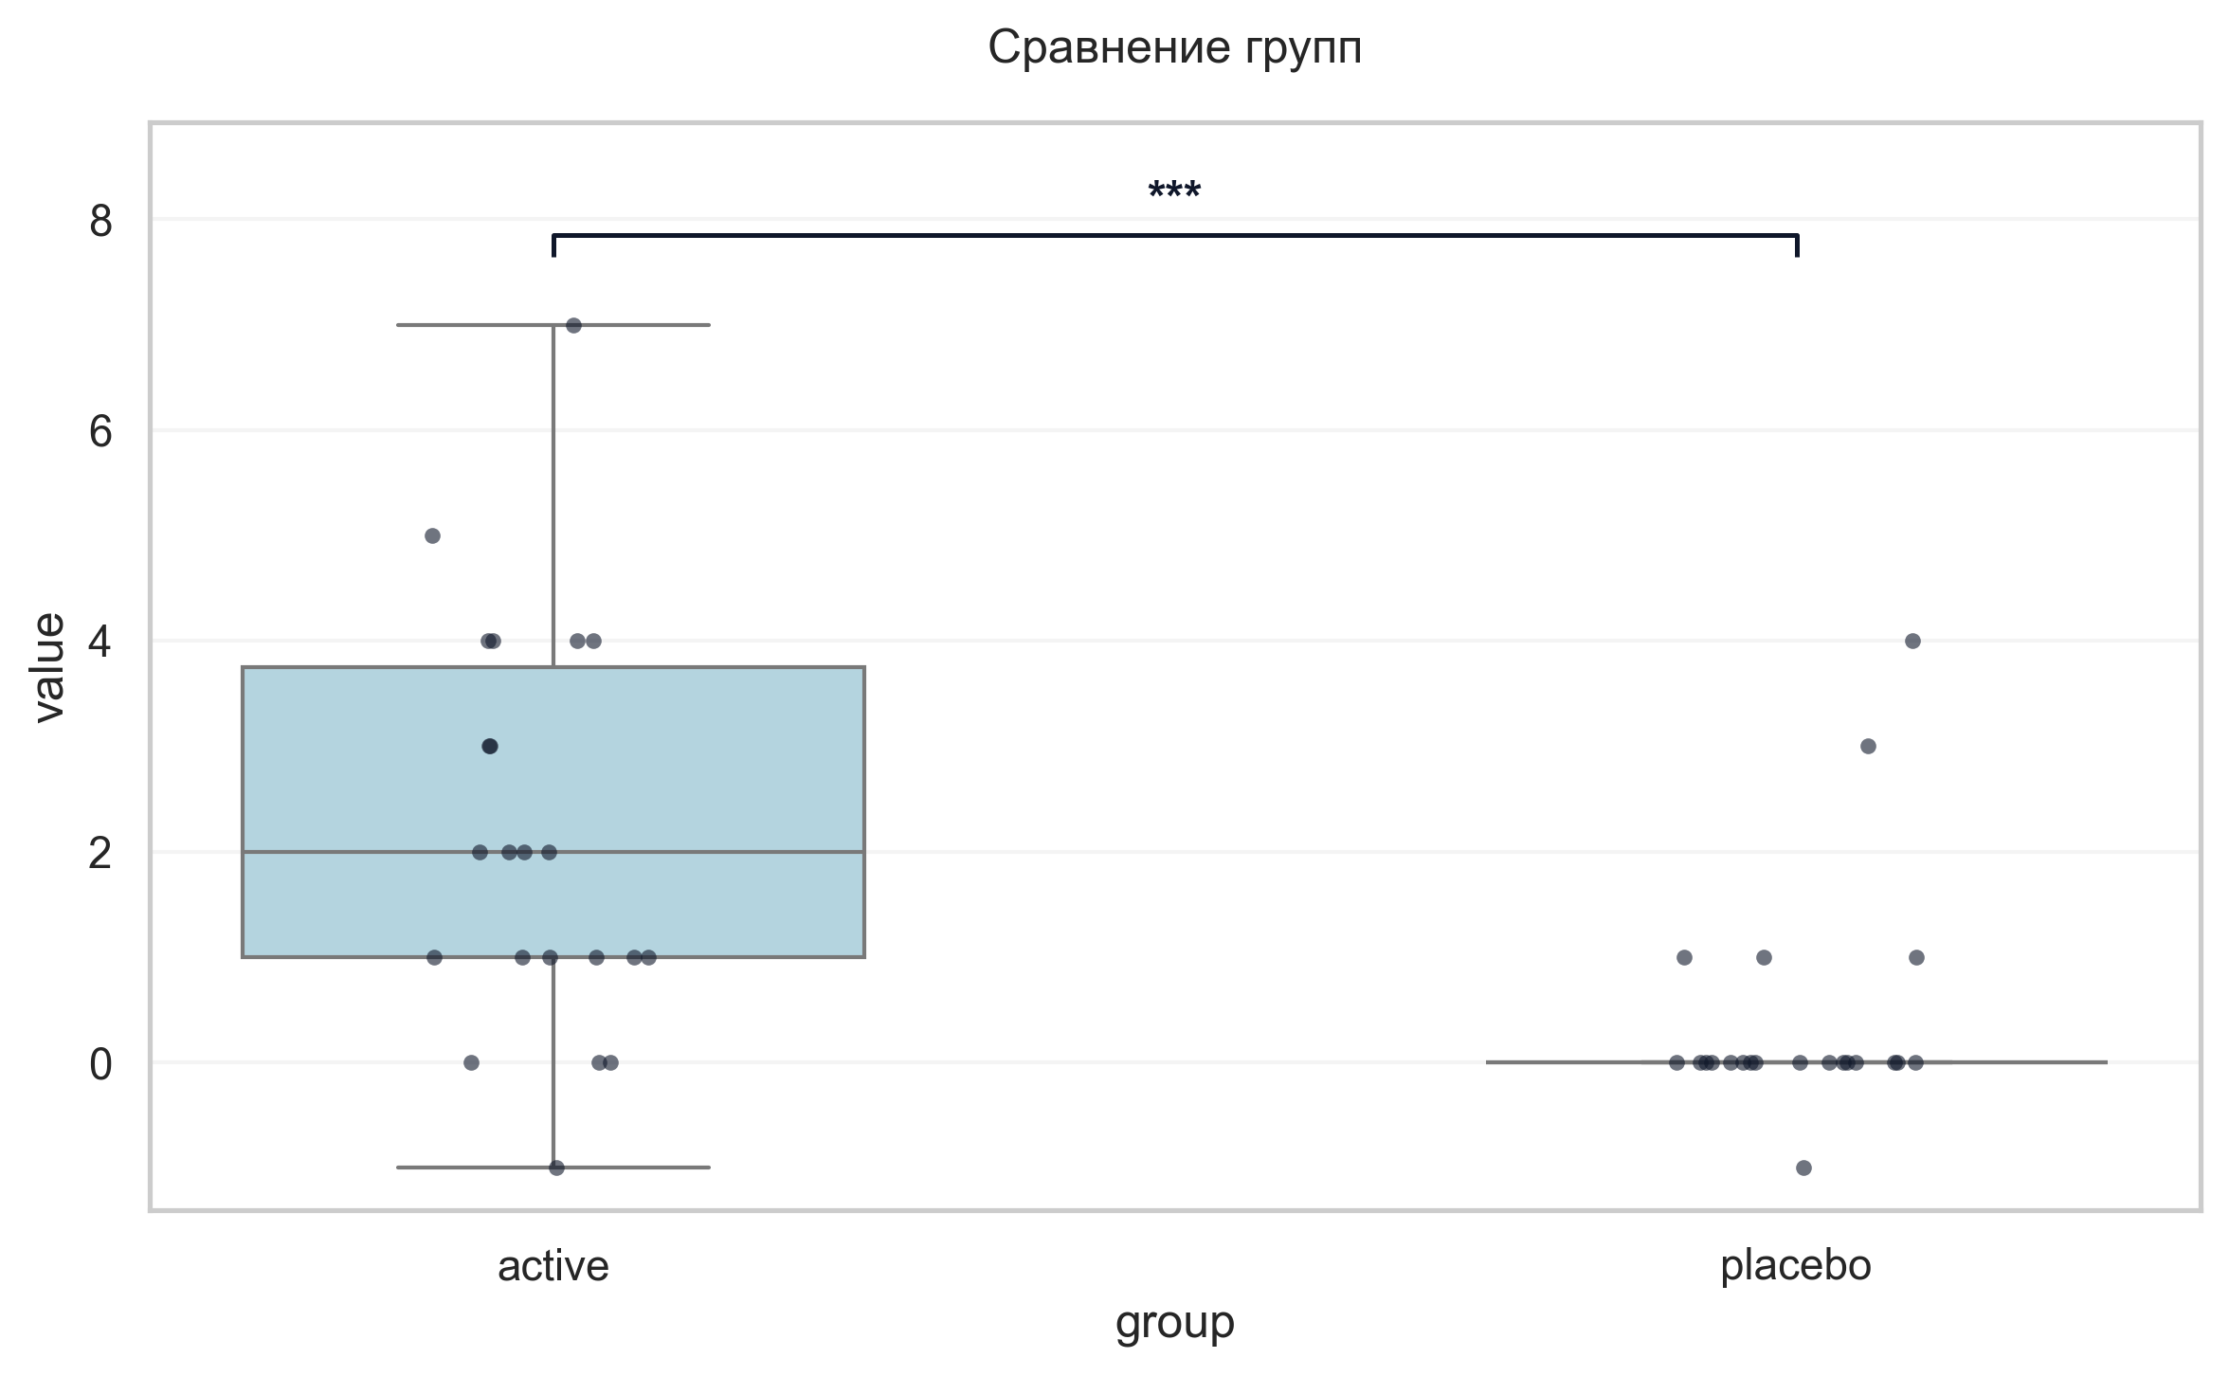
Интерпретация:
An independent Mann-Whitney U Test was conducted to determine if there were differences in Δ УШОБП часть 2 «Повседневная активность» баллы (V2→V6, улучшение) between groups defined by arm. There was a statistically significant difference between the groups (p < 0.001, r = 0.61 indicates a large effect). Specifically, the Δ УШОБП часть 2 «Повседневная активность» баллы (V2→V6, улучшение) in the active group (M = 2.14) was significantly higher than in the placebo group (M = 0.41).

Шаг: cmp__шкала_оценки_сонливости_эпуорта_баллы_v2_v6_улучшение
Метод: Mann-Whitney U Test
p-value | 0.3013
статистика | 286.000
эффект | rbc 0.18
мощность | -
BF10 | -
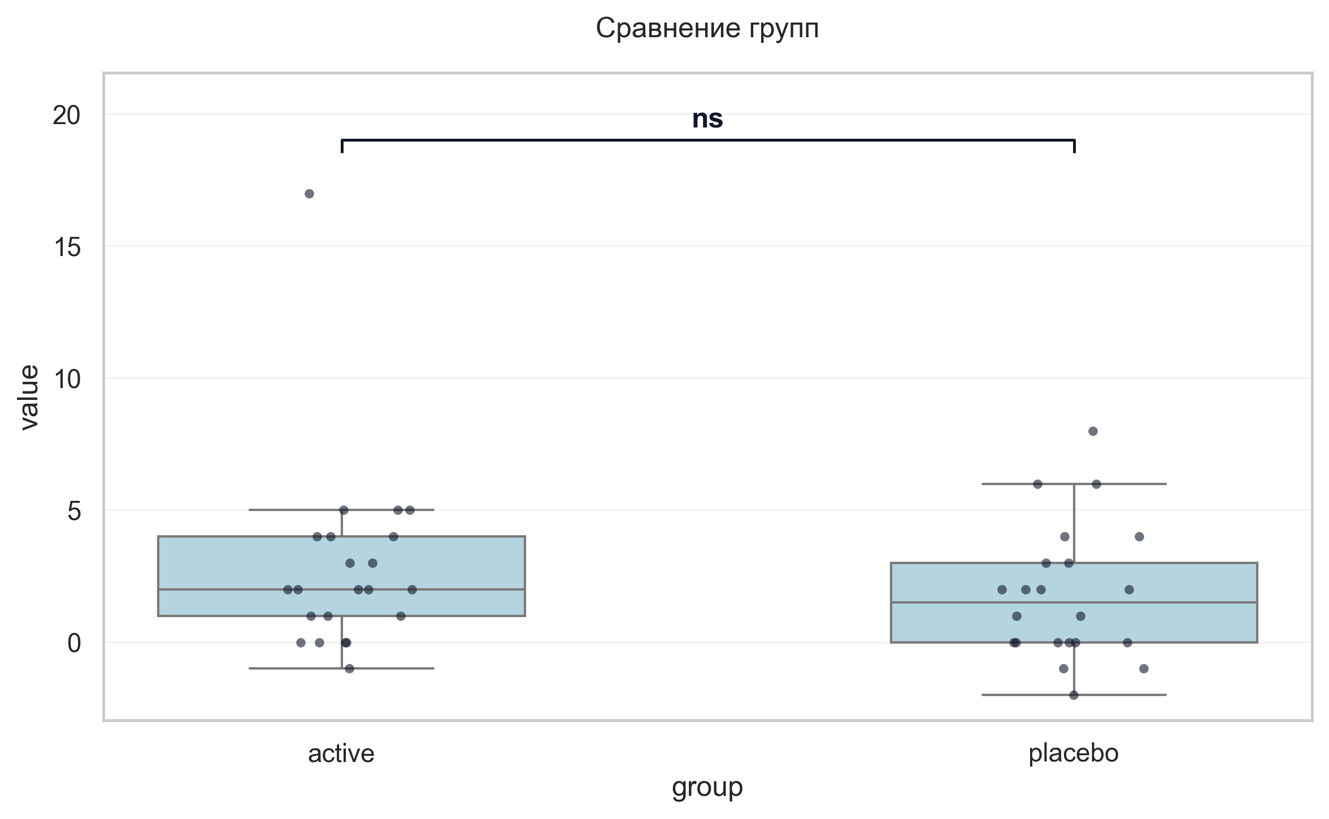
Интерпретация:
An independent Mann-Whitney U Test was conducted to determine if there were differences in Δ Шкала оценки сонливости Эпуорта баллы (V2→V6, улучшение) between groups defined by arm. The analysis revealed no statistically significant difference between the groups (p = 0.301, r = 0.18 indicates a small effect).

Шаг: cmp__шкала_оценки_утомляемости_при_бп_баллы_v2_v6_улучшение
Метод: Mann-Whitney U Test
p-value | 0.1953
статистика | 297.500
эффект | rbc 0.23
мощность | -
BF10 | -
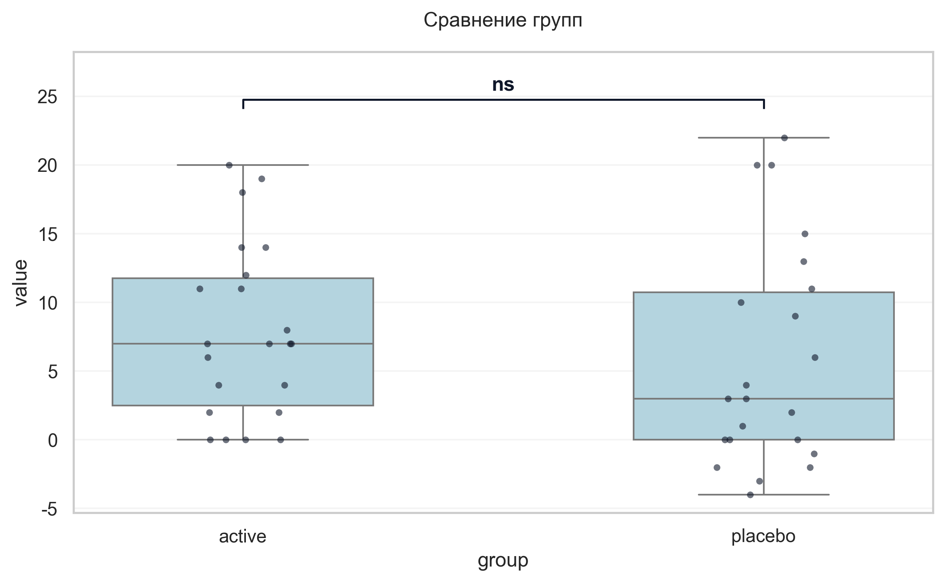
Интерпретация:
An independent Mann-Whitney U Test was conducted to determine if there were differences in Δ Шкала оценки утомляемости при БП баллы (V2→V6, улучшение) between groups defined by arm. The analysis revealed no statistically significant difference between the groups (p = 0.195, r = 0.23 indicates a small effect).

Шаг: cmp__шкала_апатии_старкстейна_баллы_v2_v6_улучшение
Метод: Mann-Whitney U Test
p-value | < 0.001
статистика | 446.000
эффект | rbc 0.84
мощность | -
BF10 | -
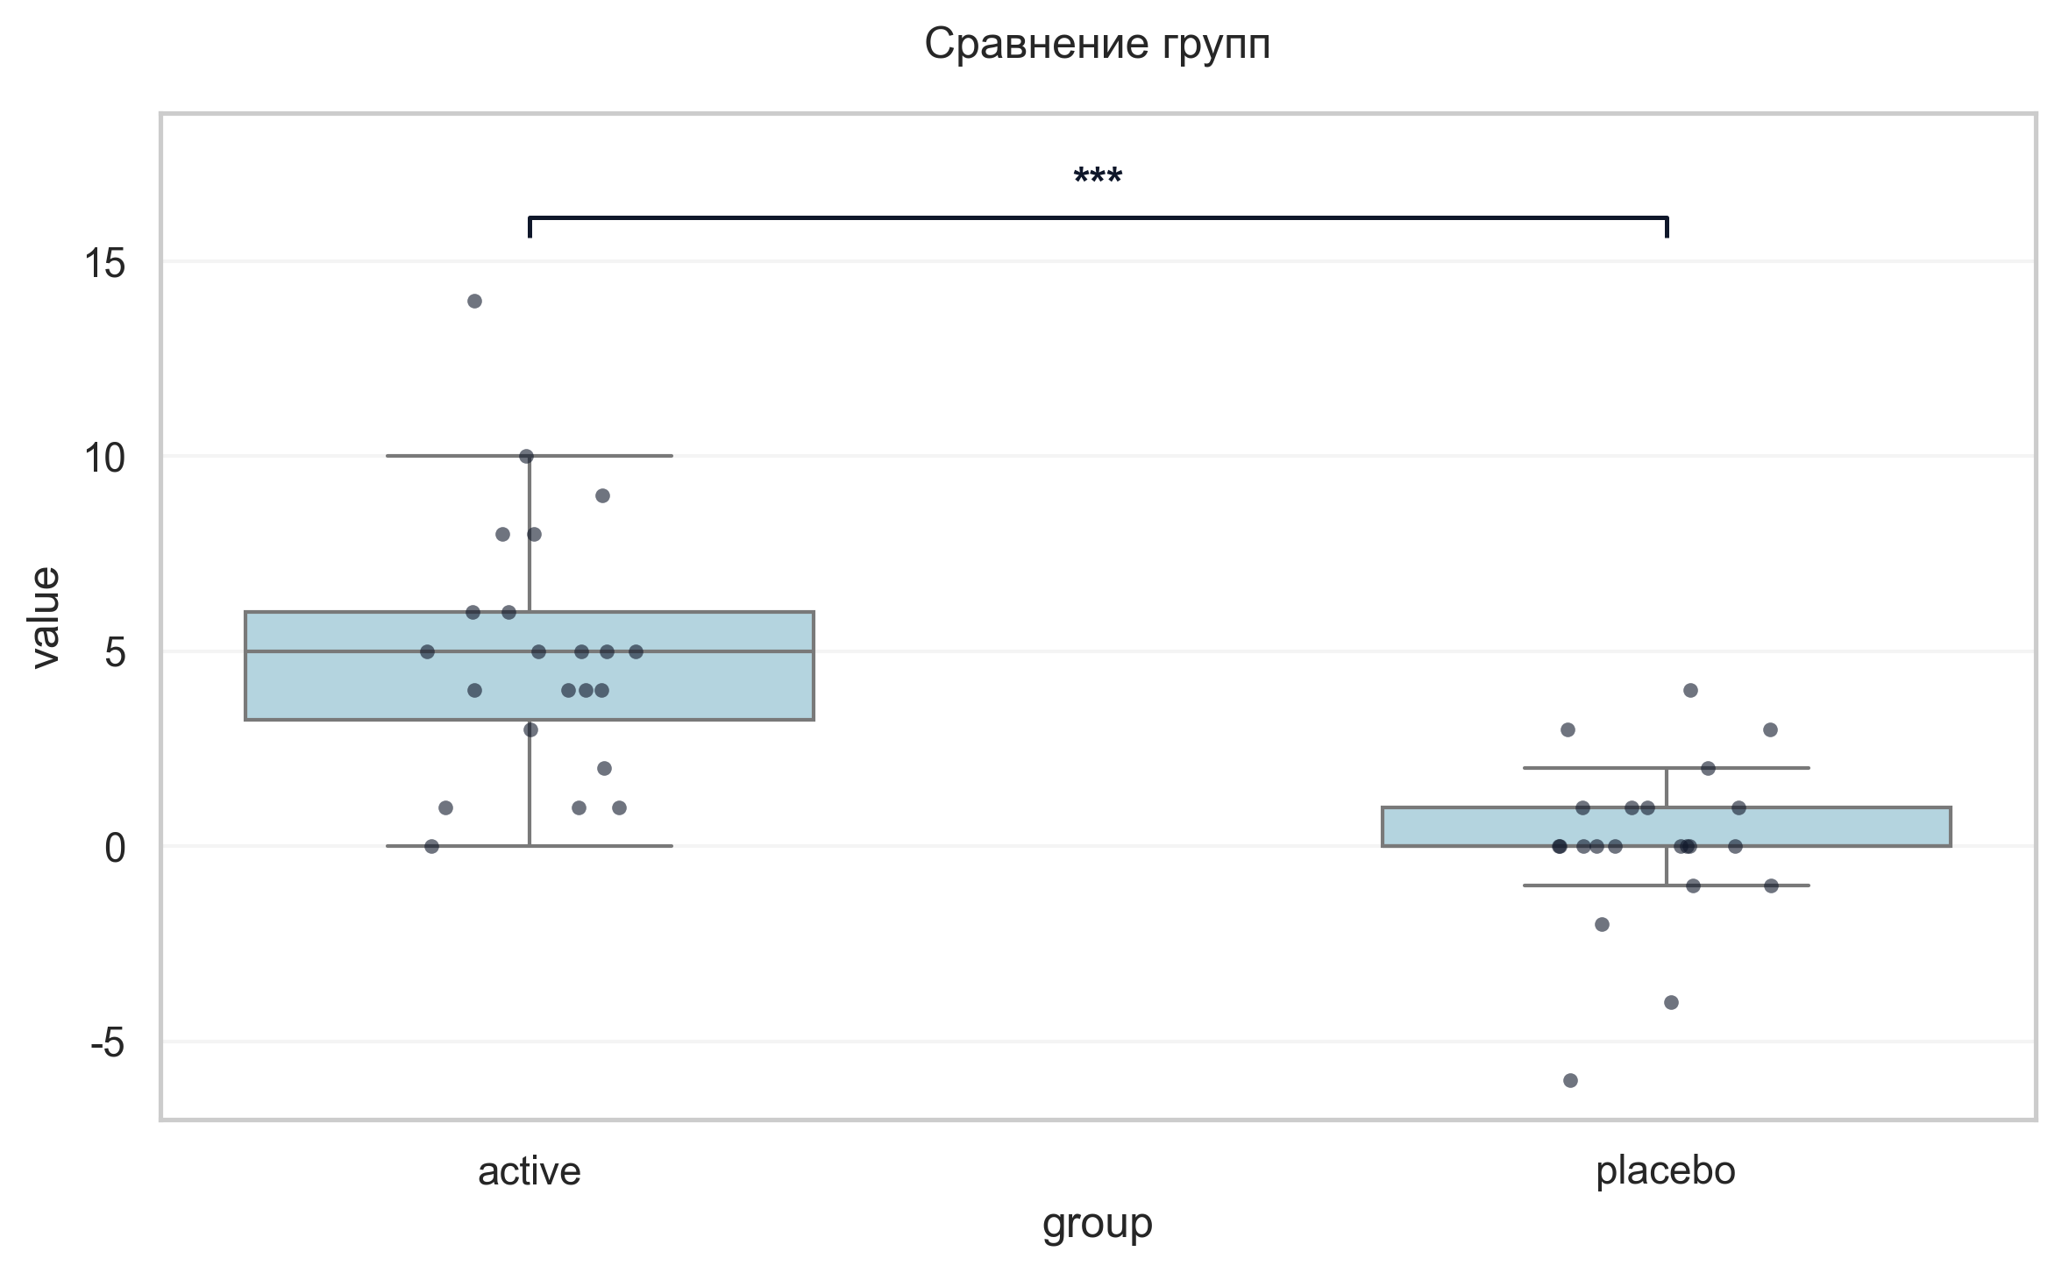
Интерпретация:
An independent Mann-Whitney U Test was conducted to determine if there were differences in Δ Шкала апатии Старкстейна баллы (V2→V6, улучшение) between groups defined by arm. There was a statistically significant difference between the groups (p < 0.001, r = 0.84 indicates a large effect). Specifically, the Δ Шкала апатии Старкстейна баллы (V2→V6, улучшение) in the active group (M = 5.00) was significantly higher than in the placebo group (M = 0.09).

Шаг: cmp__шкала_оценки_качества_жизни_при_бп_баллы_v2_v6_улучшение
Метод: Mann-Whitney U Test
p-value | < 0.001
статистика | 416.500
эффект | rbc 0.72
мощность | -
BF10 | -
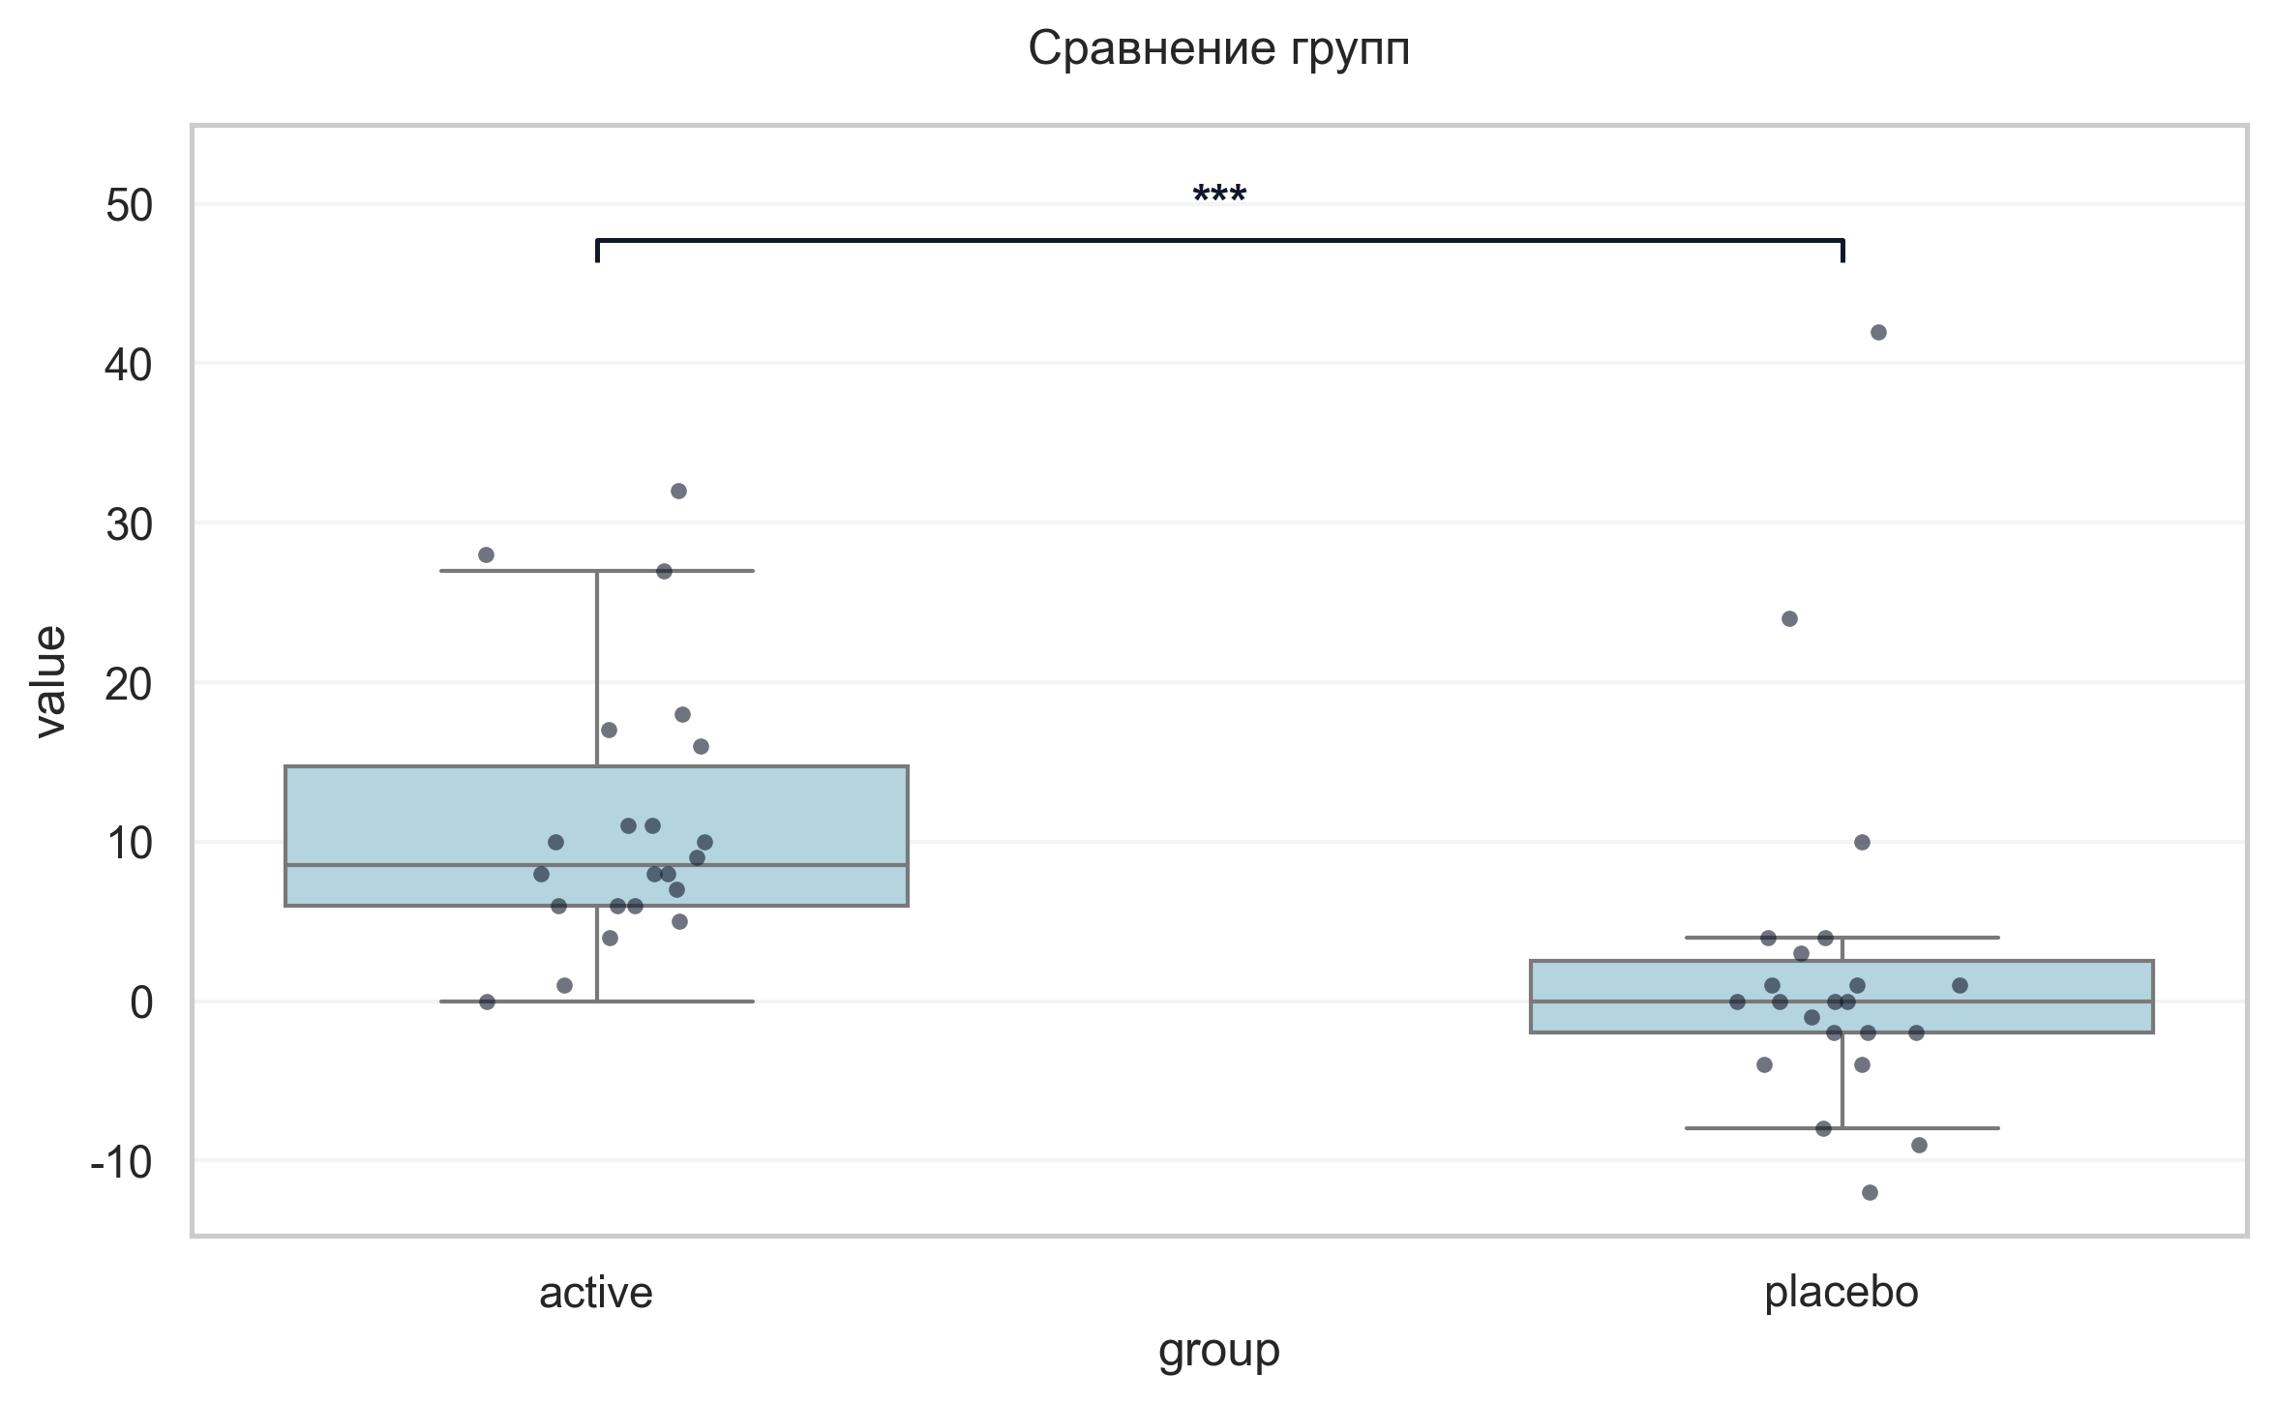
Интерпретация:
An independent Mann-Whitney U Test was conducted to determine if there were differences in Δ Шкала оценки качества жизни при БП баллы (V2→V6, улучшение) between groups defined by arm. There was a statistically significant difference between the groups (p < 0.001, r = 0.72 indicates a large effect). Specifically, the Δ Шкала оценки качества жизни при БП баллы (V2→V6, улучшение) in the active group (M = 11.27) was significantly higher than in the placebo group (M = 2.09).

Шаг: cmp__stroop_sum_v2_v6_улучшение
Метод: Student's t-test (Independent)
p-value | 0.0374
статистика | 2.155
эффект | cohen-d 0.67
мощность | 0.56
BF10 | 1.849
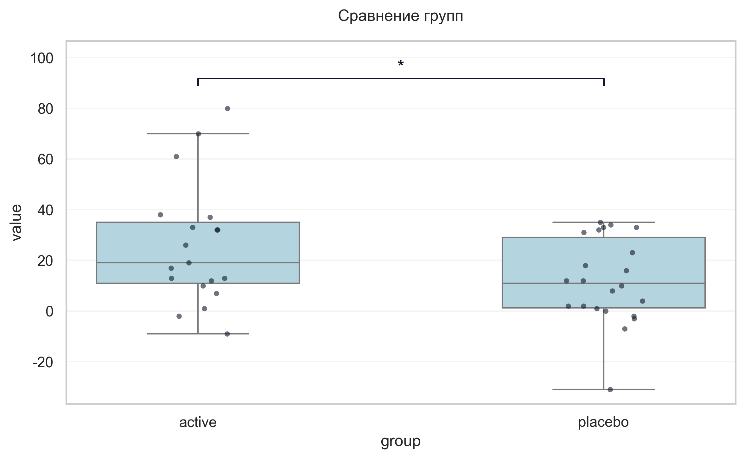
Интерпретация:
An independent Student's t-test (Independent) was conducted to determine if there were differences in Δ Stroop sum (V2→V6, улучшение) between groups defined by arm. There was a statistically significant difference between the groups (p = 0.037, Cohen's d = 0.67 indicates a medium effect). Specifically, the Δ Stroop sum (V2→V6, улучшение) in the active group (M = 25.79) was significantly higher than in the placebo group (M = 11.95).

Шаг: cmp__trail_a_b_v2_v6_улучшение
Метод: Mann-Whitney U Test
p-value | 0.0542
статистика | 324.500
эффект | rbc 0.34
мощность | -
BF10 | -
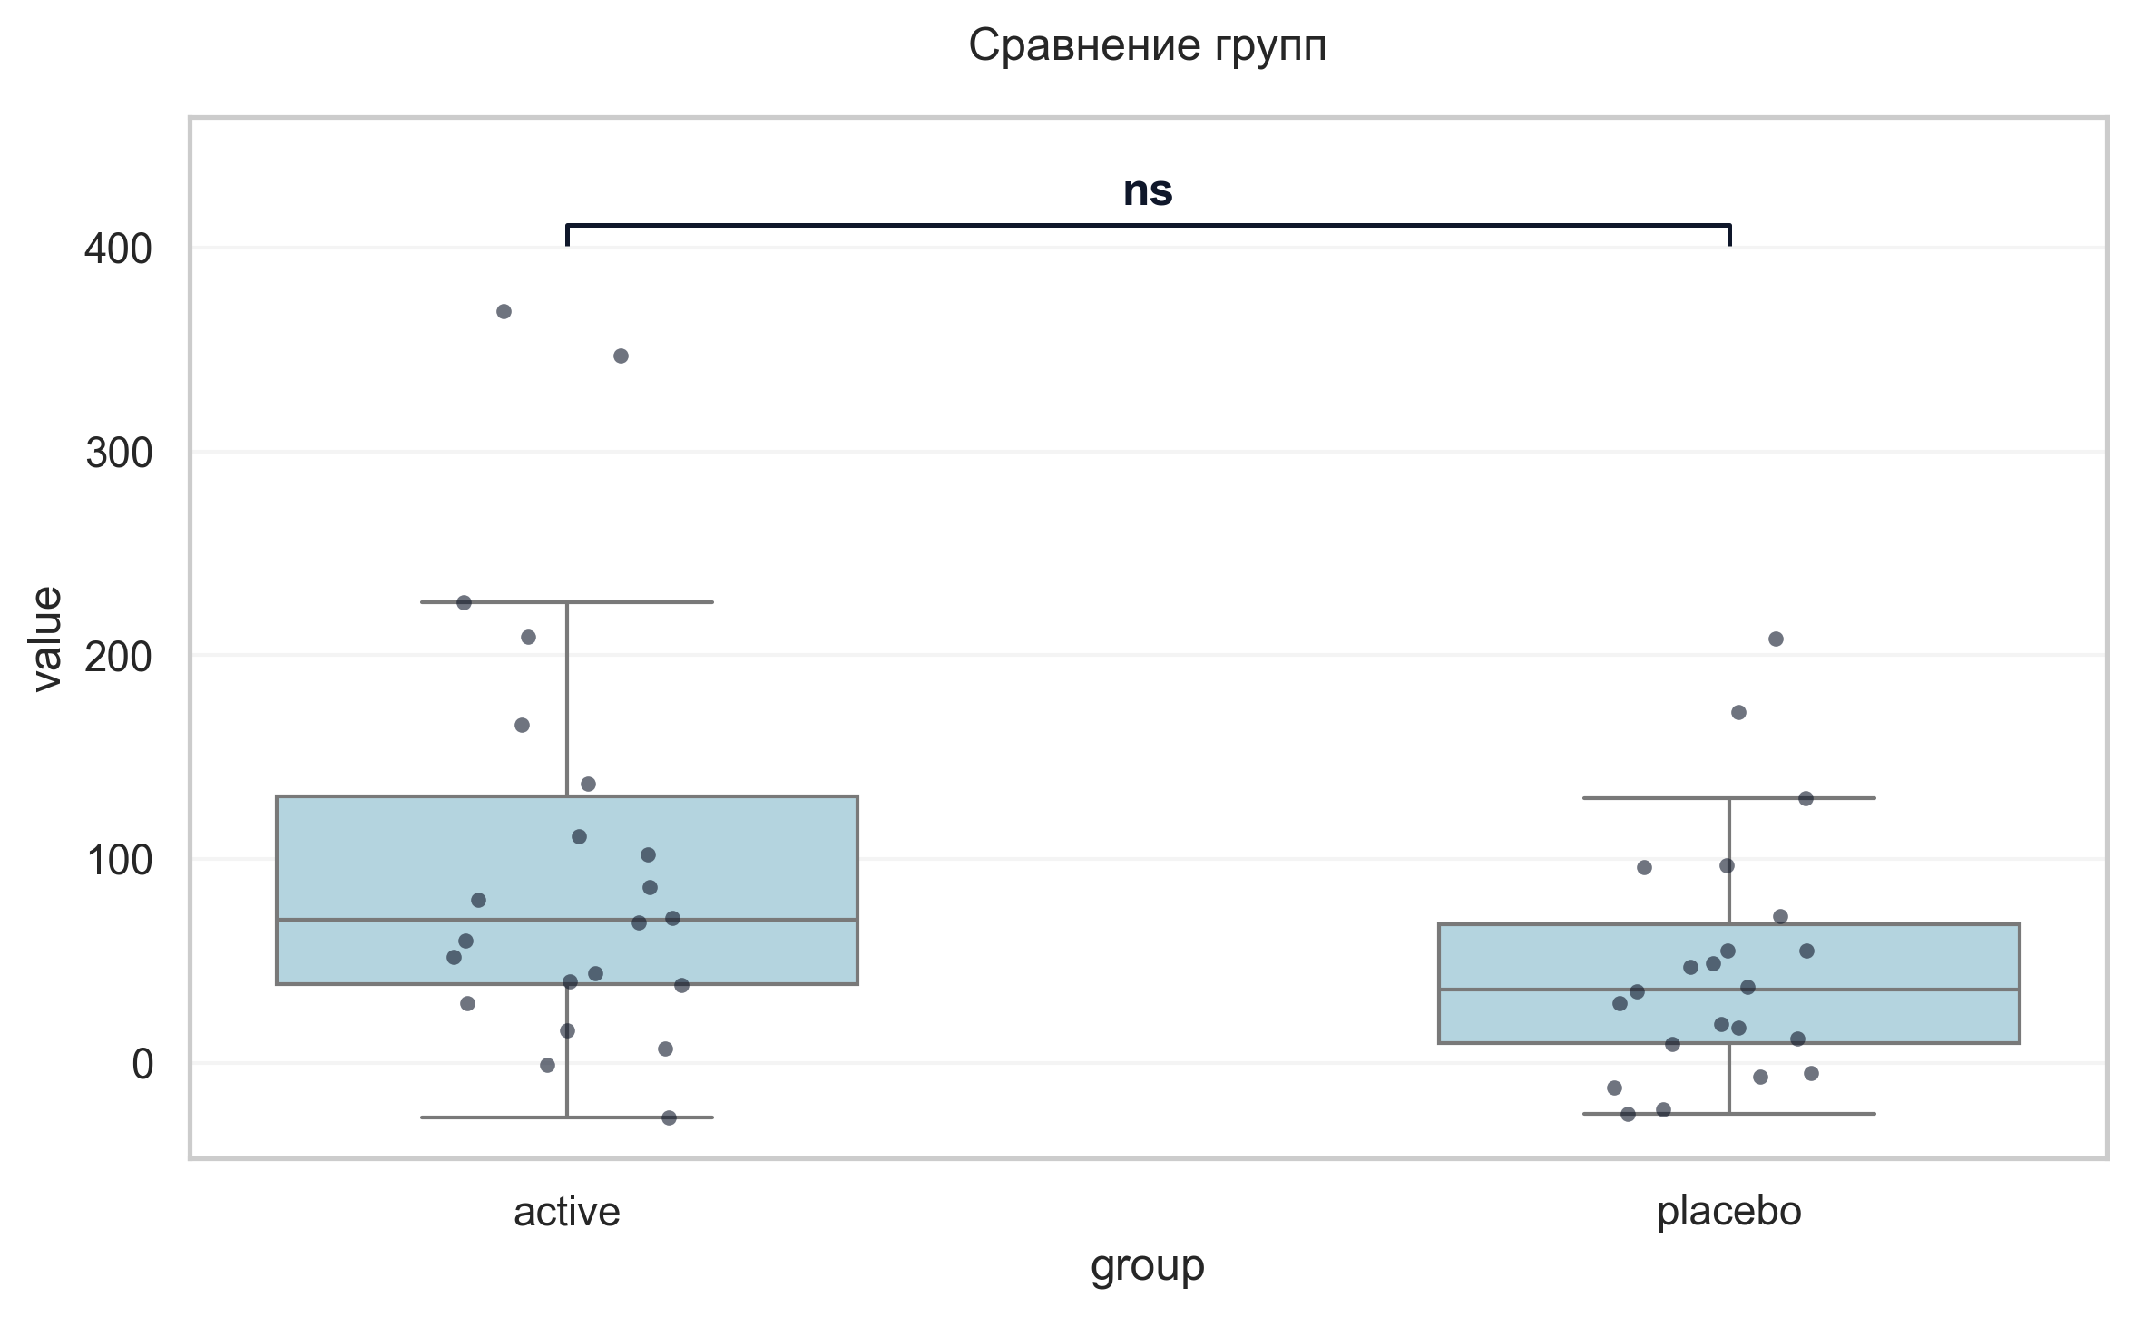
Интерпретация:
An independent Mann-Whitney U Test was conducted to determine if there were differences in Δ Trail A+B (V2→V6, улучшение) between groups defined by arm. The analysis revealed no statistically significant difference between the groups (p = 0.054, r = 0.34 indicates a medium effect).

Шаг: cmp__сад_v6_v1
Метод: Student's t-test (Independent)
p-value | 0.2159
статистика | -1.256
эффект | cohen-d 0.38
мощность | 0.23
BF10 | 0.56
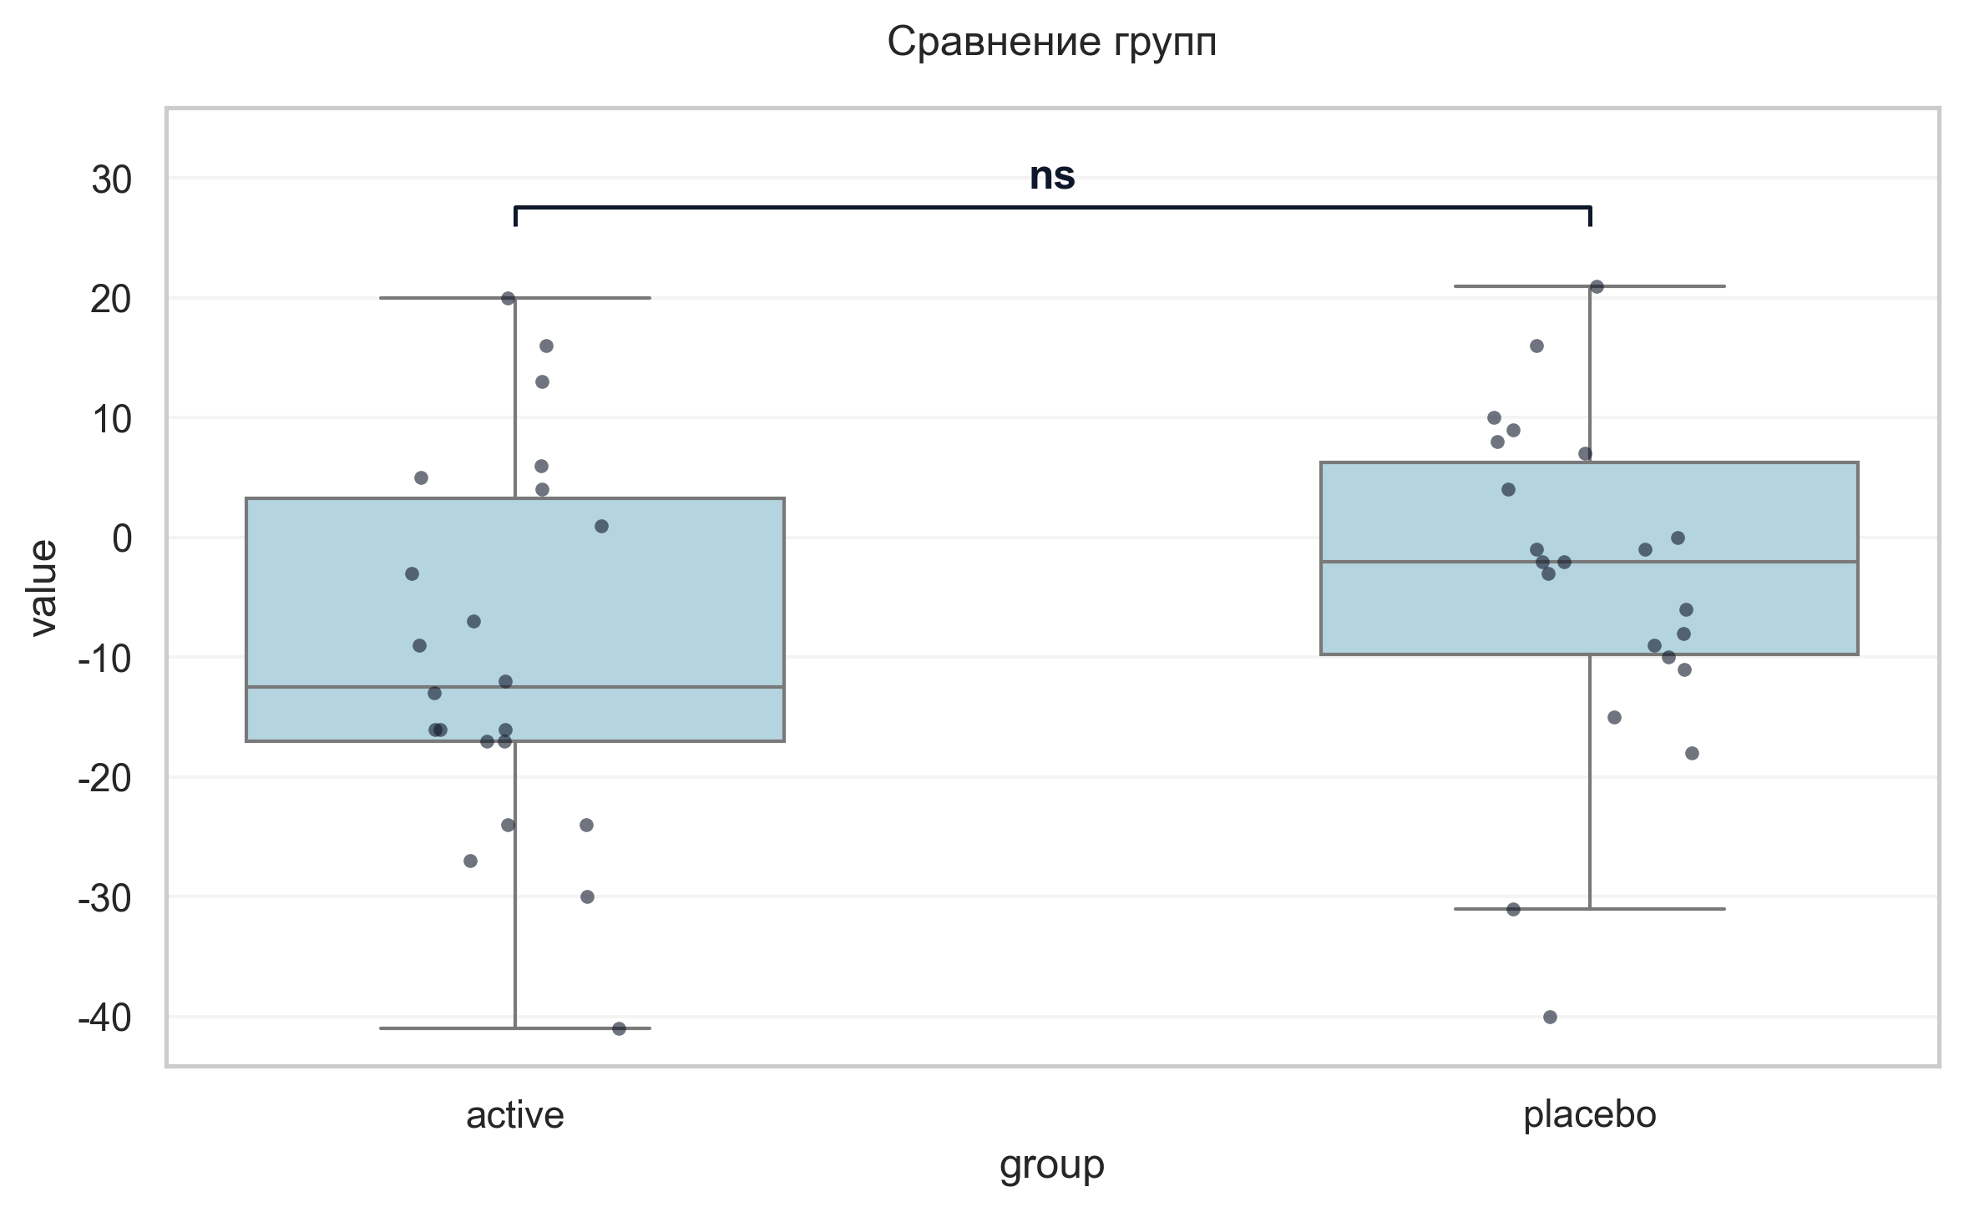
Интерпретация:
An independent Student's t-test (Independent) was conducted to determine if there were differences in Δ САД (V6−V1) between groups defined by arm. The analysis revealed no statistically significant difference between the groups (p = 0.216, Cohen's d = 0.38 indicates a small effect).

Шаг: cmp__дад_v6_v1
Метод: Student's t-test (Independent)
p-value | 0.1685
статистика | 1.401
эффект | cohen-d 0.42
мощность | 0.28
BF10 | 0.652
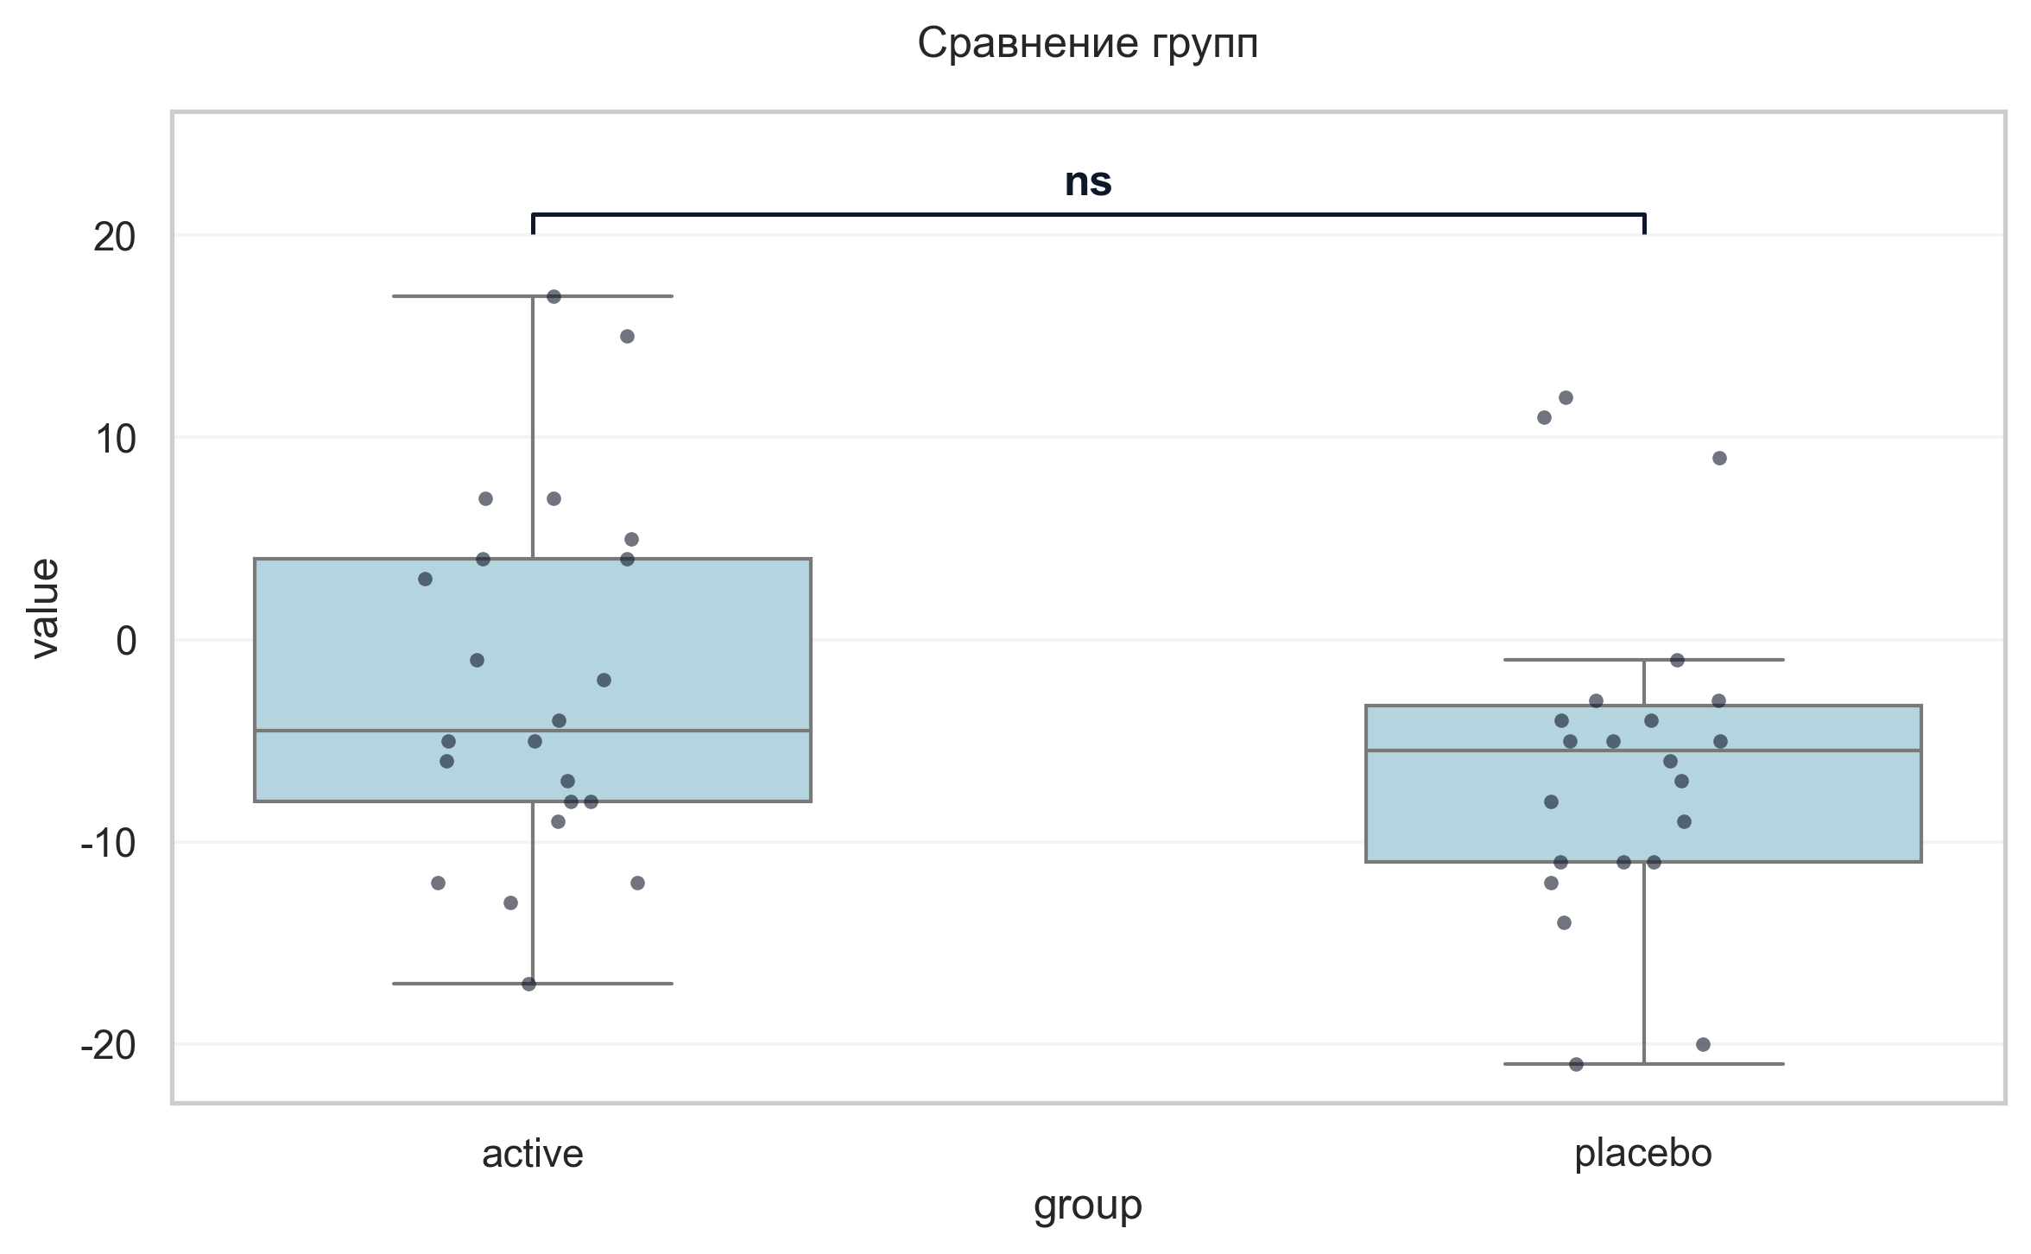
Интерпретация:
An independent Student's t-test (Independent) was conducted to determine if there were differences in Δ ДАД (V6−V1) between groups defined by arm. The analysis revealed no statistically significant difference between the groups (p = 0.169, Cohen's d = 0.42 indicates a small effect).

