**Choosing a Linear Model**

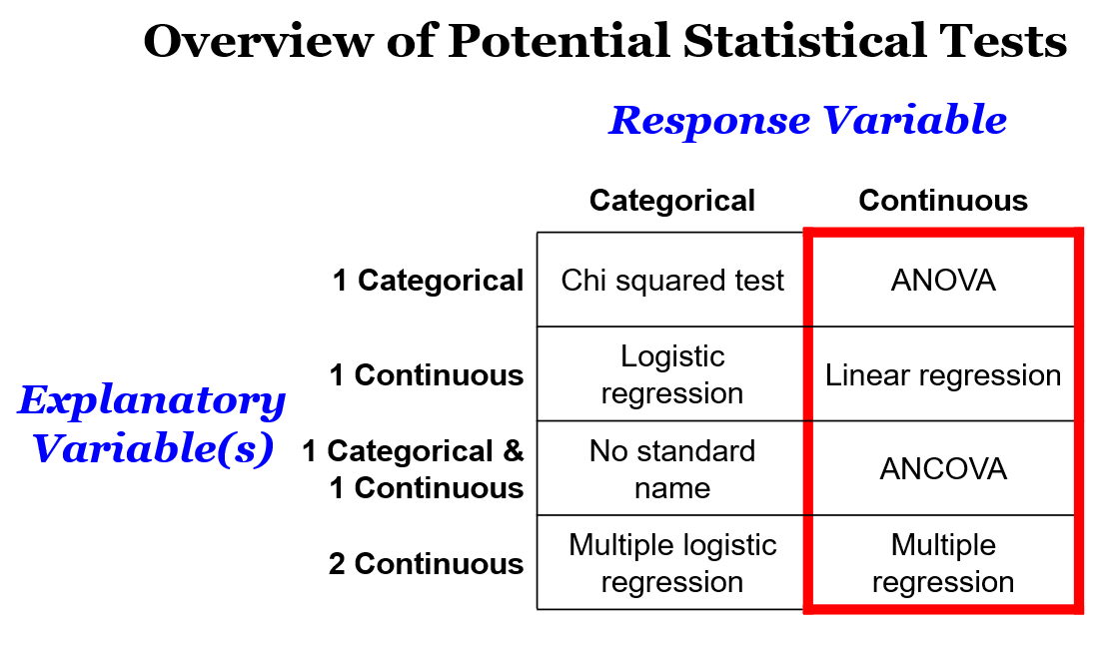

* All continuous response ones are linear models
* The **Shapiro-Wilk test** allows you to understand the normality of the residuals. The **Bartlett test** can be used to check the equality of variances. These allow us to determine whether linear models are the right way to go.

**Linear Model Assumptions**

* It’s not the end of the world if your data doesn’t match the assumptions of a linear model (it would be nice though, just once, wouldn’t it?). You can always use a non-parametric alternative to the linear model you had in mind.
* I did say that ideally you would choose your statistical test before collecting data but you might find you have to use a non-parametric alternative to the linear model you had in mind.

Flowchart to choose appropriate statistical tests 
Data 
Shapiro-Wilk Test 
Normal residuals 
Parametric tests 
Non-normal residuals 
non-parametric tests 
Explanatory 
variable 
discrete 
One factor n factors 
Explanatory 
variable 
continuous 
Explanatory 
variable 
discrete 
2 levels n levels 
Mann- 
Kruskal 
Whitney Wallis 
U Test Test 
Explanator) 
variable 
continuous 
Spearman- 
Rank Test 
2 levels 
T-test 
n levels n levels 
One-Way 
ANOVA 
Multifactorial 
ANOVA 
Slides are subject to copyright and 
for personal use only 

**Visualising Non-parametric Alternatives**

**Interpreting Your Outputs**

* Tables of outputs from all 8 statistical tests
* Don’t tend to display results in tables
* Writing the outputs in a sentence
* Advice for writing results- refer to hypothesis, the … had/did not have an effect on... or if your results weren’t significant, we saw this pattern but it was not statistically significant.
* Using report
* Diagram to explain p value

**Additional Links**

Linear mixed effects models- incorporating confounding variables into model

Log transforming based on skew of data

Incorporating distributions other than normal

Using report()

Power analysis in R

Backtransforming data

Coding club tutorials you expect them to have done