

Roadmap
Ten Thousand Credit-Flex Students in 2013

The roadmap for this winter for the Ohio market includes:

Student Poster contest Build awareness at the same time we refine the story and branding. What does creditflex mean to students? How do they see it? Do they even know about it? How do they view the opportunities?

Student Video contest We have a couple videos to show this digital generation, but nothing as good as they could tell it. So let’s get them in on telling the story. And in the process raise awareness in schools.

Student Logo contest Any good initiative needs a brand. We’ve been using a rather dated and generic graphic. What would students come up with if they had a chance?

And again, the contest itself raises awareness.

Rethinking the app’s user interface--with the community’s help. The first version of CreditFlexibility.org is functional, but not grabbing people’s attention and use. What are we missing? How could it be more instant-gratification? How could we get people using it and challenging others? What other basic functionality should it have?

Porting to smartphones The students are on moble; creditflexibilty is not.

Gamifying/socializing teacher participation The web app should be more gamelike. How? How can we prompt students and teachers to challenge each other?

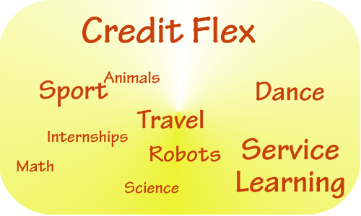
Bringing badges accumulation into the app. I got a several badges for learning to program. How can I turn them into credit for HS?

Or. Where can I look for credit-worthy badges I can earn? And how can teachers work together to assign credit to badge combinations?

Additional
- in a more entrepreneurial environment, while advancing the software and marketing concept; continuing user testing; finding partners, identifying sponsors, and working out a long-term revenue model.
- In person evangelization: visiting education schools, teacher gatherings, students.
- Investigate the potential for expanding to other states.

