Challenger Puzzle Solver
Ed Logg
May 2026
This is a program to solve Challenger problems. This is a puzzle with 4 rows and 4 columns and the totals are given for each, row, column, and diagonal. There must be at least 4 numbers in the 4x4 matric that are provided with one in each row and column but no more than 2 on a diagonal. There may be more than one solutions to the puzzle. The question I am asking is there a way to “solve” the puzzle as a human would to get to a point where any guess will guarantee a solution? Furthermore, can all puzzles with 1 or 2 solutions be solved easily? I have read that this puzzle was created my Linus Maurer a puzzle
enthusiast and and art classmate of Peanuts creator Charles M. Schulz. (Wikipedia, Linus Maurer, n.d.)

Nomenclature:
- Direction – one of the 4 rows, 4 columns or 2 diagonals. Row 0 is the top most row and column 0 is the left most column. Diag0 is the first diagonal i.e. top right to bottom left and diag1 is the other diagonal.
- Total – one of the direction totals shown on the right and bottom sides.
- Cell – one of the 4x4 matrix entries where numbers can be placed. We refer to the cells by (row,col) where (0,0) is the top left and (3,0) is the bottom left and (3,3) the botton right.
- Range – written as (min-max) which is the min and max values for any cell. If min=max we omit the range and show the value for that cell.
- Solvable Puzzle – I mean getting to a point where selecting any value of the min or max value of the range will always create a solution.

C Sample Program
I have created a C program which can do all the following. It has the ability to load or save a puzzle. If you want to enter one manually select the File option New for a blank puzzle. You can fill in the totals first in clockwise order and then fill in at least 4 cells preferably with one in each column and row but not with 4 on a diagonal. If at any time you want to start over on the same puzzle select the Game menu Restart option. The program can create a puzzle for you. In addition, it has the ability to test the current algorithm by creating as many puzzles as you like and reporting on the results. There are also additional options discussed below.

First Step
The first thing to do is to fill any vacant cell with the range (min and max values) for each direction. Starting with the first diagonal and going around the cells clockwise. As you fill in the ranges you will find that if a cell has changed you need to recheck all the directions again that use that cell. For example, in figure 1 below we have filled in all rows. The grayed out totals mean that this direction has been completed. Note that the first diagonal needs to be checked again. In Figure 2 the lower diagonal was checked causing the first three rows to change. When you have completed finding all the ranges you will have figure 3 below.
Please note the program has the ability to do this as an automated process by pressing Return or selecting the Game menu item Solve. If you want to see the process one step at a time press the space bar or select the Game menu item Step.
When this step is complete some cell range digits in final stage are grey if the Game menu option Show Valid Ranges option is sleected. This indicates this value is not part of any solution. The option to show valid ranges is off by default. All solutions are written to a file named solutions.txt. In addition, the solutions.txt file will contain the valid ranges for each cell.

Figure 1 fill in all rows Figure 2 second diagonal Firgure 3 First step complete
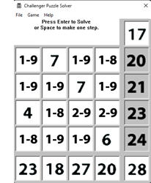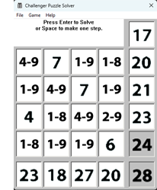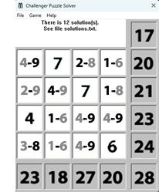

Second Step – 1st Pass on Equations
What do we do from here? Well, we have up to 12 unknown cell values and 10 equations to solve. The equations are truly not independent but can they be used to “solve” the puzzle by identifying the correct range for all cells? In general, no more than 4 variables are ever needed.
So, we can start filling each cell with variables. So how do we determine the best way to start adding variables. I tested over 18 different starting directions as well as using different directions (left to right vs right to left or top to bottom vs bottom to top, etc.) but it does not seem to matter, so I have chosen to do the rows first starting in the upper right corner but first taking any direction that has the fewest unknown cells. I continue this process of filling out the entire 4x4 grid with equations.
Normally any filled in row will add up to the total, however, once you get to a direction where it does not add up to the total, we get an equation where we can reduce the number of variables used. Take Figure 4 below and notice that when we add up column 0, we get 12=-2b+2d or d = 6+b. So now we substitute d everywhere to get Figure 5.

Figure 4 before Figure 5 col 0 reduction
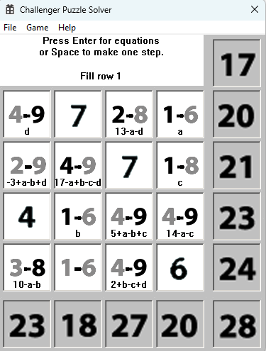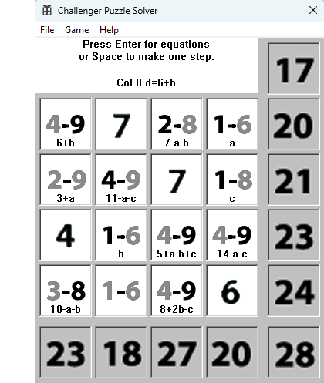
Now we try to reduce the ranges or equations even further. In Figure 5 above look at the cell at (2,1)=b with a range of (1-3) and cell (0,0)=6+b with a range of (4-9). We can see that the cell at (0,0) must have a range of (7-9) further reducing the range. In Figure 7 we can do the same using a at (0,3)=(1-6) and (1,0)=2-9. We can change the range of (1,0) to (4-9).
In Figure 8 we can reduce ranges using another method by noticing that (0,2) can never be 6, 7, or 8 because 7-a-b must be a max of 5.
Figure 6 reduce range using b Figure 7 reduce range using a Figure 8 (0,2) new min or max
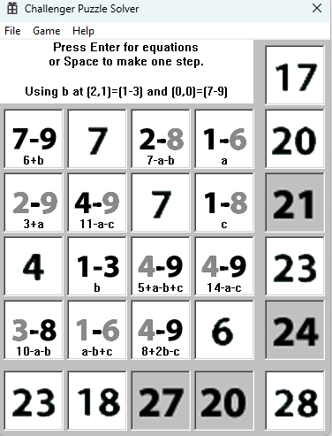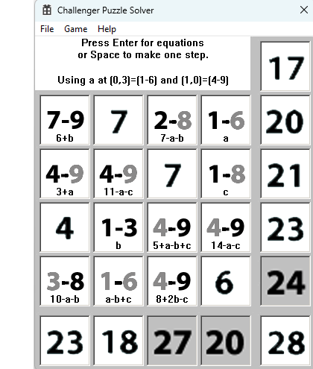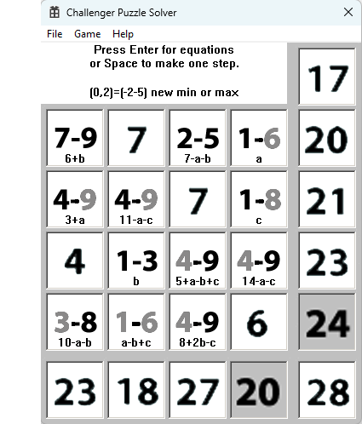
The opposite method can be used. In Figure 9 notice (0,2)=7-a-b so “a” cannot be more than 4 because the min of b is 1. This results in Figure 9 where the range of (0,2) is now (2-5).
In Figure 10 we can use a at (0,3)=(1-4) and reduce (1,0)=3+a to a new range of (4-7). In Figure 11 (1,3)=c with a range of (1-8) can be reduced by adding up the minimums on row 1 means c cannot be larger than 6 because 4+4+7+6=21.
Figure 9 reduce a by using (0,2) Figure 10 reduce (1,0) using a Figure 11 reduce (1,3)
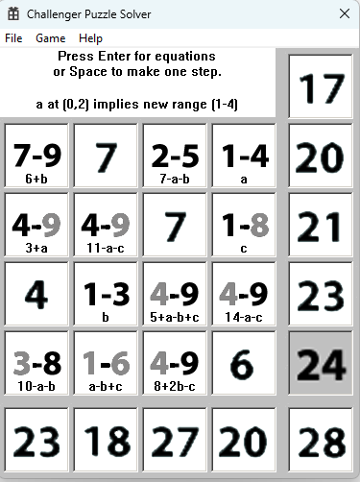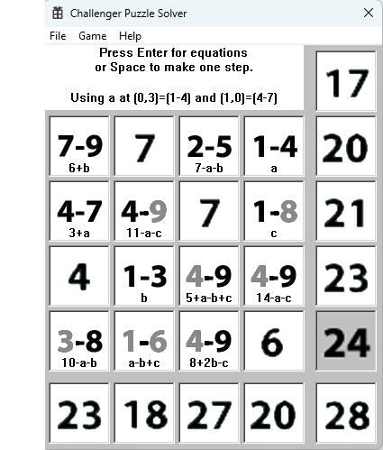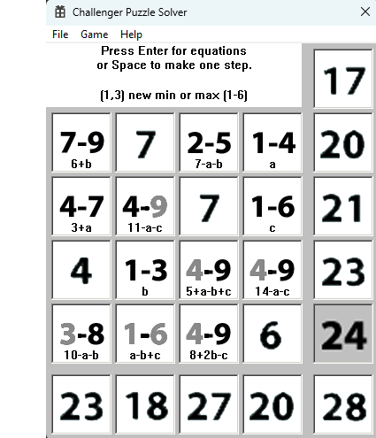
There are even more reductions that can occur. Take the example below in Figure 12 where the cell at (2,2) with a range of (4-9). If you add up other max values in row 2 you get 4+3+9 meaning the min for (0,2) must be 7 giving a new range of (7-9). In Figure 13 using the diagonal from (0,0) to (3,3) we see the max ranges for the other cells is 7+7+6 so the min of (1,1) must be 8 to get to the total of 28.
There is another reduction possible with Figure 14. The cells at (0,2)=7-a-b and (3,0)=10-a-b have similar equations. So if (0,2)=7-a-b has a range of 2-5 then 10-a-b must have a range of (5-8).
Figure 12 reduce range at (2-2) Figure 13 reduce range at (1,1) Figure 14 similar equations
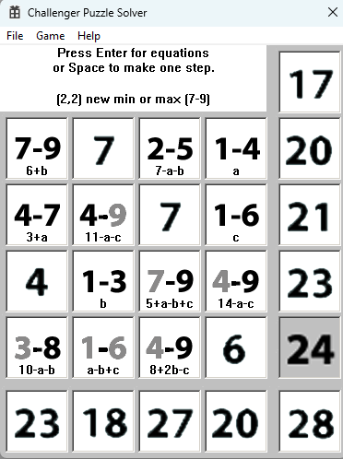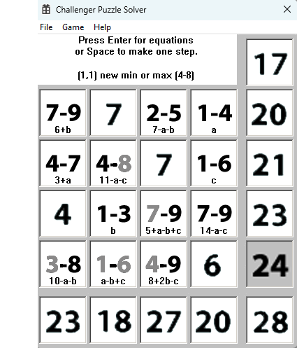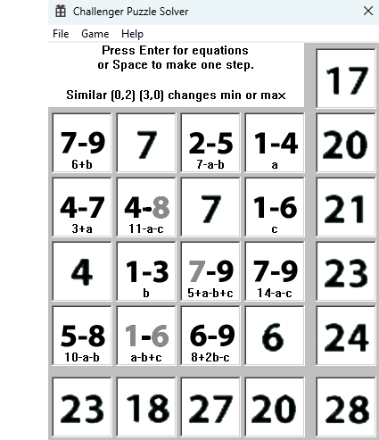
There are times when the range is reduced to a constant when the cell min = max. When this occurs, we can substitute a variable throughout any equations using that variable. In Figure 15 below we can see that b must be 3 so that -2+b at (1,3) can be in the range of (1-2). Figure 17 shows when we substitute b=3 through all the equations. In Figure 18 row 2 with a total of 7 forces (2,0)=1. In Figure 19 we have the equation -7+2a+c=1 so substitute c=8-2a everywhere.
It is also possible that the equation gets reduced to a constant. In Figure 20 we have such a case. When this occurs, we can set the range of the cell to the constant greatly reducing the complexity of the equations. This most often occurs when we have just one solution.
Figure 15 before Figure 16 we get b=3 Figure 17 after substitution
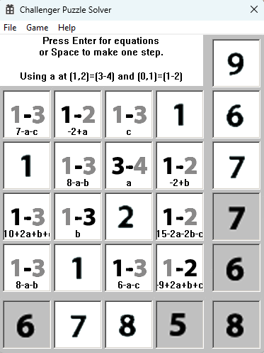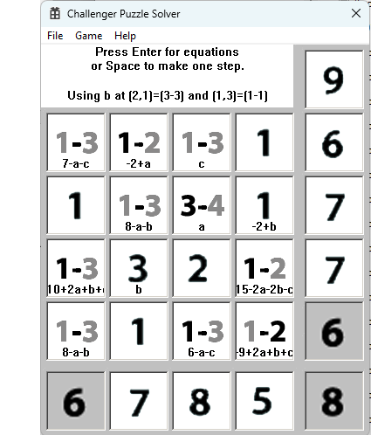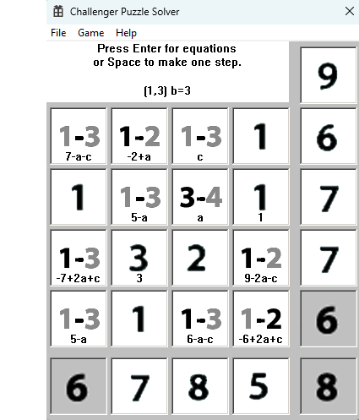
Figure 18 (2,0) new max of 1 Figure 19 substitution for c Figure 20 equation is a constant
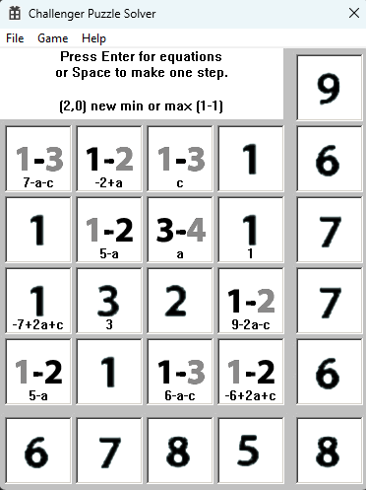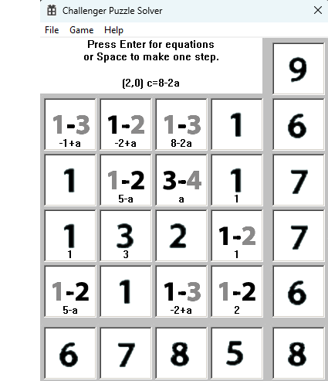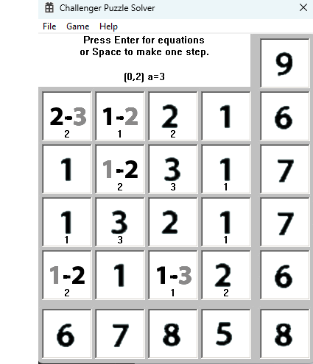
The last rule is more complex in that multiple variables in an equation can help us reduce the range of one of the variables. Figure 21 is the starting position. In Figure 22 you can see at (0,2) we have an equation 13-a-b with a range of (4-9). If a were 9 then this range could not be met so change the range of “a” to a maximum of 8 because “b” can be as little as 1. In figure 23 the cell at (3,2)=6+b+c so the range of “b” can be reduced to (1-2).

Figure 21 Figure 22 Figure 23
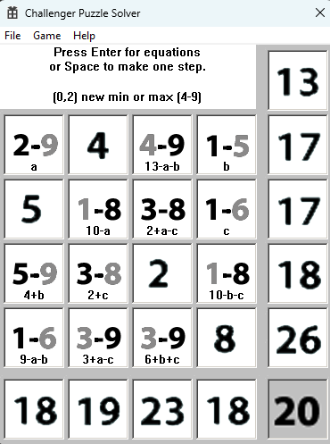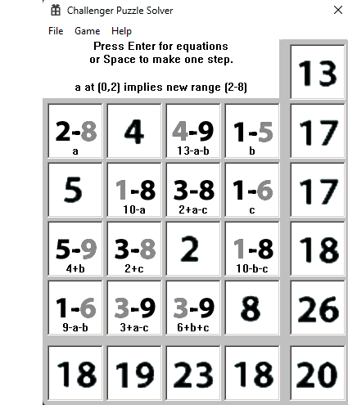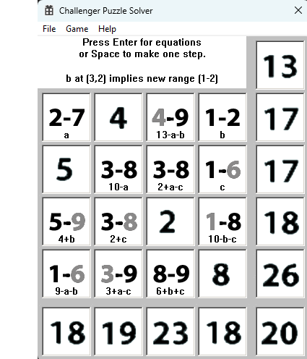
After all the equation evaluations we have made we may end up with a puzzle that is still not “solved” as in Figure 24. However, sometimes using a different assignment of variable will sometimes “solve” the puzzle. Other times it will not solve the puzzle despite trying 18 different methods of assigning variables as in Figure 25. The equations will “solve” about 75% of puzzles without using the 3rd step.
Figure 24 finished equations Figure 25 unsolved puzzle
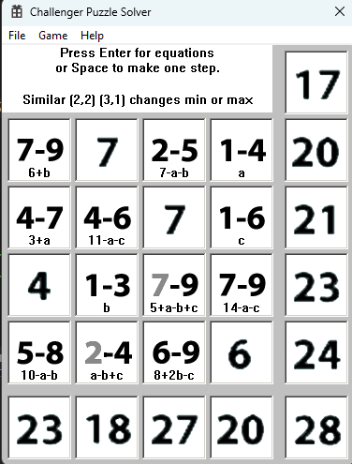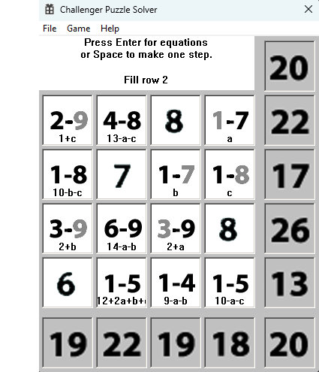

Third Step – 2nd Pass on Equations
There is something else we can do with our equations but it requires even more work. We could test the min or max range numbers in every cell and look for any contradictions. In actual practice I only test the ones I know are wrong but if you are doing this by hand it would take an extra ordinary amount of time, so I don’t recommend using it with pencil and paper. Using Figure 24 we see that the cells at (2,2) and (3,1) are not complete. Suppose we try (2,2)=7 to see if it is valid. Figure 26 shows that if (2,2)=7 then c=2-a+b which we substitute throughout. Continue with the normal equations rules above we get to Figure 28 where we get an invalid range for (3,2). Therefore, our assumption of (2,2)=7 is wrong and we can reduce the range and continue using the equations. When we continue this process, we find that this “solves” all our puzzles. We do not need any more rules.
The option to disable this third pass is off by default but it can be turned on the Game menu by selecting Use 2 Pass Equations.
Figure 26 if (2,2)=7 then c=2-a+b Figure 27 (3,2) will not be valid Figure 28 (2,2)=7 failed
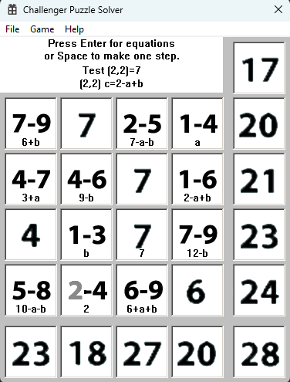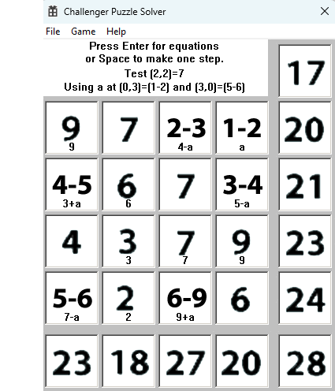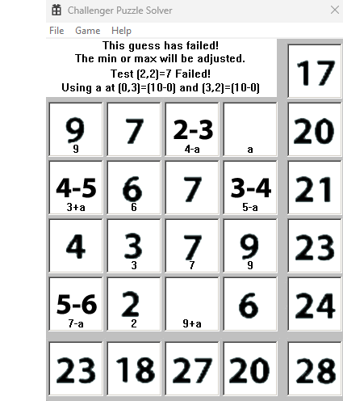

Special Puzzles
It is possible to have a solved puzzle with say a cell range of 6-8 but 7 will not be a valid solution. I noticed this when using the equations I got a cell with an equation with 12-2b and the variable “b” with a range of 2-3. Therefore, it is not always safe to guess the middle value in a range. My testing of 10,000 puzzles shows this happens in about .5% of puzzles.
Figure 29 hole at (2,0) Figure 30 hole at (0,2) Figure 31 hole at (0,1)
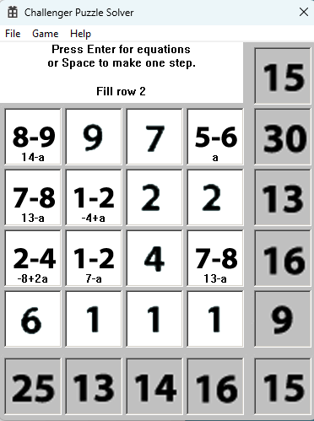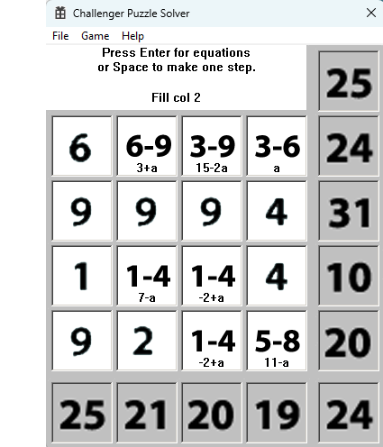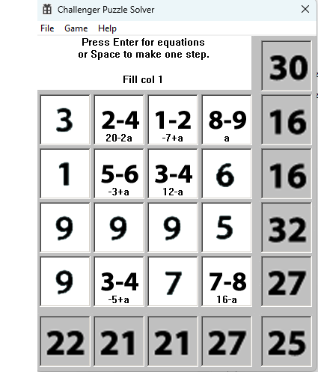

Minimum Perturbation Guessing
Since the equation method is cumbersome for someone without a computer and is very error prone using pencil and paper, are there other methods that one could use? Of course, one could guess using the ranges but this often leads to failure. Another method that was suggested which is much easier and will lead to much faster solving times. There is a concept called minimal perturbation which means making a guess that creates the smallest change in the ranges. Find a direction with 3 unknown cells and pick a cell value that causes the least total amount of changes in the remaining cells in the direction. We can then need to resolve all the ranges that this cell effects as we did in the first step. Repeat this process until we have no more directions with 3 unknown cells. I call this the “full” perturbation method. If we make a bad guess then then the totals or ranges will become invalid.
First, I tried picking the first best case usually with perturbation = 0. This leads to solving 62% of the first 10,000 puzzles using seed=1. When I tried picking the best case that was closest to the middle of the range, this only solved 56% of the same 10,000 puzzles. In the first case, it is often the lowest or highest number in the range which reduces the puzzle faster that choosing the middle range. If I pick the 1st non-diagonal for perturbations the yield is about 52% and picking the 1st diagonal yields about 68% so it very important to pick the best diagonal for perturbations. The reason for the big difference is the reduction in the number of guesses needed and diagonals affect more totals.
If we have not failed, we end up with cells that still need to be resolved. Using the equation method above we get one of three situations. Figure 32 which I call eclass0 (no unknowns) shows what happens when we start filling out the variables but then run into a situation in column 0 where 1+3+9-a+9-9=10 or 12=2a which means a=6. This leads to a single solution which happens about 75% of the time. The second situation which I call eclass1 is shown in Figure 33. Any value for “a” in the range (2-7) is a valid solution. Hence in this case we have 6 solutions. Figure 34 shows what happens when we have two loops where any value of “a” in the range (7-9) and “b” in the range (3-9) will create valid solutions. So, in this case we have 21 solutions. I call this case eclass2 with two independent unknowns.
Figure 32 eclass 0 1 solution Figure 33 eclass 1 Figure 34 eclass 2
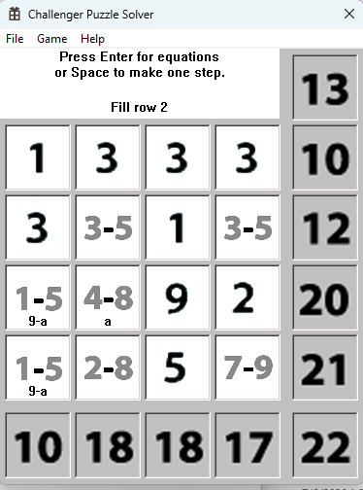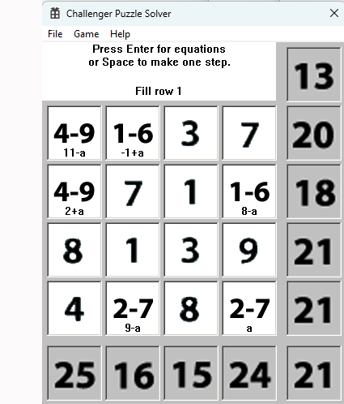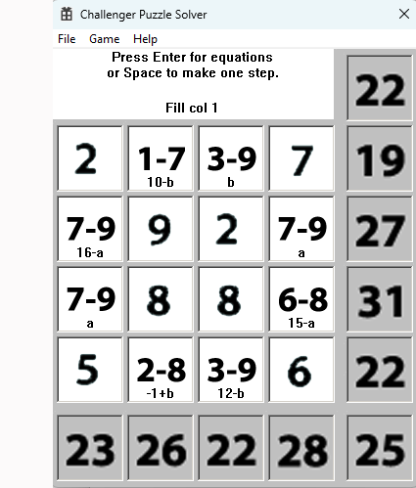
If we do at most two perturbations, we can end up with the number of unknown cells is the same as the number of equations. We will fail less often because we are guessing less but we will need to do a little more work than the “full” perturbation method to get an actual solution. This method leads to a 85.5% solve rate. Therefore, I will use this method on any following discussion. The equation method will often now resolve down to two unknows but there is now another situation besides the three above that we run into less than 3% of the time in the end game which I call eclass 3.
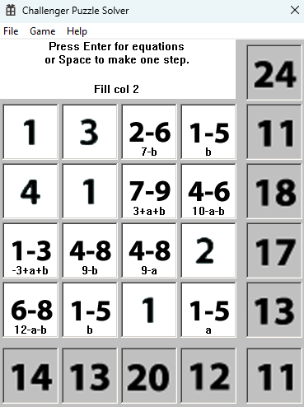
eclass=3 ending

Here we have a case where it is not obvious what the solutions are but if you notice at (2,0) we have -3+a+b with a range of (1-3). This means 1<= -3+a+b <= 3 or 4 <= a+b <= 6. Since a has a range of (1-5) and b a range of (1-5), this means if a=1 then b can be 3 to 5. If a=2 then b can be 2 to 4. If a=3 then b can be 1 to 3. If a=4 then b can be 1 or 2. If a=5 then b=1. Adding all; the solutions we get 3+3+3+2+1=12 solutions.
In over 1 million test cases I have yet to run into any other end game cases other than what I have shown here.

There is an interesting pattern I have observed using the perturbation method. I have classified all puzzles in 5 types according to where the 4 given cells are located. Type 4 is a puzzle with all 4 cells in the same diagonal. I do not use this puzzle but it has the same results as type 3 which is when all 4 cells on the diagonals but only 2 per diagonal. Type 2 is when only one diagonal has 2 cells. Type 1 is when only one cell is on any one diagonal. Type 0 is when no cells are on the diagonals. The reason I make these distinctions is that the solve rate changes greatly based on the type. Type 3 puzzles get solved 100% of the time but only constitute 2/22=9.09% of the puzzles. Type 2 gets solved about 88% of the time but constitutes 8/22=36.36% of the puzzles. Type 1 gets resolved over 87% of the time and constitutes 8/22=36.36% of the puzzles. Type 0 gets resolved about 75% of the time and constitutes 4/22=18.18% of the puzzles.
I did find some interesting situations where some perturbation methods lead to a puzzle with no solutions although all the totals and cells appeared to be valid. Figures 35 and 36 are two examples. Using the full perturbation metod (i.e. do perturbations until there are no more cases of three unknowns in any direction) I find about 1.75% of the cases will have no solution.

Figure 35 no solutions Figure 36 no solutions
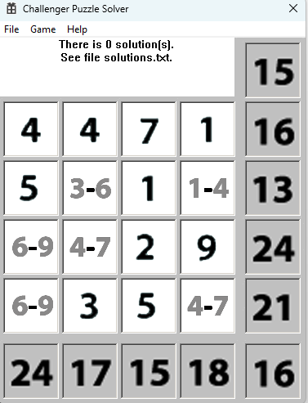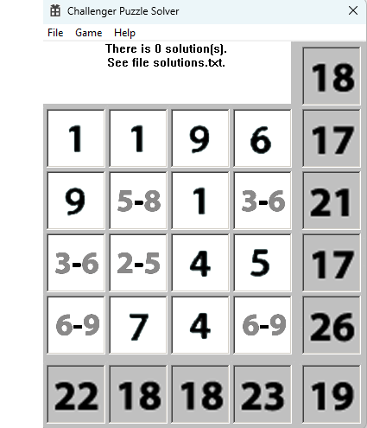

Create Puzzles
To create puzzles the program fills in the 16 cells with random numbers from 1 to 9. Then it adds up the totals for all directions. Now randomly select one of 22 patterns with one entry per row and one entry per column and no more than 2 on a diagonal. This creates a valid puzzle 100% of the time.

If you try creating random totals and trying to add 4 cells consistent with the ranges for all directions you will find that this will fail to create a valid puzzle quite often. Figiure 42 and 43 are samples.

Figure 42 no solutions Figure 43 no solutions
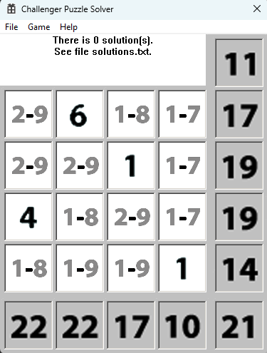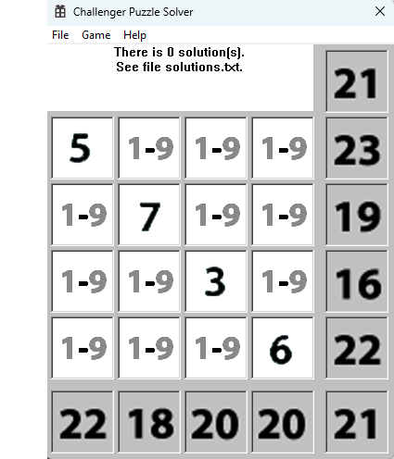

Max Number of Solutions
I do not know what the max number of solutions for certainty. However, I believe the maximum number of solutions is 1961 which is the number of solutions for the puzzle in Figure 38 below for type 3 and 4 puzzles. This puzzle has the maximum range for every cell with no additional constraints so I cannot think of any puzzle that has more possible options than this one. It is interesting to note that all puzzles with a large number of solutions have 2 given cells in both diagonals. I have created and tested almost 1,000,000 puzzles with 2 given cells in both diagonals and the solutions have not exceeded 1961 solutions. Figure 39 shows what I believe is the maximum for type 2 puzzles. I have tested over 1,000,000 puzzles with one diagonal with 2 given cells and the number of solutions has not exceeded 369 solutions. Figure 40 shows the maximum number of solutions for type 1. I have also tested this with over 1,000,000 puzzles with no puzzle exceeding 249. For type 0 puzzles the max is 369 again as shown in Figure 41. This may explain why type 0 is harder to solve than the other clases using the perturbation algorithm

Figure 38 max solutions type 3 Figure 39 max solutions type 2 Figure 40 max solutions type 1
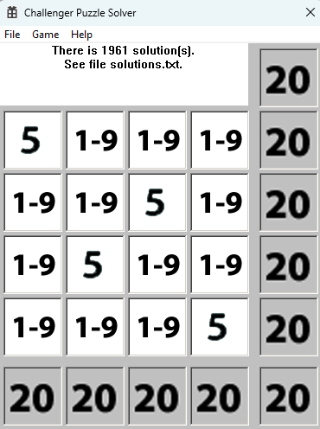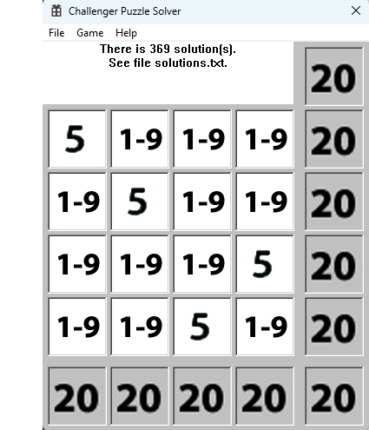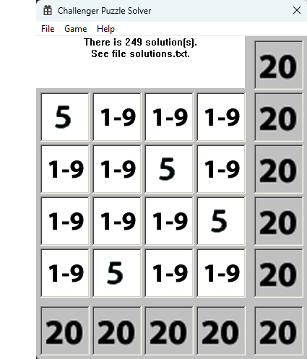

Figure 41 max solution type 0
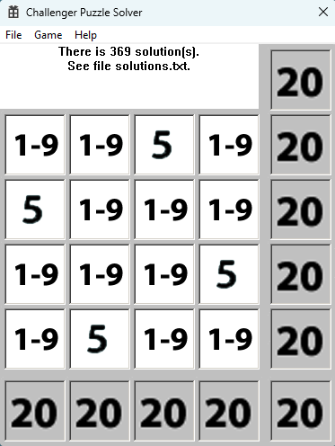

Test Feature
There is a test feature which creates a specified number of puzzles and tries to solve the puzzle using one of the four possible algorithms. You can specify the random number seed which can be used to recreate the same puzzles. The puzzles are created in a folder called “Test”. The folder not only contains the puzzles which can be loaded and played but also there is a file called summary.txt. In this file for every test run, it creates a summary of the test results. This includes the random number seed, the order in which it starts adding the variables into equations, the maximum number of solutions for the test run, and some information on the number of puzzles that were not completely solved. 100,000 puzzles can be tested in about 40-50 seconds on a new 2.4 GHz PC.
There are four options for testing. The first one is Equations only which uses the 2nd pass of the equations if the 2nd pass is enabled. The second is the Equations followed by Perturbations. The third method uses Perturbation only. The Game option to control the number of perturbations is used to control the number of perturbations. The last method uses Perturbations followed by equations which is the preferred solution method.
I have run over 1 million test cases for all four methods. The Equations method using 1st pass of equations seems to determine the min and max values of each cell 75% for just the 1st pass and 100% using the 2nd pass. Using the Equation method followed by Perturbations solves puzzles over 95% of the time. The full Perturbation method seems to correctly solve the puzzle about 68% of the time. Using minimal Perturbations then Equations solves the puzzle over 85% of the time.

Symmetry
Puzzles can be flipped horizonally or vertically or along either diagonal and the puzzle is the same with the totals and cells indifferent places. Notice that the inverse operation of any of the flips is just the same flip. However, the flip operations are not communitive which meansd HFlip, Flip0, HFlip will not be Flip0! Since the corners can end up in 4 different places and the other cells will either be flipped along the diagonal we have 8 different orientations of the puzzle. So multiple operations can yield the same position as other flip operations. For exampe, HFlip then VFlip is the same as Flip0 followed by Flip1 and so on. The 8 different orientations can be created: the start position, Hflip, VFlip, Flip0, Flip1, Hflip+Vflip, Hflip+Flip0, HFlip+Flip1.

There is another operation we can use that will create a puzzle with the same totals and given cells in different locations. We can only exchange diagonal cells with another diagonal cell because the number of totals going through diagonals is the same (three) but different for non-diagonals (two). I found only four unique different ways to exchange diagonals with another diagonal cell. They are shown below. All the other possible ways are just duplicates for the eight operations above.

FlipX0 switch the inner diagonals FlipX1 switch the outer diagonals
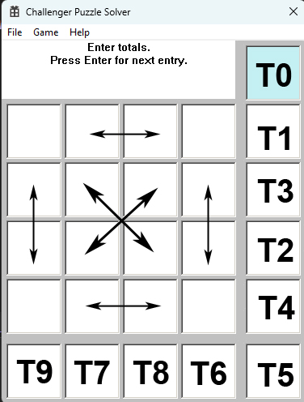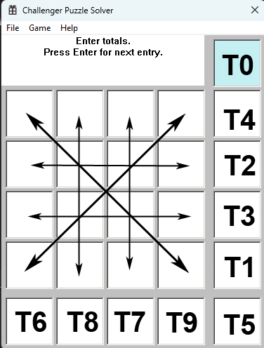
FlipX2 Switch adjacent diagonals FlipX3 switch inner with outter diagonals
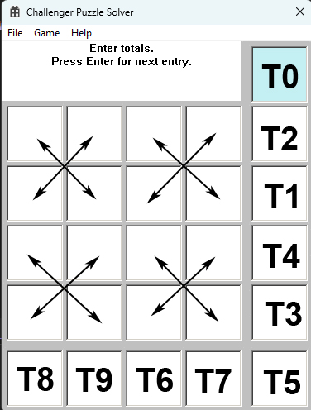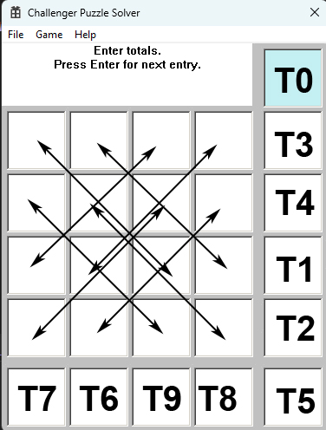

Applying any of the 4 FlipX operations with any of the other 8 symmetrical operations creates a unique puzzle, therefore there are 32 symmetries for any puzzle. Of course to get all 32 possibilities one must use multiple flips (actually up to 4 flips to get all possibilities).

The puzzles can be rotated too but the rotation is just one of the above flips. For example, rotating 90 degrees clockwise is the same as Hflip+Flip0. Rotating 90 degrees counter clockwise is the same as Hflip+Flip1. Rotating 180 degrees is the same as Hflip+Vflip.

Maximum Number of Possible Puzzles
I do not know how to calculate the maximum number of puzzles with different totals and different starting cells. I do know that we can create 9 to the power 32 different cell combinations. With symmetry we could divide this number divided by 32 but when we select the 4 starting cells, we duplicate the results of other puzzles with the same totals and same 4 cells. There are 24 different ways to select 4 cells with one in each row and column. However, if we remove the case with all 4 on a diagonal we have 22 different patterns for the 4 starting cells. So, I don’t know how many different puzzles the user could see.

Bibliography
Wikipedia. (n.d.). Linus Maurer. Retrieved from Wikipedia.com: https://en.wikipedia.org/wiki/Linus_Maurer

