**Educational Technology Self Assessment**

Here is a framework you can use to assess your own strengths and weaknesses in various aspects of educational technology.

For your self assessment, you will:

Determine your own strengths and weaknesses in each area of the course

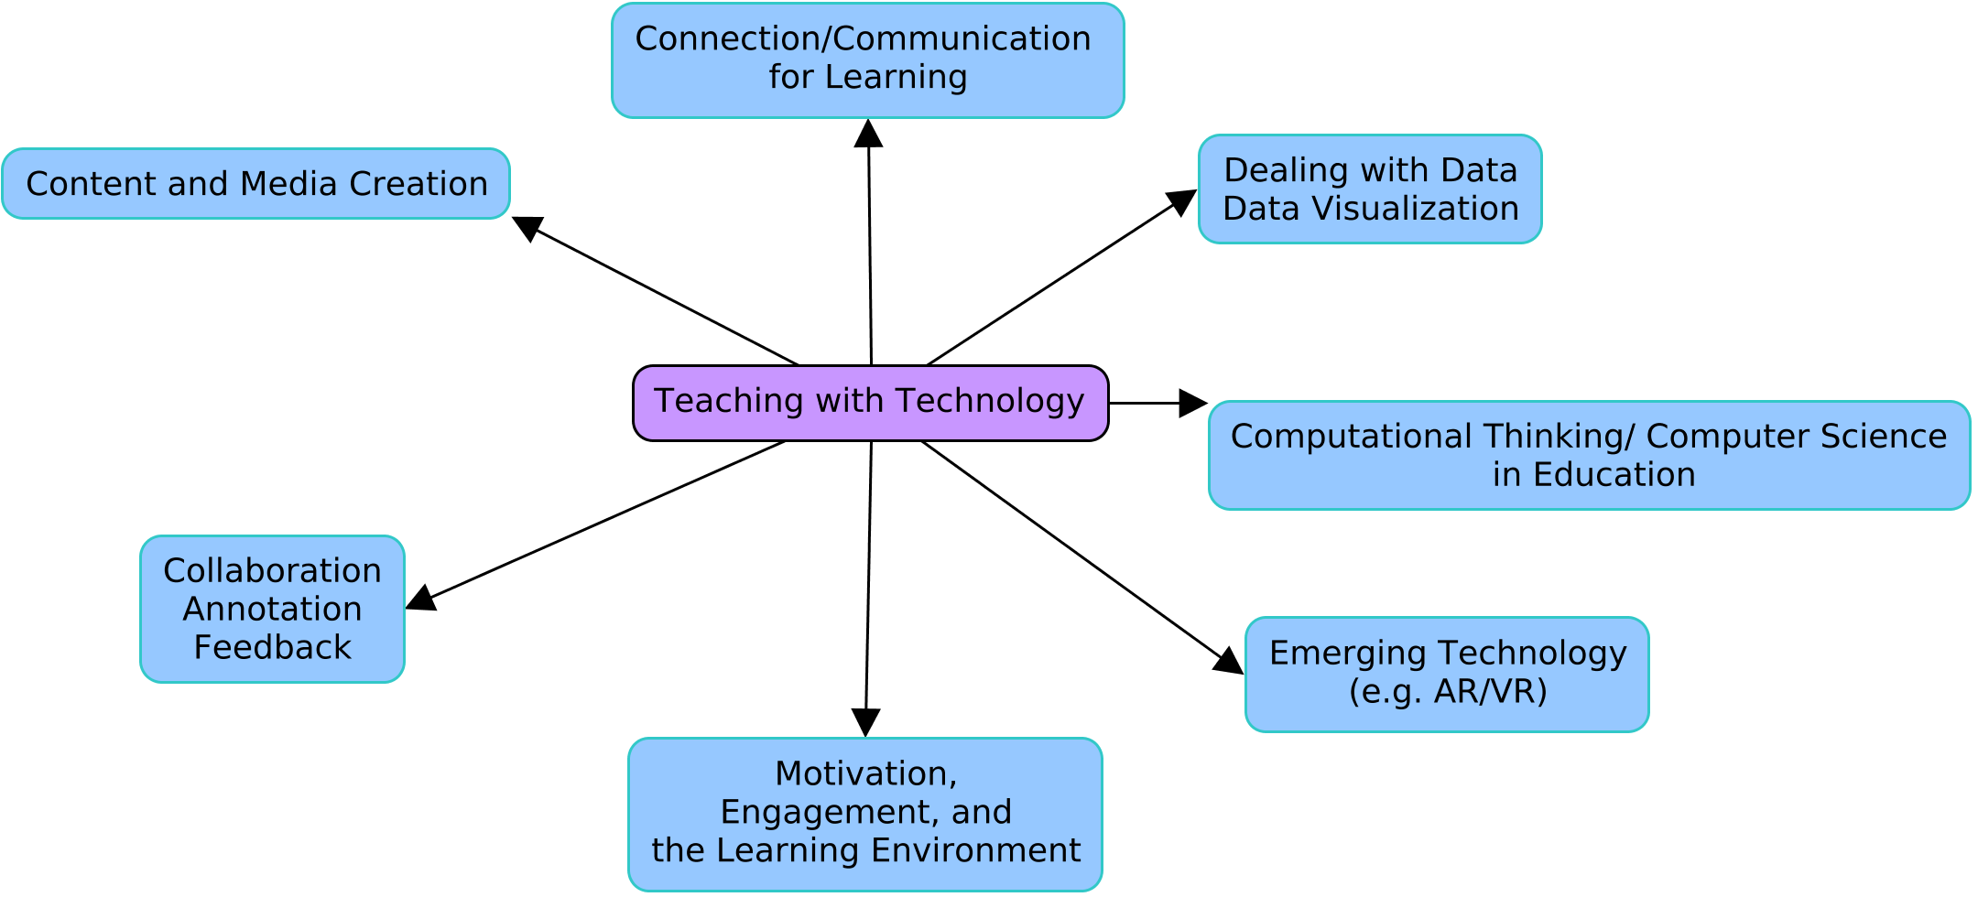

|  |  |  |
| --- | --- | --- |
| **Area** | **Types of Skills Included**  (this is not an exhaustive list) | **Notes** |
| **Content and Media Creation** | **Web pages -**  I can create web pages.  I can add links to other pages.  I can share/add/embed media of various kinds (photos, video, audio) into web pages.  **Photos**  I can take digital photos.  I can share digital photos in various ways.  **Video and Audio**  I can record digital audio and video.  I can edit digital audio and video.  I can convert digital video/audio from one format to another.  I can upload video/audio to hosting sites (like YouTube, Vimeo, Soundcloud, etc.) for easy sharing.  **Charts/Diagrams**  I can use digital tools (e.g., LucidMap, Google Draw and CmapTools) to create charts and diagrams.  I can share digital diagrams on web pages/social networks.  **Teaching**  I can effectively help others to create and share digital content in a learning context. | I have used Github for Webpage Creation  I have hosted a personal website on a home.  I have used cameras and video editing software (After Effects, Vegas, ect.) and uploaded them to YouTube  I have used LucidChart in a professional sense to develop various charts. |
| **Connected Learning** | **Social Networks**  I use social networks (such as Facebook, Twitter) for my own professional developer as an educator.  I know how to use social networks to support the learning of K-12 students.  I know how to connect with other educators via social networks to ask questions/improve my understanding about how K-12 students learn.  I understand ethical and privacy standards for the appropriate use of social networks in education.  **Teaching**  I can effectively help others to productively collaborate and use social networks in a learning context. | I do not use Social Networks personally, but have used platforms such as git to keep a blog.  I completely understand the ethics and privacy standards for use in education, but I am not sure how comfortable I am with using it in this case. |
| **Dealing with Data/Data Visualization** | **Internet Research**  I can readily perform useful internet searches using text and images.  I can perform useful internet searches of scholarly materials relevant to education and my content area (if applicable).  I can effectively help others perform productive searches for reliable information.  **Data and Data Visualization**  I can organize data (sort, for example) using tools like spreadsheets.  I can visualize the patterns I see in data using digital tools, by creating charts, diagrams, etc.  I am aware of tools that are useful for creating infographics and data visualization.  **Teaching**  I can effectively help others to productively find and visualize data using digital (and other) tools. | I have used various charting software and the office suite in order to create and visualize data.  I am proficient with search terms in order to find proper images and am able to assist others in this regard  I have used polling platforms in order to visualize data, and have previously worked with a statistical analysis program in order to record data. |
| **Collaboration/Annotation/ Feedback** | **Tools**  I can use collaborative document tools (such as [Google Drive](https://drive.google.com) (Docs, Google Sheets, Google Slides), and [Office 365](https://www.office.com) (Word, Excel, Powerpoint)) to create and collaborate on shared documents.  I can use these tools to annotate and leave feedback on documents of various kinds.  I can use collaborative white board spaces such as [Mural](https://www.mural.co) and [Padlet](https://padlet.com/dashboard) to collaborate with others.  I can use collaborative annotation tools (such as [Hypothes.is](https://web.hypothes.is)) to annotate and comment upon web pages and pdf files.  **Teaching**  I can effectively teach and support others to use this document, collaboration, and annotation tools in a learning context. | I have used the google suite of tools in order to create documents.  I have used the annotation tools to highlight and leave feedback  I have used collaborative code spaces (CodeShare) in order to share code and other things |
| **Computational Thinking** | **Concepts**  I am familiar with [the key concepts of computational thinking](https://blueprint.cs4all.nyc/concepts/): abstraction, decomposition, algorithms, and programming.  I can effectively guide learners to explore these key concepts.  I am proficient with tools (such as [Scratch](https://scratch.mit.edu), [TurtleBlocks](https://turtle.sugarlabs.org), [Python](https://hourofpython.trinket.io/a-visual-introduction-to-python#/welcome/an-hour-of-code)) that can support students to learn to code.  **Teaching**  I can effectively teach K-12 students to productively use computational thinking skills in meaningful ways.  I am able to effectively integrate computational thinking skills into other content areas (e.g., math, science, ELA). | I am very proficient in this area, and have taught much of this previously to students for coding and Artificial Intelligence.  I have taught Scratch and Python before for students. |
| **Motivation/Engagement** | I understand how educational technologies can be used to support student participation, engagement, motivation, and learning.  I am aware of the research that provides evidence for the connections between educational technology and student participation, engagement, motivation, and learning. | I am aware of the ways we can use education technologies in order to help with student participation and collaboration. Platforms such as zoom and the office suite for shared documents can assist with student collaboration, and things such as pair programming/rubber duck programming can help students work together and collaborate to understand issues. |
| **Emerging Technologies - AR/VR** |  | I have utilized VR headsets (HTC Vive) in order to develop a small game-like experiences with students. I have very little experience with AR Technologies |
| **Anything Else** | Please think about any other skills or dispositions (such as self managing) that you consider essential to this work and add them to your self assessment. | I’d like to work more on the pedagogical aspects in teaching students how to use these technologies and software. |