Deterrence
Upper Basin
Colorado River Compact Crisis Strategy

Prepared by: Ed Millard
Water Policy Advisor to Colorado Rep. Larry Don Suckla
Date: February 10, 2026
Version 1.2
Living Document, Work in Progress, Don’t Sue Me, Join Me

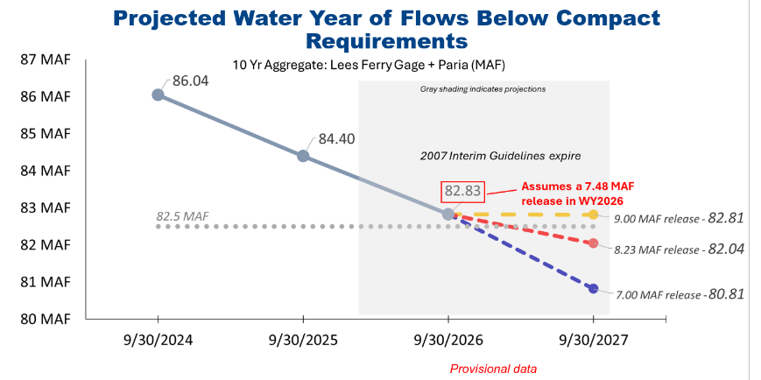

Overview
My goal here is to deter Central Arizona Project(CAP) from going down litigation road by clearly defining Upper Basin litigation strategies and to make them think twice right now, before the February 14 deadline. Numbers 2 and 3 should be close to actual Colorado and UCRC positions. Numbers 1 and 4 are not conventional wisdom, they are novel strategies. My hope is these will also make California, Nevada and Yuma think twice before they go down this dangerous road with CAP.

Disclaimer: I am a knowledgeable citizen but I do not speak for Colorado or the UCRC. I am not a lawyer. I am concerned the current doom loop in negotiations will not end well for anyone.
1. Run of the River(ROTR) in Lake Powell when all else fails. Turbines will be OK. We are OK with reverting to Long-Range Operating Criteria(LROC) with ROTR if there is no deal. Decoupling from Lower Basin will be wonderful but there will be litigation. Lower Basin will get what the river provides, it will be a learning experience for them
2. Article III(c) – Upper Basin may contest the excessive Arizona interpretation of the Mexico obligation and curtailment based on an 8.25 maf 10 year moving average, a veiled threat, or statement of the obvious, by CAP’s Burman last week. This is the first tripwire which may be tripped by the end of this year or next. (Removed pending problem resolution)
3. Article III(e) - Upper Basin may contest the excessive Arizona interpretation which was the other basis of the threat used in 2007 to demand 9 MAF releases from Powell
4. Section 603 - Upper Basin may invoke 603 because Arizona has been using the 2007 interim guidelines with “Sweet spot” gaming to crash Lake Powell and to push us into a compact call.

No Position Taken:
1. Article III(d) curtailment is not imminent, the Upper Basin argument is well known, I have nothing to add.

Run-of-the-River Operations at Glen Canyon Dam

Objective 1: Lake Powell had real value to the Upper Basin in the 80’s and 90’s when there were surplus inflows stored there. Those days are over. Rather than appreciating and cherishing that precious reserve Arizona took it for granted. They used litigation threats and gaming to abuse it. Since 2007 it’s become a liability to the Upper Basin as the Lower Basin drained it to mitigate a problem, the structural deficit, entirely of their making. Since Lake Powell is now being used to squeeze the Upper Basin for water instead of protect us it may be time to let it go.

Objective 2: The 2007 Interim Guidelines are “Interim” for a reason. When they were signed the Upper Basin knew they would fail, they wouldn’t fix anything. They agreed to them only because threatened litigation was worse. Despite the Bureau’s claims to the contrary, and in absence of a seven states compromise, I am relatively certain the only path forward is to revert to the Long Range Operating Criteria backed by Run of the River to protect the power head and turbines in Lake Powell, and this is OK. The Bureau has no authority to impose an arbitrary new alternative on the seven states though they do have the authority to protect their infrastructure and endangered fish.

Objective 3: To counter inflammatory rhetoric, terms like “crashed river”, “dancing with dead pool” and “turbines will stop turning” being used to pressure and rush stakeholders, like those of us in Colorado, into accepting deep cuts in our Compact water use. The river will instead be OK, not great, but OK.

As outlined in this 2024 Technical Memo the Bureau can not risk using bypass tubes to operate the Colorado River below Glen Canyon if they lose the power head at 3490’.

Establishment of Interim Operating Guidance for Glen Canyon Dam
Richard LaFond
Date: 2024.03.27
Director, Technical Service Center

The Bureau already has authority, in fact an obligation, to protect their infrastructure and endangered fish. Therefor, before Lake Powell loses its power head the Bureau will set a power head elevation they are going to defend, possibly 3510’, Eric Kuhn uses 3500’.
Reservoir coordination with Lake Mead and releases called for in whatever guidelines are in force will end and the Bureau will switch to Run of the River(ROTR), flow matching on an annualized basis:
Outflow = Inflow - Losses

Glen Canyon will be generating power and revenue though output will be limited by the low power head. This is good.
Fish have flows so their bellies aren’t on the bottom of the river :) Fish experts like Jack Schmidt will need to weigh in on this flow regime. If bypass tubes are used and they fail after loss of power head flows could be lost in the Grand Canyon imperiling endangered fish. This is bad.

In Glen Canyon, at low head, I think one turbine needs 1,600–2,300 cfs (per Reclamation estimates). This equates to roughly 1.2–1.7 MAF. Another common figure used is a conservative 2.3 MAF for one year’s operation. As spring runoff winds down the Bureau must insure there will be enough water in the lake to reach the start of the next Spring runoff.

They would hopefully be running 2 or 3 turbines, they can turn a turbine off and on to fine tune the target
The river can run like this indefinitely if Bureau ops people are careful. Hopefully there will be no catastrophic crisis which is key here.

When Powell is in ROTR coordination will be significantly restricted and the two basins will be somewhat decoupled. As long as the Lower Basin can’t use Lake Mead elevations to drawn down Lake Powell, there is nothing to draw, what the Bureau and the Lower Basin do regarding shortages and assigned water becomes irrelevant. The alternatives being considered could also be decoupled in this scenario as a result.

If snow pack improves you can easily revert to guideline releases. Then the basins would recouple and coordination would matter again.

ROTR is included in one DEIS alternative, Maximum Flexibility submitted by the NGO’s. It predictably performs much better protecting critical elevation than the others. In extreme traces like the one we are in this year critical elevation can still be breached if the next year’s spring runoff is less than the minimum to operate one turbine.

It is highly desirable that initial units like Flaming Gorge retain as much usable water as possible so that, in event of a catastrophic inflow year like the current one, power head can be maintained in Lake Powell. This can be justified by protection of infrastructure under coordinated operations.

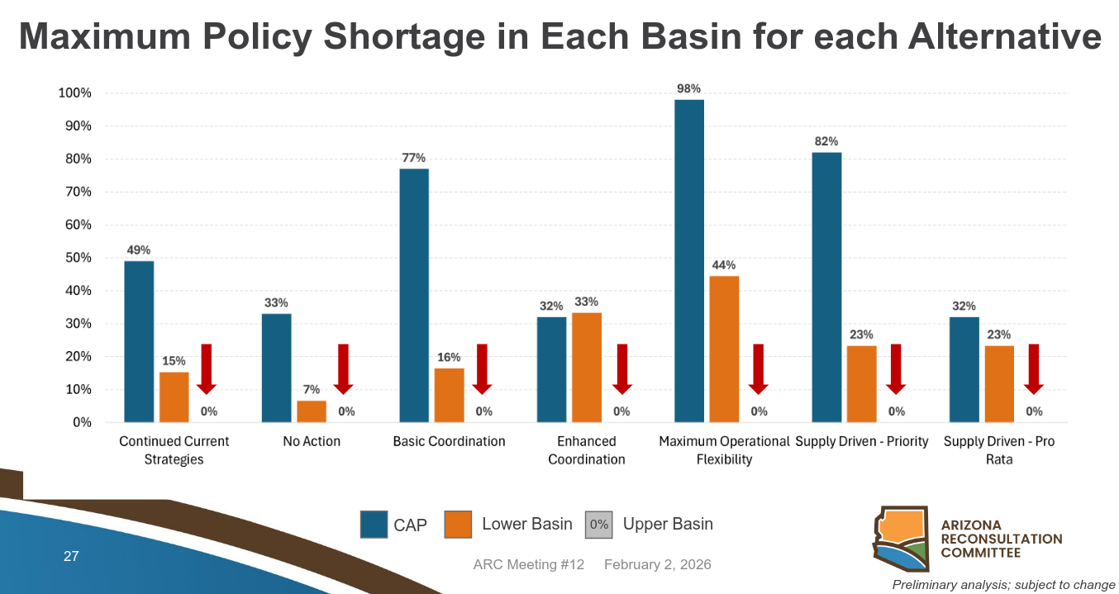

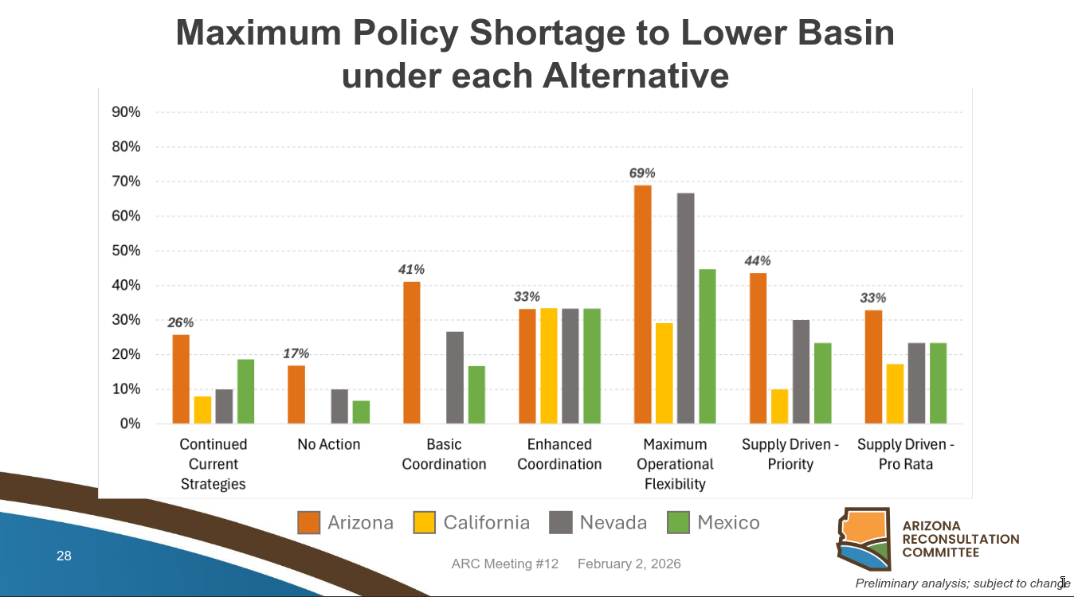

Article III(c) Interpretation

Objective: Counter Arizona's expansive interpretation of Article III(c) to restore balance

“We may breach the compact in 2026, and almost certainly it will be breached in 2027…sobering news, it’s something that hasn’t happened before, our Upper Basin neighbors have always met that obligation in the past”
Brenda Burman, General Manager, Central Arizona Project
Burman is talking about breaching Arizona’s interpretation of the compact which includes half of the Article III(c) Mexico obligation on top of Articles III(d)’s 7.5 MAF so 8.25 MAF over a 10 year moving average. Colorado doesn’t recognize this interpretation.



Background – This is Complicated, Sorry
There is problematic language in the 1922 Colorado River Compact

(c) If, as a matter of international comity, the United States of America shall hereafter recognize in the United States of Mexico any right to the use of any waters of the Colorado River System, such waters shall be supplied first from the waters which are surplus over and above the aggregate of the quantities specified in paragraphs (a) and (b); and if such surplus shall prove insufficient for this purpose, then, the burden of such deficiency shall be equally borne by the Upper Basin and the Lower Basin, and whenever necessary the States of the Upper Division shall deliver at Lee Ferry water to supply one-half of the deficiency so recognized in addition to that provided in paragraph (d).

The first problem is how do you determine whether the Colorado is in surplus or deficit. The probable interpretation by the people who wrote this thing, who thought they had a really big river is. They were thinking of natural flow at the border so surplus water above the full entitlements for the Upper and Lower Basins would be what actually flowed to Mexico:

16 MAF = 7.5 Lower Basin(A) + 1.0 Lower Basin(B) + 7.5 Upper Basin(A)

If this interpretation is correct we are ALWAYS in a deficit because this only works on a fully utilized river much bigger than it actually is. Its a little nuts, so go to Scenario 1.

Another interpretation is that they are talking about actual consumptive use. The Upper Basin doesn’t use its full entitlement and the Lower Basin is currently not using III(b) so this less nuts but also not what was intended but go to Scenario 2:

12 MAF = 7.5 Lower Basin(A) + 4.5 Upper Basin(A)

Another interpretation is that if the Lower Basin is overusing its entitlement due to the structural deficit then there must be a surplus. See Scenario 3.

If we are in deficit then:
the burden of such deficiency shall be equally borne by the Upper Basin and the Lower Basin
and:
the Upper Division shall deliver at Lee Ferry water to supply one-half of the deficiency so recognized in addition to that provided in paragraph (d).

This is the basis for the 8.25 compact call, often called the first tripwire/.

Its key that this does not say the Upper Basin must deliver one-half of the deficiency each year, if there is a big equalization or balancing release from Lake Powell then can that water in Lake Mead be used to cover multiple years of the Upper Basin III(c) obligation?

Status Quo
Arizona documented their position, the basis for litigation threats in 2007 in this paper and kind of what we got in the 2007 guidelines so its the status quo:

From a Colorado River Compact Challenge to the Next Era of Cooperation Among Seven Basin States
49 Ariz. L. Rev. 217 (2007)
W. Patrick Schiffer, Herbert R. Guenther & Thomas G. Carr

The Schiffer and Guenther paper (co-authored with Carr) argues that Article III(c) of the Colorado River Compact defines "surplus" as annual system-wide supply exceeding the 16 MAF aggregate apportionments in Articles III(a) and (b) (7.5 MAF each to Upper and Lower Basins). Any surplus over 16 MAF must first satisfy the 1.5 MAF Mexican Treaty obligation; if supply is deficient, the Upper and Lower Basins share the burden equally, with the Upper Basin delivering its half (0.75 MAF) at Lee Ferry plus evaporative/transit losses (totaling ~0.9 MAF Upper share). The authors reject the Upper Division States' view that Lower Basin usage exceeding 8.5 MAF constitutes "surplus" to be applied solely by the Lower Basin to Mexico, insisting instead on system-wide assessment to protect Arizona from undue shortages.
On releases, the paper critiques the 8.23 MAF minimum objective release from Lake Powell as inadequate, excluding full losses and risking Lake Mead depletion that fails to meet ~9 MAF mainstream Lower Division needs (Lower apportionment plus Mexico). It proposes ~8.38 MAF in deficiency years (0.9 MAF Mexican share + 7.48 MAF Article III(d)) and up to 9.28 MAF in surplus years, prioritizing the Upper's Mexican share first under the Basin Project Act and LROC. An interim solution suggests variable 7-9 MAF releases to equalize reservoirs and avert crises, bridging toward long-term augmentation.

Scenario 1 – All Deficit, All the Time

If the river is in a deficit the key question is where does the Lower Basin’s half of the obligation come from when:

- highly variable Grand Canyon tributaries which offsets Lake Mead evaporation
- stored water in Lake Mead that came from unused III(d), equalization or balancing
- conserved water from the Lower Basin’s 7.5 MAF entitlement(aka shortages)
- Wellton-Mohawk toxic return flows which would have to be taken from Ciénega de Santa Clara and be desalinated. Audubon and Mexico would oppose this

Scenario 2 – Beneficial Consumptive Use Based
Core Upper Basin Argument: The Compact Apportions Beneficial Consumptive Use, Not Raw Flow — So “Surplus” Is Defined Relative to Actual Apportioned Uses, Not a Hypothetical 16 MAF System Supply Number

- The Compact is about beneficial consumptive use, not total virgin flow or system supply Article III(a)–(b) apportion “beneficial consumptive use” (the key phrase repeated throughout the Compact). Article III(c) expressly ties the surplus calculation to “the aggregate of the quantities specified in paragraphs (a) and (b)” — i.e., the apportioned beneficial consumptive uses (Upper 7.5 + Lower 8.5 = 16 MAF). If the Lower Basin is already consuming >8.5 MAF (mainstem + tributaries + evaporation/ losses charged to it), then any water it is using beyond its apportionment is, by definition, surplus that Article III(c) says must first go to Mexico. There is no “deficiency” until the Lower Basin has reduced its use to its apportioned 8.5 MAF. → This directly refutes the paper’s claim that Lower Basin use is “irrelevant.” The Compact itself makes actual use relevant.
- Lower Basin has been using 10–11+ MAF for decades (including tributaries) In the years the paper was written (and still today), Lower Basin consumptive use (Arizona, California, Nevada mainstem + Gila, Virgin, etc. tributaries + reservoir evaporation charged to Lower) routinely exceeds 10 MAF. That excess (≥1.5 MAF) is precisely the “surplus” III(c) requires to be applied to Mexico first. No deficiency exists; Upper Basin has no III(c) obligation beyond the III(d) non-depletion floor. The paper’s insistence on a pure “system supply >16 MAF” test would mean the Lower Basin can overuse its apportionment indefinitely while still forcing the Upper Basin to deliver extra water for Mexico — an outcome the Compact negotiators never intended and that would violate the equitable division premise.
- The extra 1 MAF in III(b) was always understood as coming from surplus Article III(b) gives the Lower Basin the right to increase its use by 1 MAF “in addition to” the base apportionment. Negotiators (and later Upper Basin witnesses in 1948 Upper Compact hearings and 1960s CAP debates) treated that extra 1 MAF as the Lower Basin’s share of expected long-term surplus. If the Lower Basin is already taking that (and more), it cannot simultaneously claim there is no surplus for Mexico.
- Tributaries and losses reinforce the point Lower Basin tributaries (especially the Gila) are part of the “Colorado River System” (Art. II(a)) and count toward Lower Basin use for purposes of determining surplus/deficiency. Upper Basin deliveries at Lee Ferry do not have to compensate for Lower Basin channel losses/evaporation — those are borne by the Lower Basin from its own apportionment (the Lee Ferry delivery point was chosen for exactly this reason).
- Historical practice and the 8.23 MAF minimum objective release Since the 1970s, Reclamation has operated Glen Canyon Dam to a minimum objective release of ~8.23 MAF (≈7.5 III(d) + a small buffer, but not the full 0.75–0.9 MAF III(c) share the paper demands). Upper Basin states have never accepted the Lower Basin’s 8.25 MAF (or higher) figure as legally required under III(c), and they have never been forced to litigate it because their position has effectively prevailed in operations. The paper’s interpretation would retroactively declare decades of operations illegal.
In short, the Upper Basin’s best refutation is that the Schiffer-Guenther paper reads Article III(c) in isolation and ignores the Compact’s overarching framework of beneficial consumptive use apportionments. Once you measure “surplus” against actual basin uses (as the Compact requires), the Lower Basin’s longstanding overuse of its own apportionment supplies all the “surplus” needed for Mexico. There is no deficiency, and the Upper Basin has no additional delivery obligation under III(c).
This is why the issue has never been conclusively litigated — both sides have strong textual and historical arguments, but the Upper Basin view protects its ability to develop while holding the Lower Basin accountable for its own overuse. The 2007 Interim Guidelines and subsequent agreements deliberately punted the legal question in favor of operational compromise, but the underlying interpretive disagreement remains exactly as it was in 2004–2007.

Scenario 3 – Supply Based
Core Upper Basin Argument: The “surplus” water to satisfy Mexico’s allocation under Article III(c) of the 1922 Colorado River Compact does not have to come through Lee’s Ferry each and every year. It can (and in practice does) draw from stored surplus in Lake Mead, including water delivered in big-release years like the 2011 equalization. So as long as there is extra water in Mead for III(c) does that mean there is no deficiency. If so 8.25 isn’t the basis for a call?

- The classic compact equation is paragraphs (a) + (b) = 16 MAF of apportioned consumptive use (7.5 MAF Upper + 7.5 MAF Lower + 1 MAF extra to Lower). It makes no sense today, Neither Upper basin use or entitlement are 7.5 MAF, III(b) water does not exist.
- Today’s apportioned consumptive use equation is either this:

7.5 MAF Lower + 1 MAF extra to Lower = 8.5 MAF
or
7.5 MAF Lower

- Mexico’s 1.5 MAF (per the 1944 Treaty) comes first from any system-wide surplus above that 7.5 MAF or 8.5 MAF.
- Only if that surplus is insufficient does a “deficiency” arise — and only then does the Compact explicitly require the Upper Division to deliver extra water at Lee’s Ferry (half the shortfall, on top of the 75 MAF/10-year minimum in III(d)).
- 1.5 MAF is the default Mexico obligation. It is currently a little lower thanks to shortages Mexico is taking to help the system
The Compact never says the surplus portion itself must pass Lee’s Ferry in the same year it is used for Mexico. Surplus is a system-wide concept — water in the Colorado River System not consumed by the apportioned uses in the two basins. Once water reaches the Lower Basin (whether via Lee’s Ferry that year, Lower Basin tributaries, or releases from storage), it can be part of the “surplus” pool.
In wet years or equalization operations (like 2011 when the two reservoirs were deliberately rebalanced), extra water is released from Powell → through Lee’s Ferry → into Lake Mead. That water becomes stored surplus in Mead.
In a later year, when natural inflows are lower and Lee’s Ferry releases are at or near the minimum objective (currently ~8.23 MAF/year under the Long-Range Operating Criteria, which already bakes in 0.75 MAF as the Upper Basin’s presumed share of Mexico), operators can still release water from Mead’s storage to meet Mexico’s full 1.5 MAF (and Lower Basin demands) without triggering a Compact “deficiency.” That stored water originated as surplus and was carried forward.
This is exactly how the system has functioned for decades: reservoirs (Powell + Mead) act as a multi-year buffer. The Compact’s surplus/deficiency test is not a strict annual accounting that ignores storage; it’s a broader recognition that the river is regulated by large reservoirs. If the basins could only use “this year’s” surplus through Lee’s Ferry, the entire storage-and-carryover regime that has kept Mexico whole since 1944 would be illegal — which it obviously isn’t.
Bottom line
- Surplus water for Mexico → can be (and is) supplied from Lake Mead storage that accumulated in big years.
- Deficiency share → triggers Lee’s Ferry delivery obligation from the Upper Basin.
- The Compact draws a clear distinction between the two. The surplus clause does not contain a Lee’s Ferry requirement; only the deficiency clause does.
So yes — surplus stored in Mead from years like 2011 can satisfy Mexico without creating a deficiency that forces extra Upper Basin deliveries at Lee’s Ferry in a subsequent dry year. That’s how the “Law of the River” has always worked in practice.

Article III(e) Interpretation
Objective: Counter Arizona's expansive interpretation of Article III(e) to restore balance
“The States of the Upper Division shall not withhold water, and the States of the Lower Division shall not require the delivery of water, which cannot reasonably be applied to domestic and agricultural uses.”
This provision is deliberately symmetrical and conditional. The qualifying clause—“which cannot reasonably be applied to domestic and agricultural uses”—applies equally to both prohibitions. It does not create an unqualified duty for the Upper Basin to release water on demand, nor does it grant the Lower Basin an unrestricted right to call for deliveries. Instead, it imposes reciprocal restraints to prevent waste or unreasonable interference during the basins’ respective development phases.
During the 1922 negotiations (led by Herbert Hoover as federal representative), Upper Basin delegates (from Colorado, New Mexico, Utah, and Wyoming) expressed significant concern that Lower Basin states—particularly California, with its rapid development and access to storage at Hoover Dam (authorized later)—might use prior appropriation principles or storage infrastructure to make premature “calls” on water before Upper Basin states could fully develop their apportioned uses. The Upper Basin, where most runoff originates but infrastructure lagged, feared that such calls would impair their future consumptive uses.
Article III(e) emerged as a compromise to address this asymmetry:
- It protected the Upper Basin by prohibiting Lower Basin demands for water that the Upper Basin could reasonably apply to its own domestic and agricultural needs (e.g., storing water in future reservoirs like Powell for later use).
- Simultaneously, it restrained the Upper Basin from indefinitely hoarding water that served no beneficial purpose and could be used downstream.
- The clause was not intended as a broad delivery obligation or equity-forcing mechanism but as a pragmatic “safety valve” to promote interstate comity, avoid waste, and facilitate development without one basin unduly hindering the other.
This intent is reflected in the Compact’s preamble, which emphasizes equitable division, protection from floods, and expeditious agricultural/industrial development. The provision’s narrow focus—limited to “domestic and agricultural uses” (excluding power generation or other purposes)—further underscores its restraint-oriented design rather than an expansive release requirement.
Subsequent legislation and operations reinforce this interpretation:
- The Colorado River Basin Project Act of 1968 (Section 602(a)) explicitly conditions releases from Lake Powell for Lower Basin beneficial use under III(e) on specific criteria, such as Powell storage exceeding Mead storage and no impairment of Upper Basin consumptive uses. This subordinates III(e) to the Compact’s core apportionments (III(a), (b), (d)) and protects Upper Basin development.
- Long-Range Operating Criteria and post-2007 guidelines incorporate III(e) in a limited, conditional manner, consistent with its reciprocal nature.
- Upper Basin analyses (e.g., from the Upper Colorado River Commission, experts like Eric Kuhn, and historical reviews) consistently frame III(e) as a safeguard for Upper Basin growth, not a tool to compel releases that could shift disproportionate burdens (e.g, for the Mexican Treaty under III(c)).
In Upper Basin rebuttals, attempts to expand III(e) beyond this narrow, mutual framework—such as using it to mandate releases for Mexican Treaty deficiencies or to prioritize Lower Basin access to stored water—are viewed as contrary to the negotiated balance. The provision was crafted to preserve each basin’s exclusive beneficial consumptive use (per III(a)) while preventing abuse, not to override volumetric obligations or create new priorities.
The Guenther Schiffer paper’s emphasis on Upper Basin non-withholding as a broad duty to release usable water is seen as reading the clause one-sidedly, ignoring its symmetry and the Compact’s overall grant of “exclusive beneficial consumptive use” to each basin under Article III(a).
The Schiffer paper links III(e) to mandatory Upper Basin releases to meet half the Mexican obligation in deficiency years, arguing that withholding would cause unjustified Lower Basin shortages. Upper Basin rebuttal:
- Article III(c) already contains the precise sharing rule (first from surplus; then equal burden; Upper delivers half-deficiency at Lee Ferry “whenever necessary” in addition to III(d)). III(e) adds no extra obligation.
- Upper Basin’s preferred reading of “surplus” in III(c) is basin-specific: if the Lower Basin is already using >8.5 maf (its III(a)+(b) apportionment, including tributaries per Upper Basic view), that excess is the surplus first applied to Mexico, relieving Upper Basin of deficiency sharing.
- Forcing additional releases under III(e) to cover Mexico would impair Upper Basin’s own future uses, violating the “without impairment of annual consumptive uses in the upper basin” language in CRBPA §602(a)(3).

This is the exact position the Upper Division Governors’ Representatives took in their 2004 letter (the trigger for the Schiffer paper) and that Upper Basin entities have reiterated in post-2007 Guidelines, Drought Contingency Plan, and post-2026 negotiations.

It is a near certainty that Lower Basin, especially Arizona’s, taking delivery of water from reservoirs in the 90’s, and probably continuing today, for long term storage in its aquifers and contributing to the current crisis in Lake Powell is a direct and unambiguous violation of Article III(e).

Section 603
Objective: Based on Arizona’s misinterpretation of Article III(c) and the Eric Kuhn et al “Tripwire” paper there is a plausible case for Colorado to invoke Section 603, Federal law in the 1968 CRBPA that authorized CAP

A credible legal argument can be made that this sequence:

- the 2007 Interim Guidelines’ treatment of Compact Article III(c)
- CAP’s exploitation of the operational “sweet spot,”
- the resulting 9 MAF Powell releases in 2015–2019
- the subsequent drop to ~7.5–8.23 MAF releases today
has prejudiced Upper Basin rights in violation of Section 603(a) of the 1968 Colorado River Basin Project Act (CRBPA), especially if it forces Upper Basin curtailment.
Section 603(a), CRBPA (Pub. L. 90-537, 82 Stat. 885, 901):

“Rights of the upper basin to the consumptive use of water available to that basin from the Colorado River system under the Colorado River Compact shall not be reduced or prejudiced by any use of such water in the lower basin.”
This provision was a key Upper Basin protection inserted in 1968 to safeguard against Lower Basin development (especially the then-new CAP) impairing Upper Basin Compact rights.
On the last page of the Tripwire Paper (Eric Kuhn & John Fleck, 2025-ish draft):

The 1922 Compact is Now the Obvious Elephant in the Negotiating Room

It concludes that the system is on track to breach the “tripwire” (10-year Lee Ferry flow < 82.5 MAF) soon unless unusually wet years occur. High releases (9 MAF 2015–2019) created a temporary bubble in the moving average, but as those years roll off and are replaced by lower releases (e.g., 8.23 MAF or the current ~7.48 MAF under most-probable scenarios), the 10-year total drops below 82.5 MAF. The paper argues there is “no painless strategy” that protects both Powell (>3,500 ft) and the tripwire; the only real solution is a basin-wide enforceable agreement with Compact claim waivers.
The “Tripwire” and Article III(c) Connection
The 82.5 MAF figure is not just Article III(d)’s 75 MAF/10-year non-depletion obligation. It incorporates an interpretation of Article III(c) of the 1922 Compact: if there is no surplus above the 16 MAF apportioned to both basins (7.5 each), the Upper Basin must deliver its half-share of Mexico’s 1.5 MAF treaty obligation (0.75 MAF/year = 7.5 MAF/10 years) at Lee Ferry, for a total delivery obligation of 82.5 MAF. • Upper Basin view: III(c) creates an additional delivery requirement once “surplus” is exhausted. • Lower Basin view (historically): Surplus (including Lower Basin overuse above 8.5 MAF) covers Mexico first; Upper’s extra obligation is minimal or conditional.
The 2007 Interim Guidelines (Record of Decision) embedded operational assumptions that leaned toward the Lower Basin interpretation by coordinating Powell releases to protect Mead elevations. This produced the 9 MAF releases when Mead was in the ~1,075–1,100 ft range (the “sweet spot” that avoided Lower Basin shortages while triggering higher Powell releases under equalization/balancing rules):

The Lower Basin Drought Contingency Plan: Development and Delays
William Tintor
Water Policy in Arizona and the Semi-arid West – Research Paper
CAP’s “Sweet Spot” Strategy In 2017–2018, CAP (and Arizona) openly discussed managing demands to keep Mead in the elevation band that triggered higher Powell releases (~9 MAF) while avoiding formal shortage declarations.

Upper Basin states (via UCRC) accused Arizona/CAP of “gaming” or “manipulating” the guidelines to extract extra water from Powell storage at Upper Basin expense. This was widely reported as a flash point (e.g., Upper Basin representatives called it undermining the purpose of coordinated operations). These high releases temporarily kept the 10-year Lee Ferry average high but depleted Powell storage and inflated the moving average. As those 9 MAF years fall out (starting ~2025–2027) and are replaced by lower releases, the average is projected to cross below 82.5 MAF.
How This Ties to a Section 603 Breach Argument If the 10-year flow drops below 82.5 MAF:
- Lower Basin states could argue a Compact violation (“Compact call”).
- • This would pressure Upper Basin states to curtail uses (post-Compact rights first) to restore deliveries.
- That curtailment would be a direct reduction/prejudice to Upper Basin consumptive uses—precisely what Section 603(a) forbids if caused by Lower Basin uses/operations.
The chain of causation runs through:
1. The 2007 Guidelines’ interpretation/operation of III(c) and coordinated releases.
2. CAP’s demand management to stay in the high-release “sweet spot.”
3. The resulting excessive Powell drawdown.
4. The current low-release regime that exposes the tripwire risk.
Upper Basin interests could argue this was foreseeable, that the guidelines were administered in a way that favored Lower Basin deliveries over Upper Basin storage protection, and that Section 603 (a federal statute) overrides or constrains such prejudice.
Counterpoints and Realities
- The guidelines were negotiated with Upper Basin participation (though many Upper Basin voices later felt the “sweet spot” dynamics were not fully anticipated). However Upper Basin negotiators were under duress from litigation threats.
- Reclamation administers the dams under the CRBPA and prior acts; courts give deference to federal operational discretion.
- No court has ever ruled on the exact III(c) delivery obligation or enforced the 82.5 MAF tripwire.
- The Tripwire paper itself essentially concedes that litigation is a dead end (“will not create an additional drop of water”) and that the only viable path is negotiation + waiver of Compact claims.
In short: Yes, a strong policy/legal case exists that the described actions have prejudiced Upper Basin rights in violation of Section 603(a)’s plain language, especially if curtailment results. Whether a court would agree is another matter—the politics and federal authority make litigation risky for everyone. The paper’s conclusion is probably right: the only realistic escape is a comprehensive, enforceable basin-wide deal.

Table 1 – Release, Consumptive Use and Reservoir Data (Not yet verified!!)

