Compact Compliance Infrastructure Protection Pool(CCIPP)

Prepared by: Ed Millard
Water Policy Advisor to Colorado Rep. Larry Don Suckla
Date: March 4, 2026
Version 1.0a
Living Document, Work in Progress, Don’t Sue Me, Join Me
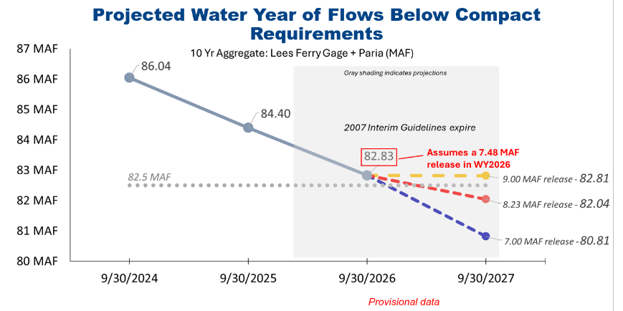
Table of Contents
Disclaimer 3
Compact Compliance Infrastructure Protection Pool (CCIPP) 4
Power Water Stranded and Potentially Stranded 5

Disclaimer
Disclaimer: I, Ed Millard, am a knowledgeable citizen but I do not speak for Colorado or the UCRC. I do not work for the State of Colorado. I am an informal water policy advisor to Colorado Representative Larry Don Suckla who represents counties in Southwestern Colorado and have been for more than a decade. I am not a lawyer. I an not a Professional Engineer. I am concerned the current doom loop in the Colorado River will not end well for anyone. There are many legal arguments in this paper, they should in no way be treated as actual legal threats or basis for actual litigation even if they sound that way. They are provided purely to spark conversation about and better understanding of these complex issues among people who are not lawyers.

Compact Compliance Infrastructure Protection Pool (CCIPP)
Three circumstances require establishment of a new pool in Lake Powell immediately, with or without Seven States agreement. This is a kind of gap water but actually real. Its pronounced “sip”:
Compact Compliance Pool Infrastructure Protection Pool
- It is imperative power head be protected at elevation 3510’ in light of the USBR LaFond 2024 memo. Bypass tubes can not safely run the river. A pool buffering this elevation is required. A safety margin is needed if extended Run of The River operations are required. USBR should really like this pool right now.
- The Upper Basin has significant established water rights that must be used “exclusively” in the Upper Basin as defined in Article III(a). These include Winters tribal water rights, in particular the two Ute Tribes in Colorado in Animas La Plata totaling about 32,000 AF/year, and water rights for power plants that have been or will be retired. This water is going to the Lower Basin for free which is inappropriate under III(a) for an established Upper Basin water right,
- Its imperative the Upper Basin have more control over the timing of releases of water under established Upper Basin water rights from Lake Powell to better balance infrastructure protection and compact compliance under Article III(d) and the 10 year 7.5 MAF moving average. Examples of problematic Arizona behavior in this area were litigation threats to increase releases from Lake Powell to 9 MAF, and documented manipulation of releases of Lake Powell by the Lower Basin under those terms which are pushing the Upper Basin toward compact noncompliance right now contrary to Section 603 in the 1968 Colorado River Basin Project Act.
A brief summary of this stranded gap water:
32,000 AFY Animas La Plata Settled Tribal Winters water rights
5,000 AFY Nucla
8,000 AFY San Juan
45,000 AFY Subtotal
30,000 AFY Navajo
75,000 AFY Subtotal
31,000 AFY Pending, don’t count on it
106,000 AFY Total, don’t count on the last 31,000

It should be made clear we are not proposing to withhold this water from the Lower Basin so it is not an Article III(e) problem. As John Entsminger famously said at CRWUA, “Gravity Works”. Once this water is in Lake Powell its going to them, all we are asking is to control when because its an Upper Basin water right and its our prerogative.

Creation of this pool has many perils which must be prevented:
- The consumptive use required under III(a) is Powell evaporation, IANAL.
- Under no circumstances can water from this pool be sold to the Lower Basin or to USBR acting in its role as Lower Basin Water Master. This would be an Article III(a) violation and compromise The Wall. The Wall can not be compromised by this pool
- Under no circumstances can this pool support or encourage speculation, its a Foundational Principal.
- Water rights which can participate in this pool must be carefully restricted to Ute ALP water and stranded power plant water for now. It cant become a destination for buy and dried Ag water
- Constraints must be developed on when this water is released from Lake Powell. Presumably it would ONLY be when there is a legally recognized compact compliance call. UCRC would be first entity to proposed this, probably in consultation with the involved state and the water rights holder
- Careful consideration has to be given to how this water right can be monetized by the rights holder. Most probably this would involve sale of the water release to an entity seeking compact compliance protection, like a city with junior water rights… BUT ONLY IN THE UPPER BASIN. The water would be released to offset their curtailment obligation. Again this can not be allowed to be a buy and dry mechanism for Ag so the water rights eligible have to be closely controlled.

Power Water Stranded and Potentially Stranded
This needs verification before use in decision making:

The cumulative water associated with the shuttered and scheduled-to-shut-down coal-fired power plants in the Upper Colorado River Basin states (Colorado, New Mexico, Utah, and Wyoming) that use Colorado River Basin sources totals approximately 55,000–65,000 acre-feet per year (AF/yr) in consumptive use (primarily evaporative losses for cooling) when all retirements are completed. This estimate aggregates the primary operational water rights or average annual consumptive volumes directly tied to these facilities, based on U.S. Bureau of Reclamation Consumptive Uses and Losses reports, U.S. Energy Information Administration data, utility filings, and analyses from sources such as the Energy and Policy Institute and Western Resource Advocates (historical averages 1991–2018 place Upper Basin thermal power consumptive use at ~144,000–162,000 AF/yr overall, with coal plants dominating).
These savings represent a potential “water dividend” for the basin upon full retirement, though actual reallocation depends on state water law (prior appropriation), utility retention of rights (e.g., for future uses like hydrogen production or to avoid abandonment), and any transfers, leases, or instream flow protections. Volumes reflect average annual consumptive use or decreed entitlements attributable to plant operations; diversion may be higher with return flows.
Shuttered Plants (Already Ceased Using Water):
- Nucla Station (Colorado, San Miguel River tributary): Shuttered 2019; ~4,000–5,000 AF/yr.
- San Juan Generating Station (New Mexico, San Juan River): Fully shuttered 2022; ~8,000 AF/yr (with portions for associated uses).

Subtotal for shuttered plants: ~12,000–13,000 AF/yr (already realized savings).

Navajo Generating Station, now shuttered in Arizona had 34,100 acre-feet under long-term contractual consumptive use allocation approved in 1968 by the Navajo Tribal Council, it used about 20,000-28,000 af in practice. Its not clear if Arizona would put this water in the CCIPP though.
Scheduled Shutdowns (Water Use to Cease Upon Retirement)
- Craig Generating Station (Colorado, Yampa River tributary): Units 1 (delayed potentially to post-March 2026), 2 (2028), and 3 (2029); full by late 2028–2029; ~16,000–16,400 AF/yr (e.g., ~7,394–8,400 AF in recent filings; collective Craig/Hayden rights ~19,000–21,000 AF/yr).
- Hayden Generating Station (Colorado, Yampa River tributary): Unit 2 (2027), Unit 1 (2028); ~4,400–5,000 AF/yr.
- Four Corners Generating Station (New Mexico, San Juan River): Full retirement no later than 2038 (potentially extended); ~17,000–24,000 AF/yr (2020 average ~17,000 AF consumptive; up to ~27,000 AF diversion makeup).
- Bonanza Power Plant (Utah, Green River): ~2030; ~6,700–7,600 AF/yr (average ~6,672 AF consumptive; primary right ~7,600 AF/yr).
Subtotal for scheduled plants: ~44,000–53,000 AF/yr (phased realization, with most by 2030–2038; subject to delays from reliability needs or federal orders).
Grand Total Upon Full Shutdown of Listed Plants
Approximately 55,000–65,000 AF/yr in aggregate consumptive use freed up (shuttered + scheduled).
This excludes plants like Jim Bridger (Wyoming, Green River; ~25,000–33,000 AF/yr when coal-active) where coal retirements have been canceled or converted to gas (reducing but not eliminating water needs) and no firm full-shutdown date exists.
Key considerations:
- Historical Upper Basin coal/thermal averages (~162,000 AF/yr peak) suggest broader retirements could yield more, but not all plants use Colorado River Basin sources, and some rights may persist.
- Post-closure, water often remains available for reallocation (e.g., discussions for Yampa River instream flows or green hydrogen), but no widespread permanent abandonment has occurred.
- Closure Schedules face uncertainty from demand growth (AI data centers), federal interventions, and economics. Volumes are estimates from operational data, not fixed decrees in all cases.

