Dolores Project
Water Accounting Report
2025

Prepared by: Ed Millard
Date: October 21, 2025

Table of Contents
MWC NON - PROJ - High Priority 3
CORTEZ PROJ - High Priority 5
CORTEZ NON - PROJ - High Priority 7
CORTEZ NON PROJ - Medium Priority 11
NARR FILL IN MCPHEE - Medium Priority 13
CUM NARR IN MCPHEE - Medium Priority 18
WET LAND - Low Priority 20
TOTAL MVI WATER USED and MVI TUNNEL - No Priority 22

MWC NON - PROJ - High Priority
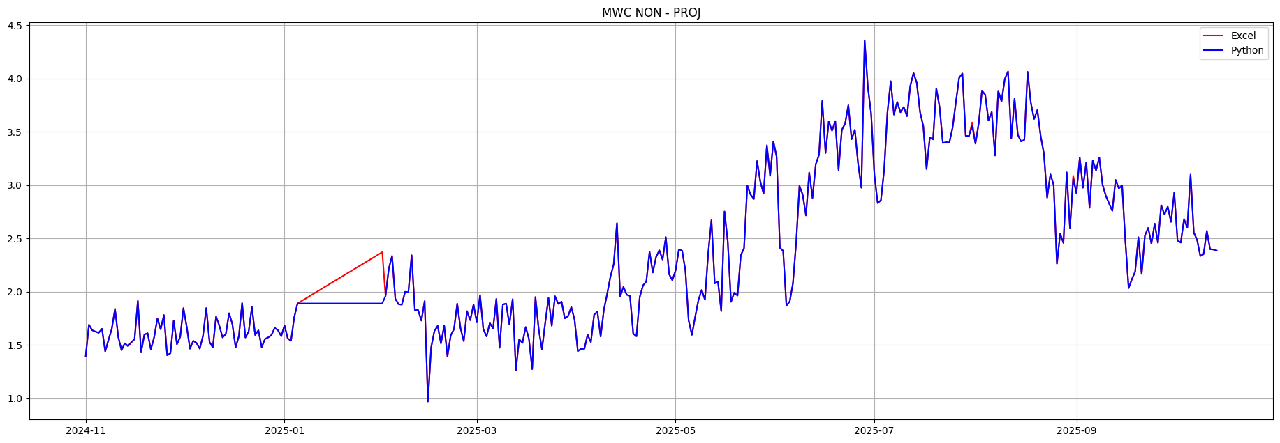

Description
Montezuma Water formulas look damaged from Jan-06 to Jan-31. The first number, which should be daily usage in gallons, isn’t changing. The coefficient which probably should be 1.02 for MWC Is incrementing by 0.01 a day causing a ramp from Excel. Python is flat lined because the first number isn’t changing..
July 31 and August 31 have a coefficient of 1.03.
I’m guessing this coefficient is a carriage loss adjustment of 2% but don’t know for sure. Cortez uses 1.04 or 4%, Ute F&R uses 1.05 or 5% and UTE PROJ uses 1.06 and 1.04.

Suggested Fix
Acquire the daily usage numbers for MWC in January in gallons, put it in these formulas and repair the coefficient to be 1.02. Fix the coefficient in July August.

Suggested Future Fix
To make these tunnel flow channels work in Python I am creating new input channels, in this case ‘MWC NON – PROJ CFS’ or ‘MWC NON – PROJ GAL’. I extract the daily usage number for these new channels from the Excel formulas. I can then use the same formulas every day to convert the input channel to CFS and apply the 1.02 loss coefficient. The way it is now the formulas change every day which is problematic for Python.
It would be better if DWCD techs weren’t editing these formulas in Excel everyday, it creates potential for errors. You really want the control entering just the usage numbers they are getting, which may be gallons for the domestic users and CFS for Ute F&R from the DWR Towaoc gage.

Errors
2025-01-06: diff= -0.019 Excel= 1.907 Python= 1.889
excel: =1196700/325851/1.9835*1.03
2025-01-07: diff= -0.037 Excel= 1.926 Python= 1.889
excel: =1196700/325851/1.9835*1.04
...
2025-01-31: diff= -0.481 Excel= 2.370 Python= 1.889
excel: =1196700/325851/1.9835*1.28
2025-07-31: diff= -0.035 Excel= 3.587 Python= 3.552
excel: =2250800/325851/1.9835*1.03
2025-08-31: diff= -0.030 Excel= 3.087 Python= 3.057
excel: =1937000/325851/1.9835*1.03

CORTEZ PROJ - High Priority
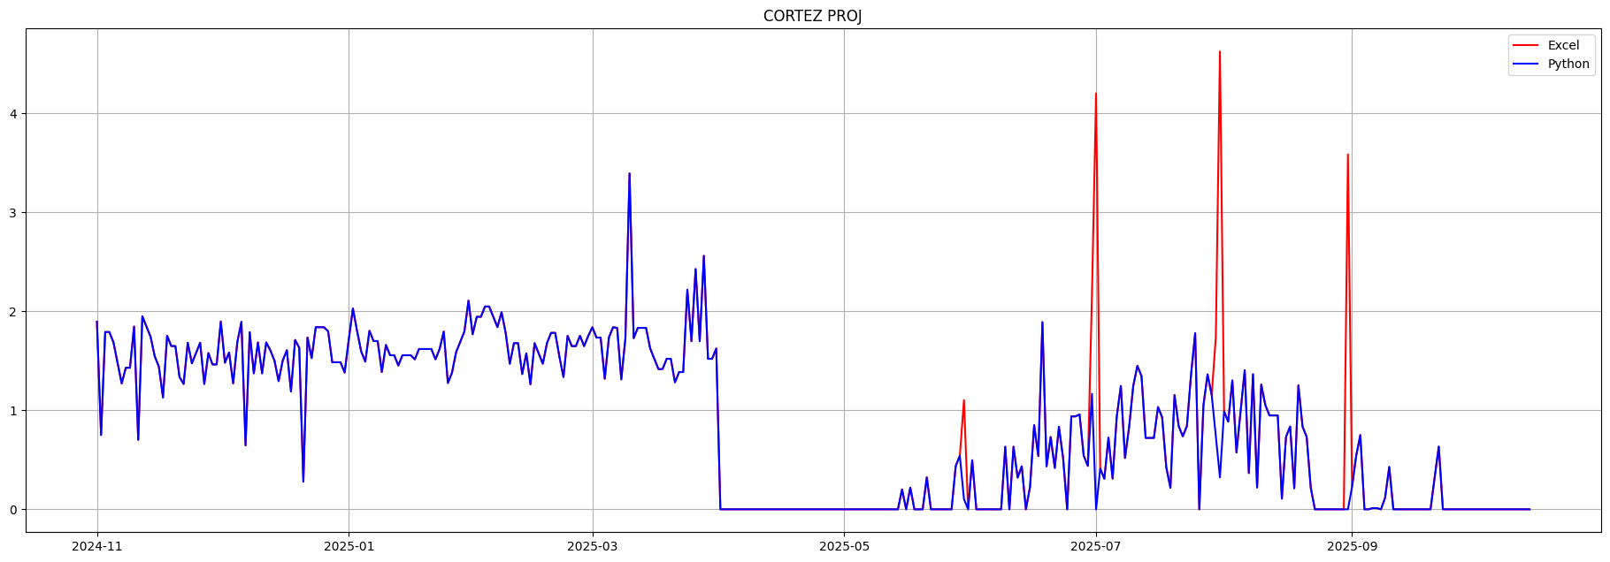

Description
Normally ‘CORTEZ PROJ’ formulas subtract 4.2, this is presumably the threshold between project and non project water. For some reason these cells are subtracting 3.2 and 1.2 causing 4 large spikes and data validation errors

Suggested Fix
Formulas should be edited to use 4.2.

Errors
2025-05-30: diff= -1.000 Excel= 1.103 Python= 0.103
excel: =IF(((5.2*1.04)-T44)>=4.2,((5.2*1.04)-T44)-3.2,0)
=IF(((5.2*1.04)-exl['UTE PROJ'][day])>=4.2,((5.2*1.04)-exl['UTE PROJ'][day])-3.2,0)
2025-06-30: diff= -1.000 Excel= 2.166 Python= 1.166
excel: =IF(((6.4*1.04)-T44)>=4.2,((6.4*1.04)-T44)-3.2,0)
=IF(((6.4*1.04)-exl['UTE PROJ'][day])>=4.2,((6.4*1.04)-exl['UTE PROJ'][day])-3.2,0)
2025-07-01: diff= -4.200 Excel= 4.200 Python= 0.000
excel: nan
comment:
D Butler Aug 5th, 2025: -2025
Values in this column are from City of Cortez final July numbers.
2025-07-30: diff= -1.000 Excel= 1.738 Python= 0.738
excel: =IF(((6*1.04)-T44)>=4.2,((6*1.04)-T44)-3.2,0)
=IF(((6*1.04)-exl['UTE PROJ'][day])>=4.2,((6*1.04)-exl['UTE PROJ'][day])-3.2,0)
2025-07-31: diff= -4.302 Excel= 4.624 Python= 0.322
excel: =IF(((5.6*1.04)-T46)>=4.2,((5.6*1.04)-T46)-1.2,0)
=IF(((5.6*1.04)-exl['UTE PROJ'][day+1])>=4.2,((5.6*1.04)-exl['UTE PROJ'][day+1])-1.2,0)
2025-08-31: diff= -3.584 Excel= 3.584 Python= 0.000
excel: =IF(((4.6*1.04)-T46)>=4.2,((4.6*1.04)-T46)-1.2,0)
=IF(((4.6*1.04)-exl['UTE PROJ'][day+1])>=4.2,((4.6*1.04)-exl['UTE PROJ'][day+1])-1.2,0)

CORTEZ NON - PROJ - High Priority
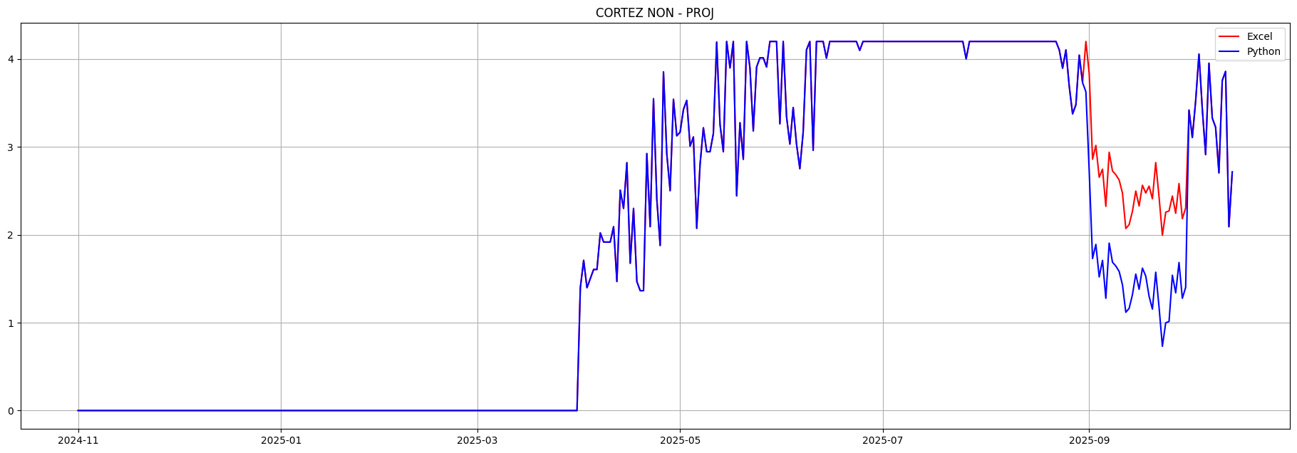

Description
It looks like someone copied formulas from MWC to CORTEZ NON PROJ, probably because they had daily usage numbers in gallons they wanted to used in September for CORTEZ. This carried over the MWC 1.02 coefficient which should probably be 1.04 for Cortez, assuming these are carriage loss adjustments...

Suggested Fix
Edit the coefficients in CORTEZ NON PROJ in September to be 1.04

Errors
2025-09-01: diff= -1.111 Excel= 3.834 Python= 2.723
excel: =2429300/325851/1.9835*1.02
=2429300/325851/1.9835*1.02
comment:
D Butler October 14th, 2025: Values in this column are from City of Cortez's final September numbers.
2025-09-02: diff= -1.130 Excel= 2.860 Python= 1.730
excel: =1812300/325851/1.9835*1.02
=1812300/325851/1.9835*1.02
2025-09-03: diff= -1.127 Excel= 3.017 Python= 1.890
excel: =1912000/325851/1.9835*1.02
=1912000/325851/1.9835*1.02
2025-09-04: diff= -1.134 Excel= 2.654 Python= 1.520
excel: =1682000/325851/1.9835*1.02
=1682000/325851/1.9835*1.02
2025-09-05: diff= -1.038 Excel= 2.747 Python= 1.709
excel: =1740600/325851/1.9835*1.02
=1740600/325851/1.9835*1.02
2025-09-06: diff= -1.046 Excel= 2.323 Python= 1.277
excel: =1472200/325851/1.9835*1.02
=1472200/325851/1.9835*1.02
2025-09-07: diff= -1.034 Excel= 2.939 Python= 1.905
excel: =1862400/325851/1.9835*1.02
=1862400/325851/1.9835*1.02
2025-09-08: diff= -1.038 Excel= 2.726 Python= 1.687
excel: =1727100/325851/1.9835*1.02
=1727100/325851/1.9835*1.02
2025-09-09: diff= -1.039 Excel= 2.683 Python= 1.644
excel: =1700400/325851/1.9835*1.02
=1700400/325851/1.9835*1.02
2025-09-10: diff= -1.040 Excel= 2.624 Python= 1.583
excel: =1662400/325851/1.9835*1.02
=1662400/325851/1.9835*1.02
2025-09-11: diff= -1.043 Excel= 2.474 Python= 1.431
excel: =1567800/325851/1.9835*1.02
=1567800/325851/1.9835*1.02
2025-09-12: diff= -0.953 Excel= 2.071 Python= 1.118
excel: =1312300/325851/1.9835*1.02
=1312300/325851/1.9835*1.02
2025-09-13: diff= -0.952 Excel= 2.115 Python= 1.162
excel: =1339900/325851/1.9835*1.02
=1339900/325851/1.9835*1.02
2025-09-14: diff= -0.949 Excel= 2.268 Python= 1.318
excel: =1437000/325851/1.9835*1.02
=1437000/325851/1.9835*1.02
2025-09-15: diff= -0.945 Excel= 2.498 Python= 1.553
excel: =1582700/325851/1.9835*1.02
=1582700/325851/1.9835*1.02
2025-09-16: diff= -0.948 Excel= 2.328 Python= 1.379
excel: =1474900/325851/1.9835*1.02
=1474900/325851/1.9835*1.02
2025-09-17: diff= -0.944 Excel= 2.564 Python= 1.620
excel: =1624600/325851/1.9835*1.02
=1624600/325851/1.9835*1.02
2025-09-18: diff= -0.945 Excel= 2.475 Python= 1.530
excel: =1568300/325851/1.9835*1.02
=1568300/325851/1.9835*1.02
2025-09-19: diff= -1.253 Excel= 2.553 Python= 1.300
excel: =1617800/325851/1.9835*1.02
=1617800/325851/1.9835*1.02
2025-09-20: diff= -1.256 Excel= 2.409 Python= 1.154
excel: =1526700/325851/1.9835*1.02
=1526700/325851/1.9835*1.02
2025-09-21: diff= -1.248 Excel= 2.821 Python= 1.574
excel: =1787800/325851/1.9835*1.02
=1787800/325851/1.9835*1.02
2025-09-22: diff= -1.255 Excel= 2.430 Python= 1.175
excel: =1539800/325851/1.9835*1.02
=1539800/325851/1.9835*1.02
2025-09-23: diff= -1.264 Excel= 1.995 Python= 0.731
excel: =1263900/325851/1.9835*1.02
=1263900/325851/1.9835*1.02
2025-09-24: diff= -1.259 Excel= 2.257 Python= 0.998
excel: =1430100/325851/1.9835*1.02
=1430100/325851/1.9835*1.02
2025-09-25: diff= -1.258 Excel= 2.271 Python= 1.013
excel: =1439300/325851/1.9835*1.02
=1439300/325851/1.9835*1.02
2025-09-26: diff= -0.901 Excel= 2.441 Python= 1.540
excel: =1546600/325851/1.9835*1.02
=1546600/325851/1.9835*1.02
2025-09-27: diff= -0.905 Excel= 2.244 Python= 1.339
excel: =1422100/325851/1.9835*1.02
=1422100/325851/1.9835*1.02
2025-09-28: diff= -0.898 Excel= 2.583 Python= 1.684
excel: =1636600/325851/1.9835*1.02
=1636600/325851/1.9835*1.02
2025-09-29: diff= -0.906 Excel= 2.183 Python= 1.277
excel: =1383400/325851/1.9835*1.02
=1383400/325851/1.9835*1.02
2025-09-30: diff= -0.904 Excel= 2.305 Python= 1.401
excel: =1460600/325851/1.9835*1.02
=1460600/325851/1.9835*1.02

CORTEZ NON PROJ - Medium Priority
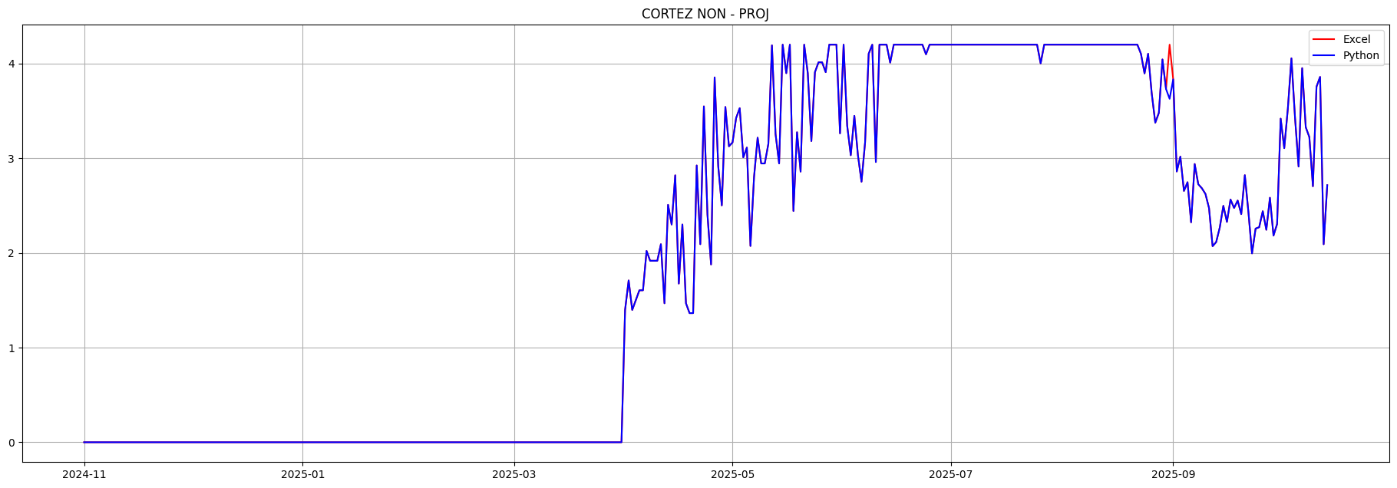

Description
Excel formulas for 'CORTEZ PROJ' and ‘CORTEZ NON – PROJ' for Jul 31 and Aug 31 are referencing an invalid row. T46 is a separator row below . ‘CORTEZ NON – PROJ' on Aug 31 is causing a data validation error. The other three cells are wrong but not causing data errors. Presumably a result of cutting and pasting cells.

Suggested Fix
Edit Excel formulas in row 45 for 'CORTEZ PROJ' and CORTEZ NON – PROJ' columns, Jul 31 and Aug 31. Both T46’s should probably be T45’s

Errors
2025-08-31: diff= -0.572 Excel= 4.200 Python= 3.628
excel: =IF(((4.6*1.04)-T46)>=4.2,4.2,(4.6*1.04)-T46)
=IF(((4.6*1.04)-exl['UTE PROJ'][day+1])>=4.2,4.2,(4.6*1.04)-exl['UTE PROJ'][day+1])

Excel Row Indexing Errors

JUL 31
Excel row reference invalid T46 in JULY in cell 'CORTEZ NON - PROJ'[45]
=IF(((5.6*1.04)-T46)>=4.2,4.2,(5.6*1.04)-T46)
Excel row reference invalid T46 in JULY in cell 'CORTEZ PROJ'[45]
=IF(((5.6*1.04)-T46)>=4.2,((5.6*1.04)-T46)-1.2,0)
AUG 31
Excel row reference invalid T46 in AUGUST in cell 'CORTEZ NON - PROJ'[45]
=IF(((4.6*1.04)-T46)>=4.2,4.2,(4.6*1.04)-T46)
Excel row reference invalid T46 in AUGUST in cell 'CORTEZ PROJ'[45]
=IF(((4.6*1.04)-T46)>=4.2,((4.6*1.04)-T46)-1.2,0)

NARR FILL IN MCPHEE - Medium Priority
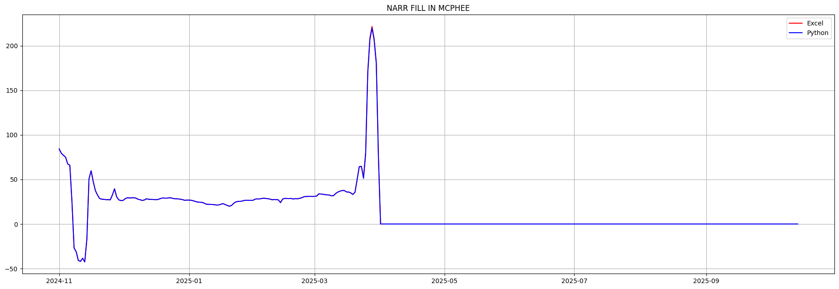

Description

Suggested Fix

Errors
2025-03-24: diff= -1.679 Excel= 52.837 Python= 51.158
excel: =IF(G38="",0,IF(I38>=795,795-MAX(0,M38-N38-P38-O38-Q38-R38-S38-T38-U38+V38+W38-BB38+AZ38),I38-MAX(0,M38-N38-P38-O38-Q38-R38-S38-T38-U38+V38+W38-BB38+AZ38)-AF38)-AJ38)
=IF(exl['DOLORES RIVER'][day]="",0,IF(exl['RECORD INFLOW'][day]>=795,795-MAX(0,exl['DOL TUN TOT DIV'][day]-exl['WET LAND'][day]-exl['SEELEY'][day]-exl['UTE F&R'][day]-exl['MWC NON - PROJ'][day]-exl['CORTEZ NON - PROJ'][day]-exl['CORTEZ PROJ'][day]-exl['UTE PROJ'][day]-exl['F-BAY BAL'][day]+exl['LONE PINE'][day]+exl['U LAT'][day]-exl['TOTTEN (FRESH WATER)'][day]+exl['DIST CLASS B'][day]),exl['RECORD INFLOW'][day]-MAX(0,exl['DOL TUN TOT DIV'][day]-exl['WET LAND'][day]-exl['SEELEY'][day]-exl['UTE F&R'][day]-exl['MWC NON - PROJ'][day]-exl['CORTEZ NON - PROJ'][day]-exl['CORTEZ PROJ'][day]-exl['UTE PROJ'][day]-exl['F-BAY BAL'][day]+exl['LONE PINE'][day]+exl['U LAT'][day]-exl['TOTTEN (FRESH WATER)'][day]+exl['DIST CLASS B'][day])-exl['D/S SENIOR MVIC'][day])-exl['SPILL'][day])
2025-03-25: diff= -1.956 Excel= 80.524 Python= 78.568
excel: =IF(G39="",0,IF(I39>=795,795-MAX(0,M39-N39-P39-O39-Q39-R39-S39-T39-U39+V39+W39-BB39+AZ39),I39-MAX(0,M39-N39-P39-O39-Q39-R39-S39-T39-U39+V39+W39-BB39+AZ39)-AF39)-AJ39)
=IF(exl['DOLORES RIVER'][day]="",0,IF(exl['RECORD INFLOW'][day]>=795,795-MAX(0,exl['DOL TUN TOT DIV'][day]-exl['WET LAND'][day]-exl['SEELEY'][day]-exl['UTE F&R'][day]-exl['MWC NON - PROJ'][day]-exl['CORTEZ NON - PROJ'][day]-exl['CORTEZ PROJ'][day]-exl['UTE PROJ'][day]-exl['F-BAY BAL'][day]+exl['LONE PINE'][day]+exl['U LAT'][day]-exl['TOTTEN (FRESH WATER)'][day]+exl['DIST CLASS B'][day]),exl['RECORD INFLOW'][day]-MAX(0,exl['DOL TUN TOT DIV'][day]-exl['WET LAND'][day]-exl['SEELEY'][day]-exl['UTE F&R'][day]-exl['MWC NON - PROJ'][day]-exl['CORTEZ NON - PROJ'][day]-exl['CORTEZ PROJ'][day]-exl['UTE PROJ'][day]-exl['F-BAY BAL'][day]+exl['LONE PINE'][day]+exl['U LAT'][day]-exl['TOTTEN (FRESH WATER)'][day]+exl['DIST CLASS B'][day])-exl['D/S SENIOR MVIC'][day])-exl['SPILL'][day])
comment:
Eric Sprague:
Because MVIC began diverting, the forebay balance column was zeroed out. Usually in MAR, this column has the rights senior to MVIC deducted twice to counter the forebay balance column. Starting today, they are only deducted once, like during the irrigation season. This will need to be amended when this sheet is cleared to use for 2026.
2025-03-26: diff= -1.884 Excel= 171.500 Python= 169.616
excel: =IF(G40="",0,IF(I40>=795,795-MAX(0,M40-N40-P40-O40-Q40-R40-S40-T40-U40+V40+W40-BB40+AZ40),I40-MAX(0,M40-N40-P40-O40-Q40-R40-S40-T40-U40+V40+W40-BB40+AZ40)-AF40)-AJ40)
=IF(exl['DOLORES RIVER'][day]="",0,IF(exl['RECORD INFLOW'][day]>=795,795-MAX(0,exl['DOL TUN TOT DIV'][day]-exl['WET LAND'][day]-exl['SEELEY'][day]-exl['UTE F&R'][day]-exl['MWC NON - PROJ'][day]-exl['CORTEZ NON - PROJ'][day]-exl['CORTEZ PROJ'][day]-exl['UTE PROJ'][day]-exl['F-BAY BAL'][day]+exl['LONE PINE'][day]+exl['U LAT'][day]-exl['TOTTEN (FRESH WATER)'][day]+exl['DIST CLASS B'][day]),exl['RECORD INFLOW'][day]-MAX(0,exl['DOL TUN TOT DIV'][day]-exl['WET LAND'][day]-exl['SEELEY'][day]-exl['UTE F&R'][day]-exl['MWC NON - PROJ'][day]-exl['CORTEZ NON - PROJ'][day]-exl['CORTEZ PROJ'][day]-exl['UTE PROJ'][day]-exl['F-BAY BAL'][day]+exl['LONE PINE'][day]+exl['U LAT'][day]-exl['TOTTEN (FRESH WATER)'][day]+exl['DIST CLASS B'][day])-exl['D/S SENIOR MVIC'][day])-exl['SPILL'][day])
comment:
Eric Sprague:
Because MVIC began diverting, the forebay balance column was zeroed out. Usually in MAR, this column has the rights senior to MVIC deducted twice to counter the forebay balance column. Starting today, they are only deducted once, like during the irrigation season. This will need to be amended when this sheet is cleared to use for 2026.
2025-03-27: diff= -1.906 Excel= 209.049 Python= 207.143
excel: =IF(G41="",0,IF(I41>=795,795-MAX(0,M41-N41-P41-O41-Q41-R41-S41-T41-U41+V41+W41-BB41+AZ41),I41-MAX(0,M41-N41-P41-O41-Q41-R41-S41-T41-U41+V41+W41-BB41+AZ41)-AF41)-AJ41)
=IF(exl['DOLORES RIVER'][day]="",0,IF(exl['RECORD INFLOW'][day]>=795,795-MAX(0,exl['DOL TUN TOT DIV'][day]-exl['WET LAND'][day]-exl['SEELEY'][day]-exl['UTE F&R'][day]-exl['MWC NON - PROJ'][day]-exl['CORTEZ NON - PROJ'][day]-exl['CORTEZ PROJ'][day]-exl['UTE PROJ'][day]-exl['F-BAY BAL'][day]+exl['LONE PINE'][day]+exl['U LAT'][day]-exl['TOTTEN (FRESH WATER)'][day]+exl['DIST CLASS B'][day]),exl['RECORD INFLOW'][day]-MAX(0,exl['DOL TUN TOT DIV'][day]-exl['WET LAND'][day]-exl['SEELEY'][day]-exl['UTE F&R'][day]-exl['MWC NON - PROJ'][day]-exl['CORTEZ NON - PROJ'][day]-exl['CORTEZ PROJ'][day]-exl['UTE PROJ'][day]-exl['F-BAY BAL'][day]+exl['LONE PINE'][day]+exl['U LAT'][day]-exl['TOTTEN (FRESH WATER)'][day]+exl['DIST CLASS B'][day])-exl['D/S SENIOR MVIC'][day])-exl['SPILL'][day])
comment:
Eric Sprague:
Because MVIC began diverting, the forebay balance column was zeroed out. Usually in MAR, this column has the rights senior to MVIC deducted twice to counter the forebay balance column. Starting today, they are only deducted once, like during the irrigation season. This will need to be amended when this sheet is cleared to use for 2026.
2025-03-28: diff= -1.749 Excel= 221.749 Python= 220.000
excel: =IF(G42="",0,IF(I42>=795,795-MAX(0,M42-N42-P42-O42-Q42-R42-S42-T42-U42+V42+W42-BB42+AZ42),I42-MAX(0,M42-N42-P42-O42-Q42-R42-S42-T42-U42+V42+W42-BB42+AZ42)-AF42)-AJ42)
=IF(exl['DOLORES RIVER'][day]="",0,IF(exl['RECORD INFLOW'][day]>=795,795-MAX(0,exl['DOL TUN TOT DIV'][day]-exl['WET LAND'][day]-exl['SEELEY'][day]-exl['UTE F&R'][day]-exl['MWC NON - PROJ'][day]-exl['CORTEZ NON - PROJ'][day]-exl['CORTEZ PROJ'][day]-exl['UTE PROJ'][day]-exl['F-BAY BAL'][day]+exl['LONE PINE'][day]+exl['U LAT'][day]-exl['TOTTEN (FRESH WATER)'][day]+exl['DIST CLASS B'][day]),exl['RECORD INFLOW'][day]-MAX(0,exl['DOL TUN TOT DIV'][day]-exl['WET LAND'][day]-exl['SEELEY'][day]-exl['UTE F&R'][day]-exl['MWC NON - PROJ'][day]-exl['CORTEZ NON - PROJ'][day]-exl['CORTEZ PROJ'][day]-exl['UTE PROJ'][day]-exl['F-BAY BAL'][day]+exl['LONE PINE'][day]+exl['U LAT'][day]-exl['TOTTEN (FRESH WATER)'][day]+exl['DIST CLASS B'][day])-exl['D/S SENIOR MVIC'][day])-exl['SPILL'][day])
comment:
Eric Sprague:
Because MVIC began diverting, the forebay balance column was zeroed out. Usually in MAR, this column has the rights senior to MVIC deducted twice to counter the forebay balance column. Starting today, they are only deducted once, like during the irrigation season. This will need to be amended when this sheet is cleared to use for 2026.
2025-03-29: diff= -1.770 Excel= 207.900 Python= 206.130
excel: =IF(G43="",0,IF(I43>=795,795-MAX(0,M43-N43-P43-O43-Q43-R43-S43-T43-U43+V43+W43-BB43+AZ43),I43-MAX(0,M43-N43-P43-O43-Q43-R43-S43-T43-U43+V43+W43-BB43+AZ43)-AF43)-AJ43)
=IF(exl['DOLORES RIVER'][day]="",0,IF(exl['RECORD INFLOW'][day]>=795,795-MAX(0,exl['DOL TUN TOT DIV'][day]-exl['WET LAND'][day]-exl['SEELEY'][day]-exl['UTE F&R'][day]-exl['MWC NON - PROJ'][day]-exl['CORTEZ NON - PROJ'][day]-exl['CORTEZ PROJ'][day]-exl['UTE PROJ'][day]-exl['F-BAY BAL'][day]+exl['LONE PINE'][day]+exl['U LAT'][day]-exl['TOTTEN (FRESH WATER)'][day]+exl['DIST CLASS B'][day]),exl['RECORD INFLOW'][day]-MAX(0,exl['DOL TUN TOT DIV'][day]-exl['WET LAND'][day]-exl['SEELEY'][day]-exl['UTE F&R'][day]-exl['MWC NON - PROJ'][day]-exl['CORTEZ NON - PROJ'][day]-exl['CORTEZ PROJ'][day]-exl['UTE PROJ'][day]-exl['F-BAY BAL'][day]+exl['LONE PINE'][day]+exl['U LAT'][day]-exl['TOTTEN (FRESH WATER)'][day]+exl['DIST CLASS B'][day])-exl['D/S SENIOR MVIC'][day])-exl['SPILL'][day])
comment:
Eric Sprague:
Because MVIC began diverting, the forebay balance column was zeroed out. Usually in MAR, this column has the rights senior to MVIC deducted twice to counter the forebay balance column. Starting today, they are only deducted once, like during the irrigation season. This will need to be amended when this sheet is cleared to use for 2026.
2025-03-30: diff= -1.855 Excel= 181.760 Python= 179.905
excel: =IF(G44="",0,IF(I44>=795,795-MAX(0,M44-N44-P44-O44-Q44-R44-S44-T44-U44+V44+W44-BB44+AZ44),I44-MAX(0,M44-N44-P44-O44-Q44-R44-S44-T44-U44+V44+W44-BB44+AZ44)-AF44)-AJ44)
=IF(exl['DOLORES RIVER'][day]="",0,IF(exl['RECORD INFLOW'][day]>=795,795-MAX(0,exl['DOL TUN TOT DIV'][day]-exl['WET LAND'][day]-exl['SEELEY'][day]-exl['UTE F&R'][day]-exl['MWC NON - PROJ'][day]-exl['CORTEZ NON - PROJ'][day]-exl['CORTEZ PROJ'][day]-exl['UTE PROJ'][day]-exl['F-BAY BAL'][day]+exl['LONE PINE'][day]+exl['U LAT'][day]-exl['TOTTEN (FRESH WATER)'][day]+exl['DIST CLASS B'][day]),exl['RECORD INFLOW'][day]-MAX(0,exl['DOL TUN TOT DIV'][day]-exl['WET LAND'][day]-exl['SEELEY'][day]-exl['UTE F&R'][day]-exl['MWC NON - PROJ'][day]-exl['CORTEZ NON - PROJ'][day]-exl['CORTEZ PROJ'][day]-exl['UTE PROJ'][day]-exl['F-BAY BAL'][day]+exl['LONE PINE'][day]+exl['U LAT'][day]-exl['TOTTEN (FRESH WATER)'][day]+exl['DIST CLASS B'][day])-exl['D/S SENIOR MVIC'][day])-exl['SPILL'][day])
comment:
Eric Sprague:
NARR water right completed in McPhee mid-day today. Remaining inflows directed towards Totten Credit. In this cell, Totten Credit is being deducted.
Because MVIC began diverting, the forebay balance column was zeroed out. Usually in MAR, this column has the rights senior to MVIC deducted twice to counter the forebay balance column. Starting today, they are only deducted once, like during the irrigation season. This will need to be amended when this sheet is cleared to use for 2026.
2025-03-31: diff= -1.736 Excel= 76.920 Python= 75.184
excel: =IF(G45="",0,IF(I45>=795,795-MAX(0,M45-N45-P45-O45-Q45-R45-S45-T45-U45+V45+W45-BB45+AZ45),I45-MAX(0,M45-N45-P45-O45-Q45-R45-S45-T45-U45+V45+W45-BB45+AZ45)-AF45)-AJ45)-AC45
=IF(exl['DOLORES RIVER'][day]="",0,IF(exl['RECORD INFLOW'][day]>=795,795-MAX(0,exl['DOL TUN TOT DIV'][day]-exl['WET LAND'][day]-exl['SEELEY'][day]-exl['UTE F&R'][day]-exl['MWC NON - PROJ'][day]-exl['CORTEZ NON - PROJ'][day]-exl['CORTEZ PROJ'][day]-exl['UTE PROJ'][day]-exl['F-BAY BAL'][day]+exl['LONE PINE'][day]+exl['U LAT'][day]-exl['TOTTEN (FRESH WATER)'][day]+exl['DIST CLASS B'][day]),exl['RECORD INFLOW'][day]-MAX(0,exl['DOL TUN TOT DIV'][day]-exl['WET LAND'][day]-exl['SEELEY'][day]-exl['UTE F&R'][day]-exl['MWC NON - PROJ'][day]-exl['CORTEZ NON - PROJ'][day]-exl['CORTEZ PROJ'][day]-exl['UTE PROJ'][day]-exl['F-BAY BAL'][day]+exl['LONE PINE'][day]+exl['U LAT'][day]-exl['TOTTEN (FRESH WATER)'][day]+exl['DIST CLASS B'][day])-exl['D/S SENIOR MVIC'][day])-exl['SPILL'][day])-exl['TO EX'][day]
comment:
Eric Sprague:
NARR water right completed in McPhee mid-day today. Remaining inflows directed towards Totten Credit. In this cell, Totten Credit is being deducted.
Because MVIC began diverting, the forebay balance column was zeroed out. Usually in MAR, this column has the rights senior to MVIC deducted twice to counter the forebay balance column. Starting today, they are only deducted once, like during the irrigation season. This will need to be amended when this sheet is cleared to use for 2026.

CUM NARR IN MCPHEE - Medium Priority
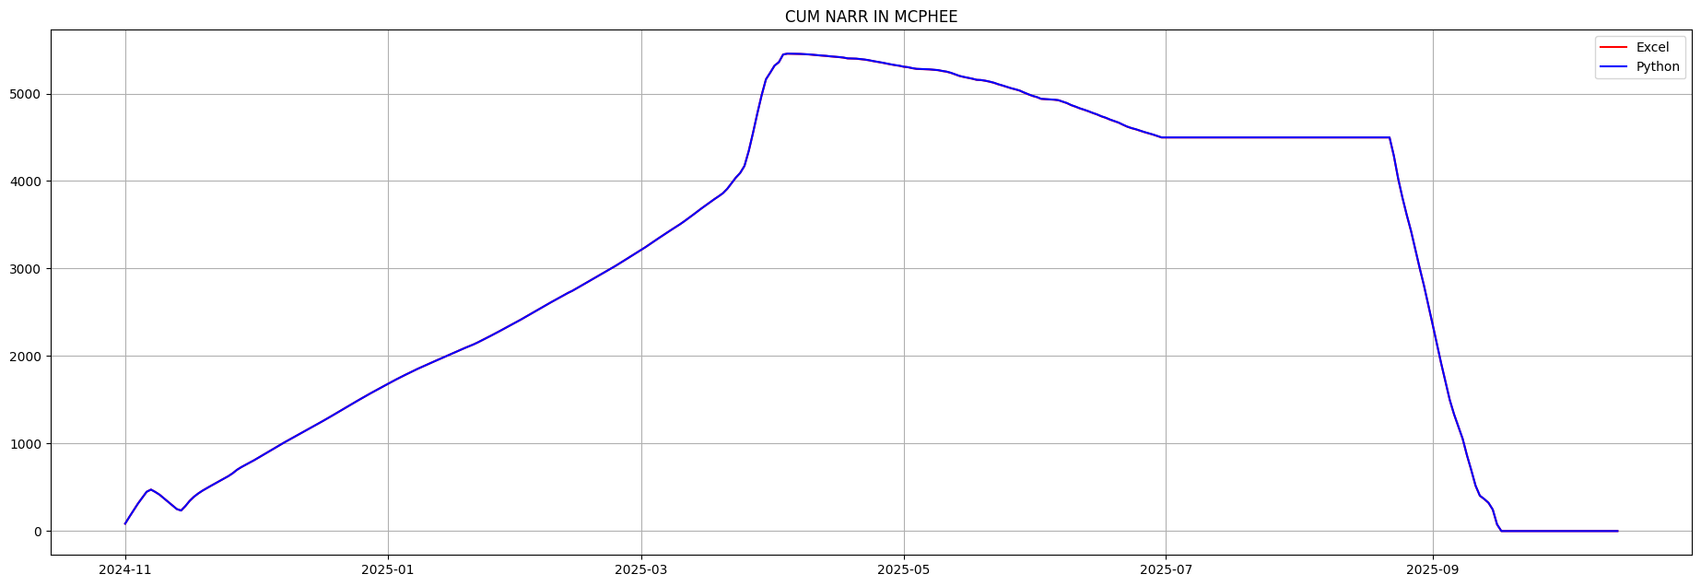

Description

Suggested Fix

Errors
2025-04-04: diff= 1.451 Excel=5454.964 Python=5456.415
excel: =(MIN(5457.172,(AP17-AO18+((I18-Q18-R18-(M18-N18-P18-O18-Q18-R18-S18-T18-U18+V18+W18-BC18+BA18)-AG18)-AK18)))-(SUM(AY15:AY17)/1.9835))
=(MIN(5457.172,(exl['CUM NARR IN MCPHEE'][day-1]-exl['NAR FILL'][day]+((exl['RECORD INFLOW'][day]-exl['MWC NON - PROJ'][day]-exl['CORTEZ NON - PROJ'][day]-(exl['DOL TUN TOT DIV'][day]-exl['WET LAND'][day]-exl['SEELEY'][day]-exl['UTE F&R'][day]-exl['MWC NON - PROJ'][day]-exl['CORTEZ NON - PROJ'][day]-exl['CORTEZ PROJ'][day]-exl['UTE PROJ'][day]-exl['F-BAY BAL'][day]+exl['LONE PINE'][day]+exl['U LAT'][day]-exl['UF&R LEASE WATER'][day]+exl['U/S USERS EXCH'][day])-exl['D/S SENIOR MVIC'][day])-exl['SPILL'][day])))-(SUM(exl['MVI STORED EVAP'][day-3]:exl['MVI STORED EVAP'][day-1])/1.9835))
comment:
Anthony Lee:
NARR water right completed in McPhee mid-day today. Remaining inflows directed towards Totten Credit.
20710-9885.7 AF means this column should finish at 5,457.172 CFS-days minus 4.38 AF (2.2CFS)(3 Days) of evaporation = 5454.964 CFS-days total.
The 3 days of evap are deducted in the function.
2025-04-05: diff= 1.451 Excel=5454.196 Python=5455.646
excel: =IF(G19="",AP18,AP18-AO19)-IF(AY18="",0,(AY18/1.9835))
=IF(exl['DOLORES RIVER'][day]="",exl['CUM NARR IN MCPHEE'][day-1],exl['CUM NARR IN MCPHEE'][day-1]-exl['NAR FILL'][day])-IF(exl['MVI STORED EVAP'][day-1]="",0,(exl['MVI STORED EVAP'][day-1]/1.9835))
2025-04-06: diff= 1.451 Excel=5454.040 Python=5455.491
excel: =IF(G20="",AP19,AP19-AO20)-IF(AY19="",0,(AY19/1.9835))
=IF(exl['DOLORES RIVER'][day]="",exl['CUM NARR IN MCPHEE'][day-1],exl['CUM NARR IN MCPHEE'][day-1]-exl['NAR FILL'][day])-IF(exl['MVI STORED EVAP'][day-1]="",0,(exl['MVI STORED EVAP'][day-1]/1.9835))
2025-04-07: diff= 1.451 Excel=5451.834 Python=5453.285
excel: =IF(G21="",AP20,AP20-AO21)-IF(AY20="",0,(AY20/1.9835))
=IF(exl['DOLORES RIVER'][day]="",exl['CUM NARR IN MCPHEE'][day-1],exl['CUM NARR IN MCPHEE'][day-1]-exl['NAR FILL'][day])-IF(exl['MVI STORED EVAP'][day-1]="",0,(exl['MVI STORED EVAP'][day-1]/1.9835))
2025-04-08: diff= 1.451 Excel=5449.124 Python=5450.575
excel: =IF(G22="",AP21,AP21-AO22)-IF(AY21="",0,(AY21/1.9835))
=IF(exl['DOLORES RIVER'][day]="",exl['CUM NARR IN MCPHEE'][day-1],exl['CUM NARR IN MCPHEE'][day-1]-exl['NAR FILL'][day])-IF(exl['MVI STORED EVAP'][day-1]="",0,(exl['MVI STORED EVAP'][day-1]/1.9835))
2025-04-09: diff= 1.451 Excel=5446.369 Python=5447.820
excel: =IF(G23="",AP22,AP22-AO23)-IF(AY22="",0,(AY22/1.9835))
=IF(exl['DOLORES RIVER'][day]="",exl['CUM NARR IN MCPHEE'][day-1],exl['CUM NARR IN MCPHEE'][day-1]-exl['NAR FILL'][day])-IF(exl['MVI STORED EVAP'][day-1]="",0,(exl['MVI STORED EVAP'][day-1]/1.9835))
2025-04-10: diff= 1.451 Excel=5441.747 Python=5443.198
excel: =IF(G24="",AP23,AP23-AO24)-IF(AY23="",0,(AY23/1.9835))
=IF(exl['DOLORES RIVER'][day]="",exl['CUM NARR IN MCPHEE'][day-1],exl['CUM NARR IN MCPHEE'][day-1]-exl['NAR FILL'][day])-IF(exl['MVI STORED EVAP'][day-1]="",0,(exl['MVI STORED EVAP'][day-1]/1.9835))

WET LAND - Low Priority

Description
These row indexing errors in Excel on WET LAND aren’t causing any data verification errors, WET LAND is zero much of the year. It would be desirable to fix them so they don’t show up in the Python excel loader error log. They could cause data errors someday as is the case with row indexing errors in CORTEZ

Suggested Fix
Change N33 in these cells to N26

Excel Row Indexing Error
Excel row invalid N33 in JANUARY in cell 'TOTAL MVI WATER USED'[26]
=MAX(0,M26-N33-P26-O26-Q26-R26-S26-T26-U26+V26+W26-BB26+AZ26-AN26)
Excel row invalid N33 in JANUARY in cell 'RECORD OTF'[26]
=N33+O26+P26+Q26+R26+S26+T26+U26+X26+AE26+AH26
Excel row invalid N33 in JANUARY in cell 'NARR FILL IN MCPHEE'[26]
=IF(G26="",0,IF(I26>=795,795-MAX(0,M26-N33-P26-O26-Q26-R26-S26-T26-U26+V26+W26-BB26+AZ26),I26-Q26-R26-MAX(0,M26-N33-P26-O26-Q26-R26-S26-T26-U26+V26+W26-BB26+AZ26)-AF26)-AJ26)
Excel row invalid N33 in JANUARY in cell 'NARR FILL IN MCPHEE'[26]
=IF(G26="",0,IF(I26>=795,795-MAX(0,M26-N33-P26-O26-Q26-R26-S26-T26-U26+V26+W26-BB26+AZ26),I26-Q26-R26-MAX(0,M26-N33-P26-O26-Q26-R26-S26-T26-U26+V26+W26-BB26+AZ26)-AF26)-AJ26)
Excel row invalid N33 in JANUARY in cell 'TOTAL TUNNEL Misc.'[26]
=SUM(N33,P26:U26)

TOTAL MVI WATER USED and MVI TUNNEL - No Priority
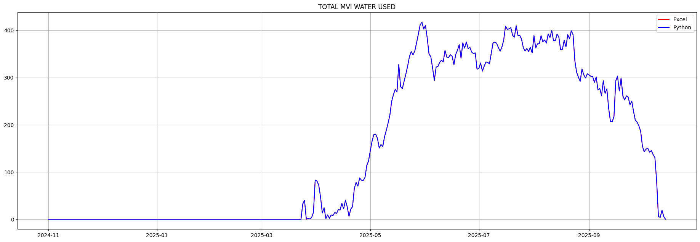

Description
The formula used to compute MVI TUNNEL flows is the same one used for FBAY BAL. All the of the other tunnel users daily usage are subtracted from the Tunnel flow. As is the case with FBAY BAL this formula can return negative numbers for MVI total usage. I implemen

Suggested Fix
This can’t easily be fixed in Excel, this equation is all over the place and can’t easily be changed. The fix for now is I’ve stopped limiting MVI TUNNEL to positive values so it matches Excel and allows negative values.
tunnel_not_mvi = out['TOTAL TUNNEL Misc.'] + exl['UTE F&R']
if not DWCDWaterYear.patch_mvi_tunnel_2025_1:
out['MVI TUNNEL'] = mvi_tunnel = WaterYear.positive_values(inp['DOL TUN TOT DIV'] - tunnel_not_mvi)
else:
out['MVI TUNNEL'] = mvi_tunnel = inp['DOL TUN TOT DIV'] - tunnel_not_mvi

Suggested Future Fix
Add an MVI TUNNEL column to Excel to the left of LONE PINE. Its pretty crazy one of the larger flows in the Dolores Project is invisible on the Inflow/Outflow sheets. Once this is more visible it might be worth studying if these negative values are OK. It may in fact be necessary to crediy MVI water in the tunnel with these negative values. It is not uncommon for the other tunnel users to use more water than is released from the tunnel on a given day. In particular UTE F&R flows are measured at the TOWAOC Canal DWR gage which is a long way and a long time from the Tunnel gage.

Errors
TOTAL MVI WATER USED
2025-03-26: diff= 0.520 Excel= 0.000 Python= 0.520
excel: =MAX(0,IF(B40="",0,M40-N40-O40-P40-Q40-R40-S40-T40-U40+V40+W40-BB40+AZ40-(IF(AN40="",0,AN40))))
=MAX(0,IF(exl['RESERV ELEV'][day]="",0,exl['DOL TUN TOT DIV'][day]-exl['WET LAND'][day]-exl['UTE F&R'][day]-exl['SEELEY'][day]-exl['MWC NON - PROJ'][day]-exl['CORTEZ NON - PROJ'][day]-exl['CORTEZ PROJ'][day]-exl['UTE PROJ'][day]-exl['F-BAY BAL'][day]+exl['LONE PINE'][day]+exl['U LAT'][day]-exl['TOTTEN (FRESH WATER)'][day]+exl['DIST CLASS B'][day]-(IF(exl['NAR FILL'][day]="",0,exl['NAR FILL'][day]))))
2025-10-09: diff= 2.075 Excel= 78.925 Python= 81.000
excel: =MAX(0,M23-N23-O23-P23-Q23-R23-S23-T23-U23+V23+W23-BD23+BA23)
=MAX(0,exl['DOL TUN TOT DIV'][day]-exl['WET LAND'][day]-exl['UTE F&R'][day]-exl['SEELEY'][day]-exl['MWC NON - PROJ'][day]-exl['CORTEZ NON - PROJ'][day]-exl['CORTEZ PROJ'][day]-exl['UTE PROJ'][day]-exl['F-BAY BAL'][day]+exl['LONE PINE'][day]+exl['U LAT'][day]-exl['TOTTEN (FRESH WATER)'][day]+exl['DIST CLASS B'][day])

