Dolores Project
Water Accounting Report
2025

Prepared by: Ed Millard
Date: October 26, 2025

Table of Contents
Inflow Outflow Data Validation Errors 4
CORTEZ PROJ - High Priority 4
MWC NON - PROJ - High Priority 6
CORTEZ NON - PROJ - High Priority 10
CORTEZ NON - PROJ - Medium Priority 15
NARR FILL IN MCPHEE - Medium Priority 17
CUM NARR IN MCPHEE - Medium Priority 21
USGS Data Validation Errors 23
LOST CAN - Low Priority 23
DWR CDSS Data Validation Errors 29
DOL TUN TOT DIV - Medium Priority 29
GRNDHOG CAPACITY - Medium Priority 30
DV CR CANAL - Low Priority 31
U LAT - Low Priority 32
Excel Issues 33
Row Indexing Errors - Medium Priority 33
Formula Noise in ‘DATE’ – Very Low Priority 34

Inflow Outflow Data Validation Errors

CORTEZ PROJ - High Priority
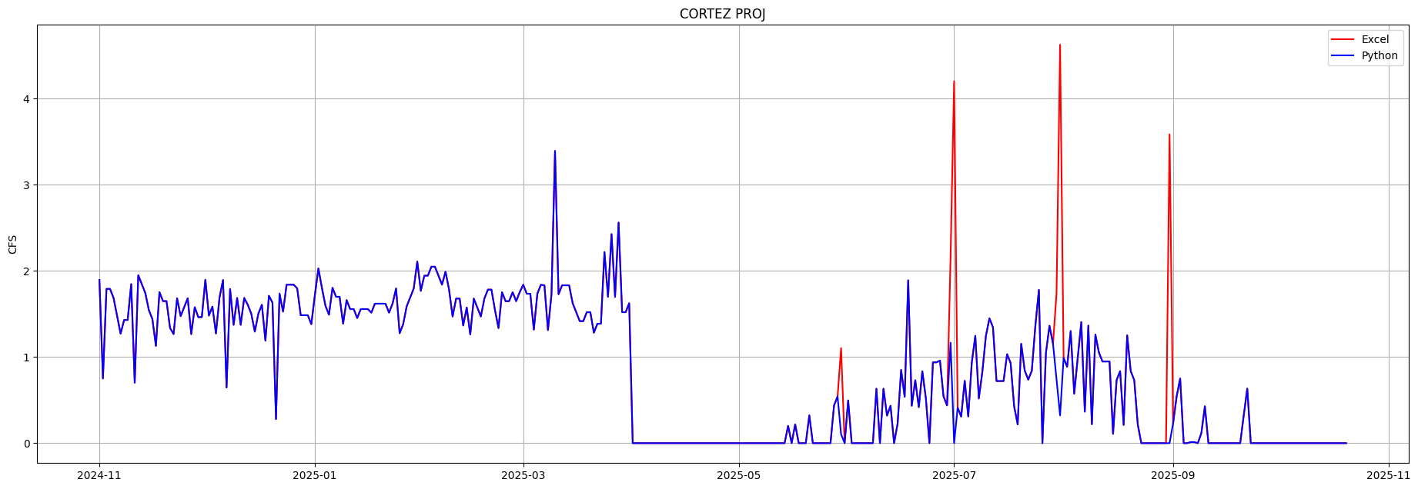

Description
Normally ‘CORTEZ PROJ’ formulas subtract 4.2, this is presumably the threshold between project and non project water. For some reason these cells are subtracting 3.2 and 1.2 causing 4 large spikes and data validation errors

Suggested Fix
‘CORTEZ PROJ’ formulas for May-30, Jun-30, July-1, July-30, Jul-31 and Aug-31 should probably be edited to use 4.2.

Errors
2025-05-30T00:00:00.000000: diff= -1.000 Excel= 1.103 Python= 0.103
excel: =IF(((5.2*1.04)-T44)>=4.2,((5.2*1.04)-T44)-3.2,0)
=IF(((5.2*1.04)-exl['UTE PROJ'][day])>=4.2,((5.2*1.04)-exl['UTE PROJ'][day])-3.2,0)
2025-06-30T00:00:00.000000: diff= -1.000 Excel= 2.166 Python= 1.166
excel: =IF(((6.4*1.04)-T44)>=4.2,((6.4*1.04)-T44)-3.2,0)
=IF(((6.4*1.04)-exl['UTE PROJ'][day])>=4.2,((6.4*1.04)-exl['UTE PROJ'][day])-3.2,0)
2025-07-01T00:00:00.000000: diff= -4.200 Excel= 4.200 Python= 0.000
excel: nan
comment:
D Butler Aug 5th, 2025: -2025
Values in this column are from City of Cortez final July numbers.
2025-07-30T00:00:00.000000: diff= -1.000 Excel= 1.738 Python= 0.738
excel: =IF(((6*1.04)-T44)>=4.2,((6*1.04)-T44)-3.2,0)
=IF(((6*1.04)-exl['UTE PROJ'][day])>=4.2,((6*1.04)-exl['UTE PROJ'][day])-3.2,0)
2025-07-31T00:00:00.000000: diff= -4.302 Excel= 4.624 Python= 0.322
excel: =IF(((5.6*1.04)-T46)>=4.2,((5.6*1.04)-T46)-1.2,0)
=IF(((5.6*1.04)-exl['UTE PROJ'][day+1])>=4.2,((5.6*1.04)-exl['UTE PROJ'][day+1])-1.2,0)
2025-08-31T00:00:00.000000: diff= -3.584 Excel= 3.584 Python= 0.000
excel: =IF(((4.6*1.04)-T46)>=4.2,((4.6*1.04)-T46)-1.2,0)
=IF(((4.6*1.04)-exl['UTE PROJ'][day+1])>=4.2,((4.6*1.04)-exl['UTE PROJ'][day+1])-1.2,0)

MWC NON - PROJ - High Priority
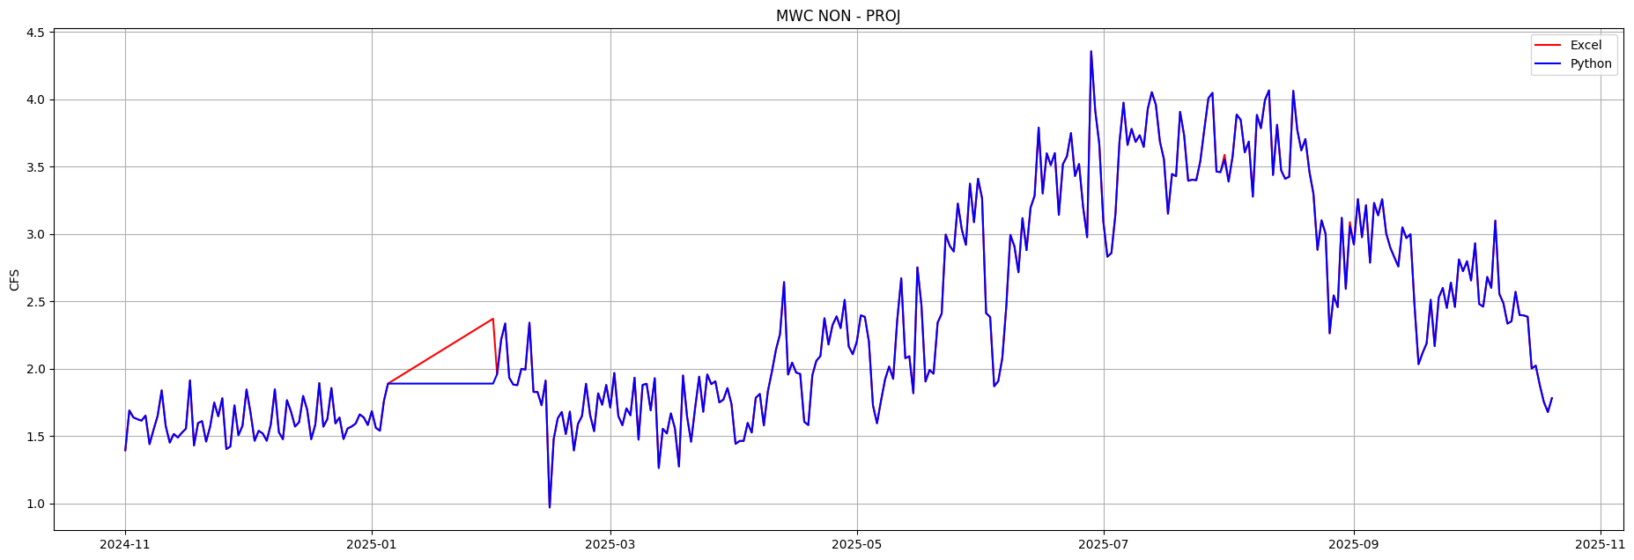

Description
Montezuma Water formulas look damaged from Jan-06 to Jan-31. The first number, which should be daily usage in gallons, isn’t changing. The coefficient which probably should be 1.02 for MWC Is incrementing by 0.01 a day causing a ramp im Excel. Python is flat lined because the first number isn’t changing qne coefficient is constant 1.04.
July 31 and August 31 have a coefficient of 1.03.
I’m guessing this coefficient is a carriage loss adjustment of 2% but don’t know for sure. Cortez uses 1.04 or 4%, Ute F&R uses 1.05 or 5% and UTE PROJ uses 1.06 and 1.04.

Suggested Fix
Acquire the daily usage numbers for MWC in January in gallons, put it in these formulas and repair the coefficient to be 1.02. Fix the coefficient in July and August.

Suggested Future Fix
To make these tunnel flow channels work in Python I am creating new input channels, in this case ‘MWC NON – PROJ CFS’ or ‘MWC NON – PROJ GAL’. I extract the daily usage number for these new channels from the Excel formulas. I can then use the same formulas every day to convert the input channel to CFS and apply the 1.02 loss coefficient. The way it is now the formulas change every day which is problematic in Python.
It would be better if DWCD techs weren’t editing these formulas in Excel everyday, it creates potential for errors. You really want the control room entering just the usage numbers they are getting, which may be gallons for the domestic users and CFS for Ute F&R from the DWR Towaoc gage.
It would be even better if these numbers were transmitted electronically and entered automatically by a script.

Errors
2025-01-06T00:00:00.000000: diff= -0.019 Excel= 1.907 Python= 1.889
excel: =1196700/325851/1.9835*1.03
=1196700/325851/1.9835*1.03
2025-01-07T00:00:00.000000: diff= -0.037 Excel= 1.926 Python= 1.889
excel: =1196700/325851/1.9835*1.04
=1196700/325851/1.9835*1.04
2025-01-08T00:00:00.000000: diff= -0.056 Excel= 1.944 Python= 1.889
excel: =1196700/325851/1.9835*1.05
=1196700/325851/1.9835*1.05
2025-01-09T00:00:00.000000: diff= -0.074 Excel= 1.963 Python= 1.889
excel: =1196700/325851/1.9835*1.06
=1196700/325851/1.9835*1.06
2025-01-10T00:00:00.000000: diff= -0.093 Excel= 1.981 Python= 1.889
excel: =1196700/325851/1.9835*1.07
=1196700/325851/1.9835*1.07
2025-01-11T00:00:00.000000: diff= -0.111 Excel= 2.000 Python= 1.889
excel: =1196700/325851/1.9835*1.08
=1196700/325851/1.9835*1.08
2025-01-12T00:00:00.000000: diff= -0.130 Excel= 2.018 Python= 1.889
excel: =1196700/325851/1.9835*1.09
=1196700/325851/1.9835*1.09
2025-01-13T00:00:00.000000: diff= -0.148 Excel= 2.037 Python= 1.889
excel: =1196700/325851/1.9835*1.1
=1196700/325851/1.9835*1.1
2025-01-14T00:00:00.000000: diff= -0.167 Excel= 2.055 Python= 1.889
excel: =1196700/325851/1.9835*1.11
=1196700/325851/1.9835*1.11
2025-01-15T00:00:00.000000: diff= -0.185 Excel= 2.074 Python= 1.889
excel: =1196700/325851/1.9835*1.12
=1196700/325851/1.9835*1.12
2025-01-16T00:00:00.000000: diff= -0.204 Excel= 2.092 Python= 1.889
excel: =1196700/325851/1.9835*1.13
=1196700/325851/1.9835*1.13
2025-01-17T00:00:00.000000: diff= -0.222 Excel= 2.111 Python= 1.889
excel: =1196700/325851/1.9835*1.14
=1196700/325851/1.9835*1.14
2025-01-18T00:00:00.000000: diff= -0.241 Excel= 2.129 Python= 1.889
excel: =1196700/325851/1.9835*1.15
=1196700/325851/1.9835*1.15
2025-01-19T00:00:00.000000: diff= -0.259 Excel= 2.148 Python= 1.889
excel: =1196700/325851/1.9835*1.16
=1196700/325851/1.9835*1.16
2025-01-20T00:00:00.000000: diff= -0.278 Excel= 2.166 Python= 1.889
excel: =1196700/325851/1.9835*1.17
=1196700/325851/1.9835*1.17
2025-01-21T00:00:00.000000: diff= -0.296 Excel= 2.185 Python= 1.889
excel: =1196700/325851/1.9835*1.18
=1196700/325851/1.9835*1.18
2025-01-22T00:00:00.000000: diff= -0.315 Excel= 2.203 Python= 1.889
excel: =1196700/325851/1.9835*1.19
=1196700/325851/1.9835*1.19
2025-01-23T00:00:00.000000: diff= -0.333 Excel= 2.222 Python= 1.889
excel: =1196700/325851/1.9835*1.2
=1196700/325851/1.9835*1.2
2025-01-24T00:00:00.000000: diff= -0.352 Excel= 2.240 Python= 1.889
excel: =1196700/325851/1.9835*1.21
=1196700/325851/1.9835*1.21
2025-01-25T00:00:00.000000: diff= -0.370 Excel= 2.259 Python= 1.889
excel: =1196700/325851/1.9835*1.22
=1196700/325851/1.9835*1.22
2025-01-26T00:00:00.000000: diff= -0.389 Excel= 2.277 Python= 1.889
excel: =1196700/325851/1.9835*1.23
=1196700/325851/1.9835*1.23
2025-01-27T00:00:00.000000: diff= -0.407 Excel= 2.296 Python= 1.889
excel: =1196700/325851/1.9835*1.24
=1196700/325851/1.9835*1.24
2025-01-28T00:00:00.000000: diff= -0.426 Excel= 2.314 Python= 1.889
excel: =1196700/325851/1.9835*1.25
=1196700/325851/1.9835*1.25
2025-01-29T00:00:00.000000: diff= -0.444 Excel= 2.333 Python= 1.889
excel: =1196700/325851/1.9835*1.26
=1196700/325851/1.9835*1.26
2025-01-30T00:00:00.000000: diff= -0.463 Excel= 2.351 Python= 1.889
excel: =1196700/325851/1.9835*1.27
=1196700/325851/1.9835*1.27
2025-01-31T00:00:00.000000: diff= -0.481 Excel= 2.370 Python= 1.889
excel: =1196700/325851/1.9835*1.28
=1196700/325851/1.9835*1.28
2025-07-31T00:00:00.000000: diff= -0.035 Excel= 3.587 Python= 3.552
excel: =2250800/325851/1.9835*1.03
=2250800/325851/1.9835*1.03
2025-08-31T00:00:00.000000: diff= -0.030 Excel= 3.087 Python= 3.057
excel: =1937000/325851/1.9835*1.03
=1937000/325851/1.9835*1.03

CORTEZ NON - PROJ - High Priority
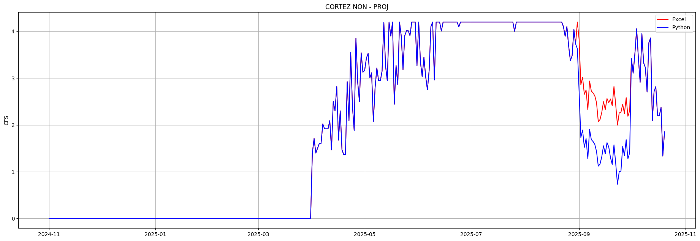

Description
For the month of September there are comments like this on Sept 1:
D Butler October 14th, 2025: Values in this column are from City of Cortez's final September numbers.
Excel formulas changed dramatically for ‘CORTEZ NON – PROJ’, in August they are like this:
=IF(((4.7*1.04)-T44)>=4.2,4.2,(4.7*1.04)-T44)
In September they are have usage in gallons, converted to acre-feet, converted to CFS multiplied by 1.02.
=1812300/325851/1.9835*1.02

Maybe someone copied ‘MWC NON PROJ’ formulas to ‘CORTEZ NON – PROJ’ because they had usage numbers in gallons and someone wanted to use MWC formulas to convert to CFS. Two problems:
- This formula isn’t subtracting ‘UTE PROJ’ water which is expected for ‘CORTEZ NON – PROJ’
(inp['CORTEZ NON - PROJ CFS'] * 1.04) - out['UTE PROJ']
- The 1.02 coefficient used is MWC’s, 1.04 is expected for ‘CORTEZ NON – PROJ’, presumably these are carriage loss adjustments
Its possible the gallon usage numbers in September already have UTE PROJ and its loss coefficient factored in, in which case the current numbers may be approximately correct, the only question would be correctness of the 1.02 coefficient. Pyrhon is using the standard formula and subtracting ‘UTE PROJ’ from the gallon numbers which looks much too low:
(inp['CORTEZ NON - PROJ CFS'] * 1.04) - out['UTE PROJ']
The graph of September usage doesn’t match surrounding months very well, this a transition from Summer to Fall, so its very difficult for me to draw conclusions.

Suggested Fix
A. Acquire and verify the correct usage numbers for ‘CORTEZ NON – PROJ’ for Sep-1 to Sep-30, convert them to CFS and apply the correct formula.
B. Leave this as is if the final numbers are correct.
C. I’ve implemented a 2025 specific patch to Python to produce the same result as Excel:
if DWCDWaterYear.patch_cortez_non_proj_2025_1:
result[sep1:oct1] = inp['CORTEZ NON - PROJ CFS'][sep1:oct1] * 1.02

Suggested Future
It would be much better to input these numbers in a standard format, probably gallons if that’s what they are delivered as. Then apply the same formula for the entire water year. Changing methods for arbitrary dates makes the accounting very difficult to understand, check, maintain or implement by other means like Python or Goldsim.

Errors
2025-09-01T00:00:00.000000: diff= -1.111 Excel= 3.834 Python= 2.723
excel: =2429300/325851/1.9835*1.02
=2429300/325851/1.9835*1.02
comment:
D Butler October 14th, 2025: Values in this column are from City of Cortez's final September numbers.
2025-09-02T00:00:00.000000: diff= -1.130 Excel= 2.860 Python= 1.730
excel: =1812300/325851/1.9835*1.02
=1812300/325851/1.9835*1.02
2025-09-03T00:00:00.000000: diff= -1.127 Excel= 3.017 Python= 1.890
excel: =1912000/325851/1.9835*1.02
=1912000/325851/1.9835*1.02
2025-09-04T00:00:00.000000: diff= -1.134 Excel= 2.654 Python= 1.520
excel: =1682000/325851/1.9835*1.02
=1682000/325851/1.9835*1.02
2025-09-05T00:00:00.000000: diff= -1.038 Excel= 2.747 Python= 1.709
excel: =1740600/325851/1.9835*1.02
=1740600/325851/1.9835*1.02
2025-09-06T00:00:00.000000: diff= -1.046 Excel= 2.323 Python= 1.277
excel: =1472200/325851/1.9835*1.02
=1472200/325851/1.9835*1.02
2025-09-07T00:00:00.000000: diff= -1.034 Excel= 2.939 Python= 1.905
excel: =1862400/325851/1.9835*1.02
=1862400/325851/1.9835*1.02
2025-09-08T00:00:00.000000: diff= -1.038 Excel= 2.726 Python= 1.687
excel: =1727100/325851/1.9835*1.02
=1727100/325851/1.9835*1.02
2025-09-09T00:00:00.000000: diff= -1.039 Excel= 2.683 Python= 1.644
excel: =1700400/325851/1.9835*1.02
=1700400/325851/1.9835*1.02
2025-09-10T00:00:00.000000: diff= -1.040 Excel= 2.624 Python= 1.583
excel: =1662400/325851/1.9835*1.02
=1662400/325851/1.9835*1.02
2025-09-11T00:00:00.000000: diff= -1.043 Excel= 2.474 Python= 1.431
excel: =1567800/325851/1.9835*1.02
=1567800/325851/1.9835*1.02
2025-09-12T00:00:00.000000: diff= -0.953 Excel= 2.071 Python= 1.118
excel: =1312300/325851/1.9835*1.02
=1312300/325851/1.9835*1.02
2025-09-13T00:00:00.000000: diff= -0.952 Excel= 2.115 Python= 1.162
excel: =1339900/325851/1.9835*1.02
=1339900/325851/1.9835*1.02
2025-09-14T00:00:00.000000: diff= -0.949 Excel= 2.268 Python= 1.318
excel: =1437000/325851/1.9835*1.02
=1437000/325851/1.9835*1.02
2025-09-15T00:00:00.000000: diff= -0.945 Excel= 2.498 Python= 1.553
excel: =1582700/325851/1.9835*1.02
=1582700/325851/1.9835*1.02
2025-09-16T00:00:00.000000: diff= -0.948 Excel= 2.328 Python= 1.379
excel: =1474900/325851/1.9835*1.02
=1474900/325851/1.9835*1.02
2025-09-17T00:00:00.000000: diff= -0.944 Excel= 2.564 Python= 1.620
excel: =1624600/325851/1.9835*1.02
=1624600/325851/1.9835*1.02
2025-09-18T00:00:00.000000: diff= -0.945 Excel= 2.475 Python= 1.530
excel: =1568300/325851/1.9835*1.02
=1568300/325851/1.9835*1.02
2025-09-19T00:00:00.000000: diff= -1.253 Excel= 2.553 Python= 1.300
excel: =1617800/325851/1.9835*1.02
=1617800/325851/1.9835*1.02
2025-09-20T00:00:00.000000: diff= -1.256 Excel= 2.409 Python= 1.154
excel: =1526700/325851/1.9835*1.02
=1526700/325851/1.9835*1.02
2025-09-21T00:00:00.000000: diff= -1.248 Excel= 2.821 Python= 1.574
excel: =1787800/325851/1.9835*1.02
=1787800/325851/1.9835*1.02
2025-09-22T00:00:00.000000: diff= -1.255 Excel= 2.430 Python= 1.175
excel: =1539800/325851/1.9835*1.02
=1539800/325851/1.9835*1.02
2025-09-23T00:00:00.000000: diff= -1.264 Excel= 1.995 Python= 0.731
excel: =1263900/325851/1.9835*1.02
=1263900/325851/1.9835*1.02
2025-09-24T00:00:00.000000: diff= -1.259 Excel= 2.257 Python= 0.998
excel: =1430100/325851/1.9835*1.02
=1430100/325851/1.9835*1.02
2025-09-25T00:00:00.000000: diff= -1.258 Excel= 2.271 Python= 1.013
excel: =1439300/325851/1.9835*1.02
=1439300/325851/1.9835*1.02
2025-09-26T00:00:00.000000: diff= -0.901 Excel= 2.441 Python= 1.540
excel: =1546600/325851/1.9835*1.02
=1546600/325851/1.9835*1.02
2025-09-27T00:00:00.000000: diff= -0.905 Excel= 2.244 Python= 1.339
excel: =1422100/325851/1.9835*1.02
=1422100/325851/1.9835*1.02
2025-09-28T00:00:00.000000: diff= -0.898 Excel= 2.583 Python= 1.684
excel: =1636600/325851/1.9835*1.02
=1636600/325851/1.9835*1.02
2025-09-29T00:00:00.000000: diff= -0.906 Excel= 2.183 Python= 1.277
excel: =1383400/325851/1.9835*1.02
=1383400/325851/1.9835*1.02
2025-09-30T00:00:00.000000: diff= -0.904 Excel= 2.305 Python= 1.401
excel: =1460600/325851/1.9835*1.02
=1460600/325851/1.9835*1.02

CORTEZ NON - PROJ - Medium Priority
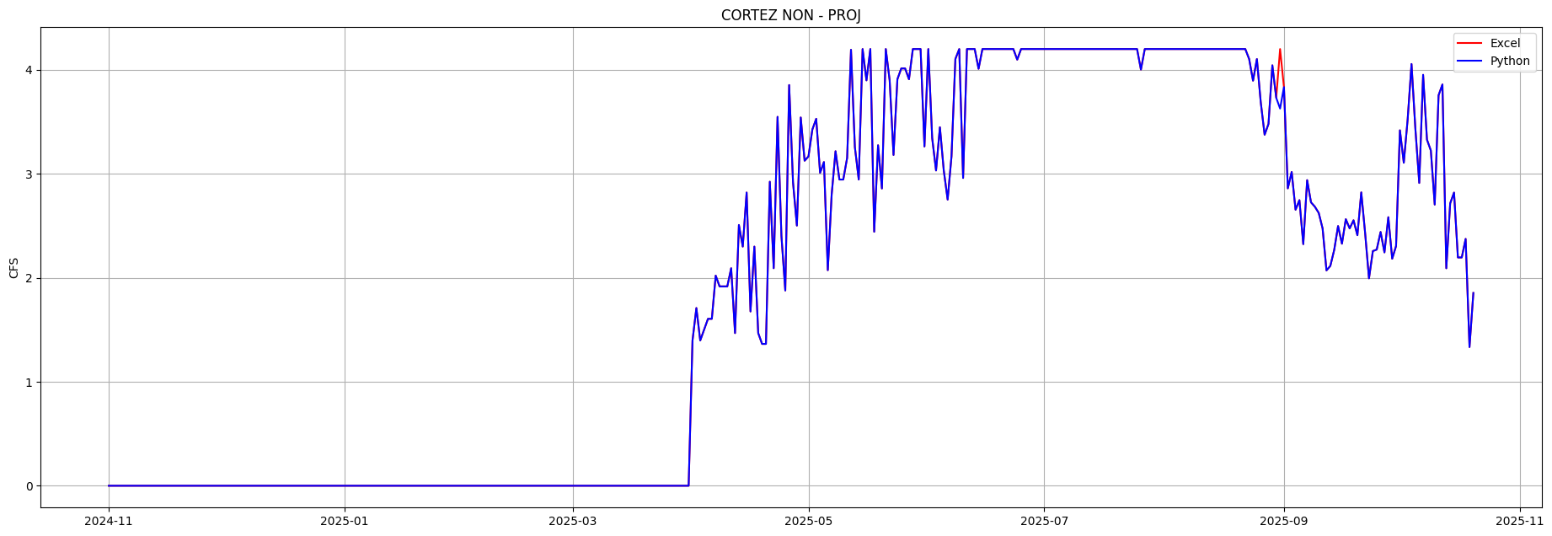

Description
Excel formulas for 'CORTEZ PROJ' and ‘CORTEZ NON – PROJ' for Jul 31 and Aug 31 are referencing an invalid row. T46 is a separator row below the last day of the month row. ‘CORTEZ NON – PROJ' on Aug 31 happens to be the only one actually causing a data validation error. The other three cells are wrong but not causing data errors this year.

Suggested Fix
Edit Excel formulas in row 45 for 'CORTEZ PROJ' and CORTEZ NON – PROJ' columns, Jul 31 and Aug 31. Both T46’s should probably be T45’s
'T46' in 'CORTEZ NON - PROJ'[Jul-31]: =IF(((5.6*1.04)-T46)>=4.2,4.2,(5.6*1.04)-T46)
'T46' in 'CORTEZ NON - PROJ'[Jul-31]: =IF(((5.6*1.04)-T46)>=4.2,4.2,(5.6*1.04)-T46)
'T46' in 'CORTEZ PROJ'[Jul-31]: =IF(((5.6*1.04)-T46)>=4.2,((5.6*1.04)-T46)-1.2,0)
'T46' in 'CORTEZ PROJ'[Jul-31]: =IF(((5.6*1.04)-T46)>=4.2,((5.6*1.04)-T46)-1.2,0)
'T46' in 'CORTEZ NON - PROJ'[Aug-31]: =IF(((4.6*1.04)-T46)>=4.2,4.2,(4.6*1.04)-T46)
'T46' in 'CORTEZ NON - PROJ'[Aug-31]: =IF(((4.6*1.04)-T46)>=4.2,4.2,(4.6*1.04)-T46)
'T46' in 'CORTEZ PROJ'[Aug-31]: =IF(((4.6*1.04)-T46)>=4.2,((4.6*1.04)-T46)-1.2,0)
'T46' in 'CORTEZ PROJ'[Aug-31]: =IF(((4.6*1.04)-T46)>=4.2,((4.6*1.04)-T46)-1.2,0)

Errors
2025-08-31T00:00:00.000000: diff= -0.572 Excel= 4.200 Python= 3.628
excel: =IF(((4.6*1.04)-T46)>=4.2,4.2,(4.6*1.04)-T46)
=IF(((4.6*1.04)-exl['UTE PROJ'][day+1])>=4.2,4.2,(4.6*1.04)-exl['UTE PROJ'][day+1])

NARR FILL IN MCPHEE - Medium Priority
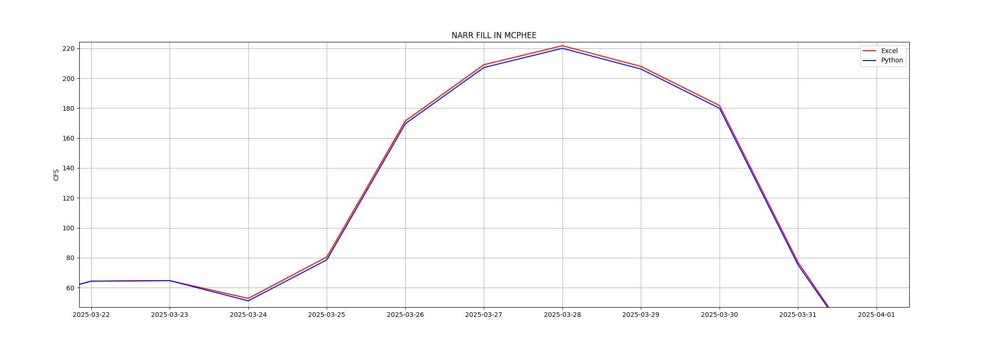

Description
Further research may be required, this is complicated
Formulas for ‘NARR FILL in MCPHEE’ were modified for Mar-24 to Mar-31 as described by Eric’s comment in Excel:
Eric Sprague:
Because MVIC began diverting, the forebay balance column was zeroed out. Usually in MAR, this column has the rights senior to MVIC deducted twice to counter the forebay balance column. Starting today, they are only deducted once, like during the irrigation season. This will need to be amended when this sheet is cleared to use for 2026.
The formula change removes the subtraction of ‘MWC NON PROJ’ and ‘CORTEZ NON PROJ’ from ‘RECORDED INFLOW’
...-exl['MWC NON - PROJ'][day]-exl['CORTEZ NON – PROJ'][day}…
The original formula from before Mar-24 with the removed part in bold
=['RECORD INFLOW'][day]-exl['MWC NON - PROJ'][day]-exl['CORTEZ NON – PROJ'][day]
-MAX(0,exl['DOL TUN TOT DIV'][day]-exl['WET LAND'][day]-exl['SEELEY'][day]-exl['UTE F&R'][day]-exl['MWC NON - PROJ'][day]-exl['CORTEZ NON - PROJ'][day]-exl['CORTEZ PROJ'][day]-exl['UTE PROJ'][day]-exl['F-BAY BAL'][day]
+exl['LONE PINE'][day]+exl['U LAT'][day]
-exl['TOTTEN (FRESH WATER)'][day]+exl['DIST CLASS B'][day])-exl['D/S SENIOR MVIC'][day])-exl['SPILL'][day]
I think the assertion in Eric’s comment is incorrect, MWC wasn’t being subtracted twice. MWC needs to be subtracted from RECORDED INFLOW and isn’t with this change. I think ‘NARR FILL IN MCP’ is slightly too large in Excel, MVI is getting extra storable water because MWC’s use is being included, and counted both as their use and MVI’s here. To patch it I have to make Python add in MWC usage:
if mar24 <= day <= mar31:
nar_fill_in_mcphee[day] = nar_fill_in_mcphee[day] + exl['MWC NON - PROJ'][day]

More Info
This formula is the complex way to compute ‘MVI STORABLE’ to figure out how much water can go in to NARR FILL. MVI STORABLE isn’t computed in March so its done here. It’s computing MVI TUNNEL flow and then MVI TOTAL WATER USED and subtracting it from RECORD INFLOW. The senior domestic rights also need to be subtracted from RECORD INFLOW
This is the formula to compute both ‘FBAY BAL’ and MVI TUNNEL use:
=exl['DOL TUN TOT DIV'][day]-(exl['MWC NON - PROJ'][day]+exl['CORTEZ NON - PROJ'][day]+exl['CORTEZ PROJ'][day]+exl['UTE PROJ'][day])
Its computing how much water came out of the tunnel, 'DOL TUN TOT DIV', and WASN’T charged to any tunnel users so they are all subtracted. Since its the same formula both can’t be used at the same time. When MVI starts using the Highline 'F-BAY BAL' is shut off and is zero which it was on Mar-24. 'CORTEZ NON – PROJ' is zero through the problem days so it isn’t a problem.
'F-BAY BAL' seems to be computing how much project water is coming out of the tunnel not charged to any user, maybe losses in the fore bay and highline over winter and project water used to charge the highline before MVI and UF&R start using it in March and April.

Suggested Fix
Restore the ‘NARR FILL in MCPHEE’ formulas for mar-24 to mar-31 to their original form, remove the comments, and I can remove the Python patch:
=['RECORD INFLOW'][day]-exl['MWC NON - PROJ'][day]-exl['CORTEZ NON – PROJ'][day]

Errors
2025-03-24T00:00:00.000000: diff= -1.679 Excel= 52.837 Python= 51.158
2025-03-25T00:00:00.000000: diff= -1.956 Excel= 80.524 Python= 78.568
excel: =IF(G39="",0,IF(I39>=795,795-MAX(0,M39-N39-P39-O39-Q39-R39-S39-T39-U39+V39+W39-BB39+AZ39),I39-MAX(0,M39-N39-P39-O39-Q39-R39-S39-T39-U39+V39+W39-BB39+AZ39)-AF39)-AJ39)
=IF(exl['DOLORES RIVER'][day]="",0,IF(exl['RECORD INFLOW'][day]>=795,795-MAX(0,exl['DOL TUN TOT DIV'][day]-exl['WET LAND'][day]-exl['SEELEY'][day]-exl['UTE F&R'][day]-exl['MWC NON - PROJ'][day]-exl['CORTEZ NON - PROJ'][day]-exl['CORTEZ PROJ'][day]-exl['UTE PROJ'][day]-exl['F-BAY BAL'][day]+exl['LONE PINE'][day]+exl['U LAT'][day]-exl['TOTTEN (FRESH WATER)'][day]+exl['DIST CLASS B'][day]),exl['RECORD INFLOW'][day]-MAX(0,exl['DOL TUN TOT DIV'][day]-exl['WET LAND'][day]-exl['SEELEY'][day]-exl['UTE F&R'][day]-exl['MWC NON - PROJ'][day]-exl['CORTEZ NON - PROJ'][day]-exl['CORTEZ PROJ'][day]-exl['UTE PROJ'][day]-exl['F-BAY BAL'][day]+exl['LONE PINE'][day]+exl['U LAT'][day]-exl['TOTTEN (FRESH WATER)'][day]+exl['DIST CLASS B'][day])-exl['D/S SENIOR MVIC'][day])-exl['SPILL'][day])
2025-03-26T00:00:00.000000: diff= -1.884 Excel= 171.500 Python= 169.616
2025-03-27T00:00:00.000000: diff= -1.906 Excel= 209.049 Python= 207.143
2025-03-28T00:00:00.000000: diff= -1.749 Excel= 221.749 Python= 220.000
2025-03-29T00:00:00.000000: diff= -1.770 Excel= 207.900 Python= 206.130
2025-03-30T00:00:00.000000: diff= -1.855 Excel= 181.760 Python= 179.905
2025-03-31T00:00:00.000000: diff= -1.736 Excel= 76.920 Python= 75.184

CUM NARR IN MCPHEE - Medium Priority
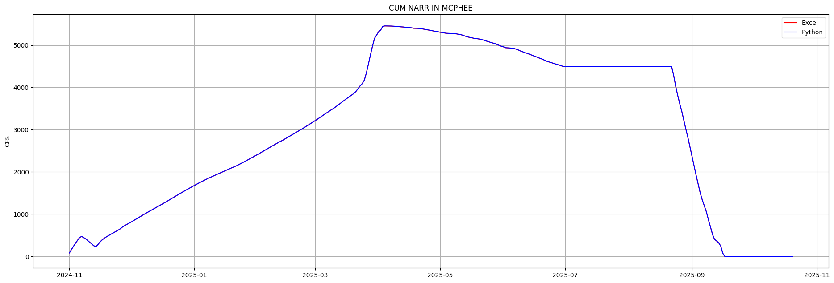

Description
Further research may be required.
On Apr-4 Anthony applied a formula change to apply MVI retroactive evaporation charges on ‘CUM NARR IN MCP’ for Apr-1 and Apr-3. As nearly as I can tell these days already have evaporation charges, the formulas for Apr-1 to Apr-3 do this:
...-IF(exl['MVI STORED EVAP'][day-1]...
If so this change on Apr-4 doubles up the evaporation charge on MVI. Its a very small error, not visible above but it is there, Excel is 1.5 CFS lower than Python. Unnecessary formula changes that cause errors aren’t good, they complicate the accounting. Its possible Eric added the evaporation charges after or the same time Anthony did his patch so it was inadvertent.

Suggested Fix
If its verified evaporation charges are being applied In ‘‘CUM NARR IN MCP’’ Apr-1 to Apr-3 amend Apr-4 to remove Anthony's evaporation charge:
-(SUM(AY15:AY17)/1.9835)
( can then remove this patch in Python to implement Anthony’s duplicative evaporation charge:
if day == apr4:
mvi_stored_evap[day - 1] / 1.9835
evap = evap + np.sum(mvi_stored_evap[day-3:day-1]) / 1.9835
fill_remaining += evap

Errors
2025-04-04T00:00:00.000000: diff= 1.451 Excel=5454.964 Python=5456.415
excel: =(MIN(5457.172,(AP17-AO18+((I18-Q18-R18-(M18-N18-P18-O18-Q18-R18-S18-T18-U18+V18+W18-BC18+BA18)-AG18)-AK18)))-(SUM(AY15:AY17)/1.9835))
=(MIN(5457.172,(exl['CUM NARR IN MCPHEE'][day-1]-exl['NAR FILL'][day]+((exl['RECORD INFLOW'][day]-exl['MWC NON - PROJ'][day]-exl['CORTEZ NON - PROJ'][day]-(exl['DOL TUN TOT DIV'][day]-exl['WET LAND'][day]-exl['SEELEY'][day]-exl['UTE F&R'][day]-exl['MWC NON - PROJ'][day]-exl['CORTEZ NON - PROJ'][day]-exl['CORTEZ PROJ'][day]-exl['UTE PROJ'][day]-exl['F-BAY BAL'][day]+exl['LONE PINE'][day]+exl['U LAT'][day]-exl['UF&R LEASE WATER'][day]+exl['U/S USERS EXCH'][day])-exl['D/S SENIOR MVIC'][day])-exl['SPILL'][day])))-(SUM(exl['MVI STORED EVAP'][day-3]:exl['MVI STORED EVAP'][day-1])/1.9835))
comment:
Anthony Lee:
NARR water right completed in McPhee mid-day today. Remaining inflows directed towards Totten Credit.
20710-9885.7 AF means this column should finish at 5,457.172 CFS-days minus 4.38 AF (2.2CFS)(3 Days) of evaporation = 5454.964 CFS-days total.
The 3 days of evap are deducted in the function.

USGS Data Validation Errors

LOST CAN - Low Priority
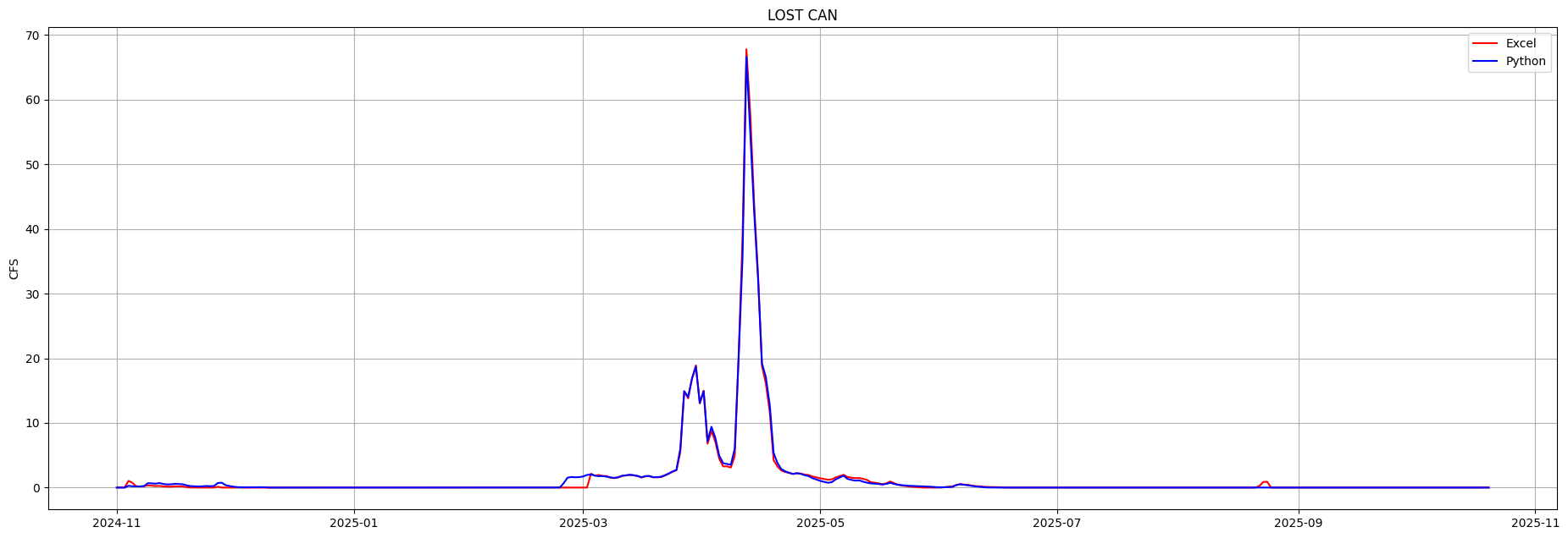

Description
Lost Canyon USGS Gage differs from the DWCD Inflow Outflow on many days, some may have been due to freezing issues or maybe USGS revised the gage data/profile since DWCD entered the data. The discrepancies at their worst are in the 1-3 CFS range.

Suggested Fix
It would be substantial work to revise all this data. Since this is part of ‘RECORDED INFLOW’ it will change everything slightly. I defer to DWCD on the priority.

Suggested Future
It would be better if USGS and CDSS data were acquired automatically with their API’s and entered without manual entry and risk of entry errors. This code could also detect when USGS and DWR revise their gauges and elevation automatically, warn the tech and revise the data in Excel as soon as the revision occurs. My python code mostly does this now. When revisions occur I backup the old data for the water year so its easy to see what changes occurred.

Errors
2024-11-04T00:00:00.000000: diff= -0.770 Excel= 1.040 Python= 0.270
2024-11-05T00:00:00.000000: diff= -0.540 Excel= 0.740 Python= 0.200
2024-11-06T00:00:00.000000: diff= -0.010 Excel= 0.190 Python= 0.180
2024-11-07T00:00:00.000000: diff= -0.010 Excel= 0.180 Python= 0.170
2024-11-09T00:00:00.000000: diff= 0.340 Excel= 0.340 Python= 0.680
2024-11-10T00:00:00.000000: diff= 0.370 Excel= 0.280 Python= 0.650
2024-11-11T00:00:00.000000: diff= 0.370 Excel= 0.230 Python= 0.600
2024-11-12T00:00:00.000000: diff= 0.440 Excel= 0.260 Python= 0.700
2024-11-13T00:00:00.000000: diff= 0.380 Excel= 0.170 Python= 0.550
2024-11-14T00:00:00.000000: diff= 0.340 Excel= 0.150 Python= 0.490
2024-11-15T00:00:00.000000: diff= 0.370 Excel= 0.140 Python= 0.510
2024-11-16T00:00:00.000000: diff= 0.390 Excel= 0.190 Python= 0.580
2024-11-17T00:00:00.000000: diff= 0.350 Excel= 0.190 Python= 0.540
2024-11-18T00:00:00.000000: diff= 0.340 Excel= 0.170 Python= 0.510
2024-11-19T00:00:00.000000: diff= 0.270 Excel= 0.070 Python= 0.340
2024-11-20T00:00:00.000000: diff= 0.220 Excel= 0.010 Python= 0.230
2024-11-21T00:00:00.000000: diff= 0.200 Excel= 0.000 Python= 0.200
2024-11-22T00:00:00.000000: diff= 0.170 Excel= 0.000 Python= 0.170
2024-11-23T00:00:00.000000: diff= 0.190 Excel= 0.000 Python= 0.190
2024-11-24T00:00:00.000000: diff= 0.240 Excel= 0.000 Python= 0.240
2024-11-25T00:00:00.000000: diff= 0.200 Excel= 0.010 Python= 0.210
2024-11-26T00:00:00.000000: diff= 0.240 Excel= 0.000 Python= 0.240
2024-11-27T00:00:00.000000: diff= 0.570 Excel= 0.130 Python= 0.700
2024-11-28T00:00:00.000000: diff= 0.750 Excel= 0.000 Python= 0.750
comment:
Easton H:
2/26/25
The DWR Lost Canyon Gauge started to freeze and now we cannot see the Lost Canyon Infow.
2024-11-29T00:00:00.000000: diff= 0.380 Excel= 0.000 Python= 0.380
2024-11-30T00:00:00.000000: diff= 0.240 Excel= 0.000 Python= 0.240
2024-12-01T00:00:00.000000: diff= 0.140 Excel= 0.000 Python= 0.140
2024-12-02T00:00:00.000000: diff= 0.070 Excel= 0.000 Python= 0.070
2024-12-03T00:00:00.000000: diff= 0.040 Excel= 0.000 Python= 0.040
2024-12-04T00:00:00.000000: diff= 0.030 Excel= 0.000 Python= 0.030
2024-12-05T00:00:00.000000: diff= 0.030 Excel= 0.000 Python= 0.030
2024-12-06T00:00:00.000000: diff= 0.040 Excel= 0.000 Python= 0.040
2024-12-07T00:00:00.000000: diff= 0.060 Excel= 0.000 Python= 0.060
2024-12-08T00:00:00.000000: diff= 0.050 Excel= 0.000 Python= 0.050
2024-12-09T00:00:00.000000: diff= 0.050 Excel= 0.000 Python= 0.050
2025-02-22T00:00:00.000000: diff= 0.010 Excel= 0.000 Python= 0.010
2025-02-23T00:00:00.000000: diff= 0.010 Excel= 0.000 Python= 0.010
2025-02-24T00:00:00.000000: diff= 0.690 Excel= 0.000 Python= 0.690
2025-02-25T00:00:00.000000: diff= 1.540 Excel= 0.000 Python= 1.540
2025-02-26T00:00:00.000000: diff= 1.630 Excel= 0.000 Python= 1.630
2025-02-27T00:00:00.000000: diff= 1.590 Excel= 0.000 Python= 1.590
2025-02-28T00:00:00.000000: diff= 1.610 Excel= 0.000 Python= 1.610
2025-03-01T00:00:00.000000: diff= 1.720 Excel= 0.000 Python= 1.720
2025-03-02T00:00:00.000000: diff= 1.950 Excel= 0.000 Python= 1.950
2025-03-03T00:00:00.000000: diff= -0.130 Excel= 2.150 Python= 2.020
2025-03-04T00:00:00.000000: diff= 0.020 Excel= 1.830 Python= 1.850
2025-03-05T00:00:00.000000: diff= -0.200 Excel= 1.950 Python= 1.750
2025-03-06T00:00:00.000000: diff= 0.010 Excel= 1.780 Python= 1.790
2025-03-07T00:00:00.000000: diff= -0.100 Excel= 1.790 Python= 1.690
2025-03-08T00:00:00.000000: diff= 0.040 Excel= 1.530 Python= 1.570
2025-03-09T00:00:00.000000: diff= 0.030 Excel= 1.460 Python= 1.490
2025-03-10T00:00:00.000000: diff= 0.040 Excel= 1.560 Python= 1.600
2025-03-11T00:00:00.000000: diff= 0.030 Excel= 1.790 Python= 1.820
2025-03-12T00:00:00.000000: diff= 0.040 Excel= 1.860 Python= 1.900
2025-03-13T00:00:00.000000: diff= 0.040 Excel= 1.940 Python= 1.980
2025-03-14T00:00:00.000000: diff= 0.010 Excel= 1.900 Python= 1.910
2025-03-15T00:00:00.000000: diff= 0.030 Excel= 1.770 Python= 1.800
2025-03-16T00:00:00.000000: diff= 0.050 Excel= 1.550 Python= 1.600
2025-03-17T00:00:00.000000: diff= 0.040 Excel= 1.730 Python= 1.770
2025-03-18T00:00:00.000000: diff= 0.010 Excel= 1.780 Python= 1.790
2025-03-19T00:00:00.000000: diff= -0.010 Excel= 1.600 Python= 1.590
2025-03-20T00:00:00.000000: diff= 0.040 Excel= 1.580 Python= 1.620
2025-03-21T00:00:00.000000: diff= 0.040 Excel= 1.620 Python= 1.660
2025-03-22T00:00:00.000000: diff= 0.050 Excel= 1.850 Python= 1.900
2025-03-23T00:00:00.000000: diff= 0.050 Excel= 2.130 Python= 2.180
2025-03-24T00:00:00.000000: diff= 0.040 Excel= 2.450 Python= 2.490
2025-03-25T00:00:00.000000: diff= 0.050 Excel= 2.680 Python= 2.730
2025-03-26T00:00:00.000000: diff= 0.550 Excel= 5.500 Python= 6.050
2025-03-28T00:00:00.000000: diff= 0.200 Excel= 13.800 Python= 14.000
2025-03-29T00:00:00.000000: diff= 0.100 Excel= 16.800 Python= 16.900
2025-03-30T00:00:00.000000: diff= -0.200 Excel= 18.900 Python= 18.700
2025-03-31T00:00:00.000000: diff= 0.100 Excel= 13.000 Python= 13.100
2025-04-01T00:00:00.000000: diff= -0.100 Excel= 15.000 Python= 14.900
2025-04-02T00:00:00.000000: diff= 0.370 Excel= 6.790 Python= 7.160
2025-04-03T00:00:00.000000: diff= 0.650 Excel= 8.750 Python= 9.400
2025-04-04T00:00:00.000000: diff= 0.610 Excel= 7.100 Python= 7.710
2025-04-05T00:00:00.000000: diff= 0.470 Excel= 4.470 Python= 4.940
2025-04-06T00:00:00.000000: diff= 0.500 Excel= 3.280 Python= 3.780
2025-04-07T00:00:00.000000: diff= 0.360 Excel= 3.280 Python= 3.640
2025-04-08T00:00:00.000000: diff= 0.430 Excel= 3.100 Python= 3.530
2025-04-09T00:00:00.000000: diff= 1.140 Excel= 4.880 Python= 6.020
2025-04-10T00:00:00.000000: diff= -0.400 Excel= 20.500 Python= 20.100
2025-04-11T00:00:00.000000: diff= -3.200 Excel= 38.700 Python= 35.500
2025-04-12T00:00:00.000000: diff= -1.200 Excel= 67.800 Python= 66.600
2025-04-13T00:00:00.000000: diff= -3.000 Excel= 57.800 Python= 54.800
2025-04-14T00:00:00.000000: diff= -1.200 Excel= 43.800 Python= 42.600
2025-04-15T00:00:00.000000: diff= -0.700 Excel= 32.900 Python= 32.200
2025-04-16T00:00:00.000000: diff= 0.400 Excel= 18.800 Python= 19.200
2025-04-17T00:00:00.000000: diff= 1.000 Excel= 16.100 Python= 17.100
2025-04-18T00:00:00.000000: diff= 1.100 Excel= 11.700 Python= 12.800
2025-04-19T00:00:00.000000: diff= 1.110 Excel= 4.240 Python= 5.350
2025-04-20T00:00:00.000000: diff= 0.540 Excel= 3.260 Python= 3.800
2025-04-21T00:00:00.000000: diff= 0.210 Excel= 2.630 Python= 2.840
2025-04-22T00:00:00.000000: diff= 0.100 Excel= 2.410 Python= 2.510
2025-04-23T00:00:00.000000: diff= 0.020 Excel= 2.260 Python= 2.280
2025-04-24T00:00:00.000000: diff= -0.040 Excel= 2.130 Python= 2.090
2025-04-26T00:00:00.000000: diff= -0.050 Excel= 2.160 Python= 2.110
2025-04-27T00:00:00.000000: diff= -0.110 Excel= 2.010 Python= 1.900
2025-04-28T00:00:00.000000: diff= -0.160 Excel= 1.940 Python= 1.780
2025-04-29T00:00:00.000000: diff= -0.260 Excel= 1.710 Python= 1.450
2025-04-30T00:00:00.000000: diff= -0.320 Excel= 1.570 Python= 1.250
2025-05-01T00:00:00.000000: diff= -0.400 Excel= 1.430 Python= 1.030
2025-05-02T00:00:00.000000: diff= -0.450 Excel= 1.330 Python= 0.880
2025-05-03T00:00:00.000000: diff= -0.470 Excel= 1.210 Python= 0.740
2025-05-04T00:00:00.000000: diff= -0.430 Excel= 1.270 Python= 0.840
2025-05-05T00:00:00.000000: diff= -0.300 Excel= 1.580 Python= 1.280
2025-05-06T00:00:00.000000: diff= -0.210 Excel= 1.770 Python= 1.560
2025-05-07T00:00:00.000000: diff= -0.130 Excel= 1.970 Python= 1.840
2025-05-08T00:00:00.000000: diff= -0.300 Excel= 1.640 Python= 1.340
2025-05-09T00:00:00.000000: diff= -0.340 Excel= 1.530 Python= 1.190
2025-05-10T00:00:00.000000: diff= -0.390 Excel= 1.460 Python= 1.070
2025-05-11T00:00:00.000000: diff= -0.370 Excel= 1.480 Python= 1.110
2025-05-12T00:00:00.000000: diff= -0.440 Excel= 1.350 Python= 0.910
2025-05-13T00:00:00.000000: diff= -0.430 Excel= 1.190 Python= 0.760
2025-05-14T00:00:00.000000: diff= -0.180 Excel= 0.830 Python= 0.650
2025-05-15T00:00:00.000000: diff= -0.150 Excel= 0.750 Python= 0.600
2025-05-16T00:00:00.000000: diff= -0.110 Excel= 0.660 Python= 0.550
2025-05-17T00:00:00.000000: diff= -0.030 Excel= 0.510 Python= 0.480
2025-05-18T00:00:00.000000: diff= -0.080 Excel= 0.640 Python= 0.560
2025-05-19T00:00:00.000000: diff= -0.200 Excel= 0.940 Python= 0.740
2025-05-20T00:00:00.000000: diff= -0.120 Excel= 0.680 Python= 0.560
2025-05-21T00:00:00.000000: diff= 0.010 Excel= 0.430 Python= 0.440
2025-05-22T00:00:00.000000: diff= 0.060 Excel= 0.310 Python= 0.370
2025-05-23T00:00:00.000000: diff= 0.090 Excel= 0.230 Python= 0.320
2025-05-24T00:00:00.000000: diff= 0.110 Excel= 0.160 Python= 0.270
2025-05-25T00:00:00.000000: diff= 0.140 Excel= 0.100 Python= 0.240
2025-05-26T00:00:00.000000: diff= 0.160 Excel= 0.060 Python= 0.220
2025-05-27T00:00:00.000000: diff= 0.170 Excel= 0.020 Python= 0.190
2025-05-28T00:00:00.000000: diff= 0.170 Excel= 0.000 Python= 0.170
2025-05-29T00:00:00.000000: diff= 0.140 Excel= 0.000 Python= 0.140
2025-05-30T00:00:00.000000: diff= 0.100 Excel= 0.000 Python= 0.100
2025-05-31T00:00:00.000000: diff= 0.060 Excel= 0.000 Python= 0.060
2025-06-01T00:00:00.000000: diff= 0.040 Excel= 0.000 Python= 0.040
2025-06-02T00:00:00.000000: diff= 0.010 Excel= 0.050 Python= 0.060
2025-06-03T00:00:00.000000: diff= -0.080 Excel= 0.140 Python= 0.060
2025-06-04T00:00:00.000000: diff= -0.060 Excel= 0.170 Python= 0.110
2025-06-05T00:00:00.000000: diff= -0.020 Excel= 0.400 Python= 0.380
2025-06-06T00:00:00.000000: diff= -0.030 Excel= 0.540 Python= 0.510
2025-06-07T00:00:00.000000: diff= -0.040 Excel= 0.460 Python= 0.420
2025-06-08T00:00:00.000000: diff= -0.050 Excel= 0.410 Python= 0.360
2025-06-09T00:00:00.000000: diff= -0.060 Excel= 0.310 Python= 0.250
2025-06-10T00:00:00.000000: diff= -0.050 Excel= 0.230 Python= 0.180
2025-06-11T00:00:00.000000: diff= -0.060 Excel= 0.190 Python= 0.130
2025-06-12T00:00:00.000000: diff= -0.080 Excel= 0.130 Python= 0.050
2025-06-13T00:00:00.000000: diff= -0.070 Excel= 0.090 Python= 0.020
2025-06-14T00:00:00.000000: diff= -0.070 Excel= 0.080 Python= 0.010
2025-06-15T00:00:00.000000: diff= -0.070 Excel= 0.070 Python= 0.000
2025-06-16T00:00:00.000000: diff= -0.060 Excel= 0.060 Python= 0.000
2025-06-17T00:00:00.000000: diff= -0.020 Excel= 0.020 Python= 0.000
2025-08-22T00:00:00.000000: diff= -0.260 Excel= 0.260 Python= 0.000
2025-08-23T00:00:00.000000: diff= -0.870 Excel= 0.870 Python= 0.000
2025-08-24T00:00:00.000000: diff= -0.900 Excel= 0.900 Python= 0.000

DWR CDSS Data Validation Errors

DOL TUN TOT DIV - Medium Priority
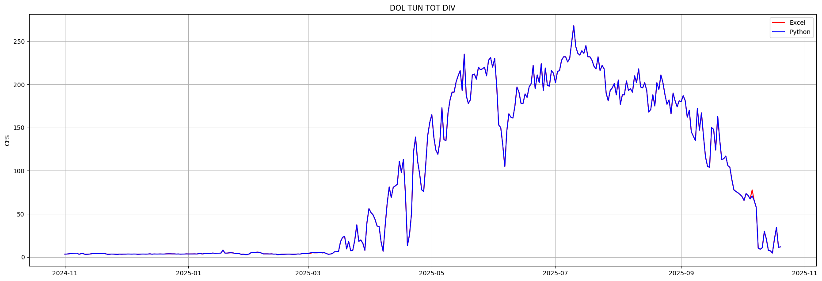

Description
Possible data entry error in ‘DOL TUN TOT DIV’ on Oct 6, 70.8 was entered as 77.8.
Values on Mar-17 and Mar-18 are also a little off.

Suggested Fix
Amend ‘DOL TUN TOT DIV’ on Oct 6 to 70.8.

Errors
2025-03-17T00:00:00.000000: diff= 0.200 Excel= 17.800 Python= 18.000
2025-03-18T00:00:00.000000: diff= 0.300 Excel= 22.700 Python= 23.000
2025-10-06T00:00:00.000000: diff= -7.000 Excel= 77.800 Python= 70.800

GRNDHOG CAPACITY - Medium Priority
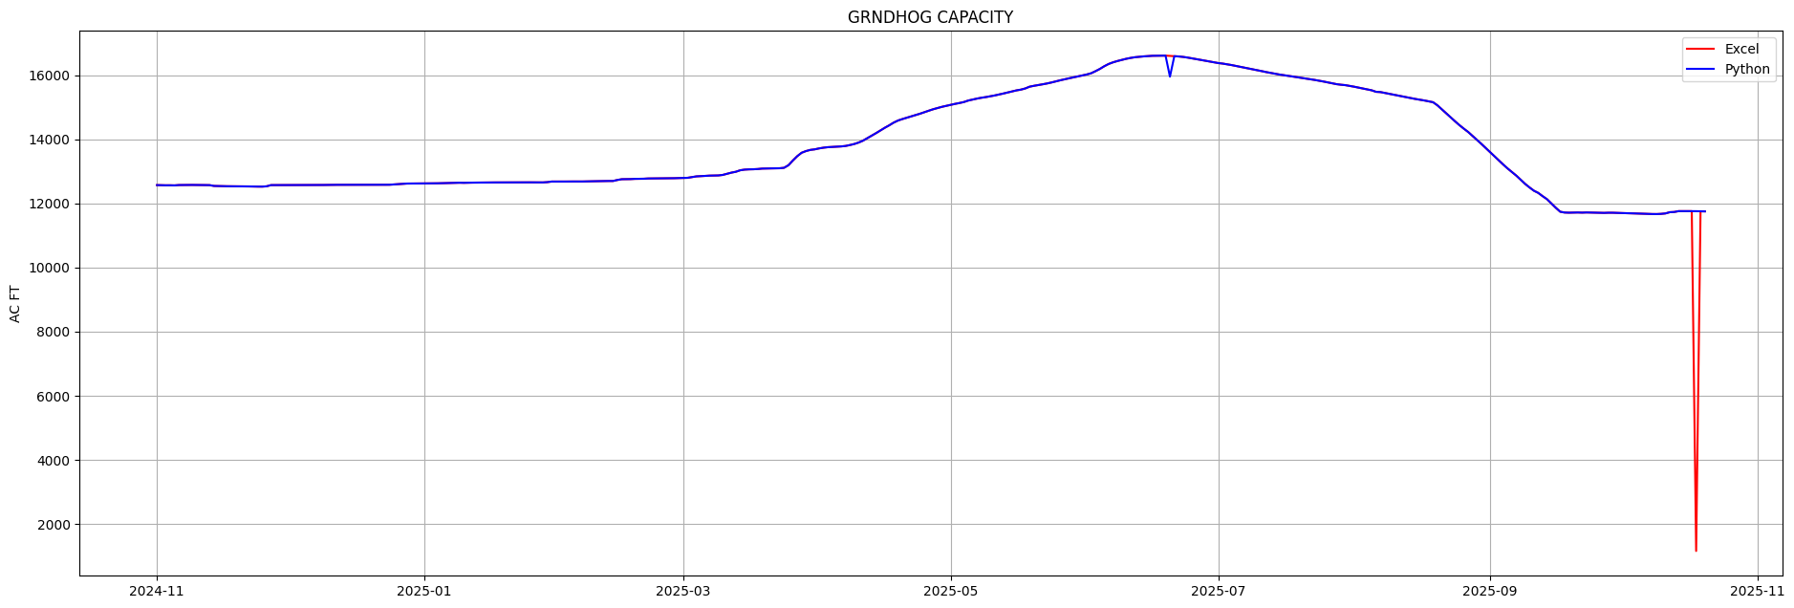

Description
Possible data entry error in ‘GRNDHOG CAPACITY’ on Oct-18, a 1 was dropped from 11757 resulting in 1157.

Suggested Fix
Amend ‘GRNDHOG CAPACITY’ on Oct 18 to 11757.812.
DWR should be notified to fix the glitch in their data in June, DWCD fixed that one previously.

Errors
2025-10-18T00:00:00.000000: diff=10600.013 Excel=1157.800 Python=11757.812

DV CR CANAL - Low Priority
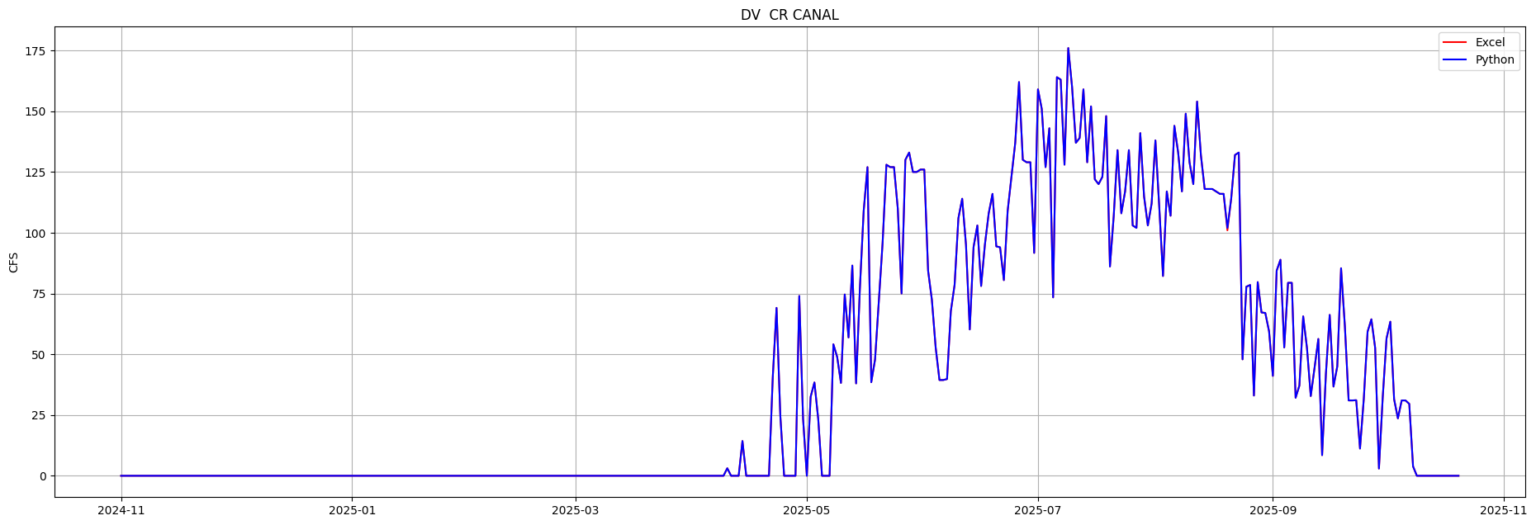

Description
Possibly a data entry error on ‘DV CR CANAL’ on Aug-20, 102 was entered as 101

Suggested Fix
Amend ‘DV CR CANAL’ on Aug-20 to 102.000

Errors
2025-08-20T00:00:00.000000: diff= 1.000 Excel= 101.000 Python= 102.000

U LAT - Low Priority
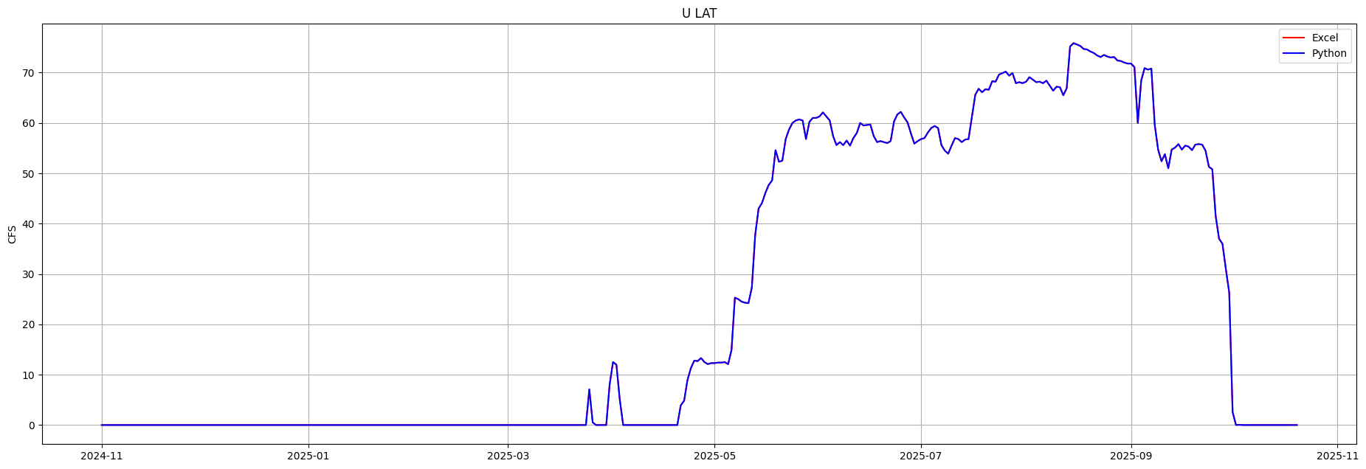

Description
Possibly a data entry error on ‘U LAT’ on Aug-15, 0.8 was entered as a 0.9.

Suggested Fix
Amend ‘U LAT’ on Aug-15 to 75.800

Errors
2025-08-15T00:00:00.000000: diff= -0.100 Excel= 75.900 Python= 75.800

Excel Issues

Row Indexing Errors - Medium Priority

Description
These columns and dates have formulas referencing rows in the future which shouldn’t happen in these formulas, they normally only reference the current row, the previos day one row back, or rows in the header to get constants or data. The CORTEZ formulas are referencing a separator row below the last day of the month row. One of these causes an actual data error(see above).

Suggested Fix
Correct the ‘WET LAND’ N33 references and CORTEZ invalid row references in Excel.

Errors
'N33' in 'TOTAL MVI WATER USED'[Jan-12]: =MAX(0,M26-N33-P26-O26-Q26-R26-S26-T26-U26+V26+W26-BB26+AZ26-AN26)
'N33' in 'RECORD OTF'[Jan-12]: =N33+O26+P26+Q26+R26+S26+T26+U26+X26+AE26+AH26
'N33' in 'NARR FILL IN MCPHEE'[Jan-12]: =IF(G26="",0,IF(I26>=795,795-MAX(0,M26-N33-P26-O26-Q26-R26-S26-T26-U26+V26+W26-BB26+AZ26),I26-Q26-R26-MAX(0,M26-N33-P26-O26-Q26-R26-S26-T26-U26+V26+W26-BB26+AZ26)-AF26)-AJ26)
'N33' in 'NARR FILL IN MCPHEE'[Jan-12]: =IF(G26="",0,IF(I26>=795,795-MAX(0,M26-N33-P26-O26-Q26-R26-S26-T26-U26+V26+W26-BB26+AZ26),I26-Q26-R26-MAX(0,M26-N33-P26-O26-Q26-R26-S26-T26-U26+V26+W26-BB26+AZ26)-AF26)-AJ26)
'N33' in 'TOTAL TUNNEL Misc.'[Jan-12]: =SUM(N33,P26:U26)
'T46' in 'CORTEZ NON - PROJ'[Jul-31]: =IF(((5.6*1.04)-T46)>=4.2,4.2,(5.6*1.04)-T46)
'T46' in 'CORTEZ NON - PROJ'[Jul-31]: =IF(((5.6*1.04)-T46)>=4.2,4.2,(5.6*1.04)-T46)
'T46' in 'CORTEZ PROJ'[Jul-31]: =IF(((5.6*1.04)-T46)>=4.2,((5.6*1.04)-T46)-1.2,0)
'T46' in 'CORTEZ PROJ'[Jul-31]: =IF(((5.6*1.04)-T46)>=4.2,((5.6*1.04)-T46)-1.2,0)
'T46' in 'CORTEZ NON - PROJ'[Aug-31]: =IF(((4.6*1.04)-T46)>=4.2,4.2,(4.6*1.04)-T46)
'T46' in 'CORTEZ NON - PROJ'[Aug-31]: =IF(((4.6*1.04)-T46)>=4.2,4.2,(4.6*1.04)-T46)
'T46' in 'CORTEZ PROJ'[Aug-31]: =IF(((4.6*1.04)-T46)>=4.2,((4.6*1.04)-T46)-1.2,0)
'T46' in 'CORTEZ PROJ'[Aug-31]: =IF(((4.6*1.04)-T46)>=4.2,((4.6*1.04)-T46)-1.2,0)

Formula Noise in ‘DATE’ – Very Low Priority

Description
It would be better if ‘DATE’ used this formula consistently instead of actual day numbers in days after 1. It generates a lot of noise in my equation log as you can see below
=A25+1

Suggested Fix
This is some work for you to fix and isn’t hurting anything. I may remove ‘DATE’ from the equation log and stop looking at it.

Errors
Output 'DATE'
Nov-2 to Nov-2
1
Nov-2 to Dec-1
+ =exl['DATE'][day-1]+1
Dec-1 to Nov-2
+ 30
Nov-2 to Dec-2
+ 1
Dec-2 to Dec-1
+ =exl['DATE'][day-1]+1
Dec-1 to Dec-2
+ 30
Dec-2 to Nov-2
+ 31
Nov-2 to Jan-2
+ 1
Jan-2 to Dec-1
+ =exl['DATE'][day-1]+1
Dec-1 to Dec-2
+ 30
Dec-2 to Nov-2
+ 31
Nov-2 to Feb-2
+ 1
Feb-2 to Nov-29
+ =exl['DATE'][day-1]+1
Nov-29 to Nov-2
+ 28
Nov-2 to Mar-2
+ 1
Mar-2 to Nov-18
+ =exl['DATE'][day-1]+1
Nov-18 to Mar-18
+ 17
Mar-18 to Dec-1
+ =exl['DATE'][day-1]+1
Dec-1 to Dec-2
+ 30
Dec-2 to Nov-2
+ 31
Nov-2 to Apr-2
+ 1
Apr-2 to Dec-1
+ =exl['DATE'][day-1]+1
Dec-1 to Nov-2
+ 30
Nov-2 to May-2
+ 1
May-2 to Nov-29
+ =exl['DATE'][day-1]+1
Nov-29 to Nov-30
+ 28
Nov-30 to Dec-1
+ 29
Dec-1 to Dec-2
+ 30
Dec-2 to Nov-2
+ 31
Nov-2 to Jun-2
+ 1
Jun-2 to Dec-1
+ =exl['DATE'][day-1]+1
Dec-1 to Nov-2
+ 30
Nov-2 to Jul-2
+ 1
Jul-2 to Dec-1
+ =exl['DATE'][day-1]+1
Dec-1 to Dec-2
+ 30
Dec-2 to Nov-2
+ 31
Nov-2 to Aug-2
+ 1
Aug-2 to Nov-12
+ =exl['DATE'][day-1]+1
Nov-12 to Nov-13
+ 11
Nov-13 to Nov-14
+ 12
Nov-14 to Nov-15
+ 13
Nov-15 to Nov-16
+ 14
Nov-16 to Nov-17
+ 15
Nov-17 to Nov-18
+ 16
Nov-18 to Nov-19
+ 17
Nov-19 to Nov-20
+ 18
Nov-20 to Nov-21
+ 19
Nov-21 to Nov-22
+ 20
Nov-22 to Nov-23
+ 21
Nov-23 to Nov-24
+ 22
Nov-24 to Nov-25
+ 23
Nov-25 to Nov-26
+ 24
Nov-26 to Nov-27
+ 25
Nov-27 to Nov-28
+ 26
Nov-28 to Nov-29
+ 27
Nov-29 to Nov-30
+ 28
Nov-30 to Dec-1
+ 29
Dec-1 to Dec-2
+ 30
Dec-2 to Nov-2
+ 31
Nov-2 to Nov-3
+ 1
Nov-3 to Nov-4
+ 2
Nov-4 to Nov-5
+ 3
Nov-5 to Nov-6
+ 4
Nov-6 to Nov-7
+ 5
Nov-7 to Nov-8
+ 6
Nov-8 to Nov-9
+ 7
Nov-9 to Nov-10
+ 8
Nov-10 to Nov-11
+ 9
Nov-11 to Nov-12
+ 10
Nov-12 to Nov-13
+ 11
Nov-13 to Nov-14
+ 12
Nov-14 to Nov-15
+ 13
Nov-15 to Nov-16
+ 14
Nov-16 to Nov-17
+ 15
Nov-17 to Nov-18
+ 16
Nov-18 to Nov-19
+ 17
Nov-19 to Nov-20
+ 18
Nov-20 to Nov-21
+ 19
Nov-21 to Nov-22
+ 20
Nov-22 to Nov-23
+ 21
Nov-23 to Nov-24
+ 22
Nov-24 to Nov-25
+ 23
Nov-25 to Nov-26
+ 24
Nov-26 to Nov-27
+ 25
Nov-27 to Nov-28
+ 26
Nov-28 to Nov-29
+ 27
Nov-29 to Nov-30
+ 28
Nov-30 to Dec-1
+ 29
Dec-1 to Nov-2
+ 30
Nov-2 to Oct-2
+ 1
Oct-2 to Oct-20
+ =exl['DATE'][day-1]+1

