Analysis of Starter Data Ed Ober 2020-12-19

1. Given the provided data, what are three conclusions we can draw about Kickstarter campaigns?
   1. There are several consistently successful categories / subcategories, **all entertainment / performance related:**
      1. **Film and Video successful / Campaigns** 
         1. Documentary 180 / 180
         2. Shorts 60 / 60
         3. Television 60 / 60
      2. **Music** 
         1. Classical 40 / 40
         2. Electronic 40 / 40
         3. Indie Rock 140 / 160
         4. Metal 20 / 20
         5. Pop 40 / 40
         6. Rock 260 / 260
      3. **Theater** 
         1. Plays 694 / 1066

* Assuming that these campaigns are for “completed” creative work and requesting funds to do recording, marketing and distribution it would make sense that these would attract backers who could view the work:
  + Lower risk since these are finished product
  + Low distribution costs since:
    - Film and video are electronic
    - Theater venues are widespread and lower cost to produce
    - 1 Time events
  1. Consistently failing categories / sub-categories have various cost and risk issues, or distribution of physical items in a supply chain that will create cost and risk:
     1. Food - recurring costs for trucks and restaurants
        1. Trucks 0/140
        2. Restaurants 0 /20
        3. small batch is relatively successful 34/40
     2. Games – risk associated with developing software and then distributing, whereas a tabletop game is inexpensive to produce.
        1. Mobile 0/40
        2. Video 0/100
        3. Tabletop highly successful 80/80
     3. Publishing – considerable production and distribution costs
        1. Art 0/20
        2. Children’s 0/40
        3. Fiction 0/40
        4. Nonfiction 60/60 (known quantity / topic?)
        5. Radio and podcasts 20/20 (easy distribution)
        6. Translations 0/57
  2. There were no appreciable differences in the data when comparing US to the rest of the world in terms of percent failures, but Rock and Indie Rock had higher submissions in the US

US Only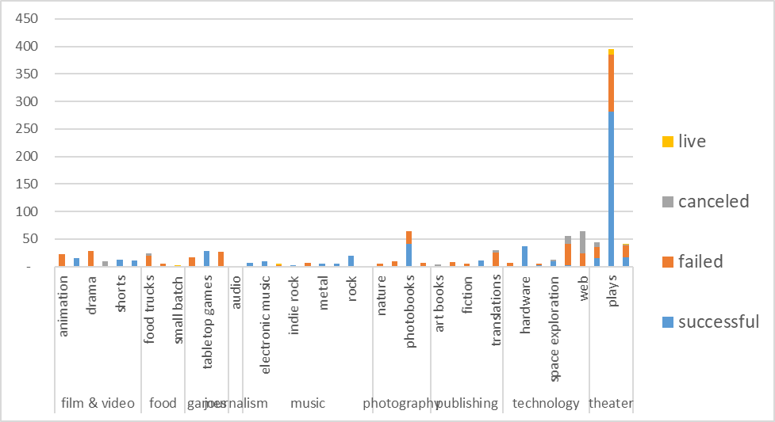

World Excluding US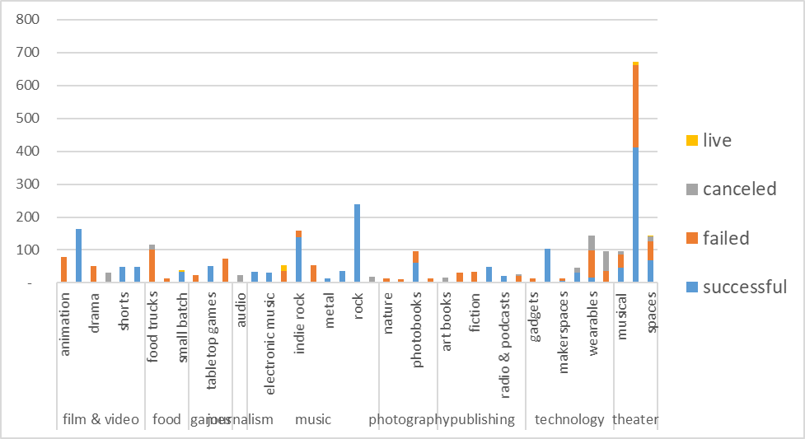

1. What are some limitations of this dataset?
   1. Would be helpful to know the state of the submission: were they proposals or completed products that already had been developed?
   2. Would be good to know “who” submitted the proposal, so that we could look for trends:
      1. Identify someone who is good and consistent in meeting their funding
      2. Identify others who submit consistently bad proposals and skew what may be a good category otherwise.
2. What are some other possible tables and/or graphs that we could create?
   1. Percent Successful by year and look for trends year-over-year
      1. Is there an upward trend where more submissions per year for a specific category are successful?
      2. Is there a perceived Failed category, but it is now improving and could be an opportunity for investment?
   2. Look at success rates by countries to see if any particular country does better that others for a specific category, and then discover “why?”
   3. Get the details on “Staff picks” and “Spotlight” and see if these provide insight into potential winners as an opportunity.