**ScreenShot of quickdatabasediagrams.com output (note: full screenshot at end of this document)**

**ERD Portion**

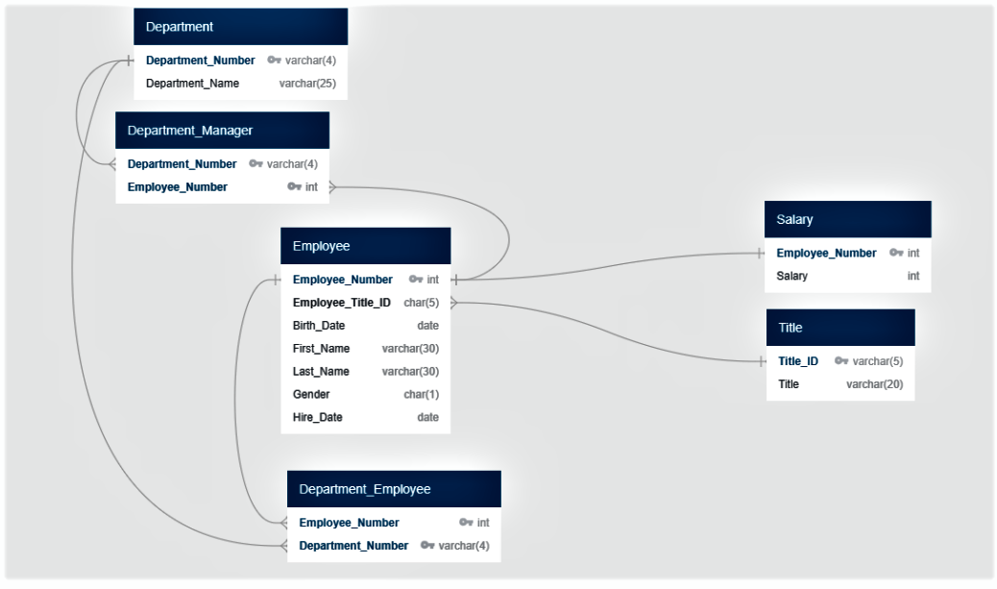

(Next pages – code screen and copy paste of code)

**Code Portion**

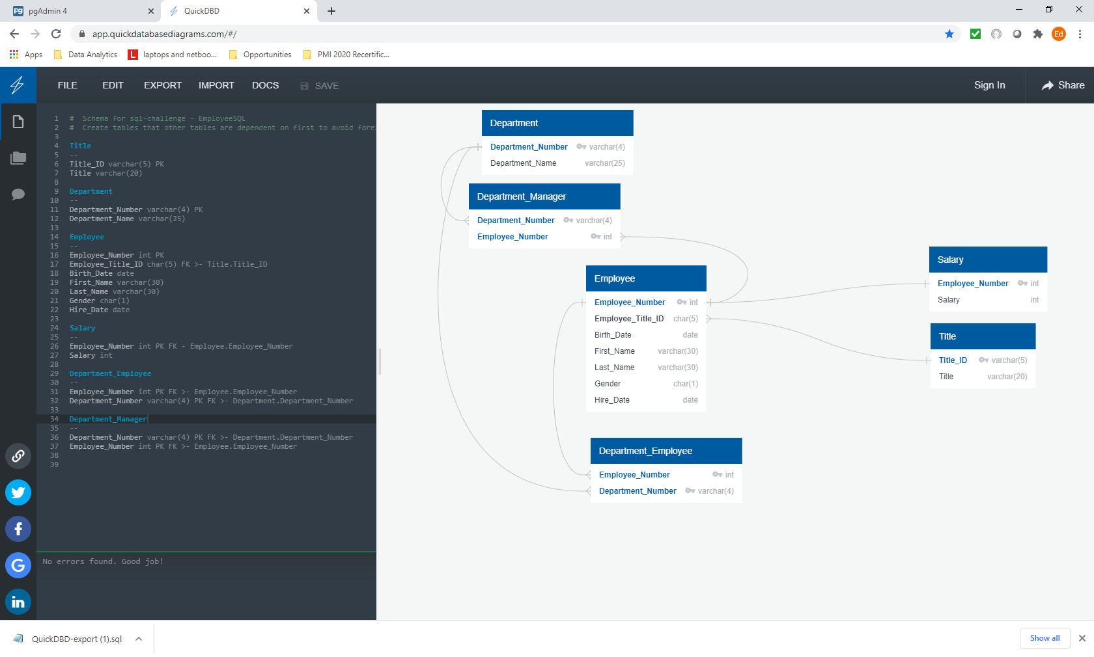

**CODE to Generate the Diagram above**

# Schema for sql-challenge - EmployeeSQL

# Create tables that other tables are dependent on first to avoid foreign key creation in dependent tables

Title

--

Title_ID varchar(5) PK

Title varchar(20)

Department

--

Department_Number varchar(4) PK

Department_Name varchar(25)

Employee

--

Employee_Number int PK

Employee_Title_ID char(5) FK >- Title.Title_ID

Birth_Date date

First_Name varchar(30)

Last_Name varchar(30)

Gender char(1)

Hire_Date date

Salary

--

Employee_Number int PK FK - Employee.Employee_Number

Salary int

Department_Employee

--

Employee_Number int PK FK >- Employee.Employee_Number

Department_Number varchar(4) PK FK >- Department.Department_Number

Department_Manager

--

Department_Number varchar(4) PK FK >- Department.Department_Number

Employee_Number int PK FK >- Employee.Employee_Number

**Full Screen Shot – all components**

