**TDS- Temperature Offset Calculation**

The offset value at specific temperatures has been determined based on the **Error rate versus Set temperature** (Refer file AvgErrorValue.xlsx).

With respect to Linear Equation of **Error rate (Y) Vs Set Temperature (X)**:

**Y = ( -0.0258(X) ) + 0.7879**

Y = Avg Error for Set temperature

X = Temperature measured from sensor

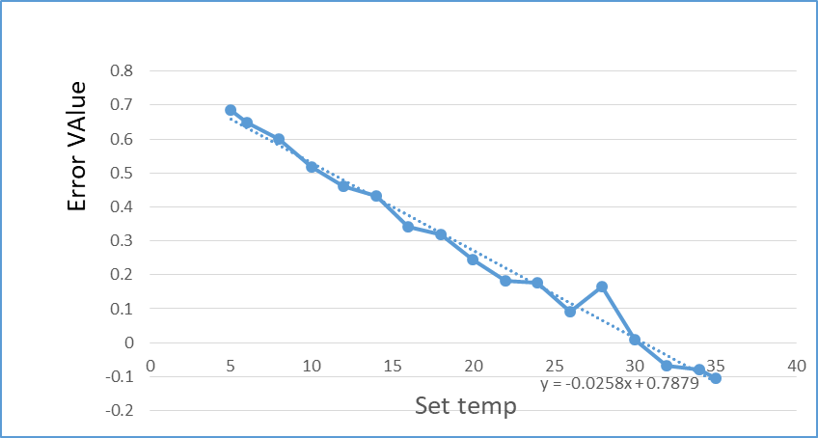

**Offset Value**:

**Offset value = ( -0.0258 * Raw_temperature ) + 0.7879**.

Raw_temperature = Temperature measured from sensor

**Calculating Temperature after Calibration**:

**Calibrated Temperature Value = Raw _temperature – Offset value**

**= Raw_temperature – ( -0.0258 * Raw_temperature + 0.7879)**

**Examples:**

**Raw_temperature = 1:**

Calibrated Temperature Value = 1 - (-0.0258 * 1 + 0.7879)

= 1 - (-0.0258 + 0.7879)

= 1 - 0.7621

= 0.2379

**Raw_temperature = 3.3:**

Calibrated Temperature = 3.3 - (-0.0258 * 3.3 + 0.7879)

= 3.3 - (-0.08514 + 0.7879)

= 3.3 - 0.70276

= 2.59724

**Raw_temperature = 7.5:**

Calibrated Temperature = 7.5 - (-0.0258 * 7.5 + 0.7879)

= 7.5 - (-0.1935 + 0.7879)

= 7.5 - 0.5944

= 6.9056

**Raw_temperature = 13.9:**

Calibrated Temperature = 13.9 - (-0.0258 * 13.9 + 0.7879)

= 13.9 - (-0.35802 + 0.7879)

= 13.9 - 0.42912

= 13.47088

**Raw_temperature = 18:**

Calibrated Temperature = 18 - (-0.0258 * 18 + 0.7879)

= 18 - (-0.4644 + 0.7879)

= 18 - 0.3235

= 17.6765

**Raw_temperature = 23.5:**

Calibrated Temperature = 23.5 - (-0.0258 * 23.5 + 0.7879)

= 23.5 - (-0.6063 + 0.7879)

= 23.5 - 0.1816

= 23.3184

**Raw_temperature = 33:**

Calibrated Temperature = 33 - (-0.0258 * 33 + 0.7879)

= 33 - (-0.8514 + 0.7879)

= 33 - 0.0635

= 32.9365

**Raw_temperature = 40:**

Calibrated Temperature = 40 - (-0.0258 * 40 + 0.7879)

= 40 - (-1.032 + 0.7879)

= 40 - (-0.2441)

**Temperature Calculation For Each Slaves:**

* Slave 1 Offset Equation : y = -0.0542x + 0.7984
* Slave 2 Offset Equation : y = -0.0607x + 0.5258
* Slave 3 Offset Equation : y = -0.0495x + 0.8077
* Slave 4 Offset Equation : y = -0.0667x + 0.555
* Slave 5 Offset Equation : y = -0.0387x + 0.7965
* Slave 6 Offset Equation : y = -0.0476x + 0.7092
* Slave 7 Offset Equation : y = -0.0462x + 0.6916
* Slave 8 Offset Equation : y = -0.0351x + 0.6391
* Slave 9 Offset Equation : y = -0.0488x + 0.5956
* Slave 10 Offset Equation : y = -0.0578x + 0.7333
* Slave 11 Offset Equation : y = -0.0509x + 0.6789
* Slave 12 Offset Equation : y = -0.0487x + 0.6869
* Slave 13 Offset Equation : y = -0.0574x + 0.8361
* Slave 14 Offset Equation : y = -0.043x + 0.5225
* Slave 15 Offset Equation : y = -0.0408x + 0.5369
* Slave 16 Offset Equation : y = -0.0512x + 0.7473
* Slave 17 Offset Equation : y = -0.0506x + 0.9799
* Slave 18 Offset Equation : y = -0.0495x + 0.7756
* Slave 19 Offset Equation : y = -0.0516x + 0.7678
* Slave 20 Offset Equation : y = -0.0543x + 0.6311
* Slave 21 Offset Equation : y = -0.0504x + 0.8102
* Slave 22 Offset Equation : y = -0.0503x + 0.7073
* Slave 23 Offset Equation : y = -0.0523x + 0.9299
* Slave 24 Offset Equation : y = -0.0551x + 0.8156
* Slave 25 Offset Equation : y = -0.0535x + 0.9058