**TDS- Temperature Offset Calculation**

The offset value at specific temperatures has been determined based on the **Error rate versus Set temperature** (Refer file AvgErrorValue.xlsx).

With respect to Linear Equation of **Error rate (Y) Vs Set Temperature (X)**:

**Y = ( -0.0258(X) ) + 0.7879**

Y = Avg Error for Set temperature

X = Temperature measured from sensor

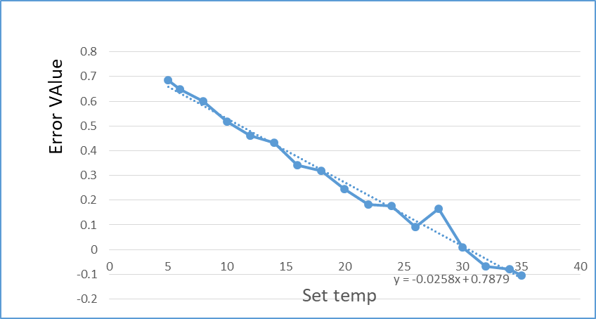

**Offset Value**:

**Offset value = ( -0.0258 * Raw_temperature ) + 0.7879**.

Raw_temperature = Temperature measured from sensor

**Calculating Temperature after Calibration**:

**Calibrated Temperature Value = Raw _temperature – Offset value**

**= Raw_temperature – ( -0.0258 * Raw_temperature + 0.7879)**

**Examples:**

**Raw_temperature = 1:**

Calibrated Temperature Value = 1 - (-0.0258 * 1 + 0.7879)

= 1 - (-0.0258 + 0.7879)

= 1 - 0.7621

= 0.2379

**Raw_temperature = 3.3:**

Calibrated Temperature = 3.3 - (-0.0258 * 3.3 + 0.7879)

= 3.3 - (-0.08514 + 0.7879)

= 3.3 - 0.70276

= 2.59724

**Raw_temperature = 7.5:**

Calibrated Temperature = 7.5 - (-0.0258 * 7.5 + 0.7879)

= 7.5 - (-0.1935 + 0.7879)

= 7.5 - 0.5944

= 6.9056

**Raw_temperature = 13.9:**

Calibrated Temperature = 13.9 - (-0.0258 * 13.9 + 0.7879)

= 13.9 - (-0.35802 + 0.7879)

= 13.9 - 0.42912

= 13.47088

**Raw_temperature = 18:**

Calibrated Temperature = 18 - (-0.0258 * 18 + 0.7879)

= 18 - (-0.4644 + 0.7879)

= 18 - 0.3235

= 17.6765

**Raw_temperature = 23.5:**

Calibrated Temperature = 23.5 - (-0.0258 * 23.5 + 0.7879)

= 23.5 - (-0.6063 + 0.7879)

= 23.5 - 0.1816

= 23.3184

**Raw_temperature = 33:**

Calibrated Temperature = 33 - (-0.0258 * 33 + 0.7879)

= 33 - (-0.8514 + 0.7879)

= 33 - 0.0635

= 32.9365

**Raw_temperature = 40:**

Calibrated Temperature = 40 - (-0.0258 * 40 + 0.7879)

= 40 - (-1.032 + 0.7879)

= 40 - (-0.2441)