**TDS - Temperature Offset Calculation**

The offset value at specific temperatures has been determined based on the **Error rate versus Set temperature** (Refer file AvgErrorValue.xlsx).

With respect to Linear Equation of **Error rate (Y) Vs Set Temperature (X)**:

**Y = ( -0.0258(X) ) + 0.7879**

Y = Avg Error for Set temperature

X = Temperature measured from sensor

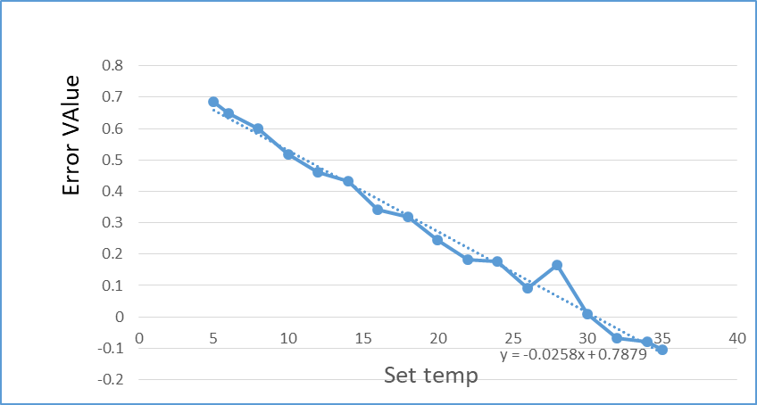

**Offset Value**:

**Offset value = ( -0.0258 * Raw_temperature ) + 0.7879**.

Raw_temperature = Temperature measured from sensor

**Calculating Temperature after Calibration**:

**Calibrated Temperature Value = Raw _temperature – Offset value**

**= Raw_temperature – ( -0.0258 * Raw_temperature + 0.7879)**

**Temperature Calculation For Each Slaves:**

The Offset value at specific Temperatures for each Slaves has been determined based on the **Error rate versus Set temperature** (Refer file *AvgErrorPerSlave*.*xlsx*)

**Offset Linear Equations of each Slaves:**

Slave 1 Offset Equation : y = -0.0542x + 0.7984

Slave 2 Offset Equation : y = -0.0607x + 0.5258

Slave 3 Offset Equation : y = -0.0495x + 0.8077

Slave 4 Offset Equation : y = -0.0667x + 0.555

Slave 5 Offset Equation : y = -0.0387x + 0.7965

Slave 6 Offset Equation : y = -0.0476x + 0.7092

Slave 7 Offset Equation : y = -0.0462x + 0.6916

Slave 8 Offset Equation : y = -0.0351x + 0.6391

Slave 9 Offset Equation : y = -0.0488x + 0.5956

Slave 10 Offset Equation : y = -0.0578x + 0.7333

Slave 11 Offset Equation : y = -0.0509x + 0.6789

Slave 12 Offset Equation : y = -0.0487x + 0.6869

Slave 13 Offset Equation : y = -0.0574x + 0.8361

Slave 14 Offset Equation : y = -0.043x + 0.5225

Slave 15 Offset Equation : y = -0.0408x + 0.5369

Slave 16 Offset Equation : y = -0.0512x + 0.7473

Slave 17 Offset Equation : y = -0.0506x + 0.9799

Slave 18 Offset Equation : y = -0.0495x + 0.7756

Slave 19 Offset Equation : y = -0.0516x + 0.7678

Slave 20 Offset Equation : y = -0.0543x + 0.6311

Slave 21 Offset Equation : y = -0.0504x + 0.8102

Slave 22 Offset Equation : y = -0.0503x + 0.7073

Slave 23 Offset Equation : y = -0.0523x + 0.9299

Slave 24 Offset Equation : y = -0.0551x + 0.8156

Slave 25 Offset Equation : y = -0.0535x + 0.9058

**Examples:**

**Y = Calibrated Temperature**

**X = Raw temperature**

**For Slave 1:**

For x = 10:

y = -0.0542 * 10 + 0.7984

y = -0.542 + 0.7984

y = 0.2564

For x = 20:

y = -0.0542 * 20 + 0.7984

y = -1.084 + 0.7984

y = -0.2856

**For Slave 2:**

For x = 15:

y = -0.0607 * 15 + 0.5258

y = -0.9105 + 0.5258

y = -0.3847

For x = 25:

y = -0.0607 * 25 + 0.5258

y = -1.5175 + 0.5258

y = -0.9917

**For Slave 3:**

For x = 5:

y = -0.0495 * 5 + 0.8077

y = -0.2475 + 0.8077

y = 0.5602

For x = 30:

y = -0.0495 * 30 + 0.8077

y = -1.485 + 0.8077

y = -0.6773

**For Slave 6:**

For x = 8:

y = -0.0476 * 8 + 0.7092

y = -0.3808 + 0.7092

y = 0.3284

For x = 35:

y = -0.0476 * 35 + 0.7092

y = -1.666 + 0.7092

y = -0.9568

**For Slave 7:**

For x = 12:

y = -0.0462 * 12 + 0.6916

y = -0.5544 + 0.6916

y = 0.1372

For x = 28:

y = -0.0462 * 28 + 0.6916

y = -1.2956 + 0.6916

y = -0.604

**For Slave 15:**

For x = 3:

y = -0.0408 * 3 + 0.5369

y = -0.1224 + 0.5369

y = 0.4145

For x = 38:

y = -0.0408 * 38 + 0.5369

y = -1.5504 + 0.5369

y = -1.0135

**For Slave 16:**

For x = 18:

y = -0.0512 * 18 + 0.7473

y = -0.9216 + 0.7473

y = -0.1743

For x = 32:

y = -0.0512 * 32 + 0.7473

y = -1.6384 + 0.7473

y = -0.8911

**For Slave 20:**

For x = 1:

y = -0.0543 * 1 + 0.6311

y = -0.0543 + 0.6311

y = 0.5768

For x = 40:

y = -0.0543 * 40 + 0.6311

y = -2.172 + 0.6311

y = -1.5409

**For Slave 24:**

For x = 4:

y = -0.0551 * 4 + 0.8156

y = -0.2204 + 0.8156

y = 0.5952

For x = 39:

y = -0.0551 * 39 + 0.8156

y = -2.1459 + 0.8156

y = -1.3303

**For Slave 25:**

For x = 6:

y = -0.0535 * 6 + 0.9058

y = -0.321 + 0.9058

y = 0.5848

For x = 36:

y = -0.0535 * 36 + 0.9058

y = -1.926 + 0.9058

y = -1.0202