**TDS – Depth Calculation**

**1. Calculation of Depth of Sensors with Pressure Sensors:-**

Sea level pressure – 1 bar

Depth = (Pressure - Atmospheric Pressure) * 10

Where:

Depth: Depth in meters

Pressure: Pressure reading from the sensor in bars

Atmospheric Pressure: Atmospheric pressure in bars (typically around 1.01325 bars)

Pressure Change per 10 Meters: Rate of pressure change with respect to depth, expressed in bars per 10 meters (customarily set to 1.0 bar/10m)

**2. Calcultion of Depth of Senors without Pressure Senosrs:-**

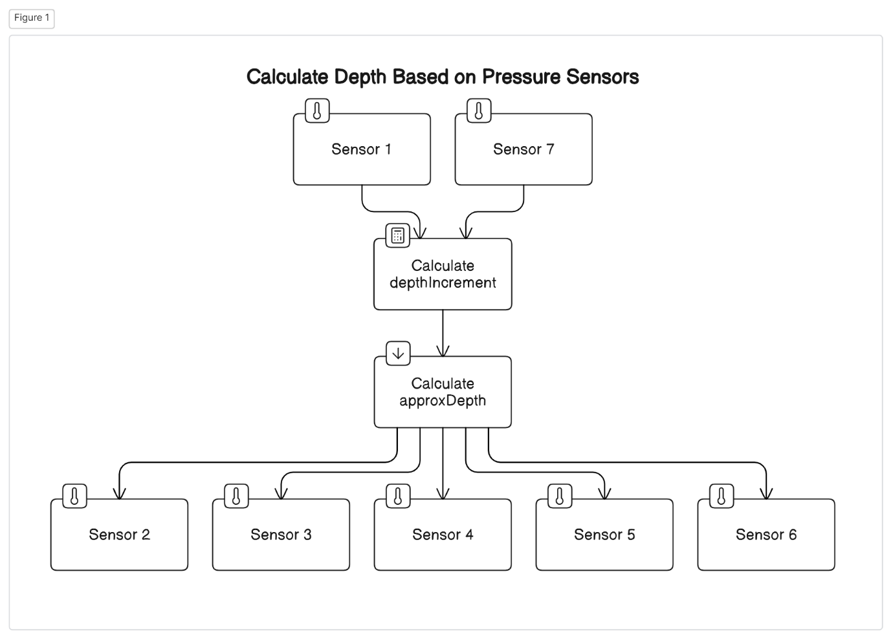

**Depth Increment Calculation:**

Depth Increment = (ending Depth – starting Depth) / (number of Sensors Between + 1)

**Approximate Depth Calculation**:

approxDepth = startingDepth + (depthIncrement * j) // j -> slave index

endingDepth = depth of 2nd pressure sensor

startingDepth = depth of 1st pressure sensor

**Examples:-**

**Case-A:**

**Sensors are in Straight line:**

Total Distance Between sensor 1 ad sensor 25 is 65 meters

**For sensors between 1st and 7th:**

Starting depth: Let's say the starting depth is X = 1 meter.

Ending depth: Let's say the ending depth is Y = 16 meters.

Number of sensors between 1st and 7th = 5 sensors

Depth increment: (Y - X) / (5 + 1) = (16 - 1) / (5 + 1) = 15 / 6 = 2.5 meters

Approximate depths for sensors 2 to 6:

Sensor 2: 1 + 2.5 = 3.5 meters

Sensor 3: 3.5 + 2.5 = 6 meters

Sensor 4: 6 + 2.5 = 8.5 meters

Sensor 5: 8.5 + 2.5 = 11 meters

Sensor 6: 11 + 2.5 = 13.5 meters

This gives us the approximate depths for sensors 2 to 6 between sensor 1 and sensor 7.

**For sensors between 7th and 13th:**

Starting depth: 16 meters

Ending depth: Let's say the ending depth is 32 meters.

Number of sensors between: 13 - 7 - 1 = 5 sensors

Depth increment: (32 - 16) / (5 + 1) = 16 / 6 = 2.67 meters

Approximate depths for sensors 8 to 12:

Sensor 8: 16 + 2.67 = 18.67 meters

Sensor 9: 18.67 + 2.67 = 21.34 meters

Sensor 10: 21.34 + 2.67 = 24.01 meters

Sensor 11: 24.01 + 2.67 = 26.68 meters

Sensor 12: 26.68 + 2.67 = 29.35 meters

**For sensors between 13th and 19th:**

Starting depth: Let's say the starting depth is 32 meters.

Ending depth: Let's say the ending depth is 48 meters.

Number of sensors between: 19 - 13 - 1 = 5 sensors

Depth increment: (48 - 32) / (5 + 1) = 16 / 6 = 2.67 meters

Approximate depths for sensors 14 to 18:

Sensor 14: 32 + 2.67 = 34.67 meters

Sensor 15: 34.67 + 2.67 = 37.34 meters

Sensor 16: 37.34 + 2.67 = 40.01 meters

Sensor 17: 40.01 + 2.67 = 42.68 meters

Sensor 18: 42.68 + 2.67 = 45.35 meters

**For sensors between 19th and 25th:**

Starting depth: Let's say the starting depth is 48 meters.

Ending depth: Let's say the ending depth is 65 meters.

Number of sensors between: 25 - 19 - 1 = 5 sensors

Depth increment: (65 - 48) / (5 + 1) = 17 / 6 ≈ 2.83 meters

Approximate depths for sensors 20 to 24:

Sensor 20: 48 + 2.83 = 50.83 meters

Sensor 21: 50.83 + 2.83 = 53.66 meters

Sensor 22: 53.66 + 2.83 = 56.49 meters

Sensor 23: 56.49 + 2.83 = 59.32 meters

Sensor 24: 59.32 + 2.83 = 62.15 meters

These calculations give us approximate depths for each sensor within the specified ranges.

**Case-B:**

**Sensors are inclined:-**

Distance between sensor 1 and sensor 25 is 50 meters

**For sensors between 1st and 7th:**

Starting depth(X): 1 meter

Ending depth(Y): 12.5 meters

Number of sensors between 1st and 7th : 7 - 1 - 1 = 5 sensors

Depth increment: (Y - X) / (5 + 1) = (12.5 - 1) / (5 + 1) = 11.5 / 6 ≈ 1.9167 meters

Approximate depths for sensors 2 to 6:

Sensor 2: 1 + 1.9167 ≈ 2.9167 meters

Sensor 3: 2.9167 + 1.9167 ≈ 4.8334 meters

Sensor 4: 4.8334 + 1.9167 ≈ 6.75 meters

Sensor 5: 6.75 + 1.9167 ≈ 8.6667 meters

Sensor 6: 8.6667 + 1.9167 ≈ 10.5834 meters

**For sensors between 7th and 13th:**

Starting depth: 12.5 meters

Ending depth: 25 meters

Number of sensors between: 13 - 7 - 1 = 5 sensors

Depth increment: (25 - 12.5) / (5 + 1) = 12.5 / 6 ≈ 2.0833 meters

Approximate depths for sensors 8 to 12:

Sensor 8: 12.5 + 2.0833 ≈ 14.5833 meters

Sensor 9: 14.5833 + 2.0833 ≈ 16.6666 meters

Sensor 10: 16.6666 + 2.0833 ≈ 18.75 meters

Sensor 11: 18.75 + 2.0833 ≈ 20.8333 meters

Sensor 12: 20.8333 + 2.0833 ≈ 22.9166 meters

**For sensors between 13th and 19th:**

Starting depth: 25 meters

Ending depth: 37.5 meters

Number of sensors between: 19 - 13 - 1 = 5 sensors

Depth increment: (37.5 - 25) / (5 + 1) = 12.5 / 6 ≈ 2.0833 meters

Approximate depths for sensors 14 to 18:

Sensor 14: 25 + 2.0833 ≈ 27.0833 meters

Sensor 15: 27.0833 + 2.0833 ≈ 29.1666 meters

Sensor 16: 29.1666 + 2.0833 ≈ 31.25 meters

Sensor 17: 31.25 + 2.0833 ≈ 33.3333 meters

Sensor 18: 33.3333 + 2.0833 ≈ 35.4166 meters

**For sensors between sensor 19th and sensor 25th:**

Starting depth: 37.5 meters

Ending depth: 50 meters

Number of sensors between: 25 - 19 - 1 = 5 sensors

Depth increment: (50 - 37.5) / (5 + 1) = 12.5 / 6 ≈ 2.0833 meters

Approximate depths for sensors 20 to 24:

Sensor 20: 37.5 + 2.0833 ≈ 39.5833 meters

Sensor 21: 39.5833 + 2.0833 ≈ 41.6666 meters

Sensor 22: 41.6666 + 2.0833 ≈ 43.75 meters

Sensor 23: 43.75 + 2.0833 ≈ 45.8333 meters

Sensor 24: 45.8333 + 2.0833 ≈ 47.9166 meters

These calculations give us the approximate depths for sensors between each pair of sensors.