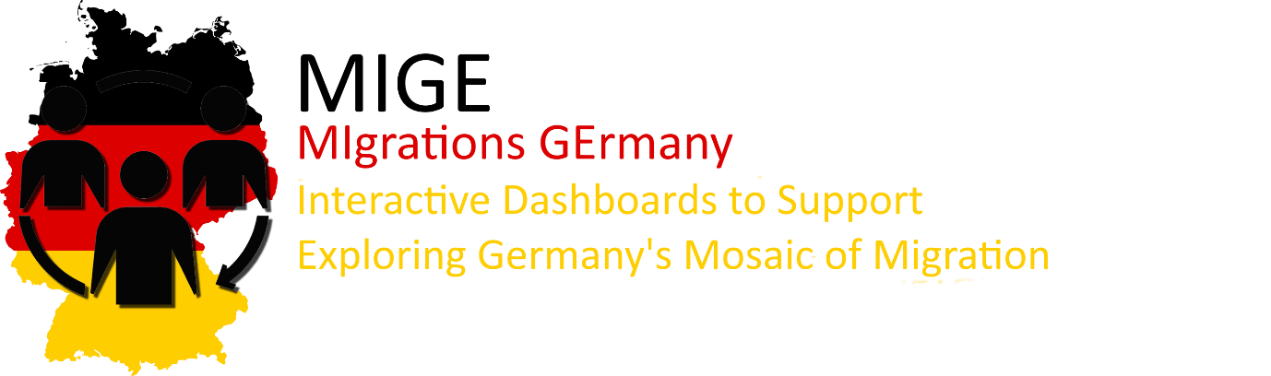

WS 2022/23

Department of Geoinformatics Z_GIS

SDI Services Implementation IP

Supervisors: Eva-Maria Steinbacher & Manfred Mittlböck

**MIGE**   
**MI**grations **GE**rmany

Project leaders:

Martin Stobbelaar – 12131617  
Edah Sahinovic – 12047186

February 15th 2023

Table of Content

1. Introduction 3

Purpose 4

2. Project Management 5

2.1. Work Packages 5

2.2. Time Management 6

2.3. GitLab Documentation 7

3. Data Sources 8

3.1. Data Acquisition 8

3.2. Data Preprocessing 9

3.2.1. Nomenclature of territorial units for statistics (NUTS) for spatial linking 10

3.2.2. Migration between the federal states of Germany (intracountry movements) 10

3.2.3. Migrations between Germany and abroad (intercountry movements) 10

3.2.4. Natural Growth and migration balance 11

3.2.5. EU Population 12

4. Open GIS Architecture 13

4.1. Data integration and implementation into a spatial database 14

4.2. Publishing spatial services 15

4.3. Visualization of migration in Germany using dashboards 16

4.3.1. Intercountry migration 16

4.3.2. Intracountry migration 17

4.3.3. Population change 18

5. Metadata 19

6. Conclusion 20

7. References 21

# 1. Introduction

Human beings have been moving to new and distant locations since the beginning of human history, transforming the demographic makeup of lands and continents, as well as the ethnic, linguistic, and racial compositions of their populations. Migrations have occurred at various scales, numbers, and for different reasons, ranging from specific ethnolinguistic groups seeking better opportunities in advanced lands to entire populations moving from one continent to another.

Today, migration continues to be a complex and multifaceted phenomenon, driven by a variety of reasons, including economic opportunities, housing, war, and natural disasters. This can be seen in the form of internal and international migrations, both voluntary and forced. For example, many people move from rural to urban areas in search of better living standards and economic opportunities, while others may be forced to flee their homes due to conflict or natural disasters.

Regardless of the reasons behind migration, it is a constantly evolving phenomenon, and international organizations are continually monitoring and predicting its numbers and outcomes. Recent estimates suggest that the number of migrants worldwide has been steadily increasing, with migrants comprising 2.3% of the global population in 1970, growing to 3.3% in 2015 (IOM, 2019).

The study of migration in Germany has gained importance in recent decades, as the country has faced various challenges and opportunities associated with immigration. Germany has a long history of immigration, dating back to the post-World War II period when guest workers were recruited to address labor shortages. By investigating the migration processes within Germany, we can gain insights into the challenges and opportunities of immigration, as well as the role that migration can play in shaping the future of Germany and beyond.

To discover the migration in Germany with a geoinformatics kind of view, an interoperable open architecture that can be leveraged by everyone can be established. This architecture is needed when working with all data that needs regular updating. It enables using the data in a spatial context, e.g., displaying data on a map. This architecture consists of a spatial database and GIS services running on an open server. From there on, data can be accessed and used with various end programs.

### Purpose

The aim of this project is to open the used data as an open GIS service. This is done by setting up a spatial data infrastructure with geoservices (like a WFS) running on a server (e.g., Geoserver). With these services running, presenting data with a particular visualization can be established with different tools.

Given that migration numbers are on the rise, it's important to delve deeper into the topic with specific goals in mind. The MIGE project provides a comprehensive approach to this, gathering data, processing it, analyzing it, and presenting it in an interactive and user-friendly manner through dashboards as presentation tools. The purpose is to make this information easily accessible and understandable to the target audience, which includes agencies involved in federal statistics and processes regarding migration, including Germany. This way, statistical agencies and migration organizations will have better overview of their data not only in numbers of who and what but also an intuitive insight of where and when by adding a geospatial context to the data in forms of charts and maps, enhancing the decision-making processes. Our aim is to provide them with dashboards with distinct purposes such as migration inflow and outflow between Germany and countries of European Union as well as migrations between the federal states of Germany. Furthermore, dashboard dedicated to the population change within the country will raise awareness of the importance of immigration to counter the effects of low birth rates and an aging population in the country.

# 2. Project Management

Regarding SDI implementations, project management is one of the core elements that encompasses steps from setting up the goals and defining and decomposing the workflow to achieve these goals. Therefore, we divide project management part into two broad categories, such as work packages and time management.

## 2.1. Work Packages

At the beginning of our project, it was crucial of us to define the workflow of the entire project, identifying critical work packages and outlining the estimated time needed for each work package, along with their subpackages to be done. As presented in the Figure 1., we have identified 5 main work packages that reflect the decomposition of our complete project workflow.

Figure . Work Breakdown Structure containing work packages and their subpackages.

The first work package „Project Management“ presents a kick-off project package where the project team has conceptualized the basis of this project by deciding upon project objectives, defining packages and subpackages as well as defining responsibilities to each (or both) project leaders, agreeing on how to deal with the documentation of the whole project and to conduct a data search in order to clarify if data relevant to our project exists. Second work package „Data Acquisition“ includes all steps from gathering and organizing data into according dataset schemas that will fit the dashboards implementation. Third work package „Data Processing“ includes the processing steps where the irrelevant indicators within the existing data is eliminated and subsequently merged into dataset schemas for which metadata will be created and finally published to the ArcGIS Server. Fourth work package „Dashboards Development“ marks the final technical package of our workflow by setting up the spatial data infrastructures, creating the dashboards that will in most convenient manner present and communicate our findings. Final work package „Project Presentation“ relates to communicating and documenting our results to the public.

For a more detailed overview of aforementioned work packages as well as on a complete project documentation, please refer to our „Project Overview“ PDF [here](https://git.sbg.ac.at/s1081994/ip-gpm/-/blob/main/project_management/Project_Overview_Template_Sahinovic_Stobbelaar.pdf).

## 2.2. Time Management

Time management served as a basis of managing the complete project in a given and reasonable time range, in this case from 2nd of November 2022 to 15th of January 2023. At the project kick-off meeting, project coordinators have estimated the time needed to work on each (sub)package and therefore at the end of our work serves as a reference to validate if our estimations were true for each package. By comparing the initially predetermined against the truly needed time for each package, with minor overdue on several projects, we conclude that our time estimations were in large realistic.

Time management has turned out to be very useful for overall communicating the needs of the project by setting up and monitoring the defined milestones (Figure 2.) which were derived from the previously set Gantt chart (Figure 3.). As both project coordinators have found themselves to deal with this kind of project management for the first time, it gave us insight of how well we performed in initially distributing time within each work package along with validating if the distributed time for each (sub)package was realistic.

Figure . Project timeline as milestones for the MIGE project

Figure . Gann chart for the MIGE project

## 2.3. GitLab Documentation

Side by side with entire work being carried out, our complete progress was documented on GitLab. This included reporting on status of work packages, filing issues, tracking time and changes etc. Beside serving as a progress tracker, it acts as a remote repository for all the crucial files of the project as well as a hub for all those who are interested in the project. Our repository can be reached from [here](https://git.sbg.ac.at/s1081994/ip-gpm).

# 3. Data Sources

Chapter 3 describes the data from its origin to the finished processed tabular form.

## 3.1. Data Acquisition

Finding data which can be used for a spatial data infrastructure can be tricky. The data should be trustworthy and have some easy possibility to be spatially enabled (e.g., using ISO codes). This makes this step automatically essential and very important as it is the basis for the architecture and thus the visualization in the end.

Data sources for our project were fairly easy and straightforward to find as indicators such as population migration, population per administrative unit and natural growth are base indicators collected by statistical agencies. As our project goals include representation of migrations and their effect on demographic balance of the federal states of Germany, we have identified in total five individual datasets as presented in Table 1.

Table . Identified datasets for the MIGE project

|  |  |  |
| --- | --- | --- |
| **Dataset** | **Format** | **URL source** |
| Nomenclature of territorial units for statistics (NUTS) | Shapefile | <https://ec.europa.eu/eurostat/web/gisco/geodata/reference-data/administrative-units-statistical-units/nuts#main-content> |
| Migration between the federal states of Germany | Spreadsheet | <https://www-genesis.destatis.de/genesis/online?operation=table&code=12711-0022&bypass=true&levelindex=1&levelid=1673348732948#abreadcrumb> |
| Migrations between Germany and abroad | Spreadsheet | <https://www-genesis.destatis.de/genesis/online?operation=table&code=12711-0009&bypass=true&levelindex=0&levelid=1673345237634#abreadcrumb> |
| Natural growth, migration balance | Spreadsheet | <https://ec.europa.eu/eurostat/databrowser/view/DEMO_R_GIND3__custom_4611398/default/table?lang=de> |
| EU population | Spreadsheet | <https://ec.europa.eu/eurostat/databrowser/view/tps00001/default/table?lang=en> |

Before joining and spatially enabling the four datasets mentioned in the table above, data preprocessing was performed to transpose cell content, clean unused columns and add the NUTS code to subsequently link the datasets, which then can be linked with the NUTS shapefile that is linked on top of the table. The output format is also in a shapefile format.

## 3.2. Data Preprocessing

After acquiring the needed data, it has to be modified and altered for it to be published to the database. This is done in a spreadsheet tool where data is cleaned, columns are transposed and saved as a finished tabular data. For spatially enabling the data by joining it with spatial dataset (administrative borders) a [python](https://git.sbg.ac.at/s1081994/ip-gpm/-/blob/main/Python/merge_data.py) script could be used. Figure 4 shows the general preprocessing steps.

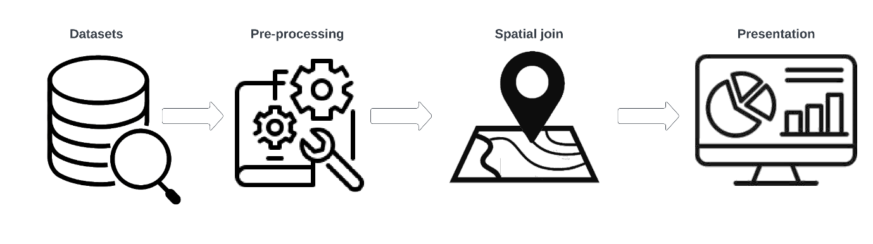

Figure . -Generalized overview of data preparation

As previously mentioned, before conjoining the spreadsheets, preprocessing steps were undertaken to best fit the dataset schema necessary for the dashboards. Therefore, for the ArcGIS Dashboards representation spreadsheets need to be merged within the shapefiles while for the ArcGIS Insights these two formats are imported separately and subsequently related within the software to create a new dataset representation. Excel was used to manually refine the spreadsheets.

For easier overview of (pre)processing steps of initial data sources, their relations and visualization software, Figure 5. depicts the implementation steps.

Figure . Simplified workflow from data to presentation tier

### 3.2.1. Nomenclature of territorial units for statistics (NUTS) for spatial linking

*Nomenclature of territorial units for statistics (NUTS)* shapefile datasetconsists of multipart polygon topology reflecting the statistical regions of European Union divided into four hierarchical levels. For the purposes of spatially enabling the acquired spreadsheets, it is split into two datasets: NUTS 0 coinciding with national boundaries and NUTS 1 consisting of major socio-economic regions.

### 3.2.2. Migration between the federal states of Germany (intracountry movements)

Theoriginal dataset contained columns that seem irrelevant to the scope of the study, specifically the division of migrations between German and non-German settlers. Second, the year of migration and origin and destination states were decomposed into distinct columns. Additionally, the inclusion of NUTS codes served to establish a clear link between countries of origin and destination.

Figure . Raw intracountry movements spreadsheet

Figure . Sample of preprocessed intracountry movements spreadsheet

### 3.2.3. Migrations between Germany and abroad (intercountry movements)

The original dataset is structured like all data downloaded from destatis.genisis. As can be seen in figure 8, years were in distinct columns and indicators (inbound, outbound and balance) were stored in the same column.

Ein Bild, das Tisch enthält.

Figure . Sample of raw data of movements between Germany and EU countries

NUTS codes were added manually for each country (for joining data with shapefile), indicators were transposed in separate columns and years were transposed to one column (see figure 9).

Ein Bild, das Tisch enthält.

Figure . Sample of preprocessed intercountry migration dataset

### 3.2.4. Natural Growth and migration balance

The original natural growth and migration balance dataset had separate columns for each year, which were later transformed into a single column for easier linking with a shapefile in ArcGIS Insights. The migration balance on a NUTS 1 level was filtered to the federal states of Germany.

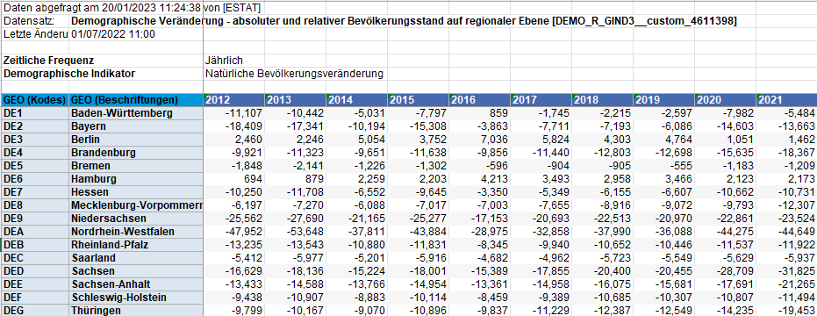

Figure . Raw natural growth spreadsheet

Figure . Sample of preprocessed natural growth spreadsheet

### 3.2.5. EU Population

This dataset was downloaded to add to the intercountry migration dataset, as an additional information in popups or other additional data visualization. As with the natural growth data, data for each year was in different columns. These values were transposed and added to the intercountry migration dataset (see figure 12). Additionally English country names were added.

Ein Bild, das Tisch enthält.

Figure . Processed population and intercountry migration dataset

# 4. Open GIS Architecture

We want to build a spatial data infrastructure which helps integrating data in a standardized spatial database. From thereon, the data can be distributed as several open geoservices on a spatial server. The portal is a interface for manipulating the data on the server via the web. The general architecture structure of the project can be seen in figure 13.

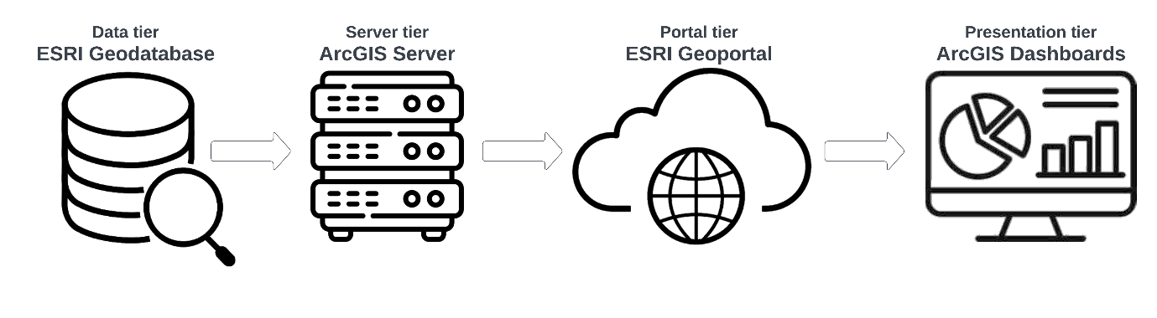

Figure . -General architecture overview

As a spatial data infrastructure, we have decided to work within the ESRI ecosystem as most of the SDI components for both of us were touched upon for the first time. As a single ecosystem ensures unhindered interoperability between its components and provides resourceful documentation for each part of the architecture, ESRI deemed as a valid choice. The architecture pipeline is depicted in detail in Figure 14, starting from the identification of datasets which undergo various transformations before being visualized using tools such as ArcGIS Dashboards and [Insights](https://www.esri.com/en-us/arcgis/products/arcgis-insights/overview). In the subsequent chapters, we will delve into each component of the SDI and its specific function in detail.

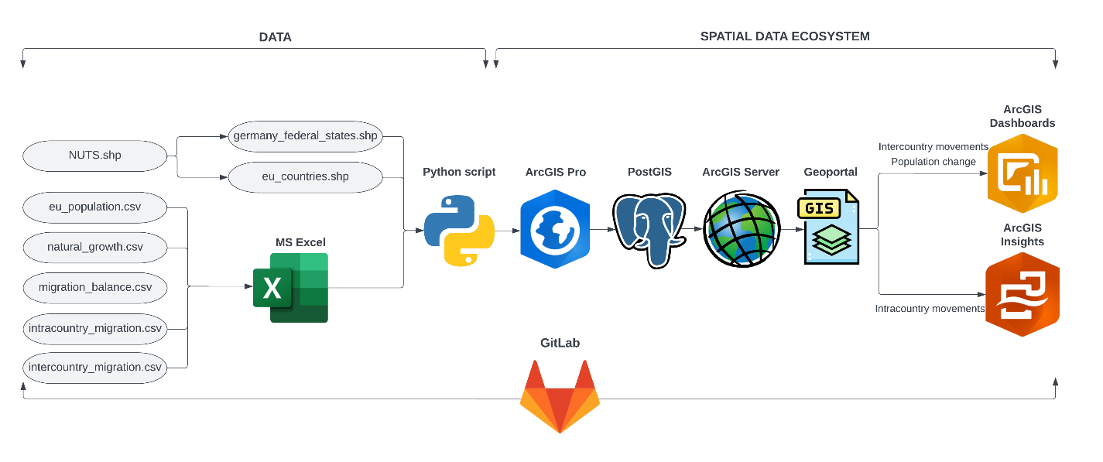

Figure . SDI architecture overview

## 4.1. Data integration and implementation into a spatial database

After the preprocessing steps of each identified dataset is done in a spreadsheet solution (excel), the next step is importing and integrating the data within a GIS program to the spatial database. As presented in the Figure 4., datasets such as *intercountry_movements* and *population_change* shapefiles are derivates of first most identified spatial and non-spatial datasets that were joined together using a custom python script as the *one to many* join function in ArcGIS Pro did not work. The python script can be seen in figure 15, additionally a link to the Gitlab resource can be found [here](https://git.sbg.ac.at/s1081994/ip-gpm/-/blob/main/Python/merge_data.py). The script uses the modules pandas and geopandas. First the data is loaded in using the modules, then only selected columns will be kept. Using the merge function of pandas the two datasets are joined using the NUTS_ID. The joined data is saved as a new shapefile.

Ein Bild, das Text enthält.

Figure . - Python code for joining excel sheets with shapefiles

These joined datasets were imported into the PostGIS database by using the *Feature Class to Feature Class* tool with *PG_GEOMETRY* as a configuration keyword to ensure the PostGIS spatial functions on the data. As previously simplistically presented in the Figure 4., Figure 16. depicts the merging of seven datasets via ArcGIS Pro has resulted into three finished datasets that have furtherly been imported into PostGIS database.

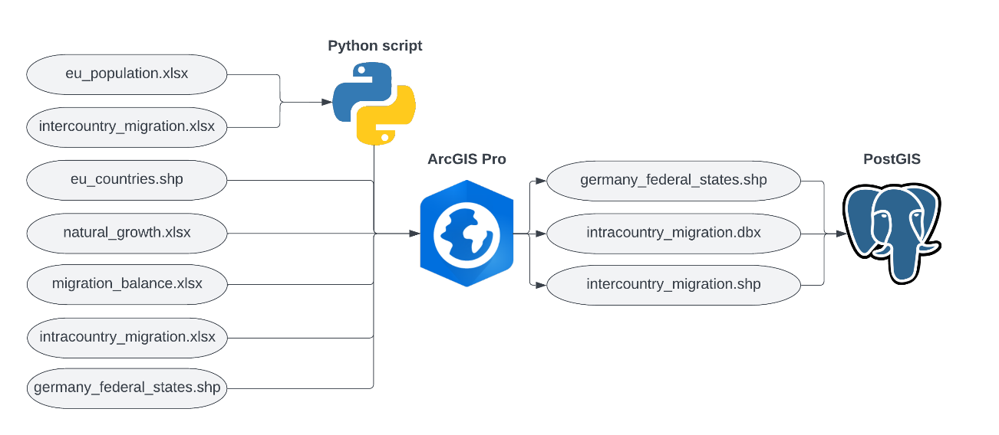

Figure . Integrating and importing the data into PostGIS

## 4.2. Publishing spatial services

The data can be published as geoservices from the database to a spatial server (like geoserver) e.g., with an OGC web feature service, using a GIS program like QGIS. Figure 17 shows the steps of publishing spatial services to a server.

Ein Bild, das Text enthält.

Figure . -Overview of publishing spatial services

Our newly derived datasets stored in the PostGIS database are pushed furtherly to ArcGIS Enterprise via ArcGIS Pro as Web Feature Services (WFS) by sharing it as a web layer. During the publishing process, various properties of the web services were configured such as name, type of services, their constraints, operations etc. These map services will be furtherly visually configured in ArcGIS Enterprise before using them in the presentation tier.

## 4.3. Visualization of migration in Germany using dashboards

With the services running on the geoportal, the data was added to webmaps to create a visualization for the final dashboard. The ESRI platform was chosen as all services are interconnected which makes it easy to build a dashboard. The webmap creation process is important as it defines the look of the dashboard and popups (e.g., when clicking on a country). Without having a webmap it is not possible to create a dashboard using ESRI, as it is the basis for accessing data. When working with insights, the creation of a webmap is not needed as the spatial relationship and visualization is created directly on the platform itself.

### 4.3.1. Intercountry migration

The first dashboard shows the relationship between inbound and outbound migration towards and from Germany and EU countries. It is based on the intercountry_migration.shp dataset.

Following figure shows a sample of the [dashboard](https://zgis.maps.arcgis.com/apps/dashboards/8531c6072efd44d693cb6adf94d22a0f). The map on the right side of the dashboard shows the movements in a cartographic way. The blue colors show countries with high inbound and outbound migration, more yellow countries show a high low relationship (inbound <-> outbound). More turquoise colors show a low high relationship (inbound <-> outbound) and more whitish colors show countries with low migration flows in both directions. On the left side of the dashboard there are two indicators (inbound and outbound) that display number of movements in the selected map extent (also in the selected year). Also on the left side are two pie charts where the distribution between the countries can be seen.

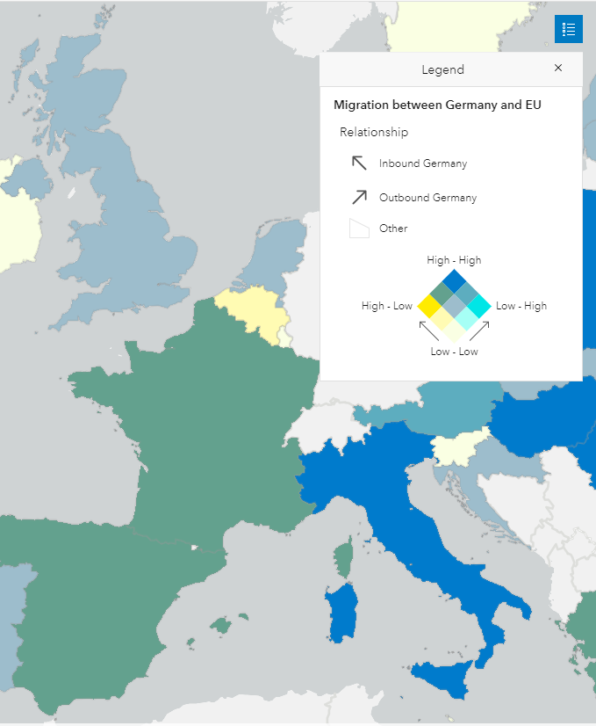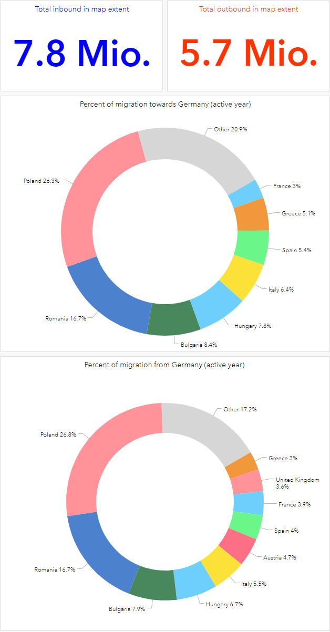

Figure . Sample from intercountry movements dashboard

### 4.3.2. Intracountry migration

The present study sought to provide a comprehensive overview of migration within Germany and to evaluate the capabilities of [ArcGIS Insights](https://www.esri.com/en-us/arcgis/products/arcgis-insights/overview) as a data visualization tool. The software offers a multitude of filters, including the ability to select specific years and federal states of asylum, allowing for a more nuanced examination of migration data. The use of these filters results in dynamic changes in graphical elements, such as maps and graphs, providing a detailed representation of the migration status.

The dashboard design enables a user-friendly exploration of the data through various indicators, including filtering by year, analyzing migration relationships between states of asylum and origin, and visualizing these relationships on a map. This design allows for querying a variety of combinations, such as identifying the top states of migration origin for a specific federal state and determining the top destination states for a monitored state over a defined time period (overall period, single or range of years). The dynamic changes in the map elements further enhance the ability to understand the spatial trends behind migratory patterns, including recurring patterns of migration to neighboring states. A snippet of how the [dashboard](https://geoportal22s.zgis.at/portal/apps/insights/index.html#/view/5fb578e5eff44d779b28178f05989774) looks like is seen in figure 19.

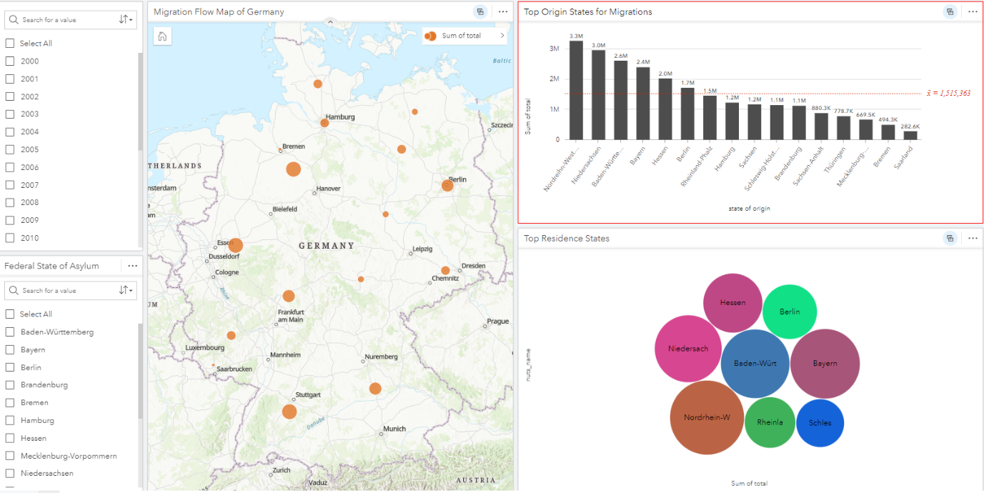

Figure . MIGE Intracountry Movements dashboard design

### 4.3.3. Population change

After having the base dashboards dedicated to migrations between Germany and countries of European Union and migrations within Germany itself set up, we wanted to dive deeper into discovering of how these movements have been affecting Germany for the recorded period. As mentioned in the introductory part, Germany is facing its native population decline due to various factors, demographic transition being one of them. On the other hand, immigration to Germany has been a significant source of population growth, with a large number of people immigrating to the country for work or to seek asylum.

This dashboard provides an analysis of the relationship between natural growth and the migration balance (i.e., migration inflow vs. migration outflow) in each federal state of Germany over the recorded period. The dashboard (figure 20) instantly displays the overall relationship status using charts and a map. The charts on the left and the map on the right showcase the status for each federal state. The elements are interrelated, such that selecting a state in a chart highlights it on the map and filters the migration and natural growth indicator values for that state. The symbology on the map indicates the positive or negative trend of both indicators, or a combination of both. These trends can be monitored for each distinct year by using a filter in the top right corner.

Upon initial examination, the dashboard reveals an overall negative trend in natural growth and positive trend in migration balance for the country on a federal level, where immigrations compensate the loss of the country’s population. For the whole monitored period, Berlin and Hamburg are experiencing positive trends in both indicators, while most of the states are affected by negative natural growth and a positive migration balance.

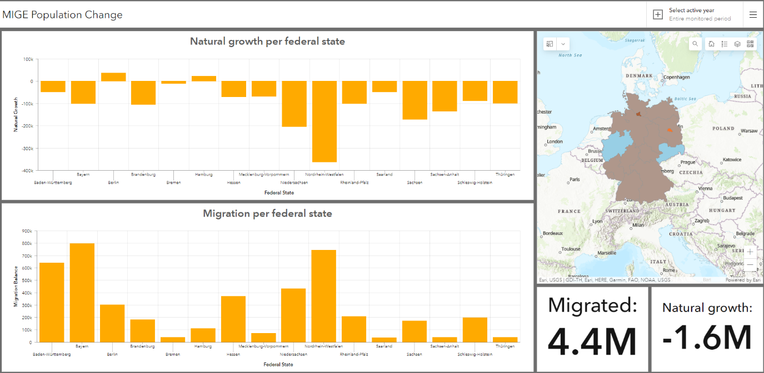

Figure . MIGE Population Change dashboard design

# 5. Metadata

For the metadata creation, the inbuilt functions in ArcGIS Pro were used. For the datasets with NUTS administrative borders as a basis, metadata is available on Eurostat and could be downloaded as an [XML file](https://gisco-services.ec.europa.eu/distribution/v2/nuts/nuts-2021-metadata.xml) ([link to original metadata](https://gisco-services.ec.europa.eu/distribution/v2/nuts/nuts-2021-metadata.pdf) in pdf form) which then is imported into ArcGIS Pro (metadata style must be set to ISO 19139 in the settings).

Depending on the dataset, the imported XML file was edited accordingly. For the data downloaded from Destatis, no metadata could be found, so it was added manually describing it as accurate as possible, using ArcGIS Pro. For the other datasets, the relevant sections of the metadata could be copied and altered for the purpose of the new dataset. After editing the Metadata for each section, it was exported to an XML file (with ISO 19139 style) and to a HTML file which then can easily be transferred to a PDF report. In figure 21, a sample of the metadata editing window in ArcGIS Pro is shown. This process was done for all datasets, before publishing them to the database.

All metadata can be found in the according [Gitlab resource folder](https://git.sbg.ac.at/s1081994/ip-gpm/-/tree/main/metadata).

Ein Bild, das Text enthält.

Figure . - Metadata editing window in ArcGIS Pro

# 6. Conclusion

The main purpose of this project was to create an SDI architecture and understand why this is necessary when working with spatial data that acts as a basis for maps and other visualizations which help describing and explaining data to a specific audience. As an idea of how we would showcase the usage of such an architecture in an interesting way, we came up with this project about migration in Germany.

The solution for this task was to create informative dashboards for stakeholders that detail migrations between the federal states of Germany, as well as the migrations between EU countries and Germany. The integration of geospatial context into migration data enables statistical agencies and migration organizations to obtain a comprehensive overview of when and where individuals relocated, thereby enhancing their decision-making capabilities. By offering easily accessible, interactive dashboards that display relevant information with a geospatial framework, individuals can avoid the need to decipher complicated static and poorly organized tables. This interactive approach, involving a map that modifies its content according to the selected dashboard elements, simplifies and streamlines the process, particularly for those without prior experience in GIS and spatial data infrastructures.

Throughout the course of this project, we became familiar with the workflow of constructing a spatial data infrastructure and designing a dashboard. The project also demonstrated the importance of having a well-defined project plan, which is particularly relevant in terms of time management. Certain aspects of the development process, such as data organization, took longer than anticipated, while others, like dashboard visualization, required less time. Given that almost all components of the project were unfamiliar to both authors, including GitLab and project management workflows, it represented a significant learning opportunity, especially in terms of managing extensive projects.

# 7. References

International Organization for Migration (IOM), 2019. *World migration report 2018*