# Project Overview Document

## Project information

*Please provide important facts for your project, e.g. acronym, title, proposed period, principal investigator and contractor.*

|  |  |  |  |  |
| --- | --- | --- | --- | --- |
| Project | IP SDI | | | |
| Acronym | **MIGE** (**Mi**gration **Ge**rmany) | | | |
| Title | Germany - population migration, anomalies and their causalities | | | |
| Period | Start: | 24.11.2022 | End: | 28.02.2023 |
| Principal investigator(s) | Edah Sahinovic  Martin Stobbelaar | | | |
| Contractor | Manfred Mittlboeck, Eva Steinbacher | | | |

## Document version

|  |  |  |  |  |  |
| --- | --- | --- | --- | --- | --- |
| Nr. | Date | Version | Altered chapters | Type of altering | Author |
| 1 | 24.11.2022 | 1.0 | all | Creation | Martin Stobbelaar |
| 2 | 27.11.2022 | 1.1 | most | Update | Martin Stobbelaar |
| 3 | 28.11.2022 | 1.2 | some | Update | Edah Sahinovic |
| 4 |  |  |  |  |  |
| 5 |  |  |  |  |  |

## Project Content and Project Goals

*Please provide an overview of your project with its main activities. Additionally give some information on the purpose, benefits and target groups as well as the proposed goals of your project. Please also provide explicit information on those aspects of the overall challenges, which you will not tackle with your project.*

|  |
| --- |
| Content & Goals |
| Project description *(~100-150 words)* |
| The overall goal of this project is to deliver the processed general information regarding the population migration to the concerned authorities of Germany as well as to organizations and stakeholders placing their interest in the alike. The idea is to present the general migration flow as follows:  Intercountry migration:   * Inbound migration (the immigration statistics to Germany on available administrative level) * Outbound migration (the emigration from Germany to other countries on country level)   Intracountry migration:   * Inbound migration on various administrative levels * Outbound migration on various administrative levels |
| Project purpose, benefits and target group description *(~100 words)* |
| The purpose of this project is to probably get a hang of working with geospatial databases and how to integrate them into a dashboard.  From this generalized migration overview, we would be able to infer which administrative units are struck the most with which migration type and in further work we would try to investigate the reasons behind this behaviour. For each discovered anomaly we will dive deeper and form a detailed research and try to look for causality and deliver a report of our findings. In the end, our findings should be a backbone to the responsible institutions of how to mitigate these issues, or in case of opportunities, how to leverage them.  The target group for this project would be the local communities and state governments in Germany, which could then tackle problems that might lead people to move to specific areas. |
| Project objectives (please also include a listing of the sub-goals) *(~100 words)* |
| Gathering and processing data   * Finding data * Accessing data * Merging data   Setting up the database and geoserver   * Transferring the data to cloud database * Interconnecting the platforms * Optional: automated dataset update   Setting up the web map  Implementing a dashboard   * Setting up the dashboard running * Overview of the situation * Inspecting and deep diving into specific issues |
| Non-Goals |
| Lets not get something blown up! |

## Frame of the project

*Please provide a description of the existing situation. Therefore, please describe the actual state and the identified challenges. As a second part, please also provide the most important information with regard to the proposed project period and the most important dates (Kick-off, interim/mid-term report/presentation, final report, paper submission etc.)*

|  |
| --- |
| Context |
| Up-to-date status *(~50-100 words)* |
| The current state of the project is in finding appropriate data to work with and setting up everything to make managing the project easy. Challenges are defining which data could be useful for us and how to integrate the spatial data. |
| Project setting *(~50 Wörter)* |
| The project is setup to get practical experience in working with Geodatabases and programs / environments like ArcGIS enterprise. Additional it could be very useful for various stakeholders like local communes. |

|  |  |  |  |  |  |
| --- | --- | --- | --- | --- | --- |
| Dates | | | | | |
| Time period | | | | | |
| Start: | | 24.11.2022 | | End | 24.01.2023 |
| Important Dates | | | | | |
| 1 | 24.11.2022 | | Kick off | | |
| 2 |  | | Mid-term report | | |
| 3 | 24.01.2023 | | Presentation | | |

## Resources & Budget

*Please provide information on the project lead and the project team. Please include information on name, role and qualification. Additionally provide information about the planned resources with regard to personal costs and other costs,*

|  |
| --- |
| Project Team |
| Projekt Lead |
| Edah Sahinovic, Martin Stobbelaar |
| Project Team |
| Edah Sahinovic, Martin Stobbelaar |

|  |
| --- |
| Resources |
| Personal costs |
| A lot of time invested in the project |
| Project costs |
| None |
| Other Costs |
| Computation, populating the disk memory with heavy files |

## Project structure, description and risk matrix

*Please provide a description about your work plan (work breakdown structure) your work packages in tabular and graphical form.*

### Work packages overview:

|  |  |  |
| --- | --- | --- |
| WP | Name | Time Frame |
| 1 | Project Management | 24.11.2022 – 02.12.2022 |
| 2 | Data acquisition | 24.11.2022 – 05.12.2022 |
| 3 | Data processing and publishing | 05.12.2022 – 14.12.2022 |
| 4 | Dashboard development | 14.12.2022 – 25.12.2022 |
| 5 | Final results, refinement and submission | 03.01.2023 – 24.01.2023 |
| 6 |  |  |
| 7 |  |  |

### Work Breakdown Structure (WBS)

*Create a work breakdown structure for your work packages including the important tasks*

Figure 1 Work breakdown Structure

## Detailed work plan

*Please document the goals, content and expected results for each work package. Provide information on the planned approach and methods you want to apply as well as the expected results (including the planned milestones and deliverables). As a first work package please use ‘project management‘. (Add as many WP tables you need)*

|  |  |  |  |  |
| --- | --- | --- | --- | --- |
| WP 1 | Project management |  | | 24.11.2022 – 02.12.2022 |
| WP Lead | | | **WP team** | |
| Edah Sahinovic, Martin Stobbelaar | | | Edah Sahinovic, Martin Stobbelaar | |
| Objectives | | | | |
| This project is planned to present the general movements of people through, across and towards Germany from datasets available across specific time range (at least for last 10 years). We hope to integrate the data, publish it through services for public access and use and through visual inspection and analysis methods to identify possible risks as well as opportunities. | | | | |
| Content & Tasks | | | | |
| Documentation: through various project templates we hope to achieve a successful project team cooperation, to identify our strengths and weaknesses and achieve our goals in manageable time range. That being said, we aim to leverage our capabilities as well as to work on our weak spots.  Data: out of various datasets publicly available by the respective authorities (shapefiles, dataframes), we expect to achieve their successful integration in order to fulfil our goals.  Publishing: Leverage identified Spatial Data Infrastructures to make our fit-for-purpose data available for public use as well as for its easier handling through web services. | | | | |
| Expected results | | | | |
| Successful data integration and presentation, to be able to fit to the needs of identified stakeholders. | | | | |
| Milstones & Deliverables | | | | |
| M1 Kick-off; M2 Project setup; M3 Data gathering; M4 Final data; M5 Data publishing; M6 Dashboard setup; M7 Final presentation | | | | |

|  |  |  |  |  |
| --- | --- | --- | --- | --- |
| WP 2 | Data acquistion |  | | 24.11.2022 – tbs |
| WP Lead | | | **WP team** | |
| Both | | | Both | |
| Objectives | | | | |
| Find the data concerning our project: inbound, outbound and intracountry migration. | | | | |
| Content & Tasks | | | | |
| Searching for data in tabular and shapefile formats and implement it to the database | | | | |
| Expected results | | | | |
| Successful gathering, cleaning and merging of the data | | | | |
| Milstones & Deliverables | | | | |
| M1 Kick off M3 Final data  M2 Data acquisition M4 Data publishing  D1 Data fit for the purpose D2 Data publication and visualization | | | | |

*Copy/Paste WP table to add additional work packages*

## Milestone plan

*Please provide a summary of the planned milestones and provide an according overview graphic.*

|  |  |  |
| --- | --- | --- |
|  | Name | Date Completion |
| M1 | Project setup | 02.12.2022 |
| M2 | Data search and preparation | 05.12.2022 |
| M3 | Final data | 14.12.2022 |
| M4 | Data publishing | 17.12.2022 |
| M5 | Dashboard development | 25.12.2022 |
| M6 | Final presentation, documentation and submission | 24.01.2022 |

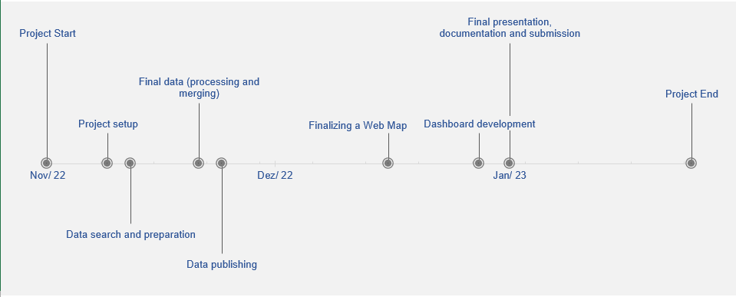

Figure 2 Milestones

## Gantt Chart

*Please provide an image of your Gantt Chart as overview graphics. Please attach the Gantt chart and it’s monthly updates in addition to this document.*

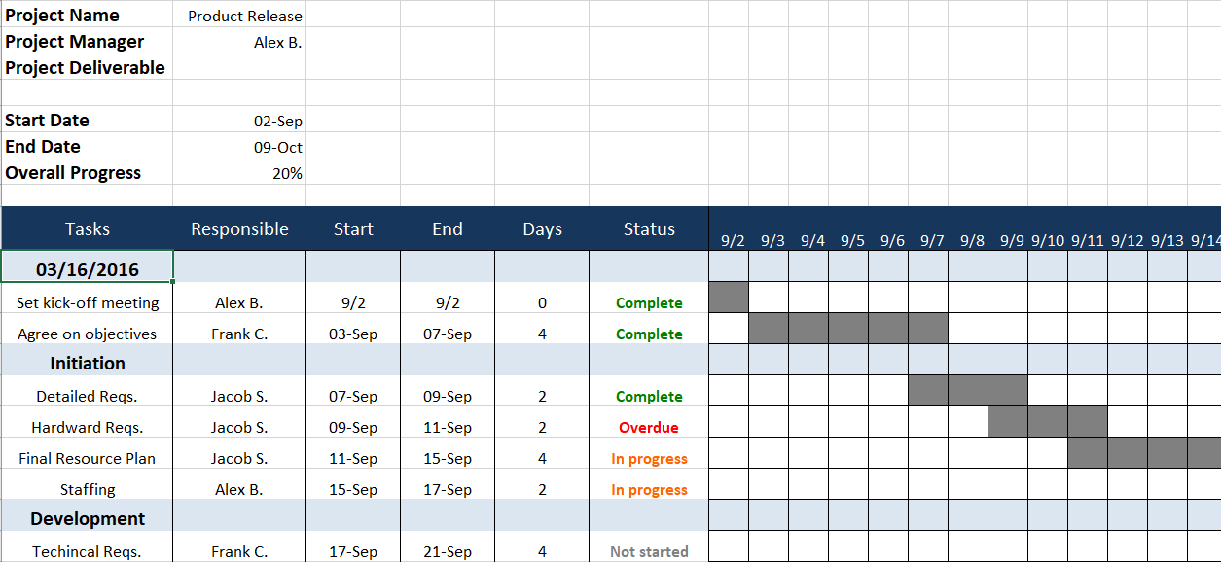

Figure 3 Gantt Chart

## Risk matrix

*In this table, please provide the important risk information. Please categorize the risks accordingly. ([L]ow, [ M ]edium, [****H****]igh], [C]leared)as well as your mitigation strategy. Please update this list accordingly during your project execution time frame.*

|  |  |  |  |  |
| --- | --- | --- | --- | --- |
|  | Risk | Mitigation Strategy | Type | Update |
| 1 | Data integration | Raw data might not fit for our purpose, we need to clean it and merge in order to fulfil our task | H | n/a |
| 2 | Automation | Since our datasets need manual pre-processing, it is very unlikely that we will achieve its automatic update | H | n/a |

## Additional comments

*Add additional comments if necessary.*

|  |
| --- |
| Comments |
| n/a |

## Approval

*Please provide further information if necessary.*

|  |  |  |  |
| --- | --- | --- | --- |
| Approval | | | |
| Approval: | Date: | | 02.12.2022 |
|  | |  | |
| Signature principal investigator | | Signature project lead/contractor | |

## Attachments

*Attachment 1: Gantt Chart (monthly updated)*

*Attachment 2: Milestones*

*Attachment 3: Work plan*

*Attachment 4: Time sheet (regularly updated)*