Abstract
- Canopy represents an importante environmental variable to different forms of biodiversity, affect its biology and ecology. To mensurate how much open canopy can be, researchers calculate Canopy Openness Index (COI).
- The coiR is the first R package focused to COI, from canopy photography, to analyze natural environmental heterogeneity. It is focused to implement a faster and open-source tool to measure how much open are canopies to ecological researches.
- coiR implements thre functions: coir_crop(), to crop images to circular shpe, coir_binarize(), to binarize images, and coir_index(), to calculate COI. coiR has a inner dataset.
- coiR allows researchers to analyze a set of many images, implementing R programming tools as loops, quickly estimating COI, assisting to maximizing ecological researches efficience.

Keywords
Forest, tree closure, microhabitat, environmental science

1 Introduction
Canopy is defined as the structure formed by leaf and branches above the ground (Campbell & Norman, 1989; Moffet, 2000). It is by itself a distinct environment, hosting a set of different forms of biodiversity, such as plants (Ollinger, 2011), invertebrates (Díaz et al., 2012; Wardhaugh et al., 2014) and vertebrates (Astiazarán‐Azcárraga et al., 2025; Moretta-Urdiales et al., 2025; Naka, 2004). More than affect its own biota, canopy can affect biodiversity in bellow vertical stratum, such as tree, ground and leaf litter. It is known the importance of canopy presence importance, but even more for its openness (Jennings et al., 1999). Canopy openness can modulate how much solar light can penetrate inner forest environment, affecting forest microenvironmental conditions, such as temperature, water availability and leaf litter density (Felix et al., 2010; Skelly et al., 2005, 2014; Van Buskirk, 2011). In anuran amphibian, highly sensitive vertebrate to environmental conditions, high open can affect species eggs deposition (Werner & Glennemeier, 1999a), species abundance (Klawinski et al., 2014) and community diversity (Skelly et al., 2005) and composition (Provete et al., 2014),
For mensurate canopy as environmental predictor to testing ecological hypothesis, researchers measure how open is a canopy, by Canopy Openness Index (COI). COI can be measuring from different ways. A known methodology is developed by Lemmon (1956, 1957), called to densiometer method, which consists to use a densiometer, a mirrored semispherical structure, positioned to open the canopy. But a most modern often used methodology consists to quantify how much a canopy image area can be interpreted as canopy elements in function the total image area, using canopy photographs through fisheye lens (Jennings et al., 1999; Nascimento et al., 2007). This modern methodology is faster than previously methodologies, allowing researchers to faster quantify COI. However, another modern tool to assists ecological researches R programming language (R Core Team, 2025).
The use of R programming to ecological researches are increasing along the year (Lai et al., 2019). R came be a often used tool in ecological investigations, such as community ecology (Cardoso et al., 2025; Laliberté et al., 2023; Oksanen et al., 2024), evolutionary ecology (Kembel et al., 2010; Orme et al., 2025; Paradis & Schliep, 2019), movement ecology (Calenge, 2024), bioacoustics (J. Sueur et al., 2008), ecological linear models (Dray & Dufour, 2007; Lüdecke et al., 2021), landscape ecology (Frichot & François, 2015; Hesselbarth et al., 2019) and species biogeography (Aiello‐Lammens et al., 2015; Di Cola et al., 2017; Naimi & Araújo, 2016). Even more, R, as an open source programming language, can be quickly actualized, allowing to implementate COI analysis.
Often biodiversity interested-researches use COI as predictor in ecological models to test hypothesis, such as how much canopy openness affects species diversity (Skelly et al., 2005, 2014; Werner & Glennemeier, 1999b) and other biodiversity proprieties (Felix et al., 2010; Klawinski et al., 2014; Provete et al., 2014; Van Buskirk, 2011; Werner & Glennemeier, 1999b). Despite its often use in ecological and other biodiversity areas researches, few are focused tools to analyze canopy images to quantify how open it is. That package introduction into a new R tool for biodiversity researches.

2 coiR Package

2.1 Package description
coiR r package is developed R natively and hosted at GitHub online platform (https://github.com/Edbbioeco/coiR) (Figure 1). The package main objective is to analyze canopy images, taken by fisheye lens (Jennings et al., 1999), and calculate how much open is the image canopy. Canopy openness index (COI) values ranging in a intervale from 0 (full close canopy, without light entrances) to 1 (full open canopy, without leaves), and it is calculated by ratio the counting images pixels standing for light, image space with no canopy, to total image pixels count (Equation 1). That package allows researchers to quantify how much open are their sampling environments, and use those values as predictors in models to test ecological gradient hypothesis. That new package increases R ecological tools ecosystem, to facility biodiversity researchers to better answer ecological questions. Up to the present moment, coiR are only hosted on GitHub, where it is necessary devtools package to download it.

# Load package
library(devtools)

# Install coiR package
devtools::install_github(“Edbbioeco/coiR”)

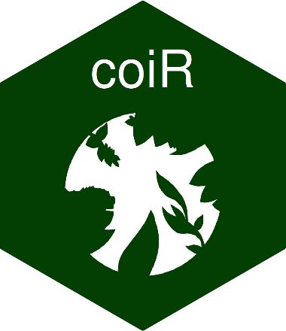
Figure 1. coiR package logo, used to standding the package. Logo stands a circular fisheye image, when contours represents canopy elements, such as branches and leaves, e white background represents sky.

$$COI= \frac{{N-Pixels}_{no canopy}}{{N-Pixels}_{total}}$$
Equation 1. Equation to describe COI workflow, where ${N-Pixels}_{no canopy}$ describe the count of image corresponding to open sky, no canopy, and ${N-Pixels}_{total}$ corresponding to total count of image pixels.

2.2 Input data structure
CoiR package input data are images, canopy images taken by fisheye (Figure 2). The images were mainly square shaped, with a clean definition between canopy elements, such as branches and leaves, and the sky. Images can be taken by professional cameras and by smartphones. Images are imported as rasters, by terra R package (Hijmans, 2024). It was chosen raster as format to input data class due their propriety to 1) count number of total pixels and count number of value-pixels, 2) high easily capacity to manipulate and filter pixel values and 3) high easily capacity to crop images into circles, even without geospatial orientation. Data can be .png, .jpg, .jpeg and .tif files, and it is imported by terra::rast().

2.3 Functionality
coiR package was developed by three functions: coir_crop(), coir_binarize() and coir_index(). Functions were build to follow framework: 1) crop the canopy image into a circular image, 2) binarize circular cropped images and 3) quantify COI (Table 1). First, Raster images were inputed to coi_crop() function. That first step takes raster image, calculate and build a buffer from its centroid and its lower extent, and finally crop that image. Whether, imputed images are previously cropped by circular shaped, coir_crop() are not required. Coir_crop() had the argument plot, wihich default is TRUE, plotting the RGB cropped image.
Next, cropped images are imputed in coir_binarize() functions. That function binarize copped images, RGB images, following that steps: 1) the three raster bans (Red, Green and Blue) are multiplied, respectivally, by 0.299, 0.587 and 0.114, following ITU-R BT.601 methodology (Žeger et al., 2024), 2) the one band raster are scaled in continuous values, ranging from 0 to 1, and 3) continuous scale are binarized, based on threshold argument, which default is 0.5, where pixels $≤$ 0.5 are interpreted by canopy elements and pixels > 0.5 are interpreted as sky. Its threshold can be set to other values, using threshold argument. Similar to coir_crop(), coir_binarize() function have a plot argument, which default is TRUE, plotting the binarized cropped image.
Finally, binarized cropped images are imputed in coir_index() function. That function calculates canopy openness index, taken by binarized cropped images. That functions count of pixels standing for no canopy elements and ratio it by the total count of image pixels. The output is a single numeric value. To optimize coiR package workflow and its functionality, it is recommended to built R code by pipe structure (Boehmke, 2016; Mailund, 2022b).

# Load package
library(coiR)

# Import image
image <- terra::raste(“image.png”)
image

# Calculating canopy openness index
index_value <- image |>
coir_crop() |>
coir_binarize() |>
coir_index()
index_value

Often, biodiversity research deal with a set of canopy images, not only an one single image. A great advantage of programming languages is their capacity to automatize process through loops (Hallgren, 2013). Because of that, it is possible implement coiR package into a loop, where loop output is a numeric vector. Loop is developed by purrr R package (Mailund, 2022a). coiR package have a set of canopy images, setted on data_coir package object.

# Load packages
library(terra)
library(purrr)

# Import images
files <- list.files(pattern = “.png$”)
images <- purrr::map(files, terra::rast)

# Creating a empty vector
vector_index <- c()

# Creating a function to lopp
multiple_index <- function(images, verbose = FALSE){

index <- images |>
coiR::coir_crop(plot = FALSE) |>
coiR::coir_binarize(plot = FALSE) |>
coiR::coir_index(round = 3)

vector_index <<- c(vector_index, index)

}

# Loop
purrr::map(images, multiple_index)

All analyzes were developed by R programming v.4.5.2 (R Core Team, 2025).

3 Package Applications
To demonstrate coiR package applications, the examples were developed with four canopy images (Figure 2). Those images were taken for different canopies, and they had different levels of openness, to assess coiR performance. Those images were imported from data_coir() function, a coiR dataset with four images as raster SpatRaster class (Figure 2). Those images are loaded as RGB images, where it is possible to notice color contrast between canopy elements and the sky.
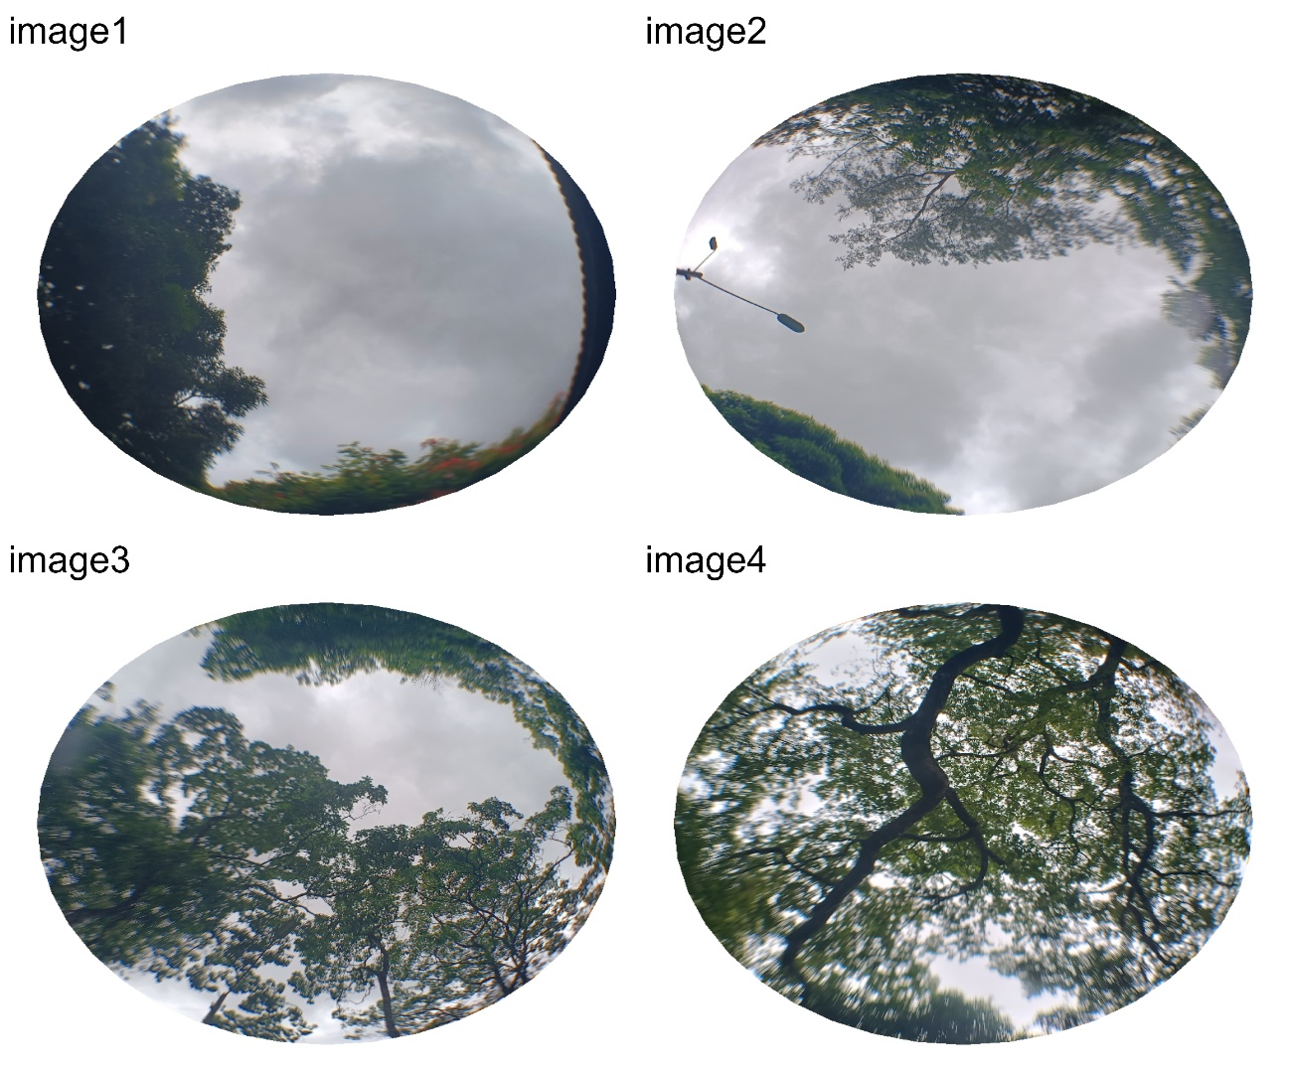
Figure 2. Canopy images, from data_coir() function. Those images follow a openness gradient, which make that dataset appropriated to understand the package performance under gradients.

Those cropped images were binarized by three different thresholds: 0.5, 0.7 and 0.9. It was following this approach to demonstrate how canopy images deal with different threshold to binarize. The threshold = 0.5, which is the package default, showed better performance to capture and interpret differences between canopy elements and the sky (Figure 3). In canopy images where cloud presence were lower, differences between thresholds 0.5 and 0.7 are lower than compared to images with high clouds presence, indicating open light days images for those analyzes. Threshold = 0.9 showed the lower performance, assuming shades in the sky as canopy elements.

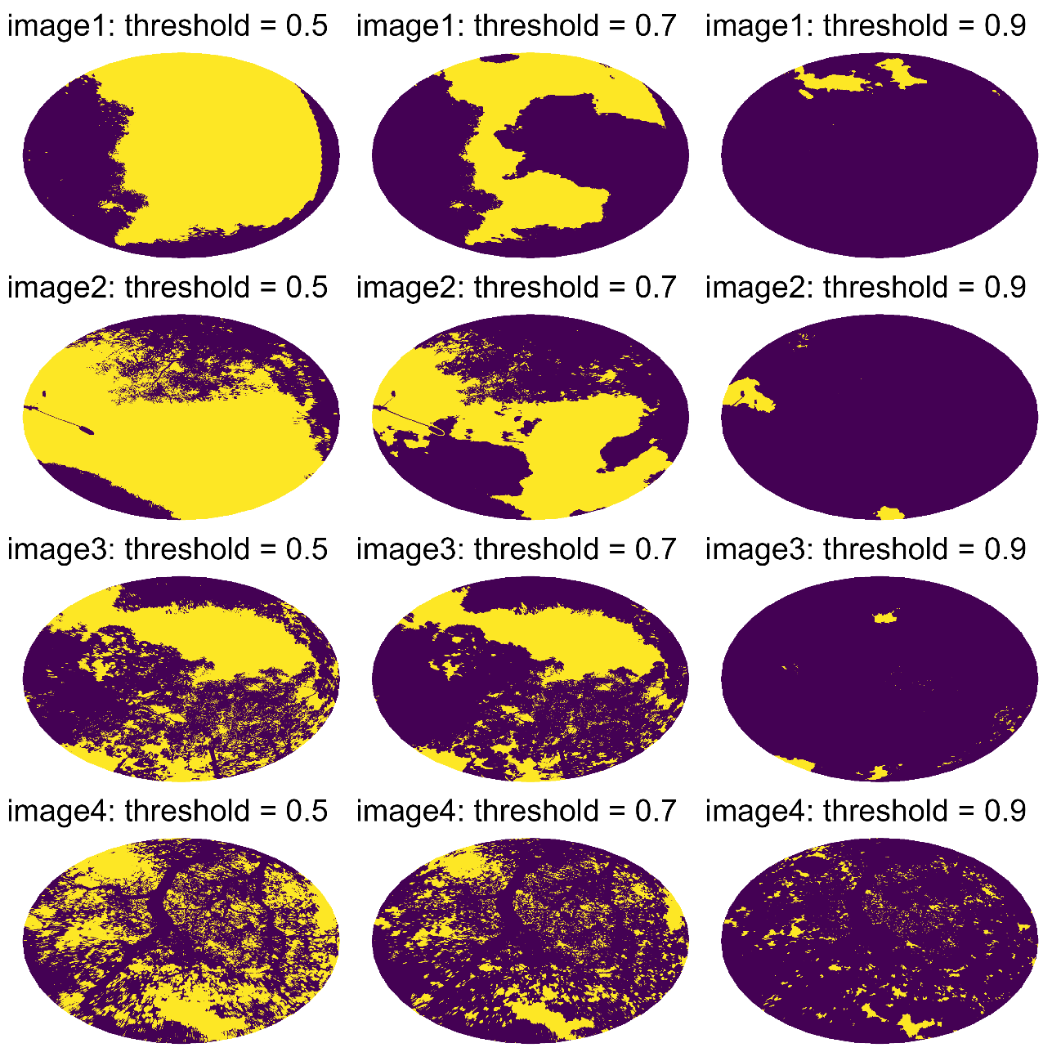Figure 3. Binarized images from different thresholds values. Each row is an image, and each column is a different threshold.

When Canopy Openness Index (COI) where calculated, it was detected not only threshold as better to detect canopy elements, but also to not underestimate canopy COI. Moreover, it was observed more variation between threshold 0.5 to 07. Than 0.7 to 0.9.

Table 1. Canopy Openess Index for each image and for different thresholds.
Image | Threshold | Index
image1 | 0.5 | 0.51
image1 | 0.7 | 0.28
image1 | 0.9 | 0.03
image2 | 0.5 | 0.54
image2 | 0.7 | 0.35
image2 | 0.9 | 0.02
image3 | 0.5 | 0.31
image3 | 0.7 | 0.23
image3 | 0.9 | 0.01
image4 | 0.5 | 0.31
image4 | 0.7 | 0.17
image4 | 0.9 | 0.05

4 Conclusions
Here I present coiR R package. This package show a new tool for R programming environment, allowing biodiversity researches calculate how much open canopy can be, faster and inner into a statistical environment such as R. The examples above illustrate how coiR works, its workflow and its practicality to implement it in loops, to automatizate processes, enabling save results in exportable files and R tables. As often biodiversity researches analyze a set of many canopy images, coiR can be a useful tool for maximize scientific investigation process.

The code and data for this study have been anonymized for search and are available for peer review at: https://anonymous.4open.science/r/coiR-7C48/README.md

References
Aiello‐Lammens, M. E., Boria, R. A., Radosavljevic, A., Vilela, B., & Anderson, R. P. (2015). spThin: an R package for spatial thinning of species occurrence records for use in ecological niche models. Ecography, 38(5), 541–545. https://doi.org/10.1111/ecog.01132
Astiazarán‐Azcárraga, A., Delfín‐Alfonso, C. A., Lira‐Noriega, A., Prieto‐Torres, D. A., & Gallina‐Tessaro, S. (2025). Neotropical non‐primate canopy mammals: historical trends, omissions, and geographic gaps in the knowledge. Mammal Review, 55(3), e12376. https://doi.org/10.1111/mam.12376
Boehmke, B. C. (2016). Simplify Your Code with %&gt;% (pp. 199–207). https://doi.org/10.1007/978-3-319-45599-0_20
Calenge, C. (2024). adehabitatHR: Home Range Estimation. https://doi.org/10.32614/CRAN.package.adehabitatHR
Campbell, G. S., & Norman, J. M. (1989). The description and measurement of plant canopy structure. In Plant Canopies (pp. 1–20). Cambridge University Press. https://doi.org/10.1017/CBO9780511752308.002
Cardoso, P., Mammola, S., Rigal, F., Hilario, R., & Carvalho, J. (2025). BAT: Biodiversity Assessment Tools. https://doi.org/10.32614/CRAN.package.BAT
Di Cola, V., Broennimann, O., Petitpierre, B., Breiner, F. T., D’Amen, M., Randin, C., Engler, R., Pottier, J., Pio, D., Dubuis, A., Pellissier, L., Mateo, R. G., Hordijk, W., Salamin, N., & Guisan, A. (2017). ecospat: an R package to support spatial analyses and modeling of species niches and distributions. Ecography, 40(6), 774–787. https://doi.org/10.1111/ecog.02671
Díaz, I. A., Sieving, K. E., Peña-Foxon, M., & Armesto, J. J. (2012). A field experiment links forest structure and biodiversity: epiphytes enhance canopy invertebrates in Chilean forests. Ecosphere, 3(1), 1–17. https://doi.org/10.1890/ES11-00168.1
Dray, S., & Dufour, A. (2007). The ade4 Package: Implementing the Duality Diagram for Ecologists. Journal of Statistical Software, 22(4), 1–20. https://doi.org/10.18637/jss.v022.i04
Felix, Z. I., Wang, Y., & Schweitzer, C. J. (2010). Effects of Experimental Canopy Manipulation on Amphibian Egg Deposition. The Journal of Wildlife Management, 74(3), 496–503. https://doi.org/10.2193/2008-181
Frichot, E., & François, O. (2015). LEA: An R package for landscape and ecological association studies. Methods in Ecology and Evolution, 6(8), 925–929. https://doi.org/10.1111/2041-210X.12382
Hallgren, K. A. (2013). Conducting Simulation Studies in the R Programming Environment. Tutorials in Quantitative Methods for Psychology, 9(2), 43–60. https://doi.org/10.20982/tqmp.09.2.p043
Hernangómez, D. (2025). tidyterra: tidyverse Methods and ggplot2 Helpers for terra Objects. https://dieghernan.github.io/tidyterra/
Hesselbarth, M. H. K., Sciaini, M., With, K. A., Wiegand, K., & Nowosad, J. (2019). landscapemetrics: an open-source R tool to calculate landscape metrics. Ecography, 42, 1648–1657.
Hijmans, R. J. (2024). terra: Spatial Data Analysis. https://rspatial.org/
J. Sueur, T. Aubin, & C. Simonis. (2008). Seewave: a free modular tool for sound analysis and synthesis. Bioacoustics, 18, 213–226.
Jennings, S. B., Brown, N. D., & Sheil, A. D. (1999). Introduction Assessing forest canopies and understorey illumination: canopy closure, canopy cover and other measures. In Forestry (Vol. 72, Number 1).
Kembel, S. W., Cowan, P. D., Helmus, M. R., Cornwell, W. K., Morlon, H., Ackerly, D. D., Blomberg, S. P., & Webb, C. O. (2010). Picante: R tools for integrating phylogenies and ecology. Bioinformatics, 26, 1463–1464.
Klawinski, P. D., Dalton, B., & Shiels, A. B. (2014). Coqui frog populations are negatively affected by canopy opening but not detritus deposition following an experimental hurricane in a tropical rainforest. Forest Ecology and Management, 332, 118–123. https://doi.org/10.1016/j.foreco.2014.02.010
Lai, J., Lortie, C. J., Muenchen, R. A., Yang, J., & Ma, K. (2019). Evaluating the popularity of R in ecology. Ecosphere, 10(1). https://doi.org/10.1002/ecs2.2567
Laliberté, E., Legendre, P., & Shipley, B. (2023). FD: Measuring Functional Diversity (FD) from Multiple Traits, and Other Tools for Functional Ecology. https://doi.org/10.32614/CRAN.package.FD
Lemmon, P. E. (1956). A Spherical Densiometer For Estimating Forest Overstory Density. Forest Science, 2(4), 314–320. https://doi.org/10.1093/forestscience/2.4.314
Lemmon, P. E. (1957). A new instrument for measuring forest overstory density. Journal of Forestry, 55, 667–669.
Lüdecke, D., Ben-Shachar, M. S., Patil, I., Waggoner, P., & Makowski, D. (2021). performance: An R Package for Assessment, Comparison and Testing of Statistical Models. Journal of Open Source Software, 6(60), 3139. https://doi.org/10.21105/joss.03139
Mailund, T. (2022a). Functional Programming. In Beginning Data Science in R 4 (pp. 349–372). Apress. https://doi.org/10.1007/978-1-4842-8155-0_11
Mailund, T. (2022b). Pipelines: magrittr. In R 4 Data Science Quick Reference (pp. 77–87). Apress. https://doi.org/10.1007/978-1-4842-8780-4_6
Moffet, M. W. (2000). What’s “Up”? A Critical Look at the Basic Terms of Canopy Biology. Biotropica, 32(4), 569–596.
Moretta-Urdiales, M. D. M., Velasquez-Espin, F., Tenorio, M., Guayasamin, J. M., Rodriguez, D., & Mccracken, S. F. (2025). Low Abundance and Diversity of Canopy Amphibians in an Andean Choco Forest of Ecuador. In Herpetological Conservation and Biology (Vol. 20, Number 2).
Naimi, B., & Araújo, M. B. (2016). sdm: a reproducible and extensible R platform for species distribution modelling. Ecography, 39(4), 368–375. https://doi.org/10.1111/ecog.01881
Naka, L. N. (2004). Structure and Organization of Canopy Bird Assemblages in Central Amazonia. The Auk, 121(1), 88–102. https://doi.org/10.1093/auk/121.1.88
Nascimento, A. R. T., Fagg, J. M. F., & Fagg, C. W. (2007). Canopy openness and lai estimates in two seasonally deciduous forests on limestone outcrops in central Brazil using hemispherical photographs. Revista Árvore, 31(1), 167–176. https://doi.org/10.1590/S0100-67622007000100019
Oksanen, J., Simpson, G. L., Blanchet, F. G., Kindt, R., Legendre, P., Minchin, P. R., O’Hara, R. B., Solymos, P., Stevens, M. H. H., Szoecs, E., Wagner, H., Barbour, M., Bedward, M., Bolker, B., Borcard, D., Carvalho, G., Chirico, M., De Caceres, M., Durand, S., … Weedon, J. (2024). vegan: Community Ecology Package. https://CRAN.R-project.org/package=vegan
Ollinger, S. V. (2011). Sources of variability in canopy reflectance and the convergent properties of plants. New Phytologist, 189(2), 375–394. https://doi.org/10.1111/j.1469-8137.2010.03536.x
Orme, D., Freckleton, R., Thomas, G., Petzoldt, T., Fritz, S., Isaac, N., & Pearse, W. (2025). caper: Comparative Analyses of Phylogenetics and Evolution in R. https://doi.org/10.32614/CRAN.package.caper
Paradis, E., & Schliep, K. (2019). ape 5.0: an environment for modern phylogenetics and evolutionary analyses in R. Bioinformatics, 35, 526–528. https://doi.org/10.1093/bioinformatics/bty633
Pebesma, E. (2018). Simple Features for R: Standardized Support for Spatial Vector Data. The R Journal, 10(1), 439–446. https://doi.org/10.32614/RJ-2018-009
Provete, D. B., Gonçalves-Souza, T., Garey, M. V., Martins, I. A., & Rossa-Feres, D. de C. (2014). Broad-scale spatial patterns of canopy cover and pond morphology affect the structure of a Neotropical amphibian metacommunity. Hydrobiologia, 734(1), 69–79. https://doi.org/10.1007/s10750-014-1870-0
R Core Team. (2025). R: A Language and Environment for Statistical Computing. https://www.R-project.org/
Skelly, D. K., Bolden, S. R., & Freidenburg, L. K. (2014). Experimental canopy removal enhances diversity of vernal pond amphibians. Ecological Applications, 24(2), 340–345. https://doi.org/10.1890/13-1042.1
Skelly, D. K., Halverson, M. A., Freidenburg, L. K., & Urban, M. C. (2005). Canopy closure and amphibian diversity in forested wetlands. Wetlands Ecology and Management, 13(3), 261–268. https://doi.org/10.1007/s11273-004-7520-y
Van Buskirk, J. (2011). Amphibian phenotypic variation along a gradient in canopy cover: Species differences and plasticity. Oikos, 120(6), 906–914. https://doi.org/10.1111/j.1600-0706.2010.18845.x
Wardhaugh, C. W., Stork, N. E., & Edwards, W. (2014). Canopy invertebrate community composition on rainforest trees: Different microhabitats support very different invertebrate communities. Austral Ecology, 39(4), 367–377. https://doi.org/10.1111/aec.12085
Werner, E. E., & Glennemeier, K. S. (1999a). Influence of Forest Canopy Cover on the Breeding Pond Distributions of Several Amphibian Species. Copeia, 5(1), 1–12. https://about.jstor.org/terms
Werner, E. E., & Glennemeier, K. S. (1999b). Influence of Forest Canopy Cover on the Breeding Pond Distributions of Several Amphibian Species. Copeia, 5(1), 1–12. https://about.jstor.org/terms
Žeger, I., Šetka, I., Marić, D., & Grgic, S. (2024). Exploring Image Decolorization: Methods, Implementations, and Performance Assessment. Applied Sciences, 14(23), 11401. https://doi.org/10.3390/app142311401

