Species recorded

We observed a count of 31 species, distributed along six families (Table 1). Hylidae was the richest family (14), followed by Leptodactylidae (six) and Bufonidae (four). Dendropsophus minutus were the most abundant species (176), followed by Physalaemus cuvieri (173) and Aplastodiscus perviridis (86). Melanophryniscus tumifrons, Scinax squalirostris, Trachycephallus typhonius, Leptodactylus fuscus, Leptodactylus mystaceus, Elachistocleis ovalis and Proceratophrys brauna had only one record. Constant was the most frequent category, accounting 17 species (55%), followed accidental (nine species, 29%) and accessory (five species, 16%).

Table1.
Species | FPR | RIO | CAP | NBA
Bufonidae
Melanophryniscus tumifrons | 0 | 0 | 1 | 0
Rhinella crucifer | 1 | 0 | 1 | 1
Rhinella icterica | 7 | 1 | 1 | 2
Rhinella ornata | 2 | 0 | 1 | 1
Centrolenidae
Vitreorana uranoscopa | 10 | 10 | 10 | 10
Craugastoridae
Ischnocnema henselii | 3 | 7 | 1 | 1
Hylidae
Aplastodiscus perviridis | 11 | 28 | 21 | 26
Boana faber | 1 | 11 | 28 | 7
Boana leptolineata | 7 | 4 | 0 | 15
Boana prasina | 12 | 13 | 31 | 8
Dendropsophus minutus | 33 | 16 | 99 | 28
Dendropsophus nanus | 0 | 3 | 0 | 5
Phyllomedusa tetraploidea | 0 | 0 | 27 | 3
Scinax berthae | 0 | 0 | 7 | 0
Scinax catharinae | 0 | 1 | 1 | 0
Scinax fuscovarius | 2 | 0 | 32 | 1
Scinax perereca | 1 | 0 | 47 | 1
Scinax rizibilis | 0 | 0 | 10 | 0
Scinax squalirostris | 0 | 0 | 1 | 0
Trachycephallus typhonius | 1 | 0 | 0 | 0
Leptodactylidae
Leptodactylus fuscus | 0 | 1 | 0 | 0
Leptodactylus latrans | 12 | 1 | 48 | 5
Leptodactylus mystacinus | 0 | 1 | 0 | 0
Leptodactylus plaumanni | 1 | 30 | 1 | 1
Physalaemus cuvieri | 8 | 18 | 72 | 15
Physalaemus gracilis | 10 | 19 | 11 | 15
Microhylidae
Elachistocleis bicolor | 0 | 31 | 1 | 0
Elachistocleis ovalis | 1 | 0 | 0 | 0
Odontophrynidae
Proceratophrys avelinoi | 2 | 1 | 9 | 16
Proceratophrys brauni | 0 | 0 | 0 | 1
Odontophrynus americanus | 0 | 0 | 3 | 1

Tabela 2.
Species | CI | Category
Bufonidae
Melanophryniscus tumifrons | 25% | Accidental
Rhinella crucifer | 75% | Constant
Rhinella icterica | 100% | Constant
Rhinella ornata | 75% | Constant
Centrolenidae
Vitreorana uranoscopa | 100% | Constant
Craugastoridae
Ischnocnema henselii | 100% | Constant
Hylidae
Aplastodiscus perviridis | 100% | Constant
Boana faber | 100% | Constant
Boana leptolineata | 75% | Constant
Boana prasina | 100% | Constant
Dendropsophus minutus | 100% | Constant
Dendropsophus nanus | 50% | Accessory
Phyllomedusa tetraploidea | 50% | Accessory
Scinax berthae | 25% | Accidental
Scinax catharinae | 50% | Accessory
Scinax fuscovarius | 75% | Constant
Scinax perereca | 75% | Constant
Scinax rizibilis | 25% | Accidental
Scinax squalirostris | 25% | Accidental
Trachycephallus typhonius | 25% | Accidental
Leptodactylidae
Leptodactylus fuscus | 25% | Accidental
Leptodactylus latrans | 100% | Constant
Leptodactylus mystacinus | 25% | Accidental
Leptodactylus plaumanni | 100% | Constant
Physalaemus cuvieri | 100% | Constant
Physalaemus gracilis | 100% | Constant
Microhylidae
Elachistocleis bicolor | 50% | Accessory
Elachistocleis ovalis | 25% | Accidental
Odontophrynidae
Proceratophrys avelinoi | 100% | Constant
Proceratophrys brauni | 25% | Accidental
Odontophrynus americanus | 50% | Accessory

Taxonomic diversity

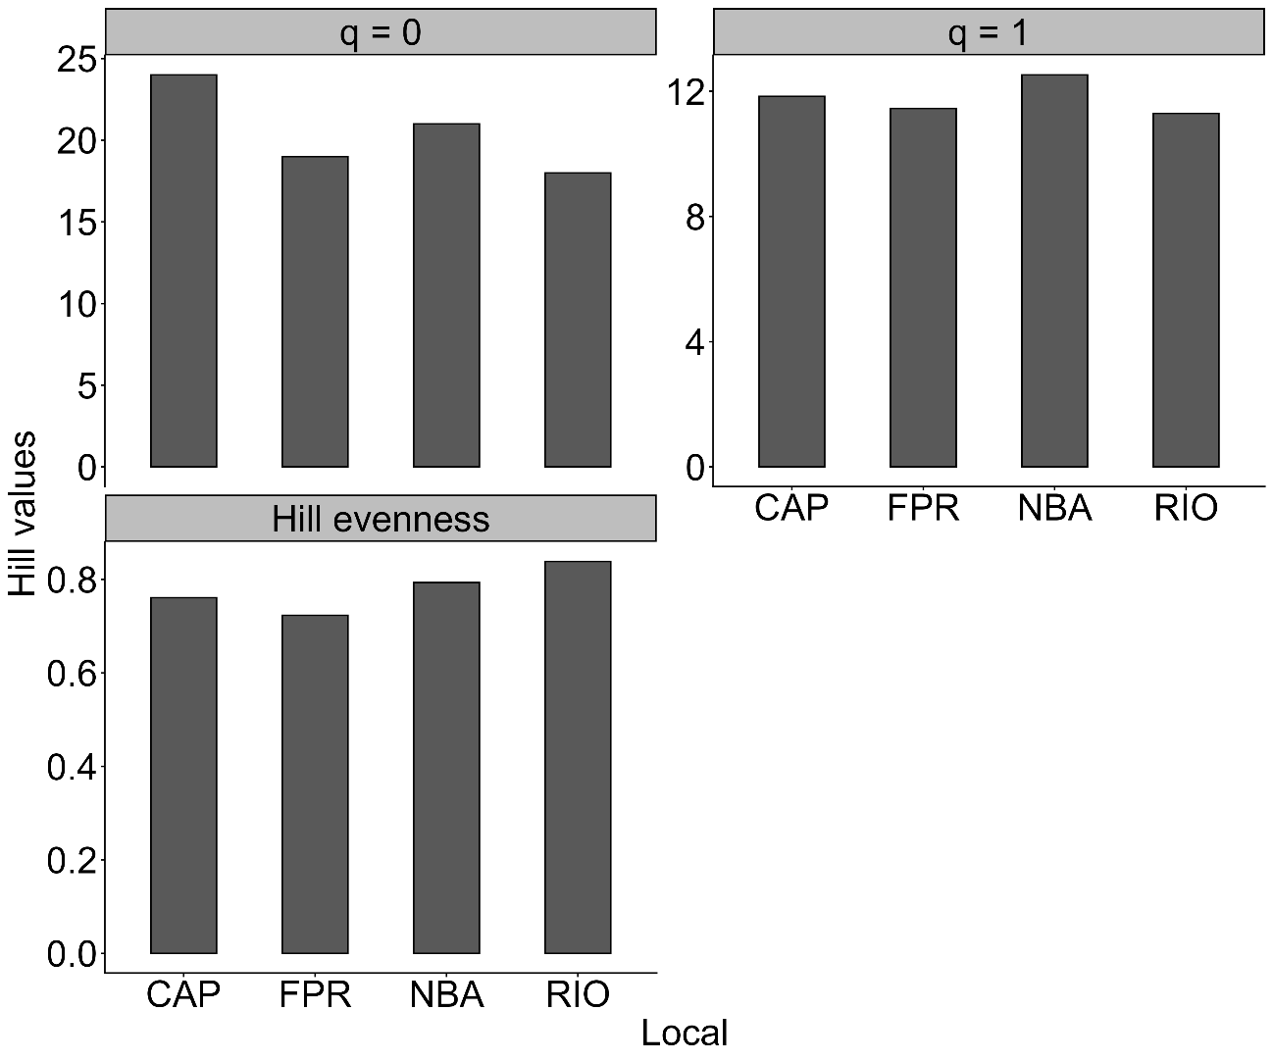
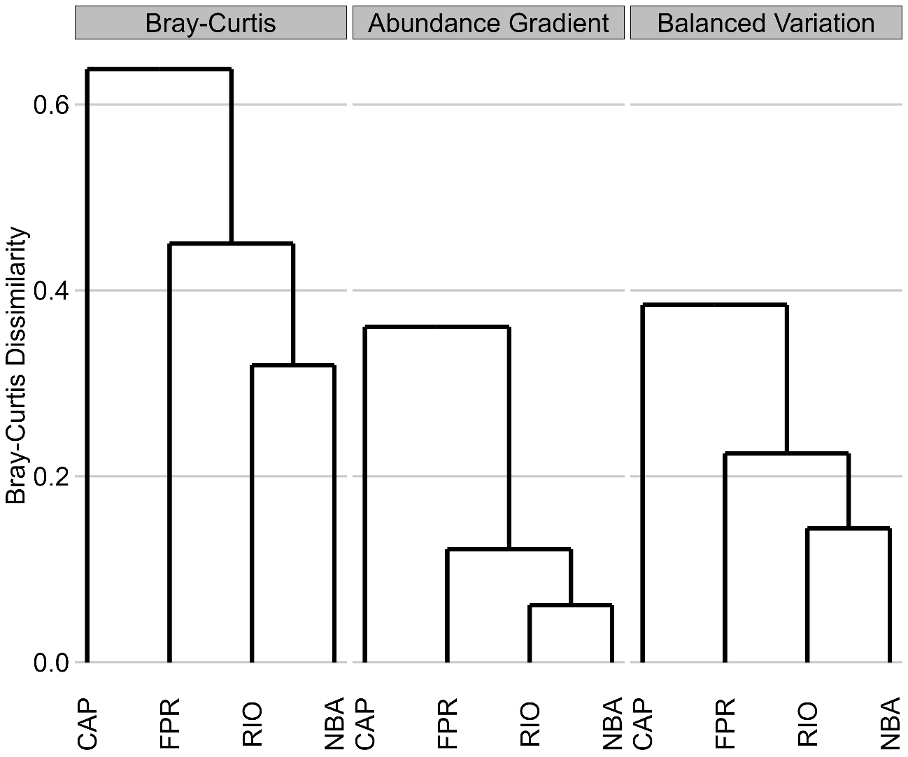
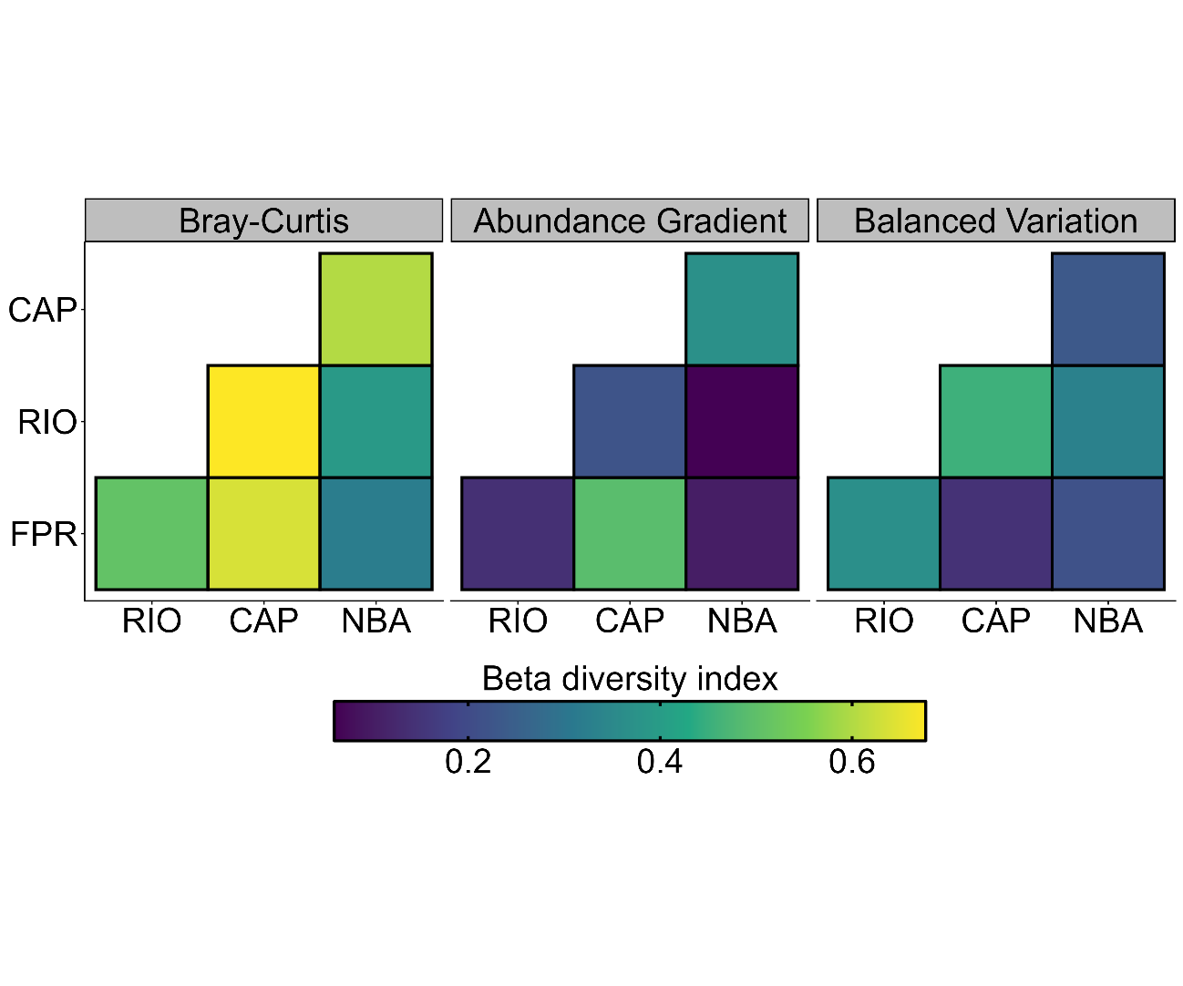

Functional Diversity

