For iteration 1 of my program I would like to create two classes to be used in the application, one being an Account class and one being a transaction class. The transaction class will need to contain information about the date of the transaction, the amount of money, and the debit account and the credit account it is affecting. The Account class will need to have a name and a list of the individual debit and credit transactions enacting onto it. This is my first goal as it will allow for transactions and accounts to be created, and the transactions will record both a debit and credit alteration to separate accounts which is the basis of double entry book keeping.

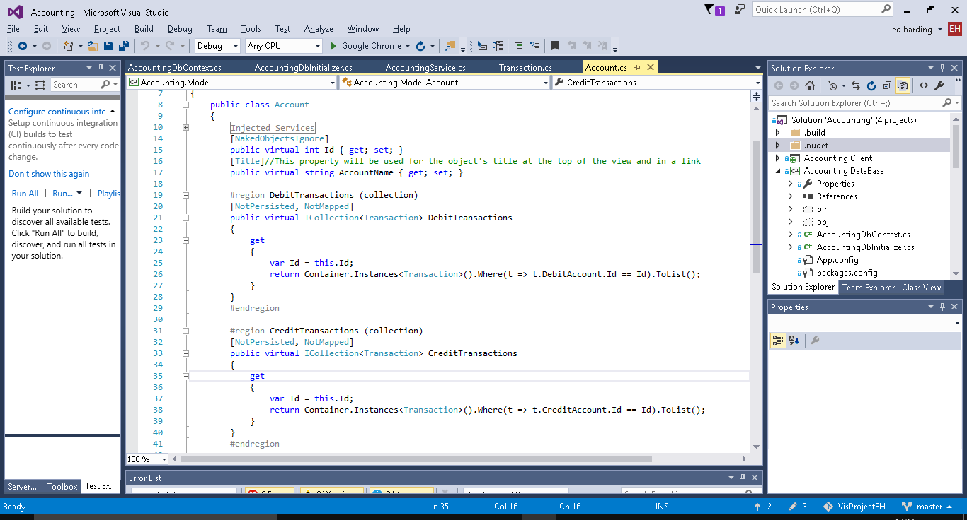

Above is the Account class, as well as the Id property which all classes have to have in Naked Objects it has an AccountName property and 2 collect properties which hold a list of debit and/or credit transactions (which are instances of the Transaction class below).

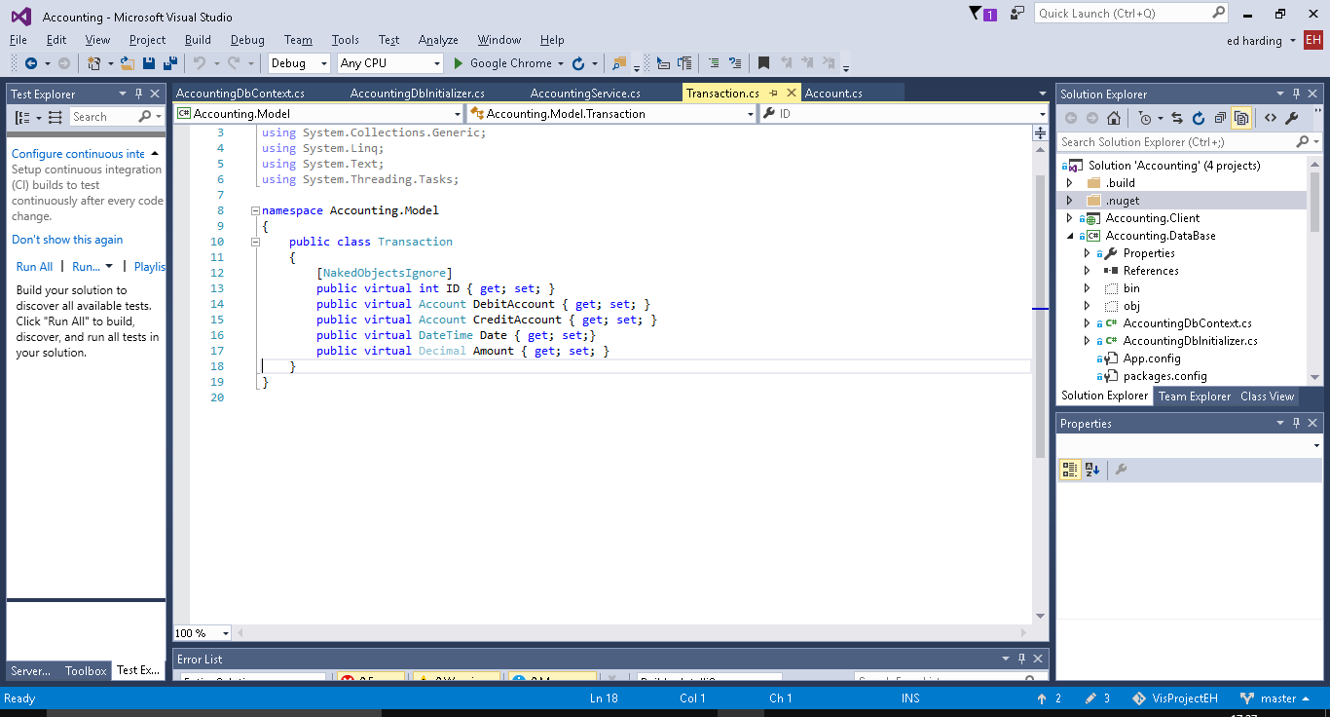

Above is the Transaction class which contains properties for the amount of money, the Date, and then the accounts it is affecting.

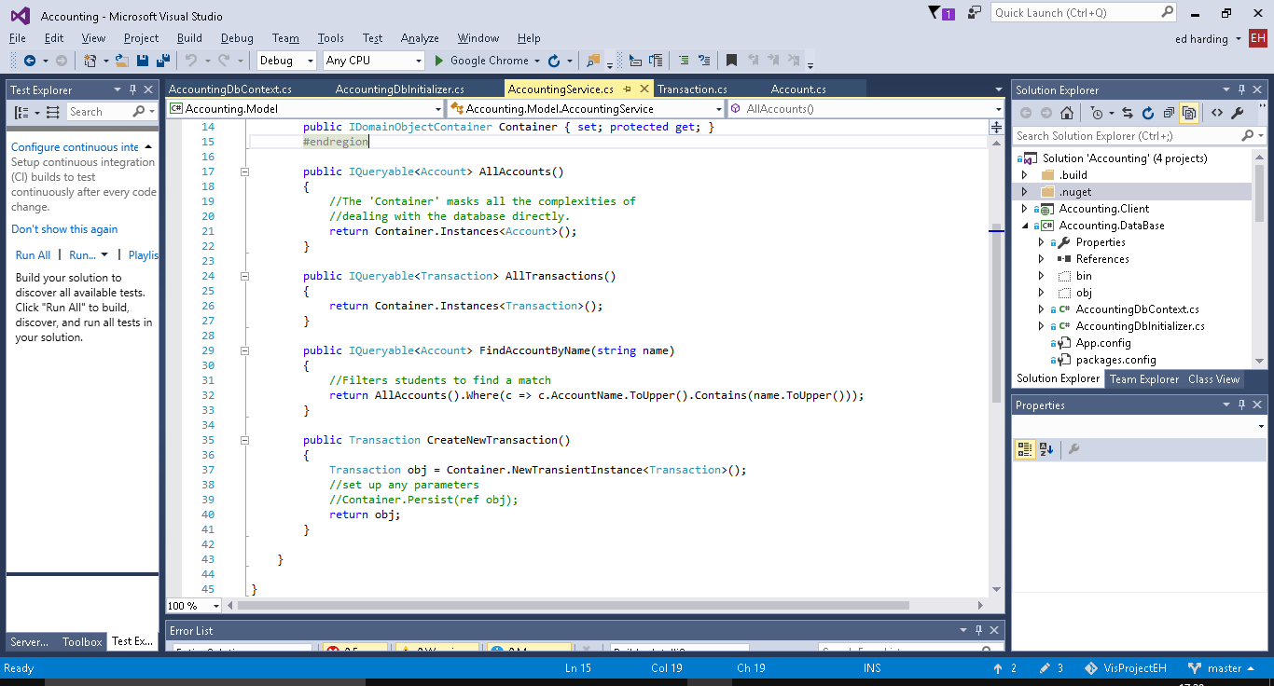

Above are the different methods (services) which can be used on both/either the transaction and/or account classes. Examples of them being used in the User interface will be shown below, they all do what you would expect based on their names.

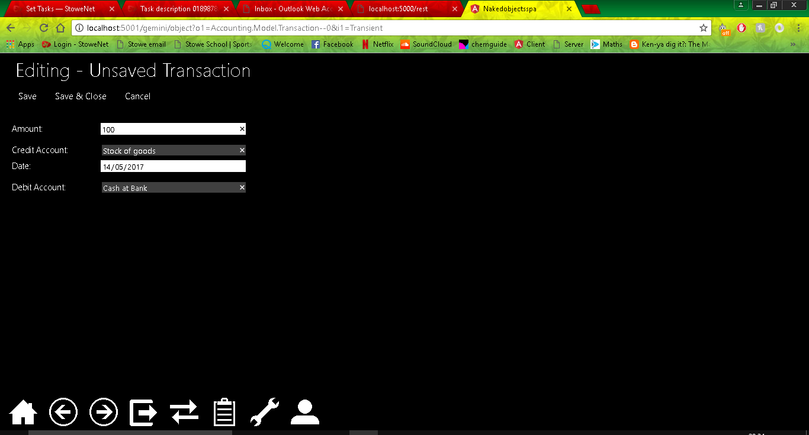

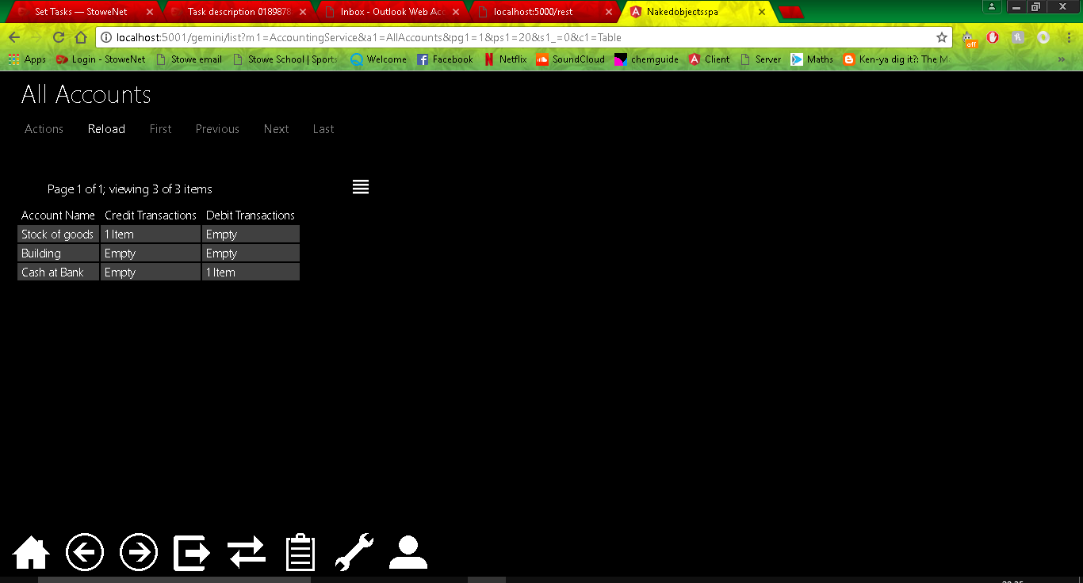

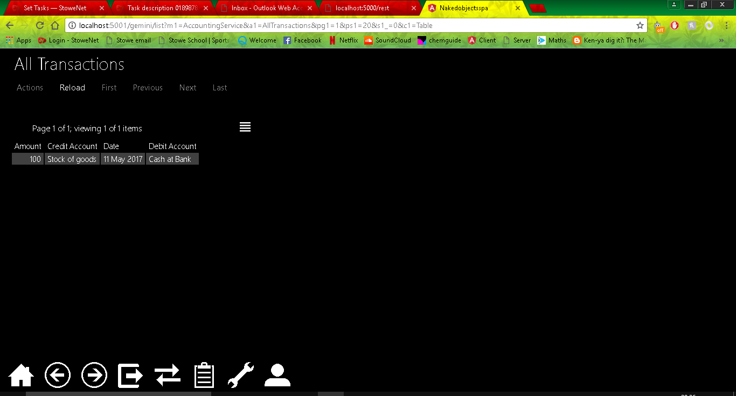

I decided to add in auto complete methods to the Debit and Credit Account fields when creating a transaction this was just to increase usability of the program as it means that you will not have to drag and drop, this will also help if there are a lot of accounts. 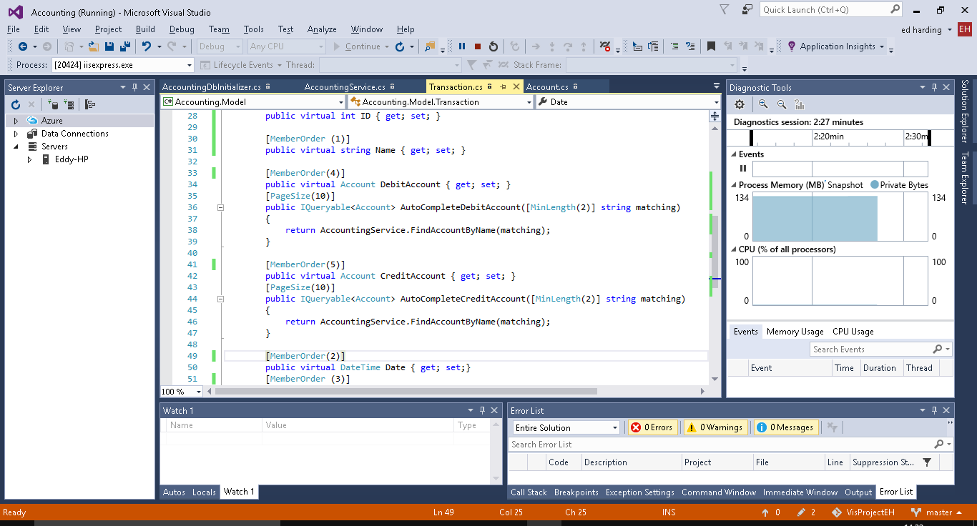

I also decided to add member order to the properties of the Transaction class this will order the CreateNewtransaction fields as numbered in the code above, as with the previous change this is not necessary but it is for purely presentation purposes as before this the Account fields were separated by the Date field. I also added a new property called Name to be used as a title for the transactions as when in AllTransactions and not in table view each transaction was called Untitled.

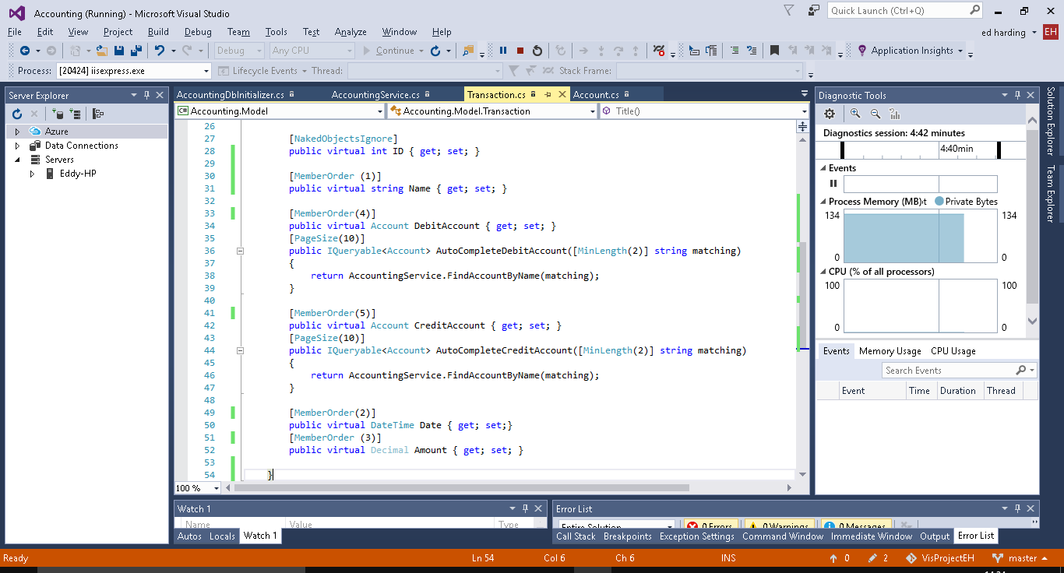

In the screenshot below you can see that that there is a new property called Name, the properties are ordered as to the member order and the autocomplete methods for the Debit and credit accounts is working.

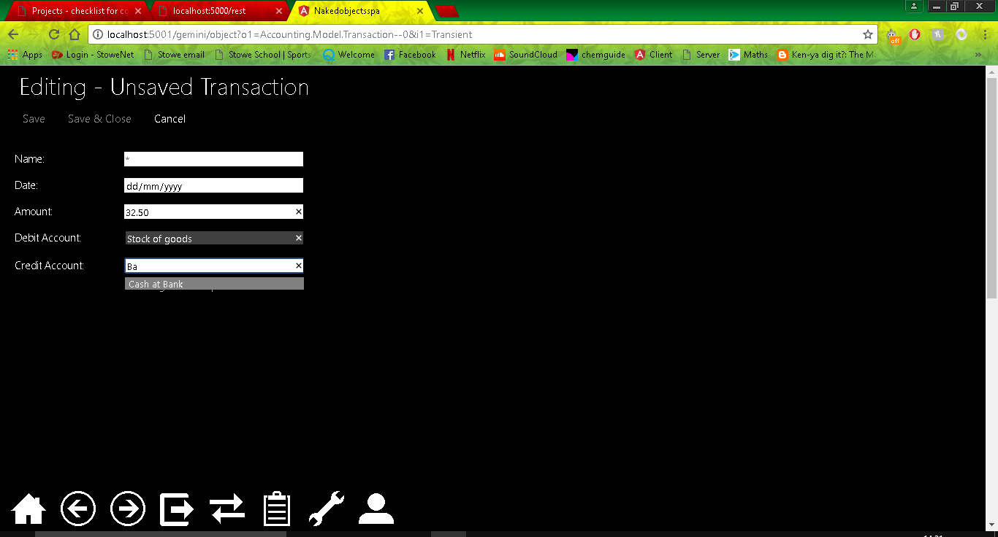

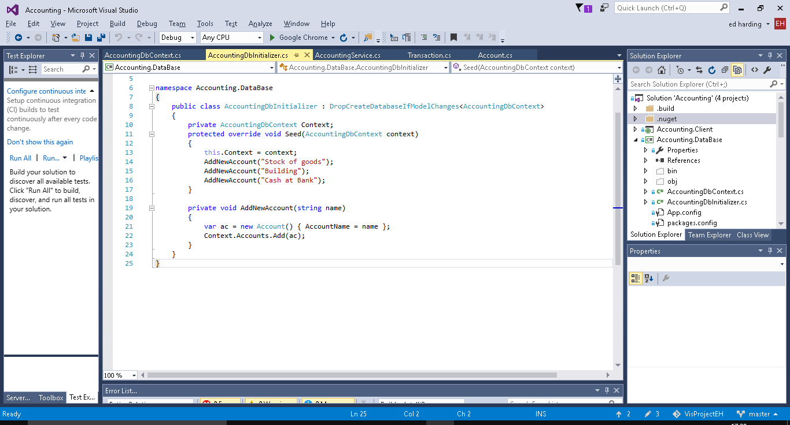

Above is some seed data for some Accounts and the method used to create them, this is in the DB initializer.

I then decided to create a better title to be used for the Transactions, I used a Title Builder method inside the transaction class to create a title by combining the Name and Date properties, again this is just to add additional usability to the software.

