For Iteration 2 my brother (the primary user of the product) has said that he would like to be able to see the debit and credit changes in a balance sheet format. He would like to be able to see the total value of the credit and debit transactions made to an account, and then be able to open a table which will show these all combined together and which shows (by doing a total) that the debit and credit balance is equal to one another.

As the developer of the program I have decided that I would like to add a Balance table as a derived property from the Account Class, the balance table will act like a normal accounting balance table as I have learned from the book I am using. I plan on it to display the credit and debit of the Accounts and for it to show that they are equal to one another as they should be. I have also decided to add some minor tweaks to the program to help accommodate for these changes in to make the program more stream-lined.

The first thing I have decided to change is how the list of transactions is displayed when looking at an Account. When the debit or credit transactions were displayed in table form you would be able to see the accounts it effects however one field of that table whether its debit or credit account would be the name of the account you are looking at, this is useless information which makes the program look unsophisticated. This change will also help as I plan to add a total to each table of debit and credit transactions for each account to be used in the balance sheet, therefore doing this early provides an organized basis to start from.

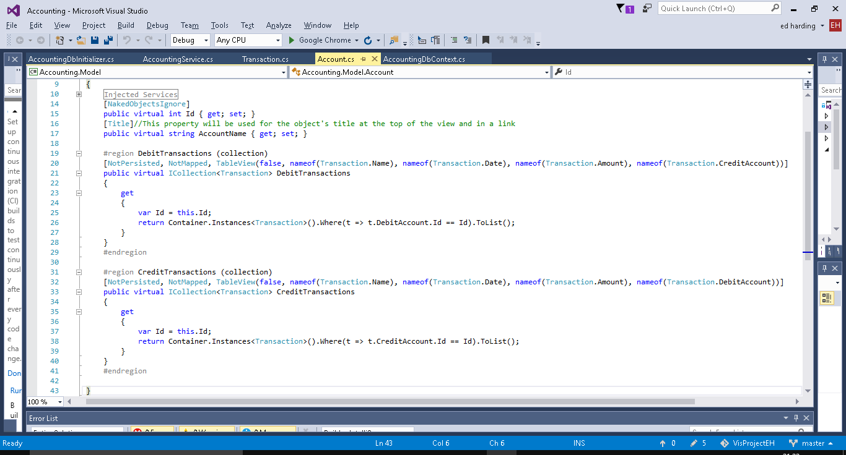

To do this (as you can see above) I used the ‘TableView’ attribute which allows me to designate which properties are visible when put into table view.

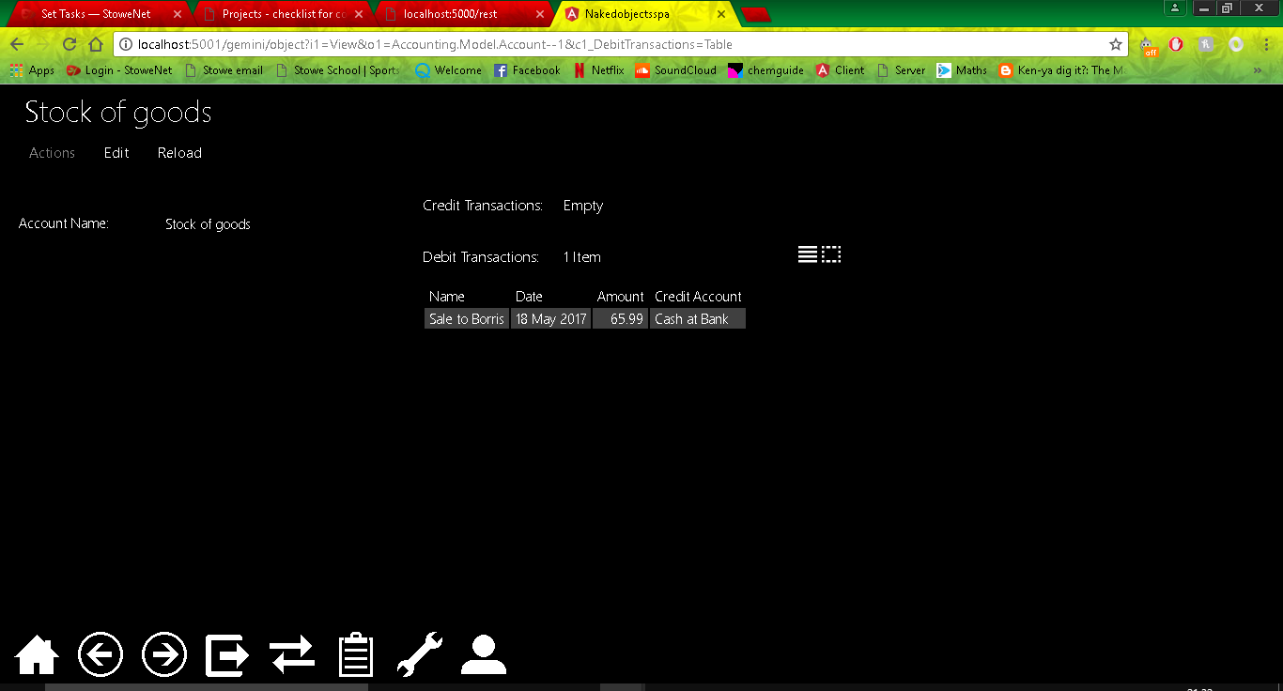

Now that I have done this I decided I should add in some seed data for some past transactions. Currently I have to add all the transactions for when I want to test something therefore having some premade will not only make the system look more like a real life system therefore improving testing but will also assist in the planning and testing of the balance sheet as it will be very heavily focused on the transactions.

