Profit and Loss Statement.

I plan on creating three new classes, one which will be similar to the balance sheet class and will be called profit and loss statement, the other will be a sales class to allow for specific sales to be entered by the user. The profit and loss statement will contain the value of stock of a given month and a field for the sales amount. The sale class will allow a user to enter the price of goods sold and what they were sold for, this will then affect the profit and loss statement accordingly. I final field will calculate the gross profit for that month of sales and display it to the user. The third class will be used as a sort of account class it will just have a name i.e. stock and will hold the values.

I will have to it this way because if I want the user to be able to check profit and loss for specific stretches of time then the accounts will need to contain a collection of all the previous sales transactions. The planned system will be very similar to the way the account, balance and balance sheet classes all interact with one another.

This will currently only calculate the gross profit.

Screenshots below of new class called SalesAccount. It is used to hold the value of the stock from the stock account and the prices goods were sold for when a sale transaction is made using the Sale class below.

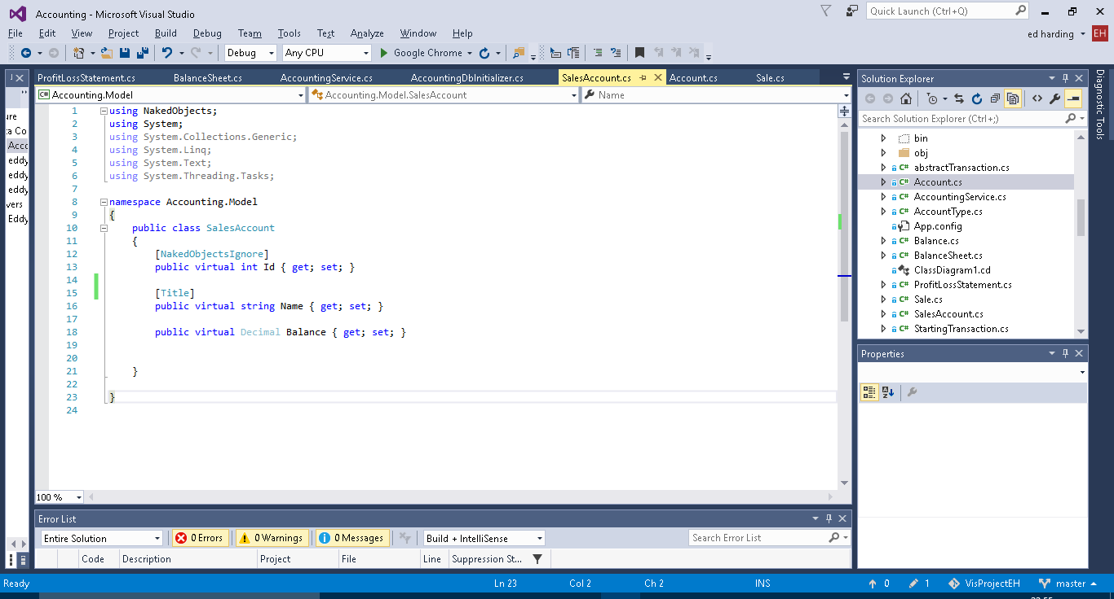

Screenshots of Sale class. Used in a similar way to transaction however it contains the date of the sale and information on the price of the stock sold and the price it was sold for. This is used to calculate gross profit.

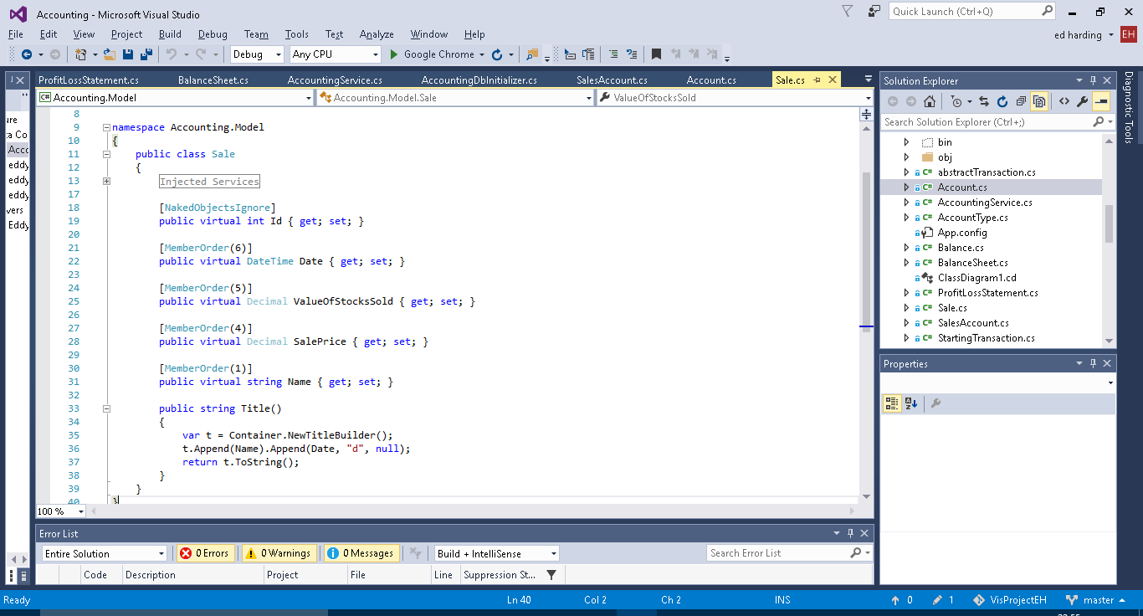

Screenshots of the new Profit and Loss Statement class. It pulls together the above to classes. The get statement is used to calculate the gross profit and loss from the sales transactions.

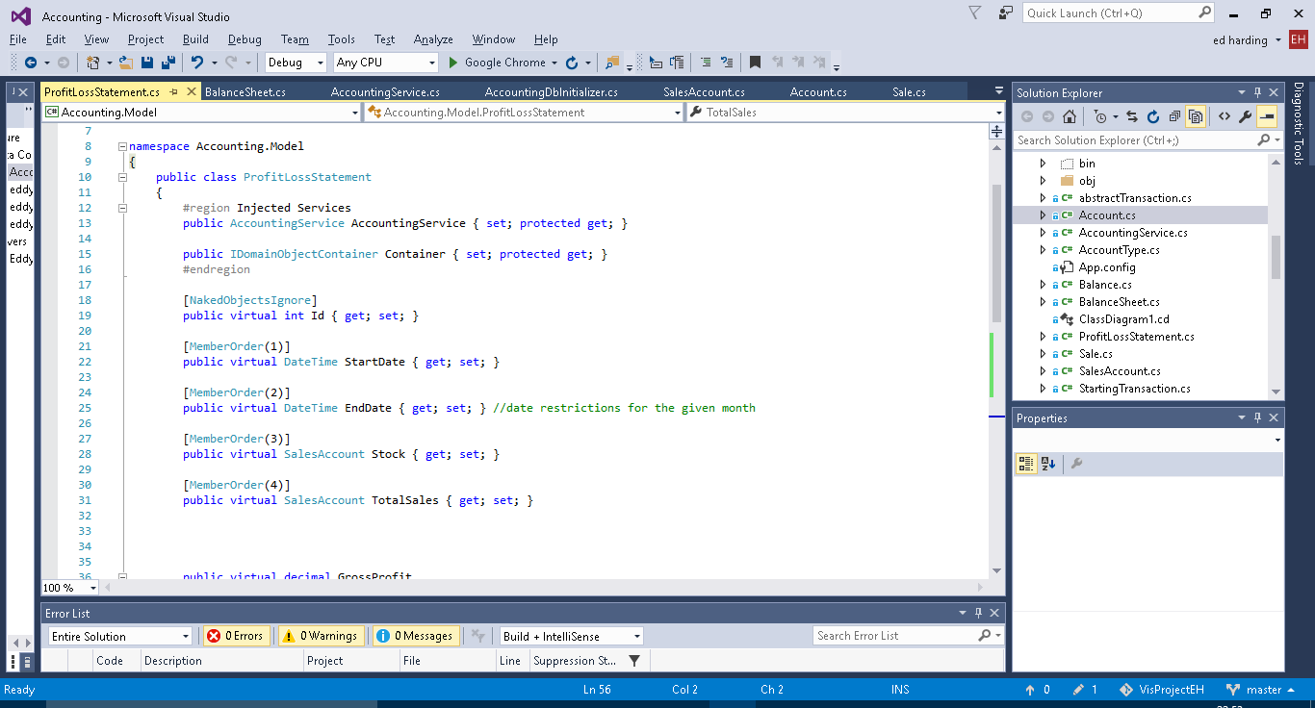

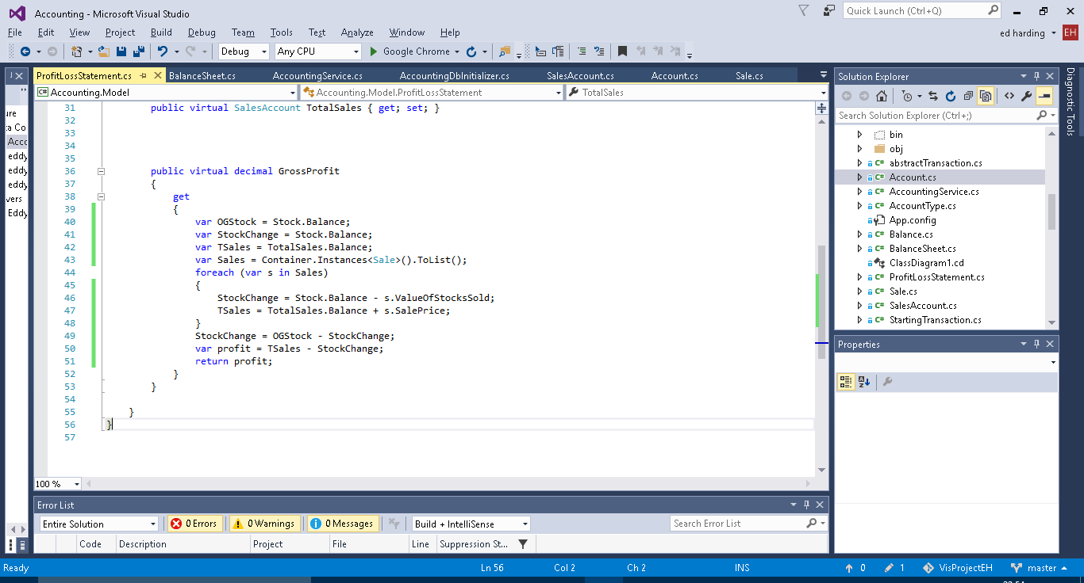

Screenshots of the new functions added to accounting services (i.e. the menu).

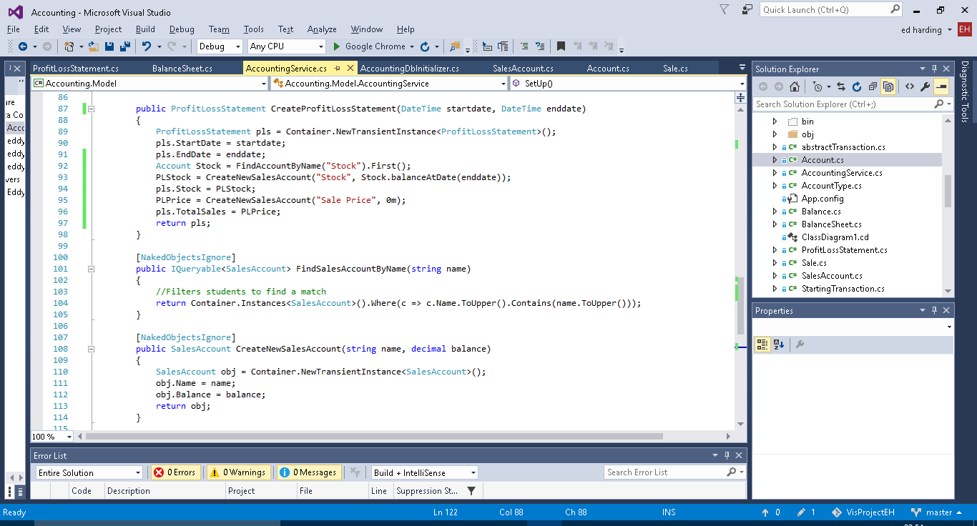

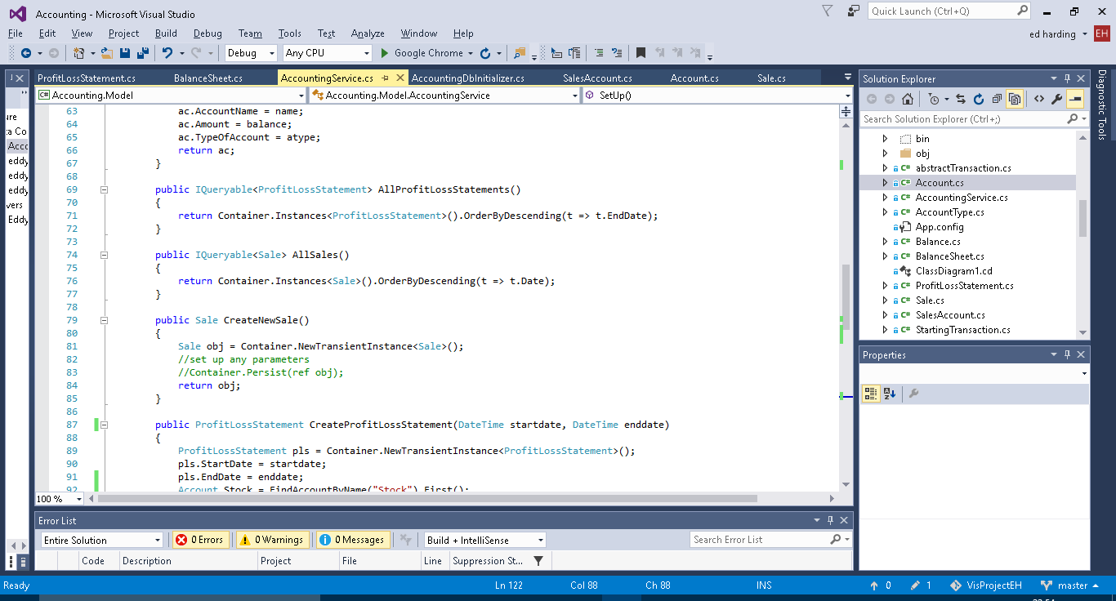

New functions added to the DB initializer. Only the AddNewSale is currently being used.

