Exercise 1

1) The Jacobian at (0,0) is $[\begin{matrix}1 & 1 \\ 0 & 2\end{matrix}]$

The eigenvalues are $λ=1$ and $λ=2$

Then eigenvector for 1 is (1; 4/3) and the eigenvector for 2 is (-.031623, 0.94868).

The first way one can graph the trajectory is by simply clicking on the curve

You can graph a trajectory by going to solutions and inputting solutions. This graph the trajectory along the curve more accurate then the method above.

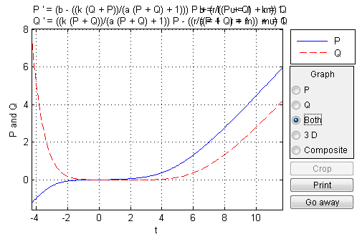

Figure : (P,Q)=(2,5)

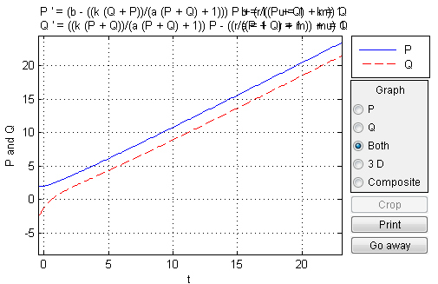

Figure :(P,Q)=(5,1)