# 交通灯作业

## 何尔恒 20172333090 通信6 A班

### 1Hz分频

LIBRARY IEEE;

USE IEEE.STD_LOGIC_1164.ALL;

USE IEEE.STD_LOGIC_UNSIGNED.ALL;

ENTITY div1 IS

GENERIC(m: INTEGER := 50000000); --原来有50000000个脉冲。现在每一个脉冲里包含原来的50000000个脉冲，所以变成1hz

PORT (clk: IN STD_LOGIC;

q: OUT STD_LOGIC);

END div1;

ARCHITECTURE behave OF div1 IS

signal count :integer range m-1 downto 0:=m-1;

BEGIN

process(clk)

begin

if rising_edge(clk) then

count<=count-1;

if count>=m/2 then --脉冲占空比是1/2，前半部分输出低电平，后半部分输出高电平

q<='0';

else

q<='1';

end if;

if count<=0 then

count<=m-1;

end if;

end if;

end process;

end behave;

### 1000Hz分频

LIBRARY IEEE;

USE IEEE.STD_LOGIC_1164.ALL;

USE IEEE.STD_LOGIC_UNSIGNED.ALL;

ENTITY div1000 IS

GENERIC(m: INTEGER := 50000); --原来有50000000个脉冲。现在每一个脉冲里包含原来的50000个脉冲，所以变成1000hz

PORT (clk: IN STD_LOGIC;

q: OUT STD_LOGIC);

END div1000;

ARCHITECTURE behave OF div1000 IS

signal count :integer range m-1 downto 0:=m-1;

BEGIN

process(clk)

begin

if rising_edge(clk) then

count<=count-1;

if count>=m/2 then --脉冲占空比是1/2，前半部分输出低电平，后半部分输出高电平

q<='0';

else

q<='1';

end if;

if count<=0 then

count<=m-1;

end if;

end if;

end process;

end behave;

### 数码管显示部分

LIBRARY IEEE;

USE IEEE.STD_LOGIC_1164.ALL;

ENTITY seg7led IS

PORT(

clk: IN STD_LOGIC; --clk为1000Hz

LIGHT1, LIGHT2, NUM1, NUM2: IN INTEGER RANGE 0 TO 9 ;

TOseg7com: OUT STD_LOGIC_VECTOR(3 downto 0);

data_out: OUT STD_LOGIC_VECTOR(7 downto 0)

);

END seg7led;

ARCHITECTURE example OF seg7led IS

SIGNAL CNT4: INTEGER RANGE 0 TO 3 := 0;

SIGNAL SHUJU: INTEGER RANGE 0 TO 9;

BEGIN

PROCESS(clk)

BEGIN

IF (clk'EVENT AND clk = '1') THEN

CNT4 <= CNT4+1;

CASE CNT4 IS

WHEN 0 =>

TOseg7com <= "0111"; SHUJU <= NUM2;

WHEN 1 =>

TOseg7com <= "1011"; SHUJU <= NUM1;

WHEN 2 =>

TOseg7com <= "1101"; SHUJU <= LIGHT2;

WHEN 3 =>

TOseg7com <= "1110"; SHUJU <= LIGHT1;

WHEN OTHERS => NULL;

END CASE;

END IF;

END PROCESS;

process(SHUJU)

begin

case SHUJU is

when 0 => data_out <= "11000000"; -- 0

when 1 => data_out <= "11111001"; -- 1

when 2 => data_out <= "10100100"; -- 2

when 3 => data_out <= "10110000"; -- 3

when 4 => data_out <= "10011001"; -- 4

when 5 => data_out <= "10010010"; -- 5

when 6 => data_out <= "10000010"; -- 6

when 7 => data_out <= "11111000"; -- 7

when 8 => data_out <= "10000000"; -- 8

when 9 => data_out <= "10010000"; -- 9

when others => NULL;

end case;

end process;

END example;

### 主要判断部分

LIBRARY IEEE;

USE IEEE.STD_LOGIC_1164.ALL;

USE IEEE.STD_LOGIC_UNSIGNED.ALL;

ENTITY jiaotongdeng IS

PORT ( clk, subway: IN STD_LOGIC; --subway按键代表次干道有无车等待，clk为1Hz

LIGHT1, LIGHT2, NUM1, NUM2: OUT INTEGER RANGE 0 TO 9 ); --数码管依次显示主干道灯，次干道灯，十位数，个位数

END jiaotongdeng;

ARCHITECTURE example OF jiaotongdeng IS

TYPE STATES IS (S1,S2,S3,S4) ; --四种状态：

SIGNAL STATE: STATES := S1;

SIGNAL COUNT : INTEGER RANGE 0 TO 45 := 0;

BEGIN

PROCESS (subway, clk)

BEGIN

IF(clk'EVENT AND clk='1')THEN

CASE STATE IS

WHEN S1 =>

IF (subway = '0' and COUNT =0) THEN

STATE <= S2;

COUNT <= 5;

LIGHT1 <= 2;

LIGHT2 <= 4;

ELSE

IF (COUNT = 0) THEN

COUNT <= 45;

ELSE

COUNT <= COUNT-1;

END IF;

LIGHT1 <= 1;

LIGHT2 <= 4;

END IF;

WHEN S2 =>

IF (COUNT = 0) THEN

STATE <= S3;

COUNT <= 25;

LIGHT1 <= 4;

LIGHT2 <= 1;

ELSE

COUNT <= COUNT-1;

END IF;

WHEN S3 =>

IF (COUNT = 0 OR SUBWAY = '1') THEN

STATE <= S4;

COUNT <= 5;

LIGHT1 <= 4;

LIGHT2 <= 2;

ELSE

COUNT <= COUNT-1;

END IF;

WHEN S4 =>

IF (COUNT = 0) THEN

STATE <= S1;

COUNT <= 45;

LIGHT1 <= 1;

LIGHT2 <= 4;

ELSE

COUNT <= COUNT-1;

END IF;

END CASE;

END IF;

NUM1 <= COUNT/10; --得十位

NUM2 <= COUNT REM 10; --得个位

END PROCESS;

END example;

### 顶层文件

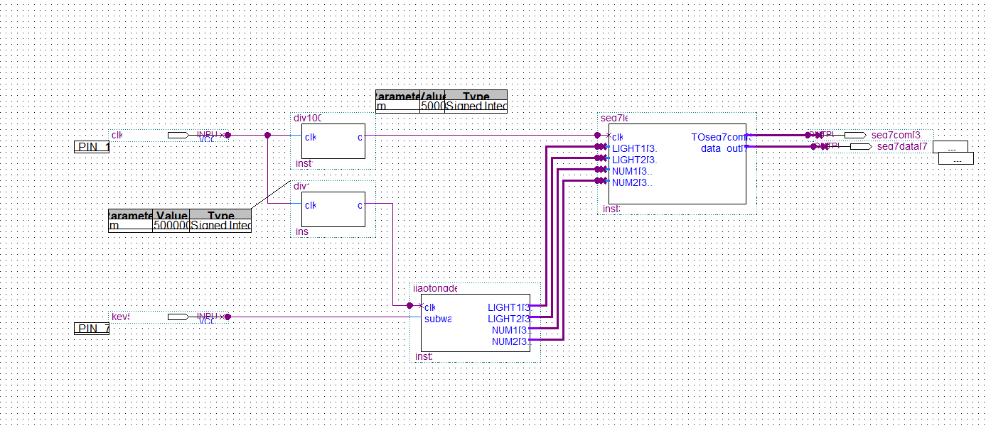

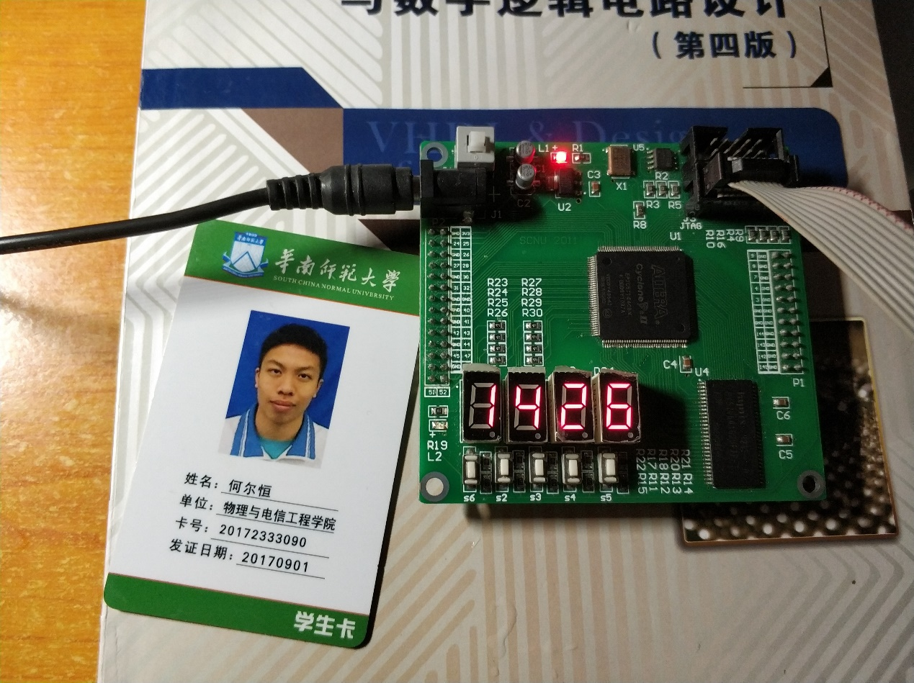

次干道无车等待，一直循环主绿次红45秒

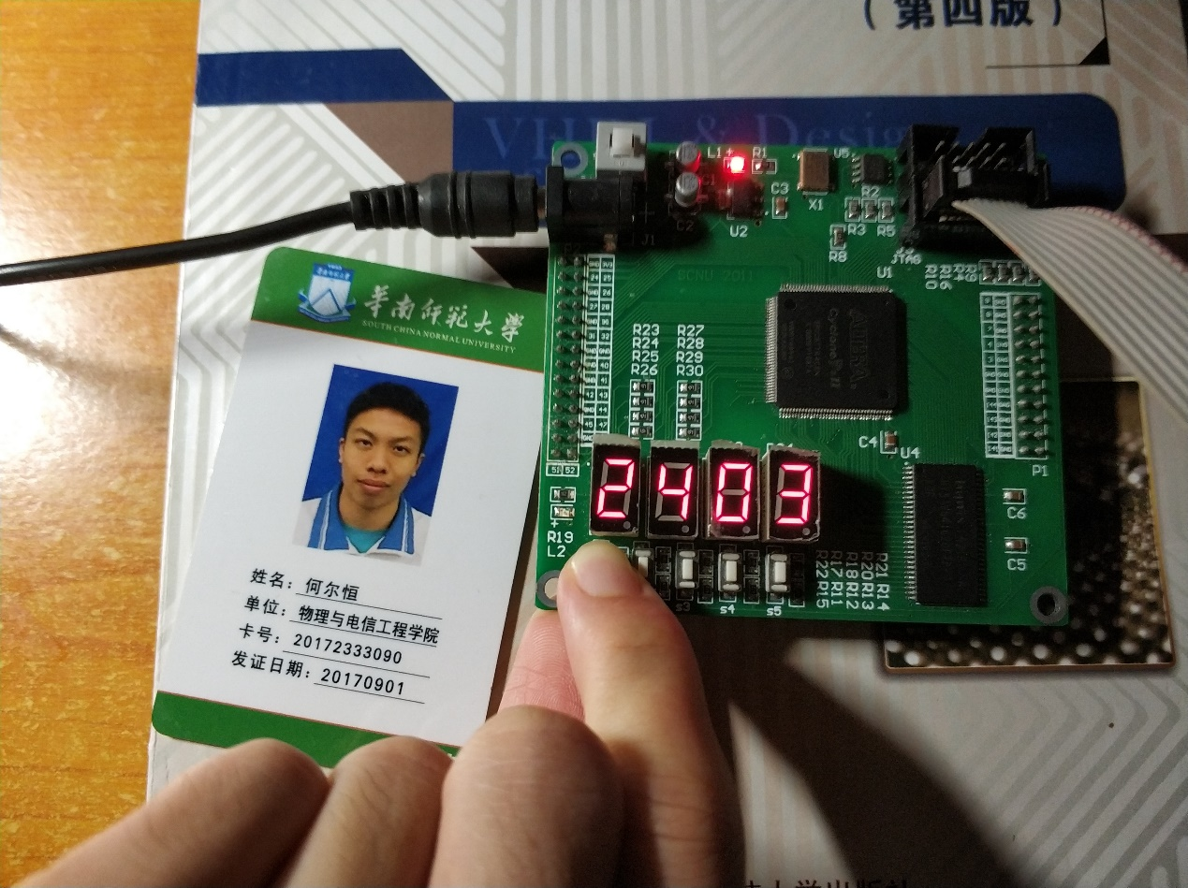

次干道有车等待（按键按下），且等45秒计完后，转变为主黄次红维持5秒

随后进入主红次绿状态，倒计时25秒

当25秒倒计时完或者未倒计时完之前次干道已无车等待（按键松开），进入主黄次绿状态

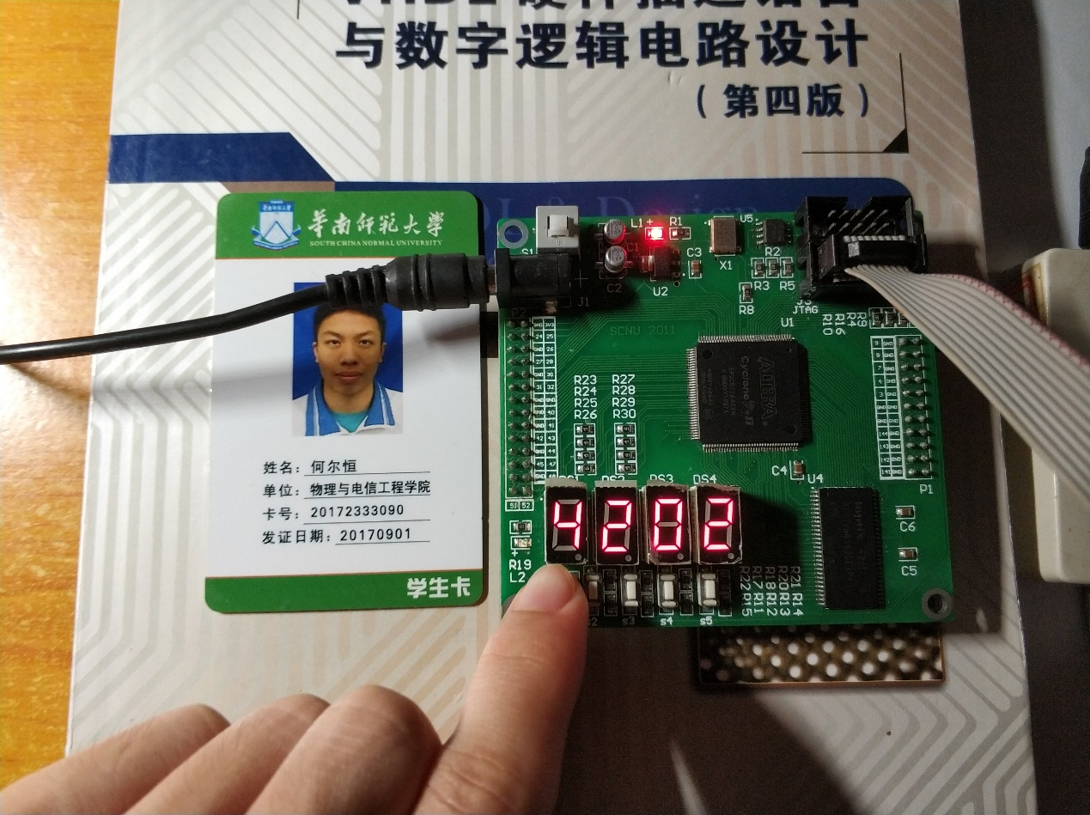

维持5秒

又进入主绿次红的状态，倒计时45秒