**“24 Hours Digital Clock”**

**Introduction**

We know that the digital clock is one of the most used components in our daily lives. Before taking this course, we basically observed the clock but never knew how exactly it works. In this particular project, we dive deeper into the core mechanics of a **“24 Hour Digital Clock”.** By dissecting the core components of the digital clock we found some basic elements which control the input and output of the digital clock itself. In those core components of the digital clock, there are 7 segment circuits, 555 placed timer (oscillator), display counter, and universal gates to control the basic communications between the IC and the output of the clock. To gain knowledge of the bigger things in the world, we cannot ignore the smallest knowledge around us. That’s why a digital clock is always important knowledge to gain.

**Proposed Model**

Firstly, we used a 555 timer to count the clock. The 555 Timer is connected with a 9V battery which sends signals as a pulse to the 7 segment circuit connected at the end. We connected a capacitor of 1.5μF. Pin number 1 is the connection to the ground. Pin number 6 is the threshold which is connected to a resistor with 470k Ω. The DC pin is connected parallels with pin number 3 which is considered output. Pulse is sent through pin number 3.  
  
The first 7 Segment Circuit has a total of 7+3 output pins and 2+2 input pins. It deals with BCD in order to generate output. The first pin(1) is the input pin which is named “CLK”, the output from pin 3 of 555 timer is sent here. Thus, an input of “0 0 0 1” is generated and output is shown as 1 (Since 0001 is the BCD of 1).

The 7 segment circuit has been designed in a way that it has the lowest BCD output of 0000 or 0 and highest BCD output of 1001 or 9. The 7 segment circuit has an output of “CO” or Carry Output. We used the carry output of the 1st digit of the second for the 2nd digit of the second in the display segment. The 2nd digit had to be limited to “0101” or “5”. So we used 7 resistors of 470 Ω and connected the parts of “e, f ,g” to another three 470Ω resistors. We connected the three resistors to a three input AND Gate and used the output of AND Gate as a carry output to the next segment (For minute)

The first digit of minutes followed the same procedure as second’s but the carry came from second’s 2nd digit. We followed the same procedure for minutes 2nd digit, just like second’s 2nd digit.

For the hour system, we used the carry output using AND Gate from minute’s 2nd digit. We also connected the hour’s first digit display to the hour’s segment. This time, for the hour's 2nd digit, we used 2 extra resistors with a three input AND Gate and 1 resistor from the 1st digit of the hour’s 1st digit’s segment. For this reason, when the hour reaches 23, the carry output goes to “MR”, which resets the whole clock and starts from zero again.

**Experimental Setup**

**Components:**

1. 7 SEG-COM-CAT-GEN-6 placed Green, 7-Segment Common Cathode
2. 555- 1 Placed Timer/Oscillator
3. 4026-6 Placed 7 Segment Display Decade Counter
4. 7411-3 placed Triple 3-input positive-AND Gates
5. Capacitor
6. METALFILM470R- 39 placed 470R 2W Resistor
7. VSOURCE - 1 placed DC Voltage Source
8. 7411

**7 SEG-COM-CAT-GEN-6 placed Green, 7-Segment Common Cathode**

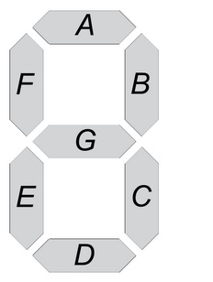

The First and main component of our Project work is the 7-segment Display (named 7 SEG-COM-CAT-GEN-6 placed Green/ 7-Segment Common Cathode in Proteus). The component takes inputs from the BCD (Binary-Coded Decimal) value and the input lights up the 7 built-in segments in the component. The BCD inputs are given from the 4 Logic Probes taken. The output segments are labeled as a,b,c,d,e,f,g which indicates the whole 7 segments.

**555- 1 Placed Timer/Oscillator:**

**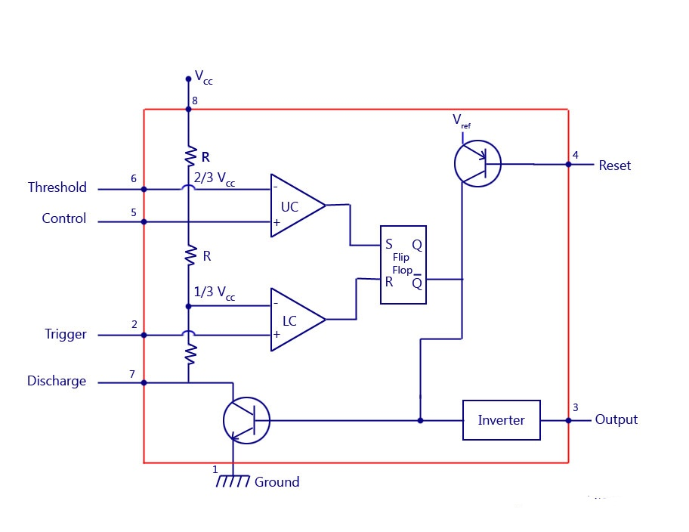*Figure 02: Clock Circuit with 555 timer.***

The 555-Timer is the powerhouse of the circuit. It works like an oscillator. The main work method of the 555-Timer is the Astable Mode. The Astable Mode functions like a pulse generator, where over a certain period of time, the voltage and capacitor of the circuit generates a Pulse, acting like input 1.

**4026-6 Placed 7 Segment Display Decade Counter:**

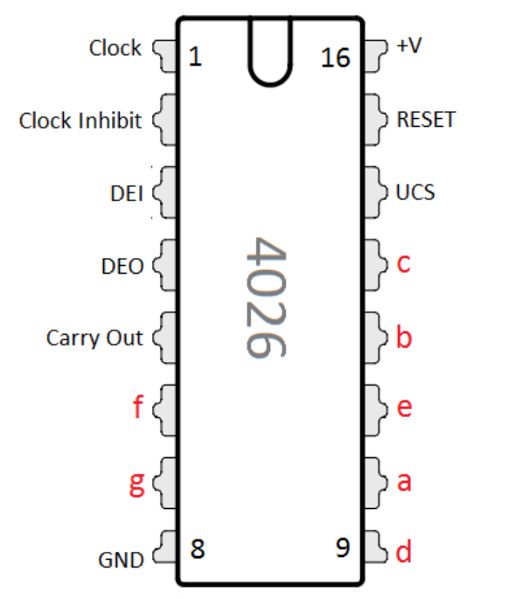

The 4026 is a decade counter *integrated circuit* (IC) with decoded outputs for driving a common-cathode seven-segment LED display. An advantage of this IC is that it has decade counter functionality together with a 7-segment decoder driver. The *CD4026BE*, manufactured by the Texas Instruments Corporation, is the chip currently utilised for simple GCSE type project circuits. It comes in a 16-pin plastic dual-in-line package, for use with strip boards and breadboards.

**7411-3 placed Triple 3-input positive-AND Gates:**

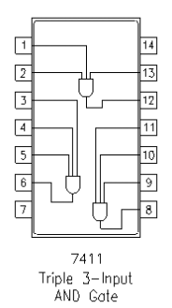

The 74LS11 IC package contains three independent positive logic 3-input AND GATES. Pins 14 and 7 provide power for all three logic gates.

**Capacitor:**

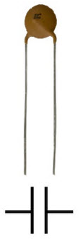

The capacitor is a component which has the ability or “capacity” to store energy in the form of an electrical charge producing a potential difference (*Static Voltage*) across its plates, much like a small rechargeable battery.

**Circuit diagram:**

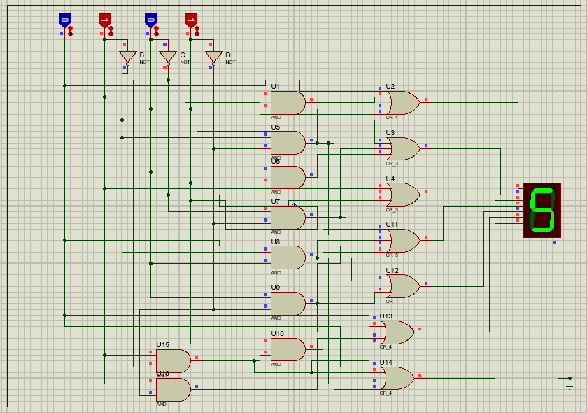

**Figure 01: Circuit of 7 segment.**

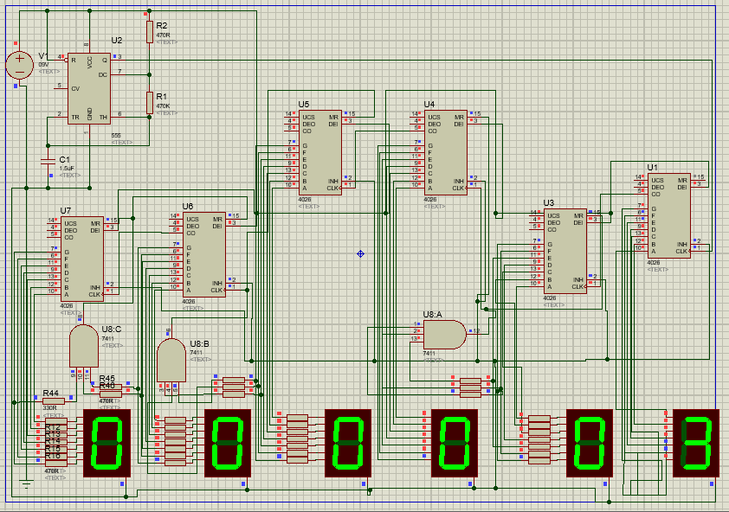

**Explanation:**

**Result and Analysis**

**Truth table of 7-segment:**

|  |  |  |  |  |  |  |  |  |  |  |  |
| --- | --- | --- | --- | --- | --- | --- | --- | --- | --- | --- | --- |
| **Inputs Output of Segment Output** | | | | | | | | | | | |
| A | B | C | D | a | b | c | d | e | f | g | Display |
| 0 | 0 | 0 | 0 | 1 | 1 | 1 | 1 | 1 | 1 | 0 | 0 |
| 0 | 0 | 0 | 1 | 0 | 1 | 1 | 0 | 0 | 0 | 0 | 1 |
| 0 | 0 | 1 | 0 | 1 | 1 | 0 | 1 | 1 | 0 | 1 | 2 |
| 0 | 0 | 1 | 1 | 1 | 1 | 1 | 1 | 0 | 0 | 1 | 3 |
| 0 | 1 | 0 | 0 | 0 | 0 | 1 | 0 | 0 | 1 | 1 | 4 |
| 0 | 1 | 0 | 1 | 1 | 0 | 1 | 1 | 0 | 1 | 1 | 5 |
| 0 | 1 | 1 | 0 | 1 | 0 | 1 | 1 | 1 | 1 | 1 | 6 |
| 0 | 1 | 1 | 1 | 1 | 1 | 1 | 0 | 0 | 0 | 0 | 7 |
| 1 | 0 | 0 | 0 | 1 | 1 | 1 | 1 | 1 | 1 | 1 | 8 |
| 1 | 0 | 0 | 1 | 1 | 1 | 1 | 1 | 0 | 1 | 1 | 9 |

**Conclusion**

The circuit, we made, was purely designed with basic knowledge. This clock is expected to operate normally. After the final test, the performance of the project meets the desired output.

There are some disadvantages such as the wires of the circuit are not being well organized. Moreover, we faced some problems while setting up the project such as,

-Labels were overlapping, selecting the wires and modifying the attributes was a bit difficult in this situation.

-We had no idea how to use the carry bit at first. So our clock had 99 seconds, 99 minutes, and 99 hours.

-Use of resistors is extremely handy when it comes to controlling the inputs.

-Keeping the resistors 470Ω gave a good advantage such as matching the time with Proteus simulation debugging time.  
-Finding out the sequence from the truth table of the BCD was a good trick to show the outputs.